**First look to the page**

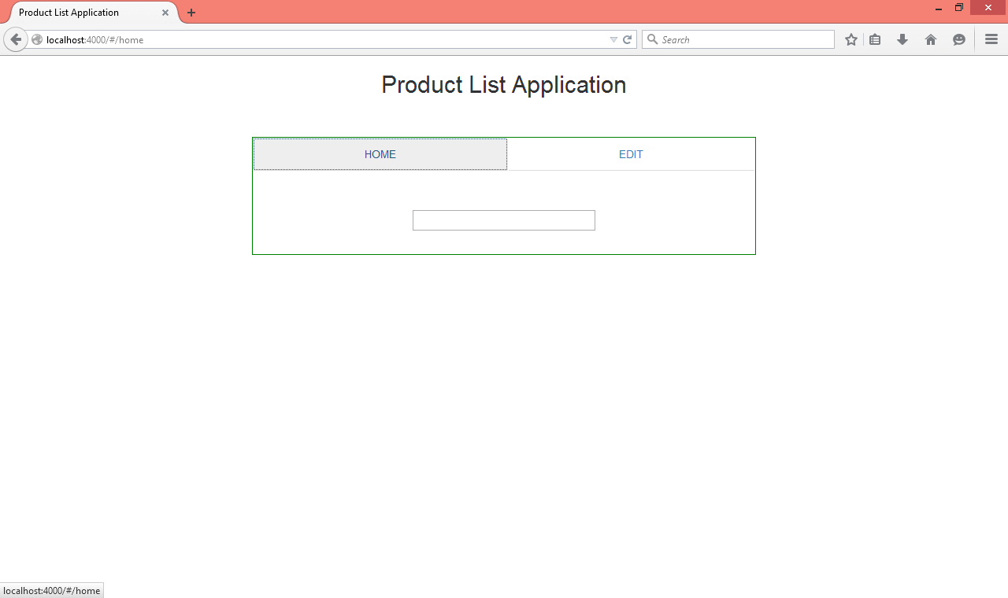

**Now adding Products from EDIT tab**

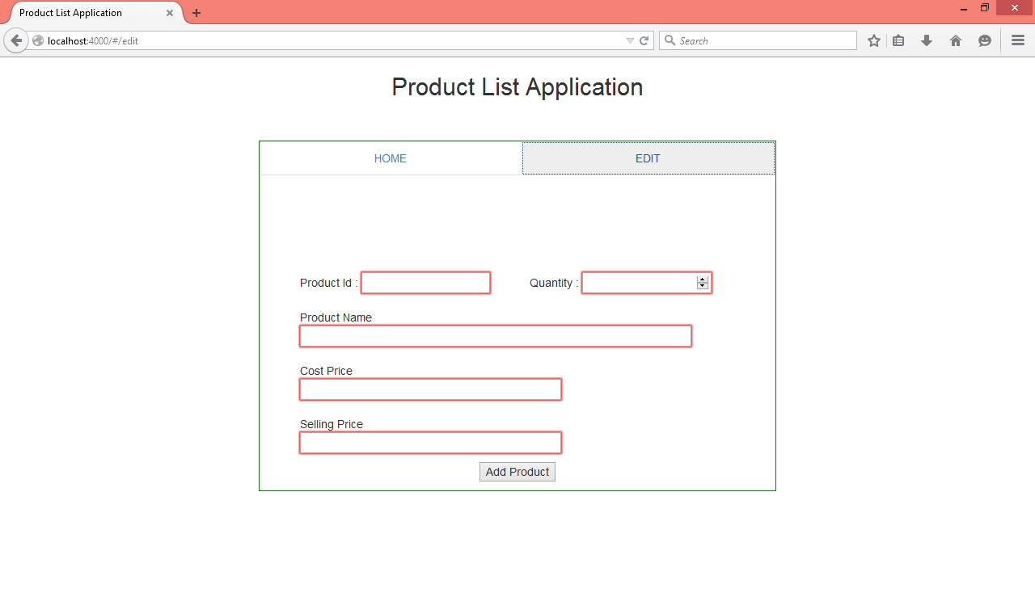

**Enter the details and then press “Enter” or Click “Add Product” button to add**

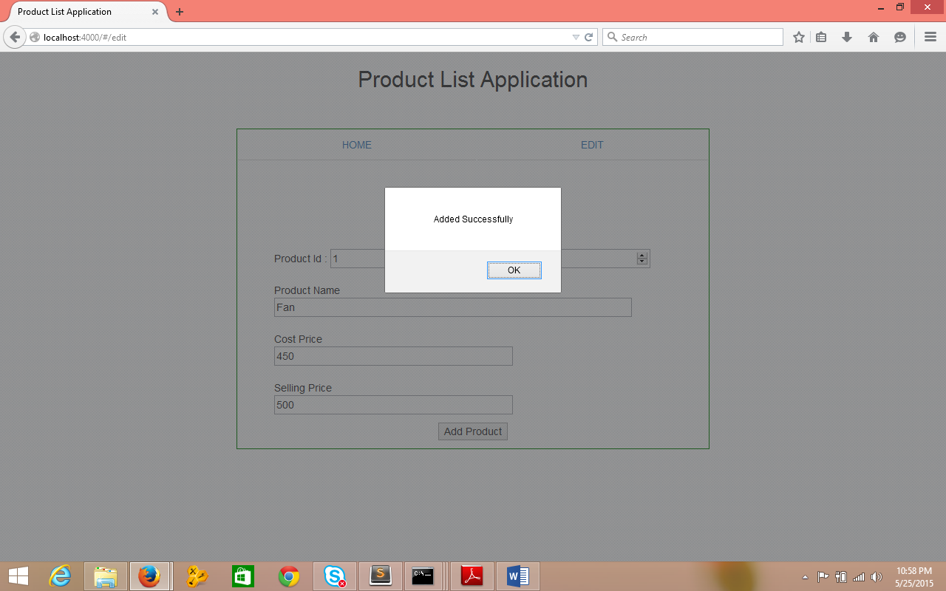

**Adding few more items**

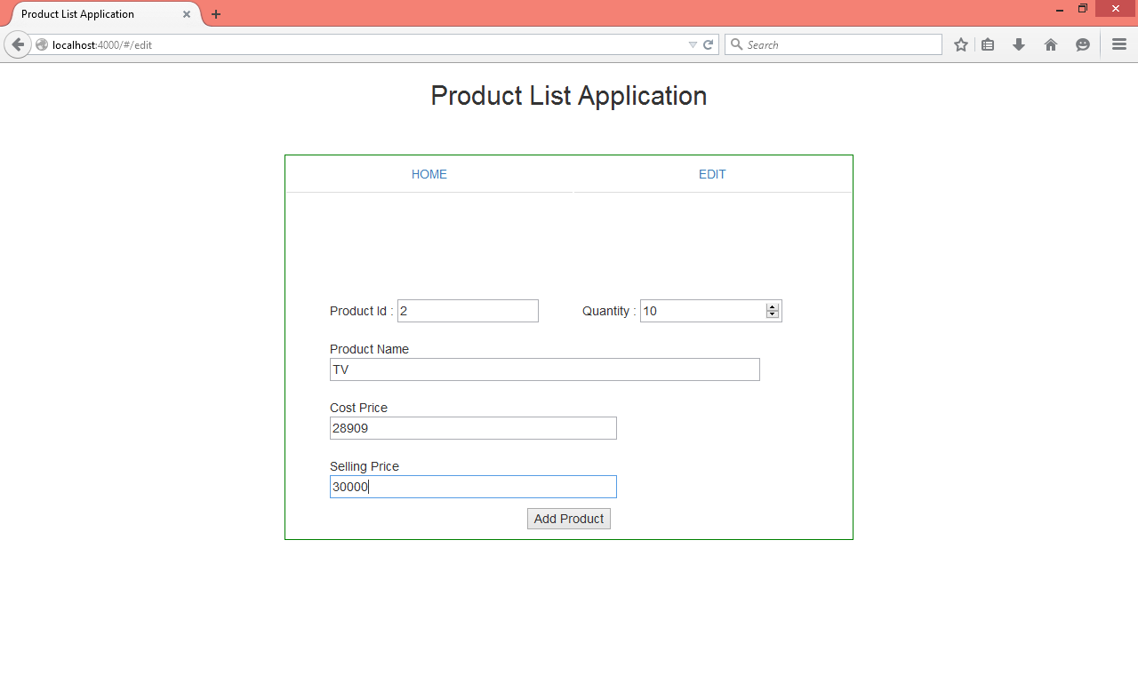

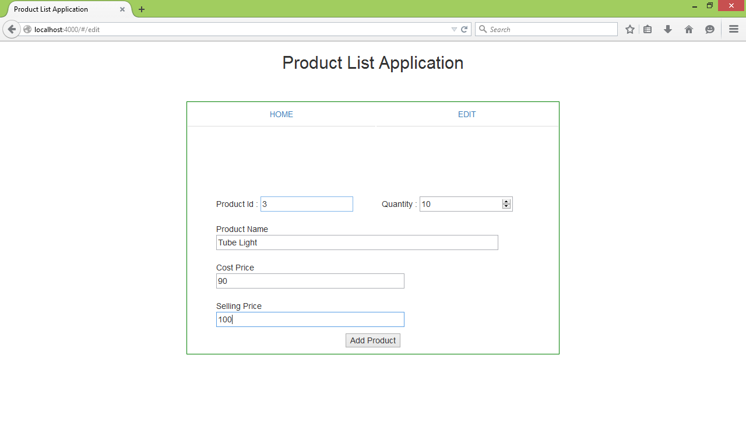

**Go to HOME tab to search products**

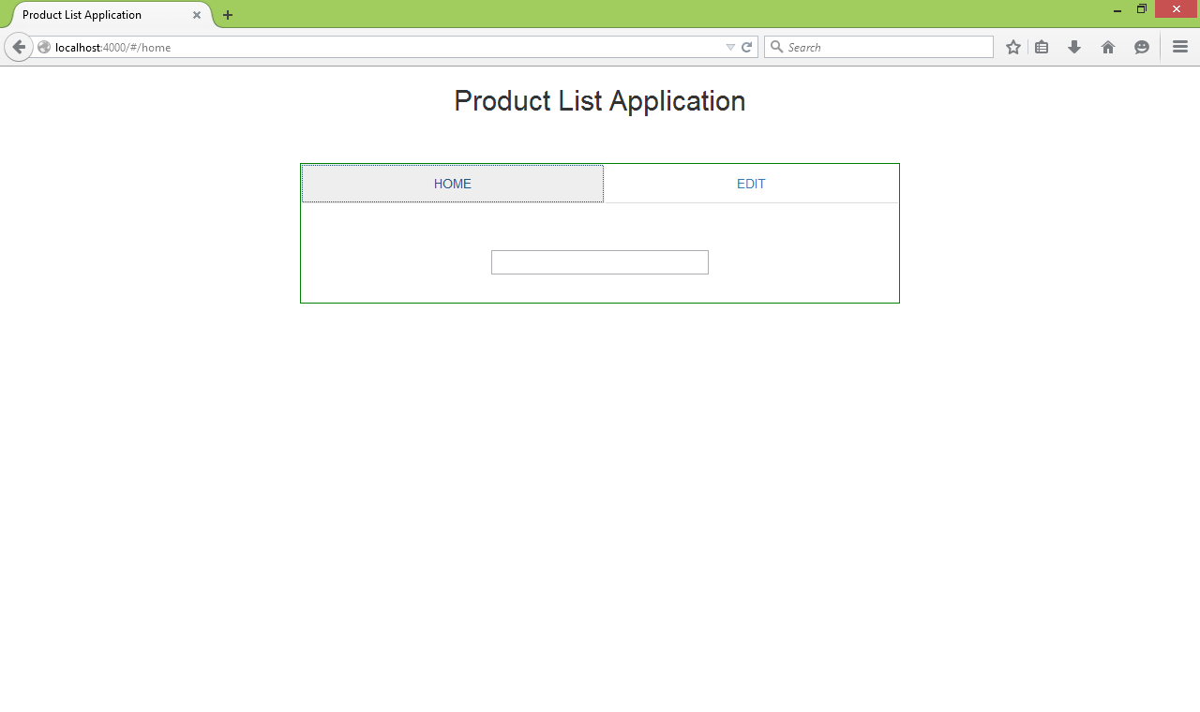

**Type charcter “T” system will suggest the products start with T**

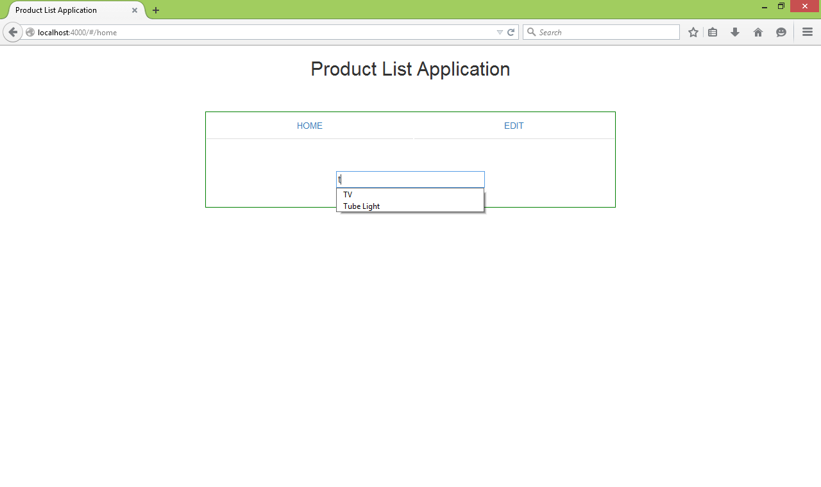

**Select any product and press enter , System will show the details of that product where only “Product Name” and “Selling Price” are editable fields**

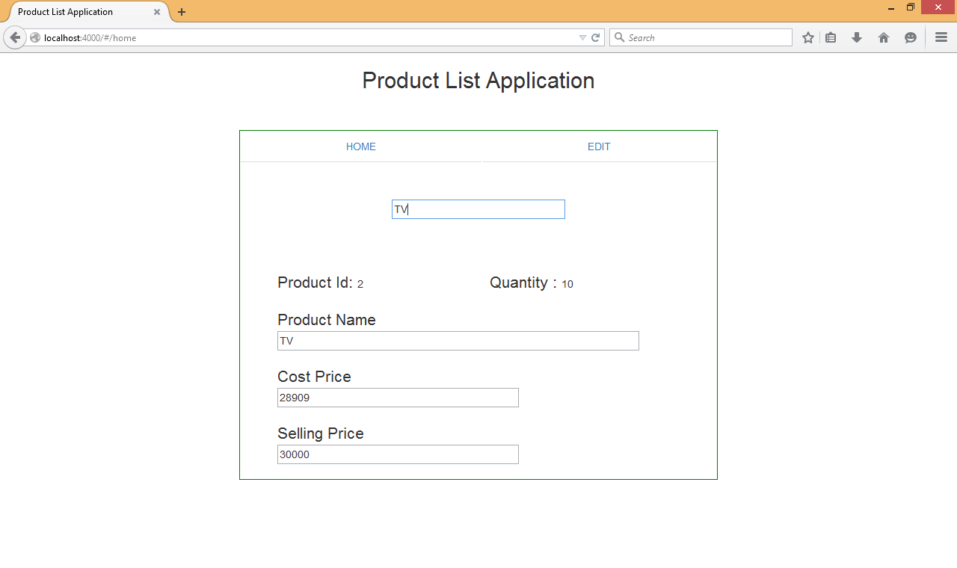

**Change the product Name and Selling Price of the selected Product and press enter , System will update the details as well as the search box value.**

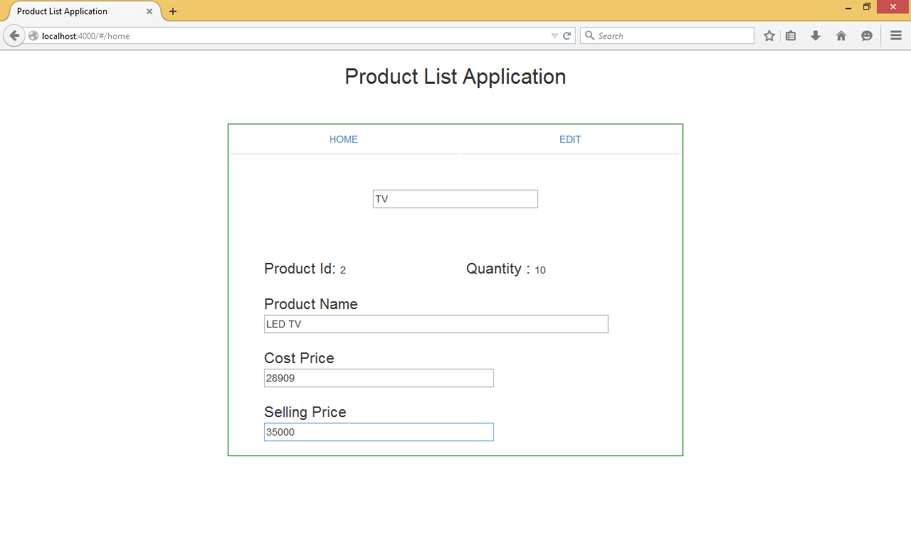

**Press Enter**

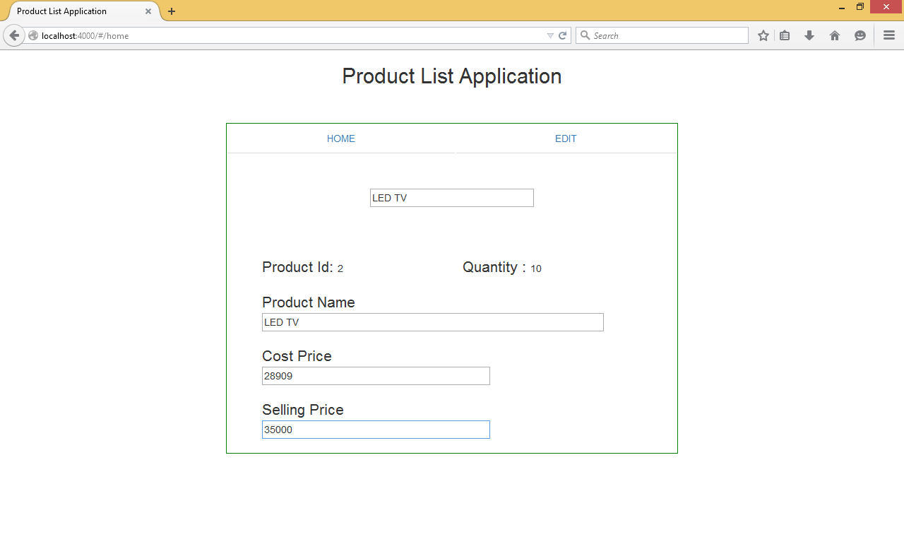

**Go to Search box again to check the updated list**

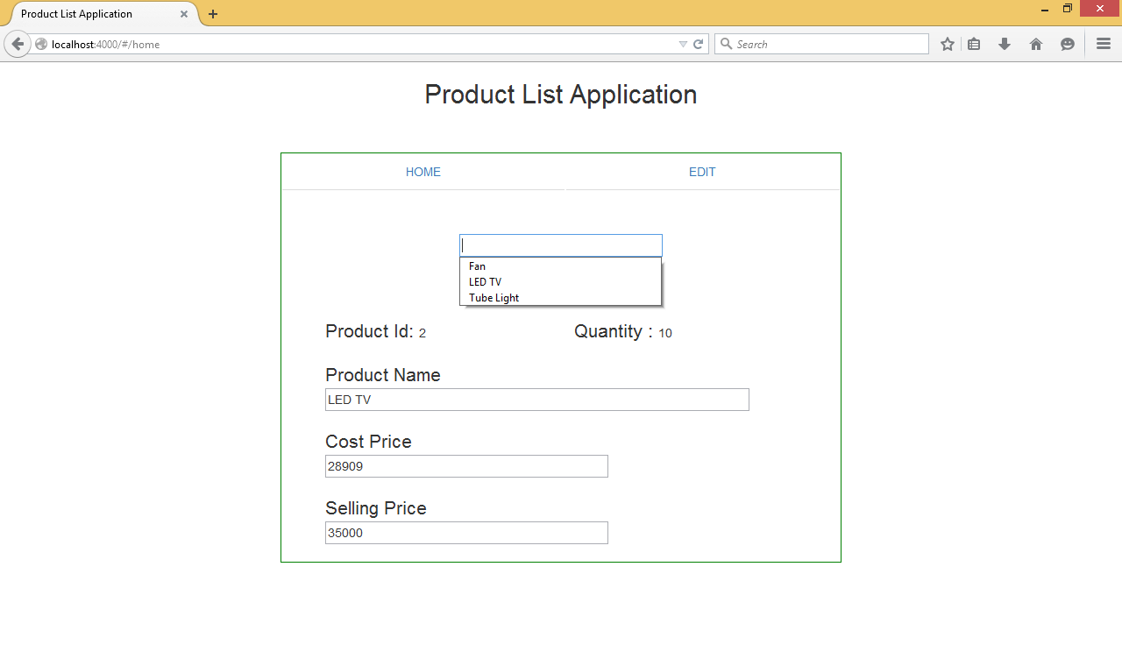

**Validations –**

1. **Alpha Numeric characters for Name**

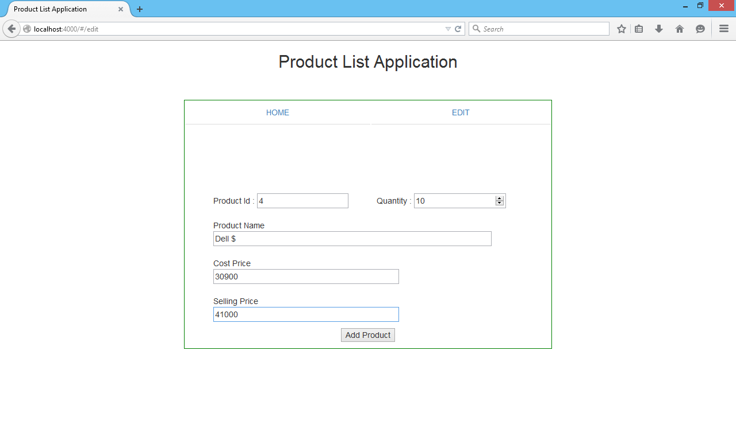

**Press Enter**

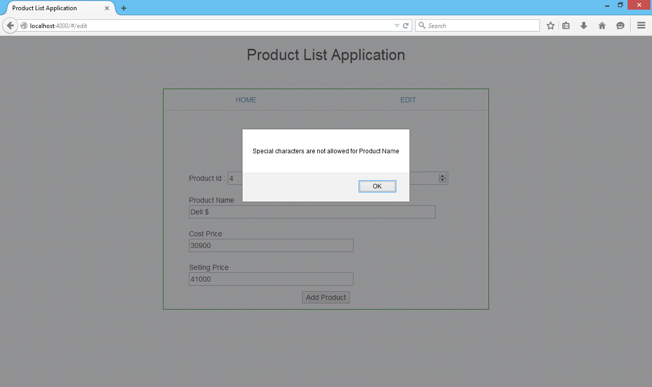

1. **Selling Price should not be less than Cost Price**

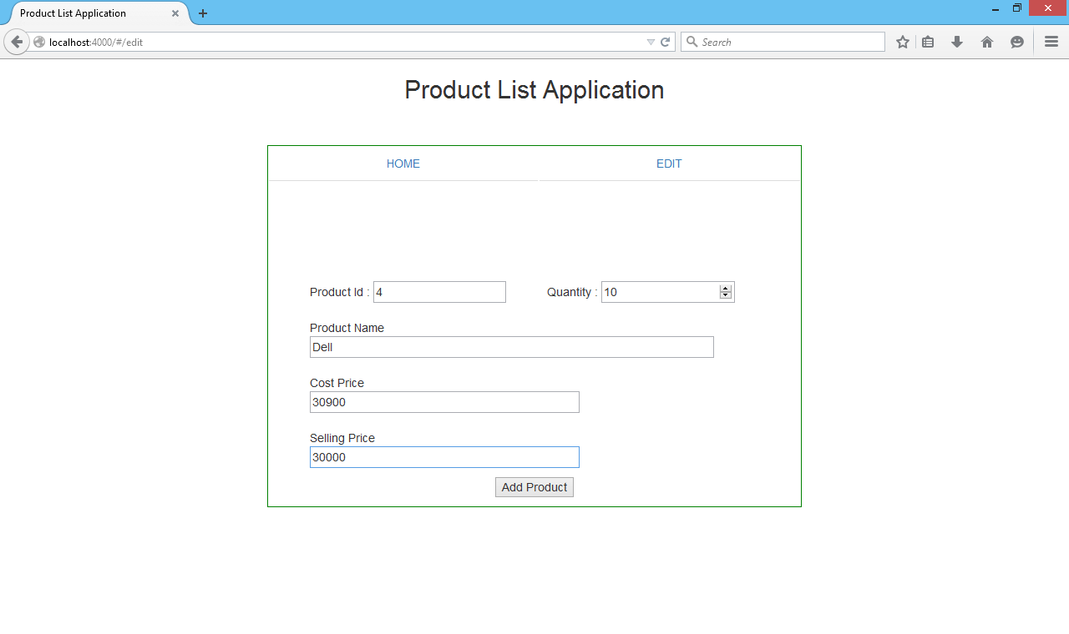

**Press Enter**

