

|  |
| --- |
| restaurant |
| 08/10/18 17:05 |
| **Author:** Raman Kumar Verma  **File name:** restaurant.vp  **Version** 1.0 |

01. Site Map / restaurant 

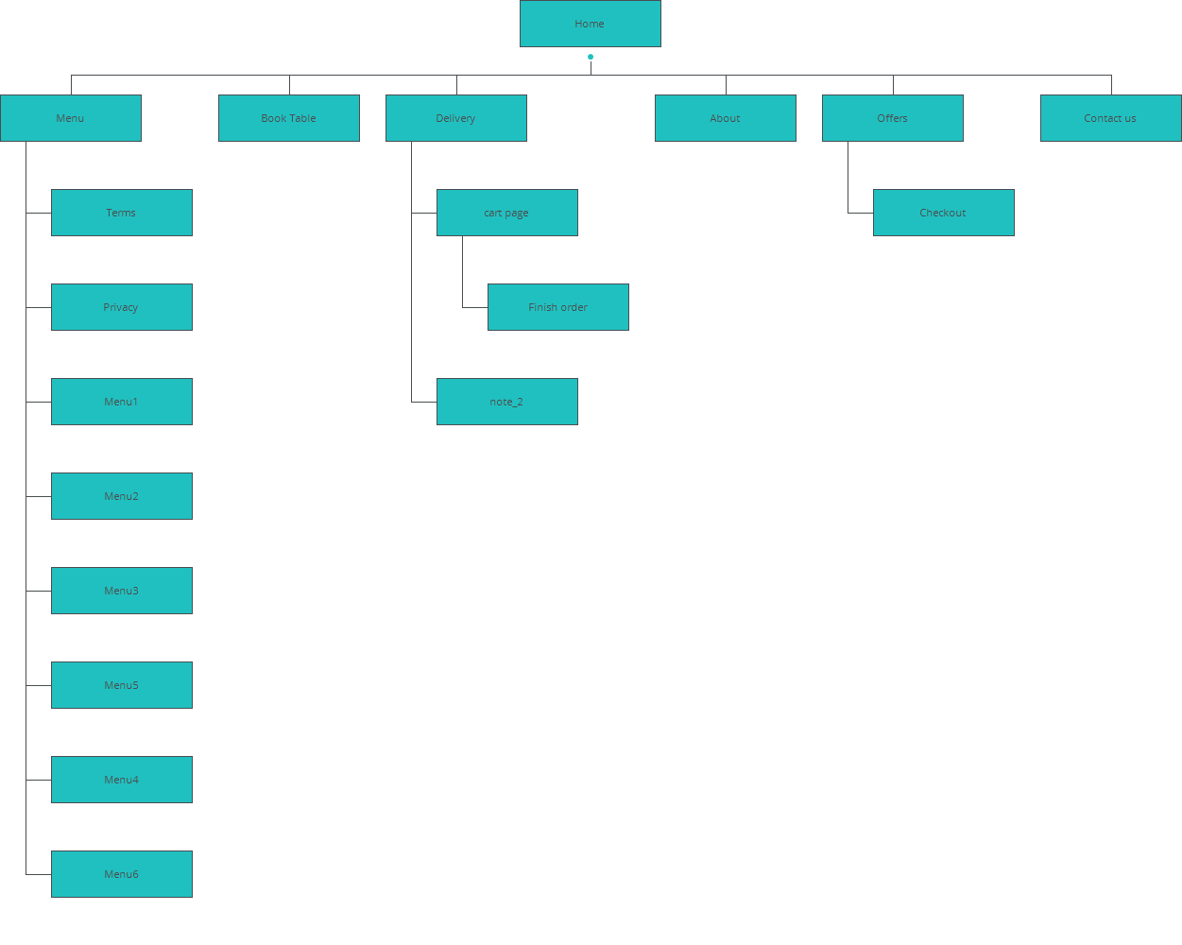

2. Screens / restaurant 

Home

|  |
| --- |
|  |

Interactions

|  |  |
| --- | --- |
| 1 | **on Click:** goes to 'Menu' 🡪 |
| 2 | **on Click:** goes to 'Book Table' 🡪 |
| 3 | **on Click:** goes to 'Delivery' 🡪 |
| 4 | **on Click:** goes to 'About' 🡪 |
| 5 | **on Click:** goes to 'Offers' 🡪 |
| 6 | **on Click:** goes to 'Contact us' 🡪 |
| 7 | **on Click:** goes to 'Menu' 🡪 |
| 8 | **on Click:** goes to 'Book Table' 🡪 |
| 9 | **on Click:** goes to 'Delivery' 🡪 |
| 10 | **on Click:** goes to 'About' 🡪 |
| 11 | **on Click:** goes to 'Offers' 🡪 |
| 12 | **on Click:** goes to 'Contact us' 🡪 |

02. Screens / restaurant 

Contact us

|  |
| --- |
|  |

Interactions

|  |  |
| --- | --- |
| 13 | **on Click:** goes to 'Home' 🡪 |
| 18 | **on Click:** goes to 'Home' 🡪 |

02. Screens / restaurant 

Terms

|  |
| --- |
|  |

Interactions

|  |  |
| --- | --- |
| 21 | **on Click:** goes to 'Home' 🡪 |
| 26 | **on Click:** goes to 'Home' 🡪 |

02. Screens / restaurant 

Privacy

|  |
| --- |
|  |

Interactions

|  |  |
| --- | --- |
| 29 | **on Click:** goes to 'Home' 🡪 |
| 34 | **on Click:** goes to 'Home' 🡪 |

02. Screens / restaurant 

Menu1

|  |
| --- |
|  |

Interactions

|  |  |
| --- | --- |
| 37 | **on Click:** goes to 'Home' 🡪 |
| 42 | **on Click:** goes to 'Home' 🡪 |
| 45 | **on Click:** goes to 'note_2' 🡪 |
| 46 | **on Click:** goes to 'Checkout' 🡪 |

02. Screens / restaurant 

Menu2

|  |
| --- |
|  |

Interactions

|  |  |
| --- | --- |
| 47 | **on Click:** goes to 'Home' 🡪 |
| 52 | **on Click:** goes to 'Home' 🡪 |
| 55 | **on Click:** goes to 'note_2' 🡪 |
| 56 | **on Click:** goes to 'Checkout' 🡪 |

02. Screens / restaurant 

Menu3

|  |
| --- |
|  |

Interactions

|  |  |
| --- | --- |
| 57 | **on Click:** goes to 'Home' 🡪 |
| 62 | **on Click:** goes to 'Home' 🡪 |
| 65 | **on Click:** goes to 'note_2' 🡪 |
| 66 | **on Click:** goes to 'Checkout' 🡪 |

02. Screens / restaurant 

Menu4

|  |
| --- |
|  |

Interactions

|  |  |
| --- | --- |
| 67 | **on Click:** goes to 'Home' 🡪 |
| 72 | **on Click:** goes to 'Home' 🡪 |
| 75 | **on Click:** goes to 'note_2' 🡪 |
| 76 | **on Click:** goes to 'Checkout' 🡪 |

02. Screens / restaurant 

Menu5

|  |
| --- |
|  |

Interactions

|  |  |
| --- | --- |
| 77 | **on Click:** goes to 'Home' 🡪 |
| 82 | **on Click:** goes to 'Home' 🡪 |
| 85 | **on Click:** goes to 'note_2' 🡪 |
| 86 | **on Click:** goes to 'Checkout' 🡪 |

02. Screens / restaurant 

Menu6

|  |
| --- |
|  |

Interactions

|  |  |
| --- | --- |
| 87 | **on Click:** goes to 'Home' 🡪 |
| 92 | **on Click:** goes to 'Home' 🡪 |
| 95 | **on Click:** goes to 'note_2' 🡪 |
| 96 | **on Click:** goes to 'Checkout' 🡪 |

02. Screens / restaurant 

About

|  |
| --- |
|  |

Interactions

|  |  |
| --- | --- |
| 97 | **on Click:** goes to 'Home' 🡪 |
| 102 | **on Click:** goes to 'Home' 🡪 |

02. Screens / restaurant 

Book Table

|  |
| --- |
|  |

Interactions

|  |  |
| --- | --- |
| 105 | **on Click:** goes to 'Home' 🡪 |
| 110 | **on Click:** goes to 'Home' 🡪 |
| 113 | **on Click:** goes to 'Menu' 🡪 |

02. Screens / restaurant 

Menu

|  |
| --- |
|  |

Interactions

|  |  |
| --- | --- |
| 114 | **on Click:** goes to 'Home' 🡪 |
| 119 | **on Click:** goes to 'Home' 🡪 |
| 122 | **on Click:** goes to 'Menu1' 🡪 |
| 123 | **on Click:** goes to 'Menu2' 🡪 |
| 124 | **on Click:** goes to 'Menu3' 🡪 |
| 125 | **on Click:** goes to 'Menu5' 🡪 |
| 126 | **on Click:** goes to 'Menu4' 🡪 |
| 127 | **on Click:** goes to 'Menu6' 🡪 |

02. Screens / restaurant 

Delivery

|  |
| --- |
|  |

Interactions

|  |  |
| --- | --- |
| 128 | **on Click:** goes to 'Home' 🡪 |
| 133 | **on Click:** goes to 'Home' 🡪 |
| 136 | **on Click:** goes to 'cart page' 🡪 |
| 137 | **on Click:** goes to 'Menu' 🡪 |
| 138 | **on Click:** goes to 'cart page' 🡪 |
| 139 | **on Click:** goes to 'Menu' 🡪 |
| 140 | **on Click:** goes to 'note_2' 🡪 |

02. Screens / restaurant 

Checkout

|  |
| --- |
|  |

Interactions

|  |  |
| --- | --- |
| 141 | **on Click:** goes to 'Home' 🡪 |
| 146 | **on Click:** goes to 'Home' 🡪 |
| 149 | **on Click:** goes to 'Finish order' 🡪 |

02. Screens / restaurant 

Finish order

|  |
| --- |
|  |

Interactions

|  |  |
| --- | --- |
| 150 | **on Click:** goes to 'Home' 🡪 |
| 155 | **on Click:** goes to 'Home' 🡪 |

02. Screens / restaurant 

cart page

|  |
| --- |
|  |

Interactions

|  |  |
| --- | --- |
| 158 | **on Click:** goes to 'Home' 🡪 |
| 163 | **on Click:** goes to 'Home' 🡪 |
| 166 | **on Click:** goes to 'Finish order' 🡪 |

02. Screens / restaurant 

Offers

|  |
| --- |
|  |

Interactions

|  |  |
| --- | --- |
| 167 | **on Click:** goes to 'Home' 🡪 |
| 172 | **on Click:** goes to 'Home' 🡪 |
| 175 | **on Click:** goes to 'Checkout' 🡪 |
| 176 | **on Click:** goes to 'Checkout' 🡪 |
| 177 | **on Click:** goes to 'Checkout' 🡪 |

02. Screens / restaurant 

note_2

|  |
| --- |
|  |

Interactions

|  |  |
| --- | --- |
| 178 | **on Click:** goes to 'Home' 🡪 |