#### CHAPTER 1

**INTRODUCTION**

The main objective of this project is to develop a face recognition based automated student attendance system. In order to achieve better performance, the test images and training images of this proposed approach are limited to frontal and upright facial images that consist of a single face only. The test images and training images have to be captured by using the same device to ensure no quality difference. In addition, the students have to register in the database to be recognized. The enrolment can be done on the spot through the user-friendly interface.

#### 1.1 Background

Face recognition is crucial in daily life in order to identify family, friends or someone we are familiar with. We might not perceive that several steps have actually taken in order to identify human faces. Human intelligence allows us to receive information and interpret the information in the recognition process. We receive information through the image projected into our eyes, by specifically retina in the form of light. Light is a form of electromagnetic waves which are radiated from a source onto an object and projected to human vision. Robinson-Riegler, G., & Robinson-Riegler, B. (2008) mentioned that after visual processing done by the human visual system, we actually classify shape, size, contour and the texture of the object in order to analyse the information. The analysed information will be compared to other representations of objects or face that exist in our memory to recognizeItit is a hard challenge to build an automated system to have the same capability as a human to recognize faces. However, we need large memory to recognize different faces, for example, in the Uniities, there are a lot of students with different race and gender, it is impossible to remember every face of the individual without making mistakes. In order to overcome human limitations, computers with almost limitless memory, high processing speed and power are used in face recognition systems.

The human face is a unique representation of individual identity. Thus, face recognition is defined as a biometric method in which identification of an individual is performed by comparing real-time capture image with stored images in the database of that person (Margaret Rouse, 2012).

Nowadays, face recognition system is prevalent due to its simplicity and awesome performance. For instance, airport protection systems and FBI use face recognition for criminal investigations by tracking suspects, missing children and drug activities ([Robert Silk](http://www.travelweekly.com/Robert-Silk), 2017). Apart from that, Facebook which is a popular social networking website implement face recognition to allow the users to tag their friends in the photo for entertainment purposes ([Sidney Fussell](https://kinja.com/sidneyfussell#_ga%3D2.33904934.647560575.1521956578-2116359232.1521956578), 2018). Furthermore, Intel Company allows the users to use face recognition to get access to their online account (Reichert, C., 2017). Apple allows the users to unlock their mobile phone, iPhone X by using face recognition (deAgonia, M., 2017).

The work on face recognition began in 1960. Woody Bledsoe, Helen Chan Wolf and Charles Bisson had introduced a system which required the administrator to locate eyes, ears, nose and mouth from images. The distance and ratios between the located features and the common reference points are then calculated and compared. The studies are further enhanced by Goldstein, Harmon, and Lesk in 1970 by using other features such as hair colour and lip thickness to automate the recognition. In 1988, Kirby and Sirovich first suggested principle component analysis (PCA) to solve face recognition problem. Many studies on face recognition were then conducted continuously until today (Ashley DuVal, 2012).

**1.2 Problem Statement**

Traditional student attendance marking technique is often facing a lot of trouble. The face recognition student attendance system emphasizes its simplicity by eliminating classical student attendance marking technique such as calling student names or checking respective identification cards. There are not only disturbing the teaching process but also causes distraction for students during exam sessions. Apart from calling names, attendance sheet is passed around the classroom during the lecture sessions. The lecture class especially the class with a large number of students might find it difficult to have the attendance sheet being passed around the class. Thus, face recognition student attendance system is proposed in order to replace the manual signing of the presence of students which are burdensome and causes students get distracted in order to sign for their attendance. Furthermore, the face recognition based automated student attendance system able to overcome the problem of fraudulent approach and lecturers does not have to count the number of students several times to ensure the presence of the students.

The paper proposed by Zhao, W et al. (2003) has listed the difficulties of facial identification. One of the difficulties of facial identification is the identification between known and unknown images. In addition, paper proposed by Pooja G.R et al. (2010) found out that the training process for face recognition student attendance system is slow and time-consuming. In addition, the paper proposed by [Priyanka](http://ieeexplore.ieee.org/search/searchresult.jsp?searchWithin=%22Authors%22%3A.QT.Priyanka%20Wagh.QT.&newsearch=true) [Wagh](http://ieeexplore.ieee.org/search/searchresult.jsp?searchWithin=%22Authors%22%3A.QT.Priyanka%20Wagh.QT.&newsearch=true) et al. (2015) mentioned that different lighting and head poses are often the problems that could degrade the performance of face recognition based student attendance system.

Hence, there is a need to develop a real time operating student attendance system which means the identification process must be done within defined time constraints to prevent omission. The extracted features from facial images which represent the identity of the students have to be consistent towards a change in background, illumination, pose and expression. High accuracy and fast computation time will be the evaluation points of the performance.

**1.3 Aims and Objectives**

The objective of this project is to develop face recognition based automated student attendance system. Expected achievements in order to fulfill the objectives are:

* To detect the face segment from the video frame.
* To extract the useful features from the face detected.
* To classify the features in order to recognize the face detected.
* To record the attendance of the identified student.

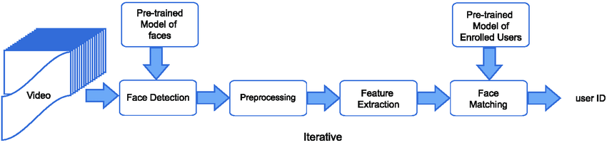

**Figure 1.1: Block Diagram of the General Framework.**

#### CHAPTER 2

**SURVEY**

**2.1 LITERATURE REVIEW**

The author proposed that different types of face detection for detecting faces in different pose .Detecting face in different pattern based on techniques. Basic pattern for detecting face is nose, eyes, hair, ears and some time it based on tone of skin. Face detection is detecting face based on location of face and presences of face in images .Different types of detecting the face techniques they are Ada-Boost Algorithm for Face Detection, Viola Jones Face Detection Algorithm, SMQT Features and SNOW Classifier Method, Local Binary Pattern (LBP). Each have advantages and disadvantages discussed in that paper. Xiang-Yu Li [2] the author proposed that recognition face using hog features and pca algorithms. By applying 0recognition algorithm to cropped faces images from that we get similarity b/w taken image and database image. In this paper PAC algorithm used for face detection and recognition. Arun Katara[3] the author shows that face recognition of facial of different person or student .from recognition attendances is upload to database using face detection and recognition of student or workers. From this manual work is decrease by human and automatically attendance system based on faces process done. In [12] authors have consider a system based on real time face recognition which is fast & which needs improvisation of images in various lighting environments. Now we need to split the data of each and every person into testing and training data. Let us take it in the ratio of 0.2:0.8 from the database. Now we will be extracting the HOG features of all the training individuals and store them in the form of bits and bytes. We need to fetch the cropped and gray scaled images. Now the training datasets are extracted with the HOG features and are stored with a count.

#### CHAPTER 3

**METHODOLOGY**

#### Methodology Flow

The approach performs face recognition based student attendance system. The methodology flow begins with the capture of image by using simple and handy interface, followed by pre-processing of the captured facial images, then feature extraction from the facial images, subjective selection and lastly classification of the facial images to be recognized. Both LBP and PCA feature extraction methods are studied in detail and computed in this proposed approach in order to make comparisons. LBP is enhanced in this approach to reduce the illumination effect. An algorithm to combine enhanced LBP and PCA is also designed for subjective selection in order to increase the accuracy. The details of each stage will be discussed in the following sections.

The flow chart for the proposed system is categorized into two parts, first training of images followed by testing images (recognize the unknown input image) shown in Figure 3.1 and Figure 3.2 respectively.

## **Training database:**

START

READ FACE IMAGES

SIZE OF

IMAGE

SCALE TO SCALE

250X250

COLOR IMAGE

OR

GRAY SCALE IMAGE

MEDIAN FILTERING ON 3 CHANNEL RGB

CONVERSION OF COLOR IMAGE TO GRAYSCALE

MEDIAN FILTERING

CONTRAST LIMITED ADAPTIVE HISTOGRAM EQUALIZATION (CLAHE)

ENHANCED CBP AND PCA FEATURE EXTRACTION

SAVE THE EXTRACTED FEATURES

END

**Figure 3.1: Flow of the Proposed Approach (Training Part).**

### **Recognition**

Cascade classifier



**Figure 3.2:Flow of the Proposed Approach (Recognition Part).**

#### 3.2 Input Images

Although our own database should be used to design real time face recognition student attendance system, the databases that are provided by the previous researchers are also used to design the system more effectively, efficiently and for evaluation purposes.

Yale face database is used as both training set and testing set to evaluate the performance. Yale face database contains one hundred and sixty-five grayscale images of fifteen individuals. There are eleven images per individual; each image of the individual is in different condition. The conditions included centre-light, with glasses, happy, left-light, without glasses, normal, right-light, sad, sleepy, surprised and wink. These different variations provided by the database is able to ensure the system to be operated consistently in variety of situations and conditions.

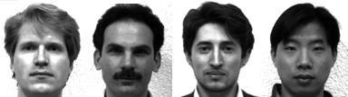

**Figure 3.3: Sample Images in Yale Face Database (Cvc.cs.yale.edu, 1997).**

For our own database, the images of students are captured by using laptop built in camera and mobile phone camera. Each student provided four images, two for training set and two for testing set. The images captured by using laptop built in camera are categorized as low quality images, whereas mobile phone camera captured images are categorized as high quality images. The high quality images consists of seventeen students while low quality images consists of twenty-six students. The recognition rate of low quality images and high quality images will be compared in Chapter 4 to draw a conclusion in term of performance between image sets of different quality.



**Figure 3.4: Sample of High Quality Images.**



**Figure 3.5: Sample of Low Quality Images.**

#### 3.2.1 Limitations of the Images

The input image for the proposed approach has to be frontal, upright and only a single face. Although the system is designed to be able to recognize the student with glasses and without glasses, student should provide both facial images with and without glasses to be trained to increase the accuracy to be recognized without glasses. The training image and testing image should be captured by using the same device to avoid quality difference. The students have to register in order to be recognized. The enrolment can be done on the spot through the user-friendly interface.These conditions have to be satisfied to ensure that the proposed approach can perform well.

**3.3 Face Detection**

Viola-Jones object detection framework will be used to detect the face from the video camera recording frame. The working principle of Viola-Jones algorithm is mentioned in Chapter 2. The limitation of the Viola-Jones framework is that the facial image has to be a frontal upright image, the face of the individual must point towards the camera in a video frame.

#### 

#### Pre-Processing

Testing set and training set images are captured using a camera. There are unwanted noise and uneven lighting exists in the images. Therefore, several pre-processing steps are necessary before proceeding to feature extraction.

Pre-processing steps that would be carried out include scaling of image, median filtering, conversion of colour images to grayscale images and adaptive histogram equalization. The details of these steps would be discussed in the later sections.

#### 3.3.1.1 Scaling of Image

Scaling of images is one of the frequent tasks in image processing. The size of the images has to be carefully manipulated to prevent loss of spatial information. (Gonzalez*,* R. C.*,* & Woods, 2008), In order to perform face recognition, the size of the image has to be equalized. This has become crucial, especially in the feature extraction process, the test images and training images have to be in the same size and dimension to ensure the precise outcome. Thus, in this proposed approach test images and train images are standardize at size 250 × 250 pixels.

**3.3.1.2 Median Filtering**

Median filtering is a robust noise reduction method. It is widely used in various applications due to its capability to remove unwanted noise as well as retaining useful detail in images. Since the colour images captured by using a camera are RGB images, median filtering is done on three different channels of the image. Figure 3.3 shows the image before and after noise removal by median filtering in three channels. If the input image is a grayscale image, then the median filtering can be performed directly without separating the channels.

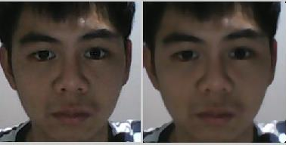

**Figure 3.6: Median Filtering Done on Three Channels.**

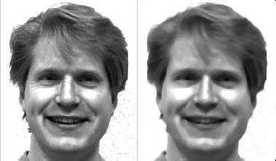

**Figure 3.7: Median Filtering Done on a Single Channel.**

#### 3.3.1.3 Conversion to Grayscale Image

Camera captures color images, however the proposed contrast improvement method CLAHE can only be performed on grayscale images. After improving the contrast, the illumination effect of the images able to be reduced. LBP extracts the grayscale features from the contrast improved images as 8 bit texture descriptor (Ojala, T. et al., 2002).Therefore, color images have to be converted to grayscale images before proceeding to the later steps. By converting color images to grayscale images, the complexity of the computation can be reduced resulting in higher speed of computation (Kanan and Cottrell, 2012). Figure 3.4 shows the conversion of images to grayscale image.

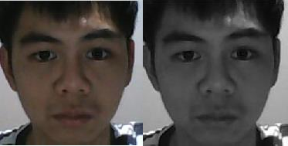

**Figure 3.8: Conversion of Image to Grayscale Image.**

**3.3.1.4 Contrast Limited Adaptive Histogram Equalization**

Histogram equalization or histogram stretching is a technique of image contrast enhancement. (Pratiksha M. Patel, 2016). The contrast improvement is usually performed on the grayscale images. Image contrast is improved by stretching the range of its pixel intensity values to span over the desired range of values, between 0 and 255 in grayscale. The reason that Contrast Limited Adaptive Histogram Equalization (CLAHE) is used instead of histogram equalization is because histogram equalization depends on the global statistics. Hence, it causes over enhancement of some parts of image while other parts are not enhanced properly. This distorts the features of the image. It is a serious issue because the features of the image have to be extracted for the face recognition. Thus, CLAHE which is depend on local statistic is used.

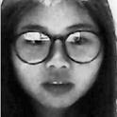

**Figure 3.9: Contrast Improvement.**

#### 3.4 Feature Extraction

Different facial images mean there are changes in textural or geometric information. In order to perform face recognition, these features have to be extracted from the facial images and classified appropriately. In this project, enhanced LBP and PCA are used for face recognition. The idea comes from nature of human visual perception which performs face recognition depending on the local statistic and global statistic features. Enhanced LBP extracts the local grayscale features by performing feature extraction on a small region throughout the entire image. On the other hand, PCA extracts the global grayscale features which means feature extraction is performed on the whole image.

**3.4.1 Working Principle of Original LBP**

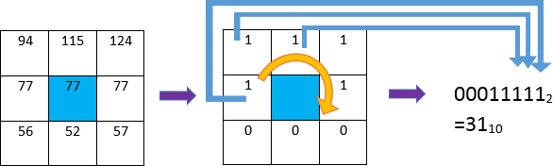LBP is basically a texture based descriptor which it encoded local primitive into binary string. (Timo Ojala et al., 2002). The original LBP operator works on a 3×3 mask size. 3×3 mask size contains 9 pixels. The center pixel will be used as a threshold to convert the neighboring pixels (the other 8 pixels) into binary digit. If the neighboring pixel value is larger than the center pixel value, then it is assigned to 1, otherwise it is assigned to 0. After that, the neighborhoods pixel bits are concatenated to a binary code to form a byte value representing the center pixel. Figure 3.6 shows an example of LBP conversion.

**Figure 3.10: Example of LBP Conversion.**

## 𝐿𝐵𝑃 = ∑ 𝑓(𝑃𝑛 − 𝑃𝑐). 2𝑛

where Pc indicates centre pixel and Pn (n=0,…,7) are 8 of its neighbouring pixels respectively.

The starting point of the encoding process can be any of neighbouring pixels as long as the formation of binary string is following the order either in clockwise or anticlockwise rotation.

#### 3.4.2 Working Principle of Proposed LBP

The original LBP operator is composed of 3 × 3 filter size with 9 pixels. Instead of the circular pattern, it looks more rectangular in shape. The 9 pixels adjacent to each other means every detail will be taken as sampling points even the non-essential details. It is more affected by uneven lighting condition because the small filter size emphasizes small scale detail (Lee and Li, 2007), even the shadow created by non-uniform lighting condition. In our proposed approach, a larger radius size, R is implemented in LBP operator. In the paper of Md. Abdur Rahim et.al (2013), the equation of modifying the radius size has been introduced. However, the paper did not mention the effect of changing the radius size. In the proposed approach, analysis is done on different radius sizes in order to enhance the system and reduce the illumination effect. By increasing the radius size, the filter size will be increased. R indicates radius from the centre pixel, 𝜃 indicates the angle of the sampling point with respect to the center pixel and P indicates number of sampling points on the edge of the circle taken to compare with the centre pixel. Given the neighbouring’s notation (P, R, 𝜃) is implemented, the coordinates of the centre pixel (Xc, Yc) and the coordinates of the P neighbours (Xp, Yp) on the edge of the circle with radius R can be computed with the sines and cosines shown in the equation (Md. Abdur Rahim et.al,2013):

# 𝑋𝑝 = 𝑋𝑐 + 𝑅𝑐𝑜𝑠(𝜃/𝑃).

𝑌𝑝 = 𝑌𝑐 + 𝑅𝑠𝑖𝑛(𝜃/𝑃).

Although the radius has been increased, total 8 sampling points are taken which is similar to the original LBP operator. In the approach, CLAHE is performed on the grayscale input facial images to improve the contrast. The contrast improved images remain as grayscale images. The proposed LBP operator extracts the grayscale features from the contrast improved grayscale images which requires only 8 bit computation. After that, the pixels at the sampling points will be encoded as 8 bit binary string in the same way as original LBP operator encoding process. Enhanced LBP with radius size two, perform better compared to original LBP and has more consistent recognition rate compared to other radius size. Hence, enhanced LBP with radius size two will be used as proposed approach.

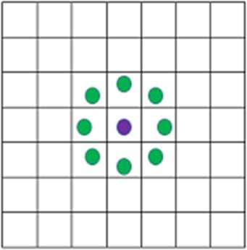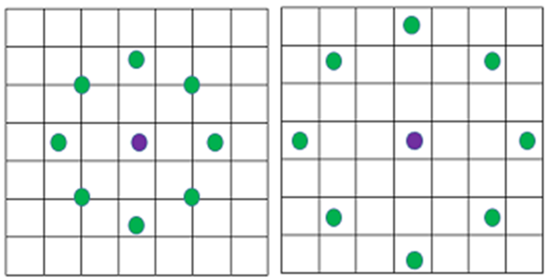

**R=1(original). R=2. R=3.**

**R=4.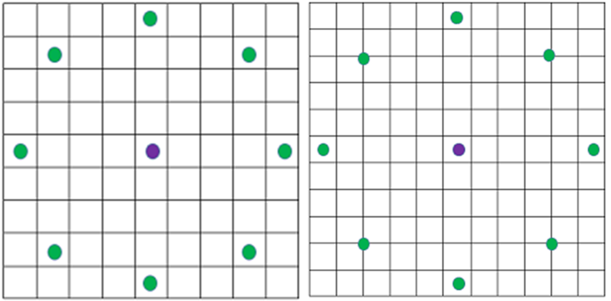R=5.**

**Figure 3.11: LBP with Different Radius Sizes.**

Basically, the increasing in the size of the radius means extending the circular pattern of LBP externally. The green spots within the blocks indicate the sampling pixels to be encoded into binary string. For the sampling pixel located in between the blocks, it indicates the average pixel value is computed from the adjacent pixels (diagonal).

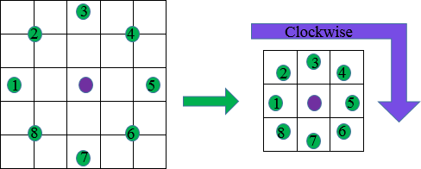

**Figure 3.12: Proposed LBP Operator with Radius 2 and Its Encoding Pattern.**

The feature vector of the image is constructed after the Local Binary Pattern of every pixel is calculated. The histogram of the feature vector image is computed in order to be classified by distance classifier. However, it loss spatial information because histogram representation does not include spatial information but only discrete information. (Gonzalez*,* R. C.*, &* Woods, 2008). In order to overcome this problem, the feature vector image is then divided into blocks. A histogram is constructed in each region respectively. Every bin in a histogram represents a pattern and contains the frequency of its appearance in the region. The feature vector of entire image is then constructed by concatenating the regional histograms in the sequence to one histogram. (Md. Abdur Rahim et al., 2013). This histogram remains its regional spatial information and represents the identity of single image which is then classified to perform the recognition.

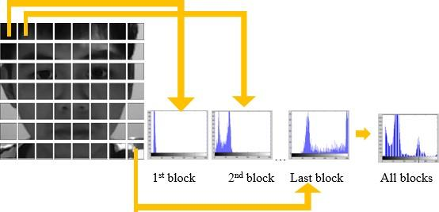

**Figure 3.13: Histogram of Image Blocks.**

#### 3.4.3 Working Principle of PCA

In this proposed approach, PCA face recognition is studied, as it is one of the popular face recognition methods that was suggested and used by the previous researchers. The accuracy of PCA is computed in order to compare with the enhanced LBP.

PCA includes a few steps which will briefly be described in the following paragraphs. For PCA, the image scale, length (M) and height (M) is not so important. This is because PCA is mostly dealing with number of total images, N instead of M. However, same size of test image and training image is a must for PCA computation. Same length and height of the image is assumed in the following equation for illustration. Given a training set of N images with size 𝑀 × 𝑀, the first step of PCA is to convert two dimensional vectors to one dimensional vector. The one dimensional vector can be either column vector or row vector. In this approach, the column vector conversion is done. For each facial image with matrix notation 𝑀 × 𝑀 will be converted to column vector Ti, with dimension 𝑀2 × 1.There are N facial images, each face is represented by column vector T1, T2, T3, .., TN. Feature vector of each face is stored in this column vector. The dimension reduced face matrix is constructed by concatenating every single column vector.

PCA is briefly explained by using the equation in the following steps:

***Step1***: Prepare the data.

***Step 2***: Obtain the mean/average face vector Next, the average face vector which is also known as mean face is calculated. The mean is computed row by row between the column vectors. The equation of mean face is shown below.

***Step 3***: Subtract the mean/average face vector.In order to ensure the image data is centred at the origin, the mean face is subtracted from each column vector.

***Step 4***: Calculate the covariance matrix.

***Step 5***: Calculate the eigenvectors and eigenvalues from the covariance matrix.

***Step 6***: Projection of facial image to Eigen face.

Steps 1 to 6 are used to train the training image set. For test image only step 1,2, 3 and 6 is required. Step 4 and 5 are not required for test image as the Eigen face is needed only to compute once while training. The Euclidean distance is then used as distance classifier to calculate the shortest distance between the projected image and projected test image for recognition.

#### 

#### Feature Classification

Chi-square statistic is used as a dissimilarity measure for LBP to determine the shortest distance between training image and the testing image. On the other hand, Euclidean distance is used to compute the shortest distance between trained and test image after PCA feature extraction. Both classifiers, Chi-square statistic and Euclidean distance determine the closest or nearest possible training image to the testing image for face recognition. However, the nearest result might not be always true. Therefore, an algorithm to combine enhanced LBP and PCA is applied in order to increase the accuracy of the system.

#### Subjective Selection Algorithm and Face Recognition

The feature classification that has been performed in previous part gives the closest result but not absolute. In order to increase the accuracy and suppress the false recognition rate, an algorithm to combine enhanced LBP and PCA is designed in this proposed approach.

In this proposed approach, best five results are obtained from enhanced LBP and PCA. This means that five individuals which have closest distance with respect to input image will be identified. LBP and PCA are two different algorithms which have a different working principle. Hence, LBP and PCA will not have exactly the same five individuals identified. In order to ensure the system capability to suppress the false recognition, one is only classified as recognized if and only if he or she is the first common individual that is identified by both LBP and PCA. From chapter 2, LBP shows higher accuracy compared to PCA. Thus, LBP is designed to have higher priority compared to PCA. This is shown in the Figure 3.14, Student_1 is recognized instead of Student_3 because LBP is prioritized. As a result, the first common individual is selected from PCA with respect to LBP and classified as recognized. If there is no common term between LBP and PCA then the system will not recognize any subject. This subjective selection algorithm is designed to be automated in the system.

LBP

PCA

Student_1

Common term

Student_3

Student_1

The input image will be recognized as Student_1. **Figure 3.14: Subjective Selection Algorithm.**

#### CHAPTER 4

**RESULT AND DISCUSSION**

#### Result

In this proposed approach, face recognition student attendance system with user- friendly interface is designed by using MATLAB GUI(Graphic User Interface). A few buttons are designed in the interface, each provides specific function, for example, start button is to initialize the camera and to perform face recognition automatically according to the face detected, register button allows enrolment or registrations of students and update button is to train the latest images that have been registered in the database. Lastly, browse button and recognize button is to browse facial images from selected database and recognized the selected image to test the functionality of the system respectively.In this part, enhanced LBP with radius two is chosen and used as proposed algorithm. The analysis of choosing the radius size will be further explained in the discussion.

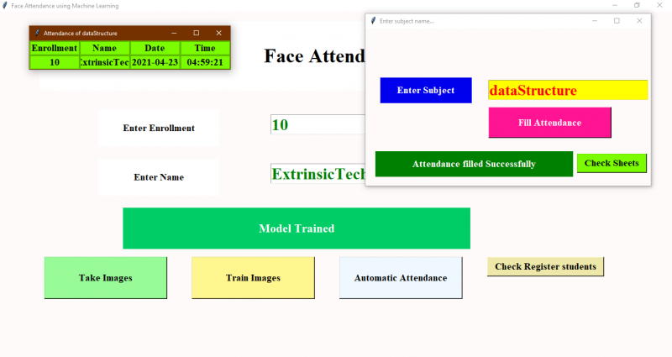

**Fig 4.1:User’s Interface(Matlab GUI).**

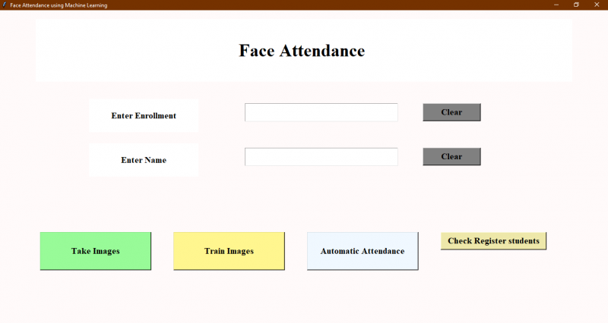

**Fig 4.2: Real-Time Face Recognitio(Automated).**

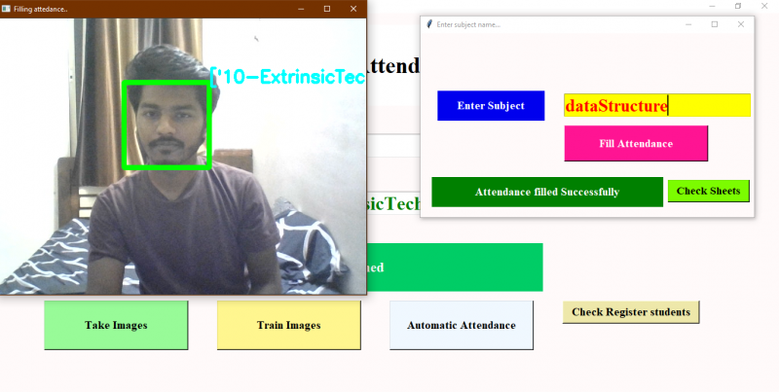

**Fig 4.3: Image Browsing and Face Recognition.**

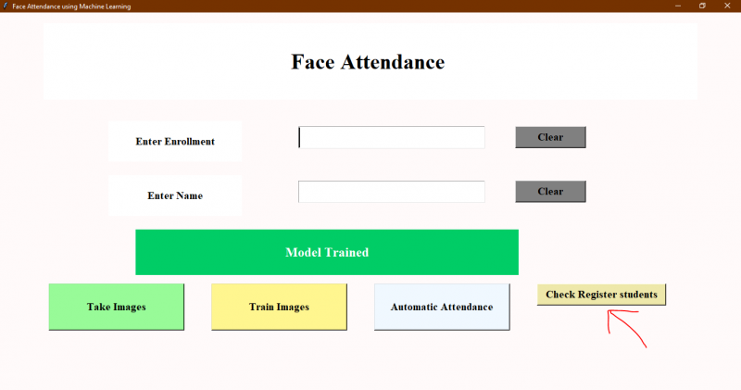

**Fig 4.4: False Recognition is Suppressed.**



**Fig 4.5: Attendance in Excel File.**

|  |  |  |  |  |  |  |  |
| --- | --- | --- | --- | --- | --- | --- | --- |
|  |  |  |  |  |  |  |  |
|  |  |  |  |  |  |  | |

#### Discussion

The Yale face database consists of one hundred and sixty-five images of fifteen individuals with multiple conditions. An algorithm that can extract the important features to perform face recognition is designed. Median filtering is used because it is able to preserve the edges of the image while removing the image noises. CLAHE is proposed in pre-processing in order to improve the image contrast and reduce the illumination effect. It can be said that the contrast of the image is more evenly improved throughout the image by CLAHE compared to histogram equalization. This could help to reduce uneven illumination.



**Figure 4.6: Images of Students With or Without Wearing Glasses.**

After pre-processing, useful feature is extracted by using enhanced LBP (local Binary pattern). Enhanced LBP operator consists of different radius size is proposed as mentioned in previous chapters. Different radius size means that uneven lighting effect can be reduced without distorting the detail of the image. By increasing the radius size, the detail information is simplified and the contour or shape of the face is emphasized. However, LBP operator with different radius does not give significant results because there is no critical illumination problem. Figure 4.7 shows conditions I, II, III and IV which illustrate different illumination effects.

The LBP operator has to be wisely selected in order to reduce the illumination effect without sacrificing much of the recognition rate. The training images have its left side relatively darker compared to its right side which is directly opposite of the test image (condition II). This is due to the lighting effect of the training image.

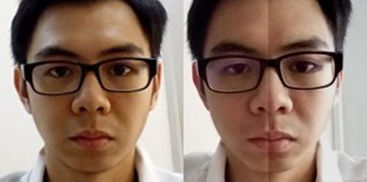

Training Image Test Image (Condition II)

**Figure 4.7: Training Image VS Testing Image.**

LBP works best with good quality images, poor quality images could degrade the performance of the algorithm. Poor quality images might include the relatively darker images, blur images or having too much unwanted noise. In blurred images, the face is blurred out. LBP has an accuracy of (86.54%) when only one image per individual is trained and (88.46%) when two images per individual are trained.

#### CHAPTER 5

**CONCLUSION AND RECOMMENDATION**

#### Conclusion

In this approach, a face recognition based automated student attendance system is thoroughly described. The proposed approach provides a method to identify the individuals by comparing their input image obtained from recording video frame with respect to train image. This proposed approach able to detect and localize face from an input facial image, which is obtained from the recording video frame. Besides, it provides a method in pre-processing stage to enhance the image contrast and reduce the illumination effect. Extraction of features from the facial image is performed by applying both LBP and PCA. The algorithm designed to combine LBP and PCA able to stabilize the system by giving consistent results. The accuracy of this proposed approach is 100 % for high-quality images, 92.31 % for low-quality images and 95.76 % of Yale face database when two images per person are trained.

As a conclusion for analysis, the extraction of facial feature could be challenging especially in different lighting. In pre-processing stage, Contrast Limited Adaptive Histogram Equalization (CLAHE) able to reduce the illumination effect. CLAHE perform better compared to histogram equalization in terms of contrast improvement. Enhanced LBP with larger radius size specifically, radius size two, perform better compared to original LBP operator, with less affected by illumination and more consistent compared to other radius sizes.

#### 5.1 Recommendation

In this proposed approach,there are a few limitations. First,the input image has to be frontal and a upright single facial image. Second,the accuracy might drop under extreme illumination problem. Third,false recognition might occur if the captured image is blurred. Besides, LBP is textural based descriptor which extracts local features. Hence, test image and train image have to be the same quality which is captured by using the same device in order to have high accuracy. Lastly, if an individual wears make up in the image for face recognition, the important features will be covered.

In fact, a better camera with a better lighting source able to reduce the illumination problem and also able to avoid the captured of blurred images. In this proposed approach, laptop built in camera is a default device. However the lighting source of the laptop camera is very dim, this cause the system to be unstable. For future work, a better camera and a better lighting source can be used in order to obtain better result. This can reduce the dependency on the brightness of environment, especially the places to capture test and train images. Furthermore, a face recognition system which has more faces other than a single facial image can be designed. This can increase the efficiency of the system. The test image and train image in this approach is highly related to each other and highly dependent on the image captured device. The capture device has to be the same for this approach to perform better. Thus, other algorithms can be used instead of LBP, for example A.I (artificial intelligence) algorithm which can be implemented to perform the face recognition. CNN (Convolution Neural Network) which is a hot topic recently, is a machine deep learning algorithm which is able to perform recognition with less dependency on a particular train image given a large database. However, CNN requires an extremely large database to increase its accuracy or having relatively small class size to have high performance.

In pre-processing stage, an algorithm, for instance affine transform can be applied to align the facial image based on coordinates in the middle of the eyes. This might help, especially in PCA algorithm, which it maps test image to train image to perform face recognition.

#### REFERENCES

[1].Robinson-Riegler, G., & Robinson-Riegler, B. (2008). *Cognitive psychology: applying the science of the mind*. Boston, Pearson/Allyn and Bacon.

[2].Margaret Rouse. (2012). *What is facial recognition? - Definition from WhatIs.com*. [online] Available at:

<http://whatis.techtarget.com/definition/facial-recognition>[Accessed 25 Mar. 2018].

[3].Solon, O. (2017). *Facial recognition database used by FBI is out of control, House committee hears*.[online]the Guardian.Available at: https:/[/www.theguardi](http://www.theguardian.com/technology/2017/mar/27/us-facial-recognition-)a[n.com/technology/2017/mar/27/us-facial-recognition-](http://www.theguardian.com/technology/2017/mar/27/us-facial-recognition-) database-fbi-drivers-licenses-passports [Accessed 25 Mar. 2018].

[4].[Robert Silk](http://www.travelweekly.com/Robert-Silk). (2017). *Biometrics: Facial recognition tech coming to an airport near you: Travel Weekly*. [online] Available at:

<http://www.travelweekly.com/Travel-News/Airline-News/Biometrics-Facial-> recognition-tech-coming-airport-near-you [Accessed 25 Mar. 2018].

[5].[Sidney Fussell.](https://kinja.com/sidneyfussell#_ga%3D2.33904934.647560575.1521956578-2116359232.1521956578) (2018). *NEWS Facebook's New Face Recognition Features: What We Do (and Don't) Know*. [online] Available at:

https://gizmodo.com/facebooks-new-face-recognition-features-what-we-do-an- 1823359911 [Accessed 25 Mar. 2018].

[6].deAgonia, M. (2017). *Apple's Face ID [The iPhone X's facial recognition tech explained]*.[online] Computerworld. Availableat: https:/[/www.comput](http://www.computerworld.com/article/3235140/apple-ios/apples-face-id-the-)e[rworld.com/article/3235140/apple-ios/apples-face-id-the-](http://www.computerworld.com/article/3235140/apple-ios/apples-face-id-the-) iphone-xs-facial-recognition-tech-explained.html [Accessed 25 Mar. 2018].

[7].Ashley DuVal. (2012).*Face Recognition Software -History of Forensic Psychology*. [online] Available at:

<http://forensicpsych.umwblogs.org/research/criminal-justice/face-recognition-> software/ [Accessed 12 Apr. 2018].

[8].[Jesse Davis West](https://www.facefirst.com/blog/brief-history-of-face-recognition-software/). (2017). *History of Face Recognition - Facial recognition software*. [online] Available at: https://[www.facefirst.com/blog/brief-history-of-face-](http://www.facefirst.com/blog/brief-history-of-face-) recognition-software/ [Accessed 25 Mar. 2018].

[9].Reichert, C. (2017). *Intel demos 5G facial-recognition payment technology | ZDNet*. [online] ZDNet. Available at:

<http://www.zdnet.com/article/intel-demos-5g-facial-recognition-payment-> technology/ [Accessed 25 Mar. 2018].