**Dear Sir/Madam,**

**CAN details correction – Reg,**

**I Request you to correct my CAN number details in TNeGA Portal based on below details.**

**District : CUDDALORE**

**Taluka:VRIDDHACHALAM**

**CAN Number : 13318057270622**

**Applicant Name : R RAMANA**

**Mobile Number : 6381281064**

**D.O.B :25.10.2002**

**Reason :**

**I lost my CAN register Mobile number and unable to Process my application. So please change my mobile number 6381281064 instead of 936023393**

**Note : Aadhaar card original scan copy attached.**

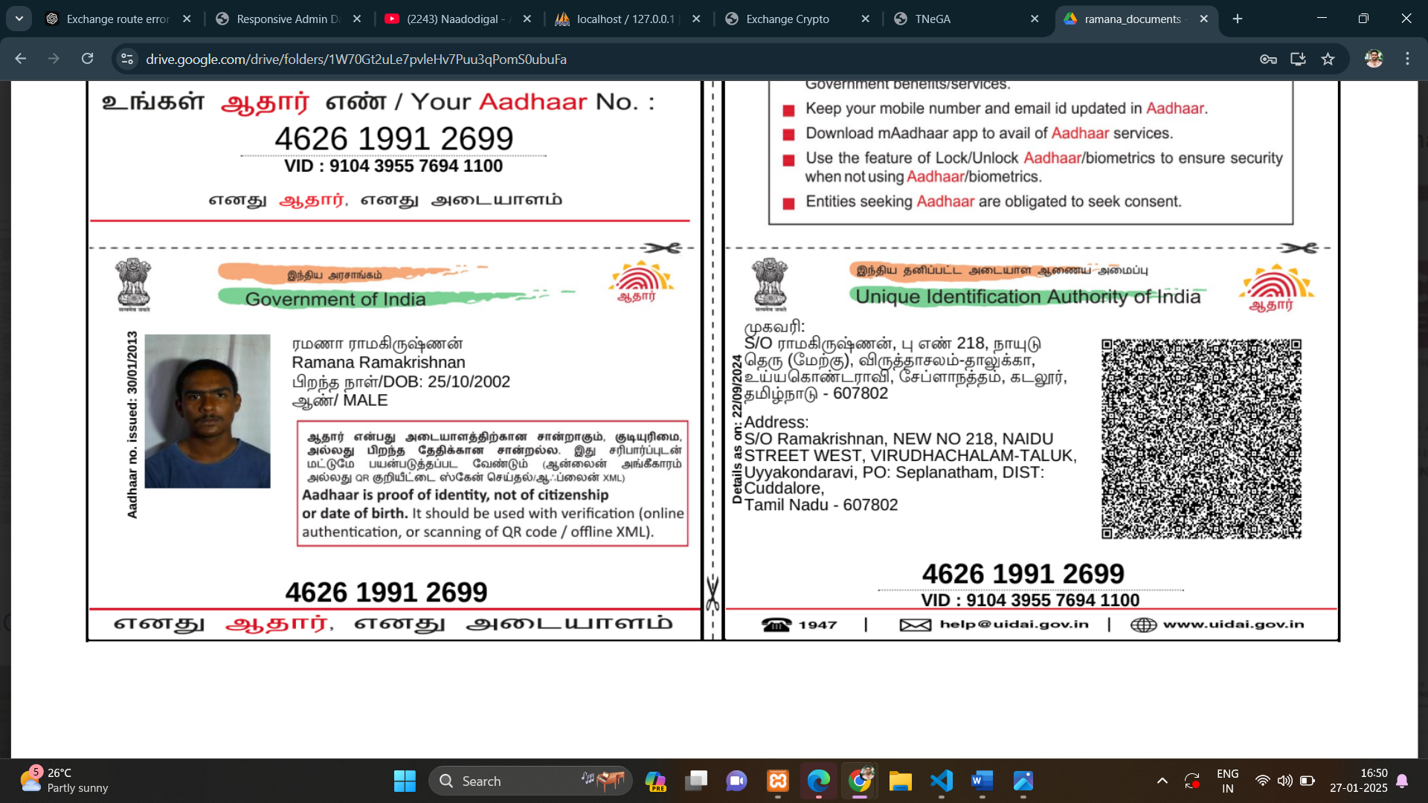

**With Regards,**

**R RAMANA**

**6381281064**