http: browser will conect to port 80 of server

http: browser will conect to port 443 of server

Note:https-hyper text transfer protocal secure

========Apache WebServer======

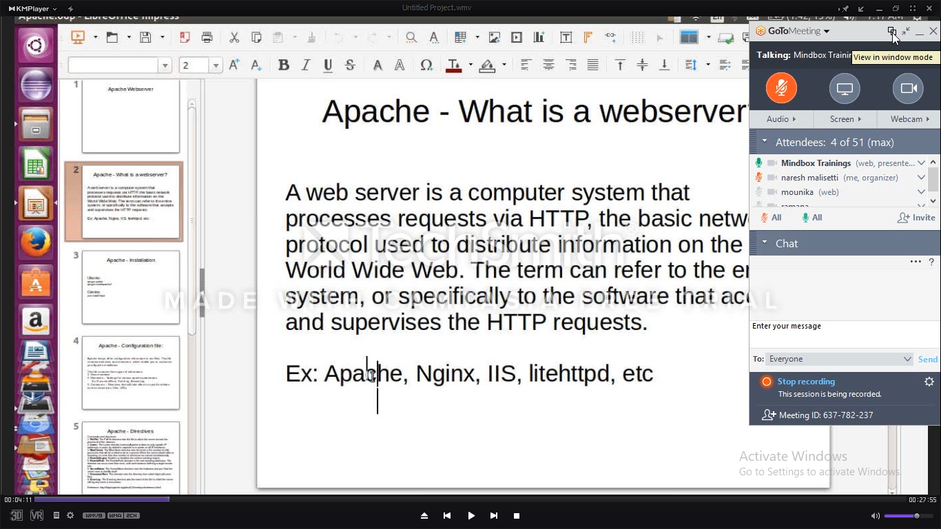

Apache and nginix used linux servers

iis-internet information services used in windows servers.

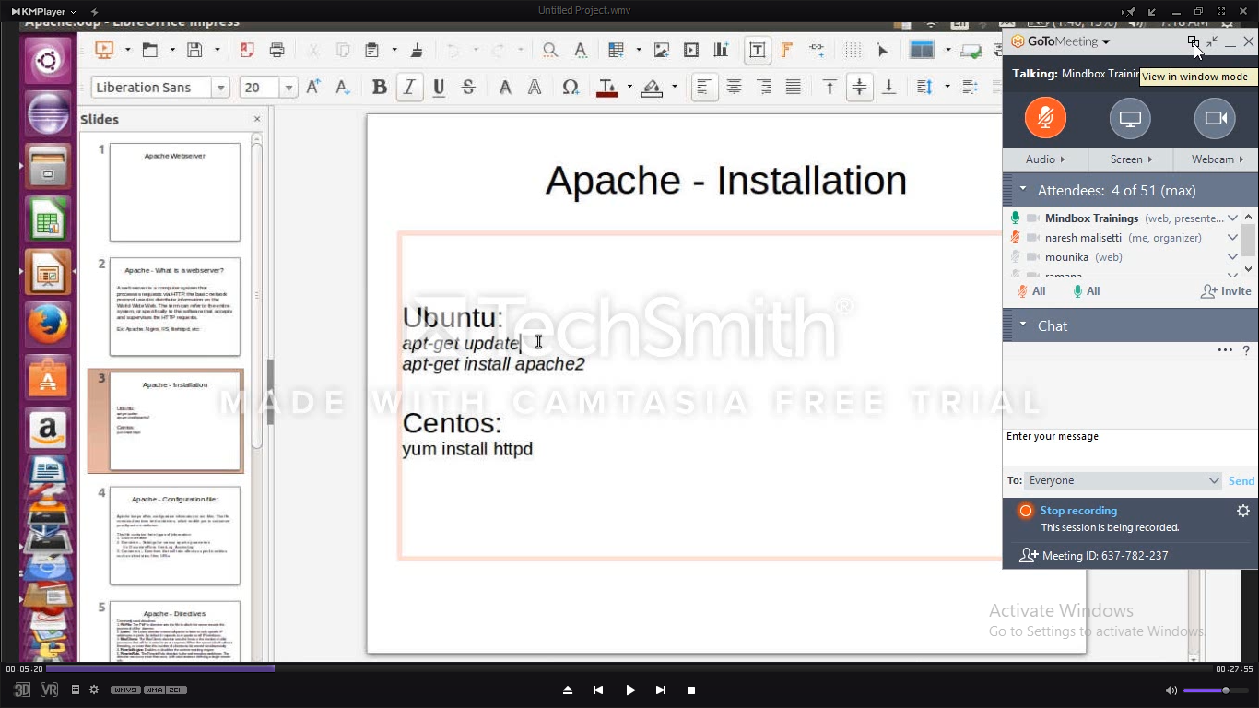

Apt-get ::is a package manager and it wil download from repository and install it.

Vi /etc/apt/source.list :::apt-get will check wth the repositorys present in path and download softwares

Check status: apt-cache policy apache2

* Default apcahe or any webserver will run on port 80 –w (-w is for to search exact pattern)
* In linux what is the command to check service listening on port?

netstat –plane | grep 80 (to know by port number)

netstat –plane | grep –i listen(to know all services running on ports)

To check service is running or not ?

Service apche2 status

To stop the running service?

Service apche2 stop

On which porta websevers will run?

Port80

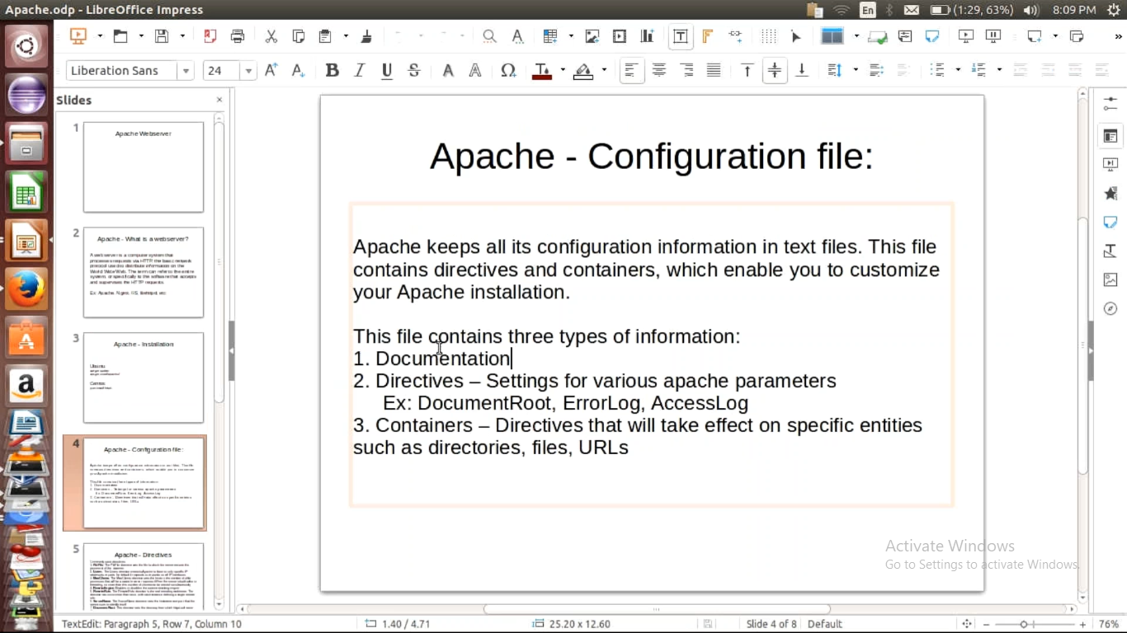

Documention:comments we wil add for our understanding purpose

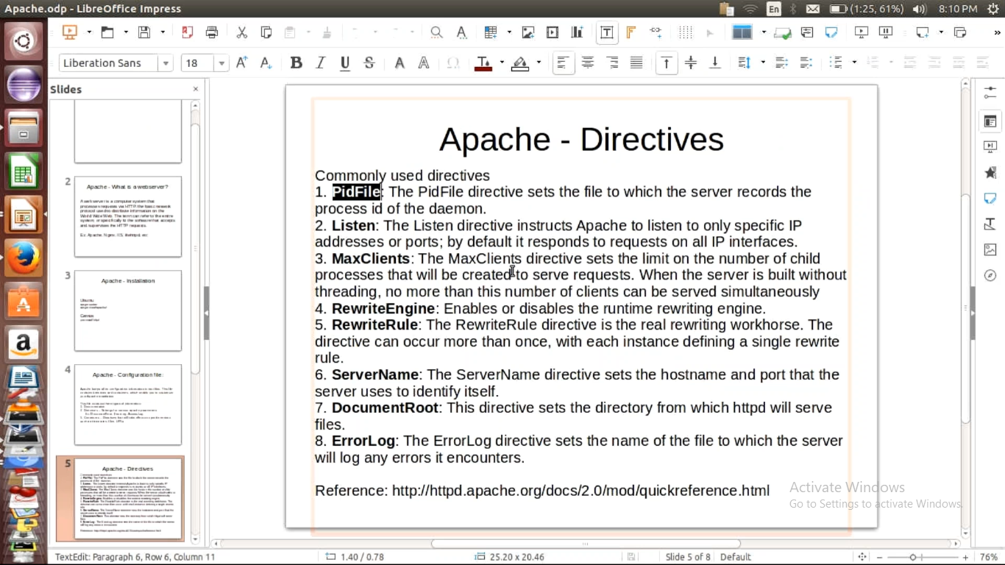

Open apache2 config file : vi /etc/apache2.config (all globall configurations available)

* Linux command to the processes runnign on linux server?

Ps

===>Listen::::

->to change ports?

Path : cd //etc/apche2

Vi ports.confi

* What is diff b/w restart and reload apache2?

===> MaxClients:::

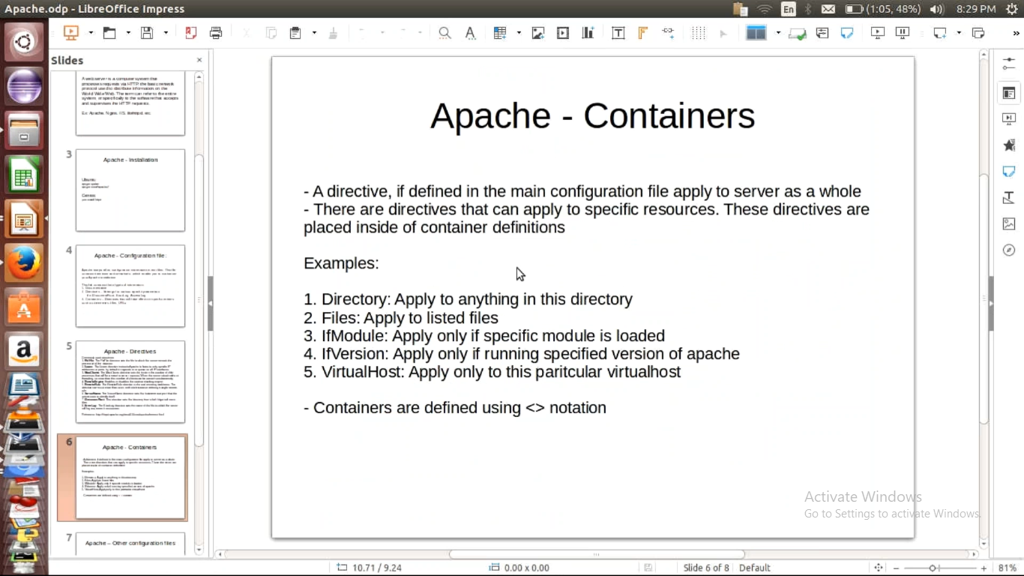

->in apache passwords are saved in .ht file

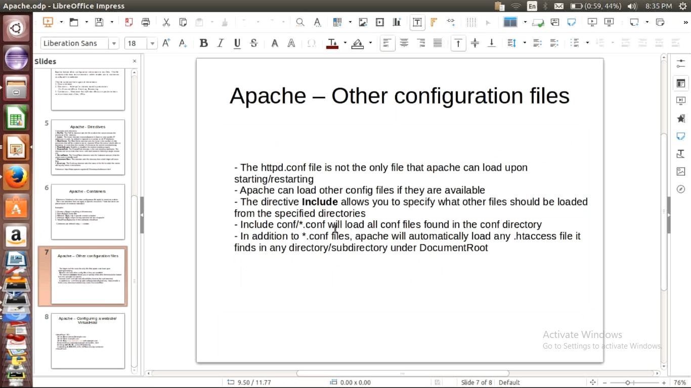

To know root directory of apache2?

Apche2 –V

* Default apache2 will check website contents in /var/www path
* Path to create website configuration file

Create file in cd /etc/ apache2/sites-available/ and provide sibling i,e shortcut in path of   
 cd /etc/ apache2/sites-enabled/

Create link :ln –s ../<target folder from where we need to copy and followd by filename>

========================wordpress=================

* It is a content managment system i,e it provides baic website structure

1)enable ssl certificates to u website and redirect connection from http to https?

Note :RewriteEngine and RewriteRule used here

2)gothrough methods in apache2

http://httpd.apache.org/docs/2.0/mod/quickreference.html

1.how to find what are all process running on host?

Ans:netstat -plane | grep –i listen

2.where is the config file prsent in apache2?

Ans:vi /etc/apache2/apache2.config

3.what is the use of vi /etc/apache2/envvars?

4.what is the default locaton where process id present?

Ans:less /var/run/apache2/apache2.pid

5.what’s the use of pid file?

6.what’s the use of listen directive?

7.what is location where we can customize port numbers?

Ans:vi /etc/apache2/ports.config

8.what is the use of MAXClient directive?

Ans:it will set the maximum number clients can access.

9.rewrite enginee and rewrite rule use?

10.document root and error log?

Ans :erro log present in

Vi /etc/apache2/ennvars

11.what are the things required while confi website?

Ans:1.upload contents in proper directory

Cd /var/www/<create directory>

2.create virtual host file in vi /etc/apache2/sites-avilalale/<config file> and make sibling i,e link to vi /etc/apache2/sites-enable/<config file>

cd /etc/apache2/sites-enable

ln –s ../sites-available/filename.config <filename_presentin enabled.config>

3.add ip adress of vm on parent host file

Vi /etc/host

=====================word press===================

How to check whether package is installed or not in ubuntu?

Ans:apt-cache policy <package name>

2.command to conect to mysql?

Ans:mysql –u root –p

Pwd:

Note:wordpress use by small companies

3.how read and understand log files in apache?

Ans:less var/log/apache2/error.log

Less var/log/apache2/access.log

4.tail -10 less var/log/apache2/error.log

It prints last 10 lines

Note : tail –f

5.learn about apache2 status call