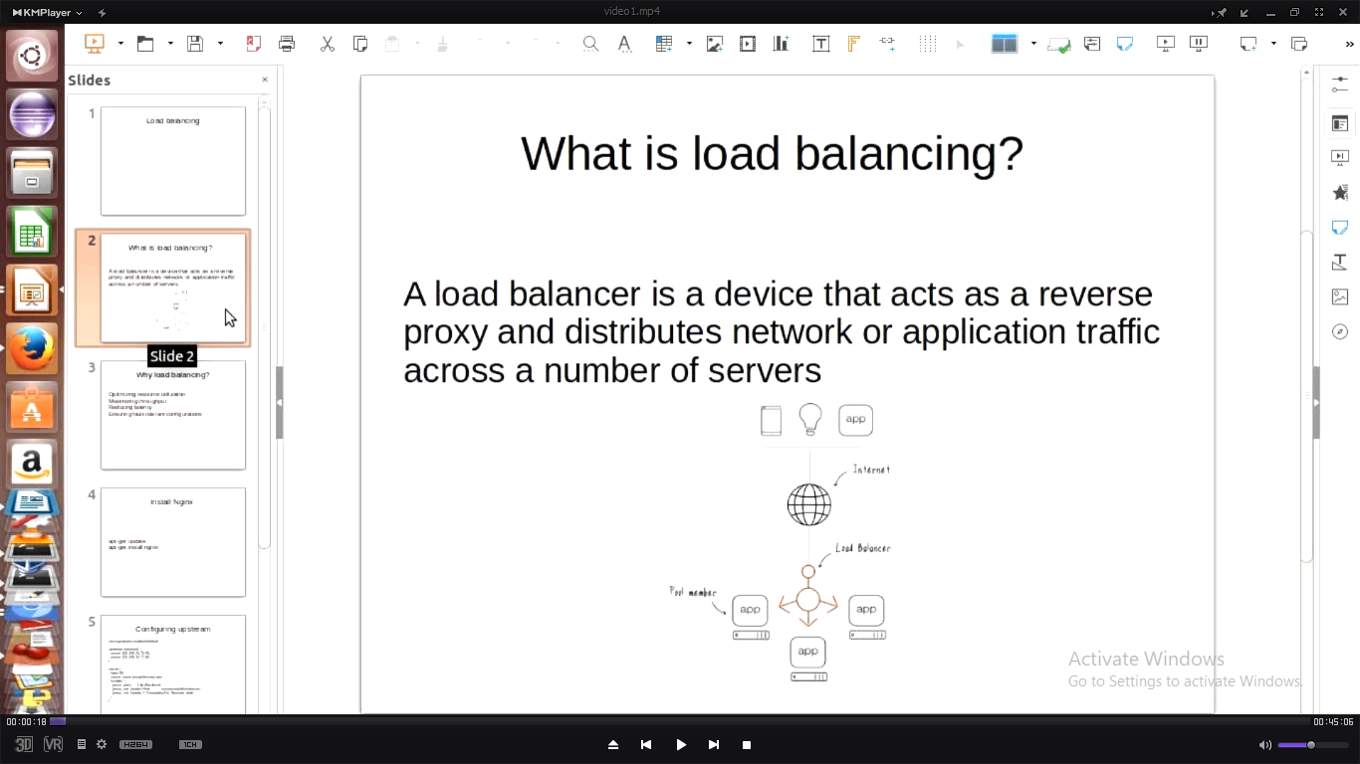

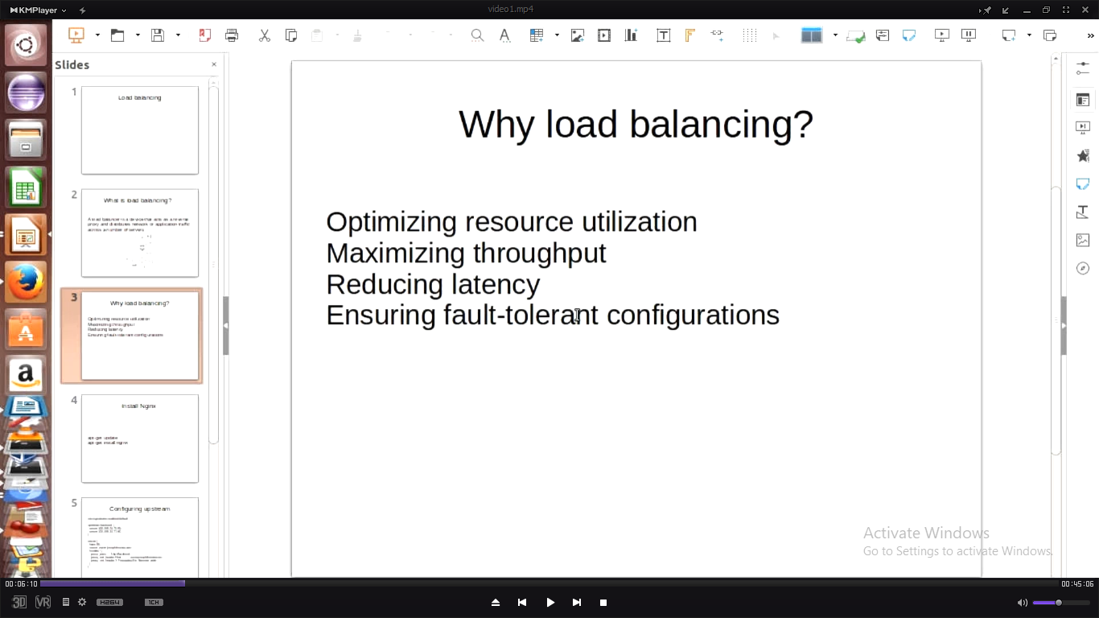

Ex:2apache and 1 load balancer

/var/www/web/index.html

To create image:

Vagrant package –output devops-com.box

Add to box:vagrant box add devops.com devops-com.box

Load balance machine:

Apt-get install nginx

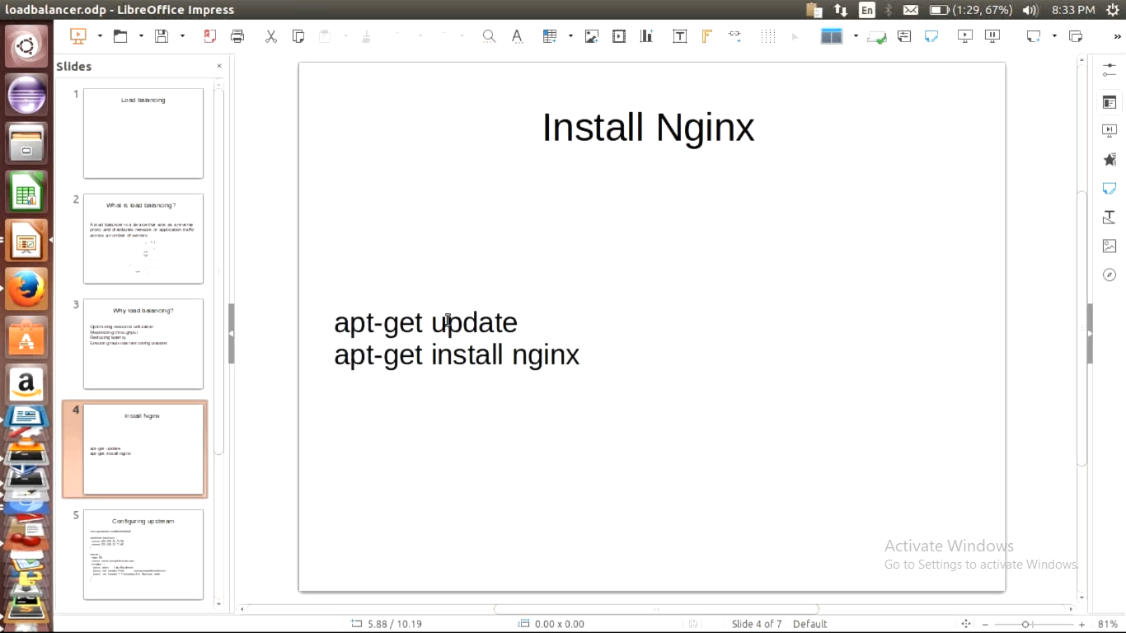

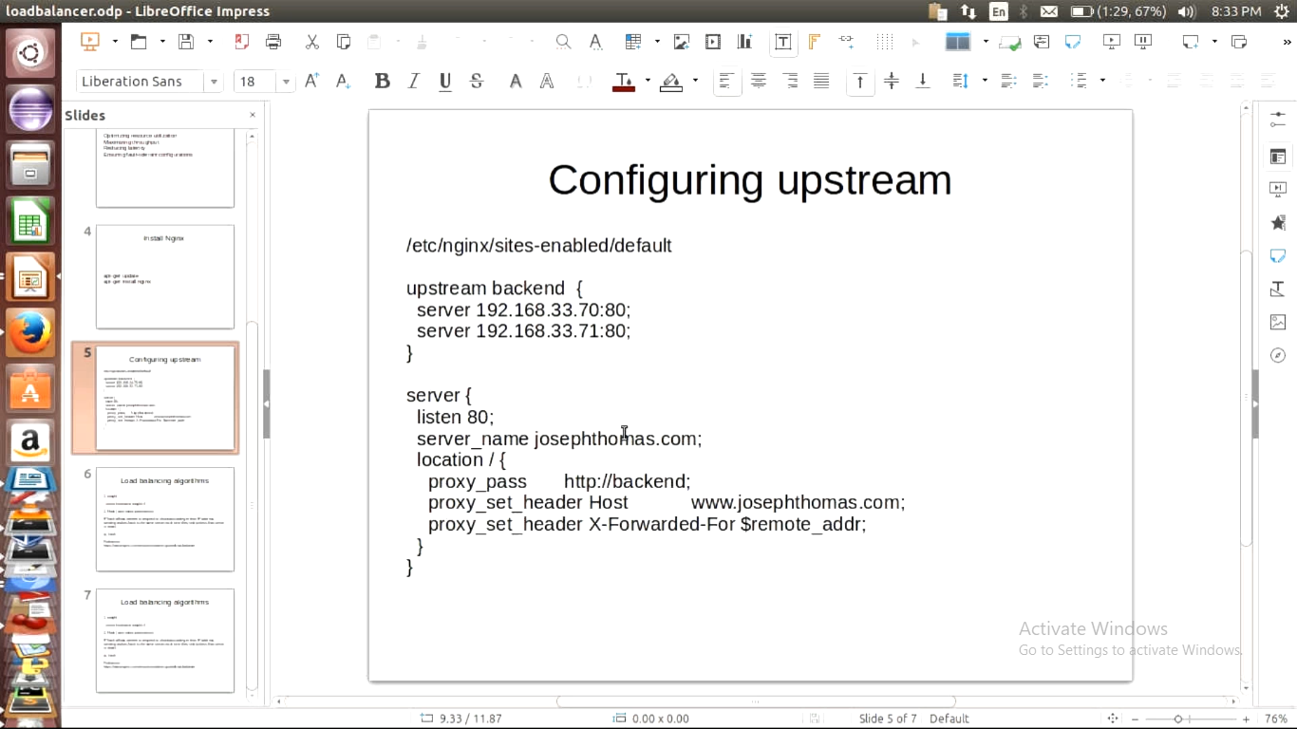

What is upstream?

Is a directive in nginix which defines back end servers

Nginx –t :: checks corect or not configuration

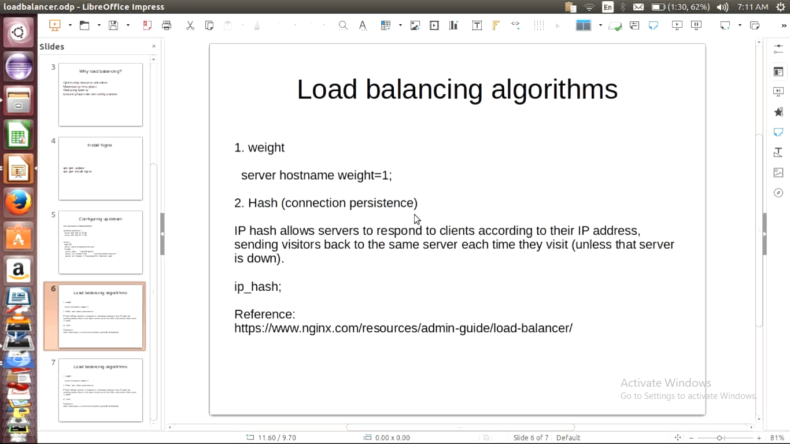

Set as below

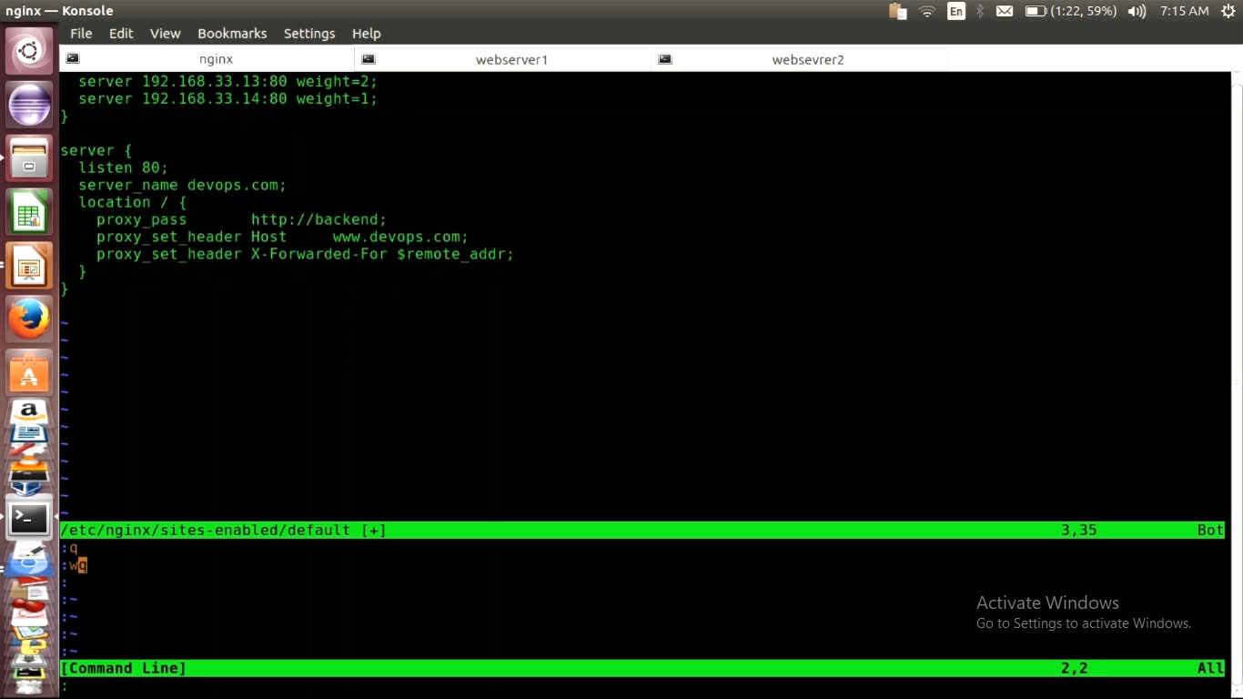

Hashing

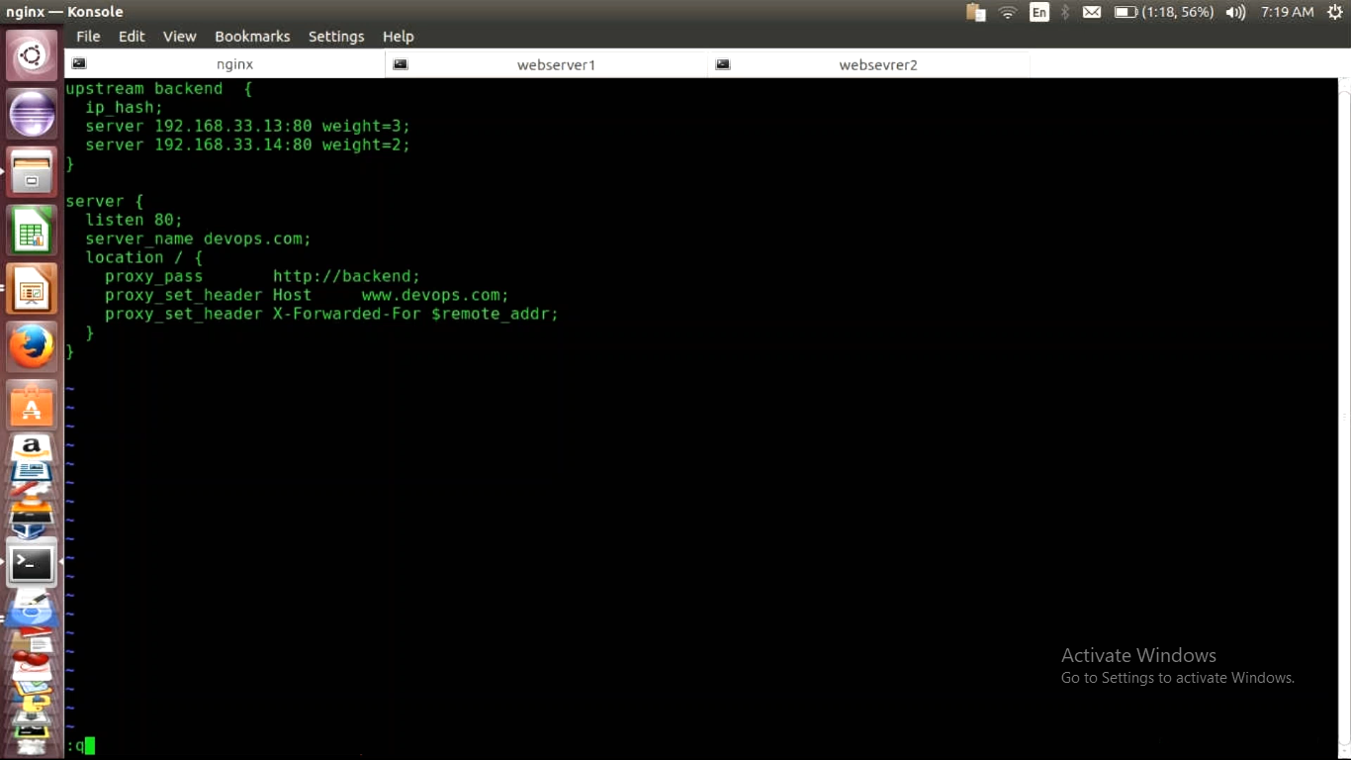

https://www.nginx.com/resources/admin-guide/load-balancer/