**Tools-cost -analysis**

**AWS Free Tier** - 5GB storage

2000 PUT, POST, COPY or LIST requests

20,000 GET requests

15 GB of outgoing data transfer per month

**AWS S3 Standard**

S3 standard is the default tier, designed for frequently accessed data. Its low latency and high throughput.

|  |  |
| --- | --- |
| **Data Size** | **Price per GB** |
| First 50 TB / Month | $0.023 |
| Next 450 TB / Month | $0.022 |
| Over 500 TB / Month | $0.021 |

Opting AWS s3 for storage purpose will it be minimal cost and maximum scalable.

**EC2 cost analysis:**

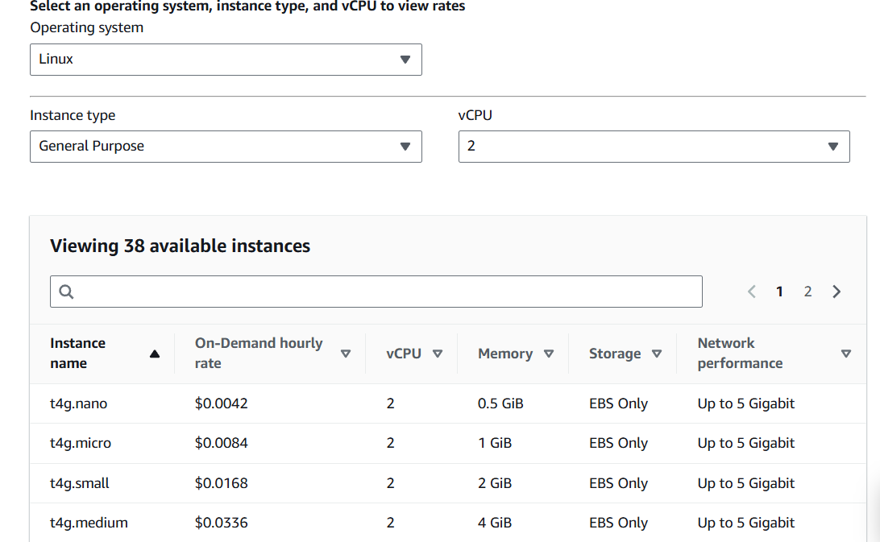

<https://aws.amazon.com/ec2/pricing/on-demand/>

**GPT4o-  Open AI-  Cost**

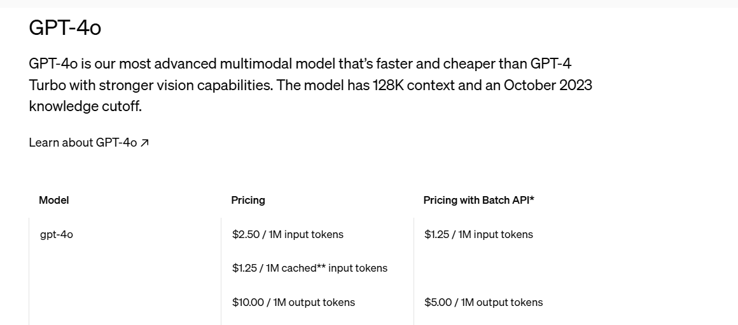

Reducing token usage lowers API costs, making it affordable to scale applications like LLM-powered RAG and LangChain systems.

**Clear ML cost:**  
