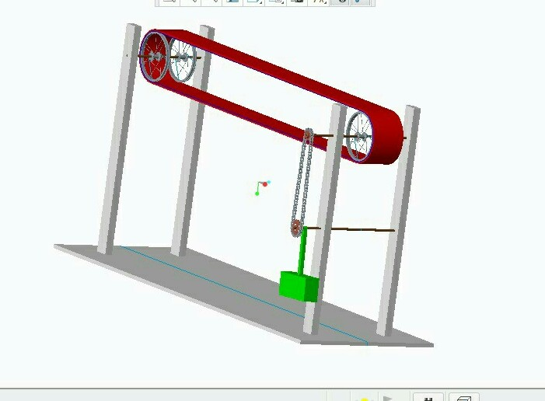

**TWO STAGE MECHANICAL OSCILLATOR**