AI ACADEMY · STUDENT · ai-1/15

Save New Examples for Testing
Project: Helpful Classroom Sorter

Before you start
Week 13: fitting a rule differs from checking unfamiliar examples.

01. Your mission

Your learning target
I can separate examples used to choose a model from examples reserved for its final evaluation.
I can record a fixed model and its predictions before revealing comparison labels.
I can explain how test feedback changes the evidence available for a revised model.

Remember before reading
Close your notes first. A rough first answer helps us choose the right starting point; it is not a score for your ability.
Without opening the old lesson, explain one key idea from Build a Human Classifier. Give an example and a mistake that the idea helps you avoid.
Without opening the old lesson, explain one key idea from Debug the Cause. Give an example and a mistake that the idea helps you avoid.
Without opening the old lesson, explain one key idea from Algorithms as Recipes. Give an example and a mistake that the idea helps you avoid.
After trying, check the relevant lesson or ask your teacher. Change the part of your explanation that the evidence shows was wrong.
A fair test uses examples not used to create the decision process.
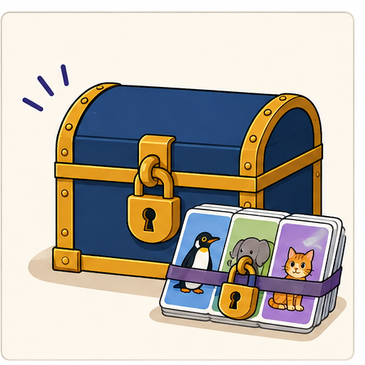
LEARNING TARGET Eight cards are used to invent a rule. Four sealed cards are then opened; the team changes its rule after seeing errors. Can those four cards still be called an untouched final test? Plan what to do next.
Learner name:

Readiness for the connected explanation
A height passes the input contract and the model predicts tall. What is still needed to check that prediction? If its comparison label changes your threshold choice, what role has that example played?

This week’s end goal
By the end, I can freeze a model before labels are revealed and report a bounded test result.

02. Notice the evidence
PICTURE STORY

Look Closely Before You Explain
Pictures give clues; evidence tells us what the clues mean.

MYSTERY If a sorter sees every mystery card while its rule is being created, later success on those same cards does not show transfer.

What do you notice?
Name three visible details without explaining them yet.
Circle the detail most connected to the system's decision.
Name one detail that may be decoration or distraction.
Make a first prediction and state the clue that supports it.
My observations, prediction, and evidence:
GOOD THINKING A prediction can change when stronger evidence appears.

A closer explanation
A rule chosen to fit examples may work differently on new cases. To investigate that difference, reserve a set of examples before development. Use the development examples to choose the model. Keep the final test examples separate until the model is fixed, then evaluate that recorded model.
In this paper activity, a teacher keeps the reserved examples in an envelope. Record the input contract, feature, category rule and model version before opening it. Once the input values are revealed, predict using the frozen model before revealing their comparison labels. This prevents copying the labels into the predictions.
The worked example below describes a completed experiment, so its test labels are visible for discussion. It is not an unseen test for you. In the workbook experiment, the teacher will supply a separate set of comparison labels after you have saved your predictions. All data are imaginary classroom records.

03. See how it works
VISUAL MECHANISM

Input → Process → Output
Follow the information instead of imagining magic inside the machine.
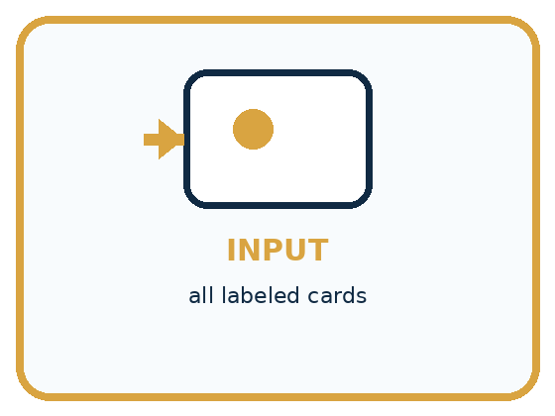
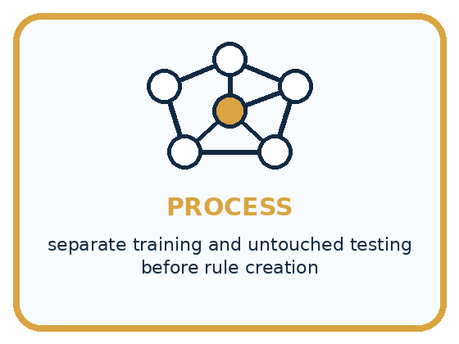
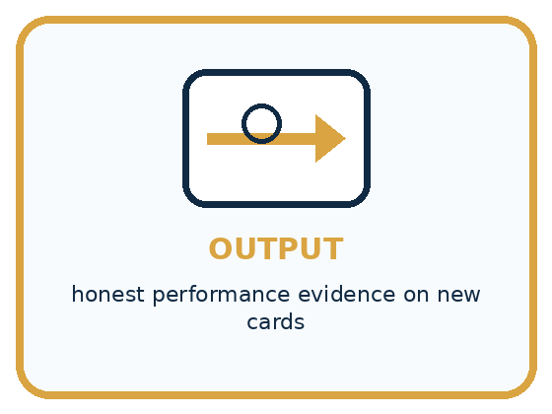
INPUT all labeled cards
PROCESS separate training and untouched testing before rule creation
OUTPUT honest performance evidence on new cards
CORE IDEA A fair test uses examples not used to create the decision process.
UNDER THE HOOD Evaluation on training data is optimistically biased. A holdout test set estimates behavior on unseen examples only if it remains untouched during design. Repeatedly tuning to test results leaks information and turns the test into training.
Draw a fresh example with all three stages:

A closer explanation

Different roles for development and final testing
Evidence available | Allowed step | Record to keep
Development examples | Fit and select a model | Choice and its reasons
Reserved inputs; labels hidden | Use the frozen model | Predictions and version
Reserved labels revealed | Compare without revising | Results for that version
Read the rows in order. Information from the final comparison must not travel back into model selection while the result is still described as an independent final test of that model.
In the completed experiment, development towers at heights 2, 4, 6 and 8 cm have labels short, short, tall and tall. Candidates predict tall at or above 5 or 6 cm. Both fit all four labels; the stated smaller-threshold tie rule selects 5. The team freezes model TowerA with threshold 5.
The reserved inputs are different records at heights 3, 5, 7 and 9 cm. TowerA accepts whole cm heights from 1 through 10. It predicts short, tall, tall and tall. These predictions are saved before the reserved labels are opened. The comparison below records what happened, including the failure.

Connect the picture and the explanation
Point to the input, the deciding step and the result in this week’s visual. Explain the same step in ordinary words. A picture helps when you can say what each part represents.

04. Compare the cases
PICTURE GALLERY

Four Cases, Four Clues
Use the visual cue, then read the evidence carefully.
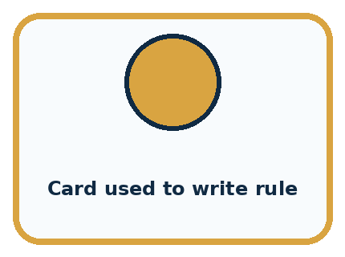
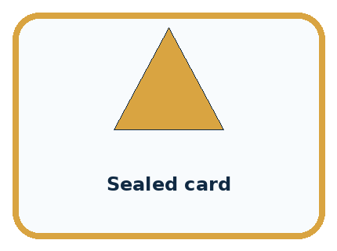
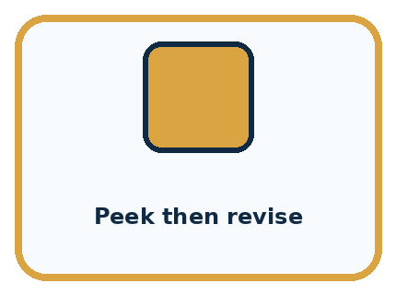

CASE 1 — Card used to write rule Clue: belongs in learn pile. Meaning: training evidence.
CASE 2 — Sealed card Clue: unseen until final run. Meaning: test evidence.
CASE 3 — Peek then revise Clue: test influenced process. Meaning: leakage.
CASE 4 — Fresh local card Clue: new after design. Meaning: strong transfer check.
BOUNDARY A test set stops being independent when its answers guide revisions.
Which two pictures are easiest to confuse? What evidence separates them?

Change one thing in the pictured case
Change: After feedback, change the boundary to 5.
Prediction: The revised rule matches all four known labels but needs a different final test.
Reason: These labels influenced the revision, so replaying them is evidence of repair rather than unseen performance.

05. Words that unlock the idea
VOCABULARY

Words You Can See and Use
The badge is a memory cue; the definition does the real thinking work.
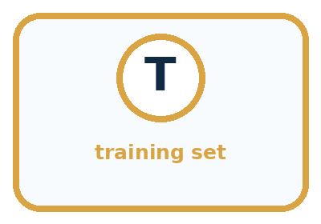
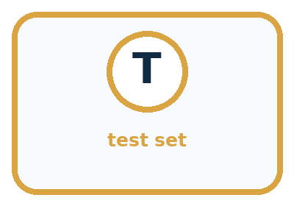
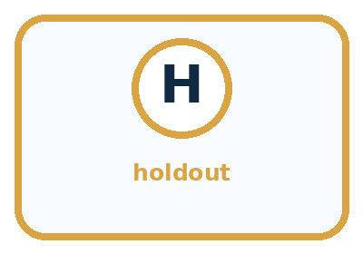
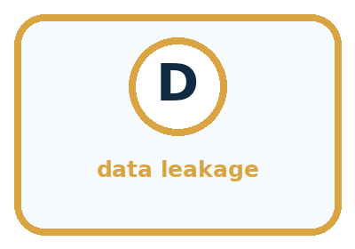
Word | Meaning | My example
training set | examples used to create or adjust a process
test set | untouched examples used for final checking
holdout | data deliberately kept separate
data leakage | test information influences design

Misconception detective
CLAIM TO REPAIR Testing on familiar cards is fair because there are more correct answers.
Use one vocabulary word and one piece of evidence to repair it:
WORD POWER A strong definition helps you decide something in a new case.

Words used in the closer explanation
Word | Meaning
Development examples | Examples available for fitting, comparing or revising a model
Held-out test set | Examples reserved from development for evaluating a fixed model
Freeze | Record a model and stop changing it for a particular evaluation
Test leakage | Information from a reserved test influencing model development
Evaluation record | A record of the tested model, predictions, comparison labels and results

06. Follow a worked example
WORKED EXAMPLE

Watch the Reasoning, Not Just the Answer
Every step connects a claim to observable evidence.

CASE If a sorter sees every mystery card while its rule is being created, later success on those same cards does not show transfer.
STEP 1 — OBSERVE all labeled cards
STEP 2 — TRACE separate training and untouched testing before rule creation
STEP 3 — CONCLUDE honest performance evidence on new cards
MODEL REASONING Randomly or deliberately reserve representative cards first. Create the decision process using only the learning pile. Open the test pile once for evidence, record every result, and do not call the revised process tested until a new holdout exists.
DO NOT OVERCLAIM A test set stops being independent when its answers guide revisions.
What new evidence could change this answer?

A closer explanation
Reserved height | Saved TowerA prediction | Revealed comparison label
3 cm | Short | Short
5 cm | Tall | Short
7 cm | Tall | Tall
9 cm | Tall | Tall
TowerA agrees on three of these four reserved examples and disagrees at 5 cm. That is evidence about this fixed model on this small set. It does not prove a success rate for every future tower. The labels, range of examples and way records were selected also matter.
After seeing the 5 cm label, the team changes the threshold to 6 and names the revision TowerB. TowerB agrees on all four of these now-seen examples. The change may be useful, but those examples have influenced its development. Four agreements on them are not an independent final test result for TowerB. Keep TowerA’s original three-of-four record.

Learn from the worked case
Cover the result before checking it. Say what is given, choose the procedure, and follow one step at a time. Then uncover the result and explain your first mismatch. Ask why a step is allowed, not only what number it produces.

A pictorial worked case: Save New Examples for Testing
A fictional envelope exercise evaluates a fixed pencil-length sorter.

The facts we will use
Freeze PencilP: long at least 6 cm; short below 6.
Reserved valid lengths are 3,5,6,9 cm. Teacher envelope labels, revealed only after predictions, are short,long,long,long.
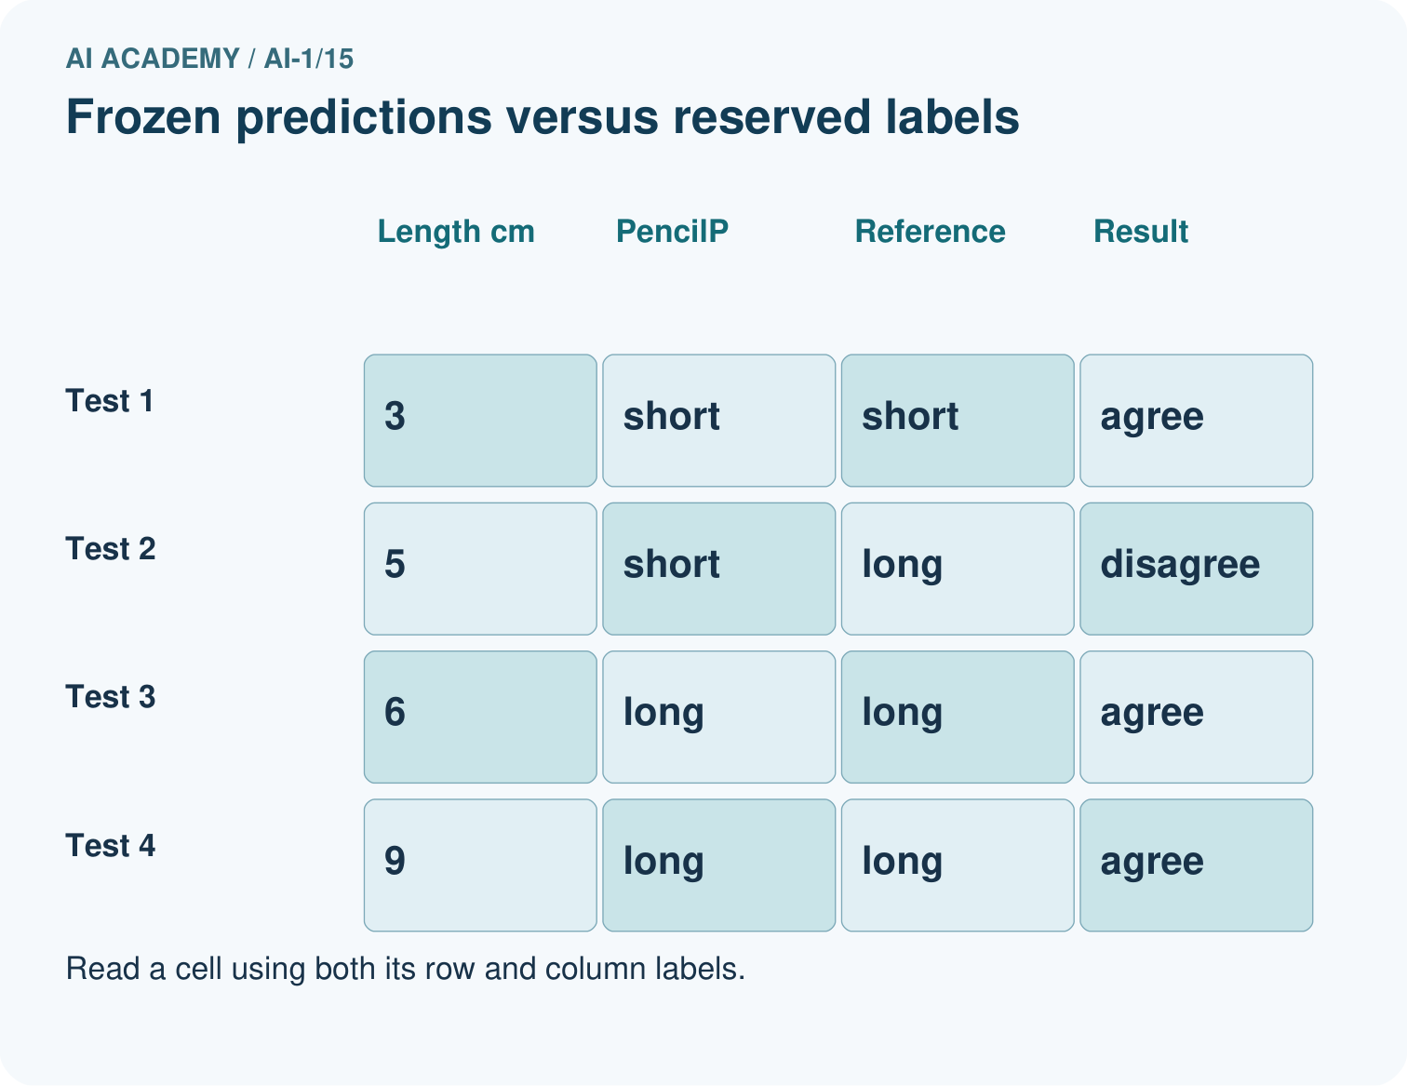
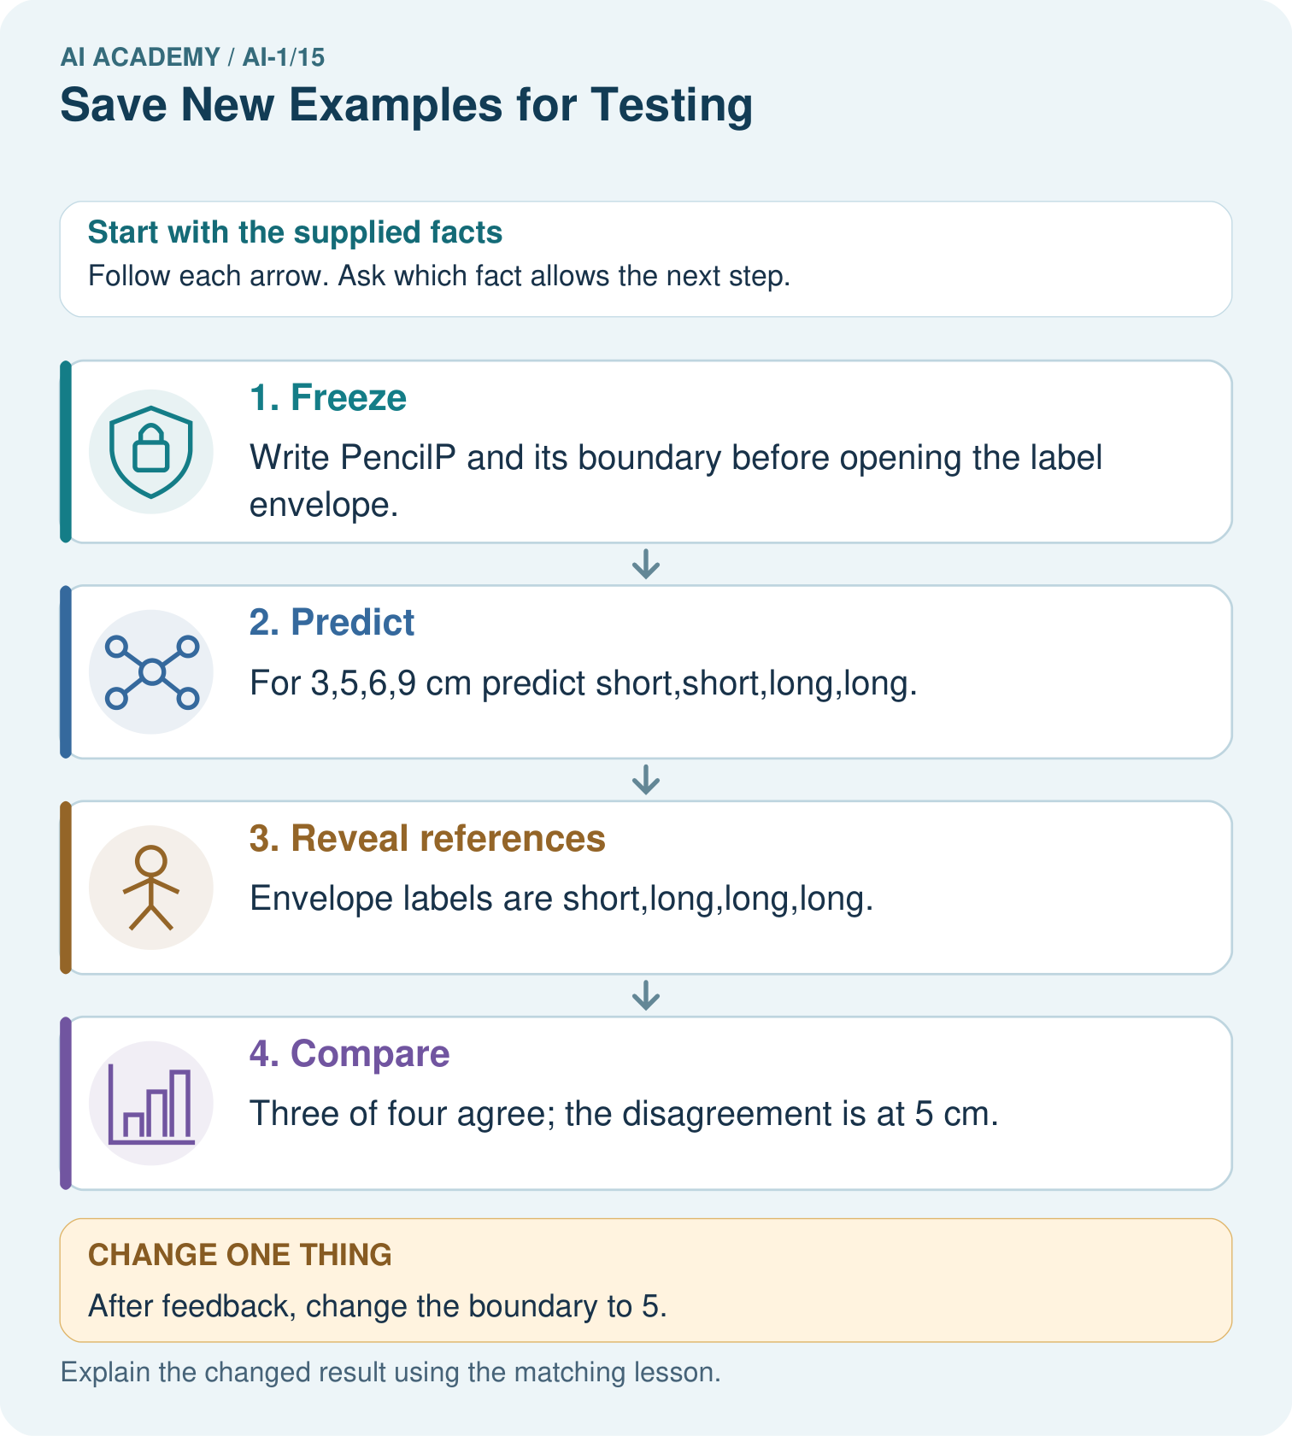

Read the picture one step at a time
Step | What happens and why
1. Freeze | Write PencilP and its boundary before opening the label envelope.
2. Predict | For 3,5,6,9 cm predict short,short,long,long.
3. Reveal references | Envelope labels are short,long,long,long.
4. Compare | Three of four agree; the disagreement is at 5 cm.
Match each pictured step to the supplied facts. This is a worked teaching case, not an independent assessment.

Why this result follows
The prediction record must exist before the labels are seen. PencilP scores 3/4=75% agreement on these four selected cases. Moving the boundary after inspecting the envelope makes this a development exercise; the same four cases can no longer serve as untouched final evaluation.

What this example does not establish
Four selected cases cannot establish a reliable accuracy rate for every future pencil or classroom.
Read the labelled picture: Does 4/4 on the replay replace the original 3/4 result? Explain.
Change one thing: After feedback, change the boundary to 5. Predict the result before checking the explanation. What remains the same?

07. Find and repair a mistake
COMPARE

Same Result, Different Reason
A comparison helps reveal the true concept boundary.
Case | Evidence | What it shows
Card used to write rule | belongs in learn pile | training evidence
Sealed card | unseen until final run | test evidence
Peek then revise | test influenced process | leakage
Fresh local card | new after design | strong transfer check

Repair two tempting claims
CLAIM A Testing on familiar cards is fair because there are more correct answers.
Repair:
CLAIM B Looking at test cards without labels cannot affect design.
Repair:
STRONG ANSWER FRAME I claim ______ because the evidence shows ______. The process is ______. One limit is ______.

A closer explanation
Keeping a set unseen is necessary for this kind of independent check, but secrecy alone does not make it a good test. Four near-identical easy cases provide little evidence about varied cases. Copies of development records can also make a reserved set misleading even if their file names differ.
Define what future cases the model is meant to handle and choose evaluation examples that address that use. Keep related or copied records together when separating sets. Record invalid inputs and no prediction outcomes separately instead of quietly dropping them from the report. Later weeks examine coverage and performance comparisons in more detail.

A team tries ten thresholds, reads the reserved test score for each, and reports only the best score as its final unseen test. Explain the problem and give an honest description of what it has measured
________________________________________________________________
________________________________________________________________
________________________________________________________________
________________________________________________________________

08. Practise together
GUIDED PRACTICE

Try It, Check It, Explain It
Use support now so you can succeed independently later.

Explain how the picture story demonstrates this idea: A fair test uses examples not used to create the decision process.
Use a fresh example to explain training set.
Trace a new input → process → output example.
Find and repair the error in: Looking at test cards without labels cannot affect design.
Invent one edge case and name the safe response.
PARTNER CHECK Point to the evidence. Do not accept an answer that only repeats the vocabulary word.

A closer explanation
Improvement after a test is allowed. State that the old test informed the revision, preserve both versions, and reserve fresh appropriate examples to evaluate the revised model independently. If none are available, report that limitation instead of inventing a fresh test result.

Write two result statements: one for TowerA on the original reserved set, and one for TowerB after the revision. Explain what must happen before a new independent evaluation of TowerB. Would shuffling the four old records make them unseen again
________________________________________________________________
________________________________________________________________
________________________________________________________________
________________________________________________________________
________________________________________________________________
________________________________________________________________
A test can lose independence even when you never copy its labels into a training table. Repeatedly trying thresholds and choosing the one with the best test score also uses test information to choose the model. Separate development comparisons from the final check.

Practise with less help: Preserve the original result
Use workbook W2 for the connected example “Keeping final tests unseen”. First fill the input and rule boxes. Try the middle steps before asking for a hint. After a hint, try the next step yourself.
Plan | Do | Check
What is given? Which rule or procedure applies? | Record each intermediate step. | Does the result follow? What remains unknown?
Explain your trace to a partner. Your partner points to one step to check. Swap roles on the next case. Each person writes their own explanation.

Check your reasoning
Use the worked case for Keeping final tests unseen. Proposed explanation: “A new file makes old records unseen”. Decide whether this explanation is supported. Point to the step or supplied fact that decides; explain your repair if needed.
Answer on your own before discussion. If you are unsure, say which step you need help with.

Explain the picture
Does 4/4 on the replay replace the original 3/4 result? Explain.

My explanation using a pictured step and the given facts
________________________________________________________________
________________________________________________________________
________________________________________________________________
________________________________________________________________
This is supported practice. Keep the separately named independent case for an attempt before feedback.

09. Run the investigation
EXPLORER LAB

Learn/Test Envelope Split
Predict first, test honestly, and explain what the evidence means.
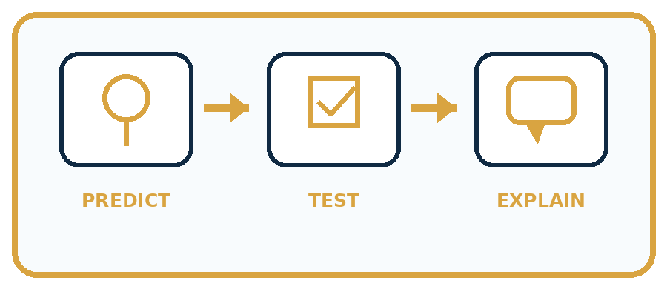
State your prediction before the result is known.
Complete the task: Split card data into learn and test piles before sorting.
Keep a normal case and an edge case clearly separated.
Record what happened—even when it does not match your prediction.
Explain the result, one limitation, and the next useful test.
Case | Prediction | Observed result | What it means
Normal
Edge
INDEPENDENCE After support is removed, repeat the proof with a fresh case.

Plan → try → check
Before trying: what do I expect, and why? While trying: which step could first go wrong? Afterwards: what did I actually observe, and what should change? Keep “not run” if you only traced the procedure.

10. Build your understanding
PRACTICE LADDER

Climb from Recall to Defense
Each step asks for a stronger kind of understanding.
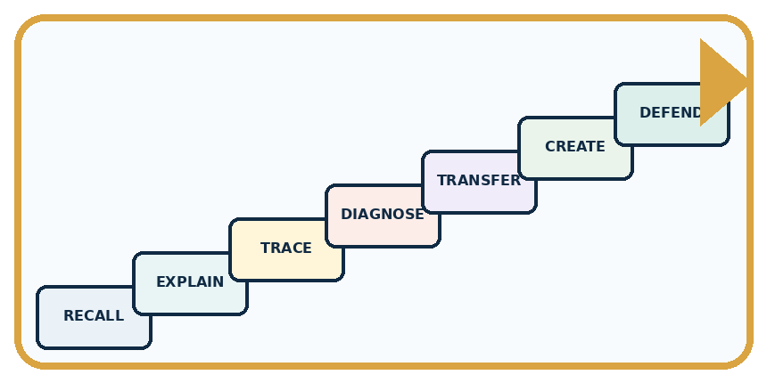
RECALL Define training set.
EXPLAIN A fair test uses examples not used to create the decision process.
TRACE Show the input, process, and output.
DIAGNOSE Repair: Testing on familiar cards is fair because there are more correct answers.
TRANSFER Apply the idea to a new home or classroom case.
CREATE Design one revealing test.
DEFEND Give a claim, evidence, mechanism, limit, and safe action.
RETRY RULE A coached answer becomes mastery only after you solve a different case independently.

11. Connect your project
PROJECT

Helpful Classroom Sorter
Build one coherent system across the year, one evidence-based decision at a time.
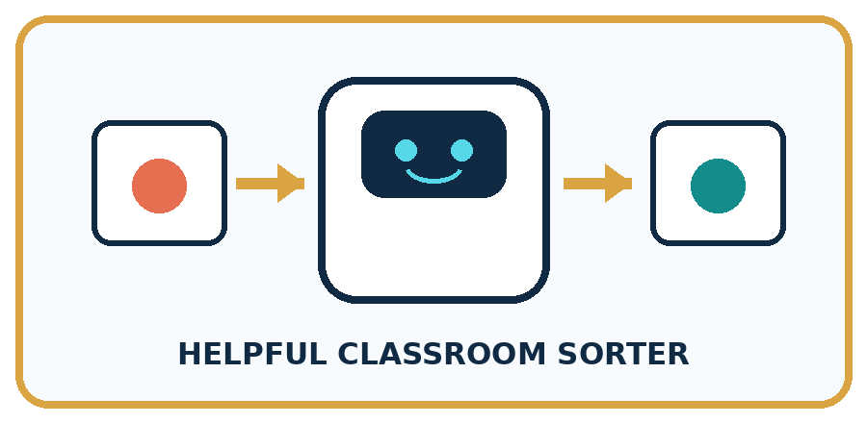
THIS WEEK'S CHECKPOINT Create separate learn and test envelopes for the Classroom Sorter and label who may open each.
What real classroom need does this serve?
What information is necessary—and what should stay private?
What happens inside the process?
What normal and edge cases will you test?
When should it say not sure or ask a person?

RESPONSIBLE DESIGN A test set stops being independent when its answers guide revisions.
My project decision:

Evidence for your project
Maintain dated sorter versions and separate development examples from reserved project-evaluation cases.

12. Show what you know
MASTERY

Fresh-Case Independent Proof
Complete this after teaching and guided practice have ended.
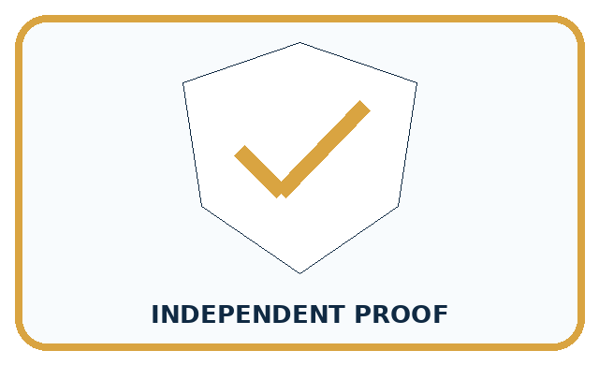
REQUIRED PROOF Split card data before building the sorter, explain why the test pile stays sealed, and report performance on it.
□ Name or draw the fresh case.
□ Trace input, process, and output.
□ State the conclusion and strongest evidence.
□ Name one limit, failure, missing clue, or fairness/privacy concern.
□ Explain one safe next action or improvement.
Independent evidence:
SELF-CHECK Randomly or deliberately reserve representative cards first. Create the decision process using only the learning pile. Open the test pile once for evidence, record every result, and do not call the revised process tested until a new holdout exists.
My level: □ Not yet □ With one hint □ Independently □ I can teach it
NEXT BRIDGE Carry today's evidence habit into: Boundaries and 'Not Sure'.

13. Study a complete case

Week 15 Worked case
Use the supplied details to practise the weekly concept before attempting the independent question. This case extends the illustrated lesson.

The situation
Cards A–F are used for practice. G and H remain sealed.

The question
Which can provide a fresh test, and under what condition?

Worked explanation
G and H, only if neither influenced teaching or revision. Familiar cases do not establish unseen performance. Keep final test answers separate.

Explain it in your own words
Which detail supports the answer, and why does it matter?

Write or draw your reasoning and evidence.
________________________________________________________________
________________________________________________________________
________________________________________________________________
________________________________________________________________
________________________________________________________________

Trace the supplied case visually

Keep the final cards unseen
Evidence or stage | Value or result
Practice A–F | 6
Sealed test G–H | 2
Cards A–F are used for practice. G and H remain sealed.
Which can provide a fresh test, and under what condition?
G and H, only if neither influenced teaching or revision. Familiar cases do not establish unseen performance. Keep final test answers separate.

14. Try a new case independently

Independent case: Run a separate ribbon experiment
Before receiving any test labels, freeze RibbonA: whole cm lengths 1 through 12, long at least 6 cm and short otherwise. Save predictions for 5, 7, 9 and 11 cm. Ask your teacher to reveal the reserved labels, then record agreements, disagreements and a limited result statement. If you later choose threshold 8 after seeing these labels, explain how you must describe its result on the same records.

My independent explanation, trace and limits
________________________________________________________________
________________________________________________________________
________________________________________________________________
________________________________________________________________
________________________________________________________________
________________________________________________________________
________________________________________________________________
Attempt this case before feedback. Record any help. Earlier examples below are further practice; a case already practised with feedback cannot establish fresh transfer.

Week 15 Independent application
Close the worked explanation. Apply the idea to this different question without copying.
You teach a sorter using cards A, B and C. You keep D and E unseen. Which cards provide the fairer first test? What changes if you show D during teaching?
My answer, with a trace, calculation or supporting evidence

Write or draw your reasoning and evidence.
________________________________________________________________
________________________________________________________________
________________________________________________________________
________________________________________________________________
________________________________________________________________

Create and test
Change one relevant detail. Predict the result before testing. Include a boundary or missing-information case when it helps reveal a limit.
My changed input and expected result

Write or draw your reasoning and evidence.
________________________________________________________________
________________________________________________________________
________________________________________________________________
________________________________________________________________
________________________________________________________________

Connect to your project
Create separate learn and test envelopes for the Classroom Sorter and label who may open each.
The evidence I will keep

Write or draw your reasoning and evidence.
________________________________________________________________
________________________________________________________________
________________________________________________________________
________________________________________________________________
________________________________________________________________
Your teacher has the independent answer and scoring criteria. Complete the matching workbook week to keep your practice evidence together.

Transfer practice from the original programme
Eight cards are used to invent a rule. Four sealed cards are then opened; the team changes its rule after seeing errors. Can those four cards still be called an untouched final test? Plan what to do next.

Explain the mechanism, evidence and one limit.
________________________________________________________________
________________________________________________________________
________________________________________________________________
________________________________________________________________
________________________________________________________________
________________________________________________________________
________________________________________________________________

Use feedback to improve
Attempt the independent case before hints. Record whether you worked alone, used a hint or followed a model. After feedback, fix the first unsupported step and explain why it changed. A later check uses a changed case, not a copied answer.

15. Your lesson route
Start with this question: A fictional envelope exercise evaluates a fixed pencil-length sorter.
By the end, I can | How I will show it
Separate examples used to choose a model from examples reserved for its final evaluation | Explain the deciding step, show a trace or test, and state one limit.
Record a fixed model and its predictions before revealing comparison labels | Explain the deciding step, show a trace or test, and state one limit.
Explain how test feedback changes the evidence available for a revised model | Explain the deciding step, show a trace or test, and state one limit.
Remember → watch and explain → try with help → investigate → try independently → keep project evidence. Your teacher may spread this lesson across several classes.
Keep your first prediction. Compare it with what the evidence shows and explain any change.

16. Finish and return
Close your notes. Explain this goal in your own words: Separate examples used to choose a model from examples reserved for its final evaluation

My deciding step, evidence and one remaining question
________________________________________________________________
________________________________________________________________
________________________________________________________________
________________________________________________________________
________________________________________________________________
If you are unsure, return to the worked picture and explain one arrow. If you are ready, change an input or assumption and justify your prediction.
Save your workbook evidence. At the next review, try a different case before opening your old answer.

17. Supported practice, repair and portfolio
Use this supported practice once, in the browser or on paper. Keep the reserved independent assessment for a separate first attempt before teacher feedback.
A fictional envelope exercise evaluates a fixed pencil-length sorter.

Practice 1: explain the deciding evidence
Which labelled step matches this detail? Three of four agree; the disagreement is at 5 cm.
1. Reveal references
2. Compare
3. Freeze
4. Predict

My selected conclusion, deciding fact and explanation
________________________________________________________________
________________________________________________________________
________________________________________________________________
________________________________________________________________
________________________________________________________________
Hint if needed: Read the steps in the pictorial case. Match the supplied detail to the stage that performs or records it.
After your attempt, compare with the supported explanation: Compare Three of four agree; the disagreement is at 5 cm. The prediction record must exist before the labels are seen. PencilP scores 3/4=75% agreement on these four selected cases. Moving the boundary after inspecting the envelope makes this a development exercise; the same four cases can no longer serve as untouched final evaluation.

Practice 2: explain the deciding evidence
Changed-case practice: After feedback, change the boundary to 5. Which conclusion is supported by the supplied facts?
1. The revised rule matches all four known labels but needs a different final test.
2. We can decide the result without examining the changed input or the procedure.
3. This one example guarantees correct results for every future input.

My selected conclusion, deciding fact and explanation
________________________________________________________________
________________________________________________________________
________________________________________________________________
________________________________________________________________
________________________________________________________________
Hint if needed: Use the changed condition and the deciding step in the pictorial trace. The answer must say what follows from those facts.
After your attempt, compare with the supported explanation: The revised rule matches all four known labels but needs a different final test. These labels influenced the revision, so replaying them is evidence of repair rather than unseen performance.

Repair a missing building block
Review Build a Human Classifier (ai-1/14). Goal: Construct a classifier with a stated input format, selected rule and recorded output. Short practice: Trace 0 cm and explain why clarification is different from predicting short.. Return to this week and explain what you changed.
Review Debug the Cause (ai-1/12). Goal: Compare expected and observed traces to locate the first difference. Short practice: Propose input 0 and give both predicted outputs without inventing an observed result.. Return to this week and explain what you changed.
Review Algorithms as Recipes (ai-1/9). Goal: Trace an ordered algorithm using the current value after every instruction. Short practice: Use the arrows to explain where the two zero-start runs first differ.. Return to this week and explain what you changed.

Keep your completed work
Use Download completed work in the hosted lesson to export your answers, reflections, practice feedback and code-run evidence. Open the HTML copy to read or print it. Drafts stay in this browser when storage is available; clear drafts on a shared device.

