AI ACADEMY · STUDENT · ai-1/23

Fair for Whom?
Project: Helpful Classroom Sorter

Before you start
Use fractions: 3 successes out of 5 is 3/5, not 3/2.

01. Your mission

Your learning target
I can compute a correct-out-of-assessed fraction and explain its denominator.
I can compare systems on shared cases while checking performance within conditions.
I can combine counts correctly and keep missing outcomes separate from assessed errors.

Remember before reading
Close your notes first. A rough first answer helps us choose the right starting point; it is not a score for your ability.
Without opening the old lesson, explain one key idea from Missing and Unbalanced Examples. Give an example and a mistake that the idea helps you avoid.
Without opening the old lesson, explain one key idea from Recommendations. Give an example and a mistake that the idea helps you avoid.
Without opening the old lesson, explain one key idea from Prediction Is Not Fact. Give an example and a mistake that the idea helps you avoid.
After trying, check the relevant lesson or ask your teacher. Change the part of your explanation that the evidence shows was wrong.
Fairness requires checking outcomes for different users and situations.

LEARNING TARGET System A succeeds on 6 of 8 quiet tests and 3 of 4 noisy tests. Is its noisy success rate lower? Show fractions and percentages. What can these small tests not establish?
Learner name:

Readiness for the connected explanation
Eight cases were selected, but one has no assessed outcome. How many have assessed outcomes, and what must a performance report say about the remaining case?

This week’s end goal
By the end, I can compare group fractions and combine unequal-sized groups correctly.

02. Notice the evidence
PICTURE STORY

Look Closely Before You Explain
Pictures give clues; evidence tells us what the clues mean.

MYSTERY A voice game may work well overall yet miss more commands from quiet speakers than loud speakers.

What do you notice?
Name three visible details without explaining them yet.
Circle the detail most connected to the system's decision.
Name one detail that may be decoration or distraction.
Make a first prediction and state the clue that supports it.
My observations, prediction, and evidence:
GOOD THINKING A prediction can change when stronger evidence appears.

A closer explanation
For this week, accuracy means the number of correctly labelled cases divided by the number of assessed cases. Every assessed case has a system label and a checked reference label, so its result can be judged correct or incorrect. State the system version, cases and scoring rule with the fraction. Cases without an assessable outcome are reported separately.
Two fixed shape-recognition versions, A and B, label the same 12 previously unseen picture cards. Eight cards are bright and four are dim; each has a checked circle or square reference label. Both versions return labels for all 12. A is correct on 8 bright and 1 dim card. B is correct on 6 bright and 2 dim cards.
A therefore has 9 correct out of 12 assessed, written 9/12. Dividing numerator and denominator by 3 gives 3/4. Three quarters equals 75 out of 100, or 75%. B has 8/12, equal to 2/3. For this comparison keep B as an exact fraction; a rounded percentage is unnecessary.

03. See how it works
VISUAL MECHANISM

Input → Process → Output
Follow the information instead of imagining magic inside the machine.
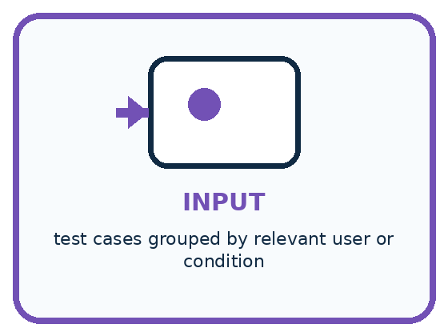
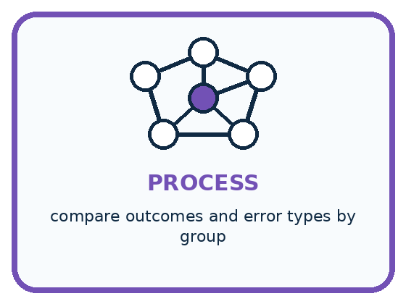
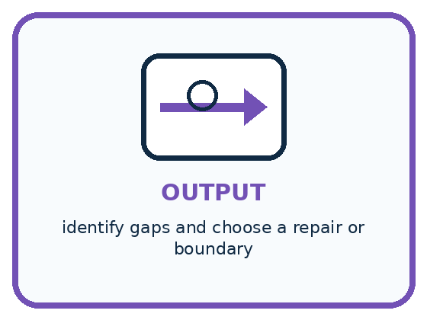
INPUT test cases grouped by relevant user or condition
PROCESS compare outcomes and error types by group
OUTPUT identify gaps and choose a repair or boundary
CORE IDEA Fairness requires checking outcomes for different users and situations.
UNDER THE HOOD Fairness is context-specific and cannot be established by overall accuracy alone. Compare performance, error costs, access, and remedy across relevant groups while avoiding stereotypes and protecting privacy.
Draw a fresh example with all three stages:

A closer explanation

Combine correct and assessed counts
Condition | Version A | Version B
Bright: 8 cards | 8 correct of 8 | 6 correct of 8
Dim: 4 cards | 1 correct of 4 | 2 correct of 4
All: 12 cards | 9 of 12 = 3 of 4 | 8 of 12 = 2 of 3
A has the higher overall accuracy on these same 12 cards, while B has the higher accuracy on the 4 dim cards. The overall fraction does not describe every condition equally.
With the same denominator 12, compare the numerators: 9 is greater than 8. A is correct on one more of these cards. This establishes the ordering on this test under this scoring rule; it does not prove that A will always outperform B on future cards.
To compare fractions with different denominators, rewrite them as equivalent fractions with a common denominator. For example, 3/4 equals 9/12 and 2/3 equals 8/12. Changing the written denominator does not create new test cases: it only helps compare the proportions.

Connect the picture and the explanation
Point to the input, the deciding step and the result in this week’s visual. Explain the same step in ordinary words. A picture helps when you can say what each part represents.

04. Compare the cases
PICTURE GALLERY

Four Cases, Four Clues
Use the visual cue, then read the evidence carefully.
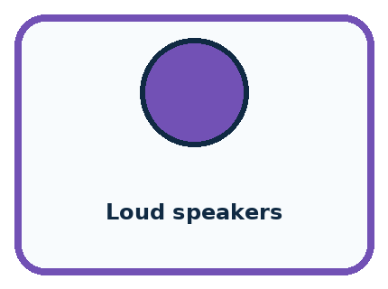
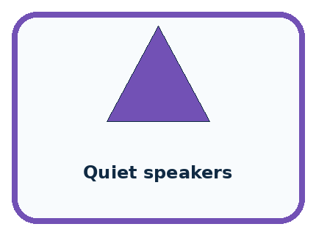
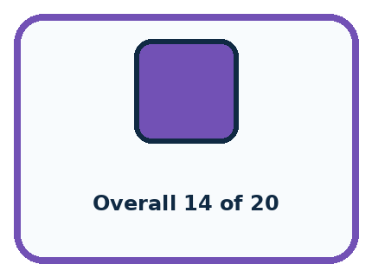
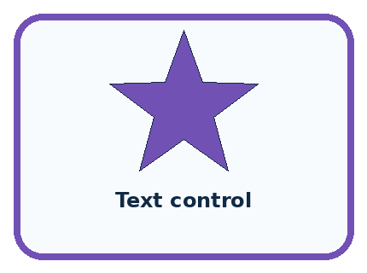
CASE 1 — Loud speakers Clue: 9 of 10 commands work. Meaning: high success.
CASE 2 — Quiet speakers Clue: 5 of 10 commands work. Meaning: performance gap.
CASE 3 — Overall 14 of 20 Clue: 70 percent total. Meaning: hides difference.
CASE 4 — Text control Clue: alternate access path. Meaning: possible remedy.
BOUNDARY Fairness work should reduce burdens without turning group labels into stereotypes.
Which two pictures are easiest to confuse? What evidence separates them?

Change one thing in the pictured case
Change: Give bright and dim groups equal weight as an explicitly different metric.
Prediction: M scores 70%; N scores about 81.7%.
Reason: This averages group rates and is not the original 16-card agreement rate.

05. Words that unlock the idea
VOCABULARY

Words You Can See and Use
The badge is a memory cue; the definition does the real thinking work.
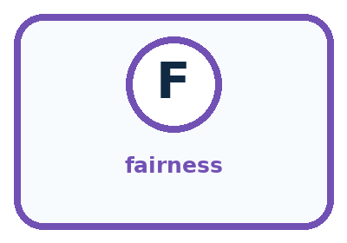
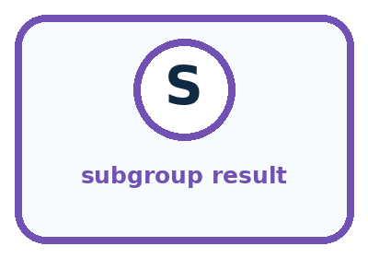
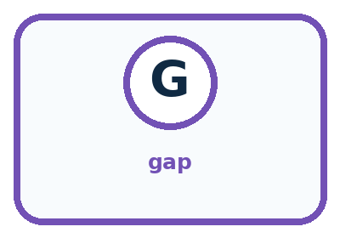
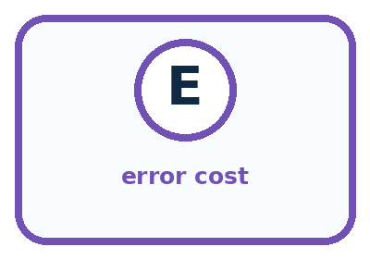
Word | Meaning | My example
fairness | reasoned treatment of outcomes across people and situations
subgroup result | performance measured for one relevant group
gap | difference between group outcomes
error cost | harm or burden caused by a mistake

Misconception detective
CLAIM TO REPAIR Good overall accuracy proves fairness.
Use one vocabulary word and one piece of evidence to repair it:
WORD POWER A strong definition helps you decide something in a new case.

Words used in the closer explanation
Word | Meaning
Numerator | The count above the fraction line; here, assessed correct cases
Denominator | The count below the fraction line; here, all assessed cases
Equivalent fractions | Different written fractions that represent the same proportion
Accuracy | The fraction of assessed classification cases labelled correctly under a stated rule
Aggregate | A result formed by combining the counts of several groups

06. Follow a worked example
WORKED EXAMPLE

Watch the Reasoning, Not Just the Answer
Every step connects a claim to observable evidence.

CASE A voice game may work well overall yet miss more commands from quiet speakers than loud speakers.
STEP 1 — OBSERVE test cases grouped by relevant user or condition
STEP 2 — TRACE compare outcomes and error types by group
STEP 3 — CONCLUDE identify gaps and choose a repair or boundary
MODEL REASONING Report each group's success count and error pattern, not only the total. Improve microphone/process testing with consented varied voices and keep a non-voice control so access does not depend on one input mode.
DO NOT OVERCLAIM Fairness work should reduce burdens without turning group labels into stereotypes.
What new evidence could change this answer?

A closer explanation
Question | Version A | Version B
Bright-card accuracy | 8/8 = 1 | 6/8 = 3/4
Dim-card accuracy | 1/4 | 2/4 = 1/2
Combined accuracy | (8 + 1)/(8 + 4) = 9/12 | (6 + 2)/(8 + 4) = 8/12
The bright group has twice as many assessed cards as the dim group. Each individual card counts once in the combined result, so add correct counts and assessed counts. Do not simply average the two group percentages and call it the all-card accuracy: that would give each group equal weight despite their different sizes.
If the intended task especially needs dim-card performance, inspect that result and gather suitable additional evidence before choosing. An overall leader can still be weaker in a relevant condition. This table alone also does not tell us whether particular mistakes have different consequences. The scoring rule must match the purpose.

Learn from the worked case
Cover the result before checking it. Say what is given, choose the procedure, and follow one step at a time. Then uncover the result and explain your first mismatch. Ask why a step is allowed, not only what number it produces.

A pictorial worked case: Fair for Whom?
A fictional badge reader is evaluated on bright and dim cards with known reference labels.

The facts we will use
Version M is correct on 9 of 10 bright cards and 3 of 6 dim cards.
Version N uses the same cards: 8 of 10 bright and 5 of 6 dim correct.
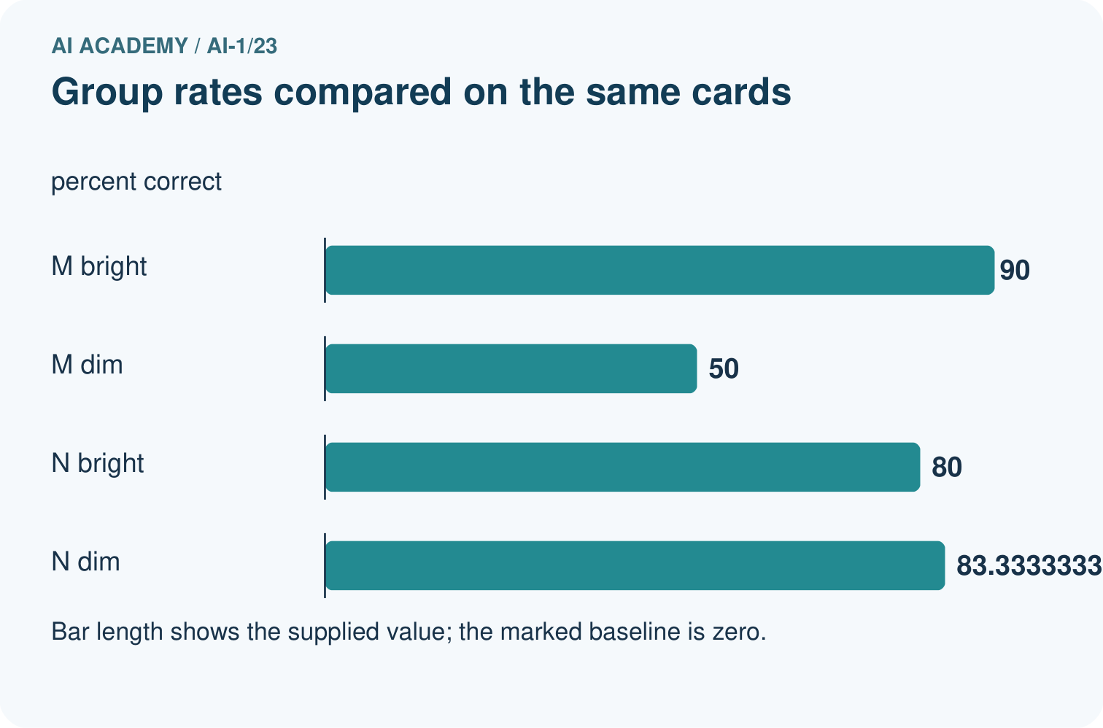
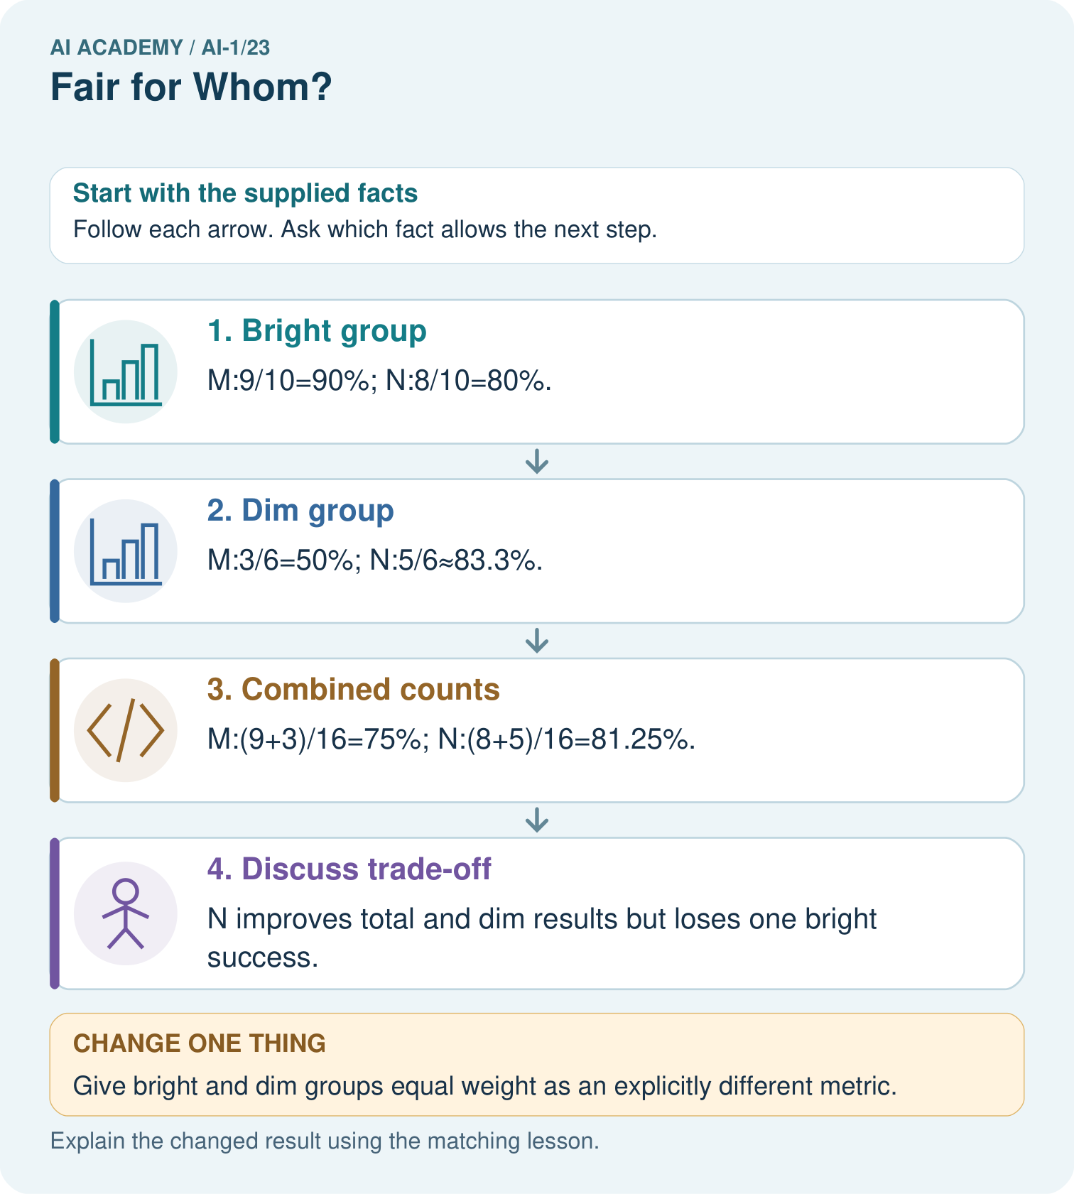

Read the picture one step at a time
Step | What happens and why
1. Bright group | M:9/10=90%; N:8/10=80%.
2. Dim group | M:3/6=50%; N:5/6≈83.3%.
3. Combined counts | M:(9+3)/16=75%; N:(8+5)/16=81.25%.
4. Discuss trade-off | N improves total and dim results but loses one bright success.
Match each pictured step to the supplied facts. This is a worked teaching case, not an independent assessment.

Why this result follows
Adding correct counts and denominators weights each tested card once. Averaging 90% and 50% would incorrectly give unequal groups equal size in the all-card rate. The group breakdown reveals a trade-off hidden by the total. Decide what matters with the relevant users rather than announcing that one number proves fairness.

What this example does not establish
Six dim cards supply limited evidence; these descriptive rates do not prove a system is fair for all users.
Read the labelled picture: Which group loses performance under N, and can total improvement erase that fact?
Change one thing: Give bright and dim groups equal weight as an explicitly different metric. Predict the result before checking the explanation. What remains the same?

07. Find and repair a mistake
COMPARE

Same Result, Different Reason
A comparison helps reveal the true concept boundary.
Case | Evidence | What it shows
Loud speakers | 9 of 10 commands work | high success
Quiet speakers | 5 of 10 commands work | performance gap
Overall 14 of 20 | 70 percent total | hides difference
Text control | alternate access path | possible remedy

Repair two tempting claims
CLAIM A Good overall accuracy proves fairness.
Repair:
CLAIM B Fairness means every group must have identical data or outcomes in every situation.
Repair:
STRONG ANSWER FRAME I claim ______ because the evidence shows ______. The process is ______. One limit is ______.

A closer explanation
A useful performance statement gives the correct count, assessed count, missing count and evaluation conditions. For A: 9/12 correct, no missing outcomes, on the shared test of 8 bright and 4 dim cards. Follow it with the important contrast: 8/8 bright and 1/4 dim. Percentages are optional shorthand, not replacements for these counts.
A score of 3/4 and a score of 75/100 are equal proportions, but they describe different quantities of evidence if they come from different tests. The collection method and case coverage still matter. Neither fraction is an individual prediction confidence or a guarantee about the next case.

A system has 2 correct of 2 in one group and 4 correct of 8 in another. Write the combined correct and assessed counts. Explain why averaging 100% and 50% would answer a different question
________________________________________________________________
________________________________________________________________
________________________________________________________________
________________________________________________________________

08. Practise together
GUIDED PRACTICE

Try It, Check It, Explain It
Use support now so you can succeed independently later.

Explain how the picture story demonstrates this idea: Fairness requires checking outcomes for different users and situations.
Use a fresh example to explain fairness.
Trace a new input → process → output example.
Find and repair the error in: Fairness means every group must have identical data or outcomes in every situation.
Invent one edge case and name the safe response.
PARTNER CHECK Point to the evidence. Do not accept an answer that only repeats the vocabulary word.

A closer explanation
A third version C is run on the same 12 cards, but two results are lost before they can be judged. Among its 10 assessed outcomes, 9 are correct and 1 is wrong: 9/10 = 90% assessed accuracy, with 2 outcomes unassessed. Do not call this 90% on all 12. Its assessed subset differs from A and B, so the headline fractions do not give the same complete-case comparison.

A report declares C best because 90% exceeds A’s 75%. Write the fraction and missing count for C, explain the comparison problem, and propose an evaluation step that would make the evidence easier to compare
________________________________________________________________
________________________________________________________________
________________________________________________________________
________________________________________________________________
________________________________________________________________
________________________________________________________________
________________________________________________________________
Recover and assess the two lost results if possible, without changing the versions. Another clearly labelled comparison can use the exact same cases with known outcomes for every version; disclose which cases it excludes and why. The current totals do not tell us how A performed on C’s ten assessed cases. Never invent that subset score.

Practise with less help: Compare totals and conditions
Use workbook W2 for the connected example “Fractions and performance comparisons”. First fill the input and rule boxes. Try the middle steps before asking for a hint. After a hint, try the next step yourself.
Plan | Do | Check
What is given? Which rule or procedure applies? | Record each intermediate step. | Does the result follow? What remains unknown?
Explain your trace to a partner. Your partner points to one step to check. Swap roles on the next case. Each person writes their own explanation.

Check your reasoning
Use the worked case for Fractions and performance comparisons. Proposed explanation: “Only correct cases belong in the denominator”. Decide whether this explanation is supported. Point to the step or supplied fact that decides; explain your repair if needed.
Answer on your own before discussion. If you are unsure, say which step you need help with.

Explain the picture
Which group loses performance under N, and can total improvement erase that fact?

My explanation using a pictured step and the given facts
________________________________________________________________
________________________________________________________________
________________________________________________________________
________________________________________________________________
This is supported practice. Keep the separately named independent case for an attempt before feedback.

09. Run the investigation
EXPLORER LAB

Voice Game Fairness Check
Predict first, test honestly, and explain what the evidence means.
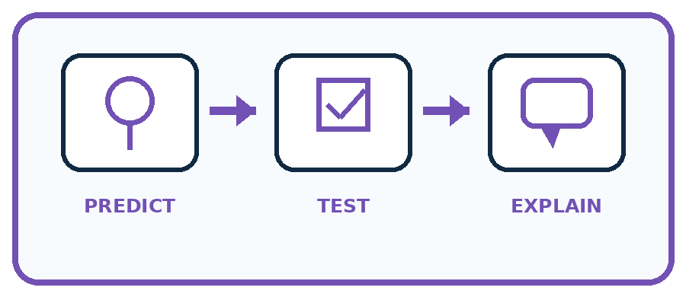
State your prediction before the result is known.
Complete the task: Run a voice-game test for quiet and loud speakers.
Keep a normal case and an edge case clearly separated.
Record what happened—even when it does not match your prediction.
Explain the result, one limitation, and the next useful test.
Case | Prediction | Observed result | What it means
Normal
Edge
INDEPENDENCE After support is removed, repeat the proof with a fresh case.

Plan → try → check
Before trying: what do I expect, and why? While trying: which step could first go wrong? Afterwards: what did I actually observe, and what should change? Keep “not run” if you only traced the procedure.

10. Build your understanding
PRACTICE LADDER

Climb from Recall to Defense
Each step asks for a stronger kind of understanding.
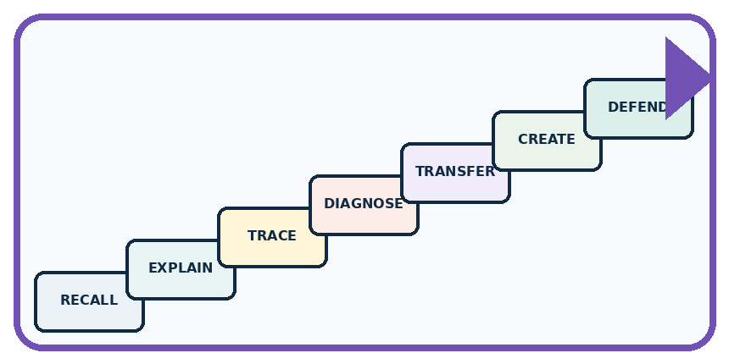
RECALL Define fairness.
EXPLAIN Fairness requires checking outcomes for different users and situations.
TRACE Show the input, process, and output.
DIAGNOSE Repair: Good overall accuracy proves fairness.
TRANSFER Apply the idea to a new home or classroom case.
CREATE Design one revealing test.
DEFEND Give a claim, evidence, mechanism, limit, and safe action.
RETRY RULE A coached answer becomes mastery only after you solve a different case independently.

11. Connect your project
PROJECT

Helpful Classroom Sorter
Build one coherent system across the year, one evidence-based decision at a time.
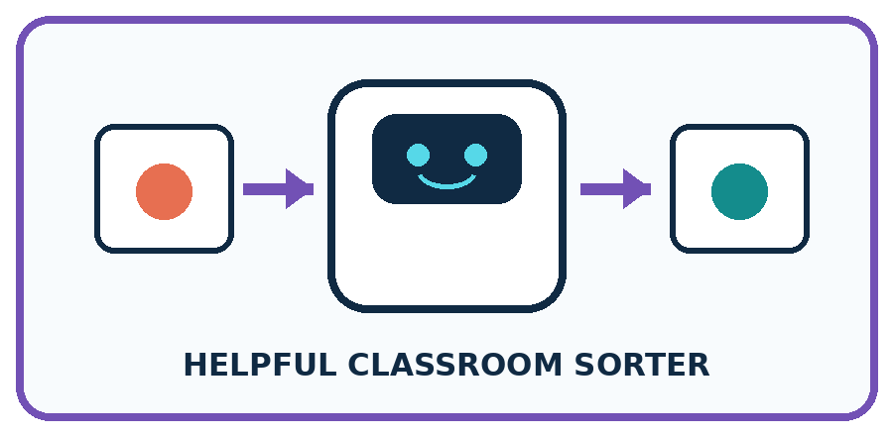
THIS WEEK'S CHECKPOINT Test the sorter across relevant item conditions and users; never infer sensitive identity to create a fairness check.
What real classroom need does this serve?
What information is necessary—and what should stay private?
What happens inside the process?
What normal and edge cases will you test?
When should it say not sure or ask a person?

RESPONSIBLE DESIGN Fairness work should reduce burdens without turning group labels into stereotypes.
My project decision:

Evidence for your project
Report sorter outcomes by relevant conditions and record whose failures matter when choosing a revision.

12. Show what you know
MASTERY

Fresh-Case Independent Proof
Complete this after teaching and guided practice have ended.

REQUIRED PROOF Test quiet and loud speaker cases separately, compare results, and propose one repair plus one alternate access path.
□ Name or draw the fresh case.
□ Trace input, process, and output.
□ State the conclusion and strongest evidence.
□ Name one limit, failure, missing clue, or fairness/privacy concern.
□ Explain one safe next action or improvement.
Independent evidence:
SELF-CHECK Report each group's success count and error pattern, not only the total. Improve microphone/process testing with consented varied voices and keep a non-voice control so access does not depend on one input mode.
My level: □ Not yet □ With one hint □ Independently □ I can teach it
NEXT BRIDGE Carry today's evidence habit into: Privacy by Choosing Less.

13. Study a complete case

Week 23 Worked case
Use the supplied details to practise the weekly concept before attempting the independent question. This case extends the illustrated lesson.

The situation
A voice system succeeds on 8/10 quiet and 4/10 noisy recordings.

The question
Compare and propose the next investigation.

Worked explanation
The rates differ. Test more varied recordings under controlled conditions and inspect other factors before claiming a cause.

Explain it in your own words
Which detail supports the answer, and why does it matter?

Write or draw your reasoning and evidence.
________________________________________________________________
________________________________________________________________
________________________________________________________________
________________________________________________________________
________________________________________________________________

Trace the supplied case visually

Compare success under two conditions
Evidence or stage | Value or result
Quiet | 8/10
Noisy | 4/10
A voice system succeeds on 8/10 quiet and 4/10 noisy recordings.
Compare and propose the next investigation.
The rates differ. Test more varied recordings under controlled conditions and inspect other factors before claiming a cause.

14. Try a new case independently

Independent case: Compare a new shared sound test
Versions X and Y label the same 20 previously unseen clips: 12 quiet and 8 noisy, with no missing outcomes. X is correct on 10 quiet and 2 noisy clips; Y on 9 quiet and 5 noisy clips. Calculate each combined fraction and percentage, identify the overall leader and compare the leaders within each group. Explain why an overall result cannot guarantee the next clip’s outcome.

My independent explanation, trace and limits
________________________________________________________________
________________________________________________________________
________________________________________________________________
________________________________________________________________
________________________________________________________________
________________________________________________________________
________________________________________________________________
Attempt this case before feedback. Record any help. Earlier examples below are further practice; a case already practised with feedback cannot establish fresh transfer.

Week 23 Independent application
Close the worked explanation. Apply the idea to this different question without copying.
A helper succeeds on 4 of 4 clear voices and 1 of 4 quiet voices. Who is less well served? What evidence should a repair preserve?
My answer, with a trace, calculation or supporting evidence

Write or draw your reasoning and evidence.
________________________________________________________________
________________________________________________________________
________________________________________________________________
________________________________________________________________
________________________________________________________________

Create and test
Change one relevant detail. Predict the result before testing. Include a boundary or missing-information case when it helps reveal a limit.
My changed input and expected result

Write or draw your reasoning and evidence.
________________________________________________________________
________________________________________________________________
________________________________________________________________
________________________________________________________________
________________________________________________________________

Connect to your project
Test the sorter across relevant item conditions and users; never infer sensitive identity to create a fairness check.
The evidence I will keep

Write or draw your reasoning and evidence.
________________________________________________________________
________________________________________________________________
________________________________________________________________
________________________________________________________________
________________________________________________________________
Your teacher has the independent answer and scoring criteria. Complete the matching workbook week to keep your practice evidence together.

Transfer practice from the original programme
System A succeeds on 6 of 8 quiet tests and 3 of 4 noisy tests. Is its noisy success rate lower? Show fractions and percentages. What can these small tests not establish?

Explain the mechanism, evidence and one limit.
________________________________________________________________
________________________________________________________________
________________________________________________________________
________________________________________________________________
________________________________________________________________
________________________________________________________________
________________________________________________________________

Use feedback to improve
Attempt the independent case before hints. Record whether you worked alone, used a hint or followed a model. After feedback, fix the first unsupported step and explain why it changed. A later check uses a changed case, not a copied answer.

15. Your lesson route
Start with this question: A fictional badge reader is evaluated on bright and dim cards with known reference labels.
By the end, I can | How I will show it
Compute a correct-out-of-assessed fraction and explain its denominator | Explain the deciding step, show a trace or test, and state one limit.
Compare systems on shared cases while checking performance within conditions | Explain the deciding step, show a trace or test, and state one limit.
Combine counts correctly and keep missing outcomes separate from assessed errors | Explain the deciding step, show a trace or test, and state one limit.
Remember → watch and explain → try with help → investigate → try independently → keep project evidence. Your teacher may spread this lesson across several classes.
Keep your first prediction. Compare it with what the evidence shows and explain any change.

16. Finish and return
Close your notes. Explain this goal in your own words: Compute a correct-out-of-assessed fraction and explain its denominator

My deciding step, evidence and one remaining question
________________________________________________________________
________________________________________________________________
________________________________________________________________
________________________________________________________________
________________________________________________________________
If you are unsure, return to the worked picture and explain one arrow. If you are ready, change an input or assumption and justify your prediction.
Save your workbook evidence. At the next review, try a different case before opening your old answer.

17. Supported practice, repair and portfolio
Use this supported practice once, in the browser or on paper. Keep the reserved independent assessment for a separate first attempt before teacher feedback.
A fictional badge reader is evaluated on bright and dim cards with known reference labels.

Practice 1: explain the deciding evidence
Which labelled step matches this detail? N improves total and dim results but loses one bright success.
1. Dim group
2. Combined counts
3. Bright group
4. Discuss trade-off

My selected conclusion, deciding fact and explanation
________________________________________________________________
________________________________________________________________
________________________________________________________________
________________________________________________________________
________________________________________________________________
Hint if needed: Read the steps in the pictorial case. Match the supplied detail to the stage that performs or records it.
After your attempt, compare with the supported explanation: Discuss trade-off N improves total and dim results but loses one bright success. Adding correct counts and denominators weights each tested card once. Averaging 90% and 50% would incorrectly give unequal groups equal size in the all-card rate. The group breakdown reveals a trade-off hidden by the total. Decide what matters with the relevant users rather than announcing that one number proves fairness.

Practice 2: explain the deciding evidence
Changed-case practice: Give bright and dim groups equal weight as an explicitly different metric. Which conclusion is supported by the supplied facts?
1. We can decide the result without examining the changed input or the procedure.
2. This one example guarantees correct results for every future input.
3. M scores 70%; N scores about 81.7%.

My selected conclusion, deciding fact and explanation
________________________________________________________________
________________________________________________________________
________________________________________________________________
________________________________________________________________
________________________________________________________________
Hint if needed: Use the changed condition and the deciding step in the pictorial trace. The answer must say what follows from those facts.
After your attempt, compare with the supported explanation: M scores 70%; N scores about 81.7%. This averages group rates and is not the original 16-card agreement rate.

Repair a missing building block
Review Missing and Unbalanced Examples (ai-1/22). Goal: Name the target collection, selection list and cases actually assessed. Short practice: Would testing only dim plain cards close every current gap? Point to the target groups.. Return to this week and explain what you changed.
Review Recommendations (ai-1/20). Goal: Apply eligibility requirements before ranking candidates by preferences. Short practice: Why does the recommendation change without changing anyone’s preferences?. Return to this week and explain what you changed.
Review Prediction Is Not Fact (ai-1/17). Goal: Separate a recorded prediction from the observation used to check it. Short practice: Which field changes the observation label, and which field changes the model prediction?. Return to this week and explain what you changed.

Keep your completed work
Use Download completed work in the hosted lesson to export your answers, reflections, practice feedback and code-run evidence. Open the HTML copy to read or print it. Drafts stay in this browser when storage is available; clear drafts on a shared device.

