AI ACADEMY · STUDENT · ai-2/15

Choose Informative Questions
Project: Transparent Book Recommender

Before you start
Week 14: a useful question separates target groups.

01. Your mission

Your learning target
I can fit a root question and leaf predictions from training examples.
I can trace a new example through the learned tree.
I can compare a shallow tree with a baseline and state its limits.

Remember before reading
Close your notes first. A rough first answer helps us choose the right starting point; it is not a score for your ability.
Without opening the old lesson, explain one key idea from Decision Trees. Give an example and a mistake that the idea helps you avoid.
Without opening the old lesson, explain one key idea from Accuracy as a Fraction. Give an example and a mistake that the idea helps you avoid.
Without opening the old lesson, explain one key idea from Features and Distractors. Give an example and a mistake that the idea helps you avoid.
After trying, check the relevant lesson or ask your teacher. Change the part of your explanation that the evidence shows was wrong.
Week 15: Choose Informative Questions
A strong question eliminates many possibilities without relying on accidents.
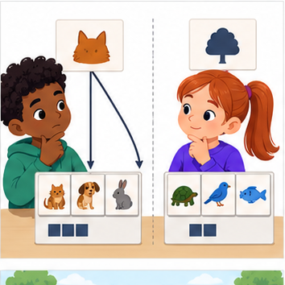
THINKER MISSION
Compare two first questions by remaining possibilities.
Thinker name and date:

Write or draw your reasoning and evidence.
________________________________________________________________
________________________________________________________________
________________________________________________________________
________________________________________________________________
________________________________________________________________

Readiness for the connected explanation
Why does a cutoff with zero training errors still need validation on separate examples?

This week’s end goal
By the end, I can choose a question that separates possibilities rather than repeating a constant clue.

02. Notice the evidence
PICTURE STORY
Notice → Predict → Explain
Begin with visible evidence. Do not explain more than the picture and information support.
MYSTERY
The learners must use choose informative questions to solve a problem. What information do they have? What decision or calculation do they make? What would count as evidence that it worked?
Three observations (what you can point to):

Write or draw your reasoning and evidence.
________________________________________________________________
________________________________________________________________
________________________________________________________________
________________________________________________________________
________________________________________________________________
My prediction and the clue supporting it:

Write or draw your reasoning and evidence.
________________________________________________________________
________________________________________________________________
________________________________________________________________
________________________________________________________________
________________________________________________________________

A closer explanation
A decision tree asks a feature question and follows a branch to a prediction. A tree with one question has depth one and is sometimes called a stump. Unlike Week 8, where the two output labels were fixed in advance, this week we fit both the question and the label stored at each leaf.
Our six fictional training rows have two binary sensor flags available before prediction: near and tall. A value of 1 means that flag is present; 0 means absent. The reviewed scene label is separate. Each row represents a different trip on a familiar route, including rows with identical values. Similar readings can have different scene labels. These are teaching examples, not robot control instructions.
Row | Near | Tall | Label
1 | 1 | 0 | blocked
2 | 1 | 1 | blocked
3 | 1 | 0 | blocked
4 | 0 | 1 | clear
5 | 0 | 0 | clear
6 | 0 | 1 | blocked
Try near first and tall second. For each question, group the training rows by 0 and 1, then predict each group’s majority label; choose clear for tied label counts. Count all training mistakes and keep the first question if scores tie. Stop after one question. This is our stated classroom fitting procedure.

03. See how it works
VISUAL MECHANISM
Input → Process → Output
Trace the information. At each stage, ask what changed and how you could test it.
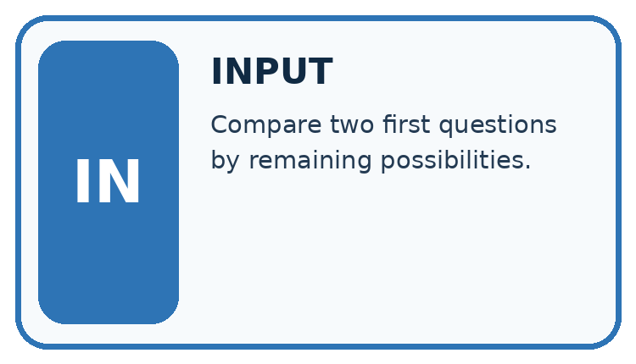
↓
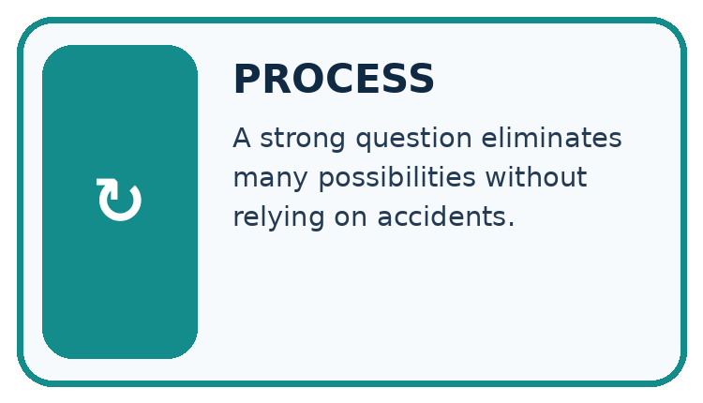
↓
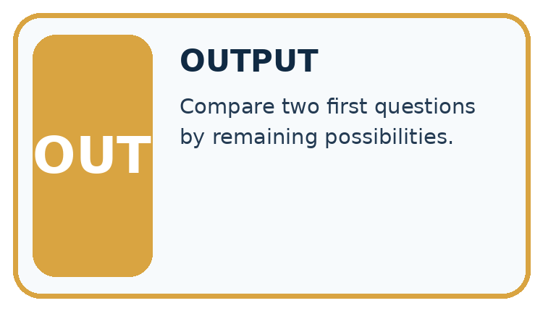
Which stage could fail even when the other two are correct? Explain:

Write or draw your reasoning and evidence.
________________________________________________________________
________________________________________________________________
________________________________________________________________
________________________________________________________________
________________________________________________________________

A closer explanation
rows = [(1, 0, "blocked"), (1, 1, "blocked"),
(1, 0, "blocked"), (0, 1, "clear"),
(0, 0, "clear"), (0, 1, "blocked")]
def majority(labels):
if labels.count("blocked") > labels.count("clear"):
return "blocked"
return "clear"
best_errors = len(rows) + 1
for feature in [0, 1]:
leaves = {}
for value in [0, 1]:
labels = [row[2] for row in rows
if row[feature] == value]
leaves[value] = majority(labels)
errors = 0
for row in rows:
if leaves[row[feature]] != row[2]:
errors = errors + 1
print(feature, errors)
if errors < best_errors:
best_errors = errors
tree = (feature, leaves)
print(tree[0], tree[1][0], tree[1][1])
Feature 0 is near; feature 1 is tall; row[2] is the label. Output is 0 1, then 1 2, then 0 clear blocked. Near makes one training mistake: near=0 contains two clear labels and one blocked, so that leaf predicts clear. Near=1 contains three blocked labels. Tall makes two mistakes because both its groups have a blocked majority.
The stored tree contains the chosen feature and its two learned leaves. The code assumes nonempty data, binary flags, allowed labels and examples on both branches of each candidate. An empty branch would need a declared fallback; this small example does not implement one. The score is total training mistakes, not an average giving small and large branches equal weight.
This is an explicitly limited depth-one learner. General tree algorithms can repeat split selection within branches and often use impurity criteria such as Gini. Our code does not implement that full procedure. Keeping the scope small lets you inspect every decision.

Connect the picture and the explanation
Point to the input, the deciding step and the result in this week’s visual. Explain the same step in ordinary words. A picture helps when you can say what each part represents.

04. Compare the cases
CASE GALLERY
Four Tests, Four Kinds of Evidence
A system is not understood until it survives more than one comfortable example.


NORMAL CASE: predict and name evidence. BOUNDARY CASE: predict and name evidence.


MISSING INFORMATION: predict and name evidence. TRANSFER CASE: predict and name evidence.
Which case is most likely to reveal a hidden assumption? Why?

Write or draw your reasoning and evidence.
________________________________________________________________
________________________________________________________________
________________________________________________________________
________________________________________________________________
________________________________________________________________

Change one thing in the pictured case
Change: The current possibility set contains only the four mystery cards.
Prediction: Asking mystery now leaves all four; it no longer narrows the set.
Reason: Question value depends on the remaining candidates, not just on its wording.

05. Words that unlock the idea
VOCABULARY LAB
Words You Can Use to Reason
A definition matters when you can recognize the idea, use it, and contrast it with a near-miss.
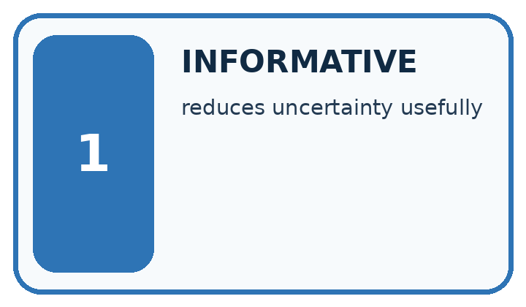
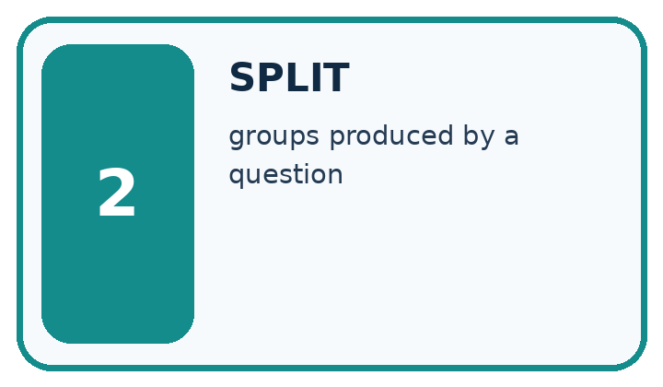
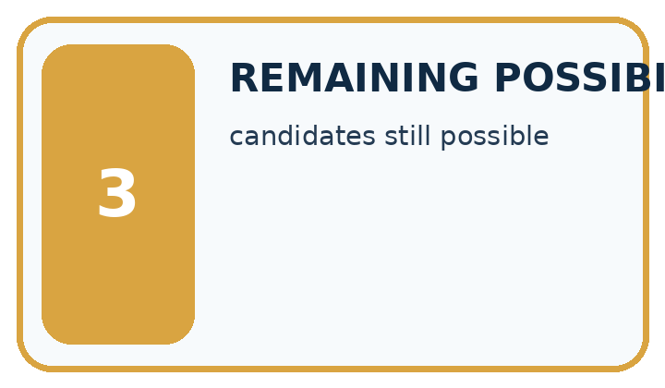
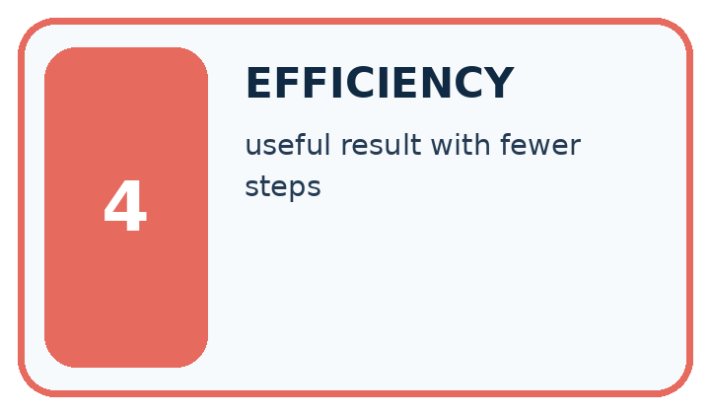
Word | My own example | Not this / boundary
informative | Providing evidence that helps distinguish relevant possibilities or reduce uncertainty.
split | Separate a dataset into portions with different development or evaluation roles.
remaining possibilities | The options still consistent with the evidence after some have been ruled out.
efficiency | The resources required to achieve a result, such as time, memory or number of steps.

Words used in the closer explanation
Word | Meaning
Root | The first question asked by a tree
Branch | A path selected by the answer to a question
Leaf | An endpoint that stores a prediction
Depth | The largest number of question steps from root to leaf

06. Follow a worked example
WORKED EVIDENCE
Reason Step by Step
Predict first. Then check each step. A correct answer without visible reasoning is incomplete evidence.
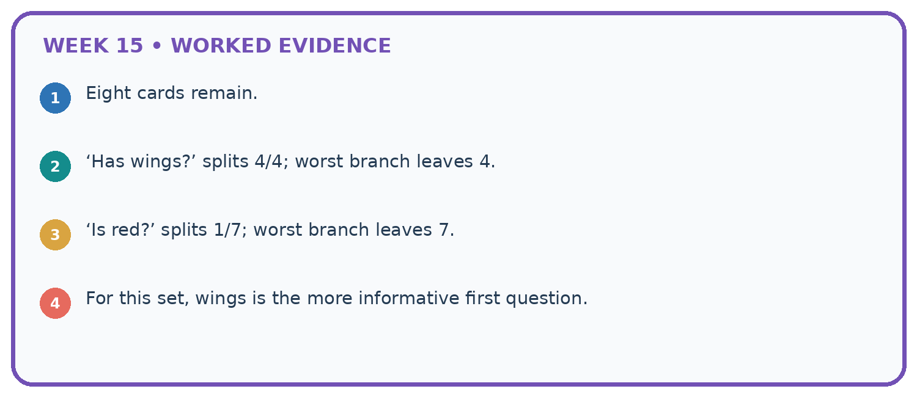
1. Eight cards remain.
2. ‘Has wings?’ splits 4/4; worst branch leaves 4.
3. ‘Is red?’ splits 1/7; worst branch leaves 7.
4. For this set, wings is the more informative first question.
Recalculate, retrace, or restate the reasoning in your own representation:

Write or draw your reasoning and evidence.
________________________________________________________________
________________________________________________________________
________________________________________________________________
________________________________________________________________
________________________________________________________________
CHECK Did the evidence answer the exact question? Did the total, path, or source record stay consistent?

A closer explanation

Two paths through the learned tree
Root question | Branch answer | Learned leaf
Is near equal to 1 | No near is 0 | Predict clear
Is near equal to 1 | Yes near is 1 | Predict blocked
Both paths start at the same root. Tall is not used by this fitted tree; the leaf labels came from training counts.
Validation rows are (near=1,tall=1,blocked), (0,0,clear), (0,1,blocked), (1,0,clear). Follow only near: predictions are blocked, clear, clear, blocked. Two of four match. The training-majority baseline predicts blocked, since training has four blocked and two clear; it also matches two of four validation labels.

Which validation rows does the tree miss, and which does the baseline miss? Explain why the tall value cannot change this tree’s prediction.
________________________________________________________________
________________________________________________________________
________________________________________________________________
________________________________________________________________
Keep the fitted root and leaves unchanged while scoring. Equal accuracy does not mean identical errors, and five correct training predictions out of six is not the validation result.

Learn from the worked case
Cover the result before checking it. Say what is given, choose the procedure, and follow one step at a time. Then uncover the result and explain your first mismatch. Ask why a step is allowed, not only what number it produces.

A pictorial worked case: Choose Informative Questions
A fictional guessing game has eight catalogue cards and asks yes/no questions to narrow the target.

The facts we will use
Cards: four mystery, four science; six paperback, two hardback; all English.
Compare worst-case remaining group size after asking mystery?, paperback? or English?. No claim about unequal target probabilities is made.
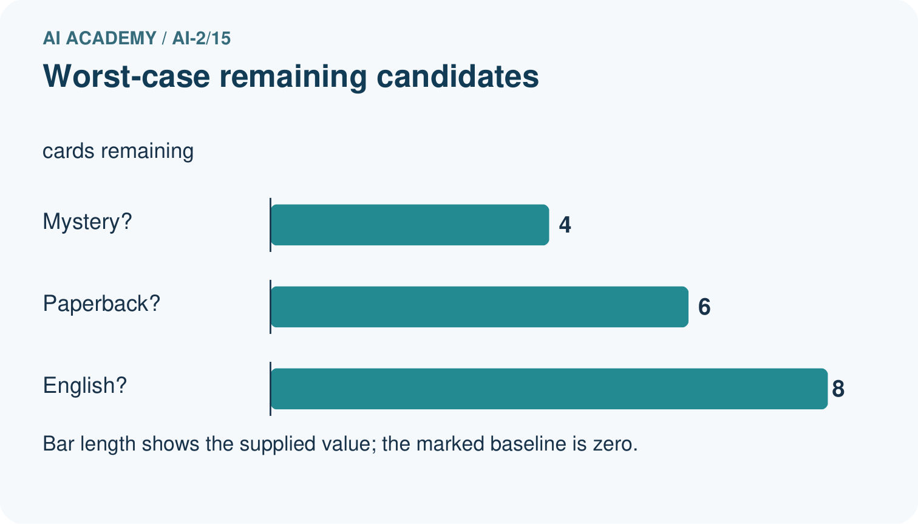
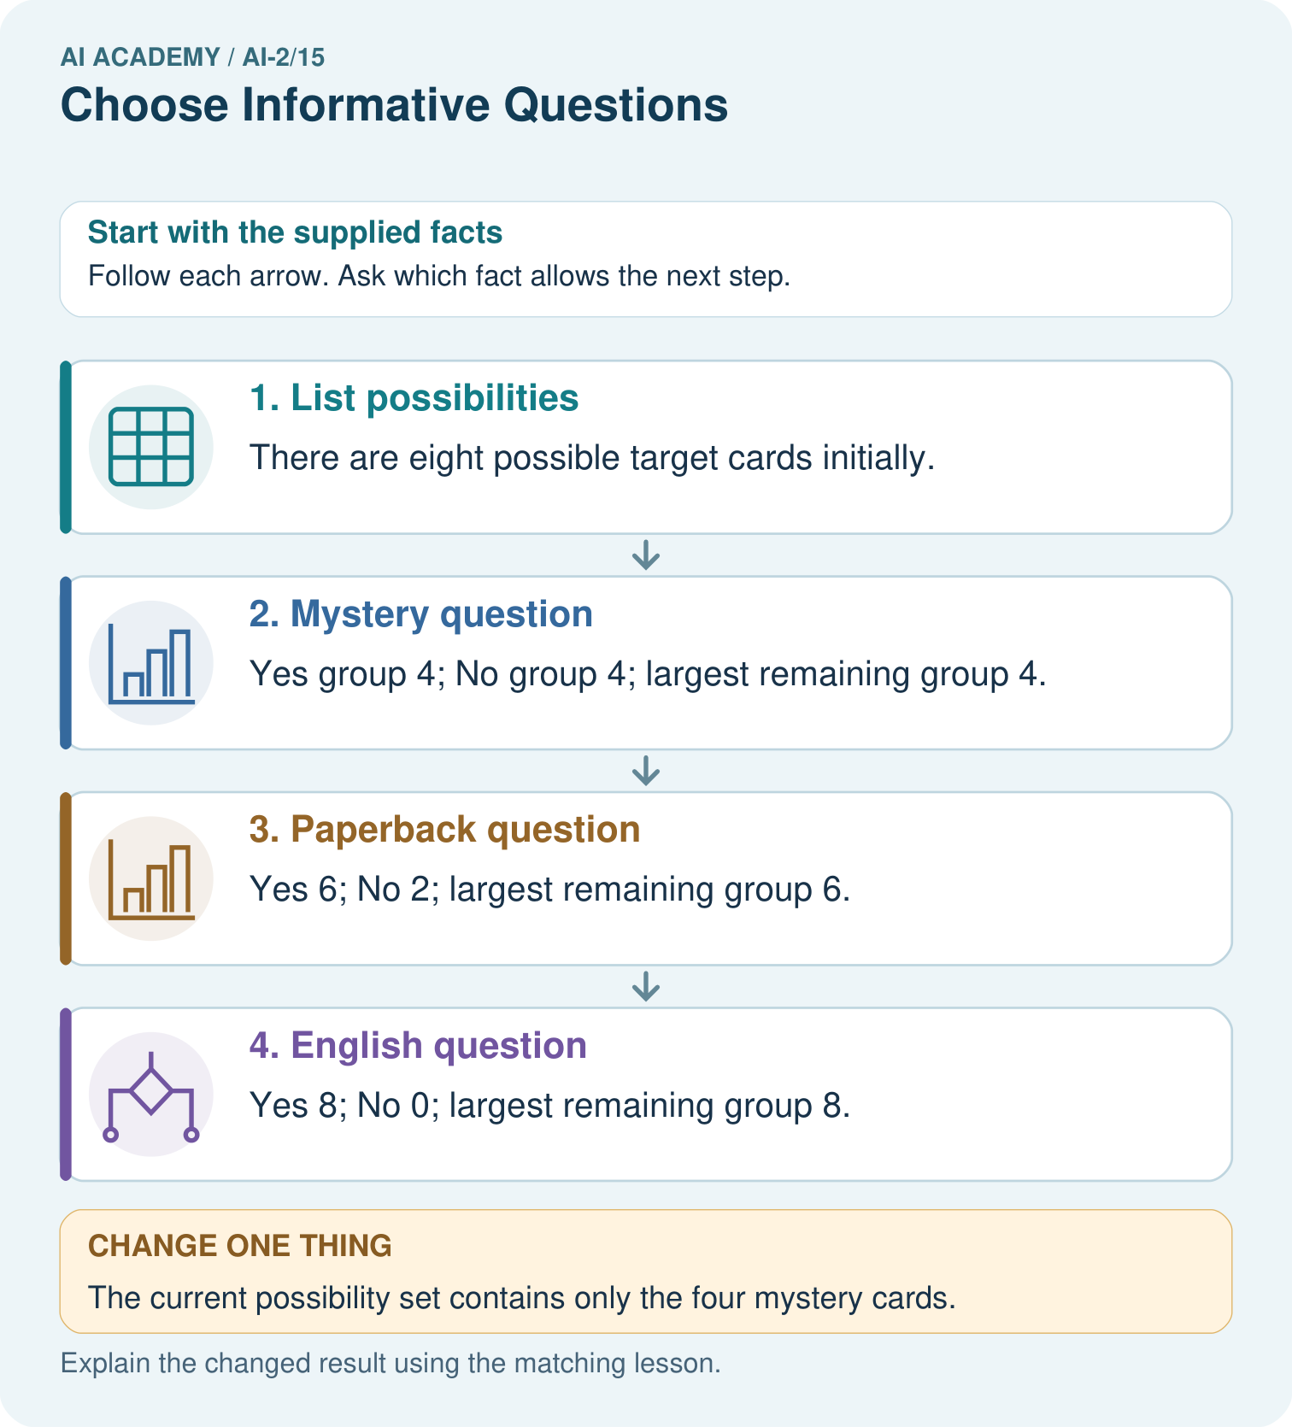

Read the picture one step at a time
Step | What happens and why
1. List possibilities | There are eight possible target cards initially.
2. Mystery question | Yes group 4; No group 4; largest remaining group 4.
3. Paperback question | Yes 6; No 2; largest remaining group 6.
4. English question | Yes 8; No 0; largest remaining group 8.
Match each pictured step to the supplied facts. This is a worked teaching case, not an independent assessment.

Why this result follows
Under the stated worst-case criterion, mystery is the most useful of these questions because it leaves at most four cards. The constant language clue never narrows the set. This is an identification-game criterion; a classifier fitting labels may instead compare prediction errors or another declared training measure.

What this example does not establish
Balanced groups do not guarantee a truthful user answer or optimal choices under every probability or cost model.
Read the labelled picture: Choose the best original question and explain why its more balanced split matters here.
Change one thing: The current possibility set contains only the four mystery cards. Predict the result before checking the explanation. What remains the same?

07. Find and repair a mistake
ERROR DETECTIVE
Compare → Diagnose → Repair
Do not patch the answer. Find the earliest unsupported assumption, wrong step, or weak evidence.
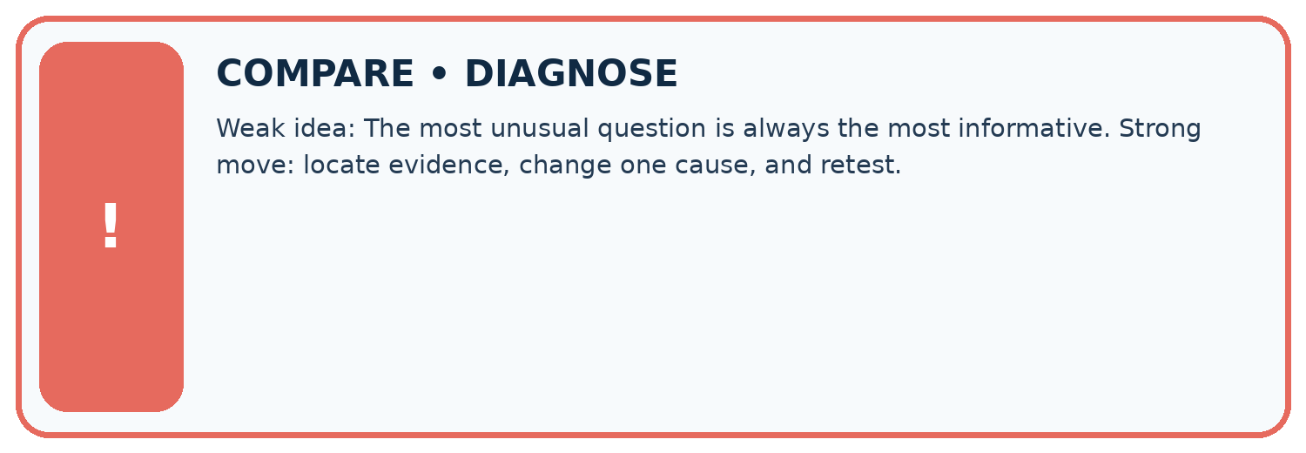
Evidence record | Expected | Actual | Likely cause / next test
normal case | works
boundary case | stated rule
missing input | safe response
fresh transfer | generalizes
Repair one cause. Why is this repair better than changing several things?

Write or draw your reasoning and evidence.
________________________________________________________________
________________________________________________________________
________________________________________________________________
________________________________________________________________
________________________________________________________________

A closer explanation
Record the two candidate questions, branch label counts, total errors, tie rules, depth limit, stored tree and validation predictions. Retain all rows, including the blocked example in the near=0 branch; removing a disagreement would change the evidence.
Our tree uses a single feature because that question scored better under this procedure. This neither establishes that near causes blockage nor that tall is useless in every dataset. Next week a nearest-neighbour method will predict by comparing examples instead of following learned questions.

A learner says the tree is reliable because near=1 has only blocked training labels. Rewrite this claim using the leaf evidence, validation score and one limitation.
________________________________________________________________
________________________________________________________________
________________________________________________________________
________________________________________________________________

08. Practise together
LOGIC STUDIO
Trace Before You Run
Block code, pseudocode, tables, and diagrams are different ways to expose the same reasoning.

SET evidence_record
PREDICT expected_result
RUN one normal case and one boundary case
COMPARE actual_result with expected_result
IF different: locate first cause; change one factor; RETEST
EXPLAIN result, limitation, and next safe step
Trace one input. Which line changes the state or chooses a path?

Write or draw your reasoning and evidence.
________________________________________________________________
________________________________________________________________
________________________________________________________________
________________________________________________________________
________________________________________________________________

A closer explanation
Do not assume near=1 must always predict blocked. If a new training set gives that branch a clear majority, this same learner will store clear there. A feature name is not the answer. Use the training labels belonging to that branch.
Adding more questions can fit finer training details but does not guarantee better new-case performance. Record any depth choice made during development, and keep final test data separate. A leaf majority describes this training group; it is not a promise about every future example.

Practise with less help: Verify the candidate scores
Use workbook W2 for the connected example “Fitting a decision tree”. First fill the input and rule boxes. Try the middle steps before asking for a hint. After a hint, try the next step yourself.
Plan | Do | Check
What is given? Which rule or procedure applies? | Record each intermediate step. | Does the result follow? What remains unknown?
Explain your trace to a partner. Your partner points to one step to check. Swap roles on the next case. Each person writes their own explanation.

Check your reasoning
Use the worked case for Fitting a decision tree. Proposed explanation: “A near branch must predict blocked”. Decide whether this explanation is supported. Point to the step or supplied fact that decides; explain your repair if needed.
Answer on your own before discussion. If you are unsure, say which step you need help with.

Explain the picture
Choose the best original question and explain why its more balanced split matters here.

My explanation using a pictured step and the given facts
________________________________________________________________
________________________________________________________________
________________________________________________________________
________________________________________________________________
This is supported practice. Keep the separately named independent case for an attempt before feedback.

09. Run the investigation
EVIDENCE LAB
Predict → Test → Record → Explain
Keep expected and actual results separate. Surprises are useful data when recorded honestly.
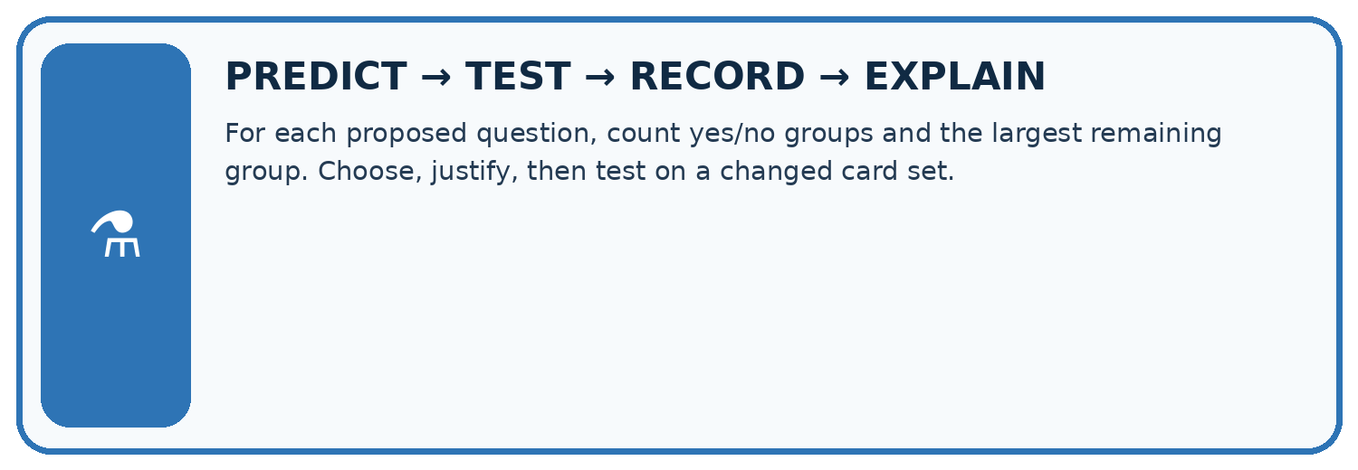
For each proposed question, count yes/no groups and the largest remaining group. Choose, justify, then test on a changed card set.
Test / input | Prediction | Actual | Evidence / calculation | Change or keep?
normal
boundary
missing
fresh transfer
What did the hardest test teach you that the normal test did not?

Write or draw your reasoning and evidence.
________________________________________________________________
________________________________________________________________
________________________________________________________________
________________________________________________________________
________________________________________________________________

Plan → try → check
Before trying: what do I expect, and why? While trying: which step could first go wrong? Afterwards: what did I actually observe, and what should change? Keep “not run” if you only traced the procedure.

10. Build your understanding
MASTERY
From Knowing the Word to Owning the Idea
Move upward only when you can produce evidence without copying the worked example.

1 • NAME: Define the concept without repeating the textbook.
2 • TRACE: Show the information, state, branch, calculation, or evidence path.
3 • APPLY: Solve a different example independently.
4 • CHALLENGE: Find a boundary case, counterexample, or unfair outcome.
5 • EXPLAIN LIMITS: Say when the result should not be trusted or used alone.
My strongest evidence of independent understanding:

Write or draw your reasoning and evidence.
________________________________________________________________
________________________________________________________________
________________________________________________________________
________________________________________________________________
________________________________________________________________

11. Connect your project
CUMULATIVE PROJECT
Transparent Book Recommender
Every week adds one inspectable piece. The system must show how it reached a result.
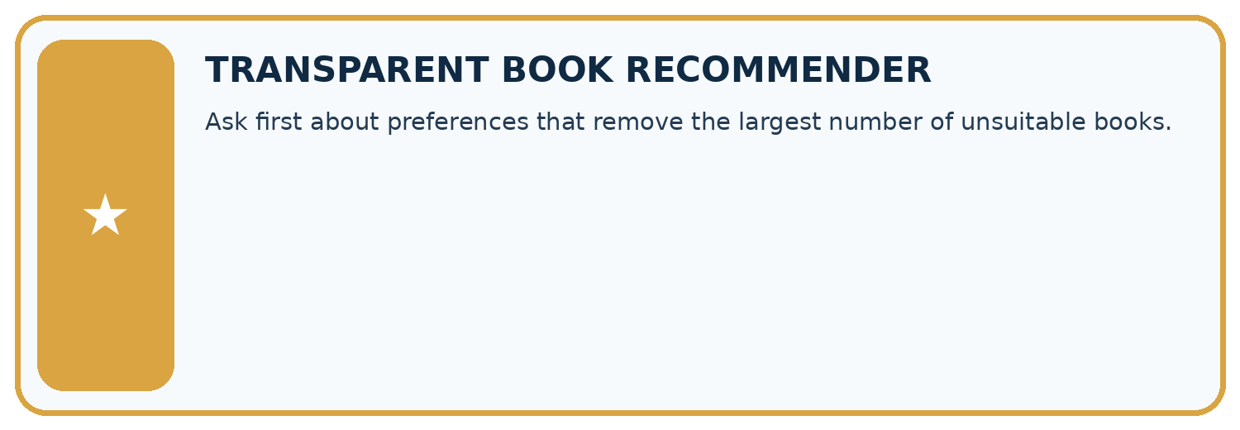
THIS WEEK’S CHECKPOINT Ask first about preferences that remove the largest number of unsuitable books.
SYSTEM MAP Reader need → allowed inputs → transparent rule or score → ranked candidates → explanation → test record → human decision
What will you add, change, or verify in the project this week?

Write or draw your reasoning and evidence.
________________________________________________________________
________________________________________________________________
________________________________________________________________
________________________________________________________________
________________________________________________________________
What should remain under human control?

Write or draw your reasoning and evidence.
________________________________________________________________
________________________________________________________________
________________________________________________________________
________________________________________________________________
________________________________________________________________
RESPONSIBLE DESIGN Collect only necessary information. Show uncertainty and limits. Never confuse a ranking with a fact about a person.

Evidence for your project
Choose recommender questions that distinguish feasible options, documenting the decision criterion rather than asking unnecessary personal details.

12. Show what you know
INDEPENDENT MASTERY PROOF
Explain • Transfer • Test • Defend
Complete this page without copying the worked example. Your reasoning matters more than decoration.
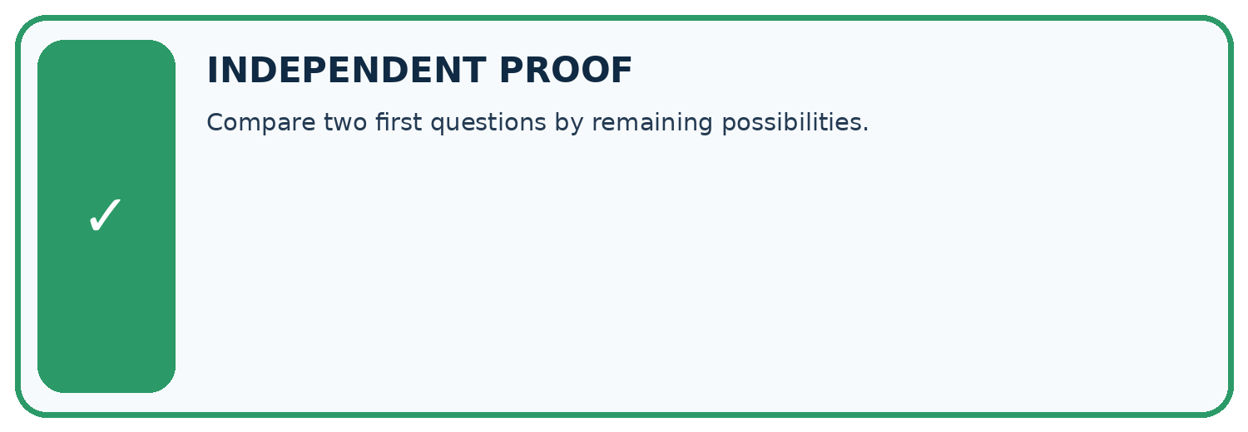
CHALLENGE Compare two first questions by remaining possibilities.
1. My fresh example, trace, calculation, or design:

Write or draw your reasoning and evidence.
________________________________________________________________
________________________________________________________________
________________________________________________________________
________________________________________________________________
________________________________________________________________
2. My evidence that it works (include a boundary or missing-data case):

Write or draw your reasoning and evidence.
________________________________________________________________
________________________________________________________________
________________________________________________________________
________________________________________________________________
________________________________________________________________
3. One limitation, fairness concern, or situation needing human review:

Write or draw your reasoning and evidence.
________________________________________________________________
________________________________________________________________
________________________________________________________________
________________________________________________________________
________________________________________________________________
SELF-CHECK □ I explained the mechanism □ I used evidence □ I tested a fresh case □ I named a limitation □ I can answer ‘why?’

13. Study a complete case

Week 15 Worked case
Use the supplied details to practise the weekly concept before attempting the independent question. This case extends the illustrated lesson.

The situation
Eight blue cards contain four circles and four triangles; target is shape.

The question
Which question is more useful: blue or circle?

Worked explanation
Circle separates target groups. Blue puts every card in one branch. Usefulness depends on the task and examples.

Explain it in your own words
Which detail supports the answer, and why does it matter?

Write or draw your reasoning and evidence.
________________________________________________________________
________________________________________________________________
________________________________________________________________
________________________________________________________________
________________________________________________________________

Trace the supplied case visually

Choose a question that separates the target
Evidence or stage | Value or result
Blue? | All eight stay together
Circle? | Four circles versus four triangles
Target | Shape, not colour
Eight blue cards contain four circles and four triangles; target is shape.
Which question is more useful: blue or circle?
Circle separates target groups. Blue puts every card in one branch. Usefulness depends on the task and examples.

14. Try a new case independently

Independent case: Changed independent case
Ten cards have six pet subjects and four space subjects; all are green. Compare asking “green?” with asking “pet?” to identify a card. Give the largest remaining group and one limitation.

My independent explanation, trace and limits
________________________________________________________________
________________________________________________________________
________________________________________________________________
________________________________________________________________
________________________________________________________________
________________________________________________________________
________________________________________________________________
Attempt this case before feedback. Record any help. Earlier examples below are further practice; a case already practised with feedback cannot establish fresh transfer.

Week 15 Independent application
Close the worked explanation. Apply the idea to this different question without copying.
Cards are two cats and two dogs, all red. Which question helps separate species: is it red or does it bark? State your assumption.
My answer, with a trace, calculation or supporting evidence

Write or draw your reasoning and evidence.
________________________________________________________________
________________________________________________________________
________________________________________________________________
________________________________________________________________
________________________________________________________________

Create and test
Change one relevant detail. Predict the result before testing. Include a boundary or missing-information case when it helps reveal a limit.
My changed input and expected result

Write or draw your reasoning and evidence.
________________________________________________________________
________________________________________________________________
________________________________________________________________
________________________________________________________________
________________________________________________________________

Connect to your project
Ask first about preferences that remove the largest number of unsuitable books.
The evidence I will keep

Write or draw your reasoning and evidence.
________________________________________________________________
________________________________________________________________
________________________________________________________________
________________________________________________________________
________________________________________________________________
Your teacher has the independent answer and scoring criteria. Complete the matching workbook week to keep your practice evidence together.

Transfer practice from the original programme
Six cards contain three animal and three space books; all have blue covers. Compare asking 'blue cover?' with 'animal subject?'. Is the better question guaranteed to work on inaccurately tagged books?

Explain the mechanism, evidence and one limit.
________________________________________________________________
________________________________________________________________
________________________________________________________________
________________________________________________________________
________________________________________________________________
________________________________________________________________
________________________________________________________________

Use feedback to improve
Attempt the independent case before hints. Record whether you worked alone, used a hint or followed a model. After feedback, fix the first unsupported step and explain why it changed. A later check uses a changed case, not a copied answer.

15. Your lesson route
Start with this question: A fictional guessing game has eight catalogue cards and asks yes/no questions to narrow the target.
By the end, I can | How I will show it
Fit a root question and leaf predictions from training examples | Explain the deciding step, show a trace or test, and state one limit.
Trace a new example through the learned tree | Explain the deciding step, show a trace or test, and state one limit.
Compare a shallow tree with a baseline and state its limits | Explain the deciding step, show a trace or test, and state one limit.
Remember → watch and explain → try with help → investigate → try independently → keep project evidence. Your teacher may spread this lesson across several classes.
Keep your first prediction. Compare it with what the evidence shows and explain any change.

16. Finish and return
Close your notes. Explain this goal in your own words: Fit a root question and leaf predictions from training examples

My deciding step, evidence and one remaining question
________________________________________________________________
________________________________________________________________
________________________________________________________________
________________________________________________________________
________________________________________________________________
If you are unsure, return to the worked picture and explain one arrow. If you are ready, change an input or assumption and justify your prediction.
Save your workbook evidence. At the next review, try a different case before opening your old answer.

17. Supported practice, repair and portfolio
Use this supported practice once, in the browser or on paper. Keep the reserved independent assessment for a separate first attempt before teacher feedback.
A fictional guessing game has eight catalogue cards and asks yes/no questions to narrow the target.

Practice 1: explain the deciding evidence
Which labelled step matches this detail? Yes 8; No 0; largest remaining group 8.
1. List possibilities
2. Mystery question
3. Paperback question
4. English question

My selected conclusion, deciding fact and explanation
________________________________________________________________
________________________________________________________________
________________________________________________________________
________________________________________________________________
________________________________________________________________
Hint if needed: Read the steps in the pictorial case. Match the supplied detail to the stage that performs or records it.
After your attempt, compare with the supported explanation: English question Yes 8; No 0; largest remaining group 8. Under the stated worst-case criterion, mystery is the most useful of these questions because it leaves at most four cards. The constant language clue never narrows the set. This is an identification-game criterion; a classifier fitting labels may instead compare prediction errors or another declared training measure.

Practice 2: explain the deciding evidence
Changed-case practice: The current possibility set contains only the four mystery cards. Which conclusion is supported by the supplied facts?
1. We can decide the result without examining the changed input or the procedure.
2. Asking mystery now leaves all four; it no longer narrows the set.
3. This one example guarantees correct results for every future input.

My selected conclusion, deciding fact and explanation
________________________________________________________________
________________________________________________________________
________________________________________________________________
________________________________________________________________
________________________________________________________________
Hint if needed: Use the changed condition and the deciding step in the pictorial trace. The answer must say what follows from those facts.
After your attempt, compare with the supported explanation: Asking mystery now leaves all four; it no longer narrows the set. Question value depends on the remaining candidates, not just on its wording.

Repair a missing building block
Review Decision Trees (ai-2/14). Goal: Fit a root question and leaf predictions from training examples. Short practice: Why does changing colour alone not change this tree’s prediction?. Return to this week and explain what you changed.
Review Accuracy as a Fraction (ai-2/12). Goal: Explain why overall accuracy can hide failure on a less common class. Short practice: Why is 100% repair detection not sufficient to declare the changed classifier best?. Return to this week and explain what you changed.
Review Features and Distractors (ai-2/9). Goal: Choose recorded properties that preserve distinctions needed for a stated task. Short practice: Does this one pair prove the classifier always ignores subject? Explain a narrower claim.. Return to this week and explain what you changed.

Predict, run and debug
The browser lab lets you edit the supported Python examples already included in this lesson. Predict first, run, inspect the actual output or error, change one input, then run again. Keep code, predictions, actual results and a reasoned revision together. On paper, label your result as a trace rather than an execution.

Keep your completed work
Use Download completed work in the hosted lesson to export your answers, reflections, practice feedback and code-run evidence. Open the HTML copy to read or print it. Drafts stay in this browser when storage is available; clear drafts on a shared device.

