AI ACADEMY · STUDENT · ai-2/29

Evidence and Sources
Project: Transparent Book Recommender

Before you start
AI-1 Week 27: verify a claim using evidence suited to it.

01. Your mission

Your learning target
I can explain the mechanism and terminology of claim support and citation evaluation.
I can apply the stated procedure to a new case with a traceable result.
I can identify an assumption or limitation and design a revealing follow-up.

Remember before reading
Close your notes first. A rough first answer helps us choose the right starting point; it is not a score for your ability.
Without opening the old lesson, explain one key idea from Prompt Experiments. Give an example and a mistake that the idea helps you avoid.
Without opening the old lesson, explain one key idea from Image and Voice Pipelines. Give an example and a mistake that the idea helps you avoid.
Without opening the old lesson, explain one key idea from Recommendation Scores. Give an example and a mistake that the idea helps you avoid.
After trying, check the relevant lesson or ask your teacher. Change the part of your explanation that the evidence shows was wrong.
Week 29: Evidence and Sources
Claims require sources matched to the question and checked independently.

THINKER MISSION
Verify a generated answer using two suitable sources.
Thinker name and date:

Write or draw your reasoning and evidence.
________________________________________________________________
________________________________________________________________
________________________________________________________________
________________________________________________________________
________________________________________________________________

Readiness for the connected explanation
Recall Building a grounded answer. Explain why a recorded result needs its input conditions and evidence source before it can support a claim.

This week’s end goal
By the end, I can separate citation presence, link validity and support for an exact claim.

02. Notice the evidence
PICTURE STORY
Notice → Predict → Explain
Begin with visible evidence. Do not explain more than the picture and information support.
MYSTERY
The learners must use evidence and sources to solve a problem. What information do they have? What decision or calculation do they make? What would count as evidence that it worked?
Three observations (what you can point to):

Write or draw your reasoning and evidence.
________________________________________________________________
________________________________________________________________
________________________________________________________________
________________________________________________________________
________________________________________________________________
My prediction and the clue supporting it:

Write or draw your reasoning and evidence.
________________________________________________________________
________________________________________________________________
________________________________________________________________
________________________________________________________________
________________________________________________________________

A closer explanation
Citation evaluation checks source existence, exact passage support and coverage of answer claims. A real citation can still be irrelevant.
Begin by writing the question the procedure is intended to answer. Identify the information already supplied, the information it will produce and the information still missing. These are constructed classroom examples; they do not require live accounts, private records or an external service. Do not treat a plausible explanation as a measured outcome.

03. See how it works
VISUAL MECHANISM
Input → Process → Output
Trace the information. At each stage, ask what changed and how you could test it.
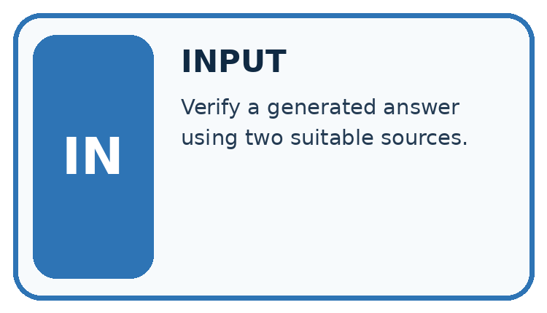
↓
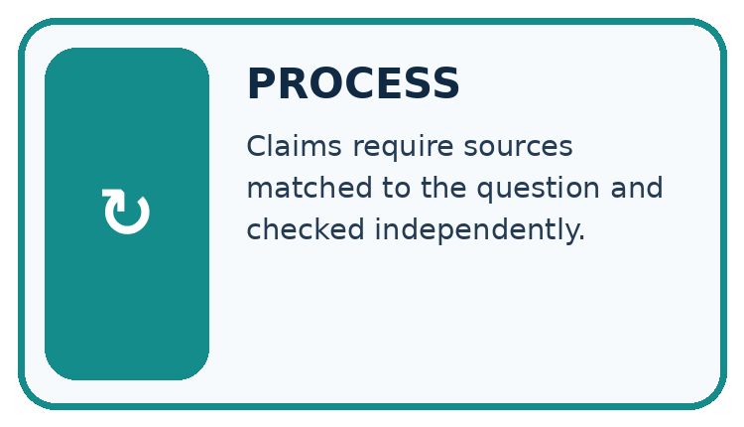
↓
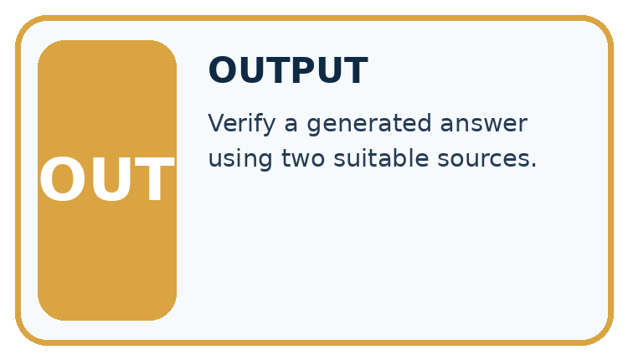
Which stage could fail even when the other two are correct? Explain:

Write or draw your reasoning and evidence.
________________________________________________________________
________________________________________________________________
________________________________________________________________
________________________________________________________________
________________________________________________________________

A closer explanation
For this classroom rubric count a claim as supported only when its cited passage entails it. Separately count correct citation links. Use the number of factual claims as the support denominator.

Claim support and citation evaluation — evidence trace
Input and scope | Check or calculation | Conclusion and limit
An answer has four factual claims. Three have citations, but only two are supported by their cited passages. All links exist. | For this classroom rubric count a claim as supported only when its cited passage entails it. | Claim support is 2/4=50%; citation presence is 3/4=75%; link existence among three citations is 3/3. These measure different failures.
The figure connects this chapter's worked input, declared procedure and result. Read the complete worked reasoning for qualifiers and intermediate steps; the abbreviated labels do not replace that reasoning.
Before applying the procedure, write its units, denominator or decision boundary where relevant. A partner should be able to repeat each step using the same inputs. If a required input is absent or violates the stated contract, record that condition explicitly instead of quietly replacing it with a convenient value.

Connect the picture and the explanation
Point to the input, the deciding step and the result in this week’s visual. Explain the same step in ordinary words. A picture helps when you can say what each part represents.

04. Compare the cases
CASE GALLERY
Four Tests, Four Kinds of Evidence
A system is not understood until it survives more than one comfortable example.


NORMAL CASE: predict and name evidence. BOUNDARY CASE: predict and name evidence.


MISSING INFORMATION: predict and name evidence. TRANSFER CASE: predict and name evidence.
Which case is most likely to reveal a hidden assumption? Why?

Write or draw your reasoning and evidence.
________________________________________________________________
________________________________________________________________
________________________________________________________________
________________________________________________________________
________________________________________________________________

Change one thing in the pictured case
Change: Change the third claim to “the record does not assess suitability”.
Prediction: That statement accurately describes the supplied record’s limits.
Reason: R gives pages and shelf only; it contains no suitability assessment.

05. Words that unlock the idea
VOCABULARY LAB
Words You Can Use to Reason
A definition matters when you can recognize the idea, use it, and contrast it with a near-miss.
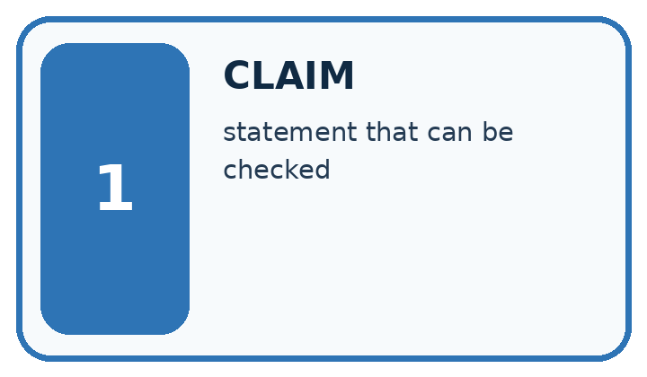
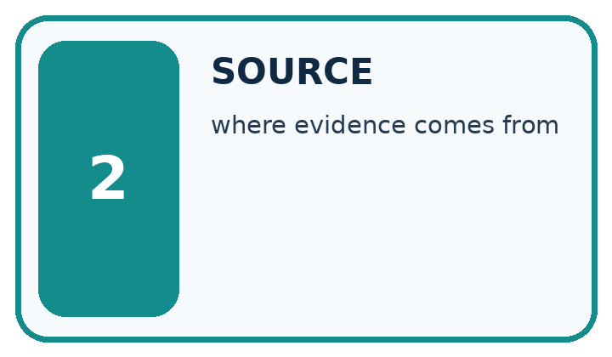
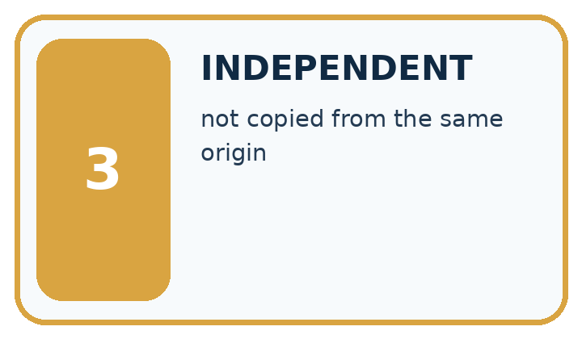
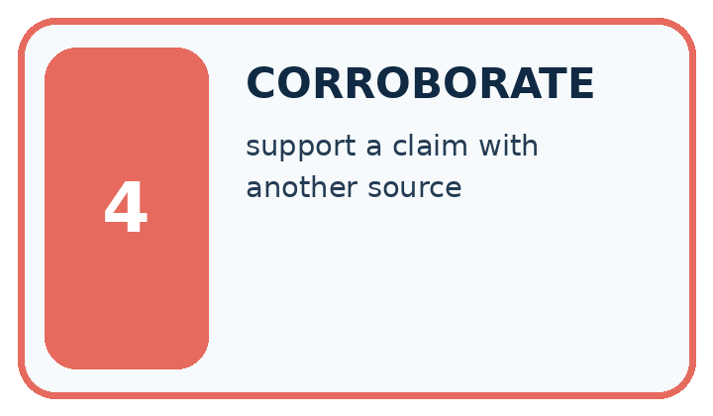
Word | My own example | Not this / boundary
claim | A statement that can be examined using evidence and reasoning.
source | The record, person or material from which information is obtained.
independent | Produced or assessed without the specific influence being excluded; state whether this means uncoached work or separate test data.
corroborate | Support a claim with additional relevant evidence, ideally independent of the first source.

Words used in the closer explanation
Word | Meaning
Entailment | Whether the cited passage supports the specific claim
Citation coverage | Which claims include source references
Link validity | Whether a source reference resolves to the intended record

06. Follow a worked example
WORKED EVIDENCE
Reason Step by Step
Predict first. Then check each step. A correct answer without visible reasoning is incomplete evidence.
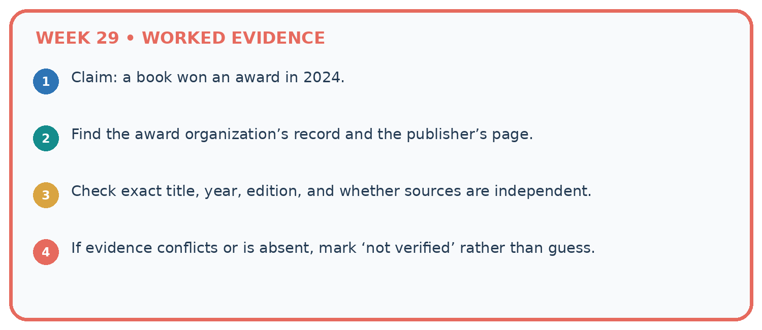
1. Claim: a book won an award in 2024.
2. Find the award organization’s record and the publisher’s page.
3. Check exact title, year, edition, and whether sources are independent.
4. If evidence conflicts or is absent, mark ‘not verified’ rather than guess.
Recalculate, retrace, or restate the reasoning in your own representation:

Write or draw your reasoning and evidence.
________________________________________________________________
________________________________________________________________
________________________________________________________________
________________________________________________________________
________________________________________________________________
CHECK Did the evidence answer the exact question? Did the total, path, or source record stay consistent?

A closer explanation
An answer has four factual claims. Three have citations, but only two are supported by their cited passages. All links exist.
Claim support is 2/4=50%; citation presence is 3/4=75%; link existence among three citations is 3/3. These measure different failures.
Compare the intermediate evidence with the final statement. Explain why each number or decision follows from the stated inputs. The conclusion belongs to this scenario and procedure; changing the inputs, evaluation population or authority can change what it establishes. Retain the raw record so a later revision can be compared honestly.

Learn from the worked case
Cover the result before checking it. Say what is given, choose the procedure, and follow one step at a time. Then uncover the result and explain your first mismatch. Ask why a step is allowed, not only what number it produces.

A pictorial worked case: Evidence and Sources
A fictional catalogue answer contains three factual statements and cites existing records.

The facts we will use
Record R: book Ocean Maps has 80 pages and is available on shelf 2.
Claims: 80 pages [R]; shelf 2 [R]; suitable for every child [R]. All three citations resolve to R.
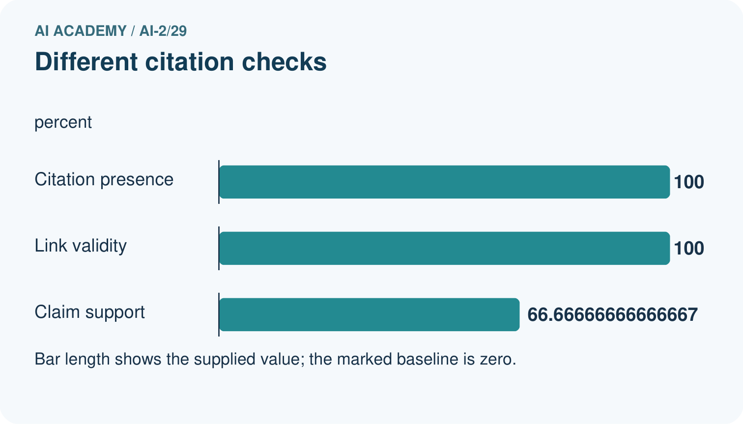
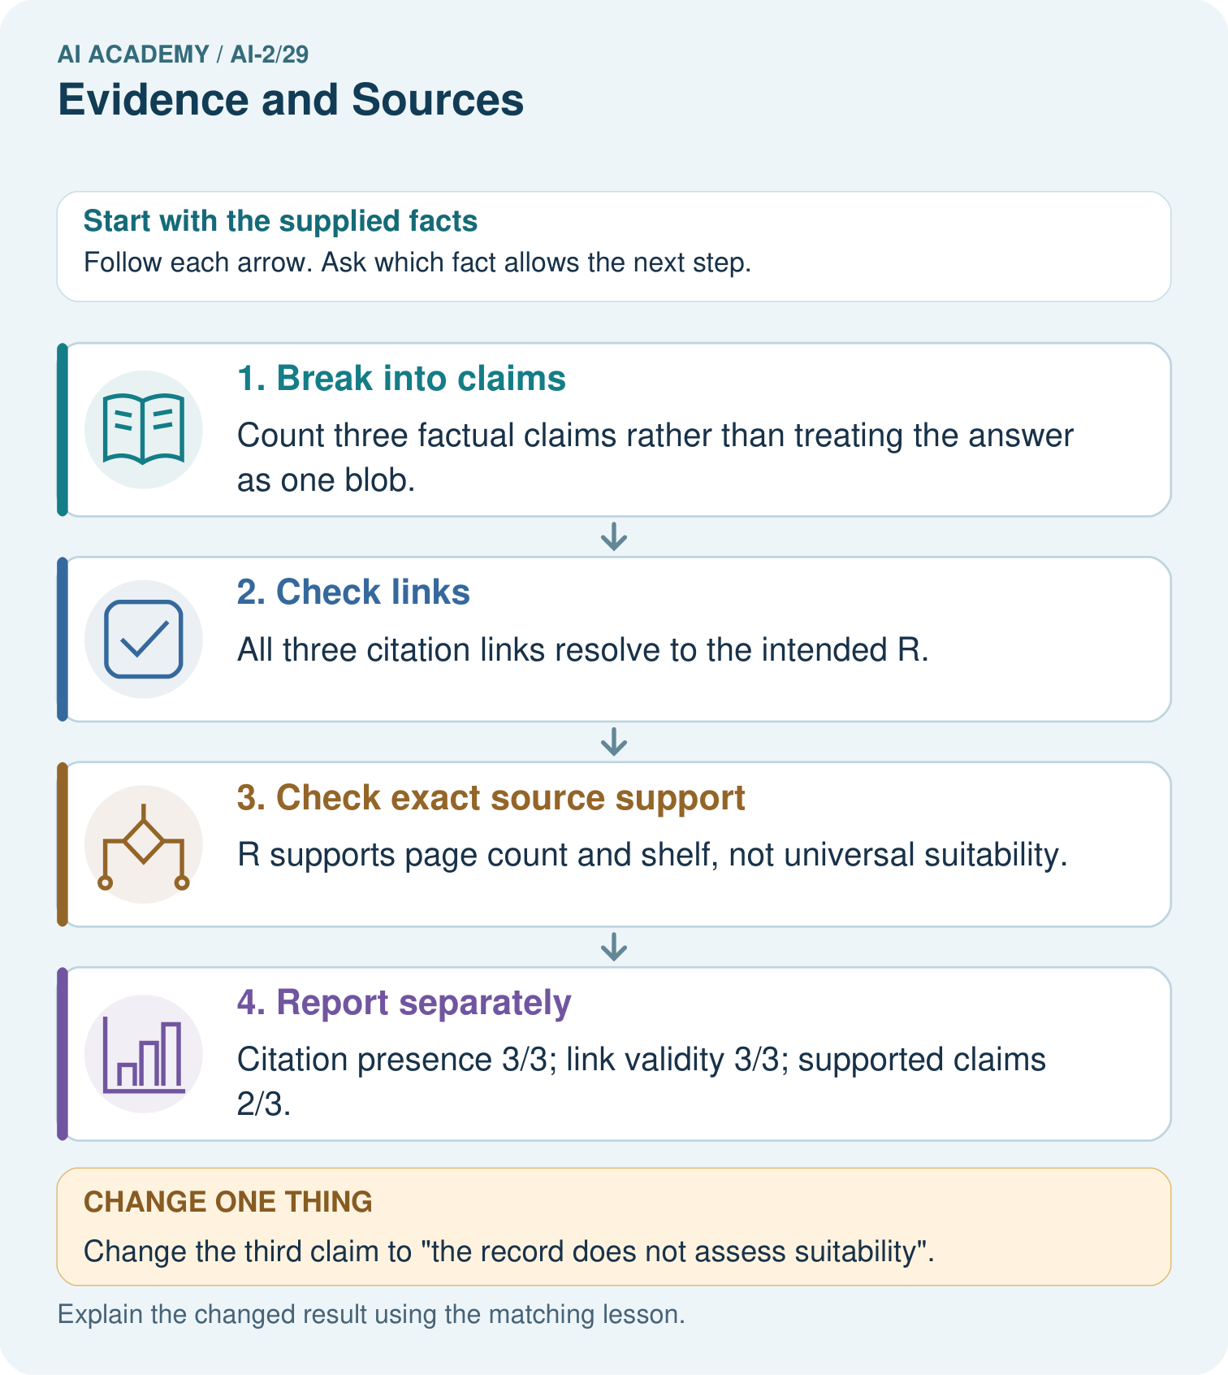

Read the picture one step at a time
Step | What happens and why
1. Break into claims | Count three factual claims rather than treating the answer as one blob.
2. Check links | All three citation links resolve to the intended R.
3. Check exact source support | R supports page count and shelf, not universal suitability.
4. Report separately | Citation presence 3/3; link validity 3/3; supported claims 2/3.
Match each pictured step to the supplied facts. This is a worked teaching case, not an independent assessment.

Why this result follows
An existing citation is not automatically evidence for every nearby sentence. Read the cited passage and compare its exact scope with the claim. The universal suitability statement extends beyond what R says. Remove or qualify unsupported content; adding more copies of the same link does not create the missing evidence.

What this example does not establish
Source support is relative to supplied records; those records can themselves be incomplete, outdated or incorrect.
Read the labelled picture: Why is the original answer not fully supported despite having citations on every claim?
Change one thing: Change the third claim to “the record does not assess suitability”. Predict the result before checking the explanation. What remains the same?

07. Find and repair a mistake
ERROR DETECTIVE
Compare → Diagnose → Repair
Do not patch the answer. Find the earliest unsupported assumption, wrong step, or weak evidence.
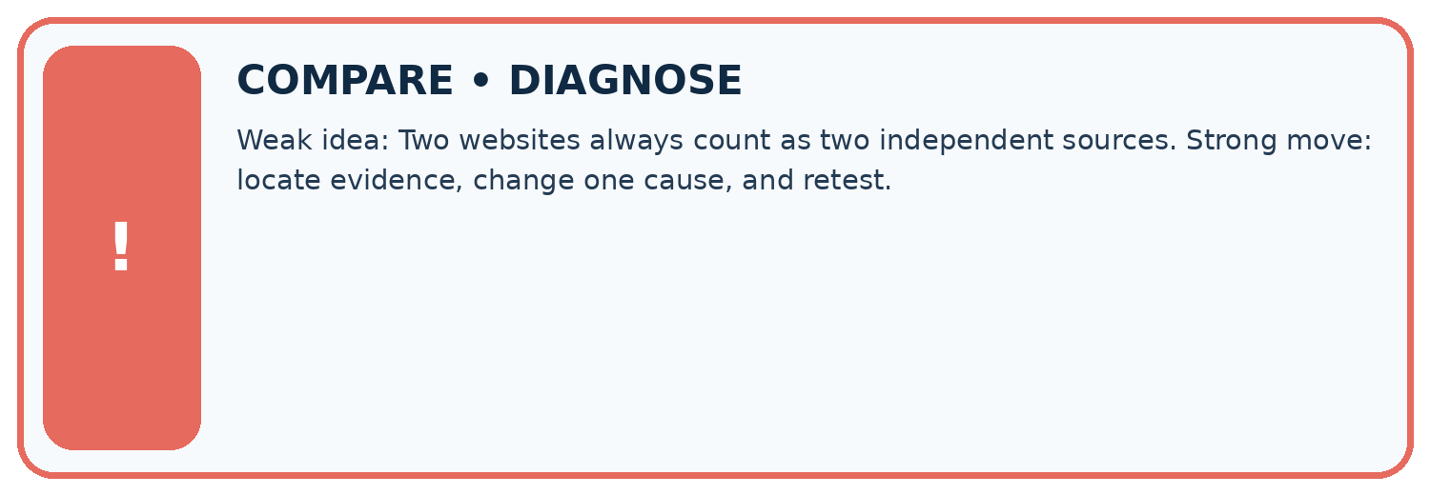
Evidence record | Expected | Actual | Likely cause / next test
normal case | works
boundary case | stated rule
missing input | safe response
fresh transfer | generalizes
Repair one cause. Why is this repair better than changing several things?

Write or draw your reasoning and evidence.
________________________________________________________________
________________________________________________________________
________________________________________________________________
________________________________________________________________
________________________________________________________________

A closer explanation
Complete the supported workbook tasks before attempting W4 independently. Record any hints or help used. After feedback, use the teacher's fresh retry rather than copying the earlier answer. For a project, select a relevant new case, predict the outcome from the declared rule and preserve the result alongside any revision.

Exit: propose one revealing change to the worked scenario. State the expected outcome and the evidence that would make you revise your explanation.
________________________________________________________________
________________________________________________________________
________________________________________________________________
________________________________________________________________
________________________________________________________________

08. Practise together
LOGIC STUDIO
Trace Before You Run
Block code, pseudocode, tables, and diagrams are different ways to expose the same reasoning.

SET evidence_record
PREDICT expected_result
RUN one normal case and one boundary case
COMPARE actual_result with expected_result
IF different: locate first cause; change one factor; RETEST
EXPLAIN result, limitation, and next safe step
Trace one input. Which line changes the state or chooses a path?

Write or draw your reasoning and evidence.
________________________________________________________________
________________________________________________________________
________________________________________________________________
________________________________________________________________
________________________________________________________________

A closer explanation
Citation counts do not establish truth beyond the supplied sources or the correctness of uncited claims.
A useful check asks what would make the reasoning fail. Distinguish a failure to execute the declared procedure from a weakness in the procedure itself. The first may require a correction; the second requires an explicitly revised method and new evidence. Preserve unsuccessful cases so an improved result cannot hide the original problem.

Guided: restate the worked result, then name the assumption or limitation that prevents a broader conclusion.
________________________________________________________________
________________________________________________________________
________________________________________________________________
________________________________________________________________
________________________________________________________________

Practise with less help: Trace the worked case
Use workbook W2 for the connected example “Claim support and citation evaluation”. First fill the input and rule boxes. Try the middle steps before asking for a hint. After a hint, try the next step yourself.
Plan | Do | Check
What is given? Which rule or procedure applies? | Record each intermediate step. | Does the result follow? What remains unknown?
Explain your trace to a partner. Your partner points to one step to check. Swap roles on the next case. Each person writes their own explanation.

Check your reasoning
Use the worked case for Claim support and citation evaluation. Proposed explanation: “The worked result establishes every future case”. Decide whether this explanation is supported. Point to the step or supplied fact that decides; explain your repair if needed.
Answer on your own before discussion. If you are unsure, say which step you need help with.

Explain the picture
Why is the original answer not fully supported despite having citations on every claim?

My explanation using a pictured step and the given facts
________________________________________________________________
________________________________________________________________
________________________________________________________________
________________________________________________________________
This is supported practice. Keep the separately named independent case for an attempt before feedback.

09. Run the investigation
EVIDENCE LAB
Predict → Test → Record → Explain
Keep expected and actual results separate. Surprises are useful data when recorded honestly.
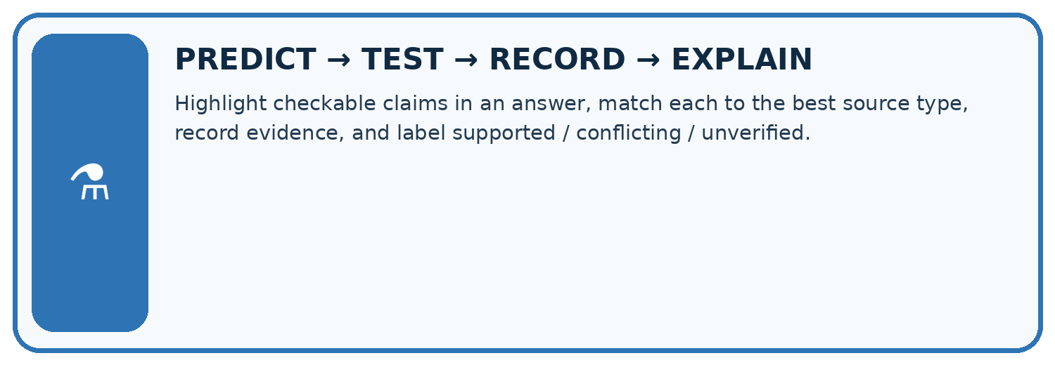
Highlight checkable claims in an answer, match each to the best source type, record evidence, and label supported / conflicting / unverified.
Test / input | Prediction | Actual | Evidence / calculation | Change or keep?
normal
boundary
missing
fresh transfer
What did the hardest test teach you that the normal test did not?

Write or draw your reasoning and evidence.
________________________________________________________________
________________________________________________________________
________________________________________________________________
________________________________________________________________
________________________________________________________________

Plan → try → check
Before trying: what do I expect, and why? While trying: which step could first go wrong? Afterwards: what did I actually observe, and what should change? Keep “not run” if you only traced the procedure.

10. Build your understanding
MASTERY
From Knowing the Word to Owning the Idea
Move upward only when you can produce evidence without copying the worked example.

1 • NAME: Define the concept without repeating the textbook.
2 • TRACE: Show the information, state, branch, calculation, or evidence path.
3 • APPLY: Solve a different example independently.
4 • CHALLENGE: Find a boundary case, counterexample, or unfair outcome.
5 • EXPLAIN LIMITS: Say when the result should not be trusted or used alone.
My strongest evidence of independent understanding:

Write or draw your reasoning and evidence.
________________________________________________________________
________________________________________________________________
________________________________________________________________
________________________________________________________________
________________________________________________________________

11. Connect your project
CUMULATIVE PROJECT
Transparent Book Recommender
Every week adds one inspectable piece. The system must show how it reached a result.
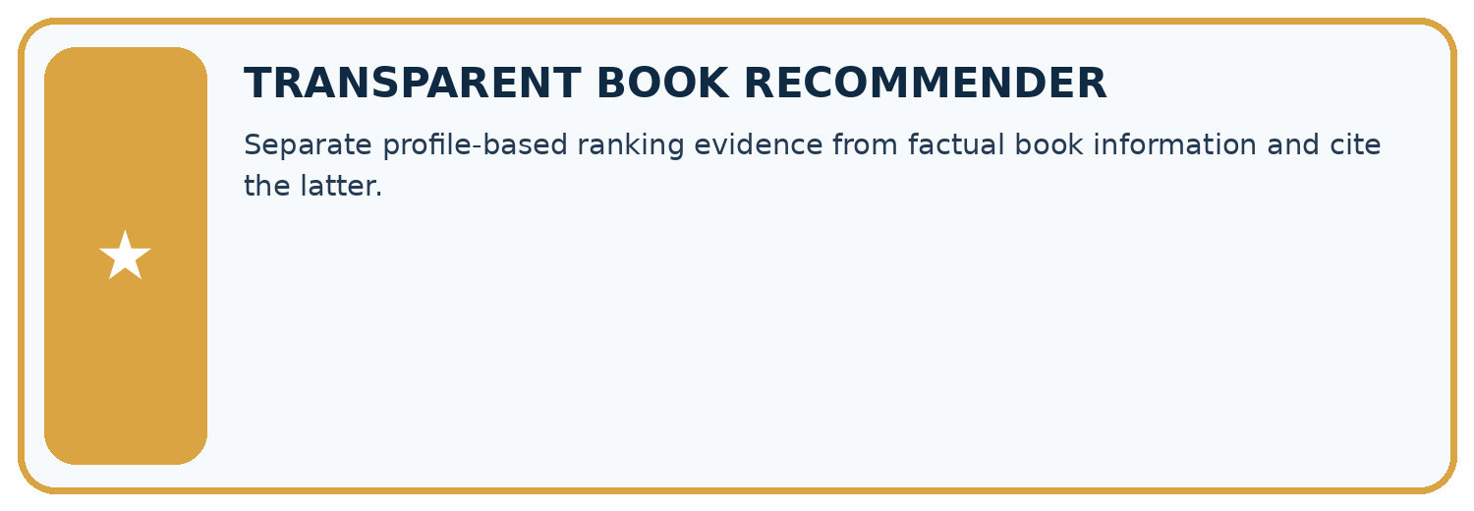
THIS WEEK’S CHECKPOINT Separate profile-based ranking evidence from factual book information and cite the latter.
SYSTEM MAP Reader need → allowed inputs → transparent rule or score → ranked candidates → explanation → test record → human decision
What will you add, change, or verify in the project this week?

Write or draw your reasoning and evidence.
________________________________________________________________
________________________________________________________________
________________________________________________________________
________________________________________________________________
________________________________________________________________
What should remain under human control?

Write or draw your reasoning and evidence.
________________________________________________________________
________________________________________________________________
________________________________________________________________
________________________________________________________________
________________________________________________________________
RESPONSIBLE DESIGN Collect only necessary information. Show uncertainty and limits. Never confuse a ranking with a fact about a person.

Evidence for your project
Attach source IDs to recommender explanation facts and separately audit whether each source supports its precise statement.

12. Show what you know
INDEPENDENT MASTERY PROOF
Explain • Transfer • Test • Defend
Complete this page without copying the worked example. Your reasoning matters more than decoration.
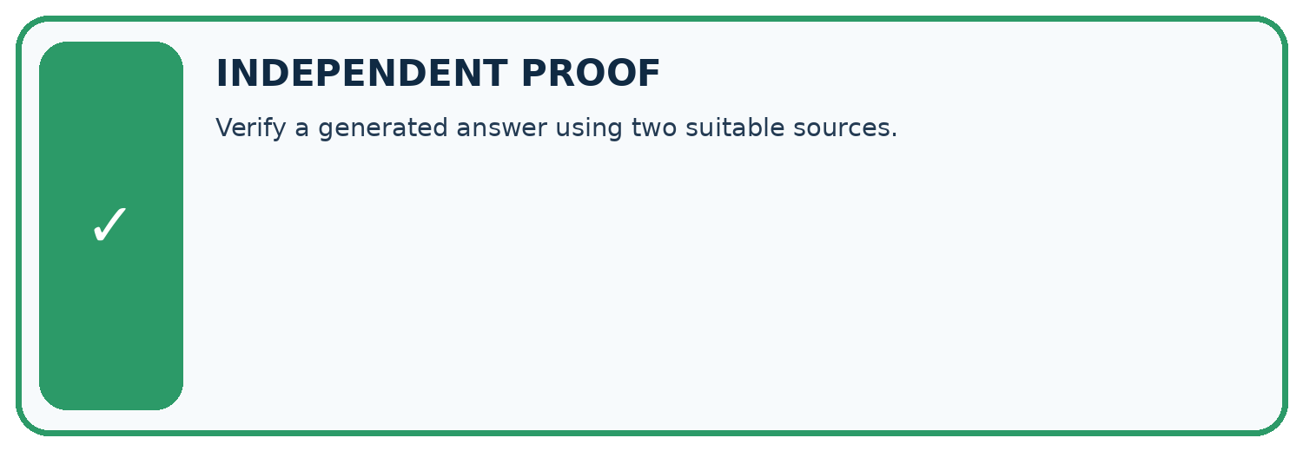
CHALLENGE Verify a generated answer using two suitable sources.
1. My fresh example, trace, calculation, or design:

Write or draw your reasoning and evidence.
________________________________________________________________
________________________________________________________________
________________________________________________________________
________________________________________________________________
________________________________________________________________
2. My evidence that it works (include a boundary or missing-data case):

Write or draw your reasoning and evidence.
________________________________________________________________
________________________________________________________________
________________________________________________________________
________________________________________________________________
________________________________________________________________
3. One limitation, fairness concern, or situation needing human review:

Write or draw your reasoning and evidence.
________________________________________________________________
________________________________________________________________
________________________________________________________________
________________________________________________________________
________________________________________________________________
SELF-CHECK □ I explained the mechanism □ I used evidence □ I tested a fresh case □ I named a limitation □ I can answer ‘why?’

13. Study a complete case

Week 29 Worked case
Use the supplied details to practise the weekly concept before attempting the independent question. This case extends the illustrated lesson.

The situation
An answer says 80 pages, but the catalogue for that edition says 120.

The question
What evidence guides correction?

Worked explanation
Check the exact edition and authoritative catalogue record. Record the supporting source.

Explain it in your own words
Which detail supports the answer, and why does it matter?

Write or draw your reasoning and evidence.
________________________________________________________________
________________________________________________________________
________________________________________________________________
________________________________________________________________
________________________________________________________________

Trace the supplied case visually

Check the claim against the exact edition
Evidence or stage | Value or result
Answer | 80 pages
Catalogue | 120 pages for this edition
Resolution | Verify edition and cite the correct record
An answer says 80 pages, but the catalogue for that edition says 120.
What evidence guides correction?
Check the exact edition and authoritative catalogue record. Record the supporting source.

14. Try a new case independently

Independent case: Apply a new case independently
Five claims; four cited; three supported by cited passages; one cited ID is nonexistent. Compute support and citation presence and explain link limits.

My independent explanation, trace and limits
________________________________________________________________
________________________________________________________________
________________________________________________________________
________________________________________________________________
________________________________________________________________
________________________________________________________________
________________________________________________________________
Attempt this case before feedback. Record any help. Earlier examples below are further practice; a case already practised with feedback cannot establish fresh transfer.

Week 29 Independent application
Close the worked explanation. Apply the idea to this different question without copying.
An answer cites a page about opening hours to support a claim about book prices. Is a citation enough? What must be checked?
My answer, with a trace, calculation or supporting evidence

Write or draw your reasoning and evidence.
________________________________________________________________
________________________________________________________________
________________________________________________________________
________________________________________________________________
________________________________________________________________

Create and test
Change one relevant detail. Predict the result before testing. Include a boundary or missing-information case when it helps reveal a limit.
My changed input and expected result

Write or draw your reasoning and evidence.
________________________________________________________________
________________________________________________________________
________________________________________________________________
________________________________________________________________
________________________________________________________________

Connect to your project
Separate profile-based ranking evidence from factual book information and cite the latter.
The evidence I will keep

Write or draw your reasoning and evidence.
________________________________________________________________
________________________________________________________________
________________________________________________________________
________________________________________________________________
________________________________________________________________
Your teacher has the independent answer and scoring criteria. Complete the matching workbook week to keep your practice evidence together.

Transfer practice from the original programme
Two catalogue records list 96 and 112 pages for a title. A helper averages them and reports 104. Explain the mistake and a better verification process.

Explain the mechanism, evidence and one limit.
________________________________________________________________
________________________________________________________________
________________________________________________________________
________________________________________________________________
________________________________________________________________
________________________________________________________________
________________________________________________________________

Use feedback to improve
Attempt the independent case before hints. Record whether you worked alone, used a hint or followed a model. After feedback, fix the first unsupported step and explain why it changed. A later check uses a changed case, not a copied answer.

15. Your lesson route
Start with this question: A fictional catalogue answer contains three factual statements and cites existing records.
By the end, I can | How I will show it
Explain the mechanism and terminology of claim support and citation evaluation | Explain the deciding step, show a trace or test, and state one limit.
Apply the stated procedure to a new case with a traceable result | Explain the deciding step, show a trace or test, and state one limit.
Identify an assumption or limitation and design a revealing follow-up | Explain the deciding step, show a trace or test, and state one limit.
Remember → watch and explain → try with help → investigate → try independently → keep project evidence. Your teacher may spread this lesson across several classes.
Keep your first prediction. Compare it with what the evidence shows and explain any change.

16. Finish and return
Close your notes. Explain this goal in your own words: Explain the mechanism and terminology of claim support and citation evaluation

My deciding step, evidence and one remaining question
________________________________________________________________
________________________________________________________________
________________________________________________________________
________________________________________________________________
________________________________________________________________
If you are unsure, return to the worked picture and explain one arrow. If you are ready, change an input or assumption and justify your prediction.
Save your workbook evidence. At the next review, try a different case before opening your old answer.

17. Supported practice, repair and portfolio
Use this supported practice once, in the browser or on paper. Keep the reserved independent assessment for a separate first attempt before teacher feedback.
A fictional catalogue answer contains three factual statements and cites existing records.

Practice 1: explain the deciding evidence
Which labelled step matches this detail? Citation presence 3/3; link validity 3/3; supported claims 2/3.
1. Check exact source support
2. Check links
3. Report separately
4. Break into claims

My selected conclusion, deciding fact and explanation
________________________________________________________________
________________________________________________________________
________________________________________________________________
________________________________________________________________
________________________________________________________________
Hint if needed: Read the steps in the pictorial case. Match the supplied detail to the stage that performs or records it.
After your attempt, compare with the supported explanation: Report separately Citation presence 3/3; link validity 3/3; supported claims 2/3. An existing citation is not automatically evidence for every nearby sentence. Read the cited passage and compare its exact scope with the claim. The universal suitability statement extends beyond what R says. Remove or qualify unsupported content; adding more copies of the same link does not create the missing evidence.

Practice 2: explain the deciding evidence
Changed-case practice: Change the third claim to “the record does not assess suitability”. Which conclusion is supported by the supplied facts?
1. That statement accurately describes the supplied record’s limits.
2. This one example guarantees correct results for every future input.
3. We can decide the result without examining the changed input or the procedure.

My selected conclusion, deciding fact and explanation
________________________________________________________________
________________________________________________________________
________________________________________________________________
________________________________________________________________
________________________________________________________________
Hint if needed: Use the changed condition and the deciding step in the pictorial trace. The answer must say what follows from those facts.
After your attempt, compare with the supported explanation: That statement accurately describes the supplied record’s limits. R gives pages and shelf only; it contains no suitability assessment.

Repair a missing building block
Review Prompt Experiments (ai-2/28). Goal: Explain the mechanism and terminology of controlled prompt experiments. Short practice: Name the case P passes and Q fails, and explain why it matters.. Return to this week and explain what you changed.
Review Image and Voice Pipelines (ai-2/26). Goal: Explain the mechanism and terminology of speech pipelines and multimodal evidence. Short practice: Which stage first fails, and why should the faulty transcript not be silently overwritten?. Return to this week and explain what you changed.
Review Recommendation Scores (ai-2/23). Goal: Compute a weighted score. Short practice: Why does B not become the winner when its score is largest?. Return to this week and explain what you changed.

Keep your completed work
Use Download completed work in the hosted lesson to export your answers, reflections, practice feedback and code-run evidence. Open the HTML copy to read or print it. Drafts stay in this browser when storage is available; clear drafts on a shared device.

