AI ACADEMY · STUDENT · ai-2/33

Build the Recommender
Project: Transparent Book Recommender

Before you start
Week 23: score only candidates satisfying hard constraints.

01. Your mission

Your learning target
I can implement a deterministic recommender.
I can handle ties and no eligible options.
I can explain recommendations with their limits.

Remember before reading
Close your notes first. A rough first answer helps us choose the right starting point; it is not a score for your ability.
Without opening the old lesson, explain one key idea from Project Problem and Success Test. Give an example and a mistake that the idea helps you avoid.
Without opening the old lesson, explain one key idea from Agents and Tools. Give an example and a mistake that the idea helps you avoid.
Without opening the old lesson, explain one key idea from Predictive vs Generative. Give an example and a mistake that the idea helps you avoid.
After trying, check the relevant lesson or ask your teacher. Change the part of your explanation that the evidence shows was wrong.
Week 33: Build the Recommender
A transparent baseline makes later improvements understandable.

THINKER MISSION
Implement a scoring table and produce ranked outputs.
Thinker name and date:

Write or draw your reasoning and evidence.
________________________________________________________________
________________________________________________________________
________________________________________________________________
________________________________________________________________
________________________________________________________________

Readiness for the connected explanation
An option violates a hard duration limit but has the best score. Should it win?

Readiness for Building the data pipeline
What are the steps between raw records and a recommendation?

My readiness explanation
________________________________________________________________
________________________________________________________________
________________________________________________________________

This week’s end goal
By the end, I can implement deterministic filtering, scoring and ties for a complete catalogue case.

02. Notice the evidence
PICTURE STORY
Notice → Predict → Explain
Begin with visible evidence. Do not explain more than the picture and information support.
MYSTERY
The learners must use build the recommender to solve a problem. What information do they have? What decision or calculation do they make? What would count as evidence that it worked?
Three observations (what you can point to):

Write or draw your reasoning and evidence.
________________________________________________________________
________________________________________________________________
________________________________________________________________
________________________________________________________________
________________________________________________________________
My prediction and the clue supporting it:

Write or draw your reasoning and evidence.
________________________________________________________________
________________________________________________________________
________________________________________________________________
________________________________________________________________
________________________________________________________________

A closer explanation
Build a fictional activity recommender using last week's score. Require duration at most a supplied limit. On a tie choose the alphabetically first name. This makes the outcome reproducible rather than dependent on input order. Assume unique names and validated numeric fields.

Apply the connected idea: Building the data pipeline
Build the validation stage of the planned chooser first. A valid record has nonempty text name, integer minutes 0 through 60 and integer fun and learning ratings 0 through 5. The batch stage must separately check name uniqueness. Only accepted records may reach the Week 24 selection function.

03. See how it works
VISUAL MECHANISM
Input → Process → Output
Trace the information. At each stage, ask what changed and how you could test it.
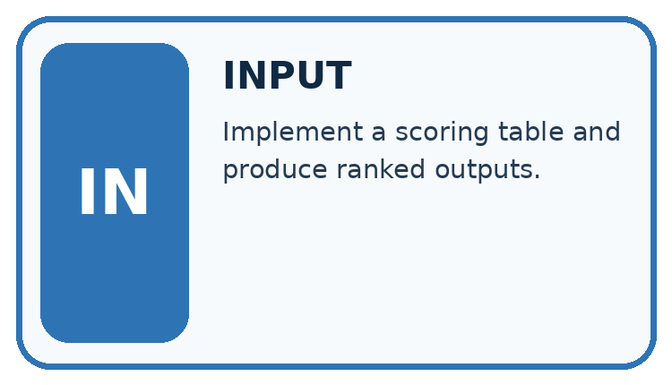
↓
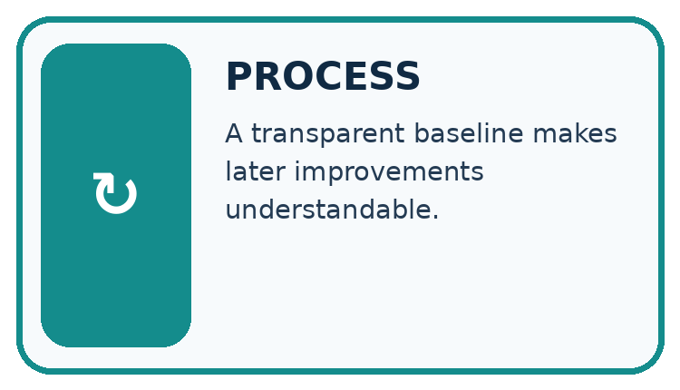
↓
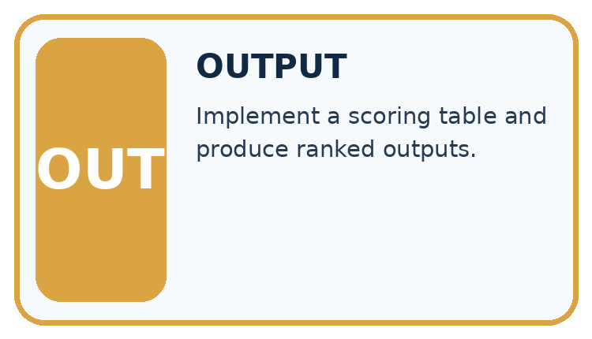
Which stage could fail even when the other two are correct? Explain:

Write or draw your reasoning and evidence.
________________________________________________________________
________________________________________________________________
________________________________________________________________
________________________________________________________________
________________________________________________________________

A closer explanation
def recommend(items, limit):
best = None
best_score = None
for item in items:
if item["minutes"] <= limit:
score = 2 * item["fun"] + item["learning"]
if (best is None or score > best_score
or (score == best_score and item["name"] < best)):
best = item["name"]
best_score = score
return best
items = [{"name": "B", "fun": 3, "learning": 2, "minutes": 10},
{"name": "A", "fun": 2, "learning": 4, "minutes": 9}]
print(recommend(items, 10))

Follow the evidence
Step or case | Evidence | Meaning
B | Eligible score 8 | Temporary best B
A | Eligible score 8 | Alphabetical tie gives A
Read each row from left to right and connect the evidence to the stated rule.
The function prints nothing; the caller prints A. best starts as None to mean no eligible option found. Python short-circuits or: when best is None, later comparisons in that condition need not run. After selecting an item, best_score is numeric. An empty list or no eligible item returns None.

Trace the best-so-far record
Write a trace table with item, eligible, score and best-so-far. In the worked list, B qualifies and scores 8, so B becomes the current best. A also qualifies and scores 8. The scores tie, so the written alphabetical rule changes the best to A. Starting with A gives the same final answer. If no item qualifies, best stays None; do not invent a winner or quietly relax the limit.

Apply the connected idea: Building the data pipeline
def valid_item(row):
if type(row) is not dict:
return False
if type(row.get("name")) is not str or not row["name"]:
return False
for key, maximum in [("minutes", 60), ("fun", 5), ("learning", 5)]:
value = row.get(key)
if type(value) is not int or not 0 <= value <= maximum:
return False
return True
print(valid_item({"name": "A", "minutes": 20, "fun": 4, "learning": 2}))
print(valid_item({"name": "B", "minutes": 10, "fun": "4", "learning": 2}))

Follow the evidence
Step or case | Evidence | Meaning
Raw rows | Check fields and types | Accepted or rejected
Accepted rows | Check unique names | No ambiguous identifiers
Unique valid rows | Apply Week 24 selector | Suggestion plus counts
Read each row from left to right and connect the evidence to the stated rule.
The worked calls print True then False. Short-circuit checks keep absent or wrongly typed fields away from later operations. This Boolean helper does not explain the reason; add reason codes in the reporting stage or use a validation result record. Do not describe a range failure as a no-match outcome.

Trace the hand-off between stages
Think of validation and selection as two desks. At the first desk, each record is checked for required fields, exact types and allowed ranges; a batch check also checks unique names. Only accepted records go to the second desk, where the time limit and scoring policy are applied. A record can be valid yet too long to qualify. Report rejected and ineligible separately so a reader knows which decision removed an item.

Connect the picture and the explanation
Point to the input, the deciding step and the result in this week’s visual. Explain the same step in ordinary words. A picture helps when you can say what each part represents.

04. Compare the cases
CASE GALLERY
Four Tests, Four Kinds of Evidence
A system is not understood until it survives more than one comfortable example.


NORMAL CASE: predict and name evidence. BOUNDARY CASE: predict and name evidence.


MISSING INFORMATION: predict and name evidence. TRANSFER CASE: predict and name evidence.
Which case is most likely to reveal a hidden assumption? Why?

Write or draw your reasoning and evidence.
________________________________________________________________
________________________________________________________________
________________________________________________________________
________________________________________________________________
________________________________________________________________

Change one thing in the pictured case
Change: Change D’s pages to 91, leaving every other field unchanged.
Prediction: D becomes ineligible, so A wins with score 2.
Reason: The strict excess over the 90-page maximum changes filtering before ranking.

05. Words that unlock the idea
VOCABULARY LAB
Words You Can Use to Reason
A definition matters when you can recognize the idea, use it, and contrast it with a near-miss.
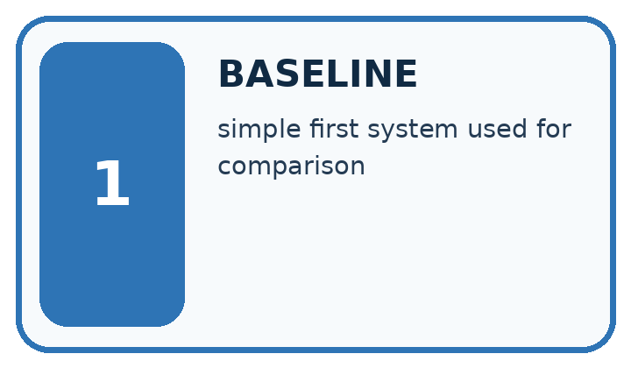
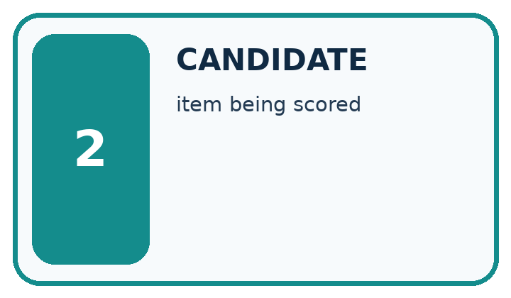
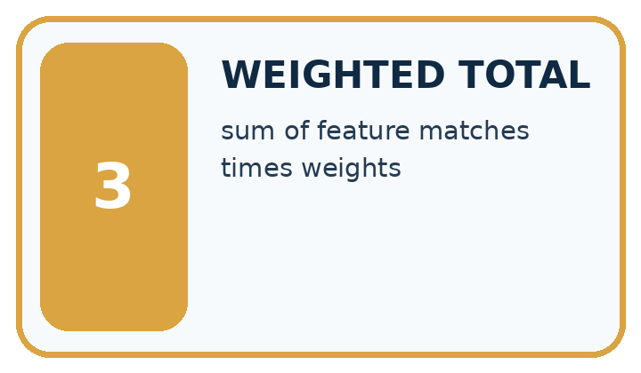
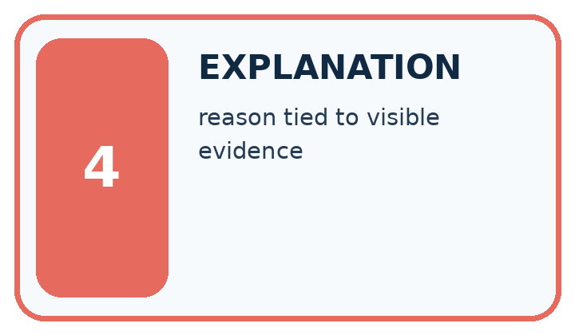
Word | My own example | Not this / boundary
baseline | A simple reference method used to judge whether a more complex method adds value.
candidate | An item or proposed answer being considered before a final selection.
weighted total | A sum formed after multiplying each contribution by its assigned weight.
explanation | An account connecting a result to the mechanism, calculation or evidence that supports it.

Words used in the closer explanation
Word | Meaning
Recommender | A procedure that suggests options using a stated policy
Tie | Two options have the same comparison score
Deterministic | The same inputs and rules produce the same result

Terms for Building the data pipeline
Term | Meaning
Stage | One part of a processing pipeline
Validation function | A function that decides whether an input meets a schema
Separation of concerns | Keeping different responsibilities in distinct parts
Rejection reason | An explanation of why a record was not accepted

06. Follow a worked example
WORKED EVIDENCE
Reason Step by Step
Predict first. Then check each step. A correct answer without visible reasoning is incomplete evidence.
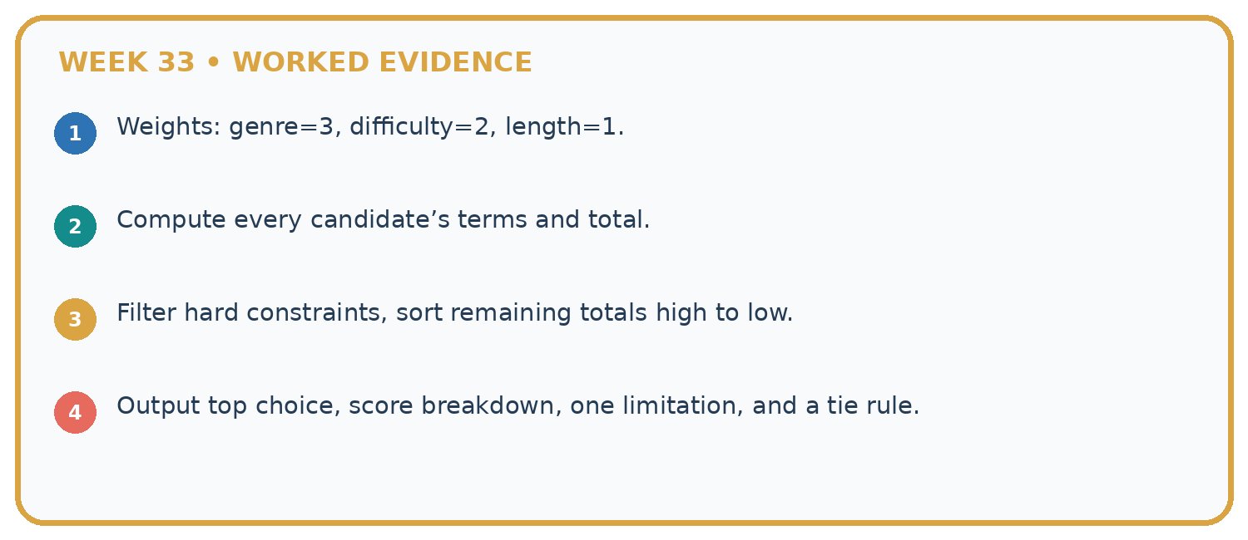
1. Weights: genre=3, difficulty=2, length=1.
2. Compute every candidate’s terms and total.
3. Filter hard constraints, sort remaining totals high to low.
4. Output top choice, score breakdown, one limitation, and a tie rule.
Recalculate, retrace, or restate the reasoning in your own representation:

Write or draw your reasoning and evidence.
________________________________________________________________
________________________________________________________________
________________________________________________________________
________________________________________________________________
________________________________________________________________
CHECK Did the evidence answer the exact question? Did the total, path, or source record stay consistent?

A closer explanation

Predict the result if the list order is reversed, and if the limit is 8.
________________________________________________________________
________________________________________________________________
________________________________________________________________
________________________________________________________________
________________________________________________________________
________________________________________________________________

Apply the connected idea: Building the data pipeline

Predict validity for minutes 0, fun 0, learning 5 with name A, then for minutes 61.
________________________________________________________________
________________________________________________________________
________________________________________________________________
________________________________________________________________
________________________________________________________________
________________________________________________________________

Learn from the worked case
Cover the result before checking it. Say what is given, choose the procedure, and follow one step at a time. Then uncover the result and explain your first mismatch. Ask why a step is allowed, not only what number it produces.

A pictorial worked case: Build the Recommender
A fictional book chooser filters a request before comparing preference scores.

The facts we will use
Request: animal subject, at most 90 pages. Score 2 for illustrated and 1 for comic. Tie chooses smaller ID.
A animal90 illustrated prose; B animal70 plain comic; C space60 illustrated comic; D animal80 illustrated comic.
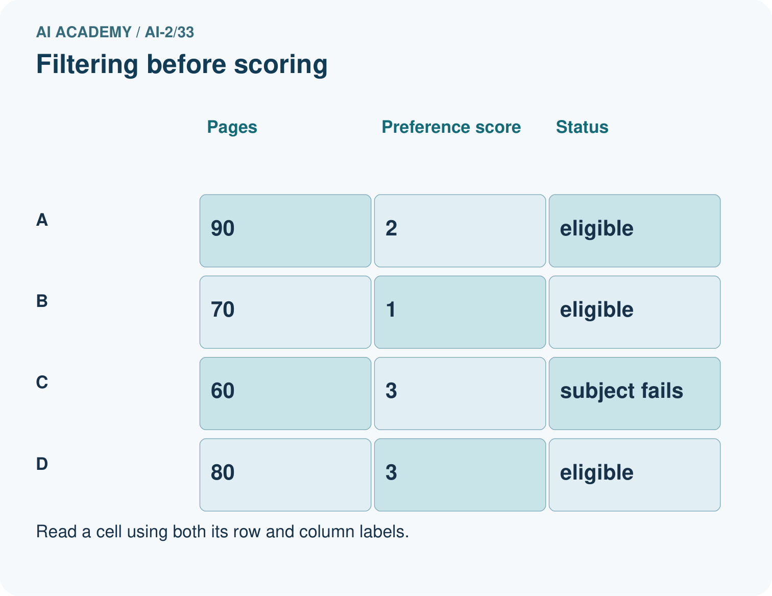
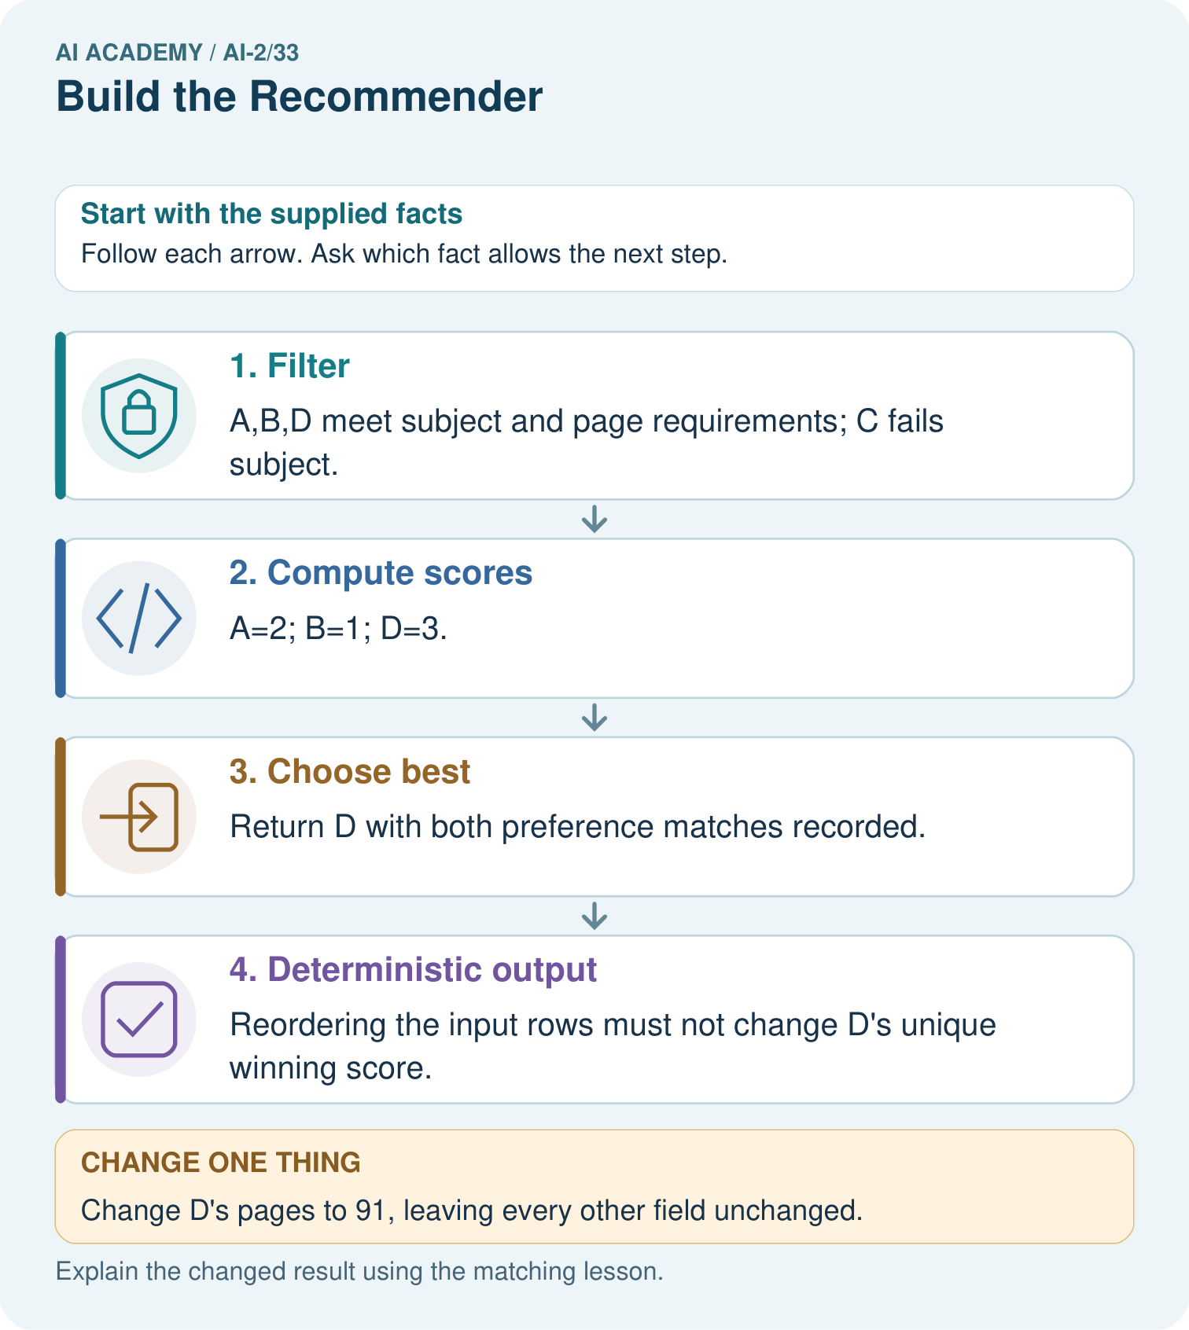

Read the picture one step at a time
Step | What happens and why
1. Filter | A,B,D meet subject and page requirements; C fails subject.
2. Compute scores | A=2; B=1; D=3.
3. Choose best | Return D with both preference matches recorded.
4. Deterministic output | Reordering the input rows must not change D’s unique winning score.
Match each pictured step to the supplied facts. This is a worked teaching case, not an independent assessment.

Why this result follows
Eligibility and ranking answer different questions. C has a high preference score but is not an animal book, so it must stay excluded. The implementation needs a no-match result and explicit tie policy even when this example has a unique winner. Save rejected reasons for an explanation, not just the final ID.

What this example does not establish
Toy preference weights do not imply shorter or illustrated books are universally better for all learners.
Read the labelled picture: Explain why B does not win after D is excluded even though it has fewer pages.
Change one thing: Change D’s pages to 91, leaving every other field unchanged. Predict the result before checking the explanation. What remains the same?

07. Find and repair a mistake
ERROR DETECTIVE
Compare → Diagnose → Repair
Do not patch the answer. Find the earliest unsupported assumption, wrong step, or weak evidence.
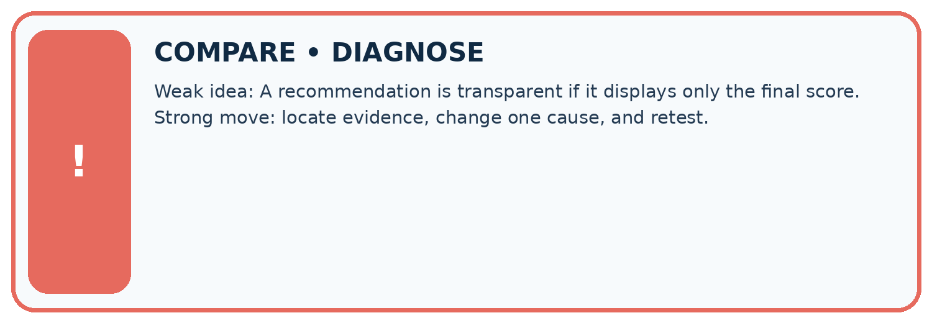
Evidence record | Expected | Actual | Likely cause / next test
normal case | works
boundary case | stated rule
missing input | safe response
fresh transfer | generalizes
Repair one cause. Why is this repair better than changing several things?

Write or draw your reasoning and evidence.
________________________________________________________________
________________________________________________________________
________________________________________________________________
________________________________________________________________
________________________________________________________________

A closer explanation
The recommendation follows a written scoring policy. It does not learn preferences, prove learning benefit or authorize an action. Display the chosen rule and let a person review whether an option is suitable.

Write a one-sentence explanation of X winning without calling it objectively best.
________________________________________________________________
________________________________________________________________
________________________________________________________________
________________________________________________________________
________________________________________________________________
________________________________________________________________

Apply the connected idea: Building the data pipeline
Each stage should have a clear input and output contract. A program can be correct at one stage but wrong at their connection, such as passing rejected rows into selection. Keep acceptance and rejection counts in the report.

Two valid rows have the same name but different ratings. Should individual validation alone permit selection?
________________________________________________________________
________________________________________________________________
________________________________________________________________
________________________________________________________________
________________________________________________________________
________________________________________________________________

08. Practise together
LOGIC STUDIO
Trace Before You Run
Block code, pseudocode, tables, and diagrams are different ways to expose the same reasoning.

SET evidence_record
PREDICT expected_result
RUN one normal case and one boundary case
COMPARE actual_result with expected_result
IF different: locate first cause; change one factor; RETEST
EXPLAIN result, limitation, and next safe step
Trace one input. Which line changes the state or chooses a path?

Write or draw your reasoning and evidence.
________________________________________________________________
________________________________________________________________
________________________________________________________________
________________________________________________________________
________________________________________________________________

A closer explanation
Updating best on score >= best_score makes the last tied item win, so reordering can change results. Use the explicit name comparison for ties. Test both orders and a no-match case after the repair.

Apply the connected idea: Building the data pipeline
Calling the selector on raw data can crash or produce a result from invalid ratings. Route data through validation first. Duplicate names require a batch check even when each row individually passes; block the ambiguous batch for review instead of arbitrarily keeping one.

Practise with less help: Handle no match
Use workbook W2 for the connected example “Implementing a recommender”. First fill the input and rule boxes. Try the middle steps before asking for a hint. After a hint, try the next step yourself.
Plan | Do | Check
What is given? Which rule or procedure applies? | Record each intermediate step. | Does the result follow? What remains unknown?
Explain your trace to a partner. Your partner points to one step to check. Swap roles on the next case. Each person writes their own explanation.

Check your reasoning
Use the worked case for Implementing a recommender. Proposed explanation: “A successful run proves the conclusion”. Decide whether this explanation is supported. Point to the step or supplied fact that decides; explain your repair if needed.
Answer on your own before discussion. If you are unsure, say which step you need help with.

Practise the connected topic: Building the data pipeline
Use its named workbook W2. Identify the given inputs, try the middle steps with less help, then explain your trace. Check this claim before group discussion: A successful run proves the conclusion

Explain the picture
Explain why B does not win after D is excluded even though it has fewer pages.

My explanation using a pictured step and the given facts
________________________________________________________________
________________________________________________________________
________________________________________________________________
________________________________________________________________
This is supported practice. Keep the separately named independent case for an attempt before feedback.

09. Run the investigation
EVIDENCE LAB
Predict → Test → Record → Explain
Keep expected and actual results separate. Surprises are useful data when recorded honestly.
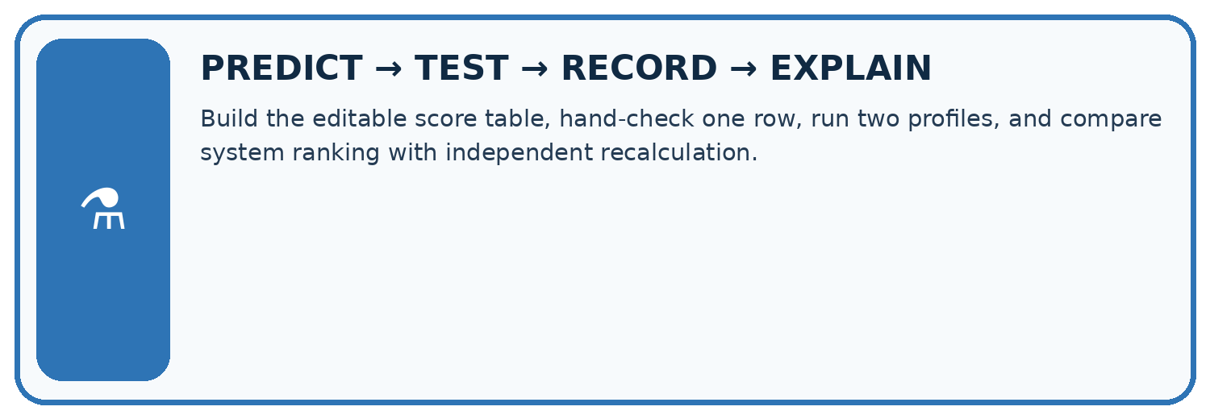
Build the editable score table, hand-check one row, run two profiles, and compare system ranking with independent recalculation.
Test / input | Prediction | Actual | Evidence / calculation | Change or keep?
normal
boundary
missing
fresh transfer
What did the hardest test teach you that the normal test did not?

Write or draw your reasoning and evidence.
________________________________________________________________
________________________________________________________________
________________________________________________________________
________________________________________________________________
________________________________________________________________

Plan → try → check
Before trying: what do I expect, and why? While trying: which step could first go wrong? Afterwards: what did I actually observe, and what should change? Keep “not run” if you only traced the procedure.

10. Build your understanding
MASTERY
From Knowing the Word to Owning the Idea
Move upward only when you can produce evidence without copying the worked example.

1 • NAME: Define the concept without repeating the textbook.
2 • TRACE: Show the information, state, branch, calculation, or evidence path.
3 • APPLY: Solve a different example independently.
4 • CHALLENGE: Find a boundary case, counterexample, or unfair outcome.
5 • EXPLAIN LIMITS: Say when the result should not be trusted or used alone.
My strongest evidence of independent understanding:

Write or draw your reasoning and evidence.
________________________________________________________________
________________________________________________________________
________________________________________________________________
________________________________________________________________
________________________________________________________________

11. Connect your project
CUMULATIVE PROJECT
Transparent Book Recommender
Every week adds one inspectable piece. The system must show how it reached a result.
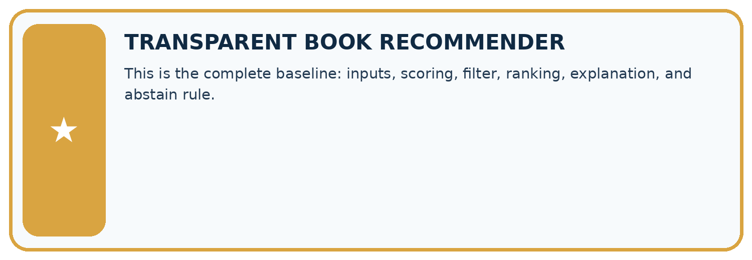
THIS WEEK’S CHECKPOINT This is the complete baseline: inputs, scoring, filter, ranking, explanation, and abstain rule.
SYSTEM MAP Reader need → allowed inputs → transparent rule or score → ranked candidates → explanation → test record → human decision
What will you add, change, or verify in the project this week?

Write or draw your reasoning and evidence.
________________________________________________________________
________________________________________________________________
________________________________________________________________
________________________________________________________________
________________________________________________________________
What should remain under human control?

Write or draw your reasoning and evidence.
________________________________________________________________
________________________________________________________________
________________________________________________________________
________________________________________________________________
________________________________________________________________
RESPONSIBLE DESIGN Collect only necessary information. Show uncertainty and limits. Never confuse a ranking with a fact about a person.

Evidence for your project
Save the recommender code, contract and this full trace; test the same records in different input orders.

12. Show what you know
INDEPENDENT MASTERY PROOF
Explain • Transfer • Test • Defend
Complete this page without copying the worked example. Your reasoning matters more than decoration.
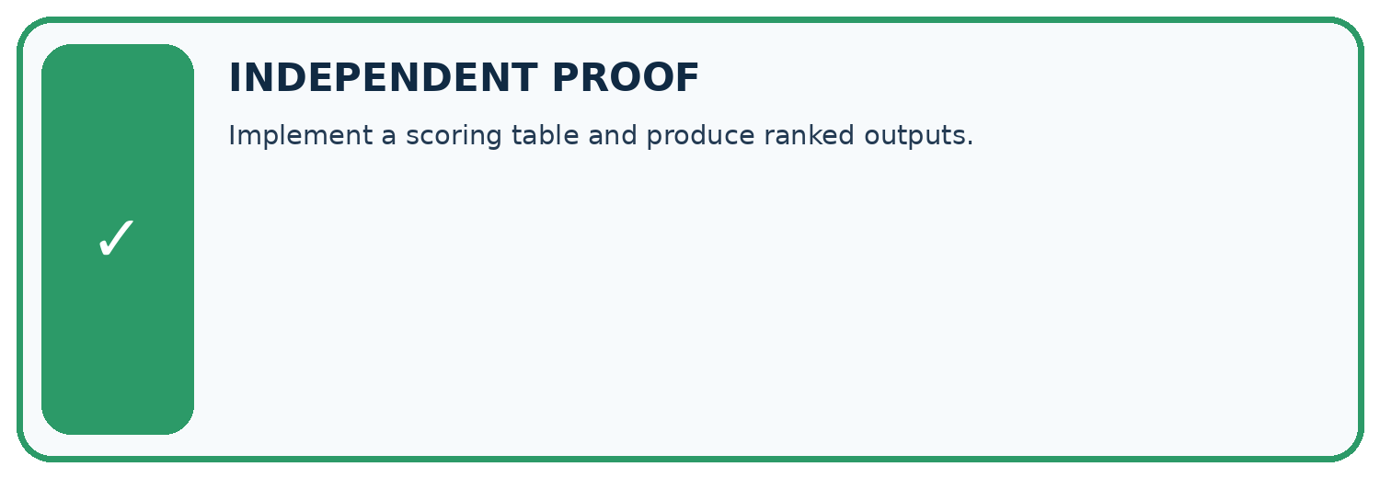
CHALLENGE Implement a scoring table and produce ranked outputs.
1. My fresh example, trace, calculation, or design:

Write or draw your reasoning and evidence.
________________________________________________________________
________________________________________________________________
________________________________________________________________
________________________________________________________________
________________________________________________________________
2. My evidence that it works (include a boundary or missing-data case):

Write or draw your reasoning and evidence.
________________________________________________________________
________________________________________________________________
________________________________________________________________
________________________________________________________________
________________________________________________________________
3. One limitation, fairness concern, or situation needing human review:

Write or draw your reasoning and evidence.
________________________________________________________________
________________________________________________________________
________________________________________________________________
________________________________________________________________
________________________________________________________________
SELF-CHECK □ I explained the mechanism □ I used evidence □ I tested a fresh case □ I named a limitation □ I can answer ‘why?’

13. Study a complete case

Week 33 Worked case
Use the supplied details to practise the weekly concept before attempting the independent question. This case extends the illustrated lesson.

The situation
A has flags (1,1), B=(1,0), C=(0,1); score=2g+l.

The question
Compute the winner and evidence to display.

Worked explanation
A wins at 3; B=2; C=1. Show flags, formula, scores and explanation; declare tie policy.

Explain it in your own words
Which detail supports the answer, and why does it matter?

Write or draw your reasoning and evidence.
________________________________________________________________
________________________________________________________________
________________________________________________________________
________________________________________________________________
________________________________________________________________

Trace the supplied case visually

Build and expose the scoring calculation
Evidence or stage | Value or result
A, genre and length | 3
B, genre only | 2
C, length only | 1
A has flags (1,1), B=(1,0), C=(0,1); score=2g+l.
Compute the winner and evidence to display.
A wins at 3; B=2; C=1. Show flags, formula, scores and explanation; declare tie policy.

14. Try a new case independently

Independent case: Changed independent case
Request: mystery, at most 100 pages. Catalogue: D mystery110 illustrated; E mystery80 plain; F science80 illustrated; G mystery95 illustrated; H mystery90 illustrated. Filter first; score 3 for mystery plus 2 for illustrations; break ties by fewer pages.

My independent explanation, trace and limits
________________________________________________________________
________________________________________________________________
________________________________________________________________
________________________________________________________________
________________________________________________________________
________________________________________________________________
________________________________________________________________
Attempt this case before feedback. Record any help. Earlier examples below are further practice; a case already practised with feedback cannot establish fresh transfer.

Week 33 Independent application
Close the worked explanation. Apply the idea to this different question without copying.
A reader requests space and at most 60 pages. Book A is space, 90 pages; B is animals, 40 pages. What should the prototype return if both conditions are required?
My answer, with a trace, calculation or supporting evidence

Write or draw your reasoning and evidence.
________________________________________________________________
________________________________________________________________
________________________________________________________________
________________________________________________________________
________________________________________________________________

Create and test
Change one relevant detail. Predict the result before testing. Include a boundary or missing-information case when it helps reveal a limit.
My changed input and expected result

Write or draw your reasoning and evidence.
________________________________________________________________
________________________________________________________________
________________________________________________________________
________________________________________________________________
________________________________________________________________

Connect to your project
This is the complete baseline: inputs, scoring, filter, ranking, explanation, and abstain rule.
The evidence I will keep

Write or draw your reasoning and evidence.
________________________________________________________________
________________________________________________________________
________________________________________________________________
________________________________________________________________
________________________________________________________________
Your teacher has the independent answer and scoring criteria. Complete the matching workbook week to keep your practice evidence together.

Transfer practice from the original programme
Catalogue: A mystery/90/illustrated, B mystery/140/not illustrated, C science/80/illustrated. Request mystery, maximum 100 pages. Rank with 2 genre points and 1 illustration point after filtering. Show why other books are excluded.

Explain the mechanism, evidence and one limit.
________________________________________________________________
________________________________________________________________
________________________________________________________________
________________________________________________________________
________________________________________________________________
________________________________________________________________
________________________________________________________________

Use feedback to improve
Attempt the independent case before hints. Record whether you worked alone, used a hint or followed a model. After feedback, fix the first unsupported step and explain why it changed. A later check uses a changed case, not a copied answer.

15. Your lesson route
Start with this question: A fictional book chooser filters a request before comparing preference scores.
By the end, I can | How I will show it
Implement a deterministic recommender | Explain the deciding step, show a trace or test, and state one limit.
Handle ties and no eligible options | Explain the deciding step, show a trace or test, and state one limit.
Explain recommendations with their limits | Explain the deciding step, show a trace or test, and state one limit.
Remember → watch and explain → try with help → investigate → try independently → keep project evidence. Your teacher may spread this lesson across several classes.
Keep your first prediction. Compare it with what the evidence shows and explain any change.

16. Finish and return
Close your notes. Explain this goal in your own words: Implement a deterministic recommender

My deciding step, evidence and one remaining question
________________________________________________________________
________________________________________________________________
________________________________________________________________
________________________________________________________________
________________________________________________________________
If you are unsure, return to the worked picture and explain one arrow. If you are ready, change an input or assumption and justify your prediction.
Save your workbook evidence. At the next review, try a different case before opening your old answer.

17. Supported practice, repair and portfolio
Use this supported practice once, in the browser or on paper. Keep the reserved independent assessment for a separate first attempt before teacher feedback.
A fictional book chooser filters a request before comparing preference scores.

Practice 1: explain the deciding evidence
Which labelled step matches this detail? Reordering the input rows must not change D’s unique winning score.
1. Choose best
2. Filter
3. Deterministic output
4. Compute scores

My selected conclusion, deciding fact and explanation
________________________________________________________________
________________________________________________________________
________________________________________________________________
________________________________________________________________
________________________________________________________________
Hint if needed: Read the steps in the pictorial case. Match the supplied detail to the stage that performs or records it.
After your attempt, compare with the supported explanation: Deterministic output Reordering the input rows must not change D’s unique winning score. Eligibility and ranking answer different questions. C has a high preference score but is not an animal book, so it must stay excluded. The implementation needs a no-match result and explicit tie policy even when this example has a unique winner. Save rejected reasons for an explanation, not just the final ID.

Practice 2: explain the deciding evidence
Changed-case practice: Change D’s pages to 91, leaving every other field unchanged. Which conclusion is supported by the supplied facts?
1. D becomes ineligible, so A wins with score 2.
2. This one example guarantees correct results for every future input.
3. We can decide the result without examining the changed input or the procedure.

My selected conclusion, deciding fact and explanation
________________________________________________________________
________________________________________________________________
________________________________________________________________
________________________________________________________________
________________________________________________________________
Hint if needed: Use the changed condition and the deciding step in the pictorial trace. The answer must say what follows from those facts.
After your attempt, compare with the supported explanation: D becomes ineligible, so A wins with score 2. The strict excess over the 90-page maximum changes filtering before ranking.

Repair a missing building block
Review Project Problem and Success Test (ai-2/32). Goal: Define a small application purpose. Short practice: Write an equality test and explain which requirement it checks.. Return to this week and explain what you changed.
Review Agents and Tools (ai-2/30). Goal: Explain the mechanism and terminology of state machines for bounded agents. Short practice: Can the assistant accept Trace B because its final state is done?. Return to this week and explain what you changed.
Review Predictive vs Generative (ai-2/27). Goal: Distinguish discriminative prediction from generation by inspecting the requested output. Short practice: Does matching the physical box in the changed table prove the generator measures boxes?. Return to this week and explain what you changed.

Predict, run and debug
The browser lab lets you edit the supported Python examples already included in this lesson. Predict first, run, inspect the actual output or error, change one input, then run again. Keep code, predictions, actual results and a reasoned revision together. On paper, label your result as a trace rather than an execution.

Keep your completed work
Use Download completed work in the hosted lesson to export your answers, reflections, practice feedback and code-run evidence. Open the HTML copy to read or print it. Drafts stay in this browser when storage is available; clear drafts on a shared device.

