AI ACADEMY · STUDENT · ai-3/1

Predictive and Generative AI
Project: Verified Study Buddy

Before you start
AI-2 Week 27: identify retrieval, prediction and generation within one pipeline.

01. Your mission

Your learning target
I can distinguish discriminative prediction from generation by inspecting the requested output.
I can calculate an empirical next-token distribution from counted continuations.
I can separate next-token fit from factual support and downstream usefulness.

Remember before reading
Close your notes first. A rough first answer helps us choose the right starting point; it is not a score for your ability.
Without opening the old lesson, explain one key idea from Capstone Expo. Give an example and a mistake that the idea helps you avoid.
After trying, check the relevant lesson or ask your teacher. Change the part of your explanation that the evidence shows was wrong.
Week 1: Predictive and Generative AI
Prediction estimates a target; generation samples a new structured output.
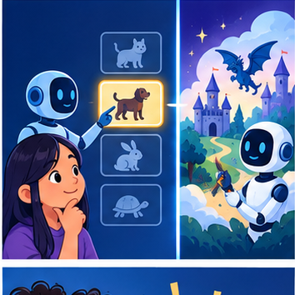
CREATOR MISSION
Classify systems and explain the output space for each.
Creator name and date:

Write or draw your reasoning and evidence.
________________________________________________________________
________________________________________________________________
________________________________________________________________
________________________________________________________________
________________________________________________________________

Readiness for the connected explanation
What is the difference between a model prediction and evidence that a statement is true?

This week’s end goal
By the end, I can identify generation and prediction objectives without confusing either with verified truth.

02. Notice the evidence
PICTURE STORY
Notice → Predict → Explain
Begin with visible evidence. Do not explain more than the picture and information support.
MYSTERY
The learners must use predictive and generative ai to solve a problem. What information do they have? What decision or calculation do they make? What would count as evidence that it worked?
Three observations (what you can point to):

Write or draw your reasoning and evidence.
________________________________________________________________
________________________________________________________________
________________________________________________________________
________________________________________________________________
________________________________________________________________
My prediction and the clue supporting it:

Write or draw your reasoning and evidence.
________________________________________________________________
________________________________________________________________
________________________________________________________________
________________________________________________________________
________________________________________________________________

A closer explanation
A classifier might map a message to the label request or report. A text generator instead produces a sequence, predicting a distribution over the next token given a prefix. Both make predictions, but the training targets and permitted outputs differ. One application can combine generation with a classifier, retrieval and human approval. Calling a whole product “generative” does not describe every component.
The objective defines what training attempts to fit. Next-token fit rewards matching observed continuations; it does not directly certify that an answer is true, well sourced or permitted. A fluent completion is still an output to evaluate against the task.

03. See how it works
VISUAL MECHANISM
Input → Process → Output
Trace the information. At each stage, ask what changed and how you could test it.
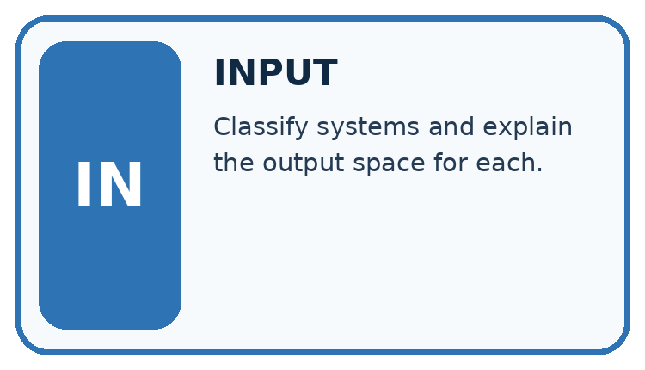
↓
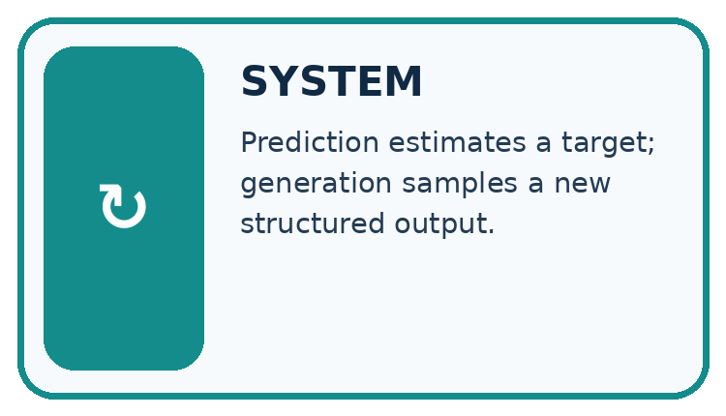
↓
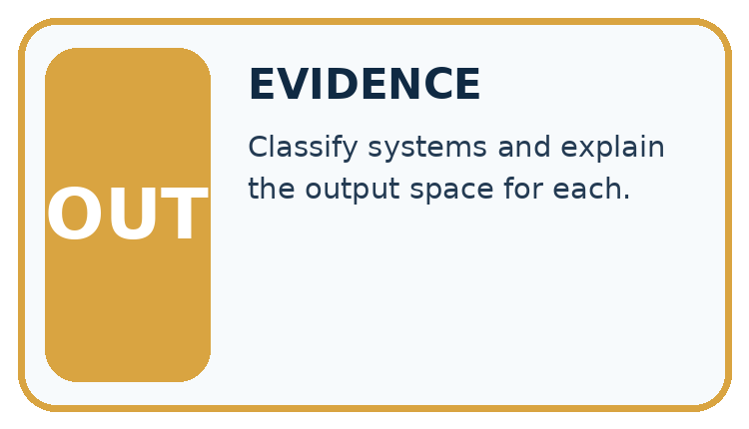
Which stage could fail even when the other two are correct? Explain:

Write or draw your reasoning and evidence.
________________________________________________________________
________________________________________________________________
________________________________________________________________
________________________________________________________________
________________________________________________________________

A closer explanation
Prefix | Continuation | Count
The marker is | red | 6
The marker is | blue | 3
The marker is | green | 1
There are ten observed continuations. The empirical probabilities are red 6/10 = 0.6, blue 3/10 = 0.3, green 1/10 = 0.1. They are nonnegative and sum to 1. A simple frequentist classroom model uses these relative counts as its next-token distribution. These probabilities describe the supplied corpus counts, not the current colour of any actual marker.

Keep the evidence roles separate
Plan or input | Procedure | Permitted conclusion
Ten corpus continuations | Count red 6, blue 3, green 1 | Distribution 0.6, 0.3, 0.1
Prefix: The marker is | Select a next token | An output, not an observation
Current marker question | Check direct evidence | Colour claim needs support
The continuation model and a factual observation have different evidence sources.

Connect the picture and the explanation
Point to the input, the deciding step and the result in this week’s visual. Explain the same step in ordinary words. A picture helps when you can say what each part represents.

04. Compare the cases
CASE GALLERY
Four Tests, Four Kinds of Evidence
A system is not understood until it survives more than one comfortable example.


NORMAL CASE: predict and name evidence. BOUNDARY CASE: predict and name evidence.


MISSING INFORMATION: predict and name evidence. TRANSFER CASE: predict and name evidence.
Which case is most likely to reveal a hidden assumption? Why?

Write or draw your reasoning and evidence.
________________________________________________________________
________________________________________________________________
________________________________________________________________
________________________________________________________________
________________________________________________________________

Change one thing in the pictured case
Change: The classifier instead predicts history while N and the draft stay unchanged.
Prediction: The category prediction changes, but the same unsupported draft claim still needs checking.
Reason: Stages can fail independently; one result does not validate another.

05. Words that unlock the idea
VOCABULARY LAB
Words You Can Use to Reason
A definition matters when you can recognize the idea, use it, and contrast it with a near-miss.
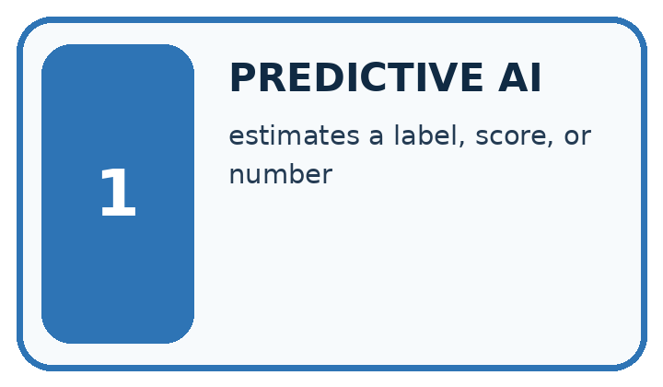
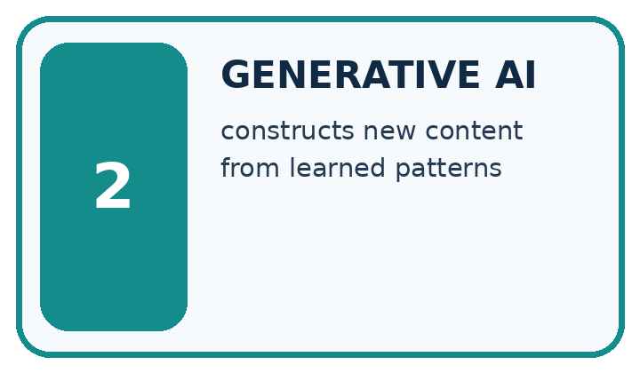
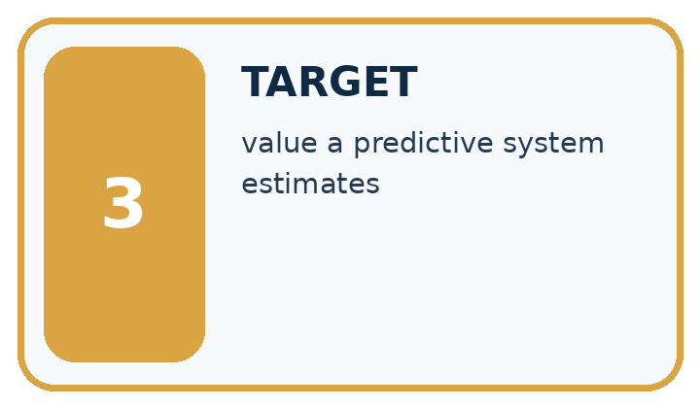
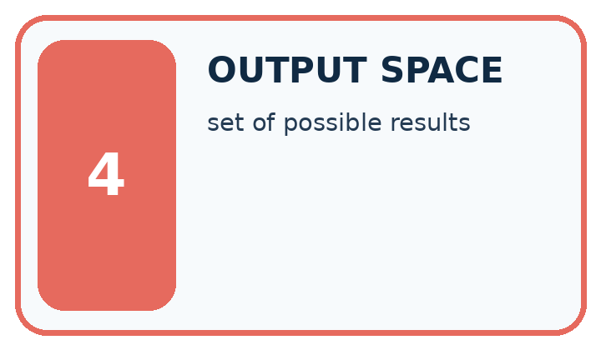
Word | My own example | Not this / boundary
predictive AI | AI used to estimate a target such as a category, number or future outcome from inputs.
generative AI | AI that produces new content such as text, images or audio rather than only selecting a category.
target | The category, value or outcome a prediction task is intended to estimate.
output space | The set or range of outputs a system can produce for a task.

Words used in the closer explanation
Word | Meaning
Generative objective | A training aim concerned with producing or modelling possible outputs
Discriminative objective | A training aim mapping inputs to a specified target such as a label
Conditional distribution | Probabilities for alternatives given stated information
Autoregressive generation | Producing a sequence one next item at a time using preceding items

06. Follow a worked example
WORKED EVIDENCE
Reason Step by Step
Predict first. Then check each step. A correct answer without visible reasoning is incomplete evidence.
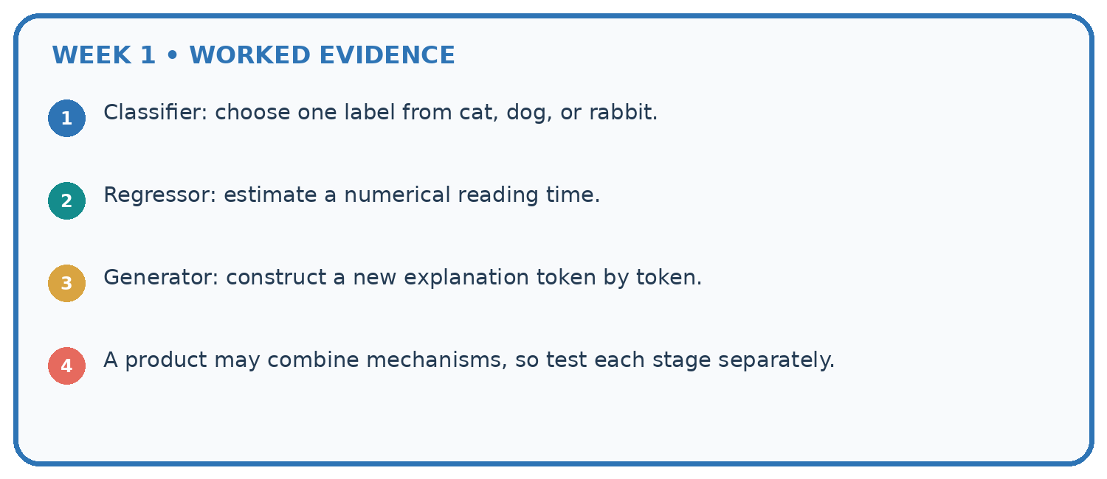
1. Classifier: choose one label from cat, dog, or rabbit.
2. Regressor: estimate a numerical reading time.
3. Generator: construct a new explanation token by token.
4. A product may combine mechanisms, so test each stage separately.
Recalculate, retrace, or restate the reasoning in your own representation:

Write or draw your reasoning and evidence.
________________________________________________________________
________________________________________________________________
________________________________________________________________
________________________________________________________________
________________________________________________________________
CHECK Did the evidence answer the exact question? Did the total, path, or source record stay consistent?

A closer explanation
After producing red, the next step conditions on the expanded prefix “The marker is red”. A second table might give an end token probability 0.8 and the token today probability 0.2. A generated sequence can stop at the end token or continue. Do not reuse the first-step table unchanged after adding a token unless the model explicitly ignores the new prefix.
A separate classifier can return red as a label from an image; that is a different input and target from continuing text. A downstream evaluation asks whether the system correctly reports the current marker. It must include ground truth or sources and appropriate failure handling, not just count plausible phrases.

Learn from the worked case
Cover the result before checking it. Say what is given, choose the procedure, and follow one step at a time. Then uncover the result and explain your first mismatch. Ask why a step is allowed, not only what number it produces.

A pictorial worked case: Predictive and Generative AI
A fictional learning tool first classifies a question, then drafts an answer from a supplied note.

The facts we will use
A fitted classifier labels a question science; its training used labelled questions.
Approved note N: evaporation changes liquid water into water vapour. A generator drafts: “Water evaporates into vapour and always disappears forever.”
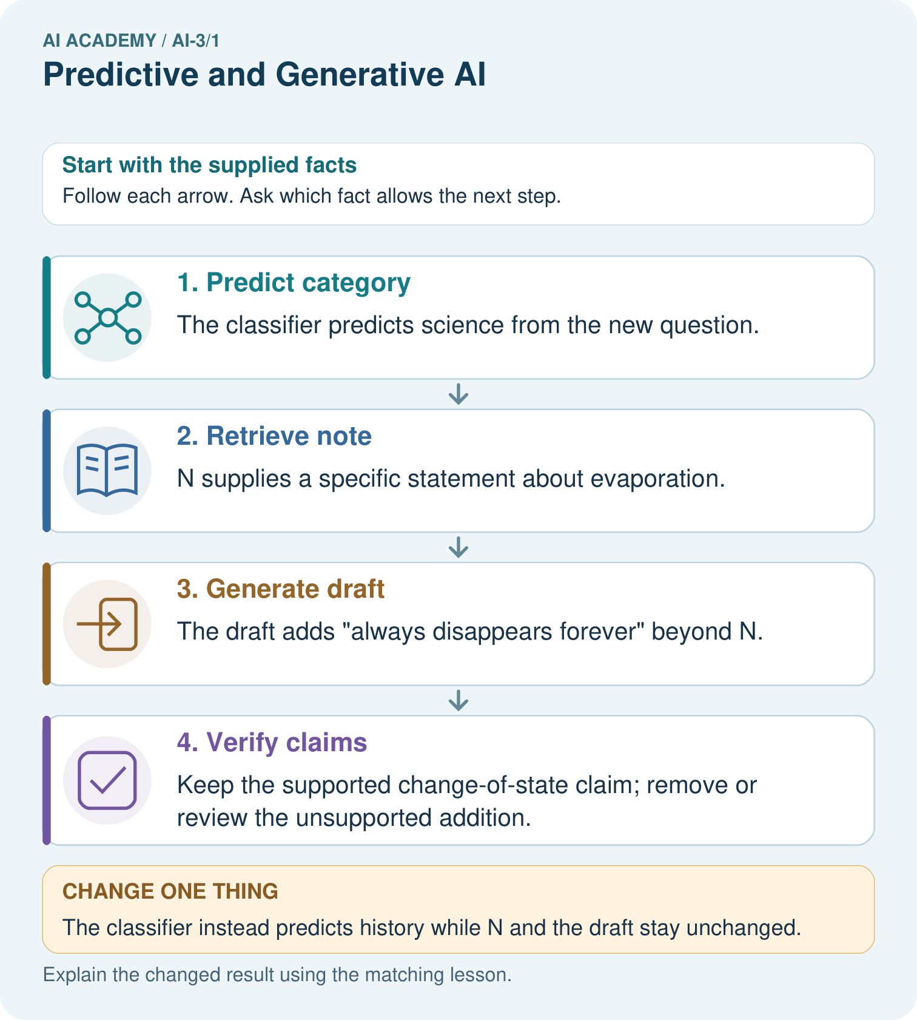

Read the picture one step at a time
Step | What happens and why
1. Predict category | The classifier predicts science from the new question.
2. Retrieve note | N supplies a specific statement about evaporation.
3. Generate draft | The draft adds “always disappears forever” beyond N.
4. Verify claims | Keep the supported change-of-state claim; remove or review the unsupported addition.
Match each pictured step to the supplied facts. This is a worked teaching case, not an independent assessment.

Why this result follows
Classification predicts a category under a trained mapping. Generation produces a sequence of words under a language objective. Supplying a note can support factual grounding, but the draft still requires claim-level checking. The category being correct does not prove every sentence in the answer is correct.

What this example does not establish
This example does not expose a real model’s architecture or prove that source-fed generation always stays grounded.
Read the labelled picture: Identify the first unsupported claim and explain what source would be needed before asserting it.
Change one thing: The classifier instead predicts history while N and the draft stay unchanged. Predict the result before checking the explanation. What remains the same?

07. Find and repair a mistake
ERROR DETECTIVE
Compare → Diagnose → Repair
Do not patch the answer. Find the earliest unsupported assumption, wrong step, or weak evidence.
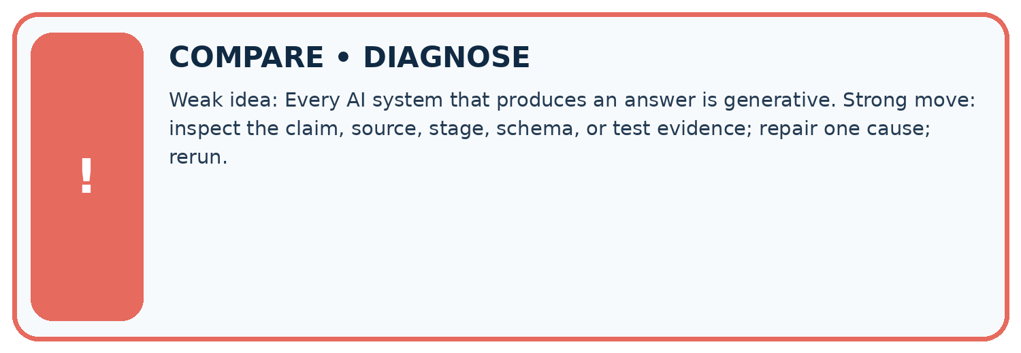
Evidence record | Expected | Actual | Likely cause / next test
normal case | works
boundary case | stated rule
missing input | safe response
fresh transfer | generalizes
Repair one cause. Why is this repair better than changing several things?

Write or draw your reasoning and evidence.
________________________________________________________________
________________________________________________________________
________________________________________________________________
________________________________________________________________
________________________________________________________________

A closer explanation
Keep three questions separate: did the model fit continuation data; did the output satisfy the requested format or task; and are factual claims supported? A system that drafts a fictional description has different criteria from one reporting a live measurement. Record the source and time when a claim refers to changing conditions. No AI account is needed to reason about these distinctions.

Exit: a team says “the highest-probability continuation proves the current fact”. Name the evidence they actually have and the evidence still needed.
________________________________________________________________
________________________________________________________________
________________________________________________________________
________________________________________________________________
________________________________________________________________

08. Practise together
LOGIC STUDIO
Specify Before You Run
Prompts, schemas, retrieval, tool calls, and code are inspectable parts of one AI product.

SET task, audience, constraints, output_schema
LOAD approved_context or retrieval_result
CALL model or allowed_tool
VALIDATE fields, claims, citations, and safety
IF evidence missing: ask, retrieve, or abstain
RETURN useful output + source trail + limitations
Trace one input. Which line changes the state or chooses a path?

Write or draw your reasoning and evidence.
________________________________________________________________
________________________________________________________________
________________________________________________________________
________________________________________________________________
________________________________________________________________

A closer explanation
Supported case: the prefix “The door is” is followed in a tiny corpus by open four times and closed once. The empirical probabilities are 4/5 and 1/5. A current sensor reports closed. Selecting the most frequent continuation open would be plausible under the corpus model but inconsistent with the sensor observation.

Guided: compute both probabilities and explain why selecting open does not establish the current door state.
________________________________________________________________
________________________________________________________________
________________________________________________________________
________________________________________________________________
________________________________________________________________

Practise with less help: Compute the distribution
Use workbook W2 for the connected example “Generative and predictive objectives”. First fill the input and rule boxes. Try the middle steps before asking for a hint. After a hint, try the next step yourself.
Plan | Do | Check
What is given? Which rule or procedure applies? | Record each intermediate step. | Does the result follow? What remains unknown?
Explain your trace to a partner. Your partner points to one step to check. Swap roles on the next case. Each person writes their own explanation.

Check your reasoning
Use the worked case for Generative and predictive objectives. Proposed explanation: “Generative models do not predict”. Decide whether this explanation is supported. Point to the step or supplied fact that decides; explain your repair if needed.
Answer on your own before discussion. If you are unsure, say which step you need help with.

Explain the picture
Identify the first unsupported claim and explain what source would be needed before asserting it.

My explanation using a pictured step and the given facts
________________________________________________________________
________________________________________________________________
________________________________________________________________
________________________________________________________________
This is supported practice. Keep the separately named independent case for an attempt before feedback.

09. Run the investigation
EVIDENCE LAB
Predict → Test → Record → Explain
Keep expected and actual results separate. Surprises are useful data when recorded honestly.
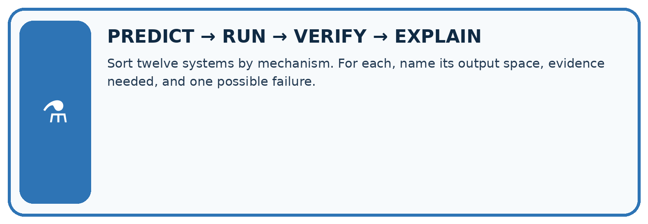
Sort twelve systems by mechanism. For each, name its output space, evidence needed, and one possible failure.
Test / input | Prediction | Actual | Evidence / calculation | Change or keep?
normal
boundary
missing
fresh transfer
What did the hardest test teach you that the normal test did not?

Write or draw your reasoning and evidence.
________________________________________________________________
________________________________________________________________
________________________________________________________________
________________________________________________________________
________________________________________________________________

Plan → try → check
Before trying: what do I expect, and why? While trying: which step could first go wrong? Afterwards: what did I actually observe, and what should change? Keep “not run” if you only traced the procedure.

10. Build your understanding
MASTERY
From Knowing the Word to Owning the Idea
Move upward only when you can produce evidence without copying the worked example.

1 • NAME: Define the concept without repeating the textbook.
2 • TRACE: Show the information, state, branch, calculation, or evidence path.
3 • APPLY: Solve a different example independently.
4 • CHALLENGE: Find a boundary case, counterexample, or unfair outcome.
5 • EXPLAIN LIMITS: Say when the result should not be trusted or used alone.
My strongest evidence of independent understanding:

Write or draw your reasoning and evidence.
________________________________________________________________
________________________________________________________________
________________________________________________________________
________________________________________________________________
________________________________________________________________

11. Connect your project
CUMULATIVE PROJECT
Verified Study Buddy
Every week adds one inspectable piece. The system must show how it reached a result.
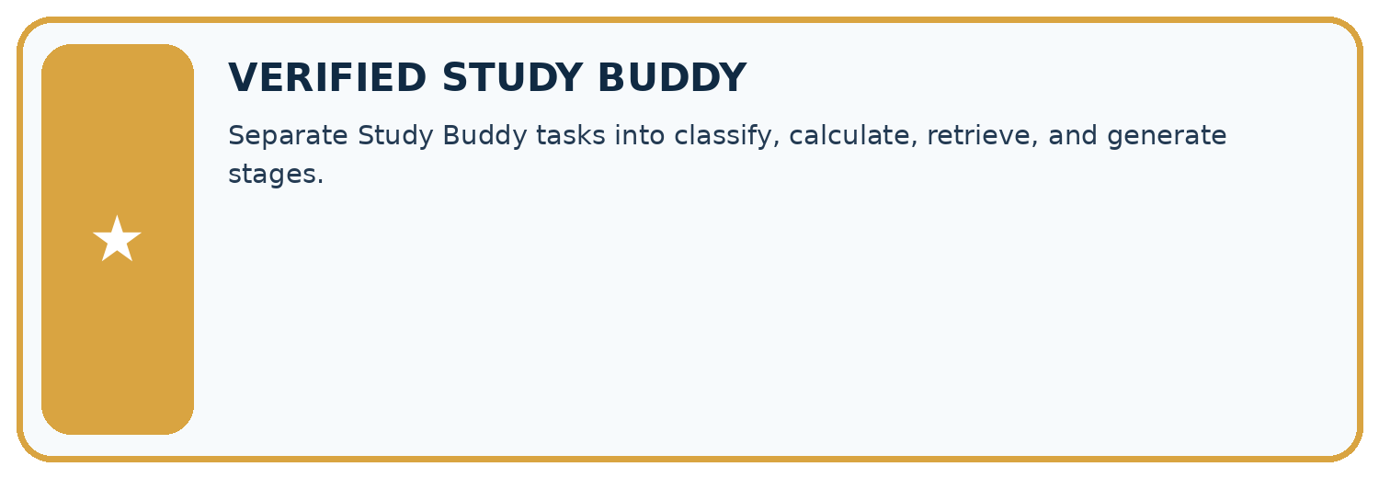
THIS WEEK’S CHECKPOINT Separate Study Buddy tasks into classify, calculate, retrieve, and generate stages.
SYSTEM MAP Learner need → prompt/schema → approved sources/retrieval → model/tool → structured answer → verification → human decision
What will you add, change, or verify in the project this week?

Write or draw your reasoning and evidence.
________________________________________________________________
________________________________________________________________
________________________________________________________________
________________________________________________________________
________________________________________________________________
What should remain under human control?

Write or draw your reasoning and evidence.
________________________________________________________________
________________________________________________________________
________________________________________________________________
________________________________________________________________
________________________________________________________________
RESPONSIBLE DESIGN Collect only necessary information. Show uncertainty and limits. Never confuse fluent output with verified truth.

Evidence for your project
For the Verified Study Buddy, separate routing predictions, source retrieval and generated explanations in its evidence record.

12. Show what you know
INDEPENDENT MASTERY PROOF
Explain • Transfer • Test • Defend
Complete this page without copying the worked example. Your reasoning matters more than decoration.
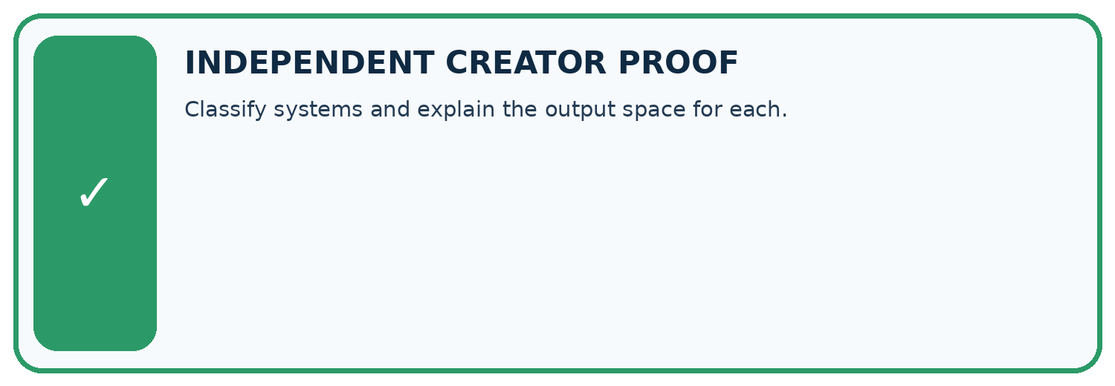
CHALLENGE Classify systems and explain the output space for each.
1. My fresh example, trace, calculation, or design:

Write or draw your reasoning and evidence.
________________________________________________________________
________________________________________________________________
________________________________________________________________
________________________________________________________________
________________________________________________________________
2. My evidence that it works (include a boundary or missing-data case):

Write or draw your reasoning and evidence.
________________________________________________________________
________________________________________________________________
________________________________________________________________
________________________________________________________________
________________________________________________________________
3. One limitation, fairness concern, or situation needing human review:

Write or draw your reasoning and evidence.
________________________________________________________________
________________________________________________________________
________________________________________________________________
________________________________________________________________
________________________________________________________________
SELF-CHECK □ I explained the mechanism □ I used evidence □ I tested a fresh case □ I named a limitation □ I can answer ‘why?’

13. Study a complete case

Week 1 Worked case
Use the supplied details to practise the weekly concept before attempting the independent question. This case extends the illustrated lesson.

The situation
A tool labels a question biology, writes a new question and computes 7 times 8.

The question
Identify each operation.

Worked explanation
Labelling selects a category; generation creates text; calculation returns 56. Generated questions need factual and instructional checks.

Explain it in your own words
Which detail supports the answer, and why does it matter?

Write or draw your reasoning and evidence.
________________________________________________________________
________________________________________________________________
________________________________________________________________
________________________________________________________________
________________________________________________________________

Trace the supplied case visually

Three outputs need three different checks
Evidence or stage | Value or result
Classify | Select biology as a category
Generate | Compose a new question
Calculate | 7 times 8 equals 56
A tool labels a question biology, writes a new question and computes 7 times 8.
Identify each operation.
Labelling selects a category; generation creates text; calculation returns 56. Generated questions need factual and instructional checks.

14. Try a new case independently

Independent case: Changed independent case
A system retrieves an approved Moon note, uses a trained classifier to predict reading difficulty, then writes a poem. Identify each mechanism and the evidence needed to check its output.

My independent explanation, trace and limits
________________________________________________________________
________________________________________________________________
________________________________________________________________
________________________________________________________________
________________________________________________________________
________________________________________________________________
________________________________________________________________
Attempt this case before feedback. Record any help. Earlier examples below are further practice; a case already practised with feedback cannot establish fresh transfer.

Week 1 Independent application
Close the worked explanation. Apply the idea to this different question without copying.
A system labels a message as spam. Another writes a new reply. Which task predicts a category and which generates content? Can the new reply contain a false fact?
My answer, with a trace, calculation or supporting evidence

Write or draw your reasoning and evidence.
________________________________________________________________
________________________________________________________________
________________________________________________________________
________________________________________________________________
________________________________________________________________

Create and test
Change one relevant detail. Predict the result before testing. Include a boundary or missing-information case when it helps reveal a limit.
My changed input and expected result

Write or draw your reasoning and evidence.
________________________________________________________________
________________________________________________________________
________________________________________________________________
________________________________________________________________
________________________________________________________________

Connect to your project
Separate Study Buddy tasks into classify, calculate, retrieve, and generate stages.
The evidence I will keep

Write or draw your reasoning and evidence.
________________________________________________________________
________________________________________________________________
________________________________________________________________
________________________________________________________________
________________________________________________________________
Your teacher has the independent answer and scoring criteria. Complete the matching workbook week to keep your practice evidence together.

Transfer practice from the original programme
A study tool finds a paragraph, labels its difficulty and invents practice questions. Identify the three operations and one check for each.

Explain the mechanism, evidence and one limit.
________________________________________________________________
________________________________________________________________
________________________________________________________________
________________________________________________________________
________________________________________________________________
________________________________________________________________
________________________________________________________________

Use feedback to improve
Attempt the independent case before hints. Record whether you worked alone, used a hint or followed a model. After feedback, fix the first unsupported step and explain why it changed. A later check uses a changed case, not a copied answer.

15. Your lesson route
Start with this question: A fictional learning tool first classifies a question, then drafts an answer from a supplied note.
By the end, I can | How I will show it
Distinguish discriminative prediction from generation by inspecting the requested output | Explain the deciding step, show a trace or test, and state one limit.
Calculate an empirical next-token distribution from counted continuations | Explain the deciding step, show a trace or test, and state one limit.
Separate next-token fit from factual support and downstream usefulness | Explain the deciding step, show a trace or test, and state one limit.
Remember → watch and explain → try with help → investigate → try independently → keep project evidence. Your teacher may spread this lesson across several classes.
Keep your first prediction. Compare it with what the evidence shows and explain any change.

16. Finish and return
Close your notes. Explain this goal in your own words: Distinguish discriminative prediction from generation by inspecting the requested output

My deciding step, evidence and one remaining question
________________________________________________________________
________________________________________________________________
________________________________________________________________
________________________________________________________________
________________________________________________________________
If you are unsure, return to the worked picture and explain one arrow. If you are ready, change an input or assumption and justify your prediction.
Save your workbook evidence. At the next review, try a different case before opening your old answer.

17. Supported practice, repair and portfolio
Use this supported practice once, in the browser or on paper. Keep the reserved independent assessment for a separate first attempt before teacher feedback.
A fictional learning tool first classifies a question, then drafts an answer from a supplied note.

Practice 1: explain the deciding evidence
Which labelled step matches this detail? Keep the supported change-of-state claim; remove or review the unsupported addition.
1. Predict category
2. Verify claims
3. Retrieve note
4. Generate draft

My selected conclusion, deciding fact and explanation
________________________________________________________________
________________________________________________________________
________________________________________________________________
________________________________________________________________
________________________________________________________________
Hint if needed: Read the steps in the pictorial case. Match the supplied detail to the stage that performs or records it.
After your attempt, compare with the supported explanation: Verify claims Keep the supported change-of-state claim; remove or review the unsupported addition. Classification predicts a category under a trained mapping. Generation produces a sequence of words under a language objective. Supplying a note can support factual grounding, but the draft still requires claim-level checking. The category being correct does not prove every sentence in the answer is correct.

Practice 2: explain the deciding evidence
Changed-case practice: The classifier instead predicts history while N and the draft stay unchanged. Which conclusion is supported by the supplied facts?
1. We can decide the result without examining the changed input or the procedure.
2. This one example guarantees correct results for every future input.
3. The category prediction changes, but the same unsupported draft claim still needs checking.

My selected conclusion, deciding fact and explanation
________________________________________________________________
________________________________________________________________
________________________________________________________________
________________________________________________________________
________________________________________________________________
Hint if needed: Use the changed condition and the deciding step in the pictorial trace. The answer must say what follows from those facts.
After your attempt, compare with the supported explanation: The category prediction changes, but the same unsupported draft claim still needs checking. Stages can fail independently; one result does not validate another.

Repair a missing building block
Review Capstone Expo (ai-2/36). Goal: Defend an application using reproducible evidence. Short practice: Give the original winning ID, its score, and counts of eligible, excluded and invalid rows.. Return to this week and explain what you changed.

Keep your completed work
Use Download completed work in the hosted lesson to export your answers, reflections, practice feedback and code-run evidence. Open the HTML copy to read or print it. Drafts stay in this browser when storage is available; clear drafts on a shared device.

