AI ACADEMY · STUDENT · ai-3/14

Hallucination Failure Types
Project: Verified Study Buddy

Before you start
Week 6: a citation must support its attached claim.

01. Your mission

Your learning target
I can explain the mechanism and terminology of generation failures and verification.
I can apply the stated procedure to a new case with a traceable result.
I can identify an assumption or limitation and design a revealing follow-up.

Remember before reading
Close your notes first. A rough first answer helps us choose the right starting point; it is not a score for your ability.
Without opening the old lesson, explain one key idea from Multimodal Evidence. Give an example and a mistake that the idea helps you avoid.
Without opening the old lesson, explain one key idea from Visual Composition. Give an example and a mistake that the idea helps you avoid.
Without opening the old lesson, explain one key idea from Structured Output and Schemas. Give an example and a mistake that the idea helps you avoid.
After trying, check the relevant lesson or ask your teacher. Change the part of your explanation that the evidence shows was wrong.
Week 14: Hallucination Failure Types
Fluent output may contain unsupported claims, fabricated detail, or faulty inference.

CREATOR MISSION
Tag claims in an answer and classify each failure type.
Creator name and date:

Write or draw your reasoning and evidence.
________________________________________________________________
________________________________________________________________
________________________________________________________________
________________________________________________________________
________________________________________________________________

Readiness for the connected explanation
Recall Controlled prompt experiments. Explain why a recorded result needs its input conditions and evidence source before it can support a claim.

This week’s end goal
By the end, I can distinguish supported, contradicted and unsupported generated claims.

02. Notice the evidence
PICTURE STORY
Notice → Predict → Explain
Begin with visible evidence. Do not explain more than the picture and information support.
MYSTERY
The learners must use hallucination failure types to solve a problem. What information do they have? What decision or calculation do they make? What would count as evidence that it worked?
Three observations (what you can point to):

Write or draw your reasoning and evidence.
________________________________________________________________
________________________________________________________________
________________________________________________________________
________________________________________________________________
________________________________________________________________
My prediction and the clue supporting it:

Write or draw your reasoning and evidence.
________________________________________________________________
________________________________________________________________
________________________________________________________________
________________________________________________________________
________________________________________________________________

A closer explanation
Generated answers may invent facts, misread quantities or cite irrelevant passages. Verification checks each claim against evidence rather than accepting fluent wording.
Begin by writing the question the procedure is intended to answer. Identify the information already supplied, the information it will produce and the information still missing. These are constructed classroom examples; they do not require live accounts, private records or an external service. Do not treat a plausible explanation as a measured outcome.

03. See how it works
VISUAL MECHANISM
Input → Process → Output
Trace the information. At each stage, ask what changed and how you could test it.
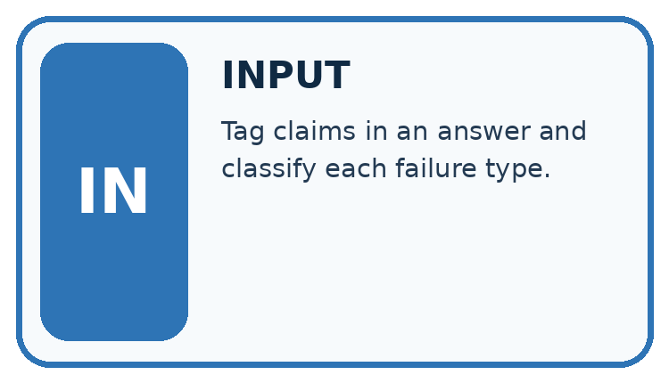
↓
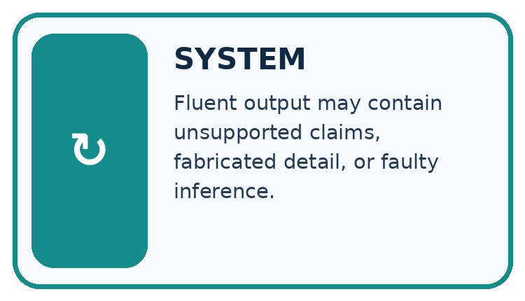
↓
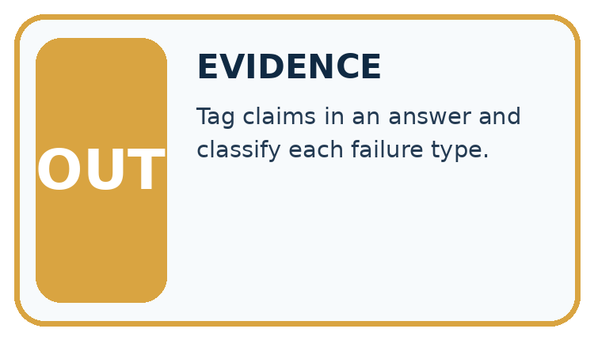
Which stage could fail even when the other two are correct? Explain:

Write or draw your reasoning and evidence.
________________________________________________________________
________________________________________________________________
________________________________________________________________
________________________________________________________________
________________________________________________________________

A closer explanation
Split an answer into atomic claims. For each, record the exact source passage, support status and any needed calculation. Mark unsupported and contradicted claims separately; do not repair them by inventing sources.

Generation failures and verification — evidence trace
Input and scope | Check or calculation | Conclusion and limit
Source R says room B seats 12 and the meeting starts at 15:00. Generated answer says B seats 20, starts at 15:00 and includes free lunch. | Split an answer into atomic claims. For each, record the exact source passage, support status and any needed calculation. Mark unsupported and contradicted claims separately; do not repair them by inventing sources. | Capacity 20 is contradicted; 15:00 is supported; free lunch is unsupported. One of three claims has support. The missing lunch fact is not evidence of no lunch.
The figure connects this chapter's worked input, declared procedure and result. Read the complete worked reasoning for qualifiers and intermediate steps; the abbreviated labels do not replace that reasoning.
Before applying the procedure, write its units, denominator or decision boundary where relevant. A partner should be able to repeat each step using the same inputs. If a required input is absent or violates the stated contract, record that condition explicitly instead of quietly replacing it with a convenient value.

Connect the picture and the explanation
Point to the input, the deciding step and the result in this week’s visual. Explain the same step in ordinary words. A picture helps when you can say what each part represents.

04. Compare the cases
CASE GALLERY
Four Tests, Four Kinds of Evidence
A system is not understood until it survives more than one comfortable example.


NORMAL CASE: predict and name evidence. BOUNDARY CASE: predict and name evidence.


MISSING INFORMATION: predict and name evidence. TRANSFER CASE: predict and name evidence.
Which case is most likely to reveal a hidden assumption? Why?

Write or draw your reasoning and evidence.
________________________________________________________________
________________________________________________________________
________________________________________________________________
________________________________________________________________
________________________________________________________________

Change one thing in the pictured case
Change: Add a planned 30-minute stop while preserving speed and distance.
Prediction: Planned total elapsed time becomes 3.5 hours.
Reason: Three moving hours plus half an hour stopped; walking-time calculation itself stays three.

05. Words that unlock the idea
VOCABULARY LAB
Words You Can Use to Reason
A definition matters when you can recognize the idea, use it, and contrast it with a near-miss.
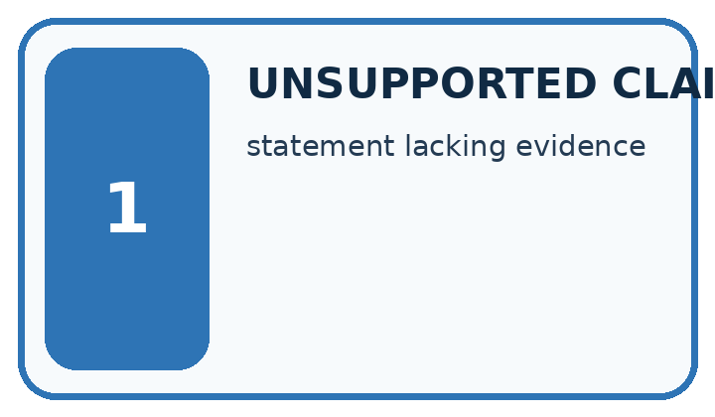
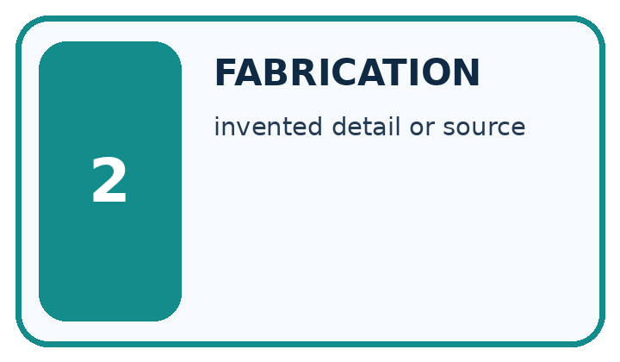
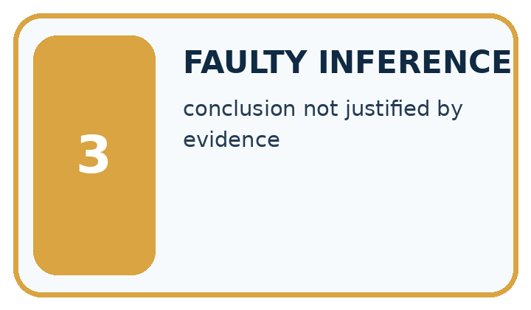
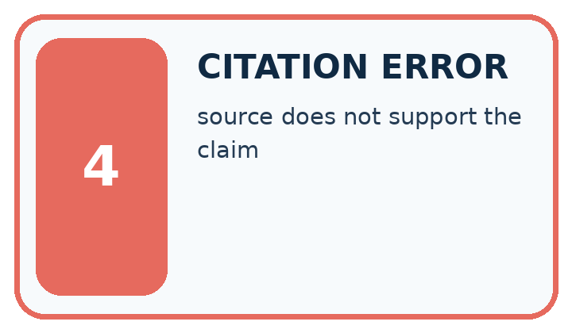
Word | My own example | Not this / boundary
unsupported claim | A statement for which the supplied evidence does not establish the asserted conclusion.
fabrication | Invented information presented as if it were established fact.
faulty inference | A conclusion that does not follow from the available premises or evidence.
citation error | A reference that is wrong, missing or does not support the claim attached to it.

Words used in the closer explanation
Word | Meaning
Atomic claim | A single factual statement checked separately
Contradicted | Inconsistent with the supplied evidence
Unsupported | Not established by the available evidence

06. Follow a worked example
WORKED EVIDENCE
Reason Step by Step
Predict first. Then check each step. A correct answer without visible reasoning is incomplete evidence.
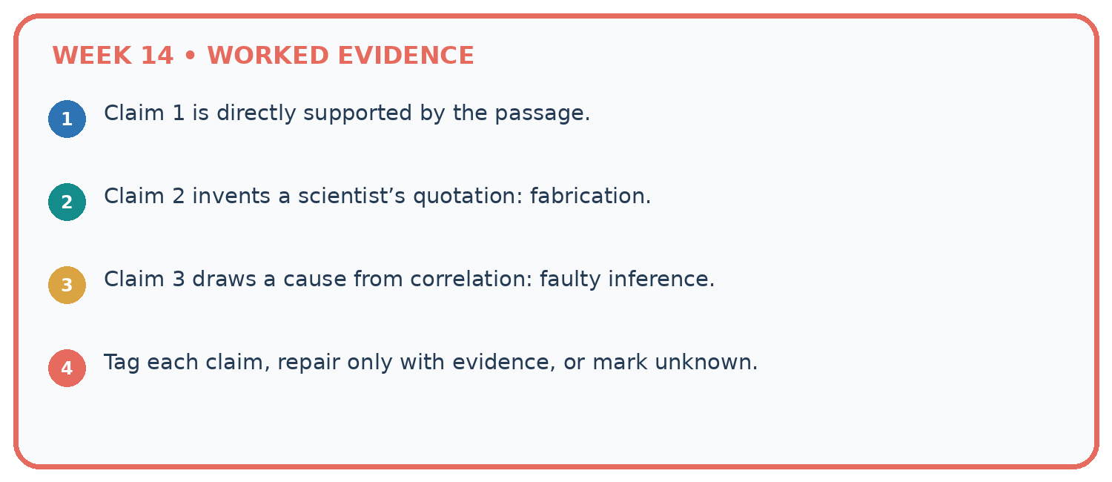
1. Claim 1 is directly supported by the passage.
2. Claim 2 invents a scientist’s quotation: fabrication.
3. Claim 3 draws a cause from correlation: faulty inference.
4. Tag each claim, repair only with evidence, or mark unknown.
Recalculate, retrace, or restate the reasoning in your own representation:

Write or draw your reasoning and evidence.
________________________________________________________________
________________________________________________________________
________________________________________________________________
________________________________________________________________
________________________________________________________________
CHECK Did the evidence answer the exact question? Did the total, path, or source record stay consistent?

A closer explanation
Source R says room B seats 12 and the meeting starts at 15:00. Generated answer says B seats 20, starts at 15:00 and includes free lunch.
Capacity 20 is contradicted; 15:00 is supported; free lunch is unsupported. One of three claims has support. The missing lunch fact is not evidence of no lunch.
Compare the intermediate evidence with the final statement. Explain why each number or decision follows from the stated inputs. The conclusion belongs to this scenario and procedure; changing the inputs, evaluation population or authority can change what it establishes. Retain the raw record so a later revision can be compared honestly.

Learn from the worked case
Cover the result before checking it. Say what is given, choose the procedure, and follow one step at a time. Then uncover the result and explain your first mismatch. Ask why a step is allowed, not only what number it produces.

A pictorial worked case: Hallucination Failure Types
A fictional Study Buddy drafts a field-trip summary from one approved record.

The facts we will use
Source S: trail length 12 km; planned constant speed 4 km/h, excluding stops; departure 09:00.
Draft: “The walk takes two hours, starts at 09:00 and includes free lunch.” No lunch record is supplied.
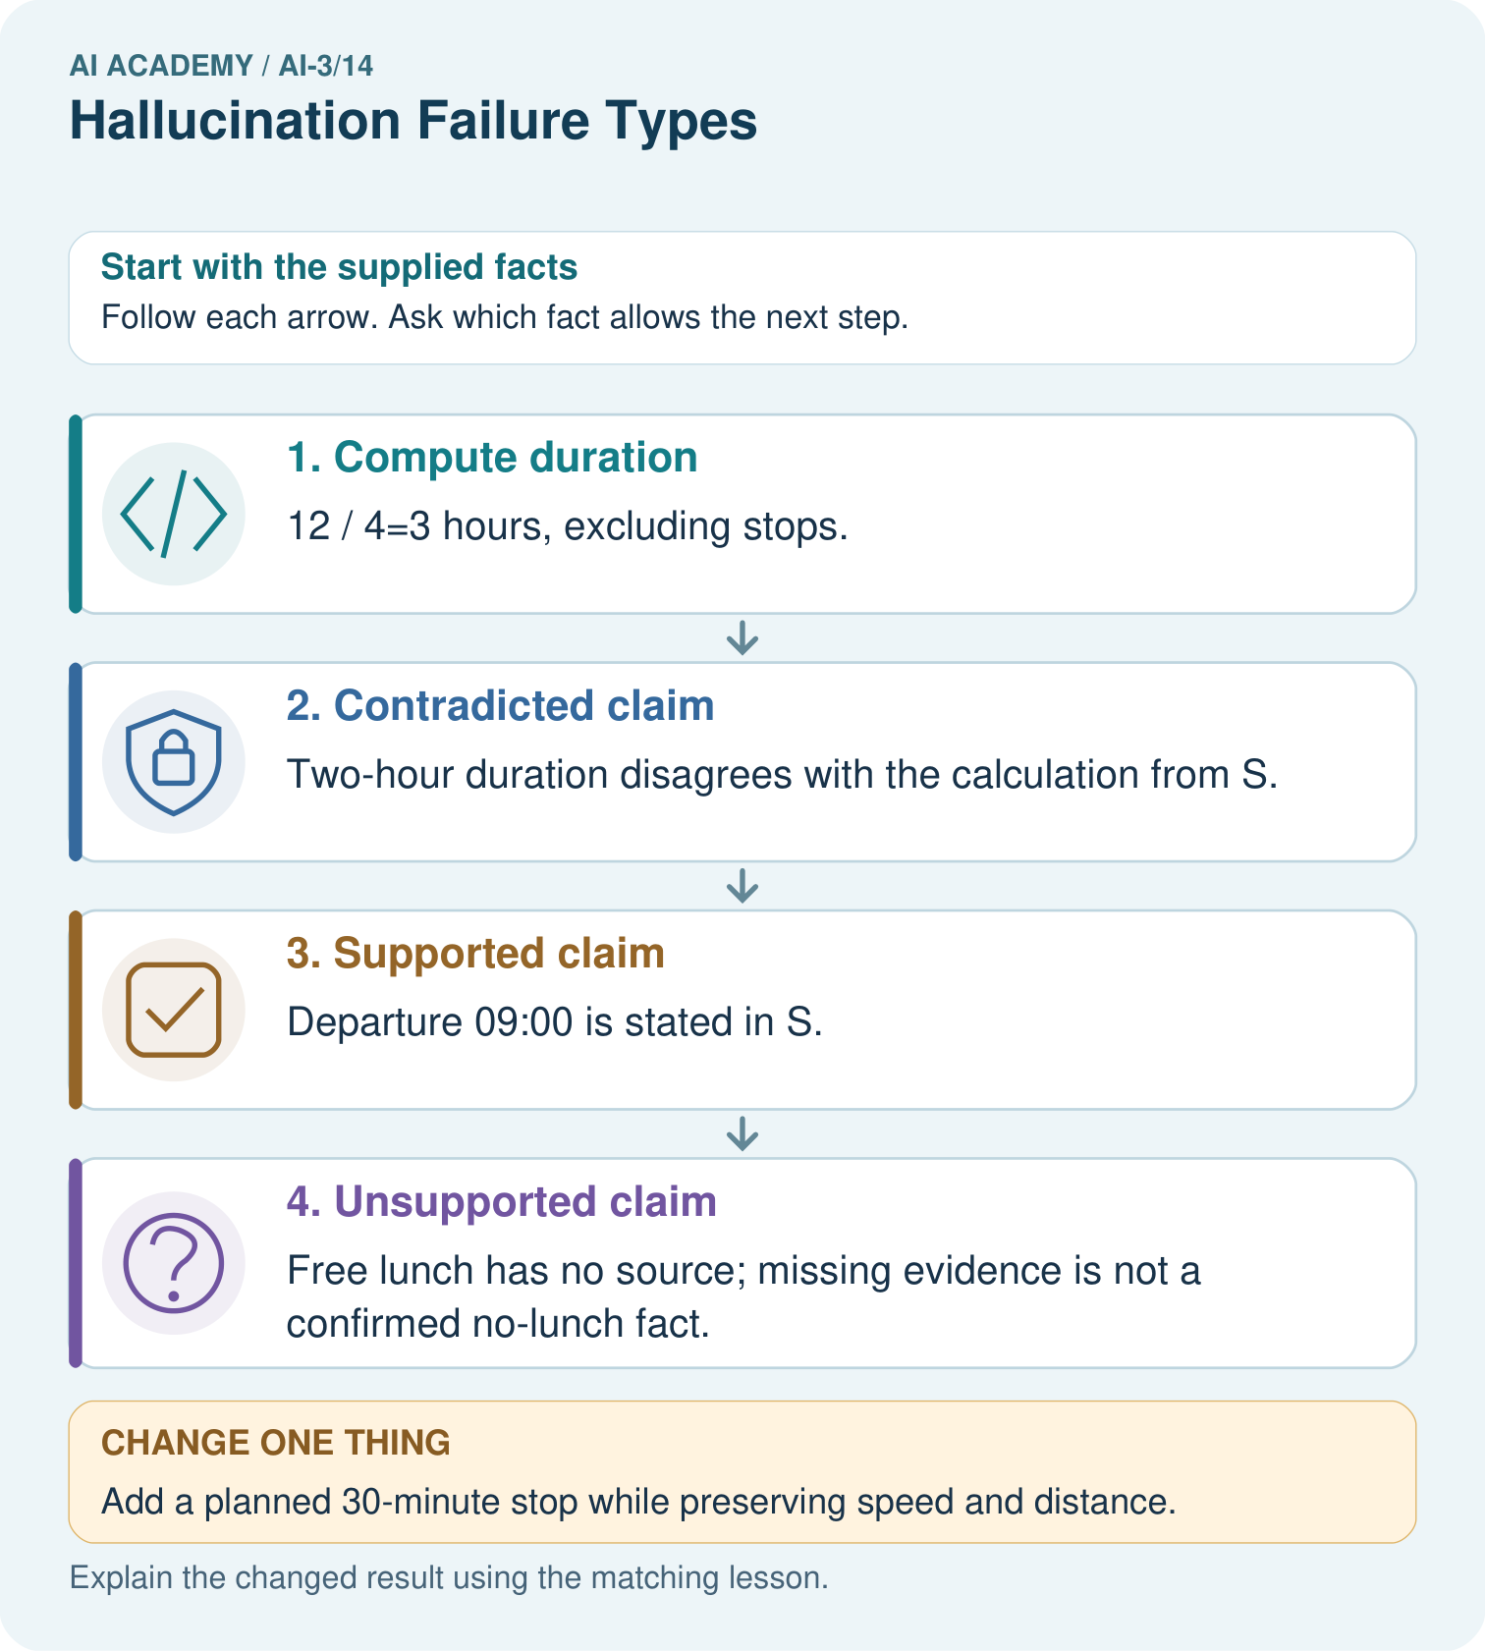

Read the picture one step at a time
Step | What happens and why
1. Compute duration | 12÷4=3 hours, excluding stops.
2. Contradicted claim | Two-hour duration disagrees with the calculation from S.
3. Supported claim | Departure 09:00 is stated in S.
4. Unsupported claim | Free lunch has no source; missing evidence is not a confirmed no-lunch fact.
Match each pictured step to the supplied facts. This is a worked teaching case, not an independent assessment.

Why this result follows
Different errors need different repairs. Recalculate the duration; keep the supported departure; remove or seek evidence for lunch. These categories are more informative than calling the whole answer wrong. Arithmetic inherits assumptions such as constant speed and no stops, so avoid turning the three-hour walking calculation into a guaranteed arrival time.

What this example does not establish
The fictional plan does not establish actual speed, delays or what eventually occurred on a real trip.
Read the labelled picture: Can we conclude there will definitely be no lunch from S alone?
Change one thing: Add a planned 30-minute stop while preserving speed and distance. Predict the result before checking the explanation. What remains the same?

07. Find and repair a mistake
ERROR DETECTIVE
Compare → Diagnose → Repair
Do not patch the answer. Find the earliest unsupported assumption, wrong step, or weak evidence.
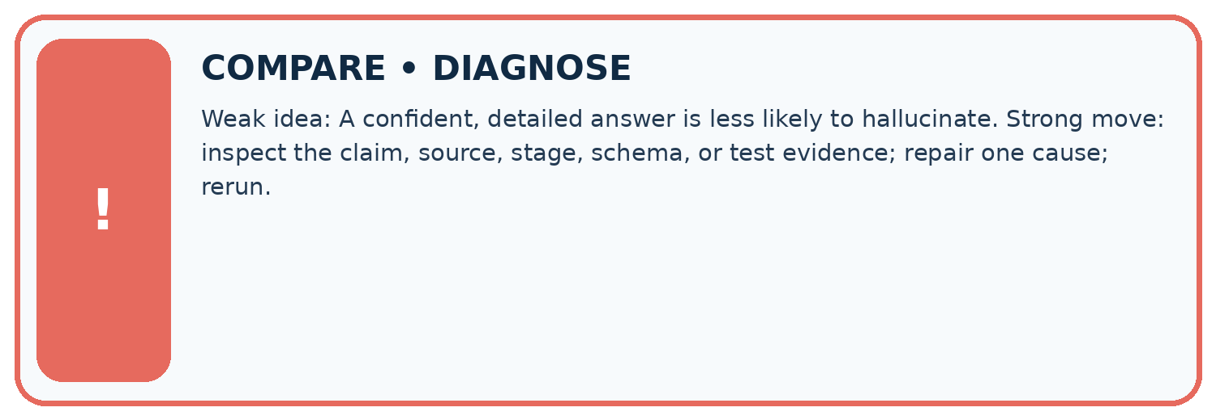
Evidence record | Expected | Actual | Likely cause / next test
normal case | works
boundary case | stated rule
missing input | safe response
fresh transfer | generalizes
Repair one cause. Why is this repair better than changing several things?

Write or draw your reasoning and evidence.
________________________________________________________________
________________________________________________________________
________________________________________________________________
________________________________________________________________
________________________________________________________________

A closer explanation
Complete the supported workbook tasks before attempting W4 independently. Record any hints or help used. After feedback, use the teacher's fresh retry rather than copying the earlier answer. For a project, select a relevant new case, predict the outcome from the declared rule and preserve the result alongside any revision.

Exit: propose one revealing change to the worked scenario. State the expected outcome and the evidence that would make you revise your explanation.
________________________________________________________________
________________________________________________________________
________________________________________________________________
________________________________________________________________
________________________________________________________________

08. Practise together
LOGIC STUDIO
Specify Before You Run
Prompts, schemas, retrieval, tool calls, and code are inspectable parts of one AI product.

SET task, audience, constraints, output_schema
LOAD approved_context or retrieval_result
CALL model or allowed_tool
VALIDATE fields, claims, citations, and safety
IF evidence missing: ask, retrieve, or abstain
RETURN useful output + source trail + limitations
Trace one input. Which line changes the state or chooses a path?

Write or draw your reasoning and evidence.
________________________________________________________________
________________________________________________________________
________________________________________________________________
________________________________________________________________
________________________________________________________________

A closer explanation
Source agreement and arithmetic validity are separate checks; missing evidence is not proof of the opposite claim.
A useful check asks what would make the reasoning fail. Distinguish a failure to execute the declared procedure from a weakness in the procedure itself. The first may require a correction; the second requires an explicitly revised method and new evidence. Preserve unsuccessful cases so an improved result cannot hide the original problem.

Guided: restate the worked result, then name the assumption or limitation that prevents a broader conclusion.
________________________________________________________________
________________________________________________________________
________________________________________________________________
________________________________________________________________
________________________________________________________________

Practise with less help: Trace the worked case
Use workbook W2 for the connected example “Generation failures and verification”. First fill the input and rule boxes. Try the middle steps before asking for a hint. After a hint, try the next step yourself.
Plan | Do | Check
What is given? Which rule or procedure applies? | Record each intermediate step. | Does the result follow? What remains unknown?
Explain your trace to a partner. Your partner points to one step to check. Swap roles on the next case. Each person writes their own explanation.

Check your reasoning
Use the worked case for Generation failures and verification. Proposed explanation: “The worked result establishes every future case”. Decide whether this explanation is supported. Point to the step or supplied fact that decides; explain your repair if needed.
Answer on your own before discussion. If you are unsure, say which step you need help with.

Explain the picture
Can we conclude there will definitely be no lunch from S alone?

My explanation using a pictured step and the given facts
________________________________________________________________
________________________________________________________________
________________________________________________________________
________________________________________________________________
This is supported practice. Keep the separately named independent case for an attempt before feedback.

09. Run the investigation
EVIDENCE LAB
Predict → Test → Record → Explain
Keep expected and actual results separate. Surprises are useful data when recorded honestly.
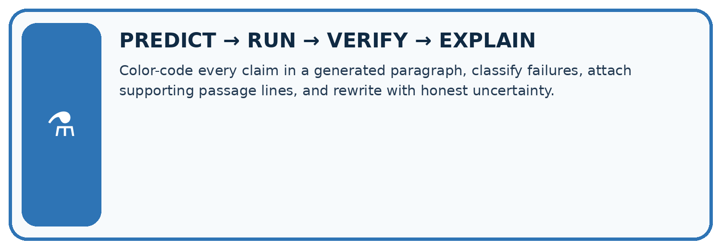
Color-code every claim in a generated paragraph, classify failures, attach supporting passage lines, and rewrite with honest uncertainty.
Test / input | Prediction | Actual | Evidence / calculation | Change or keep?
normal
boundary
missing
fresh transfer
What did the hardest test teach you that the normal test did not?

Write or draw your reasoning and evidence.
________________________________________________________________
________________________________________________________________
________________________________________________________________
________________________________________________________________
________________________________________________________________

Plan → try → check
Before trying: what do I expect, and why? While trying: which step could first go wrong? Afterwards: what did I actually observe, and what should change? Keep “not run” if you only traced the procedure.

10. Build your understanding
MASTERY
From Knowing the Word to Owning the Idea
Move upward only when you can produce evidence without copying the worked example.

1 • NAME: Define the concept without repeating the textbook.
2 • TRACE: Show the information, state, branch, calculation, or evidence path.
3 • APPLY: Solve a different example independently.
4 • CHALLENGE: Find a boundary case, counterexample, or unfair outcome.
5 • EXPLAIN LIMITS: Say when the result should not be trusted or used alone.
My strongest evidence of independent understanding:

Write or draw your reasoning and evidence.
________________________________________________________________
________________________________________________________________
________________________________________________________________
________________________________________________________________
________________________________________________________________

11. Connect your project
CUMULATIVE PROJECT
Verified Study Buddy
Every week adds one inspectable piece. The system must show how it reached a result.
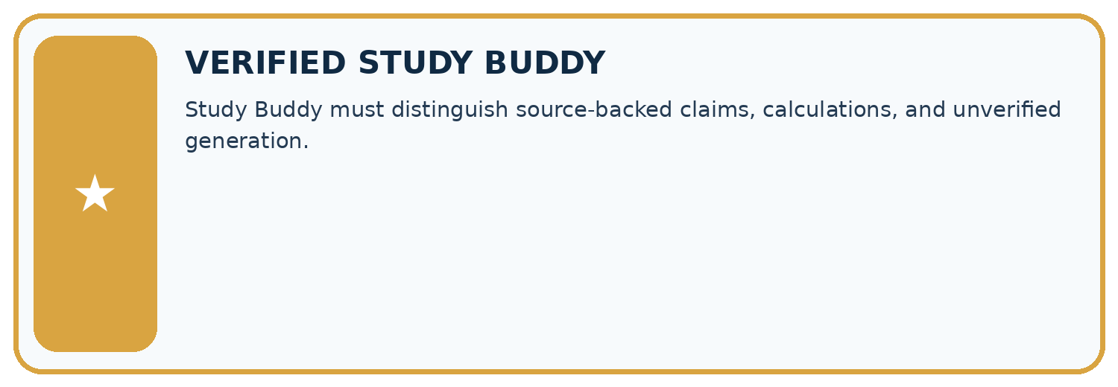
THIS WEEK’S CHECKPOINT Study Buddy must distinguish source-backed claims, calculations, and unverified generation.
SYSTEM MAP Learner need → prompt/schema → approved sources/retrieval → model/tool → structured answer → verification → human decision
What will you add, change, or verify in the project this week?

Write or draw your reasoning and evidence.
________________________________________________________________
________________________________________________________________
________________________________________________________________
________________________________________________________________
________________________________________________________________
What should remain under human control?

Write or draw your reasoning and evidence.
________________________________________________________________
________________________________________________________________
________________________________________________________________
________________________________________________________________
________________________________________________________________
RESPONSIBLE DESIGN Collect only necessary information. Show uncertainty and limits. Never confuse fluent output with verified truth.

Evidence for your project
Audit Study Buddy outputs claim by claim, recording contradiction, missing support and correct calculations separately.

12. Show what you know
INDEPENDENT MASTERY PROOF
Explain • Transfer • Test • Defend
Complete this page without copying the worked example. Your reasoning matters more than decoration.
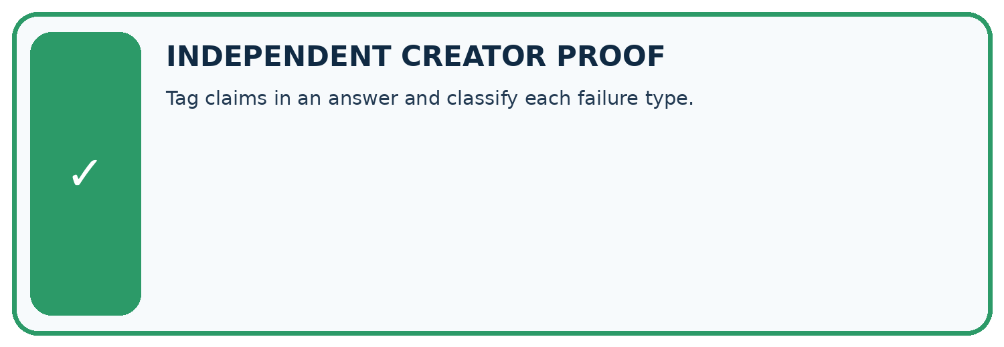
CHALLENGE Tag claims in an answer and classify each failure type.
1. My fresh example, trace, calculation, or design:

Write or draw your reasoning and evidence.
________________________________________________________________
________________________________________________________________
________________________________________________________________
________________________________________________________________
________________________________________________________________
2. My evidence that it works (include a boundary or missing-data case):

Write or draw your reasoning and evidence.
________________________________________________________________
________________________________________________________________
________________________________________________________________
________________________________________________________________
________________________________________________________________
3. One limitation, fairness concern, or situation needing human review:

Write or draw your reasoning and evidence.
________________________________________________________________
________________________________________________________________
________________________________________________________________
________________________________________________________________
________________________________________________________________
SELF-CHECK □ I explained the mechanism □ I used evidence □ I tested a fresh case □ I named a limitation □ I can answer ‘why?’

13. Study a complete case

Week 14 Worked case
Use the supplied details to practise the weekly concept before attempting the independent question. This case extends the illustrated lesson.

The situation
An answer invents a quotation, cites a source lacking it and supplies an impossible date.

The question
Separate the failures and checks.

Worked explanation
Check exact quote text, claim-to-source support and calendar consistency independently. Each failure needs its own correction.

Explain it in your own words
Which detail supports the answer, and why does it matter?

Write or draw your reasoning and evidence.
________________________________________________________________
________________________________________________________________
________________________________________________________________
________________________________________________________________
________________________________________________________________

Trace the supplied case visually

Different failures require different checks
Evidence or stage | Value or result
Quotation | Locate exact source text
Citation | Check support for the claim
Date | Check source and calendar consistency
Repair | Correct or remove unsupported statements
An answer invents a quotation, cites a source lacking it and supplies an impossible date.
Separate the failures and checks.
Check exact quote text, claim-to-source support and calendar consistency independently. Each failure needs its own correction.

14. Try a new case independently

Independent case: Apply a new case independently
Source S: trip is 18 km; vehicle speed is 6 km/h, constant, excluding stops. Answer says 2 hours, 18 km and includes lunch. Audit and recalculate.

My independent explanation, trace and limits
________________________________________________________________
________________________________________________________________
________________________________________________________________
________________________________________________________________
________________________________________________________________
________________________________________________________________
________________________________________________________________
Attempt this case before feedback. Record any help. Earlier examples below are further practice; a case already practised with feedback cannot establish fresh transfer.

Week 14 Independent application
Close the worked explanation. Apply the idea to this different question without copying.
An answer gives a book title that does not exist and quotes words absent from the cited passage. Identify two failures and a repair.
My answer, with a trace, calculation or supporting evidence

Write or draw your reasoning and evidence.
________________________________________________________________
________________________________________________________________
________________________________________________________________
________________________________________________________________
________________________________________________________________

Create and test
Change one relevant detail. Predict the result before testing. Include a boundary or missing-information case when it helps reveal a limit.
My changed input and expected result

Write or draw your reasoning and evidence.
________________________________________________________________
________________________________________________________________
________________________________________________________________
________________________________________________________________
________________________________________________________________

Connect to your project
Study Buddy must distinguish source-backed claims, calculations, and unverified generation.
The evidence I will keep

Write or draw your reasoning and evidence.
________________________________________________________________
________________________________________________________________
________________________________________________________________
________________________________________________________________
________________________________________________________________
Your teacher has the independent answer and scoring criteria. Complete the matching workbook week to keep your practice evidence together.

Transfer practice from the original programme
A generated answer contains a nonexistent quote, a real source unrelated to the claim and a correct sum using the wrong input. Classify the three failures and their repairs.

Explain the mechanism, evidence and one limit.
________________________________________________________________
________________________________________________________________
________________________________________________________________
________________________________________________________________
________________________________________________________________
________________________________________________________________
________________________________________________________________

Use feedback to improve
Attempt the independent case before hints. Record whether you worked alone, used a hint or followed a model. After feedback, fix the first unsupported step and explain why it changed. A later check uses a changed case, not a copied answer.

15. Your lesson route
Start with this question: A fictional Study Buddy drafts a field-trip summary from one approved record.
By the end, I can | How I will show it
Explain the mechanism and terminology of generation failures and verification | Explain the deciding step, show a trace or test, and state one limit.
Apply the stated procedure to a new case with a traceable result | Explain the deciding step, show a trace or test, and state one limit.
Identify an assumption or limitation and design a revealing follow-up | Explain the deciding step, show a trace or test, and state one limit.
Remember → watch and explain → try with help → investigate → try independently → keep project evidence. Your teacher may spread this lesson across several classes.
Keep your first prediction. Compare it with what the evidence shows and explain any change.

16. Finish and return
Close your notes. Explain this goal in your own words: Explain the mechanism and terminology of generation failures and verification

My deciding step, evidence and one remaining question
________________________________________________________________
________________________________________________________________
________________________________________________________________
________________________________________________________________
________________________________________________________________
If you are unsure, return to the worked picture and explain one arrow. If you are ready, change an input or assumption and justify your prediction.
Save your workbook evidence. At the next review, try a different case before opening your old answer.

17. Supported practice, repair and portfolio
Use this supported practice once, in the browser or on paper. Keep the reserved independent assessment for a separate first attempt before teacher feedback.
A fictional Study Buddy drafts a field-trip summary from one approved record.

Practice 1: explain the deciding evidence
Which labelled step matches this detail? Free lunch has no source; missing evidence is not a confirmed no-lunch fact.
1. Unsupported claim
2. Supported claim
3. Contradicted claim
4. Compute duration

My selected conclusion, deciding fact and explanation
________________________________________________________________
________________________________________________________________
________________________________________________________________
________________________________________________________________
________________________________________________________________
Hint if needed: Read the steps in the pictorial case. Match the supplied detail to the stage that performs or records it.
After your attempt, compare with the supported explanation: Unsupported claim Free lunch has no source; missing evidence is not a confirmed no-lunch fact. Different errors need different repairs. Recalculate the duration; keep the supported departure; remove or seek evidence for lunch. These categories are more informative than calling the whole answer wrong. Arithmetic inherits assumptions such as constant speed and no stops, so avoid turning the three-hour walking calculation into a guaranteed arrival time.

Practice 2: explain the deciding evidence
Changed-case practice: Add a planned 30-minute stop while preserving speed and distance. Which conclusion is supported by the supplied facts?
1. We can decide the result without examining the changed input or the procedure.
2. Planned total elapsed time becomes 3.5 hours.
3. This one example guarantees correct results for every future input.

My selected conclusion, deciding fact and explanation
________________________________________________________________
________________________________________________________________
________________________________________________________________
________________________________________________________________
________________________________________________________________
Hint if needed: Use the changed condition and the deciding step in the pictorial trace. The answer must say what follows from those facts.
After your attempt, compare with the supported explanation: Planned total elapsed time becomes 3.5 hours. Three moving hours plus half an hour stopped; walking-time calculation itself stays three.

Repair a missing building block
Review Multimodal Evidence (ai-3/13). Goal: Explain the mechanism and terminology of speech pipelines and multimodal evidence. Short practice: Why were both “exactly three” and “exactly five” unsupported before opening the box?. Return to this week and explain what you changed.
Review Visual Composition (ai-3/11). Goal: Explain the mechanism and terminology of image generation and provenance. Short practice: Which checks pass after that single change, and what still needs repair?. Return to this week and explain what you changed.
Review Structured Output and Schemas (ai-3/8). Goal: Separate JSON parsing, schema validation and source support checks. Short practice: Which object demonstrates that valid JSON and valid types are insufficient for truth?. Return to this week and explain what you changed.

Keep your completed work
Use Download completed work in the hosted lesson to export your answers, reflections, practice feedback and code-run evidence. Open the HTML copy to read or print it. Drafts stay in this browser when storage is available; clear drafts on a shared device.

