AI ACADEMY · STUDENT · ai-3/21

Tools and APIs
Project: Verified Study Buddy

Before you start
AI-2 Week 30: tools have task-specific permissions.

01. Your mission

Your learning target
I can explain the mechanism and terminology of tools and api contracts.
I can apply the stated procedure to a new case with a traceable result.
I can identify an assumption or limitation and design a revealing follow-up.

Remember before reading
Close your notes first. A rough first answer helps us choose the right starting point; it is not a score for your ability.
Without opening the old lesson, explain one key idea from Conversation State and Memory. Give an example and a mistake that the idea helps you avoid.
Without opening the old lesson, explain one key idea from Retrieval Augmented Generation. Give an example and a mistake that the idea helps you avoid.
Without opening the old lesson, explain one key idea from Source Quality. Give an example and a mistake that the idea helps you avoid.
After trying, check the relevant lesson or ask your teacher. Change the part of your explanation that the evidence shows was wrong.
Week 21: Tools and APIs
A tool call is a structured request to an external capability with returned data.
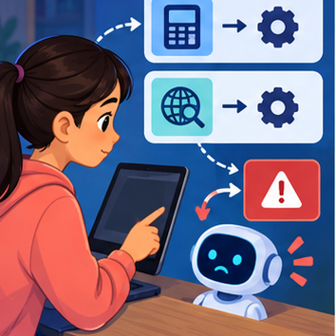
CREATOR MISSION
Match tool schemas to requests and handle one failure.
Creator name and date:

Write or draw your reasoning and evidence.
________________________________________________________________
________________________________________________________________
________________________________________________________________
________________________________________________________________
________________________________________________________________

Readiness for the connected explanation
Recall Prompt injection boundaries. Explain why a recorded result needs its input conditions and evidence source before it can support a claim.

This week’s end goal
By the end, I can explain tools and apis using a traced example and a stated limitation.

02. Notice the evidence
PICTURE STORY
Notice → Predict → Explain
Begin with visible evidence. Do not explain more than the picture and information support.
MYSTERY
The learners must use tools and apis to solve a problem. What information do they have? What decision or calculation do they make? What would count as evidence that it worked?
Three observations (what you can point to):

Write or draw your reasoning and evidence.
________________________________________________________________
________________________________________________________________
________________________________________________________________
________________________________________________________________
________________________________________________________________
My prediction and the clue supporting it:

Write or draw your reasoning and evidence.
________________________________________________________________
________________________________________________________________
________________________________________________________________
________________________________________________________________
________________________________________________________________

A closer explanation
Tools expose structured operations with input and output contracts. Generating a tool call is a proposal; validation and authorisation decide whether it executes.
Begin by writing the question the procedure is intended to answer. Identify the information already supplied, the information it will produce and the information still missing. These are constructed classroom examples; they do not require live accounts, private records or an external service. Do not treat a plausible explanation as a measured outcome.

03. See how it works
VISUAL MECHANISM
Input → Process → Output
Trace the information. At each stage, ask what changed and how you could test it.
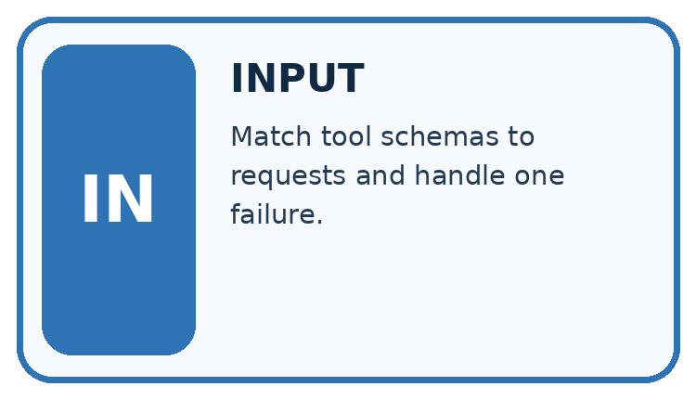
↓
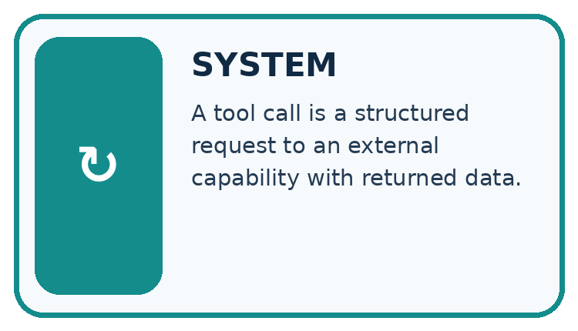
↓
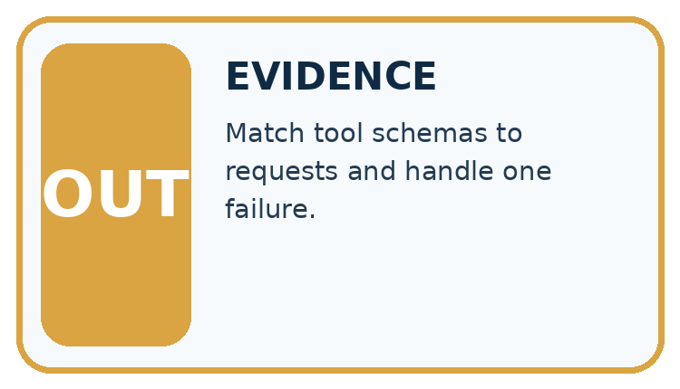
Which stage could fail even when the other two are correct? Explain:

Write or draw your reasoning and evidence.
________________________________________________________________
________________________________________________________________
________________________________________________________________
________________________________________________________________
________________________________________________________________

A closer explanation
For lookup_room accept exactly room_id as a nonempty string; return found plus capacity or a not-found result. It is read-only. Reject unknown arguments and do not replace missing values with invented facts.

Tools and API contracts — evidence trace
Input and scope | Check or calculation | Conclusion and limit
Proposed call lookup_room has room_id=B and extra argument book=true. | For lookup_room accept exactly room_id as a nonempty string; return found plus capacity or a not-found result. It is read-only. Reject unknown arguments and do not replace missing values with invented facts. | Reject the extra field under the closed input contract. The lookup tool provides no booking authority even if the requested room exists.
The figure connects this chapter's worked input, declared procedure and result. Read the complete worked reasoning for qualifiers and intermediate steps; the abbreviated labels do not replace that reasoning.
Before applying the procedure, write its units, denominator or decision boundary where relevant. A partner should be able to repeat each step using the same inputs. If a required input is absent or violates the stated contract, record that condition explicitly instead of quietly replacing it with a convenient value.

Connect the picture and the explanation
Point to the input, the deciding step and the result in this week’s visual. Explain the same step in ordinary words. A picture helps when you can say what each part represents.

04. Compare the cases
CASE GALLERY
Four Tests, Four Kinds of Evidence
A system is not understood until it survives more than one comfortable example.


NORMAL CASE: predict and name evidence. BOUNDARY CASE: predict and name evidence.


MISSING INFORMATION: predict and name evidence. TRANSFER CASE: predict and name evidence.
Which case is most likely to reveal a hidden assumption? Why?

Write or draw your reasoning and evidence.
________________________________________________________________
________________________________________________________________
________________________________________________________________
________________________________________________________________
________________________________________________________________

Change one thing in the pictured case
Change: Add lend: true to the same call.
Prediction: Reject the call before invoking the tool.
Reason: An extra operation is outside the exact allowed contract, even when book_id is valid.

05. Words that unlock the idea
VOCABULARY LAB
Words You Can Use to Reason
A definition matters when you can recognize the idea, use it, and contrast it with a near-miss.
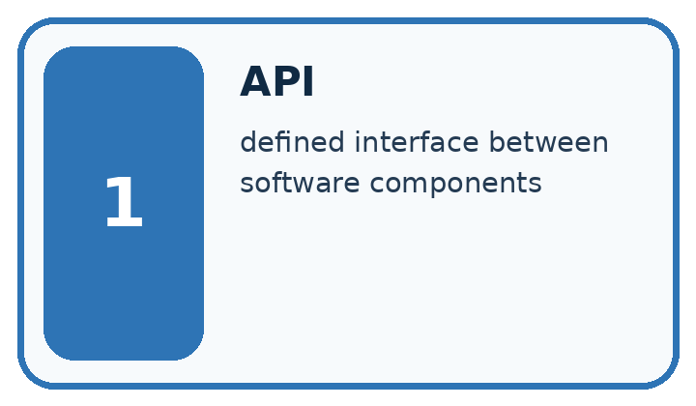
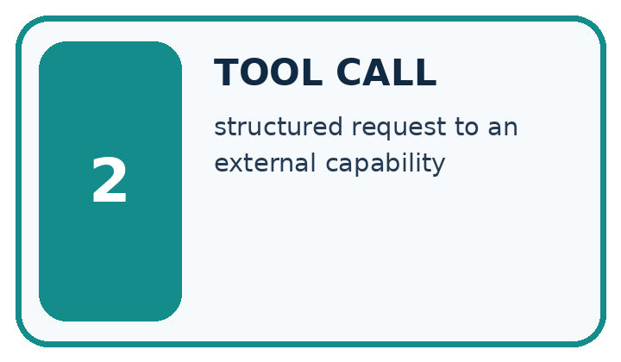
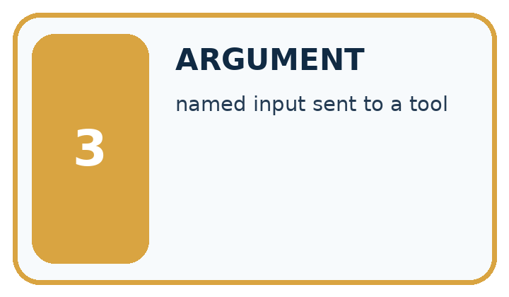
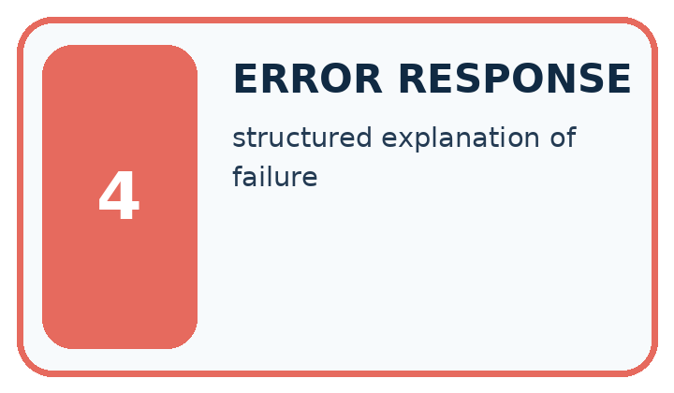
Word | My own example | Not this / boundary
API | An agreed interface through which software requests data or actions from another system.
tool call | A structured request to a tool with specified arguments.
argument | A value supplied to a function or tool to tell it what to operate on.
error response | A message or structured result indicating that a request could not be completed as expected.

Words used in the closer explanation
Word | Meaning
API contract | Declared input, output and failure rules for an interface
Not found | An explicit absence result rather than a fabricated value

06. Follow a worked example
WORKED EVIDENCE
Reason Step by Step
Predict first. Then check each step. A correct answer without visible reasoning is incomplete evidence.
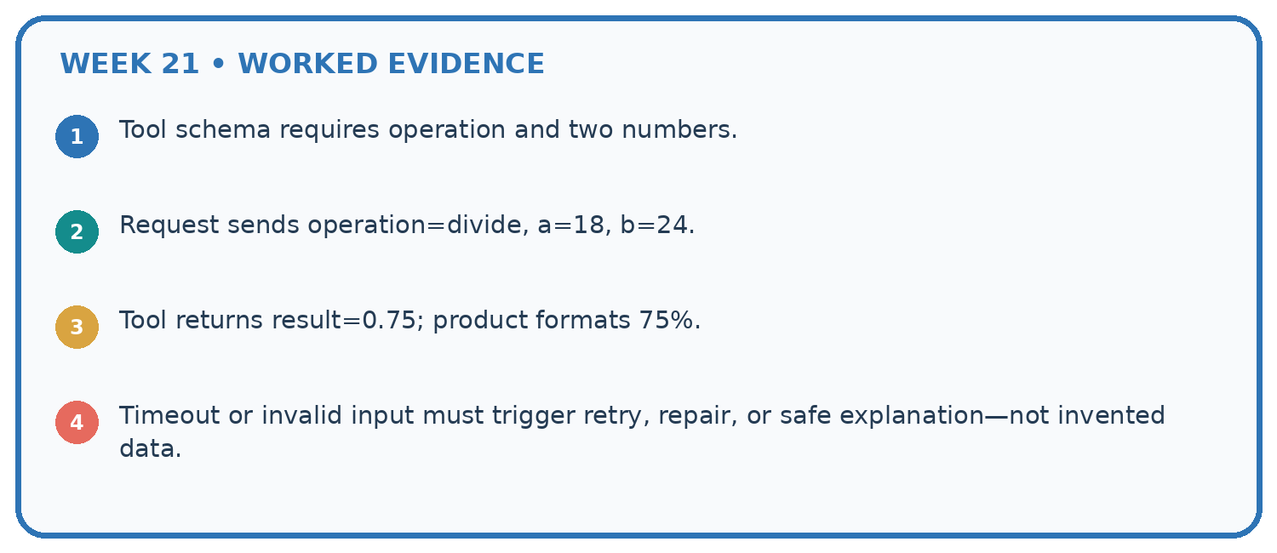
1. Tool schema requires operation and two numbers.
2. Request sends operation=divide, a=18, b=24.
3. Tool returns result=0.75; product formats 75%.
4. Timeout or invalid input must trigger retry, repair, or safe explanation—not invented data.
Recalculate, retrace, or restate the reasoning in your own representation:

Write or draw your reasoning and evidence.
________________________________________________________________
________________________________________________________________
________________________________________________________________
________________________________________________________________
________________________________________________________________
CHECK Did the evidence answer the exact question? Did the total, path, or source record stay consistent?

A closer explanation
Proposed call lookup_room has room_id=B and extra argument book=true.
Reject the extra field under the closed input contract. The lookup tool provides no booking authority even if the requested room exists.
Compare the intermediate evidence with the final statement. Explain why each number or decision follows from the stated inputs. The conclusion belongs to this scenario and procedure; changing the inputs, evaluation population or authority can change what it establishes. Retain the raw record so a later revision can be compared honestly.

Learn from the worked case
Cover the result before checking it. Say what is given, choose the procedure, and follow one step at a time. Then uncover the result and explain your first mismatch. Ask why a step is allowed, not only what number it produces.

A pictorial worked case: Tools and APIs
Check a library lookup call before it reaches a tool.

The facts we will use
lookup_book accepts exactly one field: book_id, a string. Registry IDs are C7 and M2. The proposed call is {book_id: C7}.
All inputs and outcomes in this worked example are invented classroom data; no real model run is claimed.
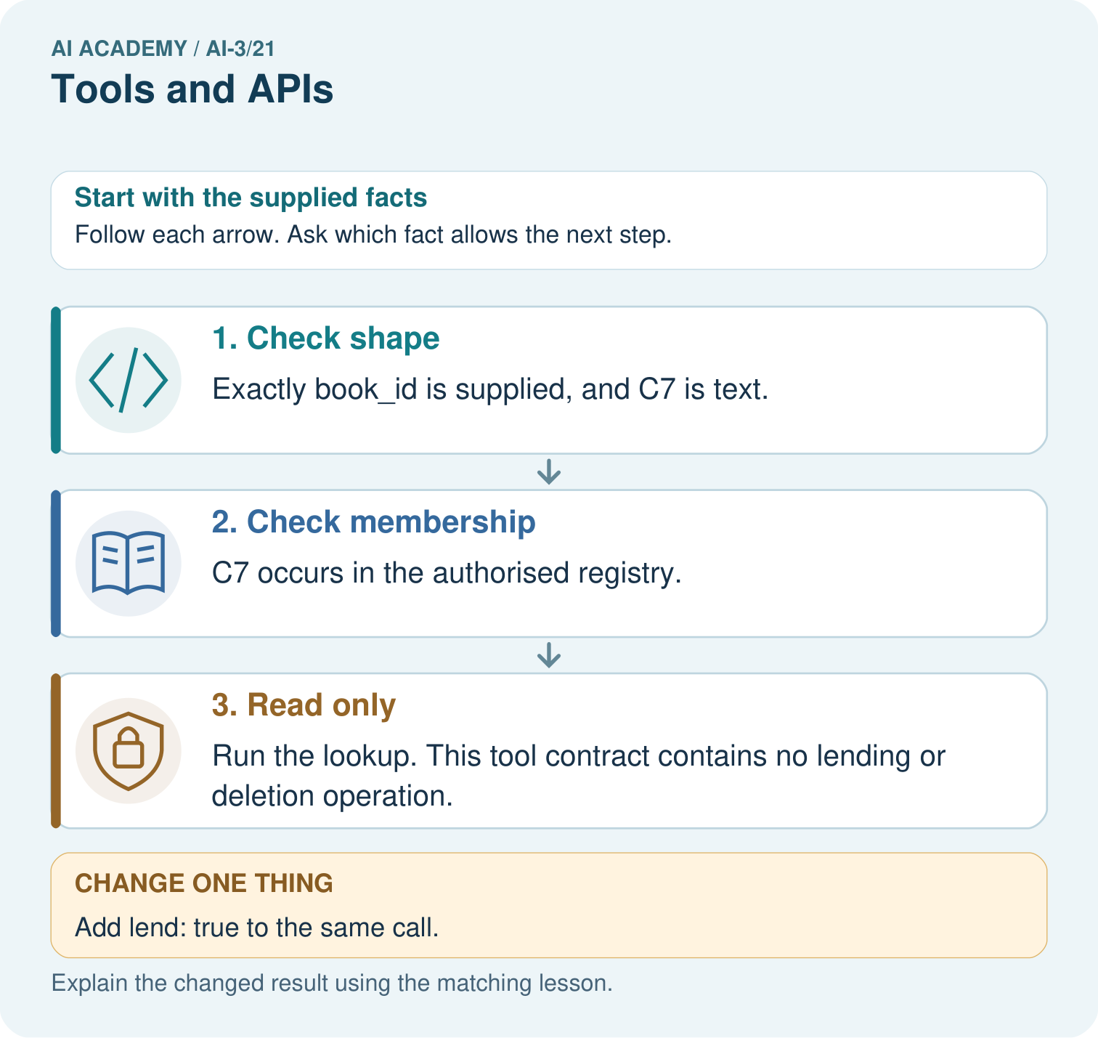

Read the picture one step at a time
Step | What happens and why
1. Check shape | Exactly book_id is supplied, and C7 is text.
2. Check membership | C7 occurs in the authorised registry.
3. Read only | Run the lookup. This tool contract contains no lending or deletion operation.
Match each pictured step to the supplied facts. This is a worked teaching case, not an independent assessment.

Why this result follows
Read the picture in order. Run the lookup. This tool contract contains no lending or deletion operation. The arrows show which recorded input or intermediate result each decision uses. Explain the deciding step aloud before checking the changed case; pointing to the final answer alone does not show how it follows.

What this example does not establish
A valid tool call can still return unavailable or outdated records. Validate the response and access rights separately.
Read the labelled picture: Does a valid C7 ID permit the extra lending action? Point to the relevant step in the picture, then write the changed result and the rule or evidence that supports it.
Change one thing: Add lend: true to the same call. Predict the result before checking the explanation. What remains the same?

07. Find and repair a mistake
ERROR DETECTIVE
Compare → Diagnose → Repair
Do not patch the answer. Find the earliest unsupported assumption, wrong step, or weak evidence.
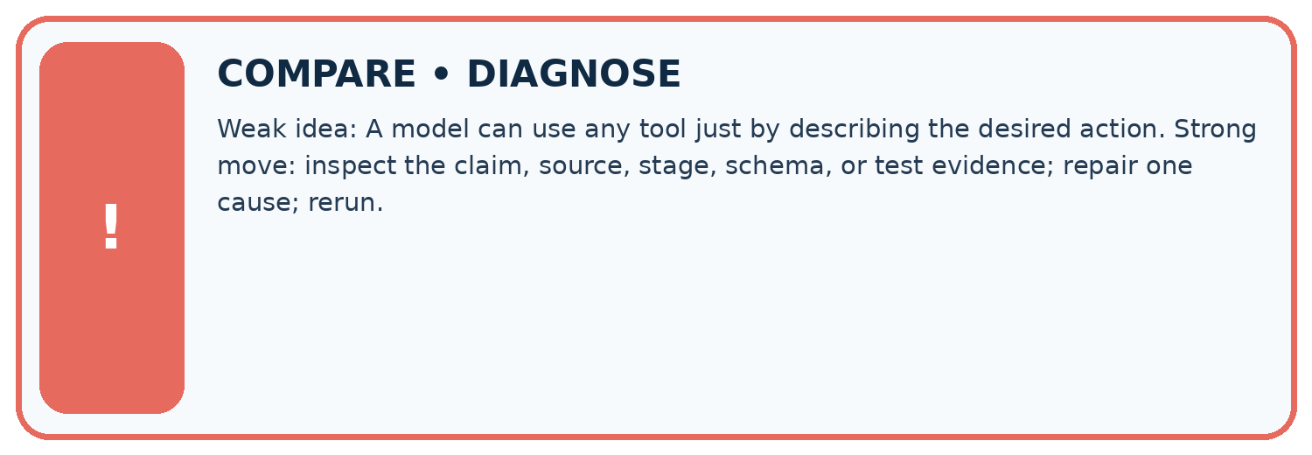
Evidence record | Expected | Actual | Likely cause / next test
normal case | works
boundary case | stated rule
missing input | safe response
fresh transfer | generalizes
Repair one cause. Why is this repair better than changing several things?

Write or draw your reasoning and evidence.
________________________________________________________________
________________________________________________________________
________________________________________________________________
________________________________________________________________
________________________________________________________________

A closer explanation
Complete the supported workbook tasks before attempting W4 independently. Record any hints or help used. After feedback, use the teacher's fresh retry rather than copying the earlier answer. For a project, select a relevant new case, predict the outcome from the declared rule and preserve the result alongside any revision.

Exit: propose one revealing change to the worked scenario. State the expected outcome and the evidence that would make you revise your explanation.
________________________________________________________________
________________________________________________________________
________________________________________________________________
________________________________________________________________
________________________________________________________________

08. Practise together
LOGIC STUDIO
Specify Before You Run
Prompts, schemas, retrieval, tool calls, and code are inspectable parts of one AI product.

SET task, audience, constraints, output_schema
LOAD approved_context or retrieval_result
CALL model or allowed_tool
VALIDATE fields, claims, citations, and safety
IF evidence missing: ask, retrieve, or abstain
RETURN useful output + source trail + limitations
Trace one input. Which line changes the state or chooses a path?

Write or draw your reasoning and evidence.
________________________________________________________________
________________________________________________________________
________________________________________________________________
________________________________________________________________
________________________________________________________________

A closer explanation
A successful tool result supports only its declared data and operation; it does not authorise subsequent side effects.
A useful check asks what would make the reasoning fail. Distinguish a failure to execute the declared procedure from a weakness in the procedure itself. The first may require a correction; the second requires an explicitly revised method and new evidence. Preserve unsuccessful cases so an improved result cannot hide the original problem.

Guided: restate the worked result, then name the assumption or limitation that prevents a broader conclusion.
________________________________________________________________
________________________________________________________________
________________________________________________________________
________________________________________________________________
________________________________________________________________

Practise with less help: Trace the worked case
Use workbook W2 for the connected example “Tools and API contracts”. First fill the input and rule boxes. Try the middle steps before asking for a hint. After a hint, try the next step yourself.
Plan | Do | Check
What is given? Which rule or procedure applies? | Record each intermediate step. | Does the result follow? What remains unknown?
Explain your trace to a partner. Your partner points to one step to check. Swap roles on the next case. Each person writes their own explanation.

Check your reasoning
Use the worked case for Tools and API contracts. Proposed explanation: “The worked result establishes every future case”. Decide whether this explanation is supported. Point to the step or supplied fact that decides; explain your repair if needed.
Answer on your own before discussion. If you are unsure, say which step you need help with.

Explain the picture
Does a valid C7 ID permit the extra lending action? Point to the relevant step in the picture, then write the changed result and the rule or evidence that supports it.

My explanation using a pictured step and the given facts
________________________________________________________________
________________________________________________________________
________________________________________________________________
________________________________________________________________
This is supported practice. Keep the separately named independent case for an attempt before feedback.

09. Run the investigation
EVIDENCE LAB
Predict → Test → Record → Explain
Keep expected and actual results separate. Surprises are useful data when recorded honestly.
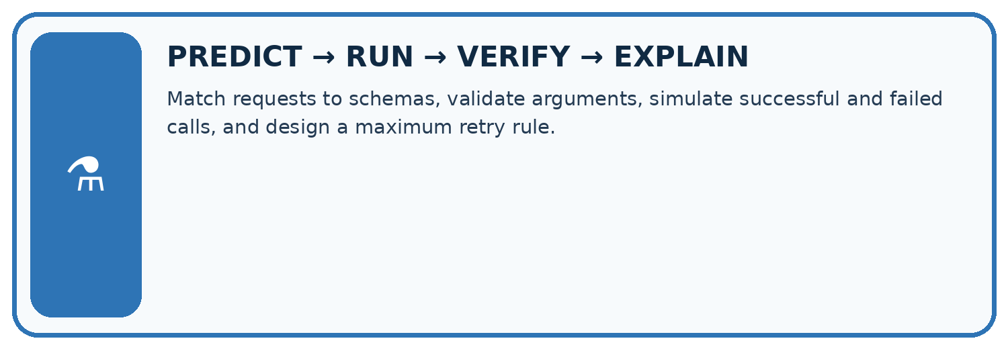
Match requests to schemas, validate arguments, simulate successful and failed calls, and design a maximum retry rule.
Test / input | Prediction | Actual | Evidence / calculation | Change or keep?
normal
boundary
missing
fresh transfer
What did the hardest test teach you that the normal test did not?

Write or draw your reasoning and evidence.
________________________________________________________________
________________________________________________________________
________________________________________________________________
________________________________________________________________
________________________________________________________________

Plan → try → check
Before trying: what do I expect, and why? While trying: which step could first go wrong? Afterwards: what did I actually observe, and what should change? Keep “not run” if you only traced the procedure.

10. Build your understanding
MASTERY
From Knowing the Word to Owning the Idea
Move upward only when you can produce evidence without copying the worked example.

1 • NAME: Define the concept without repeating the textbook.
2 • TRACE: Show the information, state, branch, calculation, or evidence path.
3 • APPLY: Solve a different example independently.
4 • CHALLENGE: Find a boundary case, counterexample, or unfair outcome.
5 • EXPLAIN LIMITS: Say when the result should not be trusted or used alone.
My strongest evidence of independent understanding:

Write or draw your reasoning and evidence.
________________________________________________________________
________________________________________________________________
________________________________________________________________
________________________________________________________________
________________________________________________________________

11. Connect your project
CUMULATIVE PROJECT
Verified Study Buddy
Every week adds one inspectable piece. The system must show how it reached a result.
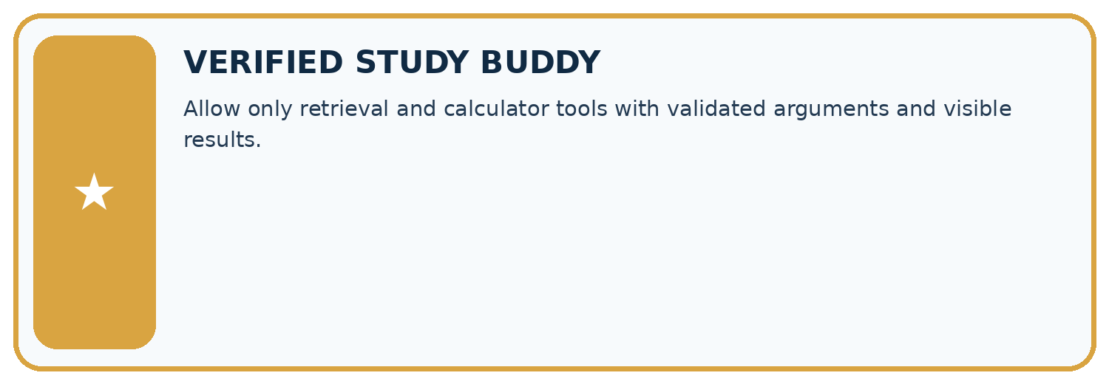
THIS WEEK’S CHECKPOINT Allow only retrieval and calculator tools with validated arguments and visible results.
SYSTEM MAP Learner need → prompt/schema → approved sources/retrieval → model/tool → structured answer → verification → human decision
What will you add, change, or verify in the project this week?

Write or draw your reasoning and evidence.
________________________________________________________________
________________________________________________________________
________________________________________________________________
________________________________________________________________
________________________________________________________________
What should remain under human control?

Write or draw your reasoning and evidence.
________________________________________________________________
________________________________________________________________
________________________________________________________________
________________________________________________________________
________________________________________________________________
RESPONSIBLE DESIGN Collect only necessary information. Show uncertainty and limits. Never confuse fluent output with verified truth.

Evidence for your project
For your Verified Study Buddy, save the input, procedure, observed result and limitation of this check. Label this worked example as practice; use a different, previously unreviewed case when checking independent understanding.

12. Show what you know
INDEPENDENT MASTERY PROOF
Explain • Transfer • Test • Defend
Complete this page without copying the worked example. Your reasoning matters more than decoration.
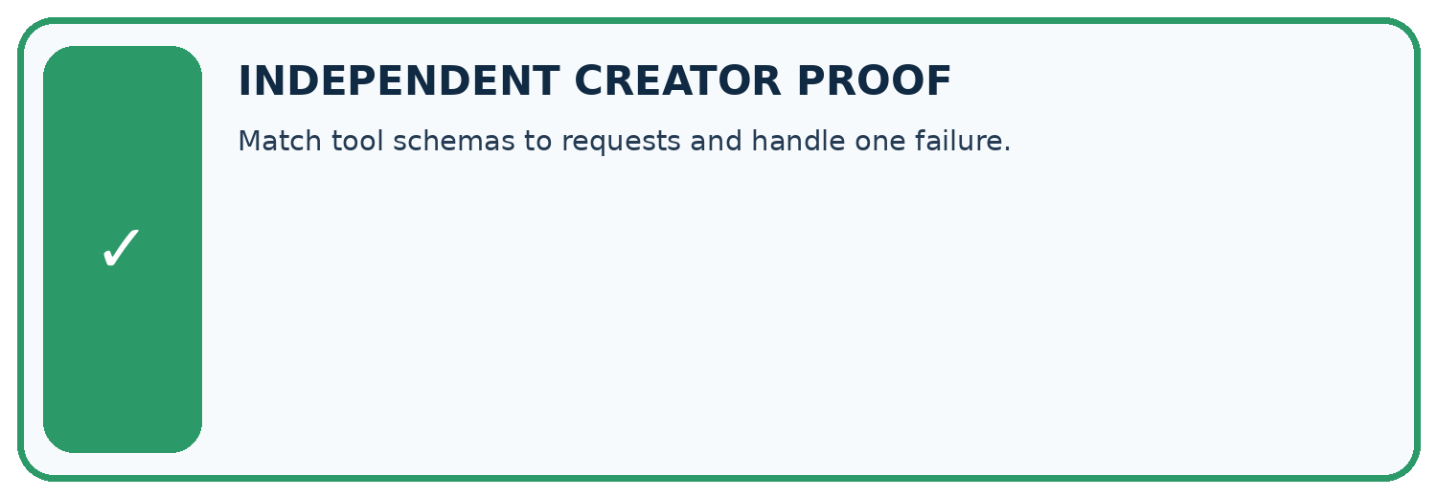
CHALLENGE Match tool schemas to requests and handle one failure.
1. My fresh example, trace, calculation, or design:

Write or draw your reasoning and evidence.
________________________________________________________________
________________________________________________________________
________________________________________________________________
________________________________________________________________
________________________________________________________________
2. My evidence that it works (include a boundary or missing-data case):

Write or draw your reasoning and evidence.
________________________________________________________________
________________________________________________________________
________________________________________________________________
________________________________________________________________
________________________________________________________________
3. One limitation, fairness concern, or situation needing human review:

Write or draw your reasoning and evidence.
________________________________________________________________
________________________________________________________________
________________________________________________________________
________________________________________________________________
________________________________________________________________
SELF-CHECK □ I explained the mechanism □ I used evidence □ I tested a fresh case □ I named a limitation □ I can answer ‘why?’

13. Study a complete case

Week 21 Worked case
Use the supplied details to practise the weekly concept before attempting the independent question. This case extends the illustrated lesson.

The situation
An assistant has calculator and source-search tools. Request: 12 times 9 and habitat definition from a class pack.

The question
Choose and verify tools.

Worked explanation
Calculator returns 108; search retrieves the definition. Verify inputs, outputs and supporting passage before answering.

Explain it in your own words
Which detail supports the answer, and why does it matter?

Write or draw your reasoning and evidence.
________________________________________________________________
________________________________________________________________
________________________________________________________________
________________________________________________________________
________________________________________________________________

Trace the supplied case visually

Choose a tool for each subtask
Evidence or stage | Value or result
12 times 9 | Calculator → 108
Habitat definition | Search approved class pack
Before answering | Verify input, result and support
An assistant has calculator and source-search tools. Request: 12 times 9 and habitat definition from a class pack.
Choose and verify tools.
Calculator returns 108; search retrieves the definition. Verify inputs, outputs and supporting passage before answering.

14. Try a new case independently

Independent case: Apply a new case independently
Tool accepts room_id string. Calls are {room_id:7}, {room_id:K} and {room_id:K, delete:true}. Validate; K is absent from the registry.

My independent explanation, trace and limits
________________________________________________________________
________________________________________________________________
________________________________________________________________
________________________________________________________________
________________________________________________________________
________________________________________________________________
________________________________________________________________
Attempt this case before feedback. Record any help. Earlier examples below are further practice; a case already practised with feedback cannot establish fresh transfer.

Week 21 Independent application
Close the worked explanation. Apply the idea to this different question without copying.
A tool can look up book availability and also place an order. The user asks only whether a book is available. Which action is authorized?
My answer, with a trace, calculation or supporting evidence

Write or draw your reasoning and evidence.
________________________________________________________________
________________________________________________________________
________________________________________________________________
________________________________________________________________
________________________________________________________________

Create and test
Change one relevant detail. Predict the result before testing. Include a boundary or missing-information case when it helps reveal a limit.
My changed input and expected result

Write or draw your reasoning and evidence.
________________________________________________________________
________________________________________________________________
________________________________________________________________
________________________________________________________________
________________________________________________________________

Connect to your project
Allow only retrieval and calculator tools with validated arguments and visible results.
The evidence I will keep

Write or draw your reasoning and evidence.
________________________________________________________________
________________________________________________________________
________________________________________________________________
________________________________________________________________
________________________________________________________________
Your teacher has the independent answer and scoring criteria. Complete the matching workbook week to keep your practice evidence together.

Transfer practice from the original programme
A tool can calculate or search supplied notes. The request is 'What is 17×6, and where do roots take up water?' Assign each subtask and describe output checks.

Explain the mechanism, evidence and one limit.
________________________________________________________________
________________________________________________________________
________________________________________________________________
________________________________________________________________
________________________________________________________________
________________________________________________________________
________________________________________________________________

Use feedback to improve
Attempt the independent case before hints. Record whether you worked alone, used a hint or followed a model. After feedback, fix the first unsupported step and explain why it changed. A later check uses a changed case, not a copied answer.

15. Your lesson route
Start with this question: Check a library lookup call before it reaches a tool.
By the end, I can | How I will show it
Explain the mechanism and terminology of tools and api contracts | Explain the deciding step, show a trace or test, and state one limit.
Apply the stated procedure to a new case with a traceable result | Explain the deciding step, show a trace or test, and state one limit.
Identify an assumption or limitation and design a revealing follow-up | Explain the deciding step, show a trace or test, and state one limit.
Remember → watch and explain → try with help → investigate → try independently → keep project evidence. Your teacher may spread this lesson across several classes.
Keep your first prediction. Compare it with what the evidence shows and explain any change.

16. Finish and return
Close your notes. Explain this goal in your own words: Explain the mechanism and terminology of tools and api contracts

My deciding step, evidence and one remaining question
________________________________________________________________
________________________________________________________________
________________________________________________________________
________________________________________________________________
________________________________________________________________
If you are unsure, return to the worked picture and explain one arrow. If you are ready, change an input or assumption and justify your prediction.
Save your workbook evidence. At the next review, try a different case before opening your old answer.

17. Supported practice, repair and portfolio
Use this supported practice once, in the browser or on paper. Keep the reserved independent assessment for a separate first attempt before teacher feedback.
Check a library lookup call before it reaches a tool.

Practice 1: explain the deciding evidence
Which labelled step matches this detail? Run the lookup. This tool contract contains no lending or deletion operation.
1. Check shape
2. Read only
3. Check membership

My selected conclusion, deciding fact and explanation
________________________________________________________________
________________________________________________________________
________________________________________________________________
________________________________________________________________
________________________________________________________________
Hint if needed: Read the steps in the pictorial case. Match the supplied detail to the stage that performs or records it.
After your attempt, compare with the supported explanation: Read only Run the lookup. This tool contract contains no lending or deletion operation. Read the picture in order. Run the lookup. This tool contract contains no lending or deletion operation. The arrows show which recorded input or intermediate result each decision uses. Explain the deciding step aloud before checking the changed case; pointing to the final answer alone does not show how it follows.

Practice 2: explain the deciding evidence
Changed-case practice: Add lend: true to the same call. Which conclusion is supported by the supplied facts?
1. This one example guarantees correct results for every future input.
2. Reject the call before invoking the tool.
3. We can decide the result without examining the changed input or the procedure.

My selected conclusion, deciding fact and explanation
________________________________________________________________
________________________________________________________________
________________________________________________________________
________________________________________________________________
________________________________________________________________
Hint if needed: Use the changed condition and the deciding step in the pictorial trace. The answer must say what follows from those facts.
After your attempt, compare with the supported explanation: Reject the call before invoking the tool. An extra operation is outside the exact allowed contract, even when book_id is valid.

Repair a missing building block
Review Conversation State and Memory (ai-3/20). Goal: Explain the mechanism and terminology of conversation state and retention. Short practice: What is selected_book after the correction and after exit? Point to the relevant step in the picture, then write the changed result and the rule or evidence that supports it.. Return to this week and explain what you changed.
Review Retrieval Augmented Generation (ai-3/18). Goal: Explain the mechanism and terminology of building a grounded answer. Short practice: Which part of the source supports a two-minute melting claim? Point to the relevant step in the picture, then write the changed result and the rule or evidence that supports it.. Return to this week and explain what you changed.
Review Source Quality (ai-3/15). Goal: Explain the mechanism and terminology of conflicting and time-sensitive sources. Short practice: Which source fields must be checked before answering day 9?. Return to this week and explain what you changed.

Keep your completed work
Use Download completed work in the hosted lesson to export your answers, reflections, practice feedback and code-run evidence. Open the HTML copy to read or print it. Drafts stay in this browser when storage is available; clear drafts on a shared device.

