AI ACADEMY · STUDENT · ai-3/32

Human AI Workflow
Project: Verified Study Buddy

Before you start
Week 25: meeting format criteria does not satisfy all learning requirements.

01. Your mission

Your learning target
I can explain the mechanism and terminology of human review and consequential use.
I can apply the stated procedure to a new case with a traceable result.
I can identify an assumption or limitation and design a revealing follow-up.

Remember before reading
Close your notes first. A rough first answer helps us choose the right starting point; it is not a score for your ability.
Without opening the old lesson, explain one key idea from Safety Boundaries. Give an example and a mistake that the idea helps you avoid.
Without opening the old lesson, explain one key idea from Copyright and Provenance. Give an example and a mistake that the idea helps you avoid.
Without opening the old lesson, explain one key idea from Evaluation Sets. Give an example and a mistake that the idea helps you avoid.
After trying, check the relevant lesson or ask your teacher. Change the part of your explanation that the evidence shows was wrong.
Week 32: Human + AI Workflow
Allocate tasks according to strengths, accountability, and verification needs.
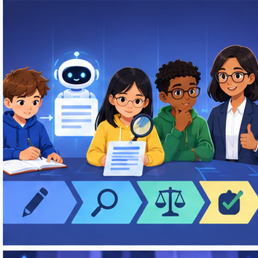
CREATOR MISSION
Map who drafts, checks, decides, and signs off.
Creator name and date:

Write or draw your reasoning and evidence.
________________________________________________________________
________________________________________________________________
________________________________________________________________
________________________________________________________________
________________________________________________________________

Readiness for the connected explanation
Recall Representation and bias evaluation. Explain why a recorded result needs its input conditions and evidence source before it can support a claim.

This week’s end goal
By the end, I can explain human ai workflow using a traced example and a stated limitation.

02. Notice the evidence
PICTURE STORY
Notice → Predict → Explain
Begin with visible evidence. Do not explain more than the picture and information support.
MYSTERY
The learners must use human + ai workflow to solve a problem. What information do they have? What decision or calculation do they make? What would count as evidence that it worked?
Three observations (what you can point to):

Write or draw your reasoning and evidence.
________________________________________________________________
________________________________________________________________
________________________________________________________________
________________________________________________________________
________________________________________________________________
My prediction and the clue supporting it:

Write or draw your reasoning and evidence.
________________________________________________________________
________________________________________________________________
________________________________________________________________
________________________________________________________________
________________________________________________________________

A closer explanation
Human review needs a responsible actor, evidence packet and explicit authority. Adding a person to a workflow does not guarantee effective oversight.
Begin by writing the question the procedure is intended to answer. Identify the information already supplied, the information it will produce and the information still missing. These are constructed classroom examples; they do not require live accounts, private records or an external service. Do not treat a plausible explanation as a measured outcome.

03. See how it works
VISUAL MECHANISM
Input → Process → Output
Trace the information. At each stage, ask what changed and how you could test it.
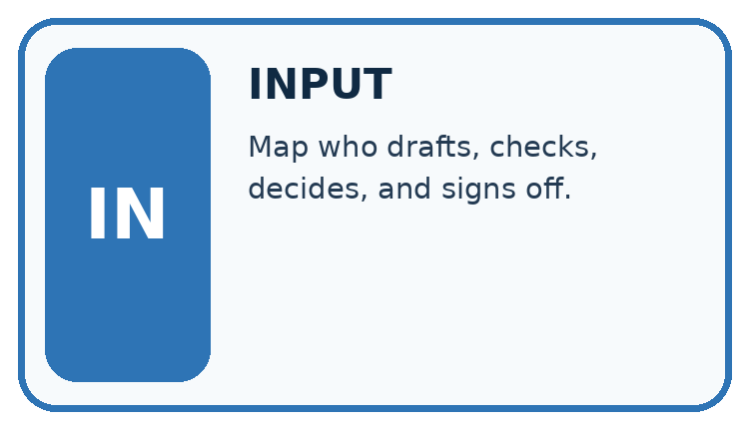
↓
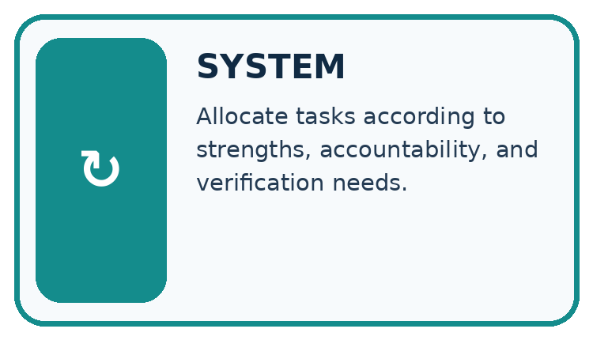
↓
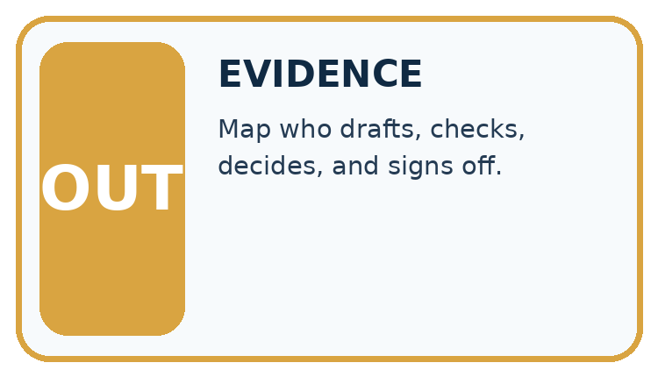
Which stage could fail even when the other two are correct? Explain:

Write or draw your reasoning and evidence.
________________________________________________________________
________________________________________________________________
________________________________________________________________
________________________________________________________________
________________________________________________________________

A closer explanation
For this fictional workflow the assistant drafts a room request but only the coordinator can approve and submit it. Review packets include sources, uncertainty, requested action and the exact version. Any material change requires new approval.

Human review and consequential use — evidence trace
Input and scope | Check or calculation | Conclusion and limit
Coordinator approves draft v1 for room B. Assistant changes room to C in v2 and submits using the old approval. | For this fictional workflow the assistant drafts a room request but only the coordinator can approve and submit it. Review packets include sources, uncertainty, requested action and the exact version. Any material change requires new approval. | The submission violates version-bound approval. Preserve v1 approval, request review of v2 and prevent submission until its exact action is approved.
The figure connects this chapter's worked input, declared procedure and result. Read the complete worked reasoning for qualifiers and intermediate steps; the abbreviated labels do not replace that reasoning.
Before applying the procedure, write its units, denominator or decision boundary where relevant. A partner should be able to repeat each step using the same inputs. If a required input is absent or violates the stated contract, record that condition explicitly instead of quietly replacing it with a convenient value.

Connect the picture and the explanation
Point to the input, the deciding step and the result in this week’s visual. Explain the same step in ordinary words. A picture helps when you can say what each part represents.

04. Compare the cases
CASE GALLERY
Four Tests, Four Kinds of Evidence
A system is not understood until it survives more than one comfortable example.


NORMAL CASE: predict and name evidence. BOUNDARY CASE: predict and name evidence.


MISSING INFORMATION: predict and name evidence. TRANSFER CASE: predict and name evidence.
Which case is most likely to reveal a hidden assumption? Why?

Write or draw your reasoning and evidence.
________________________________________________________________
________________________________________________________________
________________________________________________________________
________________________________________________________________
________________________________________________________________

Change one thing in the pictured case
Change: H2 is replaced with unchanged H1 for classroom printing.
Prediction: The original approval covers that declared action.
Reason: Both the approved content and its distribution scope now match.

05. Words that unlock the idea
VOCABULARY LAB
Words You Can Use to Reason
A definition matters when you can recognize the idea, use it, and contrast it with a near-miss.
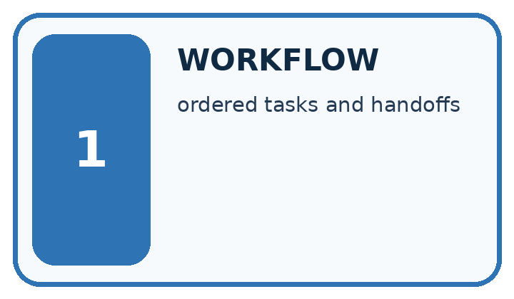
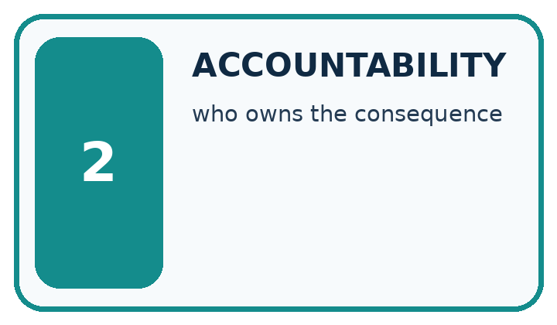
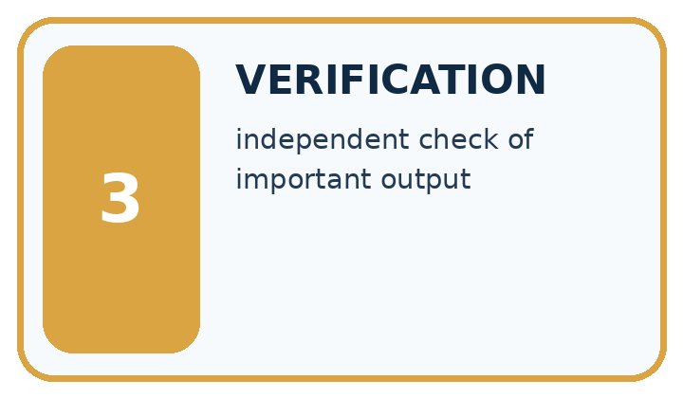
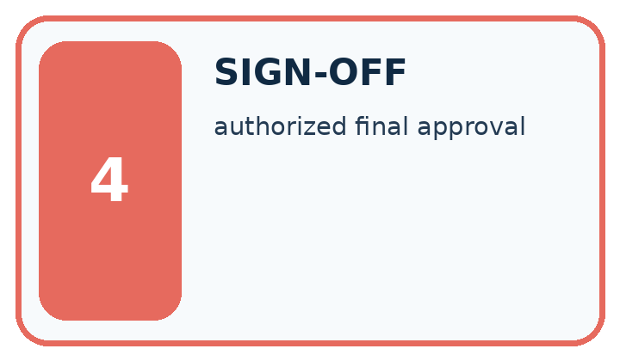
Word | My own example | Not this / boundary
workflow | An organised sequence of tasks, reviews and handoffs used to complete work.
accountability | Responsibility for explaining decisions, checking outcomes and addressing mistakes.
verification | Checking a claim or result against an appropriate independent source, calculation or observation.
sign-off | Explicit recorded approval that specified work meets the required review conditions.

Words used in the closer explanation
Word | Meaning
Review packet | Evidence and proposed action supplied to a reviewer
Version-bound approval | Permission tied to an exact proposal version
Escalation | Routing a decision to an authorised responsible person

06. Follow a worked example
WORKED EVIDENCE
Reason Step by Step
Predict first. Then check each step. A correct answer without visible reasoning is incomplete evidence.
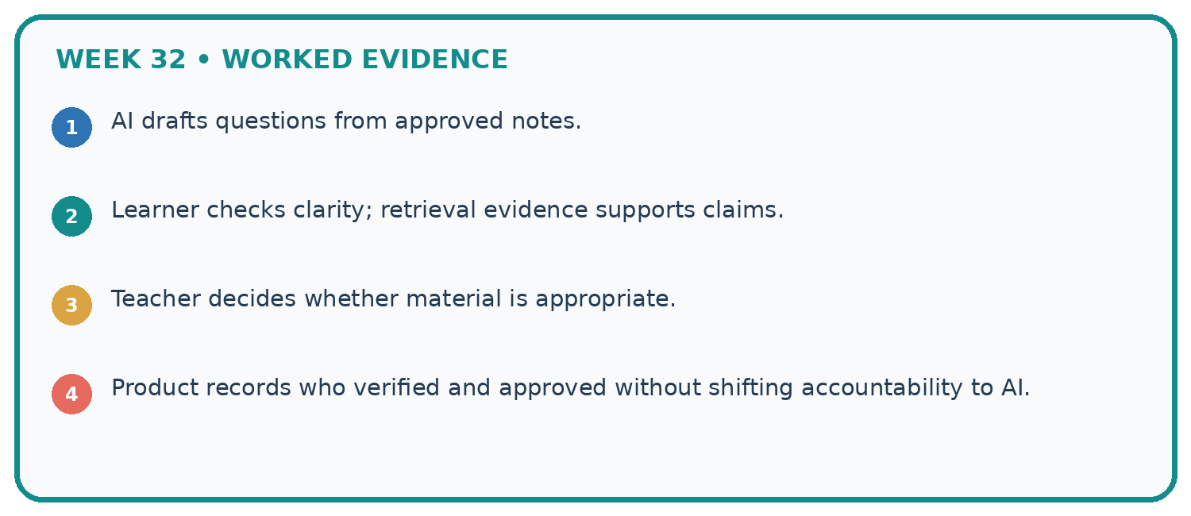
1. AI drafts questions from approved notes.
2. Learner checks clarity; retrieval evidence supports claims.
3. Teacher decides whether material is appropriate.
4. Product records who verified and approved without shifting accountability to AI.
Recalculate, retrace, or restate the reasoning in your own representation:

Write or draw your reasoning and evidence.
________________________________________________________________
________________________________________________________________
________________________________________________________________
________________________________________________________________
________________________________________________________________
CHECK Did the evidence answer the exact question? Did the total, path, or source record stay consistent?

A closer explanation
Coordinator approves draft v1 for room B. Assistant changes room to C in v2 and submits using the old approval.
The submission violates version-bound approval. Preserve v1 approval, request review of v2 and prevent submission until its exact action is approved.
Compare the intermediate evidence with the final statement. Explain why each number or decision follows from the stated inputs. The conclusion belongs to this scenario and procedure; changing the inputs, evaluation population or authority can change what it establishes. Retain the raw record so a later revision can be compared honestly.

Learn from the worked case
Cover the result before checking it. Say what is given, choose the procedure, and follow one step at a time. Then uncover the result and explain your first mismatch. Ask why a step is allowed, not only what number it produces.

A pictorial worked case: Human AI Workflow
A human approval belongs to the exact draft and action reviewed.

The facts we will use
A teacher approves study handout H1 for classroom printing. H2 adds a pupil email address and proposes public posting. No H2 approval exists.
All inputs and outcomes in this worked example are invented classroom data; no real model run is claimed.
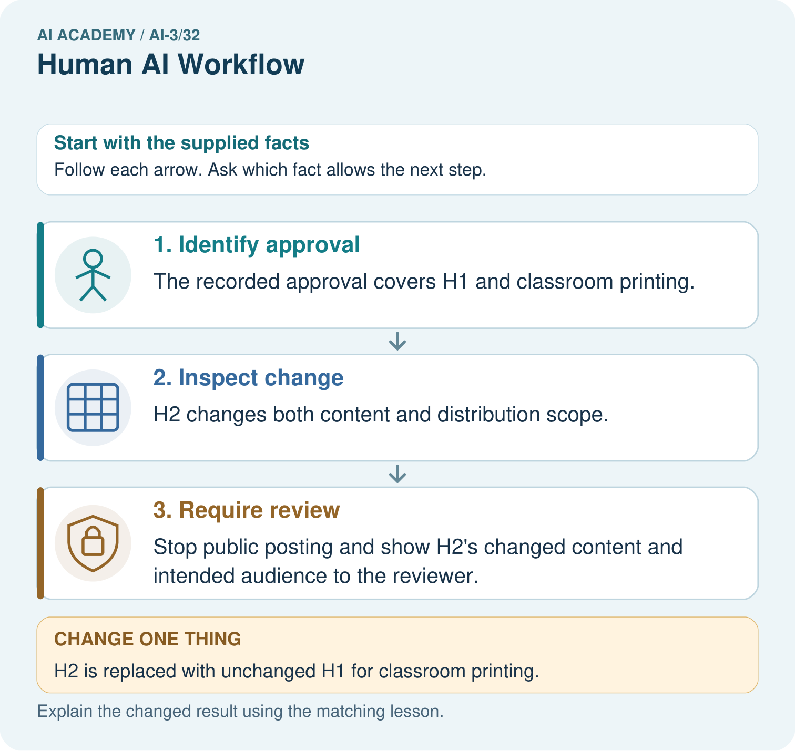

Read the picture one step at a time
Step | What happens and why
1. Identify approval | The recorded approval covers H1 and classroom printing.
2. Inspect change | H2 changes both content and distribution scope.
3. Require review | Stop public posting and show H2’s changed content and intended audience to the reviewer.
Match each pictured step to the supplied facts. This is a worked teaching case, not an independent assessment.

Why this result follows
Read the picture in order. Stop public posting and show H2’s changed content and intended audience to the reviewer. The arrows show which recorded input or intermediate result each decision uses. Explain the deciding step aloud before checking the changed case; pointing to the final answer alone does not show how it follows.

What this example does not establish
Human review helps only when the reviewer sees the material changes, evidence and actual consequences.
Read the labelled picture: Why can H1’s approval not automatically approve H2? Point to the relevant step in the picture, then write the changed result and the rule or evidence that supports it.
Change one thing: H2 is replaced with unchanged H1 for classroom printing. Predict the result before checking the explanation. What remains the same?

07. Find and repair a mistake
ERROR DETECTIVE
Compare → Diagnose → Repair
Do not patch the answer. Find the earliest unsupported assumption, wrong step, or weak evidence.
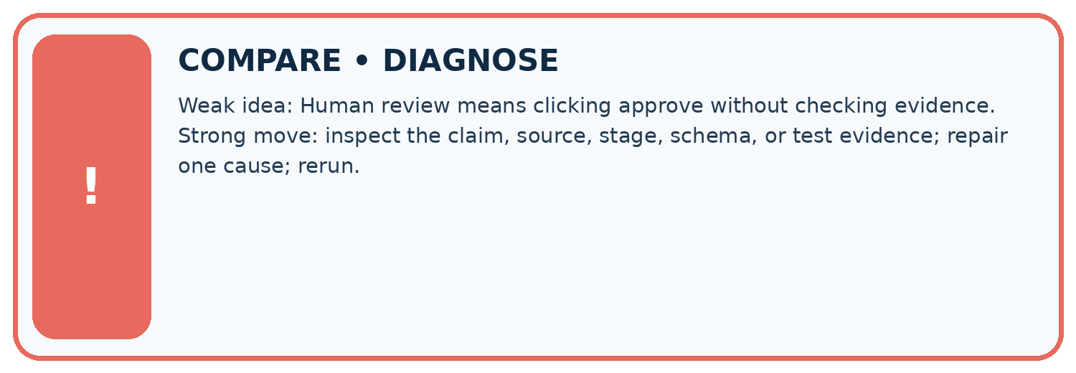
Evidence record | Expected | Actual | Likely cause / next test
normal case | works
boundary case | stated rule
missing input | safe response
fresh transfer | generalizes
Repair one cause. Why is this repair better than changing several things?

Write or draw your reasoning and evidence.
________________________________________________________________
________________________________________________________________
________________________________________________________________
________________________________________________________________
________________________________________________________________

A closer explanation
Complete the supported workbook tasks before attempting W4 independently. Record any hints or help used. After feedback, use the teacher's fresh retry rather than copying the earlier answer. For a project, select a relevant new case, predict the outcome from the declared rule and preserve the result alongside any revision.

Exit: propose one revealing change to the worked scenario. State the expected outcome and the evidence that would make you revise your explanation.
________________________________________________________________
________________________________________________________________
________________________________________________________________
________________________________________________________________
________________________________________________________________

08. Practise together
LOGIC STUDIO
Specify Before You Run
Prompts, schemas, retrieval, tool calls, and code are inspectable parts of one AI product.

SET task, audience, constraints, output_schema
LOAD approved_context or retrieval_result
CALL model or allowed_tool
VALIDATE fields, claims, citations, and safety
IF evidence missing: ask, retrieve, or abstain
RETURN useful output + source trail + limitations
Trace one input. Which line changes the state or chooses a path?

Write or draw your reasoning and evidence.
________________________________________________________________
________________________________________________________________
________________________________________________________________
________________________________________________________________
________________________________________________________________

A closer explanation
Review effectiveness depends on usable evidence, time and authority; a checkbox is not evidence of informed review.
A useful check asks what would make the reasoning fail. Distinguish a failure to execute the declared procedure from a weakness in the procedure itself. The first may require a correction; the second requires an explicitly revised method and new evidence. Preserve unsuccessful cases so an improved result cannot hide the original problem.

Guided: restate the worked result, then name the assumption or limitation that prevents a broader conclusion.
________________________________________________________________
________________________________________________________________
________________________________________________________________
________________________________________________________________
________________________________________________________________

Practise with less help: Trace the worked case
Use workbook W2 for the connected example “Human review and consequential use”. First fill the input and rule boxes. Try the middle steps before asking for a hint. After a hint, try the next step yourself.
Plan | Do | Check
What is given? Which rule or procedure applies? | Record each intermediate step. | Does the result follow? What remains unknown?
Explain your trace to a partner. Your partner points to one step to check. Swap roles on the next case. Each person writes their own explanation.

Check your reasoning
Use the worked case for Human review and consequential use. Proposed explanation: “The worked result establishes every future case”. Decide whether this explanation is supported. Point to the step or supplied fact that decides; explain your repair if needed.
Answer on your own before discussion. If you are unsure, say which step you need help with.

Explain the picture
Why can H1’s approval not automatically approve H2? Point to the relevant step in the picture, then write the changed result and the rule or evidence that supports it.

My explanation using a pictured step and the given facts
________________________________________________________________
________________________________________________________________
________________________________________________________________
________________________________________________________________
This is supported practice. Keep the separately named independent case for an attempt before feedback.

09. Run the investigation
EVIDENCE LAB
Predict → Test → Record → Explain
Keep expected and actual results separate. Surprises are useful data when recorded honestly.
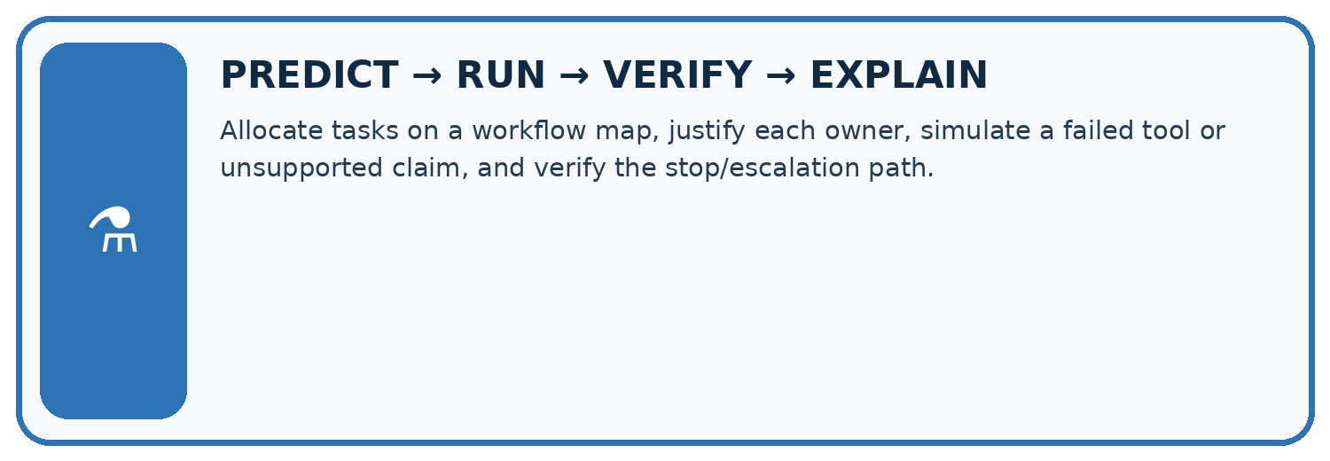
Allocate tasks on a workflow map, justify each owner, simulate a failed tool or unsupported claim, and verify the stop/escalation path.
Test / input | Prediction | Actual | Evidence / calculation | Change or keep?
normal
boundary
missing
fresh transfer
What did the hardest test teach you that the normal test did not?

Write or draw your reasoning and evidence.
________________________________________________________________
________________________________________________________________
________________________________________________________________
________________________________________________________________
________________________________________________________________

Plan → try → check
Before trying: what do I expect, and why? While trying: which step could first go wrong? Afterwards: what did I actually observe, and what should change? Keep “not run” if you only traced the procedure.

10. Build your understanding
MASTERY
From Knowing the Word to Owning the Idea
Move upward only when you can produce evidence without copying the worked example.

1 • NAME: Define the concept without repeating the textbook.
2 • TRACE: Show the information, state, branch, calculation, or evidence path.
3 • APPLY: Solve a different example independently.
4 • CHALLENGE: Find a boundary case, counterexample, or unfair outcome.
5 • EXPLAIN LIMITS: Say when the result should not be trusted or used alone.
My strongest evidence of independent understanding:

Write or draw your reasoning and evidence.
________________________________________________________________
________________________________________________________________
________________________________________________________________
________________________________________________________________
________________________________________________________________

11. Connect your project
CUMULATIVE PROJECT
Verified Study Buddy
Every week adds one inspectable piece. The system must show how it reached a result.
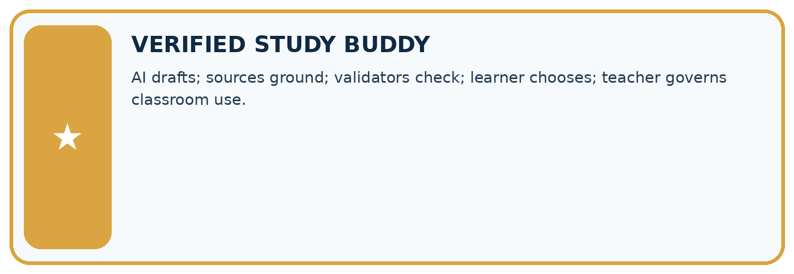
THIS WEEK’S CHECKPOINT AI drafts; sources ground; validators check; learner chooses; teacher governs classroom use.
SYSTEM MAP Learner need → prompt/schema → approved sources/retrieval → model/tool → structured answer → verification → human decision
What will you add, change, or verify in the project this week?

Write or draw your reasoning and evidence.
________________________________________________________________
________________________________________________________________
________________________________________________________________
________________________________________________________________
________________________________________________________________
What should remain under human control?

Write or draw your reasoning and evidence.
________________________________________________________________
________________________________________________________________
________________________________________________________________
________________________________________________________________
________________________________________________________________
RESPONSIBLE DESIGN Collect only necessary information. Show uncertainty and limits. Never confuse fluent output with verified truth.

Evidence for your project
For your Verified Study Buddy, save the input, procedure, observed result and limitation of this check. Label this worked example as practice; use a different, previously unreviewed case when checking independent understanding.

12. Show what you know
INDEPENDENT MASTERY PROOF
Explain • Transfer • Test • Defend
Complete this page without copying the worked example. Your reasoning matters more than decoration.
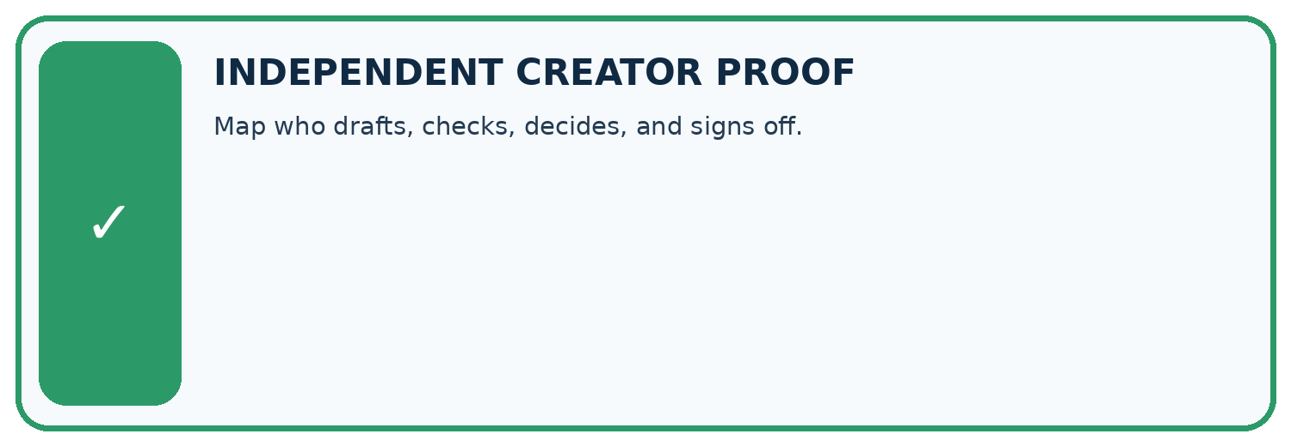
CHALLENGE Map who drafts, checks, decides, and signs off.
1. My fresh example, trace, calculation, or design:

Write or draw your reasoning and evidence.
________________________________________________________________
________________________________________________________________
________________________________________________________________
________________________________________________________________
________________________________________________________________
2. My evidence that it works (include a boundary or missing-data case):

Write or draw your reasoning and evidence.
________________________________________________________________
________________________________________________________________
________________________________________________________________
________________________________________________________________
________________________________________________________________
3. One limitation, fairness concern, or situation needing human review:

Write or draw your reasoning and evidence.
________________________________________________________________
________________________________________________________________
________________________________________________________________
________________________________________________________________
________________________________________________________________
SELF-CHECK □ I explained the mechanism □ I used evidence □ I tested a fresh case □ I named a limitation □ I can answer ‘why?’

13. Study a complete case

Week 32 Worked case
Use the supplied details to practise the weekly concept before attempting the independent question. This case extends the illustrated lesson.

The situation
An AI drafts, verifies and submits a student's assessment without review.

The question
Where should responsibility remain?

Worked explanation
The student reviews, verifies, follows class rules and remains responsible. Submission requires authorisation and must not bypass learning.

Explain it in your own words
Which detail supports the answer, and why does it matter?

Write or draw your reasoning and evidence.
________________________________________________________________
________________________________________________________________
________________________________________________________________
________________________________________________________________
________________________________________________________________

Trace the supplied case visually

Keep the learner responsible
Evidence or stage | Value or result
Task | Student defines permitted help
Draft | Assistant provides support
Review | Student verifies and follows class rules
Submit | Student authorises final work
An AI drafts, verifies and submits a student's assessment without review.
Where should responsibility remain?
The student reviews, verifies, follows class rules and remains responsible. Submission requires authorisation and must not bypass learning.

14. Try a new case independently

Independent case: Apply a new case independently
Teacher approves read-only report R1. System adds email distribution in R2. What permission is missing and what should the reviewer see?

My independent explanation, trace and limits
________________________________________________________________
________________________________________________________________
________________________________________________________________
________________________________________________________________
________________________________________________________________
________________________________________________________________
________________________________________________________________
Attempt this case before feedback. Record any help. Earlier examples below are further practice; a case already practised with feedback cannot establish fresh transfer.

Week 32 Independent application
Close the worked explanation. Apply the idea to this different question without copying.
A workflow drafts a class email, checks its claims and then sends it. Where should approval occur, and what should the approver see?
My answer, with a trace, calculation or supporting evidence

Write or draw your reasoning and evidence.
________________________________________________________________
________________________________________________________________
________________________________________________________________
________________________________________________________________
________________________________________________________________

Create and test
Change one relevant detail. Predict the result before testing. Include a boundary or missing-information case when it helps reveal a limit.
My changed input and expected result

Write or draw your reasoning and evidence.
________________________________________________________________
________________________________________________________________
________________________________________________________________
________________________________________________________________
________________________________________________________________

Connect to your project
AI drafts; sources ground; validators check; learner chooses; teacher governs classroom use.
The evidence I will keep

Write or draw your reasoning and evidence.
________________________________________________________________
________________________________________________________________
________________________________________________________________
________________________________________________________________
________________________________________________________________
Your teacher has the independent answer and scoring criteria. Complete the matching workbook week to keep your practice evidence together.

Transfer practice from the original programme
A student asks a helper to submit an unchecked generated essay under their name. Design a workflow that preserves student reasoning and follows classroom rules.

Explain the mechanism, evidence and one limit.
________________________________________________________________
________________________________________________________________
________________________________________________________________
________________________________________________________________
________________________________________________________________
________________________________________________________________
________________________________________________________________

Use feedback to improve
Attempt the independent case before hints. Record whether you worked alone, used a hint or followed a model. After feedback, fix the first unsupported step and explain why it changed. A later check uses a changed case, not a copied answer.

15. Your lesson route
Start with this question: A human approval belongs to the exact draft and action reviewed.
By the end, I can | How I will show it
Explain the mechanism and terminology of human review and consequential use | Explain the deciding step, show a trace or test, and state one limit.
Apply the stated procedure to a new case with a traceable result | Explain the deciding step, show a trace or test, and state one limit.
Identify an assumption or limitation and design a revealing follow-up | Explain the deciding step, show a trace or test, and state one limit.
Remember → watch and explain → try with help → investigate → try independently → keep project evidence. Your teacher may spread this lesson across several classes.
Keep your first prediction. Compare it with what the evidence shows and explain any change.

16. Finish and return
Close your notes. Explain this goal in your own words: Explain the mechanism and terminology of human review and consequential use

My deciding step, evidence and one remaining question
________________________________________________________________
________________________________________________________________
________________________________________________________________
________________________________________________________________
________________________________________________________________
If you are unsure, return to the worked picture and explain one arrow. If you are ready, change an input or assumption and justify your prediction.
Save your workbook evidence. At the next review, try a different case before opening your old answer.

17. Supported practice, repair and portfolio
Use this supported practice once, in the browser or on paper. Keep the reserved independent assessment for a separate first attempt before teacher feedback.
A human approval belongs to the exact draft and action reviewed.

Practice 1: explain the deciding evidence
Which labelled step matches this detail? Stop public posting and show H2’s changed content and intended audience to the reviewer.
1. Identify approval
2. Require review
3. Inspect change

My selected conclusion, deciding fact and explanation
________________________________________________________________
________________________________________________________________
________________________________________________________________
________________________________________________________________
________________________________________________________________
Hint if needed: Read the steps in the pictorial case. Match the supplied detail to the stage that performs or records it.
After your attempt, compare with the supported explanation: Require review Stop public posting and show H2’s changed content and intended audience to the reviewer. Read the picture in order. Stop public posting and show H2’s changed content and intended audience to the reviewer. The arrows show which recorded input or intermediate result each decision uses. Explain the deciding step aloud before checking the changed case; pointing to the final answer alone does not show how it follows.

Practice 2: explain the deciding evidence
Changed-case practice: H2 is replaced with unchanged H1 for classroom printing. Which conclusion is supported by the supplied facts?
1. This one example guarantees correct results for every future input.
2. The original approval covers that declared action.
3. We can decide the result without examining the changed input or the procedure.

My selected conclusion, deciding fact and explanation
________________________________________________________________
________________________________________________________________
________________________________________________________________
________________________________________________________________
________________________________________________________________
Hint if needed: Use the changed condition and the deciding step in the pictorial trace. The answer must say what follows from those facts.
After your attempt, compare with the supported explanation: The original approval covers that declared action. Both the approved content and its distribution scope now match.

Repair a missing building block
Review Safety Boundaries (ai-3/31). Goal: Explain the mechanism and terminology of untrusted input boundaries. Short practice: If AB7 passes the pattern, may it access teacher-only material? Point to the relevant step in the picture, then write the changed result and the rule or evidence that supports it.. Return to this week and explain what you changed.
Review Copyright and Provenance (ai-3/29). Goal: Explain the mechanism and terminology of copyright and permitted sources. Short practice: Does acknowledging Fern make a cropped version permitted? Point to the relevant step in the picture, then write the changed result and the rule or evidence that supports it.. Return to this week and explain what you changed.
Review Evaluation Sets (ai-3/26). Goal: Explain the mechanism and terminology of system evaluation sets. Short practice: Did the added cases demonstrate better answering? Point to the relevant step in the picture, then write the changed result and the rule or evidence that supports it.. Return to this week and explain what you changed.

Keep your completed work
Use Download completed work in the hosted lesson to export your answers, reflections, practice feedback and code-run evidence. Open the HTML copy to read or print it. Drafts stay in this browser when storage is available; clear drafts on a shared device.

