AI ACADEMY · STUDENT · ai-3/34

Capstone Build
Project: Verified Study Buddy

Before you start
Week 24: keep intermediate stages inspectable.

01. Your mission

Your learning target
I can explain the mechanism and terminology of capstone grounded assistant.
I can apply the stated procedure to a new case with a traceable result.
I can identify an assumption or limitation and design a revealing follow-up.

Remember before reading
Close your notes first. A rough first answer helps us choose the right starting point; it is not a score for your ability.
Without opening the old lesson, explain one key idea from Capstone Design. Give an example and a mistake that the idea helps you avoid.
Without opening the old lesson, explain one key idea from Safety Boundaries. Give an example and a mistake that the idea helps you avoid.
Without opening the old lesson, explain one key idea from Privacy by Design. Give an example and a mistake that the idea helps you avoid.
After trying, check the relevant lesson or ask your teacher. Change the part of your explanation that the evidence shows was wrong.
Week 34: Capstone Build
Implementation should preserve traceability from requirement to feature.

CREATOR MISSION
Build the smallest complete Study Buddy workflow.
Creator name and date:

Write or draw your reasoning and evidence.
________________________________________________________________
________________________________________________________________
________________________________________________________________
________________________________________________________________
________________________________________________________________

Readiness for the connected explanation
Recall Capstone requirements and corpus. Explain why a recorded result needs its input conditions and evidence source before it can support a claim.

This week’s end goal
By the end, I can explain capstone build using a traced example and a stated limitation.

02. Notice the evidence
PICTURE STORY
Notice → Predict → Explain
Begin with visible evidence. Do not explain more than the picture and information support.
MYSTERY
The learners must use capstone build to solve a problem. What information do they have? What decision or calculation do they make? What would count as evidence that it worked?
Three observations (what you can point to):

Write or draw your reasoning and evidence.
________________________________________________________________
________________________________________________________________
________________________________________________________________
________________________________________________________________
________________________________________________________________
My prediction and the clue supporting it:

Write or draw your reasoning and evidence.
________________________________________________________________
________________________________________________________________
________________________________________________________________
________________________________________________________________
________________________________________________________________

A closer explanation
Build the assistant as a sequence of testable stages: validate request, retrieve authorised evidence, decide answerability, draft, validate and return. Avoid merging all errors into one model score.
Begin by writing the question the procedure is intended to answer. Identify the information already supplied, the information it will produce and the information still missing. These are constructed classroom examples; they do not require live accounts, private records or an external service. Do not treat a plausible explanation as a measured outcome.

03. See how it works
VISUAL MECHANISM
Input → Process → Output
Trace the information. At each stage, ask what changed and how you could test it.
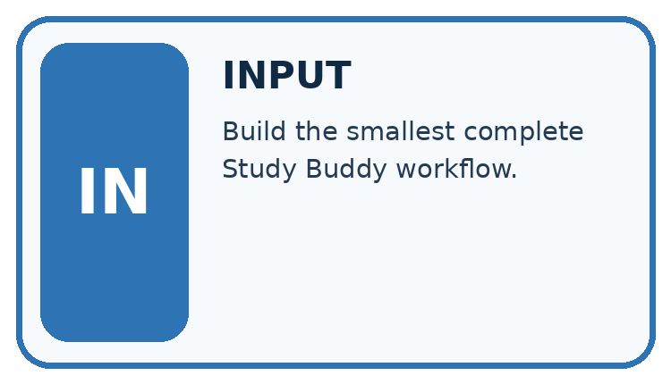
↓
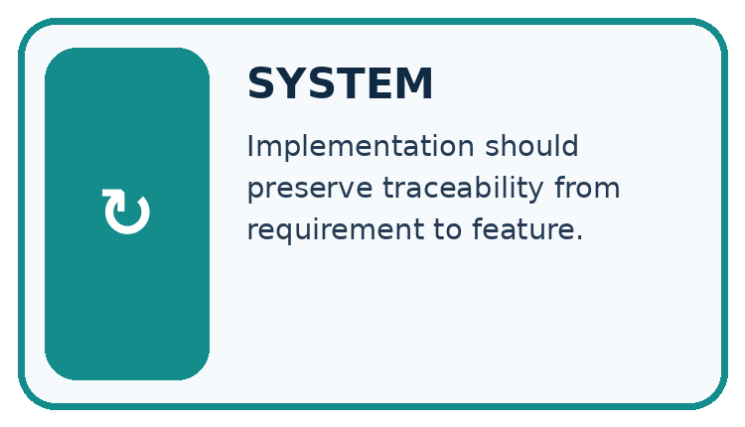
↓
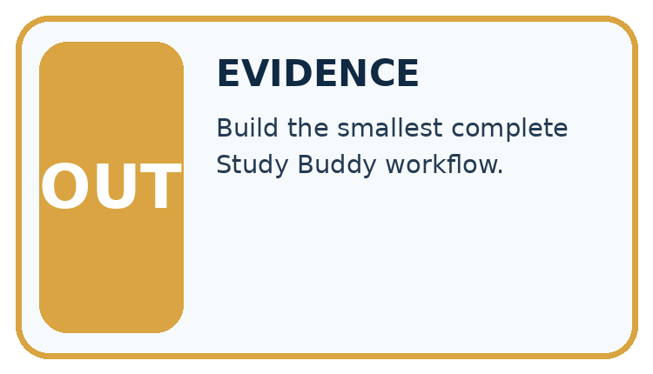
Which stage could fail even when the other two are correct? Explain:

Write or draw your reasoning and evidence.
________________________________________________________________
________________________________________________________________
________________________________________________________________
________________________________________________________________
________________________________________________________________

A closer explanation
A supported response requires current matching approval and register records. Any retrieval or validation failure gives needs_review with null claims. The classroom implementation performs no booking or external action.

Capstone grounded assistant — evidence trace
Input and scope | Check or calculation | Conclusion and limit
Request room B; retrieved approval names B but register names C. Draft gives capacity 10 from C. | A supported response requires current matching approval and register records. Any retrieval or validation failure gives needs_review with null claims. The classroom implementation performs no booking or external action. | Same-room support fails before or during semantic validation. Return needs_review with null claims; the draft capacity is unsupported for B.
The figure connects this chapter's worked input, declared procedure and result. Read the complete worked reasoning for qualifiers and intermediate steps; the abbreviated labels do not replace that reasoning.
Before applying the procedure, write its units, denominator or decision boundary where relevant. A partner should be able to repeat each step using the same inputs. If a required input is absent or violates the stated contract, record that condition explicitly instead of quietly replacing it with a convenient value.

Connect the picture and the explanation
Point to the input, the deciding step and the result in this week’s visual. Explain the same step in ordinary words. A picture helps when you can say what each part represents.

04. Compare the cases
CASE GALLERY
Four Tests, Four Kinds of Evidence
A system is not understood until it survives more than one comfortable example.


NORMAL CASE: predict and name evidence. BOUNDARY CASE: predict and name evidence.


MISSING INFORMATION: predict and name evidence. TRANSFER CASE: predict and name evidence.
Which case is most likely to reveal a hidden assumption? Why?

Write or draw your reasoning and evidence.
________________________________________________________________
________________________________________________________________
________________________________________________________________
________________________________________________________________
________________________________________________________________

Change one thing in the pictured case
Change: E3 supplies losses of 1, 2 and 3 mL.
Prediction: Report those individual losses, not “half” unless starting volumes are also available.
Reason: Absolute losses alone do not establish each cup’s fractional loss.

05. Words that unlock the idea
VOCABULARY LAB
Words You Can Use to Reason
A definition matters when you can recognize the idea, use it, and contrast it with a near-miss.
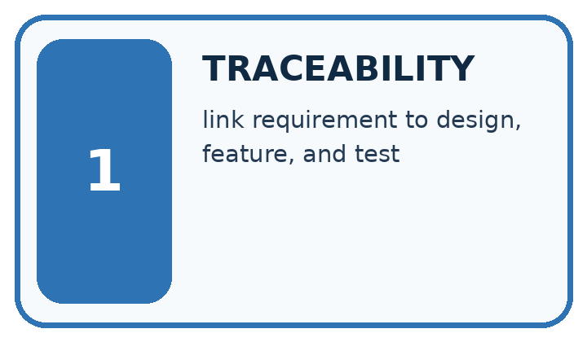
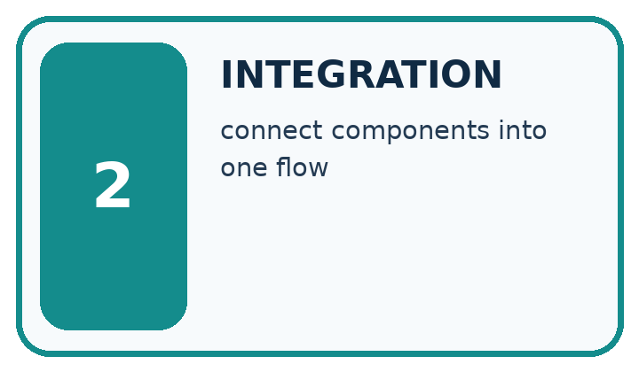
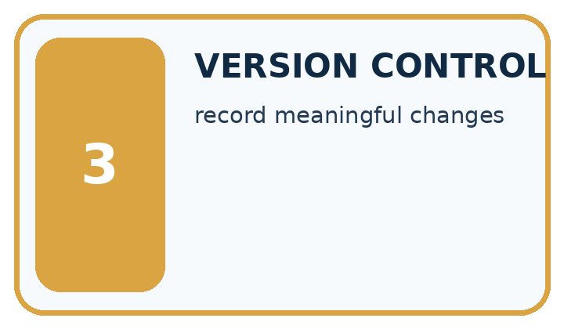
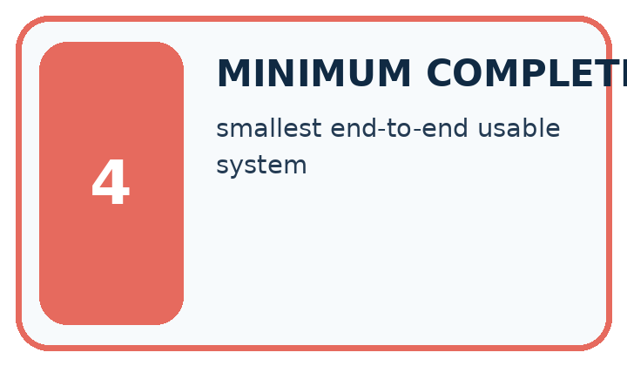
Word | My own example | Not this / boundary
traceability | The ability to connect a result back to its inputs, sources, steps and version.
integration | Connecting components so that they work together through agreed interfaces.
version control | A method for recording and comparing changes to identified versions of files.
minimum complete product | The smallest working version that fulfils its essential user task, including failure handling.

Words used in the closer explanation
Word | Meaning
Pipeline stage | One operation with defined inputs and failure handling
Answerability gate | A check for sufficient evidence before answering
Semantic validator | A check that claims match task evidence

06. Follow a worked example
WORKED EVIDENCE
Reason Step by Step
Predict first. Then check each step. A correct answer without visible reasoning is incomplete evidence.
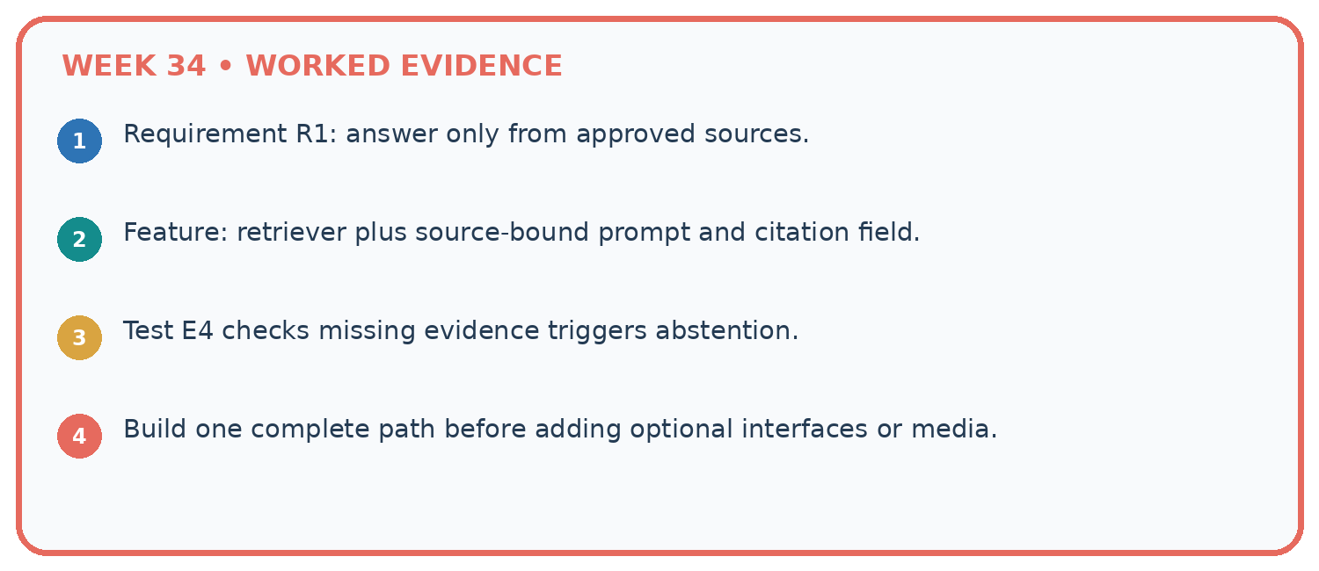
1. Requirement R1: answer only from approved sources.
2. Feature: retriever plus source-bound prompt and citation field.
3. Test E4 checks missing evidence triggers abstention.
4. Build one complete path before adding optional interfaces or media.
Recalculate, retrace, or restate the reasoning in your own representation:

Write or draw your reasoning and evidence.
________________________________________________________________
________________________________________________________________
________________________________________________________________
________________________________________________________________
________________________________________________________________
CHECK Did the evidence answer the exact question? Did the total, path, or source record stay consistent?

A closer explanation
Request room B; retrieved approval names B but register names C. Draft gives capacity 10 from C.
Same-room support fails before or during semantic validation. Return needs_review with null claims; the draft capacity is unsupported for B.
Compare the intermediate evidence with the final statement. Explain why each number or decision follows from the stated inputs. The conclusion belongs to this scenario and procedure; changing the inputs, evaluation population or authority can change what it establishes. Retain the raw record so a later revision can be compared honestly.

Learn from the worked case
Cover the result before checking it. Say what is given, choose the procedure, and follow one step at a time. Then uncover the result and explain your first mismatch. Ask why a step is allowed, not only what number it produces.

A pictorial worked case: Capstone Build
Build a claim checker for a draft summary of a fictional class investigation.

The facts we will use
Approved record E2: three cups were observed for four days. No measured water loss is provided. Draft says “three cups were observed for four days and all lost half their water”.
All inputs and outcomes in this worked example are invented classroom data; no real model run is claimed.
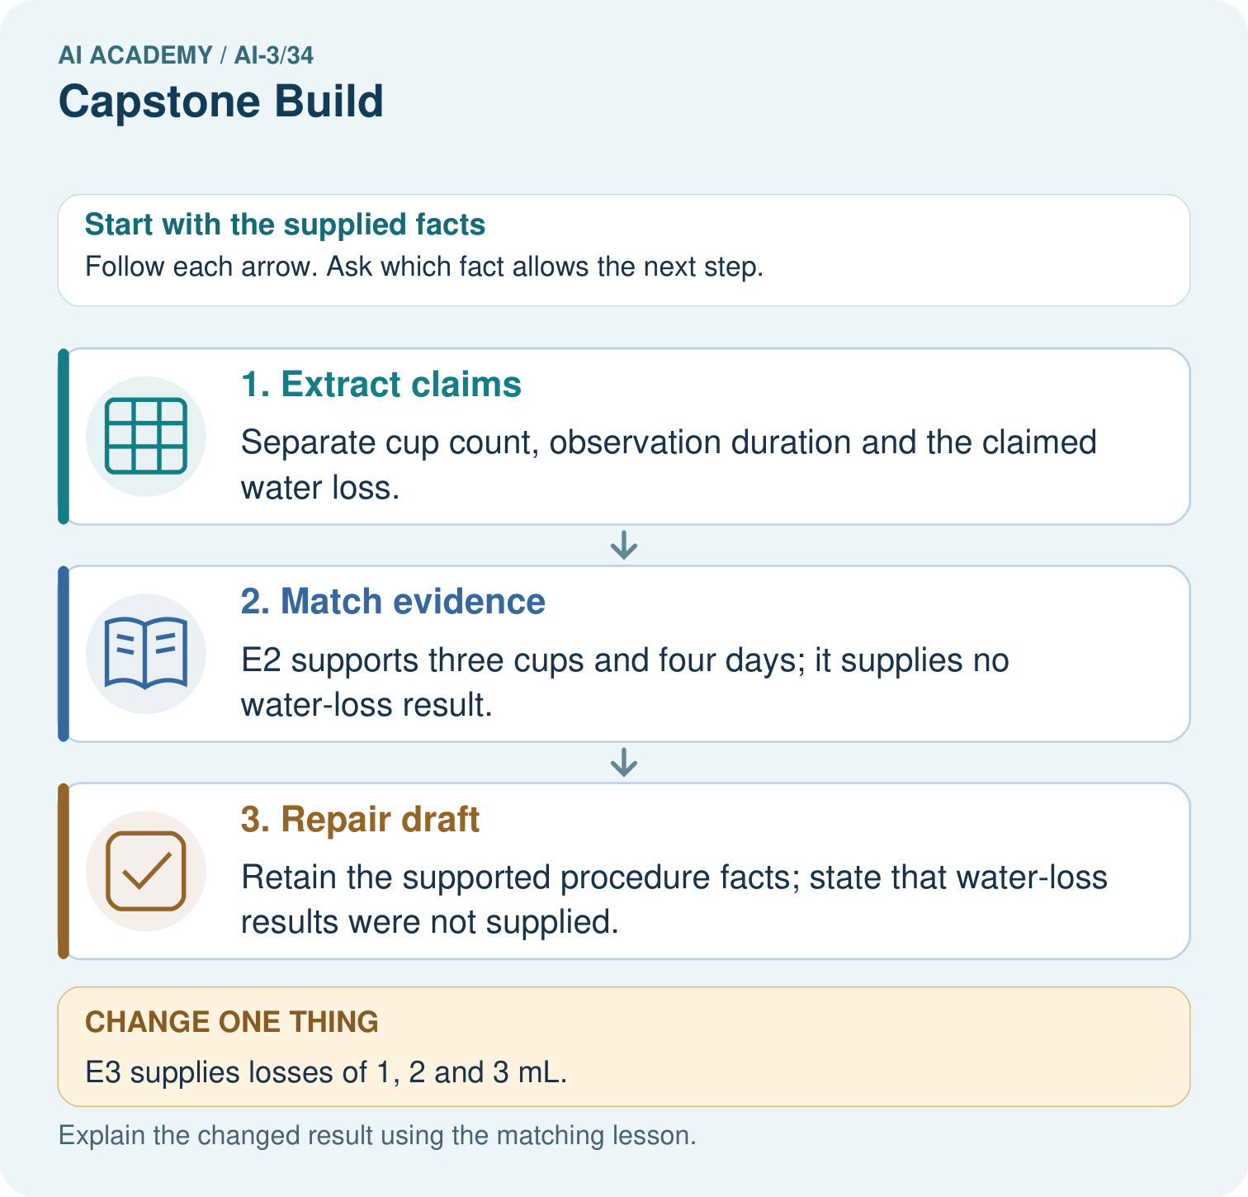

Read the picture one step at a time
Step | What happens and why
1. Extract claims | Separate cup count, observation duration and the claimed water loss.
2. Match evidence | E2 supports three cups and four days; it supplies no water-loss result.
3. Repair draft | Retain the supported procedure facts; state that water-loss results were not supplied.
Match each pictured step to the supplied facts. This is a worked teaching case, not an independent assessment.

Why this result follows
Read the picture in order. Retain the supported procedure facts; state that water-loss results were not supplied. The arrows show which recorded input or intermediate result each decision uses. Explain the deciding step aloud before checking the changed case; pointing to the final answer alone does not show how it follows.

What this example does not establish
The examples are invented observations; no real classroom investigation or model run is claimed.
Read the labelled picture: What additional numbers would a half-water claim require? Point to the relevant step in the picture, then write the changed result and the rule or evidence that supports it.
Change one thing: E3 supplies losses of 1, 2 and 3 mL. Predict the result before checking the explanation. What remains the same?

07. Find and repair a mistake
ERROR DETECTIVE
Compare → Diagnose → Repair
Do not patch the answer. Find the earliest unsupported assumption, wrong step, or weak evidence.
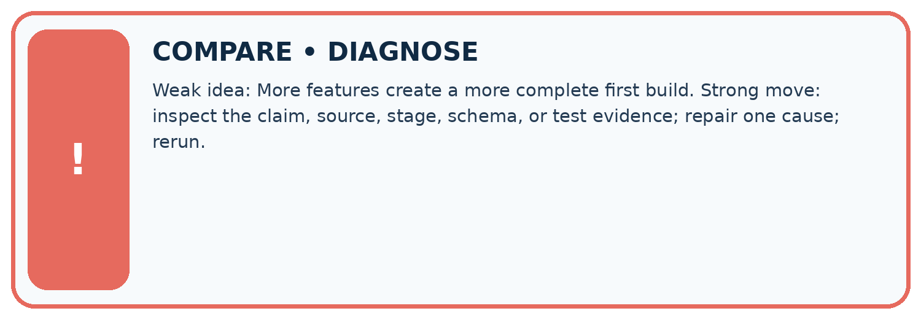
Evidence record | Expected | Actual | Likely cause / next test
normal case | works
boundary case | stated rule
missing input | safe response
fresh transfer | generalizes
Repair one cause. Why is this repair better than changing several things?

Write or draw your reasoning and evidence.
________________________________________________________________
________________________________________________________________
________________________________________________________________
________________________________________________________________
________________________________________________________________

A closer explanation
Complete the supported workbook tasks before attempting W4 independently. Record any hints or help used. After feedback, use the teacher's fresh retry rather than copying the earlier answer. For a project, select a relevant new case, predict the outcome from the declared rule and preserve the result alongside any revision.

Exit: propose one revealing change to the worked scenario. State the expected outcome and the evidence that would make you revise your explanation.
________________________________________________________________
________________________________________________________________
________________________________________________________________
________________________________________________________________
________________________________________________________________

08. Practise together
LOGIC STUDIO
Specify Before You Run
Prompts, schemas, retrieval, tool calls, and code are inspectable parts of one AI product.

SET task, audience, constraints, output_schema
LOAD approved_context or retrieval_result
CALL model or allowed_tool
VALIDATE fields, claims, citations, and safety
IF evidence missing: ask, retrieve, or abstain
RETURN useful output + source trail + limitations
Trace one input. Which line changes the state or chooses a path?

Write or draw your reasoning and evidence.
________________________________________________________________
________________________________________________________________
________________________________________________________________
________________________________________________________________
________________________________________________________________

A closer explanation
A correct happy path does not establish fallback, access control or side-effect safety.
A useful check asks what would make the reasoning fail. Distinguish a failure to execute the declared procedure from a weakness in the procedure itself. The first may require a correction; the second requires an explicitly revised method and new evidence. Preserve unsuccessful cases so an improved result cannot hide the original problem.

Guided: restate the worked result, then name the assumption or limitation that prevents a broader conclusion.
________________________________________________________________
________________________________________________________________
________________________________________________________________
________________________________________________________________
________________________________________________________________

Practise with less help: Trace the worked case
Use workbook W2 for the connected example “Capstone grounded assistant”. First fill the input and rule boxes. Try the middle steps before asking for a hint. After a hint, try the next step yourself.
Plan | Do | Check
What is given? Which rule or procedure applies? | Record each intermediate step. | Does the result follow? What remains unknown?
Explain your trace to a partner. Your partner points to one step to check. Swap roles on the next case. Each person writes their own explanation.

Check your reasoning
Use the worked case for Capstone grounded assistant. Proposed explanation: “The worked result establishes every future case”. Decide whether this explanation is supported. Point to the step or supplied fact that decides; explain your repair if needed.
Answer on your own before discussion. If you are unsure, say which step you need help with.

Explain the picture
What additional numbers would a half-water claim require? Point to the relevant step in the picture, then write the changed result and the rule or evidence that supports it.

My explanation using a pictured step and the given facts
________________________________________________________________
________________________________________________________________
________________________________________________________________
________________________________________________________________
This is supported practice. Keep the separately named independent case for an attempt before feedback.

09. Run the investigation
EVIDENCE LAB
Predict → Test → Record → Explain
Keep expected and actual results separate. Surprises are useful data when recorded honestly.
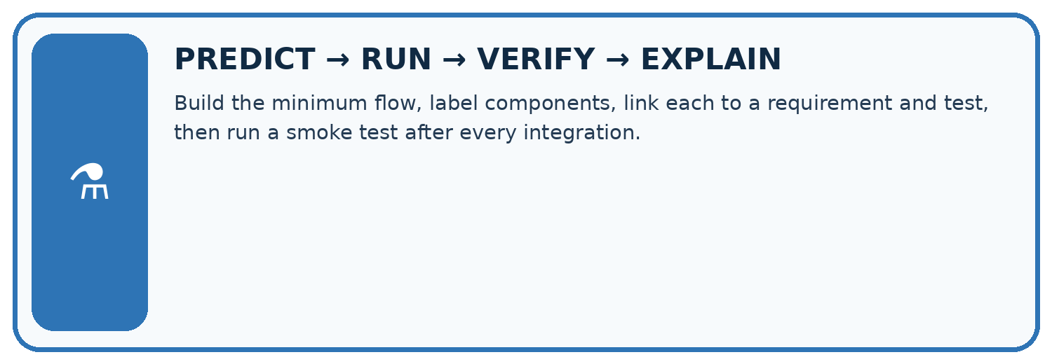
Build the minimum flow, label components, link each to a requirement and test, then run a smoke test after every integration.
Test / input | Prediction | Actual | Evidence / calculation | Change or keep?
normal
boundary
missing
fresh transfer
What did the hardest test teach you that the normal test did not?

Write or draw your reasoning and evidence.
________________________________________________________________
________________________________________________________________
________________________________________________________________
________________________________________________________________
________________________________________________________________

Plan → try → check
Before trying: what do I expect, and why? While trying: which step could first go wrong? Afterwards: what did I actually observe, and what should change? Keep “not run” if you only traced the procedure.

10. Build your understanding
MASTERY
From Knowing the Word to Owning the Idea
Move upward only when you can produce evidence without copying the worked example.

1 • NAME: Define the concept without repeating the textbook.
2 • TRACE: Show the information, state, branch, calculation, or evidence path.
3 • APPLY: Solve a different example independently.
4 • CHALLENGE: Find a boundary case, counterexample, or unfair outcome.
5 • EXPLAIN LIMITS: Say when the result should not be trusted or used alone.
My strongest evidence of independent understanding:

Write or draw your reasoning and evidence.
________________________________________________________________
________________________________________________________________
________________________________________________________________
________________________________________________________________
________________________________________________________________

11. Connect your project
CUMULATIVE PROJECT
Verified Study Buddy
Every week adds one inspectable piece. The system must show how it reached a result.
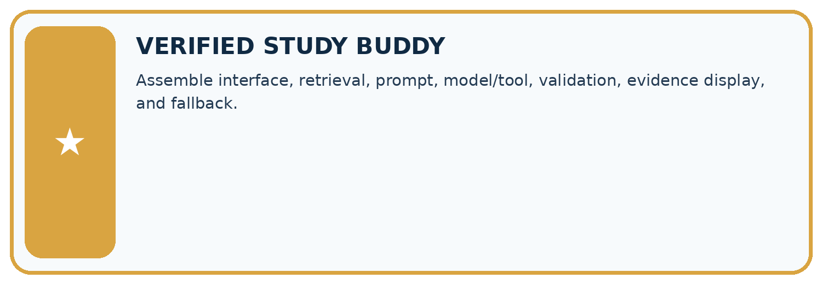
THIS WEEK’S CHECKPOINT Assemble interface, retrieval, prompt, model/tool, validation, evidence display, and fallback.
SYSTEM MAP Learner need → prompt/schema → approved sources/retrieval → model/tool → structured answer → verification → human decision
What will you add, change, or verify in the project this week?

Write or draw your reasoning and evidence.
________________________________________________________________
________________________________________________________________
________________________________________________________________
________________________________________________________________
________________________________________________________________
What should remain under human control?

Write or draw your reasoning and evidence.
________________________________________________________________
________________________________________________________________
________________________________________________________________
________________________________________________________________
________________________________________________________________
RESPONSIBLE DESIGN Collect only necessary information. Show uncertainty and limits. Never confuse fluent output with verified truth.

Evidence for your project
For your Verified Study Buddy, save the input, procedure, observed result and limitation of this check. Label this worked example as practice; use a different, previously unreviewed case when checking independent understanding.

12. Show what you know
INDEPENDENT MASTERY PROOF
Explain • Transfer • Test • Defend
Complete this page without copying the worked example. Your reasoning matters more than decoration.
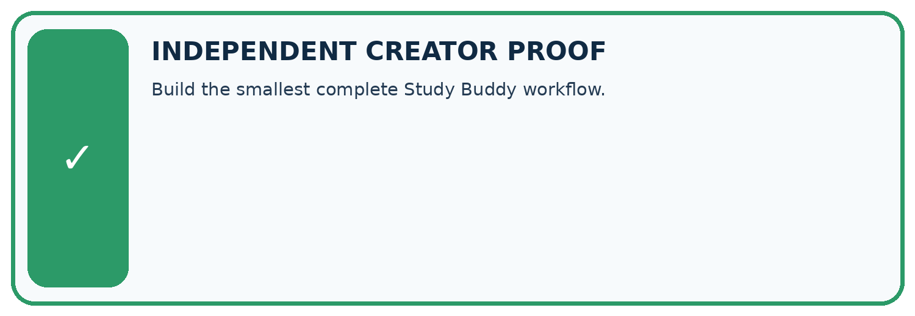
CHALLENGE Build the smallest complete Study Buddy workflow.
1. My fresh example, trace, calculation, or design:

Write or draw your reasoning and evidence.
________________________________________________________________
________________________________________________________________
________________________________________________________________
________________________________________________________________
________________________________________________________________
2. My evidence that it works (include a boundary or missing-data case):

Write or draw your reasoning and evidence.
________________________________________________________________
________________________________________________________________
________________________________________________________________
________________________________________________________________
________________________________________________________________
3. One limitation, fairness concern, or situation needing human review:

Write or draw your reasoning and evidence.
________________________________________________________________
________________________________________________________________
________________________________________________________________
________________________________________________________________
________________________________________________________________
SELF-CHECK □ I explained the mechanism □ I used evidence □ I tested a fresh case □ I named a limitation □ I can answer ‘why?’

13. Study a complete case

Week 34 Worked case
Use the supplied details to practise the weekly concept before attempting the independent question. This case extends the illustrated lesson.

The situation
A pipeline retrieves passages, drafts and displays without checking citations.

The question
What step is missing?

Worked explanation
Validate every factual claim against its citation, plus required fields and boundaries. Revise or stop unsupported answers; retain diagnostic stages.

Explain it in your own words
Which detail supports the answer, and why does it matter?

Write or draw your reasoning and evidence.
________________________________________________________________
________________________________________________________________
________________________________________________________________
________________________________________________________________
________________________________________________________________

Trace the supplied case visually

Validate before displaying the draft
Evidence or stage | Value or result
Retrieve | Relevant approved passages
Draft | Compose the answer
Validate | Check claims and citations
Display or stop | Show supported content or explain the limit
A pipeline retrieves passages, drafts and displays without checking citations.
What step is missing?
Validate every factual claim against its citation, plus required fields and boundaries. Revise or stop unsupported answers; retain diagnostic stages.

14. Try a new case independently

Independent case: Changed independent case
An experiment note records four fictional seeds observed for six days but supplies no growth results. A generated draft says all four sprouted and the method always works in any soil. Repair it.

My independent explanation, trace and limits
________________________________________________________________
________________________________________________________________
________________________________________________________________
________________________________________________________________
________________________________________________________________
________________________________________________________________
________________________________________________________________
Attempt this case before feedback. Record any help. Earlier examples below are further practice; a case already practised with feedback cannot establish fresh transfer.

Week 34 Independent application
Close the worked explanation. Apply the idea to this different question without copying.
The interface looks complete, but its answer button returns the same saved sentence for every question. What capability is still missing, and how can you expose it?
My answer, with a trace, calculation or supporting evidence

Write or draw your reasoning and evidence.
________________________________________________________________
________________________________________________________________
________________________________________________________________
________________________________________________________________
________________________________________________________________

Create and test
Change one relevant detail. Predict the result before testing. Include a boundary or missing-information case when it helps reveal a limit.
My changed input and expected result

Write or draw your reasoning and evidence.
________________________________________________________________
________________________________________________________________
________________________________________________________________
________________________________________________________________
________________________________________________________________

Connect to your project
Assemble interface, retrieval, prompt, model/tool, validation, evidence display, and fallback.
The evidence I will keep

Write or draw your reasoning and evidence.
________________________________________________________________
________________________________________________________________
________________________________________________________________
________________________________________________________________
________________________________________________________________
Your teacher has the independent answer and scoring criteria. Complete the matching workbook week to keep your practice evidence together.

Transfer practice from the original programme
A prototype cites note A but its answer adds a detail found nowhere in A. What should the final validation stage check and do?

Explain the mechanism, evidence and one limit.
________________________________________________________________
________________________________________________________________
________________________________________________________________
________________________________________________________________
________________________________________________________________
________________________________________________________________
________________________________________________________________

Use feedback to improve
Attempt the independent case before hints. Record whether you worked alone, used a hint or followed a model. After feedback, fix the first unsupported step and explain why it changed. A later check uses a changed case, not a copied answer.

15. Your lesson route
Start with this question: Build a claim checker for a draft summary of a fictional class investigation.
By the end, I can | How I will show it
Explain the mechanism and terminology of capstone grounded assistant | Explain the deciding step, show a trace or test, and state one limit.
Apply the stated procedure to a new case with a traceable result | Explain the deciding step, show a trace or test, and state one limit.
Identify an assumption or limitation and design a revealing follow-up | Explain the deciding step, show a trace or test, and state one limit.
Remember → watch and explain → try with help → investigate → try independently → keep project evidence. Your teacher may spread this lesson across several classes.
Keep your first prediction. Compare it with what the evidence shows and explain any change.

16. Finish and return
Close your notes. Explain this goal in your own words: Explain the mechanism and terminology of capstone grounded assistant

My deciding step, evidence and one remaining question
________________________________________________________________
________________________________________________________________
________________________________________________________________
________________________________________________________________
________________________________________________________________
If you are unsure, return to the worked picture and explain one arrow. If you are ready, change an input or assumption and justify your prediction.
Save your workbook evidence. At the next review, try a different case before opening your old answer.

17. Supported practice, repair and portfolio
Use this supported practice once, in the browser or on paper. Keep the reserved independent assessment for a separate first attempt before teacher feedback.
Build a claim checker for a draft summary of a fictional class investigation.

Practice 1: explain the deciding evidence
Which labelled step matches this detail? Retain the supported procedure facts; state that water-loss results were not supplied.
1. Extract claims
2. Match evidence
3. Repair draft

My selected conclusion, deciding fact and explanation
________________________________________________________________
________________________________________________________________
________________________________________________________________
________________________________________________________________
________________________________________________________________
Hint if needed: Read the steps in the pictorial case. Match the supplied detail to the stage that performs or records it.
After your attempt, compare with the supported explanation: Repair draft Retain the supported procedure facts; state that water-loss results were not supplied. Read the picture in order. Retain the supported procedure facts; state that water-loss results were not supplied. The arrows show which recorded input or intermediate result each decision uses. Explain the deciding step aloud before checking the changed case; pointing to the final answer alone does not show how it follows.

Practice 2: explain the deciding evidence
Changed-case practice: E3 supplies losses of 1, 2 and 3 mL. Which conclusion is supported by the supplied facts?
1. We can decide the result without examining the changed input or the procedure.
2. Report those individual losses, not “half” unless starting volumes are also available.
3. This one example guarantees correct results for every future input.

My selected conclusion, deciding fact and explanation
________________________________________________________________
________________________________________________________________
________________________________________________________________
________________________________________________________________
________________________________________________________________
Hint if needed: Use the changed condition and the deciding step in the pictorial trace. The answer must say what follows from those facts.
After your attempt, compare with the supported explanation: Report those individual losses, not “half” unless starting volumes are also available. Absolute losses alone do not establish each cup’s fractional loss.

Repair a missing building block
Review Capstone Design (ai-3/33). Goal: Explain the mechanism and terminology of capstone requirements and corpus. Short practice: What should the project plan record before the new flower test? Point to the relevant step in the picture, then write the changed result and the rule or evidence that supports it.. Return to this week and explain what you changed.
Review Safety Boundaries (ai-3/31). Goal: Explain the mechanism and terminology of untrusted input boundaries. Short practice: If AB7 passes the pattern, may it access teacher-only material? Point to the relevant step in the picture, then write the changed result and the rule or evidence that supports it.. Return to this week and explain what you changed.
Review Privacy by Design (ai-3/28). Goal: Explain the mechanism and terminology of data retention and deletion. Short practice: Which IDs and locations must appear in the deletion evidence? Point to the relevant step in the picture, then write the changed result and the rule or evidence that supports it.. Return to this week and explain what you changed.

Keep your completed work
Use Download completed work in the hosted lesson to export your answers, reflections, practice feedback and code-run evidence. Open the HTML copy to read or print it. Drafts stay in this browser when storage is available; clear drafts on a shared device.

