AI ACADEMY · STUDENT · ai-4/2

Features, Labels, Targets
Project: Responsible Plant Classifier

Before you start
AI-2 Week 9: a feature is an input; the target is what is predicted.

01. Your mission

Your learning target
I can separate prediction inputs from observed targets.
I can check whether each feature exists at prediction time.
I can repair target leakage and state a feature contract.

Remember before reading
Close your notes first. A rough first answer helps us choose the right starting point; it is not a score for your ability.
Without opening the old lesson, explain one key idea from The ML Lifecycle. Give an example and a mistake that the idea helps you avoid.
After trying, check the relevant lesson or ask your teacher. Change the part of your explanation that the evidence shows was wrong.
Features are the information available at prediction time; the target is the value the model should estimate; labels are observed target values in examples.
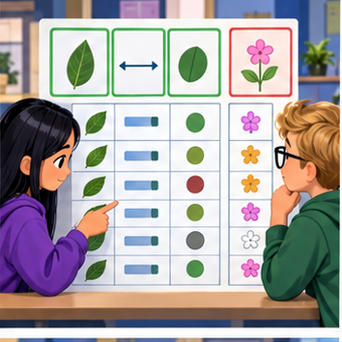
LEARNING TARGET A table has leaf length, edge type and verified species. A model predicts species using all three columns. Identify leakage and a legitimate input set.
Builder name and experiment date:

Readiness for the connected explanation
Why must held out labels not be used to choose the threshold in Week 1?

This week’s end goal
By the end, I can explain features, labels, targets using a traced example and a stated limitation.

02. Notice the evidence
PICTURE ENTRY

Notice → Predict → Explain
Begin with visible evidence; do not explain more than the picture and information support.
MYSTERY The team must use features, labels, targets to solve a model-building problem. What information do they have? What important evidence is still missing?
Name three visible details without interpreting them.
Predict the data, model, or evaluation decision being made.
Identify one hidden assumption that could change the result.
State what evidence would confirm or reject your prediction.
My prediction and supporting evidence:

A closer explanation
Week 1 separated training examples from testing examples. This week asks a different question: could each input actually be known when a prediction is needed? A historical table may contain facts added after the event. A model trained with those facts can appear successful even though the inputs will be missing when it is used.
Use fictional library loans. At the instant a book is checked out, predict whether it will be returned more than 14 days later. For completed historical loans, label 1 means days_to_return is greater than 14; label 0 means it is at most 14. Exactly 14 days is on time. Assume no changed due dates in this exercise. All records and values are invented; do not collect classmates' borrowing histories.
Field | When known | Role for this task
pages | At checkout | Candidate feature
queue_at_checkout | At checkout | Candidate feature
days_to_return | After return | Creates the label only
returned_late | After return | Label to predict
loan_id | At checkout | Tracking metadata
queue_at_checkout is a saved count of waiting requests at that instant. It is not the queue when we later export the table. Candidate means available to consider, not proven useful or appropriate. Exclude the arbitrary loan identifier from this exercise; keep it separately to track records.

03. See how it works
ML MECHANISM

Input → Model → Evidence
Trace the information, fitted behavior, and evaluation proof separately.
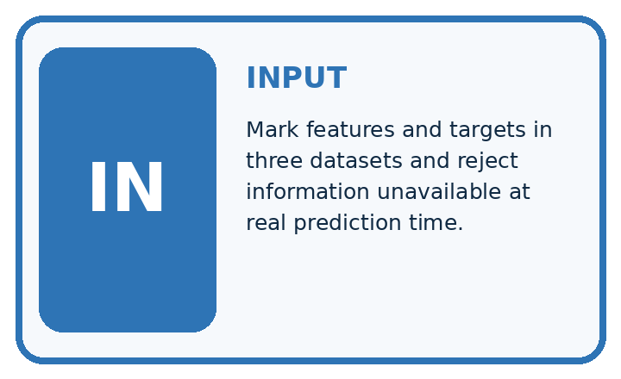
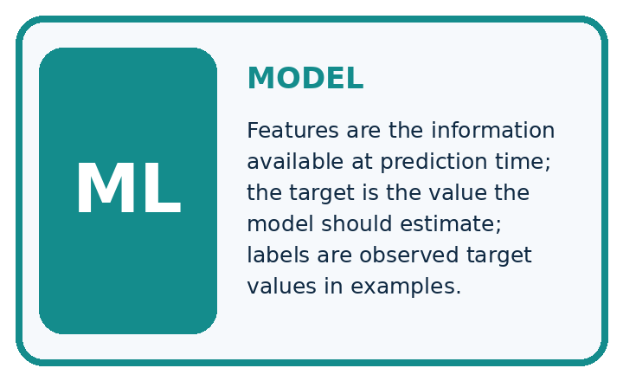
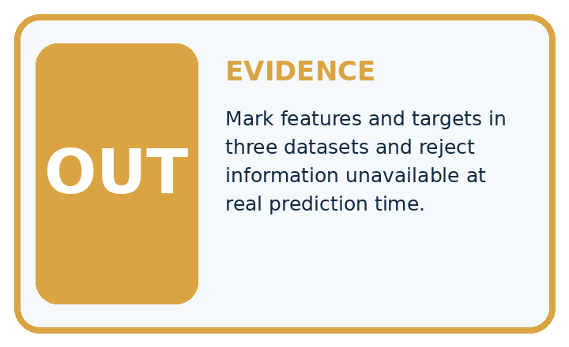
QUESTION Mark features and targets in three datasets and reject information unavailable at real prediction time.
MODEL IDEA Features are the information available at prediction time; the target is the value the model should estimate; labels are observed target values in examples.
PROOF NEEDED Use an unseen case, visible calculation, error analysis, and a stated limitation.
UNDER THE HOOD Plant row: leaf_width=6 cm, color_score=0.72, health=spotted. Features are leaf_width and color_score because they exist before prediction.
Draw a fresh data → model → prediction → evaluation trace:

A closer explanation
def features(row):
return [row["pages"], row["queue_at_checkout"]]
past = {"loan_id": "A", "pages": 120,
"queue_at_checkout": 2, "days_to_return": 18,
"returned_late": 1}
print(features(past))
print(past["returned_late"])
new = {"loan_id": "B", "pages": 80,
"queue_at_checkout": 0}
print(features(new))
The feature order is always pages first, queue count second. The first output is [120, 2]; the separate label is 1 because this historical loan took 18 days. The new loan produces [80, 0] even though its return outcome does not yet exist. The same feature function serves past and new records. It deliberately selects allowed fields rather than copying every column except returned_late.

Follow information through time
Moment | Available information | Allowed use
Checkout | Pages and saved queue | Prediction inputs
Later return | Elapsed days | Create observed label
Historical training | Inputs plus separate label | Fit a model later
The outcome may teach the model during training, but it cannot be an input to an earlier checkout prediction.
This code prepares inputs; it does not fit a model or predict lateness. It assumes the two feature fields contain valid nonnegative integer values and pages is positive. A missing required field raises KeyError. A real pipeline needs explicit validation and a missing-data policy.

Connect the picture and the explanation
Point to the input, the deciding step and the result in this week’s visual. Explain the same step in ordinary words. A picture helps when you can say what each part represents.

04. Compare the cases
EVALUATION DESIGN

Four Tests, Four Kinds of Evidence
A system is not understood until it survives more than one comfortable example.




NORMAL Expected data and expected behavior.
BOUNDARY Value close to a threshold, ambiguous label, or uncertain prediction.
MISSING Necessary field, label, source, or measurement is unavailable.
SHIFTED New lighting, species, device, subgroup, or time condition.
RELEASE RULE Passing one case never proves generalization. Predefine expected behavior for all four categories.
Which case most threatens today's claim, and why?

Change one thing in the pictured case
Change: A table adds tomorrow_soil_moisture as an input.
Prediction: Reject it for this prediction-time contract.
Reason: Tomorrow’s measurement is unavailable when today’s prediction must be issued.

05. Words that unlock the idea
VOCABULARY

Words You Can Calculate and Defend
A definition matters when it lets you interpret a new dataset, model, or result.
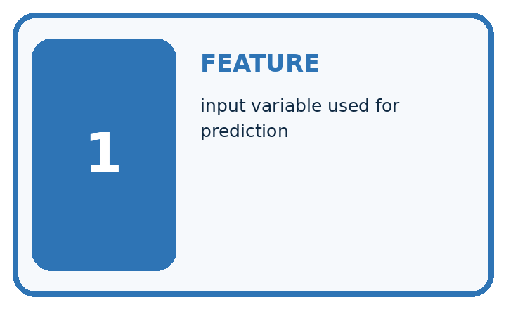
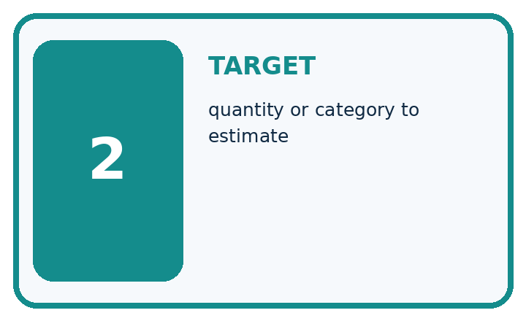
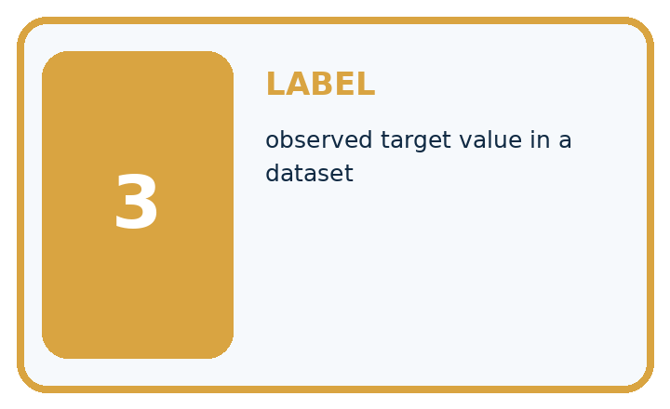
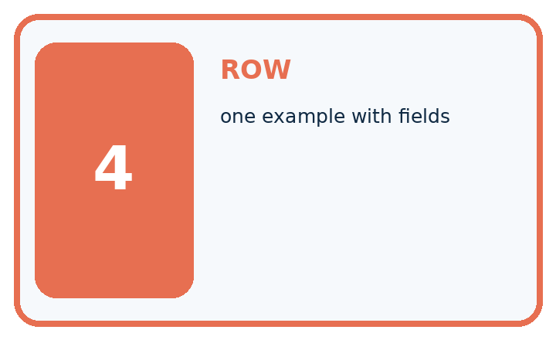
Term | Precise meaning | My ML example
feature | input variable used for prediction
target | quantity or category to estimate
label | observed target value in a dataset
row | one example with fields
MISCONCEPTION TO REPAIR Any column correlated with the answer is automatically a good feature.
Repair the claim using a definition, calculation, or test record:

Words used in the closer explanation
Word | Meaning
Feature contract | A specification of input meaning units order and timing
Target | The outcome a prediction aims to estimate
Prediction time | The moment when the prediction must be made
Target leakage | Predictor information that reveals the outcome but is unavailable at prediction time

06. Follow a worked example
WORKED EVIDENCE

Reason Step by Step
Predict first. Then check each step. A correct answer without visible evidence cannot be audited.
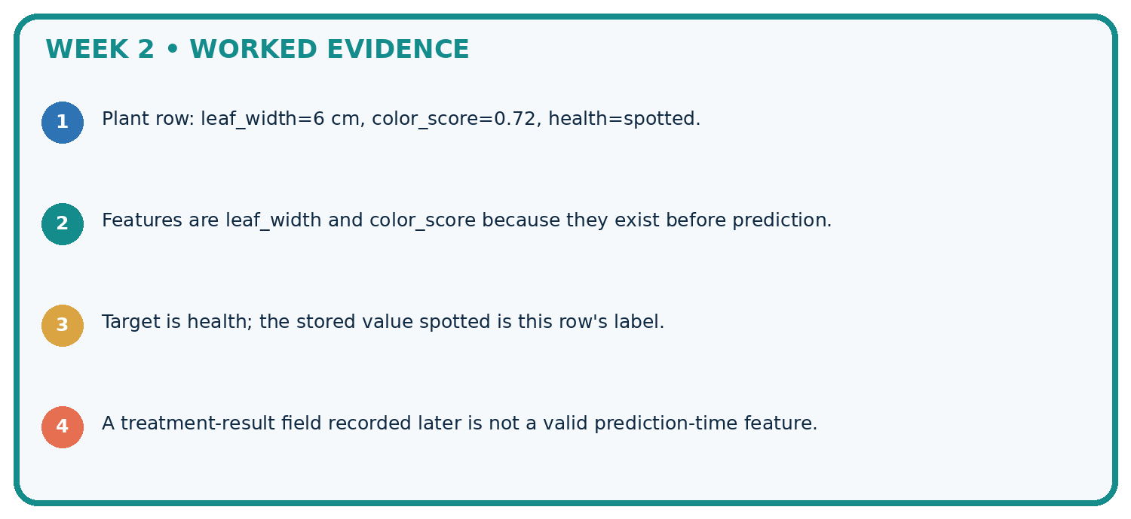
STEP 1 Plant row: leaf_width=6 cm, color_score=0.72, health=spotted.
STEP 2 Features are leaf_width and color_score because they exist before prediction.
STEP 3 Target is health; the stored value spotted is this row's label.
STEP 4 A treatment-result field recorded later is not a valid prediction-time feature.
CHECK Verify the denominator, unit, split, class definition, and data version before interpreting a score.
Recalculate, retrace, or restate the evidence independently:

A closer explanation
For every proposed input, ask what it means, when it was recorded, and whether the same definition can be supplied at checkout. A field in the historical export is not automatically available at prediction time. An input calculated from later information is also unavailable, even if its name does not mention the outcome.

A completed loan has pages 200, queue_at_checkout 3 and days_to_return 14. Write the feature list and label. Someone adds overdue_fee calculated after return. Can it become a feature for the checkout prediction? Explain.
________________________________________________________________
________________________________________________________________
________________________________________________________________
________________________________________________________________
________________________________________________________________

Learn from the worked case
Cover the result before checking it. Say what is given, choose the procedure, and follow one step at a time. Then uncover the result and explain your first mismatch. Ask why a step is allowed, not only what number it produces.

A pictorial worked case: Features, Labels, Targets
Choose features that exist when a plant prediction must be made.

The facts we will use
Predict next-week wilting at today’s photo capture. Available fields: today_light, today_soil_moisture, plant_id; next_week_wilt is the target recorded later.
All inputs and outcomes in this worked example are invented classroom data; no real model run is claimed.
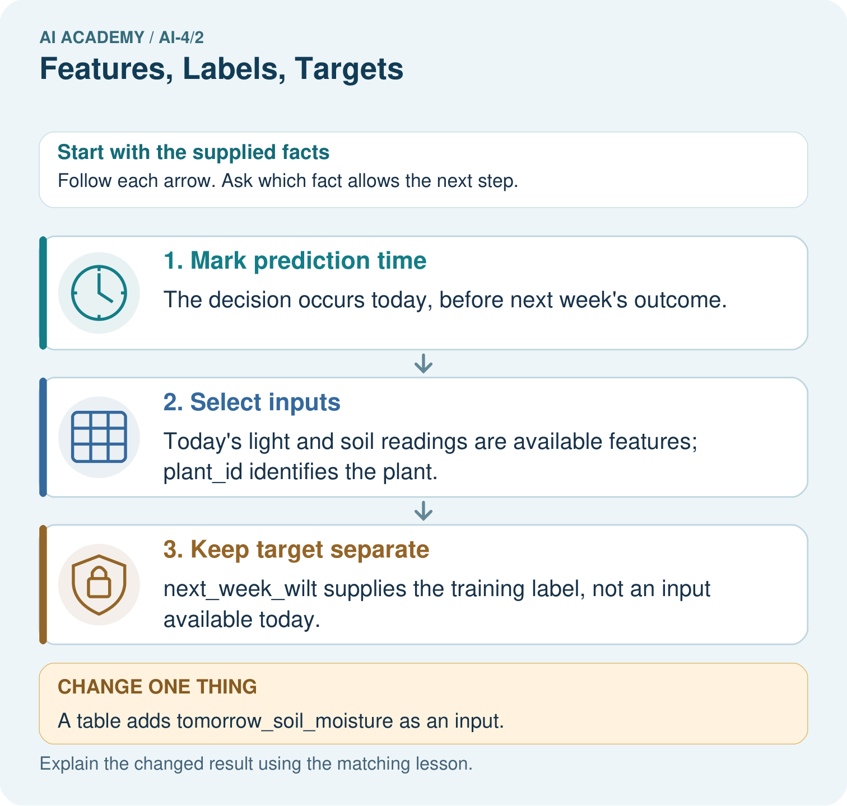

Read the picture one step at a time
Step | What happens and why
1. Mark prediction time | The decision occurs today, before next week’s outcome.
2. Select inputs | Today’s light and soil readings are available features; plant_id identifies the plant.
3. Keep target separate | next_week_wilt supplies the training label, not an input available today.
Match each pictured step to the supplied facts. This is a worked teaching case, not an independent assessment.

Why this result follows
Read the picture in order. next_week_wilt supplies the training label, not an input available today. The arrows show which recorded input or intermediate result each decision uses. Explain the deciding step aloud before checking the changed case; pointing to the final answer alone does not show how it follows.

What this example does not establish
Eligible fields are not automatically useful or causal. Measure their predictive value with a valid split.
Read the labelled picture: Why can a historical table contain a field that is an invalid input? Point to the relevant step in the picture, then write the changed result and the rule or evidence that supports it.
Change one thing: A table adds tomorrow_soil_moisture as an input. Predict the result before checking the explanation. What remains the same?

07. Find and repair a mistake
ERROR DETECTIVE

Compare → Diagnose → Repair
Do not patch the answer. Find the earliest unsupported assumption, data problem, or experiment error.
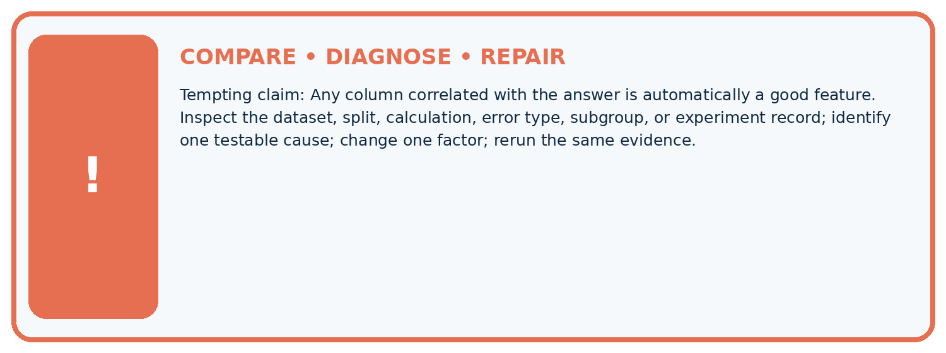
Evidence record | Expected | Actual | Likely cause / next test
normal case | passes
boundary case | defined behavior
missing case | safe fallback
shifted case | measured limit
CLAIM TO CHALLENGE Any column correlated with the answer is automatically a good feature.
Diagnose one cause and name the cleanest next experiment:

A closer explanation
A feature contract records field names, meaning, units, order and availability time. Here the inputs are pages in pages, then queue_at_checkout in requests, both captured at checkout. The target definition is returned more than 14 days later. Historical outcomes may be available for training, while new outcomes are unknown. Never fill an unknown label with 0 merely because the book has not yet been returned.
Availability alone does not establish predictive value, fairness, a causal effect or a reason to use a model. This lesson audits inputs; later lessons evaluate models. If an input cannot be collected at checkout, revise the design or specify a justified missing-input policy before use.

Write a two-sentence input contract for this checkout task. Include the feature order and timing, then explain why an unknown future outcome must not be recorded as an on-time return.
________________________________________________________________
________________________________________________________________
________________________________________________________________
________________________________________________________________
________________________________________________________________

08. Practise together
ML STUDIO

Specify Before You Run
A trustworthy result can be reproduced from the recorded data, code, settings, and evaluation rule.


Experiment record
QUESTION + intended use + success threshold
DATA version + grouped split + leakage check
CODE/preprocessing + features + model + settings + seed
METRICS + positive class + units + denominators
PREDICTIONS + errors + subgroup slices + limitations
HUMAN reviewer + release, revise, limit, or stop decision
Write the minimum record needed to reproduce today's result:

A closer explanation
A learner removes returned_late but keeps days_to_return in the inputs. That still reveals the answer: compare days_to_return with 14. Remove both the target and the later return measurement from prediction inputs. Also exclude a fee calculated after return or a renewal made after checkout. These are examples of target leakage, where unavailable outcome information enters the predictors.
Moving rows into a test set does not repair this problem if each test row still contains the later return measurement. Rebuild the inputs to match checkout time and repeat development and evaluation honestly. If earlier test results influenced changes, obtain a new final evaluation set as well.

Practise with less help: Trace the feature contract
Use workbook W2 for the connected example “Features labels and prediction time”. First fill the input and rule boxes. Try the middle steps before asking for a hint. After a hint, try the next step yourself.
Plan | Do | Check
What is given? Which rule or procedure applies? | Record each intermediate step. | Does the result follow? What remains unknown?
Explain your trace to a partner. Your partner points to one step to check. Swap roles on the next case. Each person writes their own explanation.

Check your reasoning
Use the worked case for Features labels and prediction time. Proposed explanation: “Every stored column is a feature”. Decide whether this explanation is supported. Point to the step or supplied fact that decides; explain your repair if needed.
Answer on your own before discussion. If you are unsure, say which step you need help with.

Explain the picture
Why can a historical table contain a field that is an invalid input? Point to the relevant step in the picture, then write the changed result and the rule or evidence that supports it.

My explanation using a pictured step and the given facts
________________________________________________________________
________________________________________________________________
________________________________________________________________
________________________________________________________________
This is supported practice. Keep the separately named independent case for an attempt before feedback.

09. Run the investigation
EVIDENCE LAB

Predict → Run → Calculate → Interpret
Keep the test conditions fixed, record every result, and change only one planned factor.
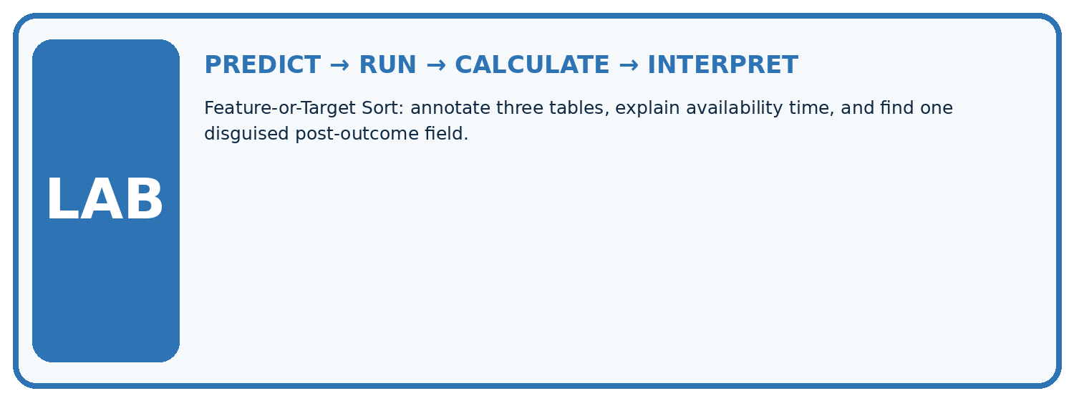
1. Write the hypothesis and expected evidence before running.
2. Feature-or-Target Sort: annotate three tables, explain availability time, and find one disguised post-outcome field.
3. Run one normal, one boundary, one missing, and one shifted case.
4. Calculate the metric from raw counts or row-level errors.
5. Interpret what changed, what did not, and what remains unsafe or unknown.
Case | Prediction | Actual | Calculation / evidence | Meaning / next test
Normal
Boundary
Missing
Shifted

Plan → try → check
Before trying: what do I expect, and why? While trying: which step could first go wrong? Afterwards: what did I actually observe, and what should change? Keep “not run” if you only traced the procedure.

10. Build your understanding
MASTERY

From Knowing the Word to Owning the Idea
Move upward only when you can produce evidence without copying the example.

DEFINE Use all four terms precisely: feature, target, label, row.
CALCULATE Reproduce the worked evidence with units and denominator.
TRACE Explain the data, code or decision path.
DIAGNOSE Any column correlated with the answer is automatically a good feature.
TRANSFER Solve a fresh dataset or model case.
IMPROVE Change one cause and rerun fixed evidence.
DEFEND State intended use, metric, limitation, and human responsibility.
MASTERY RULE A coached calculation becomes mastery only after a different case is completed independently.

11. Connect your project
CUMULATIVE PROJECT

Responsible Plant Classifier
Every week adds one reviewable artifact to the same evidence-based capstone.
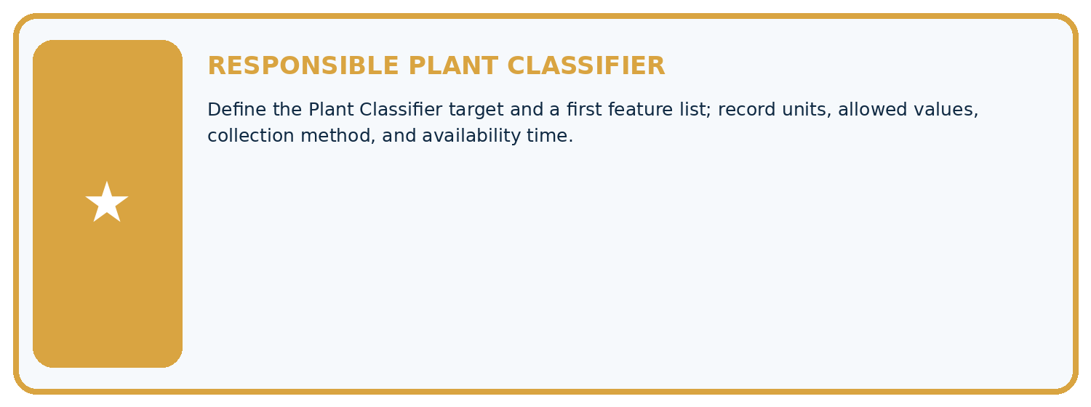
THIS WEEK'S CHECKPOINT Define the Plant Classifier target and a first feature list; record units, allowed values, collection method, and availability time.
Which requirement or risk does this artifact address?
Which dataset, split, code, and metric version does it use?
What normal and shifted cases were tested?
What remains uncertain or weak?
What decision still belongs to a teacher or qualified human?
RESPONSIBLE RELEASE Never use this classroom prototype for medical, pesticide, agricultural, or other consequential decisions.
My evidence-linked project decision:

Evidence for your project
For your Responsible Plant Classifier, save the input, procedure, observed result and limitation of this check. Label this worked example as practice; use a different, previously unreviewed case when checking independent understanding.

12. Show what you know
INDEPENDENT PROOF

Explain • Calculate • Transfer • Defend
Complete this with a fresh case after guided practice and compare it with the mastery criteria.
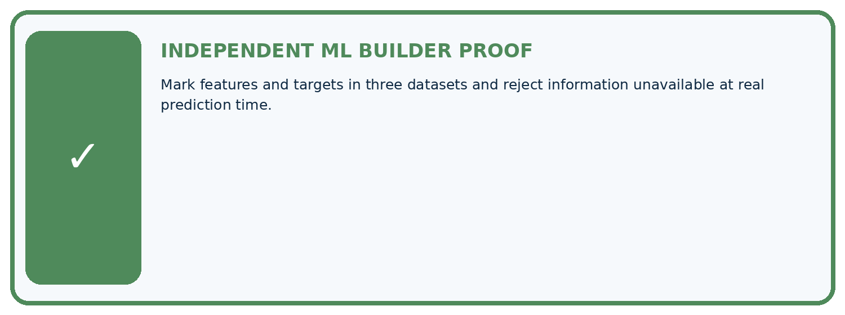
REQUIRED PROOF Mark features and targets in three datasets and reject information unavailable at real prediction time.
□ Define the task, feature/target roles, and intended-use boundary.
□ Show the calculation, code trace, or experiment record.
□ Test a normal case and one revealing boundary, missing, or shifted case.
□ Diagnose one failure without changing several factors at once.
□ Name a limitation, fairness concern, and the human-review action.
Independent evidence and defense:
My level: □ Not yet □ With one hint □ Independently □ I can teach and defend it
NEXT BRIDGE Carry the experiment evidence into: Classification or Regression?.

13. Study a complete case

Week 2 Worked case
Use the supplied details to practise the weekly concept before attempting the independent question. This case extends the illustrated lesson.

The situation
Rows contain leaf length, edge type and healthy/spotted label.

The question
Identify features, target and prediction-time inputs.

Worked explanation
Length and edge type are candidate features; the label is the target. Do not supply the true target as an input to predicting it. Evaluate feature usefulness.

Explain it in your own words
Which detail supports the answer, and why does it matter?

Write or draw your reasoning and evidence.
________________________________________________________________
________________________________________________________________
________________________________________________________________
________________________________________________________________
________________________________________________________________

Trace the supplied case visually

Separate features from the target
Evidence or stage | Value or result
Length | Candidate input feature
Edge type | Candidate input feature
Healthy or spotted | Target label
Prediction time | True target is unavailable
Rows contain leaf length, edge type and healthy/spotted label.
Identify features, target and prediction-time inputs.
Length and edge type are candidate features; the label is the target. Do not supply the true target as an input to predicting it. Evaluate feature usefulness.

14. Try a new case independently

Independent case: Audit a new task independently
A fictional robot predicts at dispatch whether a parcel trip will take more than 10 minutes. Fields are route_steps and queue_at_dispatch captured at dispatch, trip_id for tracking, arrival_minutes measured after arrival, and slow = 1 when arrival_minutes > 10. Specify inputs, order, target and exclusions. For a past trip with steps 30, queue 2, arrival 10, give features and label. For a new trip with steps 24 and queue 0, give features and explain whether slow is known.

My independent explanation, trace and limits
________________________________________________________________
________________________________________________________________
________________________________________________________________
________________________________________________________________
________________________________________________________________
________________________________________________________________
________________________________________________________________
Attempt this case before feedback. Record any help. Earlier examples below are further practice; a case already practised with feedback cannot establish fresh transfer.

Week 2 Independent application
Close the worked explanation. Apply the idea to this different question without copying.
A row contains leaf_length_cm=8, leaf_width_cm=3 and species=fern. For predicting species, identify two features and the target.
My answer, with a trace, calculation or supporting evidence

Write or draw your reasoning and evidence.
________________________________________________________________
________________________________________________________________
________________________________________________________________
________________________________________________________________
________________________________________________________________

Create and test
Change one relevant detail. Predict the result before testing. Include a boundary or missing-information case when it helps reveal a limit.
My changed input and expected result

Write or draw your reasoning and evidence.
________________________________________________________________
________________________________________________________________
________________________________________________________________
________________________________________________________________
________________________________________________________________

Connect to your project
Define the Plant Classifier target and a first feature list; record units, allowed values, collection method, and availability time.
The evidence I will keep

Write or draw your reasoning and evidence.
________________________________________________________________
________________________________________________________________
________________________________________________________________
________________________________________________________________
________________________________________________________________
Your teacher has the independent answer and scoring criteria. Complete the matching workbook week to keep your practice evidence together.

Transfer practice from the original programme
A table has leaf length, edge type and verified species. A model predicts species using all three columns. Identify leakage and a legitimate input set.

Explain the mechanism, evidence and one limit.
________________________________________________________________
________________________________________________________________
________________________________________________________________
________________________________________________________________
________________________________________________________________
________________________________________________________________
________________________________________________________________

Use feedback to improve
Attempt the independent case before hints. Record whether you worked alone, used a hint or followed a model. After feedback, fix the first unsupported step and explain why it changed. A later check uses a changed case, not a copied answer.

15. Your lesson route
Start with this question: Choose features that exist when a plant prediction must be made.
By the end, I can | How I will show it
Separate prediction inputs from observed targets | Explain the deciding step, show a trace or test, and state one limit.
Check whether each feature exists at prediction time | Explain the deciding step, show a trace or test, and state one limit.
Repair target leakage and state a feature contract | Explain the deciding step, show a trace or test, and state one limit.
Remember → watch and explain → try with help → investigate → try independently → keep project evidence. Your teacher may spread this lesson across several classes.
Keep your first prediction. Compare it with what the evidence shows and explain any change.

16. Finish and return
Close your notes. Explain this goal in your own words: Separate prediction inputs from observed targets

My deciding step, evidence and one remaining question
________________________________________________________________
________________________________________________________________
________________________________________________________________
________________________________________________________________
________________________________________________________________
If you are unsure, return to the worked picture and explain one arrow. If you are ready, change an input or assumption and justify your prediction.
Save your workbook evidence. At the next review, try a different case before opening your old answer.

17. Supported practice, repair and portfolio
Use this supported practice once, in the browser or on paper. Keep the reserved independent assessment for a separate first attempt before teacher feedback.
Choose features that exist when a plant prediction must be made.

Practice 1: explain the deciding evidence
Which labelled step matches this detail? next_week_wilt supplies the training label, not an input available today.
1. Select inputs
2. Mark prediction time
3. Keep target separate

My selected conclusion, deciding fact and explanation
________________________________________________________________
________________________________________________________________
________________________________________________________________
________________________________________________________________
________________________________________________________________
Hint if needed: Read the steps in the pictorial case. Match the supplied detail to the stage that performs or records it.
After your attempt, compare with the supported explanation: Keep target separate next_week_wilt supplies the training label, not an input available today. Read the picture in order. next_week_wilt supplies the training label, not an input available today. The arrows show which recorded input or intermediate result each decision uses. Explain the deciding step aloud before checking the changed case; pointing to the final answer alone does not show how it follows.

Practice 2: explain the deciding evidence
Changed-case practice: A table adds tomorrow_soil_moisture as an input. Which conclusion is supported by the supplied facts?
1. Reject it for this prediction-time contract.
2. This one example guarantees correct results for every future input.
3. We can decide the result without examining the changed input or the procedure.

My selected conclusion, deciding fact and explanation
________________________________________________________________
________________________________________________________________
________________________________________________________________
________________________________________________________________
________________________________________________________________
Hint if needed: Use the changed condition and the deciding step in the pictorial trace. The answer must say what follows from those facts.
After your attempt, compare with the supported explanation: Reject it for this prediction-time contract. Tomorrow’s measurement is unavailable when today’s prediction must be issued.

Repair a missing building block
Review The ML Lifecycle (ai-4/1). Goal: Distinguish fitting a rule from applying a fixed rule. Short practice: Should the team silently retune on the changed test? Point to the relevant step in the picture, then write the changed result and the rule or evidence that supports it.. Return to this week and explain what you changed.

Predict, run and debug
The browser lab lets you edit the supported Python examples already included in this lesson. Predict first, run, inspect the actual output or error, change one input, then run again. Keep code, predictions, actual results and a reasoned revision together. On paper, label your result as a trace rather than an execution.

Keep your completed work
Use Download completed work in the hosted lesson to export your answers, reflections, practice feedback and code-run evidence. Open the HTML copy to read or print it. Drafts stay in this browser when storage is available; clear drafts on a shared device.

