AI ACADEMY · STUDENT · ai-4/7

Sampling and Intended Use
Project: Responsible Plant Classifier

Before you start
AI-2 Week 19: compare the sample with the intended population.

01. Your mission

Your learning target
I can inspect row meaning missing values and repeated records.
I can document dataset source schema and limitations.
I can separate observed quality flags from justified corrections.

Remember before reading
Close your notes first. A rough first answer helps us choose the right starting point; it is not a score for your ability.
Without opening the old lesson, explain one key idea from Label Quality. Give an example and a mistake that the idea helps you avoid.
Without opening the old lesson, explain one key idea from Python and Table Readiness. Give an example and a mistake that the idea helps you avoid.
Without opening the old lesson, explain one key idea from The ML Lifecycle. Give an example and a mistake that the idea helps you avoid.
After trying, check the relevant lesson or ask your teacher. Change the part of your explanation that the evidence shows was wrong.
Training examples should represent the people, objects, conditions, and devices described by the intended-use statement.
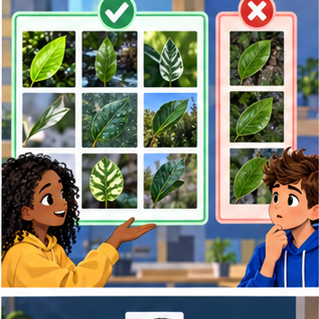
LEARNING TARGET Training uses indoor photos from one phone; deployment uses outdoor photos from several phones. Specify two evaluation slices and explain why adding more indoor photos may not resolve the gap.
Builder name and experiment date:

Readiness for the connected explanation
Why is elapsed trip duration in minutes a regression target even when recorded as whole numbers?

This week’s end goal
By the end, I can explain sampling and intended use using a traced example and a stated limitation.

02. Notice the evidence
PICTURE ENTRY

Notice → Predict → Explain
Begin with visible evidence; do not explain more than the picture and information support.
MYSTERY The team must use sampling and intended use to solve a model-building problem. What information do they have? What important evidence is still missing?
Name three visible details without interpreting them.
Predict the data, model, or evaluation decision being made.
Identify one hidden assumption that could change the result.
State what evidence would confirm or reject your prediction.
My prediction and supporting evidence:

A closer explanation
A dataset can look like a neat table and still contain missing outcomes, repeated records or impossible values. Before fitting a model, inspect what one row represents and document where the table came from. A dataset card is a short record of its purpose, contents, collection, changes and limits. It helps another person decide whether the data suits a proposed use.
Our source is a teacher-authored fictional export called Robot practice v1, created for this lesson. Each row is intended to describe one trip, with one unique trip ID and elapsed duration in minutes. Durations may be zero or positive; None means unknown. All trips are described as indoor practice trips. No real robot measurements or personal records were collected, and there is no evidence about outdoor performance.
Trip ID | Duration in minutes | What is visible
A | 8 | A recorded duration
B | None | An unknown duration
B | None | The same ID appears again
C | -2 | A negative duration
D | 12 | A recorded duration
Keep this raw version unchanged. At this stage a flag means investigate, not automatically delete or replace. A repeated ID might be a copied row or a problem with the supposed one-row-per-trip definition. We need evidence before deciding what happened.

03. See how it works
ML MECHANISM

Input → Model → Evidence
Trace the information, fitted behavior, and evaluation proof separately.
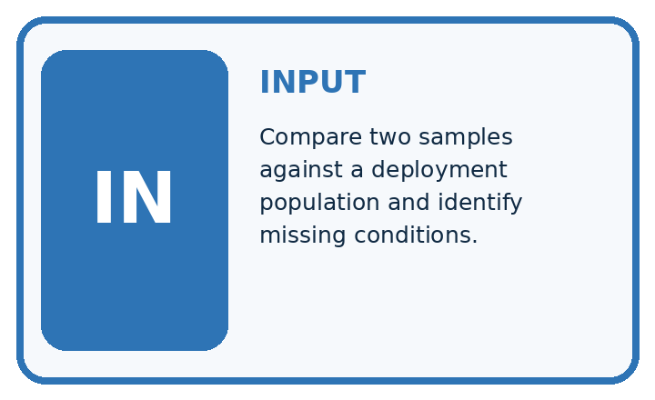
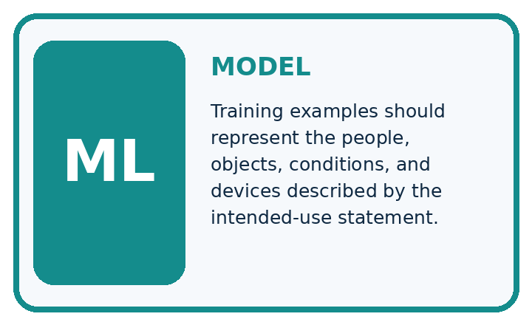
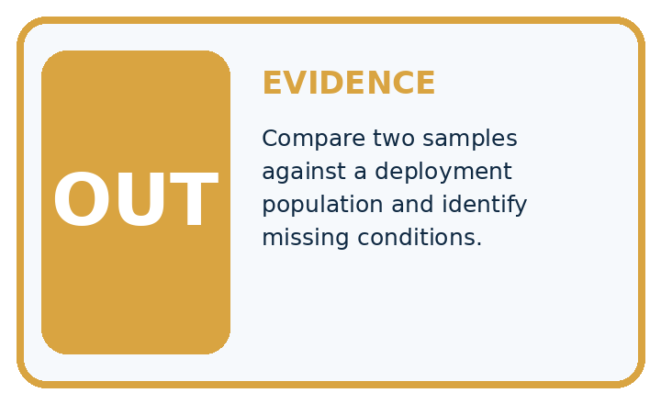
QUESTION Compare two samples against a deployment population and identify missing conditions.
MODEL IDEA Training examples should represent the people, objects, conditions, and devices described by the intended-use statement.
PROOF NEEDED Use an unseen case, visible calculation, error analysis, and a stated limitation.
UNDER THE HOOD Intended use includes indoor classroom plants under day and evening light. Sample A has 90% daylight photos from one camera.
Draw a fresh data → model → prediction → evaluation trace:

A closer explanation
rows = [("A", 8), ("B", None), ("B", None),
("C", -2), ("D", 12)]
ids = set()
missing = 0
negative = 0
for trip_id, minutes in rows:
ids.add(trip_id)
if minutes is None:
missing = missing + 1
elif minutes < 0:
negative = negative + 1
print(len(rows), len(ids), missing, negative)
A set stores each distinct ID once. The output is 5 4 2 1: five rows, four distinct IDs, two rows with unknown duration and one row with a negative duration. There is one extra occurrence beyond the four distinct IDs. This is not a count of all rows in repeated-ID groups: both B rows belong to that group.

Turn an observation into a documented action
Finding | What it establishes | Next action
B appears twice | Identity needs review | Check export history
Two None values | 2 of 5 rows lack duration | Keep unknown explicit
C has minus 2 | Invalid elapsed duration | Check source and units
Flags can overlap: both rows with ID B also have missing duration. Do not add flag counts as if they were separate groups.
The code assumes every row is a pair and each duration is a number or None. It is a small audit, not full schema validation. It does not check text values, units, source truth or whether IDs refer to real unique events. A successful run does not certify data quality.

Connect the picture and the explanation
Point to the input, the deciding step and the result in this week’s visual. Explain the same step in ordinary words. A picture helps when you can say what each part represents.

04. Compare the cases
EVALUATION DESIGN

Four Tests, Four Kinds of Evidence
A system is not understood until it survives more than one comfortable example.




NORMAL Expected data and expected behavior.
BOUNDARY Value close to a threshold, ambiguous label, or uncertain prediction.
MISSING Necessary field, label, source, or measurement is unavailable.
SHIFTED New lighting, species, device, subgroup, or time condition.
RELEASE RULE Passing one case never proves generalization. Predefine expected behavior for all four categories.
Which case most threatens today's claim, and why?

Change one thing in the pictured case
Change: Collect 12 more midday windowsill photos of the same plants.
Prediction: The evening-coverage gap remains.
Reason: More rows in the same condition do not supply evidence about the missing condition.

05. Words that unlock the idea
VOCABULARY

Words You Can Calculate and Defend
A definition matters when it lets you interpret a new dataset, model, or result.
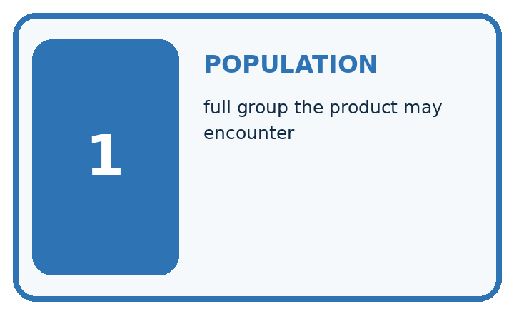
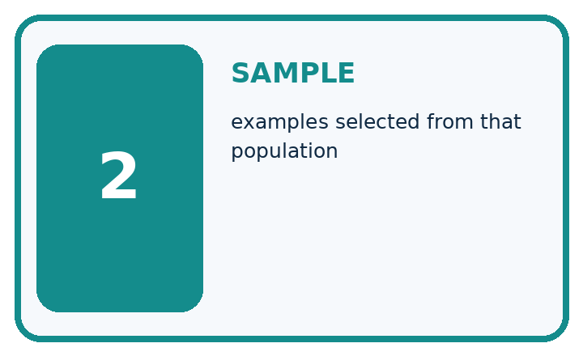
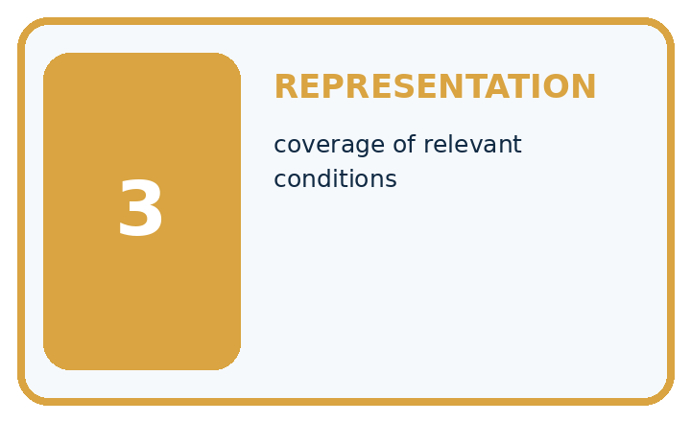
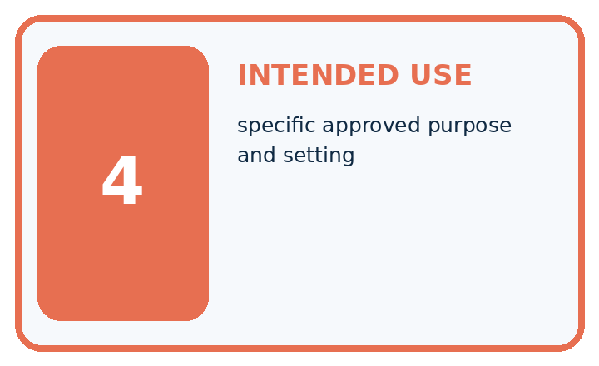
Term | Precise meaning | My ML example
population | full group the product may encounter
sample | examples selected from that population
representation | coverage of relevant conditions
intended use | specific approved purpose and setting
MISCONCEPTION TO REPAIR A large dataset is representative simply because it contains many examples.
Repair the claim using a definition, calculation, or test record:

Words used in the closer explanation
Word | Meaning
Provenance | Where data came from and how it was created
Schema | The stated meaning types units and rules for fields
Missing value | An unknown or unavailable value rather than a measured zero
Dataset card | A concise record of dataset contents creation intended use and limitations

06. Follow a worked example
WORKED EVIDENCE

Reason Step by Step
Predict first. Then check each step. A correct answer without visible evidence cannot be audited.
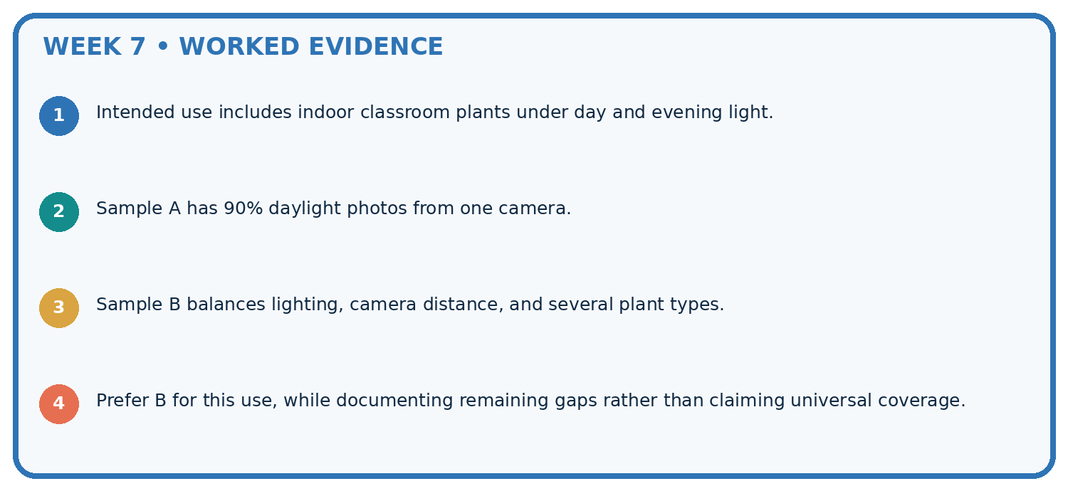
STEP 1 Intended use includes indoor classroom plants under day and evening light.
STEP 2 Sample A has 90% daylight photos from one camera.
STEP 3 Sample B balances lighting, camera distance, and several plant types.
STEP 4 Prefer B for this use, while documenting remaining gaps rather than claiming universal coverage.
CHECK Verify the denominator, unit, split, class definition, and data version before interpreting a score.
Recalculate, retrace, or restate the evidence independently:

A closer explanation
For Robot practice v1, record the purpose as practising inspection, the source as teacher-authored fictional data, and the row meaning as an intended single indoor trip. Record the five-row count, the ID field, minutes as the duration unit and None as unknown. List the duplicate-ID and invalid-duration findings. State that no cleaning has occurred, no train/test split is assigned, and no model has been evaluated.
Add intended use, excluded uses, known gaps, version and a contact or owner. Here the lesson teacher maintains the practice copy; its allowed classroom purpose is inspection practice. Do not describe it as validated navigation data. For a real external dataset, also verify its actual permission or licence and collection context; an absent field in the documentation is an unanswered question, not permission to invent a value.

What fraction of the five raw rows has unknown duration? Can you subtract two missing rows, one negative row and one extra ID occurrence from five to count distinct usable trips? Explain using the B rows.
________________________________________________________________
________________________________________________________________
________________________________________________________________
________________________________________________________________
________________________________________________________________

Learn from the worked case
Cover the result before checking it. Say what is given, choose the procedure, and follow one step at a time. Then uncover the result and explain your first mismatch. Ask why a step is allowed, not only what number it produces.

A pictorial worked case: Sampling and Intended Use
Sample for the conditions in which the plant classifier will actually be used.

The facts we will use
Training set: 12 windowsill plants photographed at midday. Intended use includes evening desk photos; no evening examples have been collected.
All inputs and outcomes in this worked example are invented classroom data; no real model run is claimed.
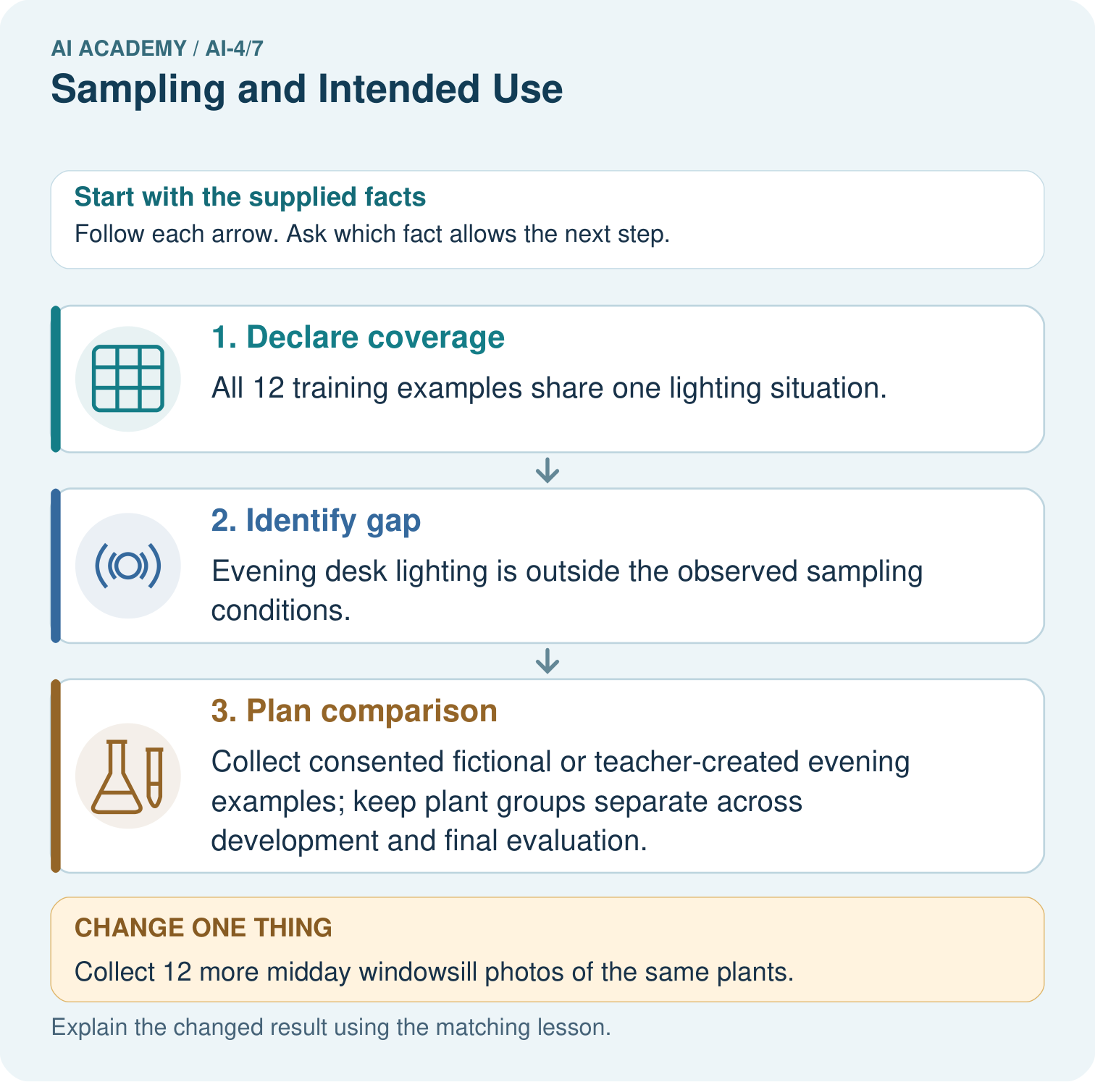

Read the picture one step at a time
Step | What happens and why
1. Declare coverage | All 12 training examples share one lighting situation.
2. Identify gap | Evening desk lighting is outside the observed sampling conditions.
3. Plan comparison | Collect consented fictional or teacher-created evening examples; keep plant groups separate across development and final evaluation.
Match each pictured step to the supplied facts. This is a worked teaching case, not an independent assessment.

Why this result follows
Read the picture in order. Collect consented fictional or teacher-created evening examples; keep plant groups separate across development and final evaluation. The arrows show which recorded input or intermediate result each decision uses. Explain the deciding step aloud before checking the changed case; pointing to the final answer alone does not show how it follows.

What this example does not establish
Condition coverage reduces a known gap but does not guarantee accuracy; test the selected model on fresh intended-use examples.
Read the labelled picture: Which collection would address the intended-use gap most directly? Point to the relevant step in the picture, then write the changed result and the rule or evidence that supports it.
Change one thing: Collect 12 more midday windowsill photos of the same plants. Predict the result before checking the explanation. What remains the same?

07. Find and repair a mistake
ERROR DETECTIVE

Compare → Diagnose → Repair
Do not patch the answer. Find the earliest unsupported assumption, data problem, or experiment error.
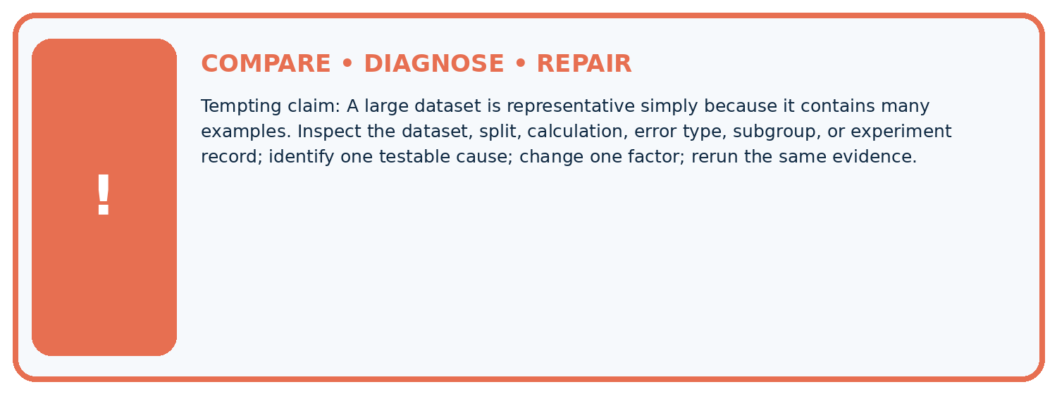
Evidence record | Expected | Actual | Likely cause / next test
normal case | passes
boundary case | defined behavior
missing case | safe fallback
shifted case | measured limit
CLAIM TO CHALLENGE A large dataset is representative simply because it contains many examples.
Diagnose one cause and name the cleanest next experiment:

A closer explanation
A complete-looking card does not prove the table is accurate or suitable for a model. It makes claims and unanswered questions reviewable. Report raw counts separately from any later accepted subset, with explicit rules for missing, invalid and repeated records. Do not silently change denominators after cleaning.
For this exercise, zero is allowed and unknown is not zero. That is a stated schema choice, not a universal rule for all duration datasets. In a real task, measurement resolution and event definitions determine which values make sense. Dataset inspection also does not replace protecting held out data from model choices.

A card says the dataset is ready because it has no empty cells. Name two checks that claim misses, then write a more accurate statement about Robot practice v1.
________________________________________________________________
________________________________________________________________
________________________________________________________________
________________________________________________________________
________________________________________________________________

08. Practise together
ML STUDIO

Specify Before You Run
A trustworthy result can be reproduced from the recorded data, code, settings, and evaluation rule.


Experiment record
QUESTION + intended use + success threshold
DATA version + grouped split + leakage check
CODE/preprocessing + features + model + settings + seed
METRICS + positive class + units + denominators
PREDICTIONS + errors + subgroup slices + limitations
HUMAN reviewer + release, revise, limit, or stop decision
Write the minimum record needed to reproduce today's result:

A closer explanation
A learner replaces both None values with 0 and removes the negative sign from -2. The table now passes a simple nonnegative check, but those edits invent durations. Keep the original values, record the reason for each flag, and check the source. If a correction is supported, save a new version with the original value, corrected value and reason. If not, keep the uncertainty visible.
Another learner says all robot trips are covered because every row says indoor. A dataset card should instead state that outdoor trips are absent and that the data is fictional. Extra copies of existing rows do not create new conditions or new independent evidence.

Practise with less help: Interpret the audit counts
Use workbook W2 for the connected example “Dataset inspection and cards”. First fill the input and rule boxes. Try the middle steps before asking for a hint. After a hint, try the next step yourself.
Plan | Do | Check
What is given? Which rule or procedure applies? | Record each intermediate step. | Does the result follow? What remains unknown?
Explain your trace to a partner. Your partner points to one step to check. Swap roles on the next case. Each person writes their own explanation.

Check your reasoning
Use the worked case for Dataset inspection and cards. Proposed explanation: “A complete card certifies data quality”. Decide whether this explanation is supported. Point to the step or supplied fact that decides; explain your repair if needed.
Answer on your own before discussion. If you are unsure, say which step you need help with.

Explain the picture
Which collection would address the intended-use gap most directly? Point to the relevant step in the picture, then write the changed result and the rule or evidence that supports it.

My explanation using a pictured step and the given facts
________________________________________________________________
________________________________________________________________
________________________________________________________________
________________________________________________________________
This is supported practice. Keep the separately named independent case for an attempt before feedback.

09. Run the investigation
EVIDENCE LAB

Predict → Run → Calculate → Interpret
Keep the test conditions fixed, record every result, and change only one planned factor.
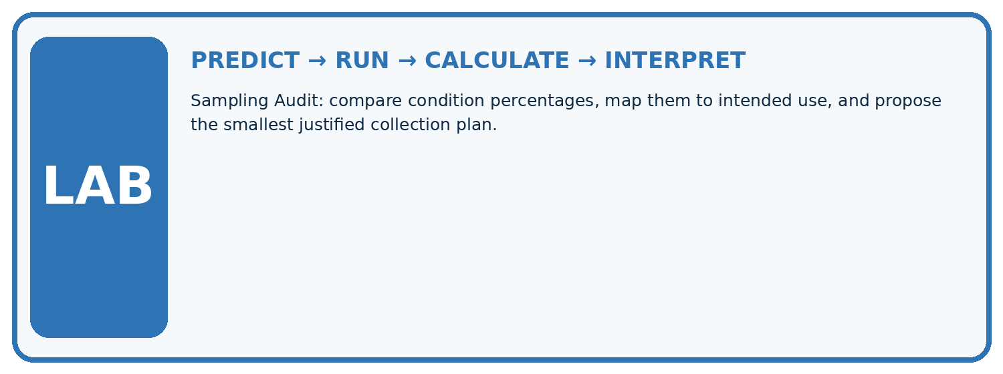
1. Write the hypothesis and expected evidence before running.
2. Sampling Audit: compare condition percentages, map them to intended use, and propose the smallest justified collection plan.
3. Run one normal, one boundary, one missing, and one shifted case.
4. Calculate the metric from raw counts or row-level errors.
5. Interpret what changed, what did not, and what remains unsafe or unknown.
Case | Prediction | Actual | Calculation / evidence | Meaning / next test
Normal
Boundary
Missing
Shifted

Plan → try → check
Before trying: what do I expect, and why? While trying: which step could first go wrong? Afterwards: what did I actually observe, and what should change? Keep “not run” if you only traced the procedure.

10. Build your understanding
MASTERY

From Knowing the Word to Owning the Idea
Move upward only when you can produce evidence without copying the example.

DEFINE Use all four terms precisely: population, sample, representation, intended use.
CALCULATE Reproduce the worked evidence with units and denominator.
TRACE Explain the data, code or decision path.
DIAGNOSE A large dataset is representative simply because it contains many examples.
TRANSFER Solve a fresh dataset or model case.
IMPROVE Change one cause and rerun fixed evidence.
DEFEND State intended use, metric, limitation, and human responsibility.
MASTERY RULE A coached calculation becomes mastery only after a different case is completed independently.

11. Connect your project
CUMULATIVE PROJECT

Responsible Plant Classifier
Every week adds one reviewable artifact to the same evidence-based capstone.
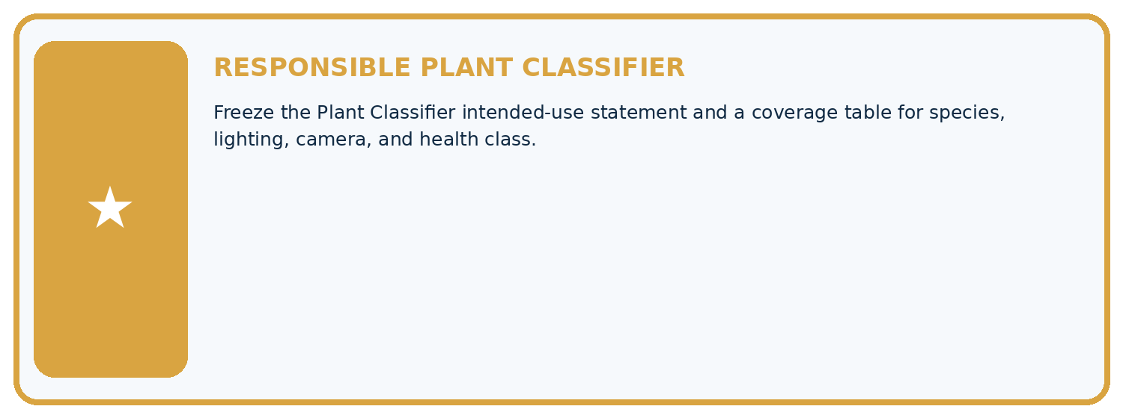
THIS WEEK'S CHECKPOINT Freeze the Plant Classifier intended-use statement and a coverage table for species, lighting, camera, and health class.
Which requirement or risk does this artifact address?
Which dataset, split, code, and metric version does it use?
What normal and shifted cases were tested?
What remains uncertain or weak?
What decision still belongs to a teacher or qualified human?
RESPONSIBLE RELEASE Never use this classroom prototype for medical, pesticide, agricultural, or other consequential decisions.
My evidence-linked project decision:

Evidence for your project
For your Responsible Plant Classifier, save the input, procedure, observed result and limitation of this check. Label this worked example as practice; use a different, previously unreviewed case when checking independent understanding.

12. Show what you know
INDEPENDENT PROOF

Explain • Calculate • Transfer • Defend
Complete this with a fresh case after guided practice and compare it with the mastery criteria.
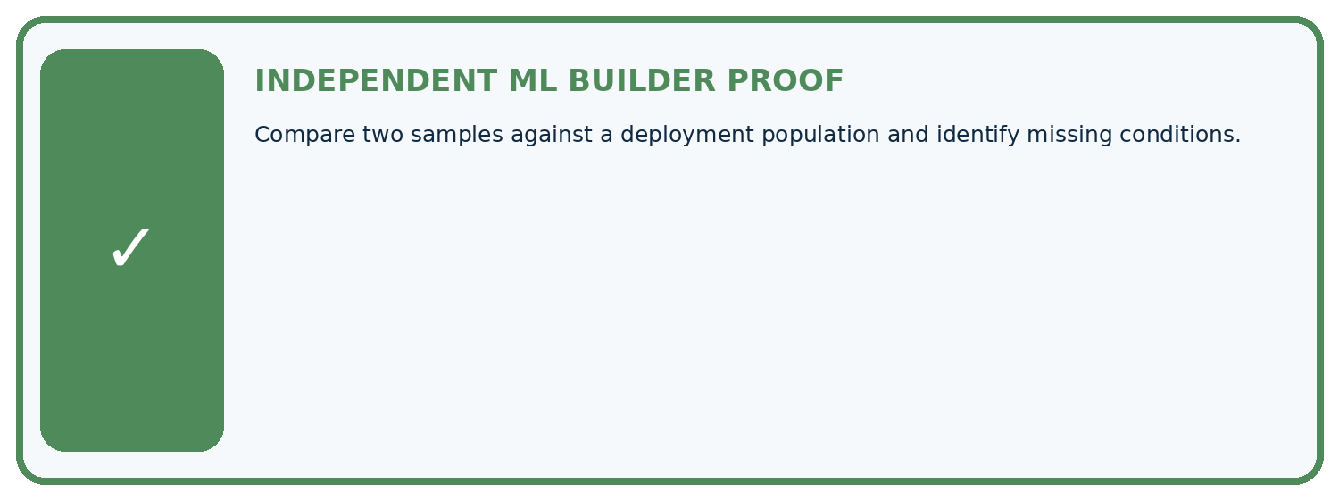
REQUIRED PROOF Compare two samples against a deployment population and identify missing conditions.
□ Define the task, feature/target roles, and intended-use boundary.
□ Show the calculation, code trace, or experiment record.
□ Test a normal case and one revealing boundary, missing, or shifted case.
□ Diagnose one failure without changing several factors at once.
□ Name a limitation, fairness concern, and the human-review action.
Independent evidence and defense:
My level: □ Not yet □ With one hint □ Independently □ I can teach and defend it
NEXT BRIDGE Carry the experiment evidence into: Leakage.

13. Study a complete case

Week 7 Worked case
Use the supplied details to practise the weekly concept before attempting the independent question. This case extends the illustrated lesson.

The situation
Training photos use indoor white backgrounds; intended use is outdoors.

The question
Identify the coverage gap.

Worked explanation
Lighting, background and device conditions may differ. Collect representative examples and evaluate outdoor slices separately.

Explain it in your own words
Which detail supports the answer, and why does it matter?

Write or draw your reasoning and evidence.
________________________________________________________________
________________________________________________________________
________________________________________________________________
________________________________________________________________
________________________________________________________________

Trace the supplied case visually

Match data coverage to intended use
Evidence or stage | Value or result
Training | Indoor white backgrounds
Intended use | Outdoor plants
Possible shift | Lighting, background and device
Evaluation | Inspect outdoor cases separately
Training photos use indoor white backgrounds; intended use is outdoors.
Identify the coverage gap.
Lighting, background and device conditions may differ. Collect representative examples and evaluate outdoor slices separately.

14. Try a new case independently

Independent case: Changed independent case
Training plant photos are all indoors on one phone. Intended use includes outdoor photos on other cameras. Plan a sampling check before making a general accuracy claim.

My independent explanation, trace and limits
________________________________________________________________
________________________________________________________________
________________________________________________________________
________________________________________________________________
________________________________________________________________
________________________________________________________________
________________________________________________________________
Attempt this case before feedback. Record any help. Earlier examples below are further practice; a case already practised with feedback cannot establish fresh transfer.

Week 7 Independent application
Close the worked explanation. Apply the idea to this different question without copying.
Training photographs all show mature plants in bright light, but intended users photograph seedlings indoors. What claim is unsupported and what data is needed?
My answer, with a trace, calculation or supporting evidence

Write or draw your reasoning and evidence.
________________________________________________________________
________________________________________________________________
________________________________________________________________
________________________________________________________________
________________________________________________________________

Create and test
Change one relevant detail. Predict the result before testing. Include a boundary or missing-information case when it helps reveal a limit.
My changed input and expected result

Write or draw your reasoning and evidence.
________________________________________________________________
________________________________________________________________
________________________________________________________________
________________________________________________________________
________________________________________________________________

Connect to your project
Freeze the Plant Classifier intended-use statement and a coverage table for species, lighting, camera, and health class.
The evidence I will keep

Write or draw your reasoning and evidence.
________________________________________________________________
________________________________________________________________
________________________________________________________________
________________________________________________________________
________________________________________________________________
Your teacher has the independent answer and scoring criteria. Complete the matching workbook week to keep your practice evidence together.

Transfer practice from the original programme
Training uses indoor photos from one phone; deployment uses outdoor photos from several phones. Specify two evaluation slices and explain why adding more indoor photos may not resolve the gap.

Explain the mechanism, evidence and one limit.
________________________________________________________________
________________________________________________________________
________________________________________________________________
________________________________________________________________
________________________________________________________________
________________________________________________________________
________________________________________________________________

Use feedback to improve
Attempt the independent case before hints. Record whether you worked alone, used a hint or followed a model. After feedback, fix the first unsupported step and explain why it changed. A later check uses a changed case, not a copied answer.

15. Your lesson route
Start with this question: Sample for the conditions in which the plant classifier will actually be used.
By the end, I can | How I will show it
Inspect row meaning missing values and repeated records | Explain the deciding step, show a trace or test, and state one limit.
Document dataset source schema and limitations | Explain the deciding step, show a trace or test, and state one limit.
Separate observed quality flags from justified corrections | Explain the deciding step, show a trace or test, and state one limit.
Remember → watch and explain → try with help → investigate → try independently → keep project evidence. Your teacher may spread this lesson across several classes.
Keep your first prediction. Compare it with what the evidence shows and explain any change.

16. Finish and return
Close your notes. Explain this goal in your own words: Inspect row meaning missing values and repeated records

My deciding step, evidence and one remaining question
________________________________________________________________
________________________________________________________________
________________________________________________________________
________________________________________________________________
________________________________________________________________
If you are unsure, return to the worked picture and explain one arrow. If you are ready, change an input or assumption and justify your prediction.
Save your workbook evidence. At the next review, try a different case before opening your old answer.

17. Supported practice, repair and portfolio
Use this supported practice once, in the browser or on paper. Keep the reserved independent assessment for a separate first attempt before teacher feedback.
Sample for the conditions in which the plant classifier will actually be used.

Practice 1: explain the deciding evidence
Which labelled step matches this detail? Collect consented fictional or teacher-created evening examples; keep plant groups separate across development and final evaluation.
1. Identify gap
2. Declare coverage
3. Plan comparison

My selected conclusion, deciding fact and explanation
________________________________________________________________
________________________________________________________________
________________________________________________________________
________________________________________________________________
________________________________________________________________
Hint if needed: Read the steps in the pictorial case. Match the supplied detail to the stage that performs or records it.
After your attempt, compare with the supported explanation: Plan comparison Collect consented fictional or teacher-created evening examples; keep plant groups separate across development and final evaluation. Read the picture in order. Collect consented fictional or teacher-created evening examples; keep plant groups separate across development and final evaluation. The arrows show which recorded input or intermediate result each decision uses. Explain the deciding step aloud before checking the changed case; pointing to the final answer alone does not show how it follows.

Practice 2: explain the deciding evidence
Changed-case practice: Collect 12 more midday windowsill photos of the same plants. Which conclusion is supported by the supplied facts?
1. This one example guarantees correct results for every future input.
2. We can decide the result without examining the changed input or the procedure.
3. The evening-coverage gap remains.

My selected conclusion, deciding fact and explanation
________________________________________________________________
________________________________________________________________
________________________________________________________________
________________________________________________________________
________________________________________________________________
Hint if needed: Use the changed condition and the deciding step in the pictorial trace. The answer must say what follows from those facts.
After your attempt, compare with the supported explanation: The evening-coverage gap remains. More rows in the same condition do not supply evidence about the missing condition.

Repair a missing building block
Review Label Quality (ai-4/6). Goal: Write an observable label rule with boundaries and a review option. Short practice: Why should two annotators not vote away Z’s missing evidence? Point to the relevant step in the picture, then write the changed result and the rule or evidence that supports it.. Return to this week and explain what you changed.
Review Python and Table Readiness (ai-4/4). Goal: Specify a table schema. Short practice: Why should the missing value not silently become zero? Point to the relevant step in the picture, then write the changed result and the rule or evidence that supports it.. Return to this week and explain what you changed.
Review The ML Lifecycle (ai-4/1). Goal: Distinguish fitting a rule from applying a fixed rule. Short practice: Should the team silently retune on the changed test? Point to the relevant step in the picture, then write the changed result and the rule or evidence that supports it.. Return to this week and explain what you changed.

Predict, run and debug
The browser lab lets you edit the supported Python examples already included in this lesson. Predict first, run, inspect the actual output or error, change one input, then run again. Keep code, predictions, actual results and a reasoned revision together. On paper, label your result as a trace rather than an execution.

Keep your completed work
Use Download completed work in the hosted lesson to export your answers, reflections, practice feedback and code-run evidence. Open the HTML copy to read or print it. Drafts stay in this browser when storage is available; clear drafts on a shared device.

