AI ACADEMY · STUDENT · ai-4/13

Train a Classifier
Project: Responsible Plant Classifier

Before you start
Week 11: selecting a threshold is different from applying it.

01. Your mission

Your learning target
I can connect training-only scaling and neighbour prediction in one pipeline.
I can reproduce predictions from recorded data settings and fitted values.
I can audit a pipeline for refitting feature-order errors and evaluation leakage.

Remember before reading
Close your notes first. A rough first answer helps us choose the right starting point; it is not a score for your ability.
Without opening the old lesson, explain one key idea from Nearest Neighbors. Give an example and a mistake that the idea helps you avoid.
Without opening the old lesson, explain one key idea from Baselines First. Give an example and a mistake that the idea helps you avoid.
Without opening the old lesson, explain one key idea from Sampling and Intended Use. Give an example and a mistake that the idea helps you avoid.
After trying, check the relevant lesson or ask your teacher. Change the part of your explanation that the evidence shows was wrong.
Training fits model parameters from labeled examples; prediction applies the frozen fitted model to new feature rows.
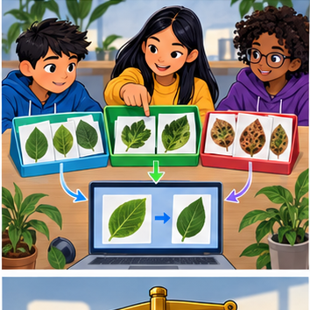
LEARNING TARGET Training: spots 0:H,2:H,4:S,6:S. Compare rules S if spots>=1,>=3,>=5. Choose by training accuracy, then predict held-out 1:H and 5:S without revising. Report both stages.
Builder name and experiment date:

Readiness for the connected explanation
Which values does min-max scaling learn, and which values should be reused for a validation query?

Readiness for Searching candidate rules
How does a training-majority baseline choose its prediction, and where is its validation accuracy measured?

My readiness explanation
________________________________________________________________
________________________________________________________________
________________________________________________________________

This week’s end goal
By the end, I can explain train a classifier using a traced example and a stated limitation.

02. Notice the evidence
PICTURE ENTRY

Notice → Predict → Explain
Begin with visible evidence; do not explain more than the picture and information support.
MYSTERY The team must use train a classifier to solve a model-building problem. What information do they have? What important evidence is still missing?
Name three visible details without interpreting them.
Predict the data, model, or evaluation decision being made.
Identify one hidden assumption that could change the result.
State what evidence would confirm or reject your prediction.
My prediction and supporting evidence:

A closer explanation
A pipeline connects steps so a new query receives the same preparation as the training examples. This week combines the scale from Week 11 with a one-neighbour classifier. We will fit once, keep the fitted state, and call one prediction function for every raw query.
Use the same fictional trip data. Each feature pair is ordered (distance in cm, brightness in sensor units). Training IDs are A,B,C. Validation IDs V1,V2,V3 belong to separate trips; related trips were grouped before splitting. Use min-max scaling, sum of absolute scaled differences, k=1 and alphabetical ID order for exact distance ties.
Training ID | Feature pair | Label
A | (10,200) | clear
B | (20,100) | blocked
C | (20,200) | blocked
The input contract requires two finite numeric features in the stated order and units, with no missing values. Training also needs unique IDs, known labels, at least one row and nonzero ranges. These assumptions must be checked before this short classroom program is used; its explicit guard only checks zero ranges.

Apply the connected idea: Searching candidate rules
Last week the baseline ignored scene features. This week a small fitting algorithm will choose a rule that uses one feature. We supply the rule form: predict blocked when a distance reading is at or below a cutoff, otherwise predict clear. The algorithm will try three cutoffs and keep the one making the fewest training mistakes.
The teacher-authored fictional rows contain a sensor distance in centimetres and a separate reviewed lane label, blocked or clear. The reading is available before prediction; the label comes from the scene review. A single distance need not describe every obstruction. These numbers are for learning, not real robot control. Each row comes from a different trip, and training and validation trips are separate.
Training row | Distance in cm | Reference label
1 | 2 | blocked
2 | 4 | blocked
3 | 6 | clear
4 | 8 | clear
Before scoring, declare cutoffs 3, 5 and 7 cm in ascending order, predict blocked at equality, and keep the smaller cutoff if training errors tie. This search tests only these three rules with this direction. It does not find the best possible model or prove that distance causes the label.

03. See how it works
ML MECHANISM

Input → Model → Evidence
Trace the information, fitted behavior, and evaluation proof separately.
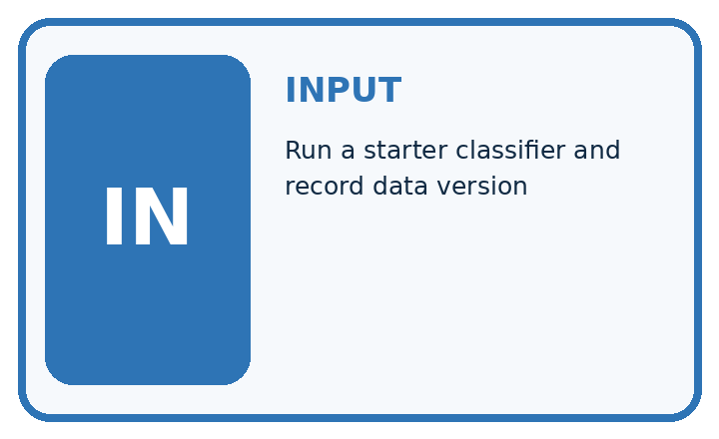
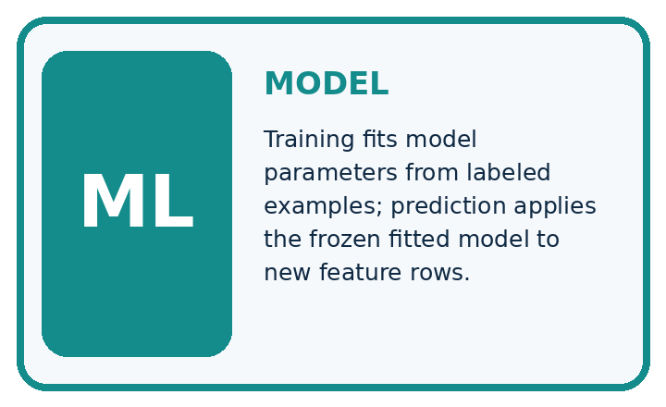
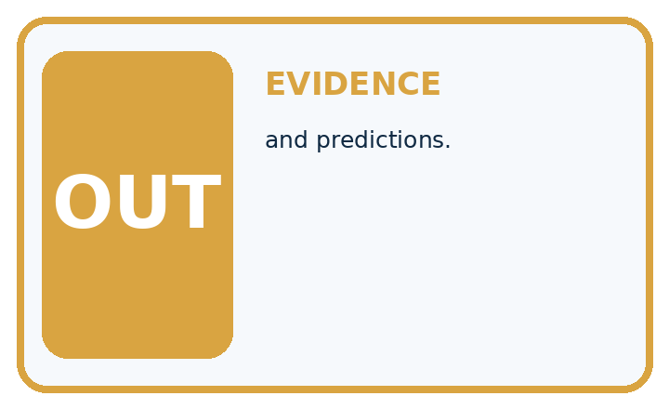
QUESTION Run a starter classifier and record data version, split, settings, and predictions.
MODEL IDEA Training fits model parameters from labeled examples; prediction applies the frozen fitted model to new feature rows.
PROOF NEEDED Use an unseen case, visible calculation, error analysis, and a stated limitation.
UNDER THE HOOD Load data version v1 and a saved train/test split. Fit preprocessing on training rows only, then fit the classifier.
Draw a fresh data → model → prediction → evaluation trace:

A closer explanation
def scale(x, low, span):
return tuple((x[j] - low[j]) / span[j] for j in range(2))
def fit(rows):
xs = [x for item_id, x, label in rows]
low = tuple(min(x[j] for x in xs) for j in range(2))
span = tuple(max(x[j] for x in xs) - low[j]
for j in range(2))
if 0 in span:
raise ValueError("Review a constant training feature")
stored = tuple((i, scale(x, low, span), y) for i, x, y in rows)
return low, span, stored
def predict(x, model):
low, span, stored = model
q = scale(x, low, span)
ranked = sorted((sum(abs(a - b) for a, b in zip(q, v)), i, y)
for i, v, y in stored)
return ranked[0][1], ranked[0][2]
train = [("A", (10, 200), "clear"),
("B", (20, 100), "blocked"),
("C", (20, 200), "blocked")]
model = fit(train)
queries = [(11, 120), (19, 190), (12, 80)]
for x in queries:
print(predict(x, model))
fit returns minima (10,100), ranges (10,100) and scaled training examples. predict transforms a raw query with that state, ranks distances, then returns the selected ID and label. zip pairs matching features; sum adds their absolute differences. sorted uses distance first and unique ID second.
Run the whole script in Python 3. It prints ('A', 'clear'), ('C', 'blocked'), ('B', 'blocked') on separate lines. No validation labels enter fit or predict. This is a small pipeline written with functions, not the scikit-learn Pipeline class.

Apply the connected idea: Searching candidate rules
train = [(2, "blocked"), (4, "blocked"),
(6, "clear"), (8, "clear")]
best_errors = len(train) + 1
best_cutoff = None
for cutoff in [3, 5, 7]:
errors = 0
for distance, label in train:
guess = "clear"
if distance <= cutoff:
guess = "blocked"
if guess != label:
errors = errors + 1
print(cutoff, errors)
if errors < best_errors:
best_errors = errors
best_cutoff = cutoff
print("chosen", best_cutoff)
The output lines are 3 1, 5 0, 7 1, then chosen 5. Cutoff 3 misses the blocked row at 4 cm. Cutoff 5 matches all four training labels. Cutoff 7 wrongly marks the 6 cm clear row as blocked. Fitting stores cutoff 5; prediction then applies that stored rule to a new distance.

Separate search from later scoring
Stage | Evidence | Decision
Try cutoffs 3 5 7 | Training labels | Count 1 0 1 errors
Store cutoff 5 | Smallest training error | Freeze this rule
Compare with baseline | Same validation rows | Report both scores
The supplied search chooses a cutoff using training errors. A perfect training fit does not establish performance on new examples.
best_errors starts above any possible mistake count. The strict < keeps the first tied candidate; ascending order makes that the smaller cutoff. The code assumes nonempty training data, numeric distances and the two allowed labels. Validate those assumptions before using another dataset.

Connect the picture and the explanation
Point to the input, the deciding step and the result in this week’s visual. Explain the same step in ordinary words. A picture helps when you can say what each part represents.

04. Compare the cases
EVALUATION DESIGN

Four Tests, Four Kinds of Evidence
A system is not understood until it survives more than one comfortable example.




NORMAL Expected data and expected behavior.
BOUNDARY Value close to a threshold, ambiguous label, or uncertain prediction.
MISSING Necessary field, label, source, or measurement is unavailable.
SHIFTED New lighting, species, device, subgroup, or time condition.
RELEASE RULE Passing one case never proves generalization. Predefine expected behavior for all four categories.
Which case most threatens today's claim, and why?

Change one thing in the pictured case
Change: Transform training but leave query numerically at 5.
Prediction: Distances become 15 and 55, incorrectly selecting healthy.
Reason: The query is now compared in inconsistent units; the changed result is a pipeline defect.

05. Words that unlock the idea
VOCABULARY

Words You Can Calculate and Defend
A definition matters when it lets you interpret a new dataset, model, or result.
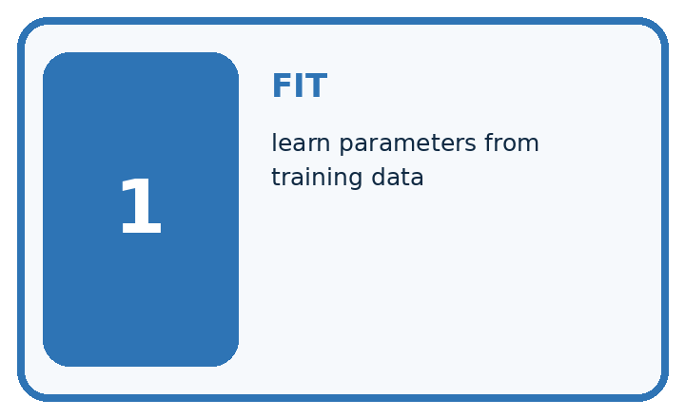
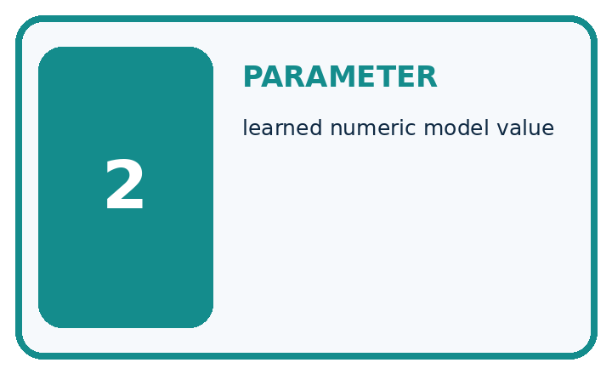
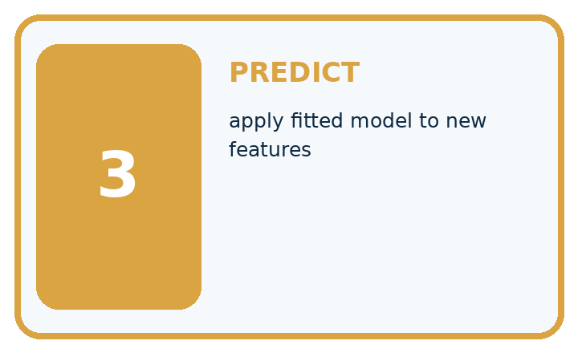
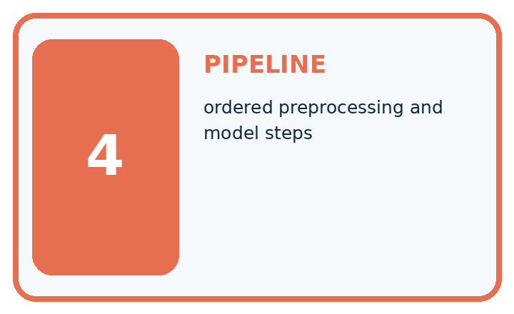
Term | Precise meaning | My ML example
fit | learn parameters from training data
parameter | learned numeric model value
predict | apply fitted model to new features
pipeline | ordered preprocessing and model steps
MISCONCEPTION TO REPAIR The model keeps learning whenever it sees test examples during evaluation.
Repair the claim using a definition, calculation, or test record:

Words used in the closer explanation
Word | Meaning
Pipeline | An ordered sequence of data transformations and prediction steps
Fitted state | The learned values and stored examples needed to make predictions
Reproduce | Obtain the same result using the same recorded inputs and procedure
Input contract | The documented feature names order units and accepted values

Terms for Searching candidate rules
Term | Meaning
Candidate rule | One possible prediction rule in a declared search
Threshold | A numerical boundary used to choose between outcomes
Training error | A mismatch between a prediction and its reference label in training data
Fitting | Using training examples to choose a model value or rule

06. Follow a worked example
WORKED EVIDENCE

Reason Step by Step
Predict first. Then check each step. A correct answer without visible evidence cannot be audited.
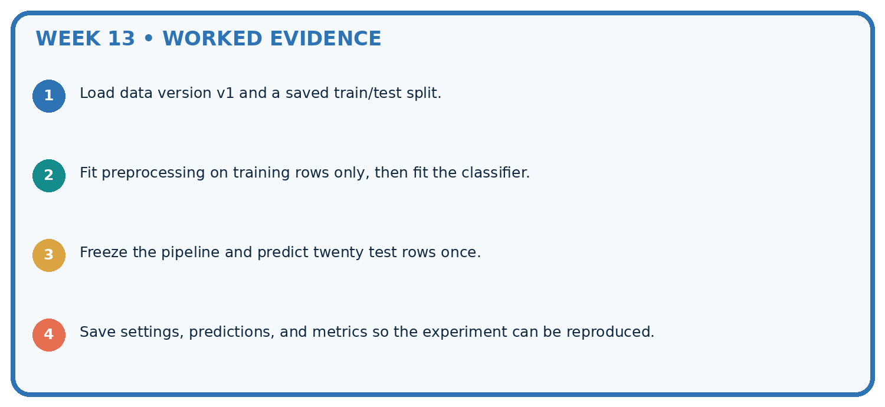
STEP 1 Load data version v1 and a saved train/test split.
STEP 2 Fit preprocessing on training rows only, then fit the classifier.
STEP 3 Freeze the pipeline and predict twenty test rows once.
STEP 4 Save settings, predictions, and metrics so the experiment can be reproduced.
CHECK Verify the denominator, unit, split, class definition, and data version before interpreting a score.
Recalculate, retrace, or restate the evidence independently:

A closer explanation

Two stages with one fitted state
Stage | Input and action | Result
Fit once | Training rows only | Scale plus stored rows
Predict each query | Raw pair plus state | Neighbour ID and label
Evaluate afterward | Prediction plus reference | Recorded match or error
Reference labels are used after prediction to score results. They do not enter the fitted scale or stored neighbour pool.
For raw query (11,120), scale gives (0.1,0.2). Distances to A,B,C are 0.9,1.1,1.7, so the function returns A and clear. It does not recalculate minima or add the query to stored rows. The returned ID is useful for checking the reasoning, but it is not evidence that the label is true.

Trace (11,120) through both functions. What does fit store, what does predict reuse, and at which point may a validation reference label be compared?
________________________________________________________________
________________________________________________________________
________________________________________________________________
________________________________________________________________
Store the fitted state together with the input contract and method settings. A model without its scale or feature order is incomplete. Swapping the raw pair to (120,11) produces B and blocked here; the function cannot detect that the caller swapped the meanings.

Apply the connected idea: Searching candidate rules
Now reveal four validation rows in order: (3, blocked), (5, clear), (7, clear), (9, blocked). With the stored cutoff 5, predictions are blocked, blocked, clear, clear. Rows 1 and 3 match, so validation accuracy is 2/4 or 50 percent despite zero training mistakes.
The training labels tie at two blocked and two clear. Carry forward Week 7’s baseline tie rule, choose clear. That baseline matches validation rows 2 and 3, also 2/4 or 50 percent. The fitted rule has not improved total accuracy on this set, and the two methods make different mistakes.

For the validation distance exactly 5 cm, what does the fitted rule predict and why? Which rows are wrong for the rule and the baseline? State their difference in percentage points.
________________________________________________________________
________________________________________________________________
________________________________________________________________
________________________________________________________________
________________________________________________________________
Keep the rule and baseline fixed for this comparison. Do not secretly choose a different cutoff after seeing validation labels and call that a training-only choice. Validation can guide later development, but record those choices and reserve an untouched final test. No final test is supplied here.

Learn from the worked case
Cover the result before checking it. Say what is given, choose the procedure, and follow one step at a time. Then uncover the result and explain your first mismatch. Ask why a step is allowed, not only what number it produces.

A pictorial worked case: Train a Classifier
Separate a reproducible fitted pipeline from merely displaying predictions.

The facts we will use
Toy training lengths are [2, 6] cm with labels [healthy, spotted]. Pipeline converts cm to mm, then uses k=1 absolute distance. Query is 5 cm.
All inputs and outcomes in this worked example are invented classroom data; no real model run is claimed.
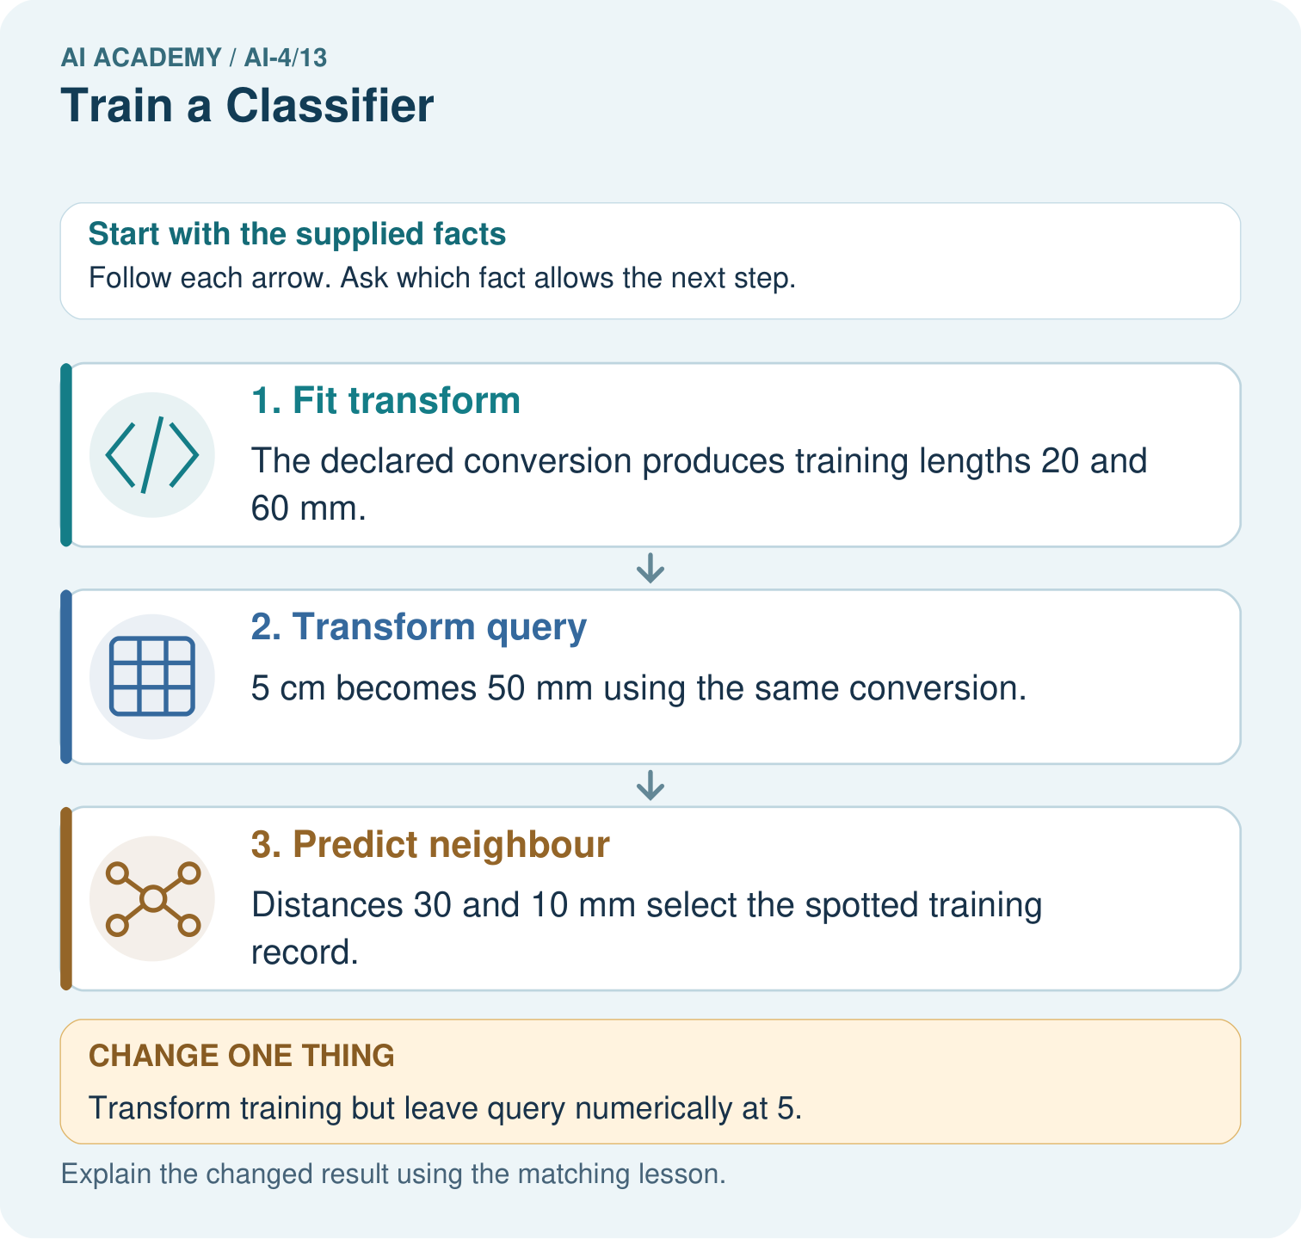

Read the picture one step at a time
Step | What happens and why
1. Fit transform | The declared conversion produces training lengths 20 and 60 mm.
2. Transform query | 5 cm becomes 50 mm using the same conversion.
3. Predict neighbour | Distances 30 and 10 mm select the spotted training record.
Match each pictured step to the supplied facts. This is a worked teaching case, not an independent assessment.

Why this result follows
Read the picture in order. Distances 30 and 10 mm select the spotted training record. The arrows show which recorded input or intermediate result each decision uses. Explain the deciding step aloud before checking the changed case; pointing to the final answer alone does not show how it follows.

What this example does not establish
A reproducible toy pipeline can still perform poorly; evaluation must use separate records and appropriate group splits.
Read the labelled picture: Which pipeline record would help another team reproduce the result? Point to the relevant step in the picture, then write the changed result and the rule or evidence that supports it.
Change one thing: Transform training but leave query numerically at 5. Predict the result before checking the explanation. What remains the same?

07. Find and repair a mistake
ERROR DETECTIVE

Compare → Diagnose → Repair
Do not patch the answer. Find the earliest unsupported assumption, data problem, or experiment error.
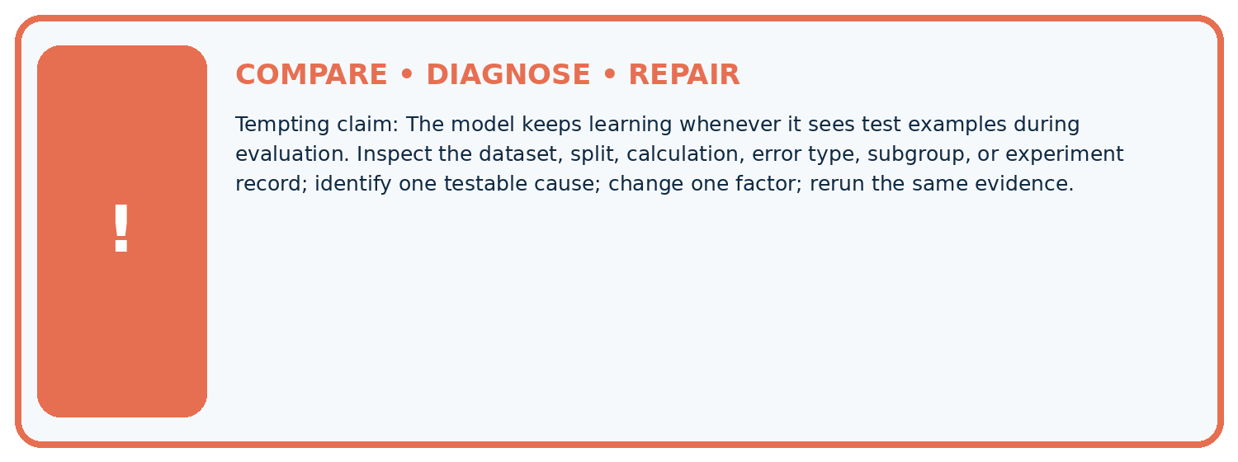
Evidence record | Expected | Actual | Likely cause / next test
normal case | passes
boundary case | defined behavior
missing case | safe fallback
shifted case | measured limit
CLAIM TO CHALLENGE The model keeps learning whenever it sees test examples during evaluation.
Diagnose one cause and name the cleanest next experiment:

A closer explanation
Check that fit receives training rows only, predict receives raw features in the correct order, and the fitted state stays unchanged during prediction. Do not scale a query twice, fit again on validation, or add labelled validation rows to the neighbour pool. A pipeline still leaks if the wrong rows are passed to its fit step.
The tuple state groups the learned numbers and stored examples. Keep the associated data and code versions with it, and compare stored values and outputs when repeating a run. Do not accept a matching score alone: two different prediction lists can have the same score.

A learner gets the same 2/3 score twice after fitting on training plus validation rows. They claim the pipeline must be valid because the result repeats. Explain why the claim fails and describe the repair.
________________________________________________________________
________________________________________________________________
________________________________________________________________
________________________________________________________________

Apply the connected idea: Searching candidate rules
Humans chose the feature, labels, candidate cutoffs, direction and scoring method. The program used training examples to select the cutoff. That is a small example of fitting a model; writing a loop alone does not make a method learn. Choosing the cutoff in advance without consulting training examples would instead be a fixed rule.
Record the source and split, rule form, candidate list, all training error counts, tie policy, selected cutoff and both validation prediction lists. Do not discard a difficult row to improve a score. Next week a decision tree will extend the idea of feature-based decisions, while the need for honest evaluation stays the same.

A learner reports that cutoff 5 is perfect because training error is zero. Rewrite the claim using the training result, validation comparison and the limits of this small search.
________________________________________________________________
________________________________________________________________
________________________________________________________________
________________________________________________________________
________________________________________________________________

08. Practise together
ML STUDIO

Specify Before You Run
A trustworthy result can be reproduced from the recorded data, code, settings, and evaluation rule.


Experiment record
QUESTION + intended use + success threshold
DATA version + grouped split + leakage check
CODE/preprocessing + features + model + settings + seed
METRICS + positive class + units + denominators
PREDICTIONS + errors + subgroup slices + limitations
HUMAN reviewer + release, revise, limit, or stop decision
Write the minimum record needed to reproduce today's result:

A closer explanation
Record dataset and code versions, training IDs A B C, validation IDs V1 V2 V3, feature order and units, fitted minima and ranges, k=1, distance and tie policy, zero-range policy and the actual Python version. Save the predictions in validation ID order. This script has no random step; a seed would not fix changed data or swapped features.
References for V1,V2,V3 are clear,blocked,clear. The printed predictions clear,blocked,blocked match V1 and V2: 2/3. The training-majority blocked baseline matches only V2: 1/3. Rerunning the same code and inputs should reproduce these outputs, including the V3 mistake. Reproducibility does not establish correctness or performance on new data.
Changing the scaling, k or feature list creates a new development run to record. Keep a separate final test for the final evaluation. Next week a confusion matrix will show which kinds of label errors the predictions make.

Apply the connected idea: Searching candidate rules
A learner uses distance < cutoff instead of distance <= cutoff during prediction. That changes the boundary: at 5 cm the stored cutoff now predicts clear. Recheck code against the declared rule before interpreting the score. A small symbol can change which examples match.
Another learner uses <= when deciding whether a candidate has fewer errors. That replaces an earlier candidate on a tie. The prediction boundary <= and the search comparison < have different jobs. Use the declared tie policy; a tied training score gives no evidence that one tied rule will be better on new cases.

Practise with less help: Trace and score the saved run
Use workbook W2 for the connected example “A reproducible classifier pipeline”. First fill the input and rule boxes. Try the middle steps before asking for a hint. After a hint, try the next step yourself.
Plan | Do | Check
What is given? Which rule or procedure applies? | Record each intermediate step. | Does the result follow? What remains unknown?
Explain your trace to a partner. Your partner points to one step to check. Swap roles on the next case. Each person writes their own explanation.

Check your reasoning
Use the worked case for A reproducible classifier pipeline. Proposed explanation: “A pipeline prevents every leak automatically”. Decide whether this explanation is supported. Point to the step or supplied fact that decides; explain your repair if needed.
Answer on your own before discussion. If you are unsure, say which step you need help with.

Practise the connected topic: Searching candidate rules
Use its named workbook W2. Identify the given inputs, try the middle steps with less help, then explain your trace. Check this claim before group discussion: Zero training error means perfect predictions

Explain the picture
Which pipeline record would help another team reproduce the result? Point to the relevant step in the picture, then write the changed result and the rule or evidence that supports it.

My explanation using a pictured step and the given facts
________________________________________________________________
________________________________________________________________
________________________________________________________________
________________________________________________________________
This is supported practice. Keep the separately named independent case for an attempt before feedback.

09. Run the investigation
EVIDENCE LAB

Predict → Run → Calculate → Interpret
Keep the test conditions fixed, record every result, and change only one planned factor.
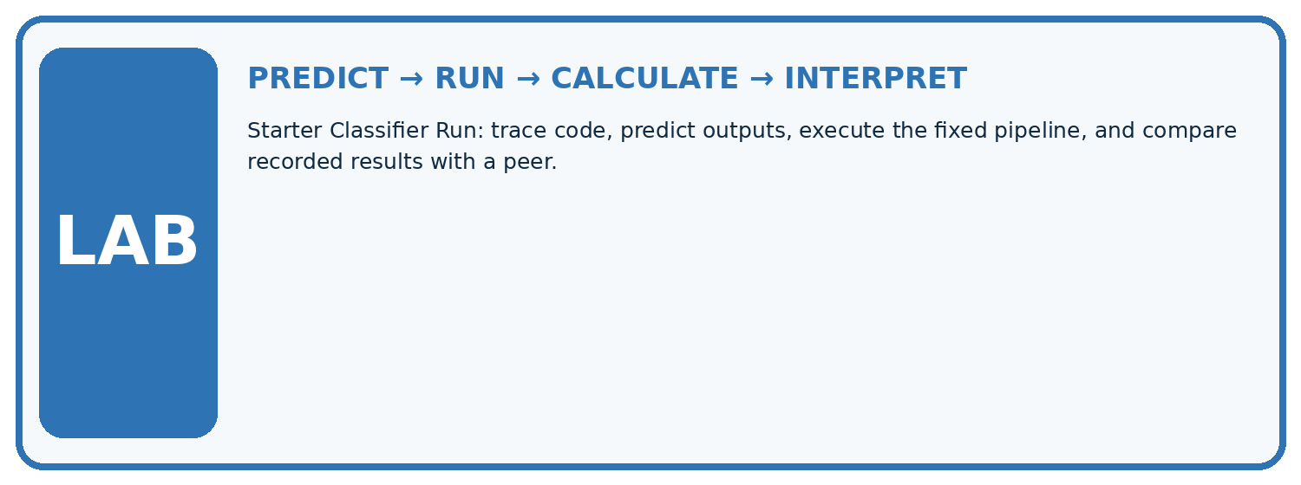
1. Write the hypothesis and expected evidence before running.
2. Starter Classifier Run: trace code, predict outputs, execute the fixed pipeline, and compare recorded results with a peer.
3. Run one normal, one boundary, one missing, and one shifted case.
4. Calculate the metric from raw counts or row-level errors.
5. Interpret what changed, what did not, and what remains unsafe or unknown.
Case | Prediction | Actual | Calculation / evidence | Meaning / next test
Normal
Boundary
Missing
Shifted

Plan → try → check
Before trying: what do I expect, and why? While trying: which step could first go wrong? Afterwards: what did I actually observe, and what should change? Keep “not run” if you only traced the procedure.

10. Build your understanding
MASTERY

From Knowing the Word to Owning the Idea
Move upward only when you can produce evidence without copying the example.

DEFINE Use all four terms precisely: fit, parameter, predict, pipeline.
CALCULATE Reproduce the worked evidence with units and denominator.
TRACE Explain the data, code or decision path.
DIAGNOSE The model keeps learning whenever it sees test examples during evaluation.
TRANSFER Solve a fresh dataset or model case.
IMPROVE Change one cause and rerun fixed evidence.
DEFEND State intended use, metric, limitation, and human responsibility.
MASTERY RULE A coached calculation becomes mastery only after a different case is completed independently.

11. Connect your project
CUMULATIVE PROJECT

Responsible Plant Classifier
Every week adds one reviewable artifact to the same evidence-based capstone.
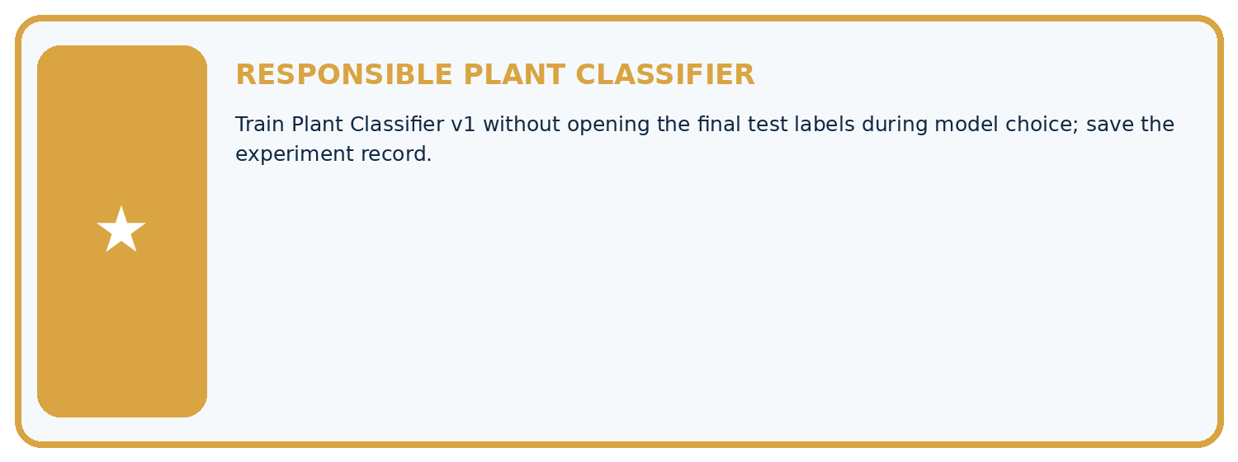
THIS WEEK'S CHECKPOINT Train Plant Classifier v1 without opening the final test labels during model choice; save the experiment record.
Which requirement or risk does this artifact address?
Which dataset, split, code, and metric version does it use?
What normal and shifted cases were tested?
What remains uncertain or weak?
What decision still belongs to a teacher or qualified human?
RESPONSIBLE RELEASE Never use this classroom prototype for medical, pesticide, agricultural, or other consequential decisions.
My evidence-linked project decision:

Evidence for your project
For your Responsible Plant Classifier, save the input, procedure, observed result and limitation of this check. Label this worked example as practice; use a different, previously unreviewed case when checking independent understanding.

12. Show what you know
INDEPENDENT PROOF

Explain • Calculate • Transfer • Defend
Complete this with a fresh case after guided practice and compare it with the mastery criteria.
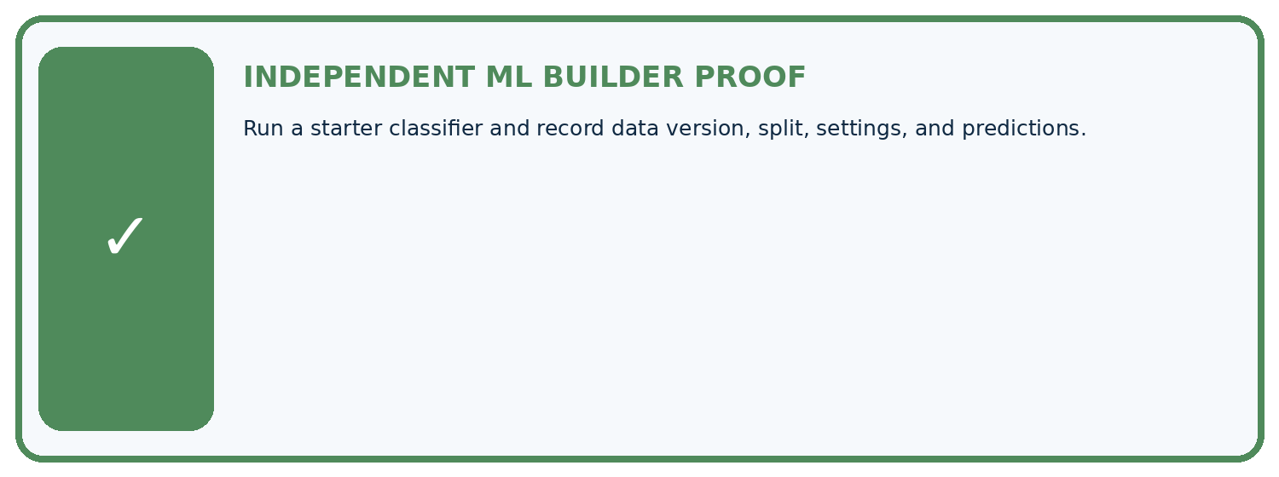
REQUIRED PROOF Run a starter classifier and record data version, split, settings, and predictions.
□ Define the task, feature/target roles, and intended-use boundary.
□ Show the calculation, code trace, or experiment record.
□ Test a normal case and one revealing boundary, missing, or shifted case.
□ Diagnose one failure without changing several factors at once.
□ Name a limitation, fairness concern, and the human-review action.
Independent evidence and defense:
My level: □ Not yet □ With one hint □ Independently □ I can teach and defend it
NEXT BRIDGE Carry the experiment evidence into: Scores and Calibration Intuition.

13. Study a complete case

Week 13 Worked case
Use the supplied details to practise the weekly concept before attempting the independent question. This case extends the illustrated lesson.

The situation
Training is (0,H),(1,H),(4,S),(5,S). Candidate rule predicts S for spots>=3. Held-out cases are (2,H),(3,S).

The question
Apply the rule and distinguish fitting from inference.

Worked explanation
Predictions H,S give 2/2 on this tiny set. Choosing the rule is development; applying it is inference. Two cases do not establish broad performance.

Explain it in your own words
Which detail supports the answer, and why does it matter?

Write or draw your reasoning and evidence.
________________________________________________________________
________________________________________________________________
________________________________________________________________
________________________________________________________________
________________________________________________________________

Trace the supplied case visually

Apply a developed rule to new cases
Evidence or stage | Value or result
Training | 0 and 1 labelled H, 4 and 5 labelled S
Supplied rule | Spots at least 3 predicts S
Test 2 spots | Predict H
Test 3 spots | Predict S
Training is (0,H),(1,H),(4,S),(5,S). Candidate rule predicts S for spots>=3. Held-out cases are (2,H),(3,S).
Apply the rule and distinguish fitting from inference.
Predictions H,S give 2/2 on this tiny set. Choosing the rule is development; applying it is inference. Two cases do not establish broad performance.

14. Try a new case independently

Independent case: Build and trace a fresh fitted state
Use P (0,60) blocked, Q (20,20) clear, R (20,60) clear as new training rows. Fit the same pipeline. Predict validation queries (2,28),(18,56),(4,12) with references blocked,clear,blocked. Give fitted minima and ranges, transformed queries, selected IDs, predictions, accuracy and training-majority baseline.

My independent explanation, trace and limits
________________________________________________________________
________________________________________________________________
________________________________________________________________
________________________________________________________________
________________________________________________________________
________________________________________________________________
________________________________________________________________
Attempt this case before feedback. Record any help. Earlier examples below are further practice; a case already practised with feedback cannot establish fresh transfer.

Week 13 Independent application
Close the worked explanation. Apply the idea to this different question without copying.
A classifier fits on rows 1–80 and is evaluated on those same rows. Its accuracy is 100%. What additional evidence is needed before claiming generalization?
My answer, with a trace, calculation or supporting evidence

Write or draw your reasoning and evidence.
________________________________________________________________
________________________________________________________________
________________________________________________________________
________________________________________________________________
________________________________________________________________

Create and test
Change one relevant detail. Predict the result before testing. Include a boundary or missing-information case when it helps reveal a limit.
My changed input and expected result

Write or draw your reasoning and evidence.
________________________________________________________________
________________________________________________________________
________________________________________________________________
________________________________________________________________
________________________________________________________________

Connect to your project
Train Plant Classifier v1 without opening the final test labels during model choice; save the experiment record.
The evidence I will keep

Write or draw your reasoning and evidence.
________________________________________________________________
________________________________________________________________
________________________________________________________________
________________________________________________________________
________________________________________________________________
Your teacher has the independent answer and scoring criteria. Complete the matching workbook week to keep your practice evidence together.

Transfer practice from the original programme
Training: spots 0:H,2:H,4:S,6:S. Compare rules S if spots>=1,>=3,>=5. Choose by training accuracy, then predict held-out 1:H and 5:S without revising. Report both stages.

Explain the mechanism, evidence and one limit.
________________________________________________________________
________________________________________________________________
________________________________________________________________
________________________________________________________________
________________________________________________________________
________________________________________________________________
________________________________________________________________

Use feedback to improve
Attempt the independent case before hints. Record whether you worked alone, used a hint or followed a model. After feedback, fix the first unsupported step and explain why it changed. A later check uses a changed case, not a copied answer.

15. Fit and test a threshold classifier

Fit and test a threshold classifier
The program chooses a threshold using training labels only. Spotted is 1 and healthy is 0. Candidate thresholds lie between consecutive training values. Test rows are used after selection.
"""Fit a threshold using training data, then evaluate untouched examples."""
train = [(0, 0), (1, 0), (4, 1), (5, 1)]
values = sorted({x for x, y in train})
if len(values) < 2:
raise ValueError("Two distinct training values are required")
candidates = [(a + b) / 2 for a, b in zip(values, values[1:])]
def errors(threshold):
return sum(int(x >= threshold) != y for x, y in train)
threshold = min(candidates, key=errors)
test = [(2, 0), (3, 1)]
predictions = [int(x >= threshold) for x, y in test]
correct = sum(pred == y for pred, (x, y) in zip(predictions, test))
print(threshold, predictions, correct, len(test))
Expected output: 2.5 [0, 1] 2 2
Candidate thresholds 0.5, 2.5 and 4.5 have training errors 1, 0 and 1. The selected threshold is 2.5. Both test predictions are correct. This tiny artificial example demonstrates fitting and evaluation; it does not establish reliability on real leaf photos.

Independent code change
Change the final test row to (3, 0), keeping training unchanged. Predict before running.
My prediction and evidence

Write or draw your reasoning and evidence.
________________________________________________________________
________________________________________________________________
________________________________________________________________
________________________________________________________________
________________________________________________________________

16. Your lesson route
Start with this question: Separate a reproducible fitted pipeline from merely displaying predictions.
By the end, I can | How I will show it
Connect training-only scaling and neighbour prediction in one pipeline | Explain the deciding step, show a trace or test, and state one limit.
Reproduce predictions from recorded data settings and fitted values | Explain the deciding step, show a trace or test, and state one limit.
Audit a pipeline for refitting feature-order errors and evaluation leakage | Explain the deciding step, show a trace or test, and state one limit.
Remember → watch and explain → try with help → investigate → try independently → keep project evidence. Your teacher may spread this lesson across several classes.
Keep your first prediction. Compare it with what the evidence shows and explain any change.

17. Finish and return
Close your notes. Explain this goal in your own words: Connect training-only scaling and neighbour prediction in one pipeline

My deciding step, evidence and one remaining question
________________________________________________________________
________________________________________________________________
________________________________________________________________
________________________________________________________________
________________________________________________________________
If you are unsure, return to the worked picture and explain one arrow. If you are ready, change an input or assumption and justify your prediction.
Save your workbook evidence. At the next review, try a different case before opening your old answer.

18. Supported practice, repair and portfolio
Use this supported practice once, in the browser or on paper. Keep the reserved independent assessment for a separate first attempt before teacher feedback.
Separate a reproducible fitted pipeline from merely displaying predictions.

Practice 1: explain the deciding evidence
Which labelled step matches this detail? Distances 30 and 10 mm select the spotted training record.
1. Predict neighbour
2. Fit transform
3. Transform query

My selected conclusion, deciding fact and explanation
________________________________________________________________
________________________________________________________________
________________________________________________________________
________________________________________________________________
________________________________________________________________
Hint if needed: Read the steps in the pictorial case. Match the supplied detail to the stage that performs or records it.
After your attempt, compare with the supported explanation: Predict neighbour Distances 30 and 10 mm select the spotted training record. Read the picture in order. Distances 30 and 10 mm select the spotted training record. The arrows show which recorded input or intermediate result each decision uses. Explain the deciding step aloud before checking the changed case; pointing to the final answer alone does not show how it follows.

Practice 2: explain the deciding evidence
Changed-case practice: Transform training but leave query numerically at 5. Which conclusion is supported by the supplied facts?
1. Distances become 15 and 55, incorrectly selecting healthy.
2. We can decide the result without examining the changed input or the procedure.
3. This one example guarantees correct results for every future input.

My selected conclusion, deciding fact and explanation
________________________________________________________________
________________________________________________________________
________________________________________________________________
________________________________________________________________
________________________________________________________________
Hint if needed: Use the changed condition and the deciding step in the pictorial trace. The answer must say what follows from those facts.
After your attempt, compare with the supported explanation: Distances become 15 and 55, incorrectly selecting healthy. The query is now compared in inconsistent units; the changed result is a pipeline defect.

Repair a missing building block
Review Nearest Neighbors (ai-4/12). Goal: Compute absolute distances and rank training neighbours. Short practice: Why is the k=1 outcome at length5 not uniquely determined without a tie rule? Point to the relevant step in the picture, then write the changed result and the rule or evidence that supports it.. Return to this week and explain what you changed.
Review Baselines First (ai-4/10). Goal: Fit a majority label baseline using training labels only. Short practice: Can the candidate’s training accuracy replace this validation comparison? Point to the relevant step in the picture, then write the changed result and the rule or evidence that supports it.. Return to this week and explain what you changed.
Review Sampling and Intended Use (ai-4/7). Goal: Inspect row meaning missing values and repeated records. Short practice: Which collection would address the intended-use gap most directly? Point to the relevant step in the picture, then write the changed result and the rule or evidence that supports it.. Return to this week and explain what you changed.

Predict, run and debug
The browser lab lets you edit the supported Python examples already included in this lesson. Predict first, run, inspect the actual output or error, change one input, then run again. Keep code, predictions, actual results and a reasoned revision together. On paper, label your result as a trace rather than an execution.

Keep your completed work
Use Download completed work in the hosted lesson to export your answers, reflections, practice feedback and code-run evidence. Open the HTML copy to read or print it. Drafts stay in this browser when storage is available; clear drafts on a shared device.

