AI ACADEMY · STUDENT · ai-4/18

Error Analysis
Project: Responsible Plant Classifier

Before you start
Week 15: errors can be grouped by relevant conditions.

01. Your mission

Your learning target
I can categorize development errors using evidence.
I can design a controlled change with a stated hypothesis.
I can preserve failures and test boundaries.

Remember before reading
Close your notes first. A rough first answer helps us choose the right starting point; it is not a score for your ability.
Without opening the old lesson, explain one key idea from Precision and Recall. Give an example and a mistake that the idea helps you avoid.
Without opening the old lesson, explain one key idea from Confusion Matrix. Give an example and a mistake that the idea helps you avoid.
Without opening the old lesson, explain one key idea from Nearest Neighbors. Give an example and a mistake that the idea helps you avoid.
After trying, check the relevant lesson or ask your teacher. Change the part of your explanation that the evidence shows was wrong.
Grouping errors by observable conditions connects a metric problem to possible data, label, feature, or model causes.
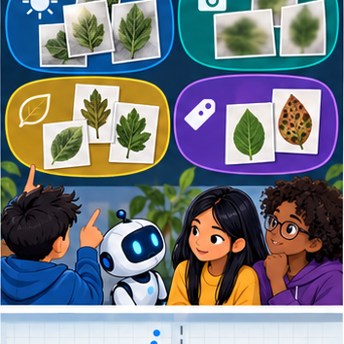
LEARNING TARGET A model fails 6/10 backlit and 2/20 front-lit photos. Compute error rates and design a follow-up that tests lighting rather than leaf identity.
Builder name and experiment date:

Readiness for the connected explanation
What does a confusion matrix omit?

This week’s end goal
By the end, I can explain error analysis using a traced example and a stated limitation.

02. Notice the evidence
PICTURE ENTRY

Notice → Predict → Explain
Begin with visible evidence; do not explain more than the picture and information support.
MYSTERY The team must use error analysis to solve a model-building problem. What information do they have? What important evidence is still missing?
Name three visible details without interpreting them.
Predict the data, model, or evaluation decision being made.
Identify one hidden assumption that could change the result.
State what evidence would confirm or reject your prediction.
My prediction and supporting evidence:

A closer explanation
Error analysis begins with prediction IDs and reference labels. Inspect features, collection conditions and the labelling policy. Do not assume every surprising prediction proves the reference is wrong. Use development errors to propose a change and specify what outcome would support the explanation.
Use fictional classroom data throughout this investigation. Keep the task, units, reference labels and data split visible as you reason. Earlier weeks supplied the model-building process; this week examines error analysis and controlled follow-up.

03. See how it works
ML MECHANISM

Input → Model → Evidence
Trace the information, fitted behavior, and evaluation proof separately.
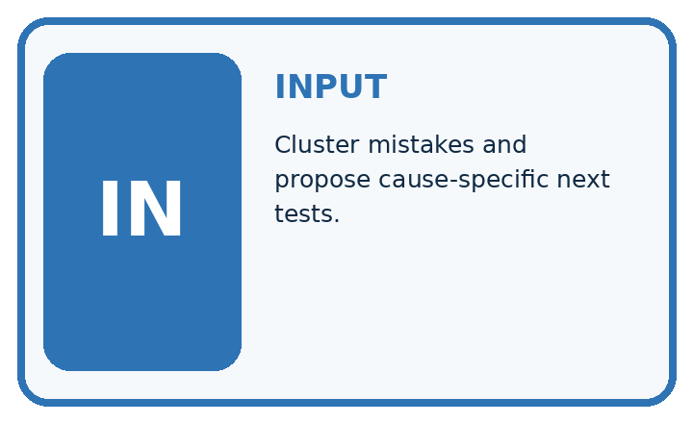
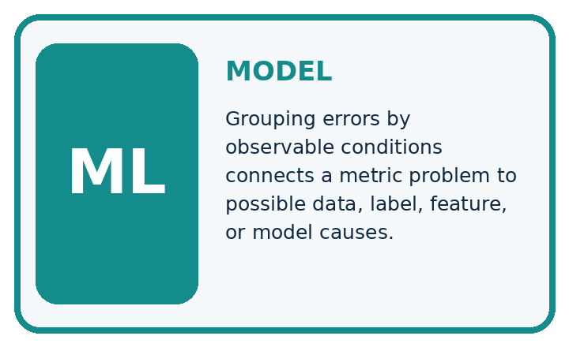
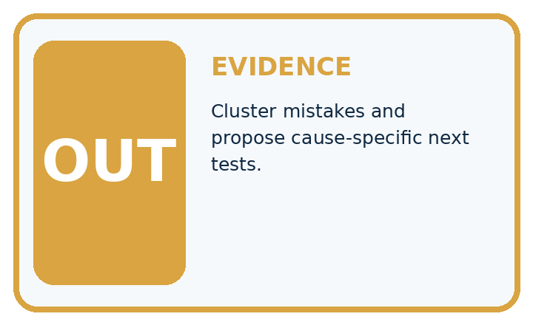
QUESTION Cluster mistakes and propose cause-specific next tests.
MODEL IDEA Grouping errors by observable conditions connects a metric problem to possible data, label, feature, or model causes.
PROOF NEEDED Use an unseen case, visible calculation, error analysis, and a stated limitation.
UNDER THE HOOD Twelve errors are grouped: 6 low light, 3 blurred, 2 label disagreements, 1 unusual species. Largest cluster suggests a lighting representation problem, not proof of the cause.
Draw a fresh data → model → prediction → evaluation trace:

A closer explanation
A validation audit has 12 dim-light cases with 4 errors and 18 bright-light cases with 3 errors. Rates are 4/12=1/3 and 3/18=1/6. Dim lighting is a useful lead, not proof of causation: camera, route or labels may also differ. A planned change uses a training-fitted brightness normalization while keeping split and classifier settings fixed.
old_errors = [4, 3]
new_errors = [2, 4]
counts = [12, 18]
for old, new, n in zip(old_errors, new_errors, counts):
print(old / n, new / n)
print(sum(old_errors), sum(new_errors))
# Total errors fall from 7 to 6; one group worsens.
Trace the calculation on paper before running this optional Python check. Use the stated fictional inputs and compare intermediate values. The code checks this example; your independent workbook case uses different evidence.

Connect the picture and the explanation
Point to the input, the deciding step and the result in this week’s visual. Explain the same step in ordinary words. A picture helps when you can say what each part represents.

04. Compare the cases
EVALUATION DESIGN

Four Tests, Four Kinds of Evidence
A system is not understood until it survives more than one comfortable example.




NORMAL Expected data and expected behavior.
BOUNDARY Value close to a threshold, ambiguous label, or uncertain prediction.
MISSING Necessary field, label, source, or measurement is unavailable.
SHIFTED New lighting, species, device, subgroup, or time condition.
RELEASE RULE Passing one case never proves generalization. Predefine expected behavior for all four categories.
Which case most threatens today's claim, and why?

Change one thing in the pictured case
Change: Dim errors fall to1/6 in a later same-case replay.
Prediction: The replay’s dim error rate is 16.7%; it is development evidence if those cases guided the revision.
Reason: Observed improvement on reused cases is not an untouched final generalisation test.

05. Words that unlock the idea
VOCABULARY

Words You Can Calculate and Defend
A definition matters when it lets you interpret a new dataset, model, or result.
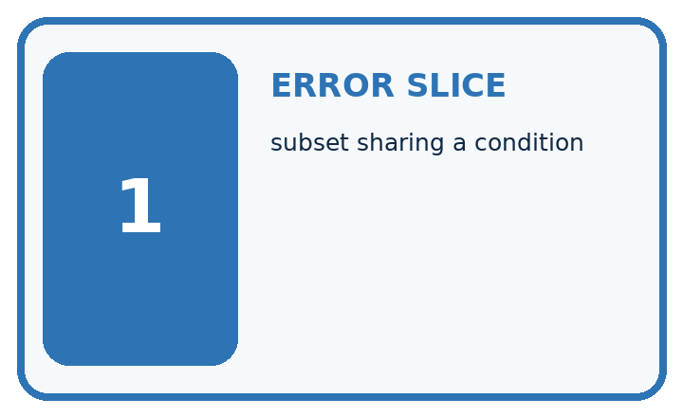
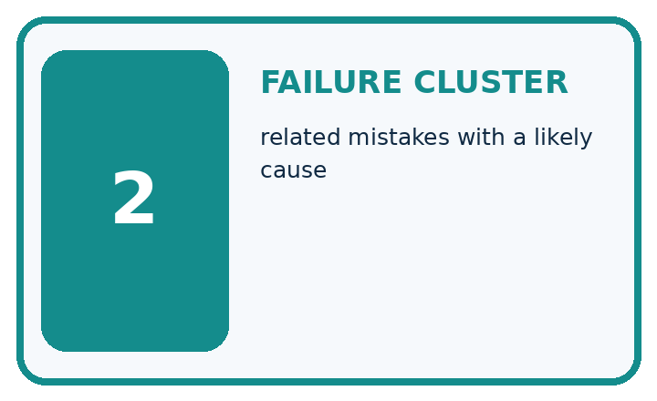
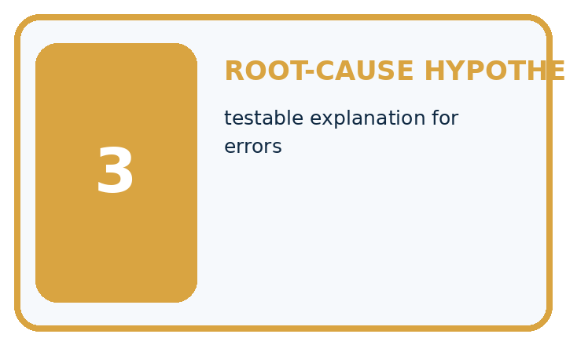
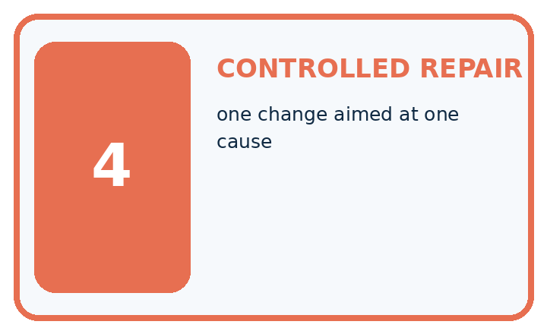
Term | Precise meaning | My ML example
error slice | subset sharing a condition
failure cluster | related mistakes with a likely cause
root-cause hypothesis | testable explanation for errors
controlled repair | one change aimed at one cause
MISCONCEPTION TO REPAIR Looking closely at one surprising error is enough to diagnose the model.
Repair the claim using a definition, calculation, or test record:

Words used in the closer explanation
Word | Meaning
Error analysis | Inspection of mistakes to propose explanations
Hypothesis | A testable proposed explanation
Controlled comparison | A comparison that changes one planned factor while holding relevant conditions fixed
Regression | A new failure introduced by a change

06. Follow a worked example
WORKED EVIDENCE

Reason Step by Step
Predict first. Then check each step. A correct answer without visible evidence cannot be audited.
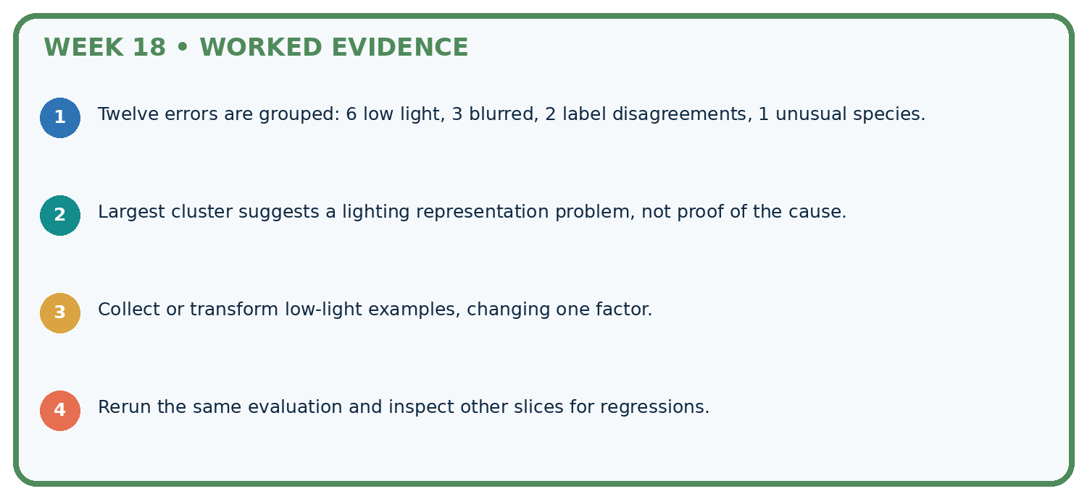
STEP 1 Twelve errors are grouped: 6 low light, 3 blurred, 2 label disagreements, 1 unusual species.
STEP 2 Largest cluster suggests a lighting representation problem, not proof of the cause.
STEP 3 Collect or transform low-light examples, changing one factor.
STEP 4 Rerun the same evaluation and inspect other slices for regressions.
CHECK Verify the denominator, unit, split, class definition, and data version before interpreting a score.
Recalculate, retrace, or restate the evidence independently:

A closer explanation

Error analysis and controlled follow-up at a glance
Part | Evidence or action | Interpretation
Inspect | IDs and conditions | Propose a hypothesis
Change | One planned factor | Keep comparison fixed
Evaluate | All validation records | Report gains and regressions
After the change, the same validation groups have 2/12 and 4/18 errors. Total errors fall from 7 to 6, but bright-light errors increase from 3 to 4. Report both results. A net improvement does not mean every part improved, and repeated experiments can overfit validation.

Does the difference prove dim light causes model errors? Explain the steps or evidence behind your response.
________________________________________________________________
________________________________________________________________
________________________________________________________________
________________________________________________________________

Learn from the worked case
Cover the result before checking it. Say what is given, choose the procedure, and follow one step at a time. Then uncover the result and explain your first mismatch. Ask why a step is allowed, not only what number it produces.

A pictorial worked case: Error Analysis
Find an error cluster before choosing a controlled follow-up.

The facts we will use
Candidate errors: bright-light photos1/8; dim-light photos3/6. Images and reference labels are fixed for this audit.
All inputs and outcomes in this worked example are invented classroom data; no real model run is claimed.
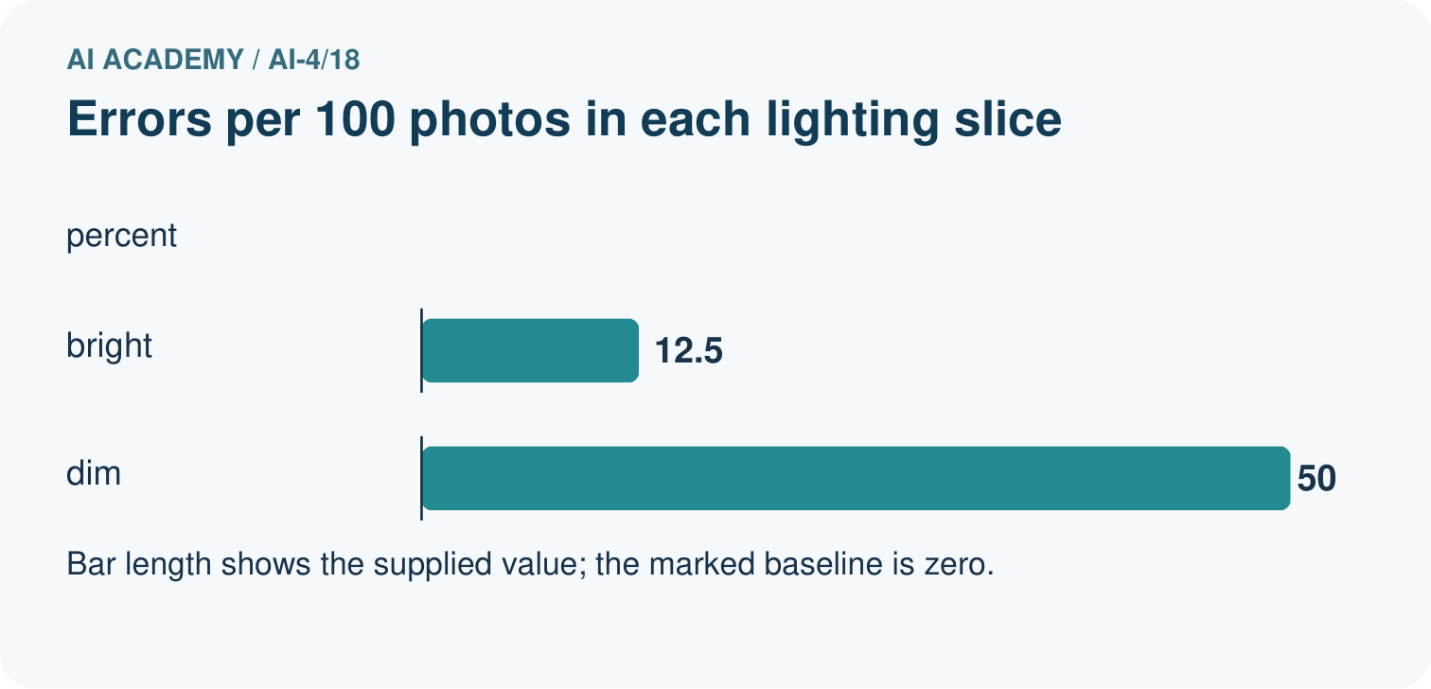
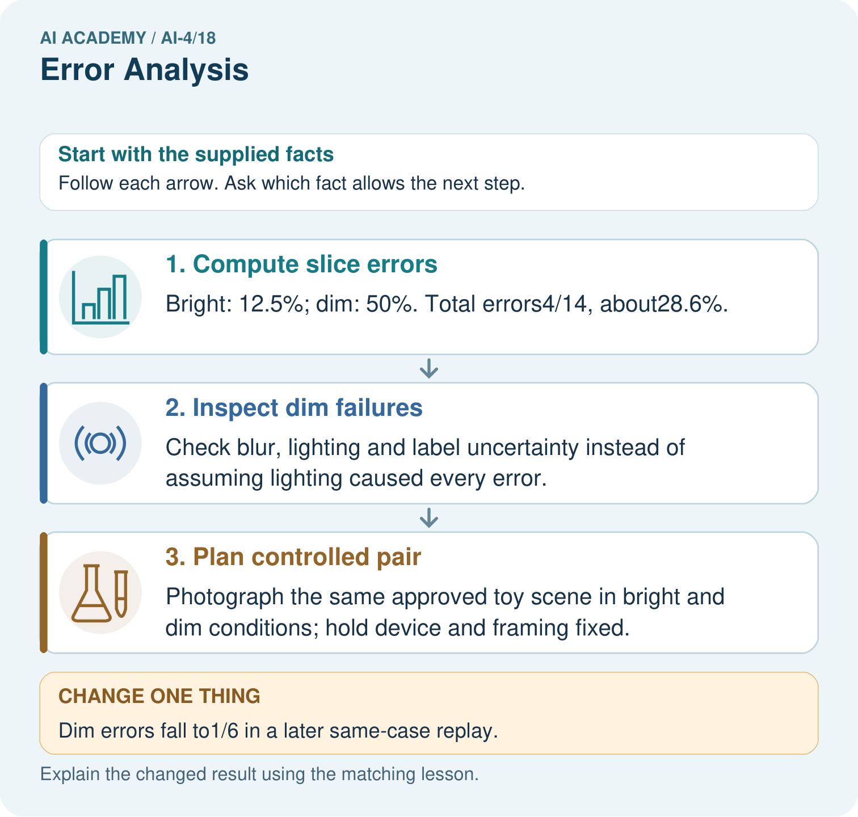

Read the picture one step at a time
Step | What happens and why
1. Compute slice errors | Bright: 12.5%; dim: 50%. Total errors4/14, about28.6%.
2. Inspect dim failures | Check blur, lighting and label uncertainty instead of assuming lighting caused every error.
3. Plan controlled pair | Photograph the same approved toy scene in bright and dim conditions; hold device and framing fixed.
Match each pictured step to the supplied facts. This is a worked teaching case, not an independent assessment.

Why this result follows
Read the picture in order. Photograph the same approved toy scene in bright and dim conditions; hold device and framing fixed. The arrows show which recorded input or intermediate result each decision uses. Explain the deciding step aloud before checking the changed case; pointing to the final answer alone does not show how it follows.

What this example does not establish
A slice difference suggests investigation; it does not establish a causal lighting explanation by itself.
Read the labelled picture: What evidence would support the claim that a change helps fresh dim-light images? Point to the relevant step in the picture, then write the changed result and the rule or evidence that supports it.
Change one thing: Dim errors fall to1/6 in a later same-case replay. Predict the result before checking the explanation. What remains the same?

07. Find and repair a mistake
ERROR DETECTIVE

Compare → Diagnose → Repair
Do not patch the answer. Find the earliest unsupported assumption, data problem, or experiment error.
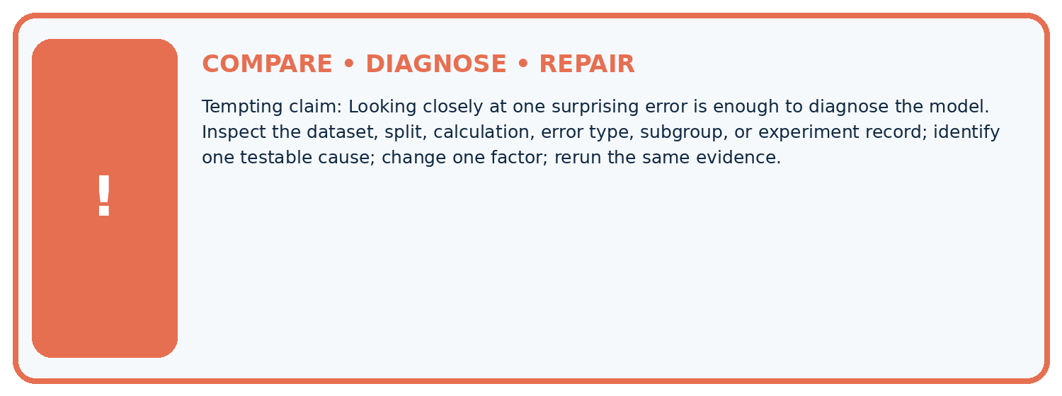
Evidence record | Expected | Actual | Likely cause / next test
normal case | passes
boundary case | defined behavior
missing case | safe fallback
shifted case | measured limit
CLAIM TO CHALLENGE Looking closely at one surprising error is enough to diagnose the model.
Diagnose one cause and name the cleanest next experiment:

A closer explanation
Do not delete difficult cases to raise the score or reuse final-test errors for an unreported revision. Once test feedback guides a change, treat it as development evidence and obtain a new independent evaluation for a fresh final claim.

A team removes all disputed records only from the new model report. Why is the comparison invalid?
________________________________________________________________
________________________________________________________________
________________________________________________________________
________________________________________________________________

08. Practise together
ML STUDIO

Specify Before You Run
A trustworthy result can be reproduced from the recorded data, code, settings, and evaluation rule.


Experiment record
QUESTION + intended use + success threshold
DATA version + grouped split + leakage check
CODE/preprocessing + features + model + settings + seed
METRICS + positive class + units + denominators
PREDICTIONS + errors + subgroup slices + limitations
HUMAN reviewer + release, revise, limit, or stop decision
Write the minimum record needed to reproduce today's result:

A closer explanation
Write a change record: hypothesis, exact code/data version, controlled factors, predicted effect, full before/after results and decision. Review disagreements using a consistent annotation policy. If labels are corrected, version the data and rerun all candidates on the same corrected evaluation set.

Practise with less help: Explain the limit
Use workbook W2 for the connected example “Error analysis and controlled follow-up”. First fill the input and rule boxes. Try the middle steps before asking for a hint. After a hint, try the next step yourself.
Plan | Do | Check
What is given? Which rule or procedure applies? | Record each intermediate step. | Does the result follow? What remains unknown?
Explain your trace to a partner. Your partner points to one step to check. Swap roles on the next case. Each person writes their own explanation.

Check your reasoning
Use the worked case for Error analysis and controlled follow-up. Proposed explanation: “A final answer is enough”. Decide whether this explanation is supported. Point to the step or supplied fact that decides; explain your repair if needed.
Answer on your own before discussion. If you are unsure, say which step you need help with.

Explain the picture
What evidence would support the claim that a change helps fresh dim-light images? Point to the relevant step in the picture, then write the changed result and the rule or evidence that supports it.

My explanation using a pictured step and the given facts
________________________________________________________________
________________________________________________________________
________________________________________________________________
________________________________________________________________
This is supported practice. Keep the separately named independent case for an attempt before feedback.

09. Run the investigation
EVIDENCE LAB

Predict → Run → Calculate → Interpret
Keep the test conditions fixed, record every result, and change only one planned factor.
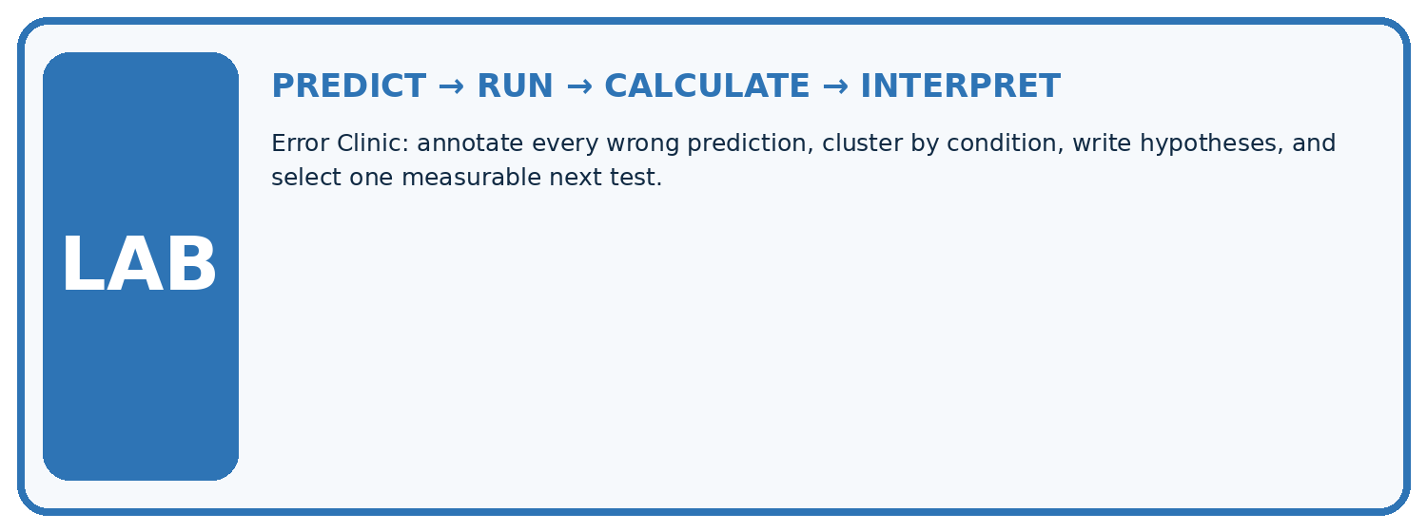
1. Write the hypothesis and expected evidence before running.
2. Error Clinic: annotate every wrong prediction, cluster by condition, write hypotheses, and select one measurable next test.
3. Run one normal, one boundary, one missing, and one shifted case.
4. Calculate the metric from raw counts or row-level errors.
5. Interpret what changed, what did not, and what remains unsafe or unknown.
Case | Prediction | Actual | Calculation / evidence | Meaning / next test
Normal
Boundary
Missing
Shifted

Plan → try → check
Before trying: what do I expect, and why? While trying: which step could first go wrong? Afterwards: what did I actually observe, and what should change? Keep “not run” if you only traced the procedure.

10. Build your understanding
MASTERY

From Knowing the Word to Owning the Idea
Move upward only when you can produce evidence without copying the example.

DEFINE Use all four terms precisely: error slice, failure cluster, root-cause hypothesis, controlled repair.
CALCULATE Reproduce the worked evidence with units and denominator.
TRACE Explain the data, code or decision path.
DIAGNOSE Looking closely at one surprising error is enough to diagnose the model.
TRANSFER Solve a fresh dataset or model case.
IMPROVE Change one cause and rerun fixed evidence.
DEFEND State intended use, metric, limitation, and human responsibility.
MASTERY RULE A coached calculation becomes mastery only after a different case is completed independently.

11. Connect your project
CUMULATIVE PROJECT

Responsible Plant Classifier
Every week adds one reviewable artifact to the same evidence-based capstone.
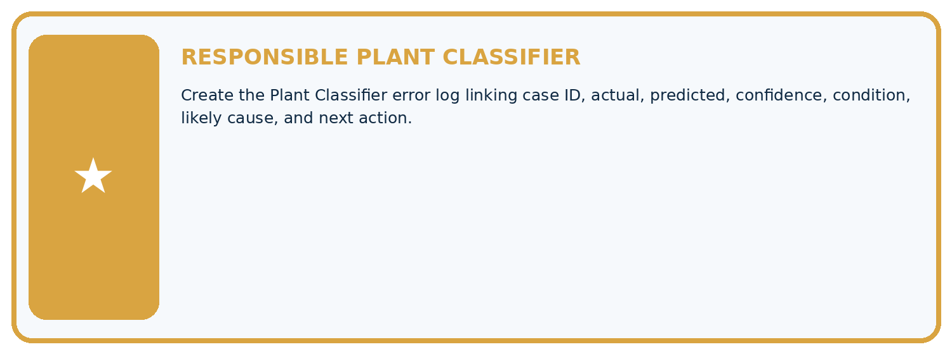
THIS WEEK'S CHECKPOINT Create the Plant Classifier error log linking case ID, actual, predicted, confidence, condition, likely cause, and next action.
Which requirement or risk does this artifact address?
Which dataset, split, code, and metric version does it use?
What normal and shifted cases were tested?
What remains uncertain or weak?
What decision still belongs to a teacher or qualified human?
RESPONSIBLE RELEASE Never use this classroom prototype for medical, pesticide, agricultural, or other consequential decisions.
My evidence-linked project decision:

Evidence for your project
For your Responsible Plant Classifier, save the input, procedure, observed result and limitation of this check. Label this worked example as practice; use a different, previously unreviewed case when checking independent understanding.

12. Show what you know
INDEPENDENT PROOF

Explain • Calculate • Transfer • Defend
Complete this with a fresh case after guided practice and compare it with the mastery criteria.
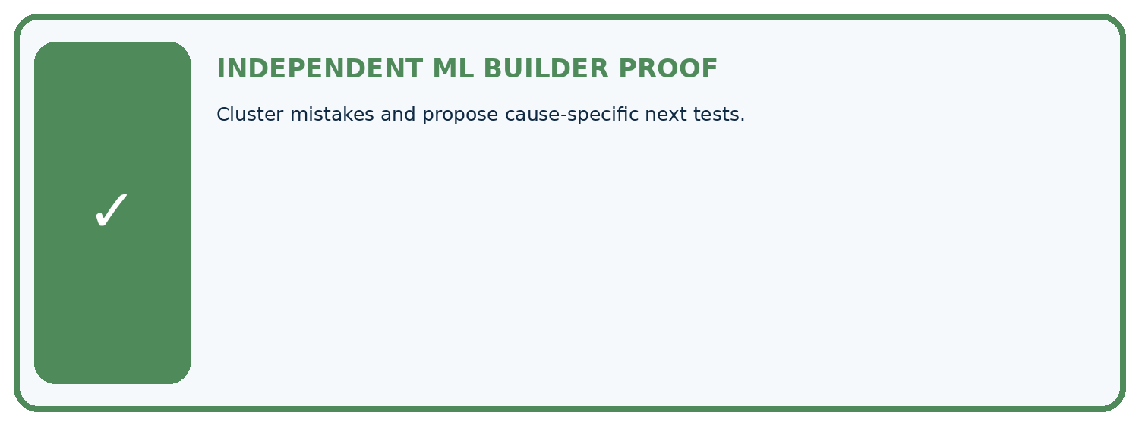
REQUIRED PROOF Cluster mistakes and propose cause-specific next tests.
□ Define the task, feature/target roles, and intended-use boundary.
□ Show the calculation, code trace, or experiment record.
□ Test a normal case and one revealing boundary, missing, or shifted case.
□ Diagnose one failure without changing several factors at once.
□ Name a limitation, fairness concern, and the human-review action.
Independent evidence and defense:
My level: □ Not yet □ With one hint □ Independently □ I can teach and defend it
NEXT BRIDGE Carry the experiment evidence into: Regression and Residuals.

13. Study a complete case

Week 18 Worked case
Use the supplied details to practise the weekly concept before attempting the independent question. This case extends the illustrated lesson.

The situation
Four errors occur among five backlit photos; two among twenty ordinary photos.

The question
Compare rates and investigate.

Worked explanation
Backlit error=80%; ordinary=10%. Inspect image quality and confounding differences. Association motivates controlled testing; it does not alone prove cause.

Explain it in your own words
Which detail supports the answer, and why does it matter?

Write or draw your reasoning and evidence.
________________________________________________________________
________________________________________________________________
________________________________________________________________
________________________________________________________________
________________________________________________________________

Trace the supplied case visually

Compare error rates, not only error counts
Evidence or stage | Value or result
Backlit errors | 4/5
Ordinary-light errors | 2/20
Four errors occur among five backlit photos; two among twenty ordinary photos.
Compare rates and investigate.
Backlit error=80%; ordinary=10%. Inspect image quality and confounding differences. Association motivates controlled testing; it does not alone prove cause.

14. Try a new case independently

Independent case: Apply independently
Old errors are 5/10 on route A and 2/20 on B. New errors are 3/10 and 5/20. State total and group changes and a justified next step.

My independent explanation, trace and limits
________________________________________________________________
________________________________________________________________
________________________________________________________________
________________________________________________________________
________________________________________________________________
________________________________________________________________
________________________________________________________________
Attempt this case before feedback. Record any help. Earlier examples below are further practice; a case already practised with feedback cannot establish fresh transfer.

Week 18 Independent application
Close the worked explanation. Apply the idea to this different question without copying.
Of eight errors, six are on blurry images and two on clear images. Can you conclude blurry images have a higher error rate without group totals?
My answer, with a trace, calculation or supporting evidence

Write or draw your reasoning and evidence.
________________________________________________________________
________________________________________________________________
________________________________________________________________
________________________________________________________________
________________________________________________________________

Create and test
Change one relevant detail. Predict the result before testing. Include a boundary or missing-information case when it helps reveal a limit.
My changed input and expected result

Write or draw your reasoning and evidence.
________________________________________________________________
________________________________________________________________
________________________________________________________________
________________________________________________________________
________________________________________________________________

Connect to your project
Create the Plant Classifier error log linking case ID, actual, predicted, confidence, condition, likely cause, and next action.
The evidence I will keep

Write or draw your reasoning and evidence.
________________________________________________________________
________________________________________________________________
________________________________________________________________
________________________________________________________________
________________________________________________________________
Your teacher has the independent answer and scoring criteria. Complete the matching workbook week to keep your practice evidence together.

Transfer practice from the original programme
A model fails 6/10 backlit and 2/20 front-lit photos. Compute error rates and design a follow-up that tests lighting rather than leaf identity.

Explain the mechanism, evidence and one limit.
________________________________________________________________
________________________________________________________________
________________________________________________________________
________________________________________________________________
________________________________________________________________
________________________________________________________________
________________________________________________________________

Use feedback to improve
Attempt the independent case before hints. Record whether you worked alone, used a hint or followed a model. After feedback, fix the first unsupported step and explain why it changed. A later check uses a changed case, not a copied answer.

15. Your lesson route
Start with this question: Find an error cluster before choosing a controlled follow-up.
By the end, I can | How I will show it
Categorize development errors using evidence | Explain the deciding step, show a trace or test, and state one limit.
Design a controlled change with a stated hypothesis | Explain the deciding step, show a trace or test, and state one limit.
Preserve failures and test boundaries | Explain the deciding step, show a trace or test, and state one limit.
Remember → watch and explain → try with help → investigate → try independently → keep project evidence. Your teacher may spread this lesson across several classes.
Keep your first prediction. Compare it with what the evidence shows and explain any change.

16. Finish and return
Close your notes. Explain this goal in your own words: Categorize development errors using evidence

My deciding step, evidence and one remaining question
________________________________________________________________
________________________________________________________________
________________________________________________________________
________________________________________________________________
________________________________________________________________
If you are unsure, return to the worked picture and explain one arrow. If you are ready, change an input or assumption and justify your prediction.
Save your workbook evidence. At the next review, try a different case before opening your old answer.

17. Supported practice, repair and portfolio
Use this supported practice once, in the browser or on paper. Keep the reserved independent assessment for a separate first attempt before teacher feedback.
Find an error cluster before choosing a controlled follow-up.

Practice 1: explain the deciding evidence
Which labelled step matches this detail? Photograph the same approved toy scene in bright and dim conditions; hold device and framing fixed.
1. Plan controlled pair
2. Compute slice errors
3. Inspect dim failures

My selected conclusion, deciding fact and explanation
________________________________________________________________
________________________________________________________________
________________________________________________________________
________________________________________________________________
________________________________________________________________
Hint if needed: Read the steps in the pictorial case. Match the supplied detail to the stage that performs or records it.
After your attempt, compare with the supported explanation: Plan controlled pair Photograph the same approved toy scene in bright and dim conditions; hold device and framing fixed. Read the picture in order. Photograph the same approved toy scene in bright and dim conditions; hold device and framing fixed. The arrows show which recorded input or intermediate result each decision uses. Explain the deciding step aloud before checking the changed case; pointing to the final answer alone does not show how it follows.

Practice 2: explain the deciding evidence
Changed-case practice: Dim errors fall to1/6 in a later same-case replay. Which conclusion is supported by the supplied facts?
1. The replay’s dim error rate is 16.7%; it is development evidence if those cases guided the revision.
2. We can decide the result without examining the changed input or the procedure.
3. This one example guarantees correct results for every future input.

My selected conclusion, deciding fact and explanation
________________________________________________________________
________________________________________________________________
________________________________________________________________
________________________________________________________________
________________________________________________________________
Hint if needed: Use the changed condition and the deciding step in the pictorial trace. The answer must say what follows from those facts.
After your attempt, compare with the supported explanation: The replay’s dim error rate is 16.7%; it is development evidence if those cases guided the revision. Observed improvement on reused cases is not an untouched final generalisation test.

Repair a missing building block
Review Precision and Recall (ai-4/17). Goal: Choose the denominator that answers the question. Short practice: Were the original precision and recall denominators the same? Point to the relevant step in the picture, then write the changed result and the rule or evidence that supports it.. Return to this week and explain what you changed.
Review Confusion Matrix (ai-4/15). Goal: Build a labelled confusion matrix from matched reference and prediction pairs. Short practice: Why is adding TP alone without reducing FN an incorrect revision? Point to the relevant step in the picture, then write the changed result and the rule or evidence that supports it.. Return to this week and explain what you changed.
Review Nearest Neighbors (ai-4/12). Goal: Compute absolute distances and rank training neighbours. Short practice: Why is the k=1 outcome at length5 not uniquely determined without a tie rule? Point to the relevant step in the picture, then write the changed result and the rule or evidence that supports it.. Return to this week and explain what you changed.

Predict, run and debug
The browser lab lets you edit the supported Python examples already included in this lesson. Predict first, run, inspect the actual output or error, change one input, then run again. Keep code, predictions, actual results and a reasoned revision together. On paper, label your result as a trace rather than an execution.

Keep your completed work
Use Download completed work in the hosted lesson to export your answers, reflections, practice feedback and code-run evidence. Open the HTML copy to read or print it. Drafts stay in this browser when storage is available; clear drafts on a shared device.

