AI ACADEMY · STUDENT · ai-5/6

Forward passes by hand
Project: Image-pattern Network Investigation

Before you start
In Week 5, what does the output layer receive?

01. Your mission

Your learning target
I can record scores and activations in dependency order.
I can locate the first incorrect value in a forward trace.
I can separate a final output from evidence of model accuracy.

Remember before reading
Close your notes first. A rough first answer helps us choose the right starting point; it is not a score for your ability.
Without opening the old lesson, explain one key idea from Composing layers. Give an example and a mistake that the idea helps you avoid.
Without opening the old lesson, explain one key idea from Bias terms and decision boundaries. Give an example and a mistake that the idea helps you avoid.
After trying, check the relevant lesson or ask your teacher. Change the part of your explanation that the evidence shows was wrong.
This week you will practise:
Record scores and activations in dependency order
Locate the first incorrect value in a forward trace
Separate a final output from evidence of model accuracy

Retrieve what you already know
In Week 5, what does the output layer receive?

My starting explanation
________________________________________________________________
________________________________________________________________
________________________________________________________________

This week’s end goal
By the end, I can explain forward passes by hand using a traced example and a stated limitation.

02. Notice the evidence
Use a new one-input network with two hidden units. Its scores are z1 = 2x - 1 and z2 = -x + 2. Apply ReLU to obtain h1 and h2. The output is y = h1 - 2h2 + 1. Parameters stay fixed while the input changes. The input x is an abstract number; these are arithmetic examples, not measurements of children.
A forward pass evaluates this network in dependency order. Compute both scores from x, then both activations, then the output contributions h1 and -2h2, and finally add bias 1. A trace table makes an omitted bias or a sign error easier to locate than a final answer alone.
x | z1 and z2 | h1 and h2 | y
0 | -1 and 2 | 0 and 2 | -3
1 | 1 and 1 | 1 and 1 | 0
3 | 5 and -1 | 5 and 0 | 6
At x = 1 the output is exactly zero. If we later declare class 1 for y >= 0, equality belongs to class 1. Applying ReLU in the hidden layer does not make the final output nonnegative.

List the given facts and one fact that is not supplied.
________________________________________________________________
________________________________________________________________
________________________________________________________________

03. See how it works
For x = 0, the first score is -1, which ReLU changes to 0. The second score is 2, which ReLU leaves at 2. Therefore y = 0 - 4 + 1 = -3. Negative output is allowed because this output layer uses identity.
def trace(x):
z = [2 * x - 1, -x + 2]
h = [max(0, value) for value in z]
y = h[0] - 2 * h[1] + 1
return z, h, y
for x in [0, 1, 3]:
print(x, trace(x))
This optional Python uses only numeric inputs. Compare every returned component against the table. The same code being run twice is a repeatability check; comparing it with a separately calculated expectation is a stronger check of correctness.

Connect the picture and the explanation
Point to the input, the deciding step and the result in this week’s visual. Explain the same step in ordinary words. A picture helps when you can say what each part represents.

04. Compare the cases

Compare a familiar case with a changed case
At x = 3 a trace gives z = [5, -1], h = [5, 0] and y = 5. Identify the first incorrect stage and repair it.

Keep the procedure fixed. Explain what changed in the inputs and result.
________________________________________________________________
________________________________________________________________
________________________________________________________________
________________________________________________________________
________________________________________________________________

Change one thing in the pictured case
Change: A submitted x = 0 trace uses h=-1 and y = 5.
Prediction: Its first error is retaining the negative value after ReLU; correct h = 0 gives y = 4.
Reason: ReLU(-1)=0, so the output must use0, not the earlier preactivation.

05. Words that unlock the idea
Word | Meaning
Trace | A record of intermediate values in a computation
Preactivation | A weighted score before an activation function
Dependency | An earlier value needed to compute a later value
Regression check | A retained test rerun after a change to detect a new error

Use two terms to explain a step in this week’s example.
________________________________________________________________
________________________________________________________________
________________________________________________________________

06. Follow a worked example

Correct a trace from the earliest error
Trace stage at x is 0 | Expected value | Submitted value
Scores | [-1, 2] | [-1, 2]
ReLU activations | [0, 2] | [-1, 2]
Output | -3 | -4
The columns compare expected and submitted traces. The first disagreement is the activation of -1, not the final addition. Recompute all dependent values after repairing it.

Trace x = 2, recording both scores, both activations and y. What happens to the second unit at its zero-score boundary?
________________________________________________________________
________________________________________________________________
________________________________________________________________
________________________________________________________________

Learn from the worked case
Cover the result before checking it. Say what is given, choose the procedure, and follow one step at a time. Then uncover the result and explain your first mismatch. Ask why a step is allowed, not only what number it produces.

A pictorial worked case: Forward passes by hand
Audit a forward pass by writing every value at its correct stage.

The facts we will use
Toy scalar network z=2x-1, h=ReLU(z), y=-h+4. Trace x=0 and x=2.
All inputs and outcomes in this worked example are invented classroom data; no real model run is claimed.
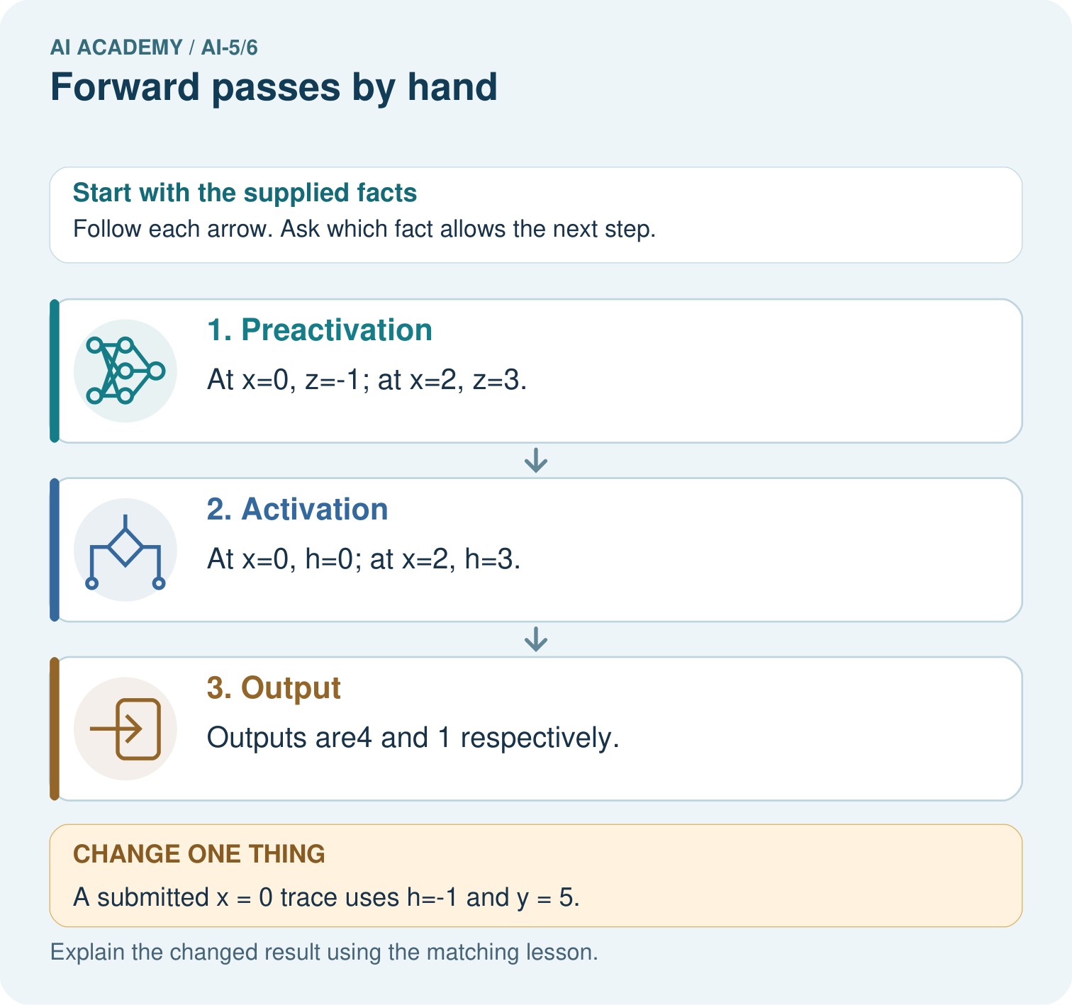

Read the picture one step at a time
Step | What happens and why
1. Preactivation | At x=0, z=-1; at x=2, z=3.
2. Activation | At x=0, h=0; at x=2, h=3.
3. Output | Outputs are4 and 1 respectively.
Match each pictured step to the supplied facts. This is a worked teaching case, not an independent assessment.

Why this result follows
A forward pass applies a fixed network to an input; it does not update weights. Keep the preactivation z, activated value h and final output y in separate trace columns. For zero, ReLU changes minus one to zero. Using the earlier minus one in the output layer is the first error, even if later arithmetic follows that mistaken value correctly.

What this example does not establish
A correct forward trace verifies this declared computation; it does not show that the parameter choices solve a useful task.
Read the labelled picture: Why should feedback identify h before correcting only y? Point to the relevant step in the picture, then write the changed result and the rule or evidence that supports it.
Change one thing: A submitted x = 0 trace uses h=-1 and y = 5. Predict the result before checking the explanation. What remains the same?

07. Find and repair a mistake
A test where both scores are positive cannot reveal a missing ReLU. Include x = 0, where the first score is negative, and x = 3, where the second score is negative. Include x = 0.5 and x = 2 to exercise each hidden zero-score boundary. Neither a few examples nor an attractive diagram proves every implementation case is correct.
A missing output bias shifts every output by -1. A swapped hidden order may pass a case where h1 equals h2; x = 1 has this limitation. Keep several checks with different intermediate values, and retain them when repairing code.

Locate the earliest unsupported step
Trace x = 0.5 and x = 2. Which hidden score is zero in each case?

State one repair and the checks you would rerun.
________________________________________________________________
________________________________________________________________
________________________________________________________________
________________________________________________________________
________________________________________________________________
________________________________________________________________

08. Practise together
Trace x = -1 through the lesson network. Record z, h and y.

Trace x = 2, recording both scores, both activations and y. What happens to the second unit at its zero-score boundary?
________________________________________________________________
________________________________________________________________
________________________________________________________________
________________________________________________________________

Explain your prediction to a partner before comparing results.
________________________________________________________________
________________________________________________________________
________________________________________________________________
________________________________________________________________

Practise with less help: Locate a bias omission
Use workbook W2 for the connected example “Forward passes by hand”. First fill the input and rule boxes. Try the middle steps before asking for a hint. After a hint, try the next step yourself.
Plan | Do | Check
What is given? Which rule or procedure applies? | Record each intermediate step. | Does the result follow? What remains unknown?
Explain your trace to a partner. Your partner points to one step to check. Swap roles on the next case. Each person writes their own explanation.

Check your reasoning
Use the worked case for Forward passes by hand. Proposed explanation: “ReLU means the output cannot be negative”. Decide whether this explanation is supported. Point to the step or supplied fact that decides; explain your repair if needed.
Answer on your own before discussion. If you are unsure, say which step you need help with.

Explain the picture
Why should feedback identify h before correcting only y? Point to the relevant step in the picture, then write the changed result and the rule or evidence that supports it.

My explanation using a pictured step and the given facts
________________________________________________________________
________________________________________________________________
________________________________________________________________
________________________________________________________________
This is supported practice. Keep the separately named independent case for an attempt before feedback.

09. Run the investigation

Predict, investigate and preserve the evidence
At x = 3 a trace gives z = [5, -1], h = [5, 0] and y = 5. Identify the first incorrect stage and repair it.
def trace(x):
z = [2 * x - 1, -x + 2]
h = [max(0, value) for value in z]
y = h[0] - 2 * h[1] + 1
return z, h, y
for x in [0, 1, 3]:
print(x, trace(x))
Record | Your evidence
Given input and fixed rule
Prediction before checking
Actual result, or “not run”
First mismatch and one explanation
Boundary or missing input and expected response
On paper, trace the supplied procedure. If code is provided, predict before running it in a local practice file. Never write an expected answer as though it were an observed run.

Plan → try → check
Before trying: what do I expect, and why? While trying: which step could first go wrong? Afterwards: what did I actually observe, and what should change? Keep “not run” if you only traced the procedure.

10. Build your understanding

Explain → apply → challenge
Trace x = -1 through the lesson network. Record z, h and y.
Trace x = 0.5 and x = 2. Which hidden score is zero in each case?
Explain why testing only x = 1 in the lesson model may miss a hidden-order swap.

Explain which evidence supports your conclusion and which claim remains unproved.
________________________________________________________________
________________________________________________________________
________________________________________________________________
________________________________________________________________
________________________________________________________________

11. Connect your project
Add a labelled forward passes by hand evidence sheet to Image-pattern Network Investigation. Show how you can record scores and activations in dependency order. Use the supplied fictional case and keep its inputs, intermediate steps, calculation or prediction, and limitation. Connect this record to last week’s record; a matching answer without a trace is insufficient.
Project evidence | Record
Component and version
Inputs permitted at prediction time
Trace and comparison with earlier work
Failure, limit and human review

Evidence for your project
For your Image-pattern Network Investigation, save the input, procedure, observed result and limitation of this check. Label this worked example as practice; use a different, previously unreviewed case when checking independent understanding.

12. Show what you know
A forward trace verifies what specified parameters calculate for one input. It does not show how those parameters were learned or whether the output is useful. Classification accuracy also needs a declared class rule, true labels and suitable independent examples.

A program matches y at x = 1 but its hidden activations are wrong. Is the implementation verified? Explain what evidence to retain after fixing it.
________________________________________________________________
________________________________________________________________
________________________________________________________________
________________________________________________________________
Next week separates the network architecture from its numerical parameters and counts the values that training could change.
Explain why testing only x = 1 in the lesson model may miss a hidden-order swap.

My limited claim and a useful next check
________________________________________________________________
________________________________________________________________
________________________________________________________________
________________________________________________________________

13. Study a complete case

Complete evidence record

Correct a trace from the earliest error
Trace stage at x is 0 | Expected value | Submitted value
Scores | [-1, 2] | [-1, 2]
ReLU activations | [0, 2] | [-1, 2]
Output | -3 | -4
The columns compare expected and submitted traces. The first disagreement is the activation of -1, not the final addition. Recompute all dependent values after repairing it.
Follow the input through the stated procedure to its result. Cover the result first, predict it, then explain every intermediate step. The text/table accompanies the figure so the example can be read without colour.

My complete trace of the worked case
________________________________________________________________
________________________________________________________________
________________________________________________________________
________________________________________________________________
________________________________________________________________
________________________________________________________________

14. Try a new case independently

Independent case: Audit a different network independently
Use z1 = x + 1, z2 = 2 - 2x, h = ReLU(z) component by component, and y = 2h1 + h2 - 3. Trace x = 0 and x = 2. A submitted x = 2 trace uses h = [3, -2] and y = 1. Find its first error and correct all later values.

My independent explanation, trace and limits
________________________________________________________________
________________________________________________________________
________________________________________________________________
________________________________________________________________
________________________________________________________________
________________________________________________________________
________________________________________________________________
Attempt this case before feedback. Record any help. Earlier examples below are further practice; a case already practised with feedback cannot establish fresh transfer.

Attempt this without hints
Use z1 = x + 1, z2 = 2 - 2x, h = ReLU(z) component by component, and y = 2h1 + h2 - 3. Trace x = 0 and x = 2. A submitted x = 2 trace uses h = [3, -2] and y = 1. Find its first error and correct all later values.

My independent procedure, result and limitation
________________________________________________________________
________________________________________________________________
________________________________________________________________
________________________________________________________________
________________________________________________________________
________________________________________________________________
________________________________________________________________
________________________________________________________________
Record support used: none, hint or teacher explanation. After feedback, a different case is needed to demonstrate independence.

Use feedback to improve
Attempt the independent case before hints. Record whether you worked alone, used a hint or followed a model. After feedback, fix the first unsupported step and explain why it changed. A later check uses a changed case, not a copied answer.

15. Your lesson route
Start with this question: Audit a forward pass by writing every value at its correct stage.
By the end, I can | How I will show it
Record scores and activations in dependency order | Explain the deciding step, show a trace or test, and state one limit.
Locate the first incorrect value in a forward trace | Explain the deciding step, show a trace or test, and state one limit.
Separate a final output from evidence of model accuracy | Explain the deciding step, show a trace or test, and state one limit.
Remember → watch and explain → try with help → investigate → try independently → keep project evidence. Your teacher may spread this lesson across several classes.
Keep your first prediction. Compare it with what the evidence shows and explain any change.

16. Finish and return
Close your notes. Explain this goal in your own words: Record scores and activations in dependency order

My deciding step, evidence and one remaining question
________________________________________________________________
________________________________________________________________
________________________________________________________________
________________________________________________________________
________________________________________________________________
If you are unsure, return to the worked picture and explain one arrow. If you are ready, change an input or assumption and justify your prediction.
Save your workbook evidence. At the next review, try a different case before opening your old answer.

17. Supported practice, repair and portfolio
Use this supported practice once, in the browser or on paper. Keep the reserved independent assessment for a separate first attempt before teacher feedback.
Audit a forward pass by writing every value at its correct stage.

Practice 1: explain the deciding evidence
Which labelled step matches this detail? Outputs are4 and 1 respectively.
1. Preactivation
2. Output
3. Activation

My selected conclusion, deciding fact and explanation
________________________________________________________________
________________________________________________________________
________________________________________________________________
________________________________________________________________
________________________________________________________________
Hint if needed: Read the steps in the pictorial case. Match the supplied detail to the stage that performs or records it.
After your attempt, compare with the supported explanation: Output Outputs are4 and 1 respectively. A forward pass applies a fixed network to an input; it does not update weights. Keep the preactivation z, activated value h and final output y in separate trace columns. For zero, ReLU changes minus one to zero. Using the earlier minus one in the output layer is the first error, even if later arithmetic follows that mistaken value correctly.

Practice 2: explain the deciding evidence
Changed-case practice: A submitted x = 0 trace uses h=-1 and y = 5. Which conclusion is supported by the supplied facts?
1. Its first error is retaining the negative value after ReLU; correct h = 0 gives y = 4.
2. This one example guarantees correct results for every future input.
3. We can decide the result without examining the changed input or the procedure.

My selected conclusion, deciding fact and explanation
________________________________________________________________
________________________________________________________________
________________________________________________________________
________________________________________________________________
________________________________________________________________
Hint if needed: Use the changed condition and the deciding step in the pictorial trace. The answer must say what follows from those facts.
After your attempt, compare with the supported explanation: Its first error is retaining the negative value after ReLU; correct h = 0 gives y = 4. ReLU(-1)=0, so the output must use0, not the earlier preactivation.

Repair a missing building block
Review Composing layers (ai-5/5). Goal: Trace how one layer supplies the next layer inputs. Short practice: What intermediate value explains the changed output? Point to the relevant step in the picture, then write the changed result and the rule or evidence that supports it.. Return to this week and explain what you changed.
Review Bias terms and decision boundaries (ai-5/3). Goal: Calculate a weighted score with a bias term. Short practice: Is B positive under the original or changed model? Point to the relevant step in the picture, then write the changed result and the rule or evidence that supports it.. Return to this week and explain what you changed.

Predict, run and debug
The browser lab lets you edit the supported Python examples already included in this lesson. Predict first, run, inspect the actual output or error, change one input, then run again. Keep code, predictions, actual results and a reasoned revision together. On paper, label your result as a trace rather than an execution.

Keep your completed work
Use Download completed work in the hosted lesson to export your answers, reflections, practice feedback and code-run evidence. Open the HTML copy to read or print it. Drafts stay in this browser when storage is available; clear drafts on a shared device.

