AI ACADEMY · STUDENT · ai-5/7

Parameters and architecture
Project: Image-pattern Network Investigation

Before you start
In the Week 6 network, which quantities change when x changes while the model stays fixed?

01. Your mission

Your learning target
I can distinguish architectural choices from parameter values.
I can count weights and biases in a small dense network.
I can explain why parameter count alone cannot establish quality.

Remember before reading
Close your notes first. A rough first answer helps us choose the right starting point; it is not a score for your ability.
Without opening the old lesson, explain one key idea from Forward passes by hand. Give an example and a mistake that the idea helps you avoid.
Without opening the old lesson, explain one key idea from Activation functions. Give an example and a mistake that the idea helps you avoid.
Without opening the old lesson, explain one key idea from Representing inputs as vectors. Give an example and a mistake that the idea helps you avoid.
After trying, check the relevant lesson or ask your teacher. Change the part of your explanation that the evidence shows was wrong.
This week you will practise:
Distinguish architectural choices from parameter values
Count weights and biases in a small dense network
Explain why parameter count alone cannot establish quality

Retrieve what you already know
In the Week 6 network, which quantities change when x changes while the model stays fixed?

My starting explanation
________________________________________________________________
________________________________________________________________
________________________________________________________________

This week’s end goal
By the end, I can explain parameters and architecture using a traced example and a stated limitation.

02. Notice the evidence
Consider a dense network with 2 inputs, 3 hidden units using ReLU, and 1 output unit using identity. We call its widths 2 to 3 to 1. These widths, connectivity and activation choices describe its architecture. The weights and biases supply the numerical values used by that architecture.
A fully connected hidden unit receiving 2 inputs needs 2 weights plus 1 bias. Three such units need 6 weights and 3 biases. The output receives 3 activations and needs 3 weights plus 1 bias. Total: 13 parameters. Input values and computed activations are not additional parameters.
Layer | Weights | Biases | Total
2 inputs to 3 hidden units | 2 times 3 = 6 | 3 | 9
3 hidden values to 1 output | 3 times 1 = 3 | 1 | 4
Whole network | 9 | 4 | 13
This counting rule assumes one separate bias per output unit and no shared or tied weights. Other architectures can use different rules.

List the given facts and one fact that is not supplied.
________________________________________________________________
________________________________________________________________
________________________________________________________________

03. See how it works
For a dense layer with n input components and m output units, each output has n weights and one bias. The count is n times m plus m, or (n + 1) times m. Count each layer separately before adding.
def dense_count(inputs, outputs):
return inputs * outputs + outputs
print(dense_count(2, 3)) # 9
print(dense_count(3, 1)) # 4
print(dense_count(2, 3) + dense_count(3, 1)) # 13
The helper assumes positive integer widths and the bias convention stated above. It is a counting aid, not a model trainer. A ReLU has no fitted numerical parameters in this example.

Connect the picture and the explanation
Point to the input, the deciding step and the result in this week’s visual. Explain the same step in ordinary words. A picture helps when you can say what each part represents.

04. Compare the cases

Compare a familiar case with a changed case
Classify hidden activation 0.7, weight -2, hidden width 3 and learning rate 0.1 as computed value, parameter, architecture choice or training setting.

Keep the procedure fixed. Explain what changed in the inputs and result.
________________________________________________________________
________________________________________________________________
________________________________________________________________
________________________________________________________________
________________________________________________________________

Change one thing in the pictured case
Change: Increase hidden width from 3 to4.
Prediction: First layer12 parameters; output layer5; total 17.
Reason: Each new hidden unit adds2 input weights, 1 hidden bias and 1 outgoing weight.

05. Words that unlock the idea
Word | Meaning
Parameter | A numerical model value that a fitting procedure may adjust
Architecture | The arrangement of layers, connections and activation choices
Dense layer | A layer in which each output unit has a weight for every input component
Hyperparameter | A setting chosen for a model or training procedure rather than fitted as an ordinary weight

Use two terms to explain a step in this week’s example.
________________________________________________________________
________________________________________________________________
________________________________________________________________

06. Follow a worked example

Decide what a change alters
Proposed change | Type of change | Consequence
Change one weight 2 to 3 | Parameter value | Same architecture
Use 4 hidden units | Architecture width | Different parameter count
Use learning rate 0.1 | Training setting | No extra model weight
Each row is a separate proposed change. A parameter value, an architectural choice and a training setting answer different questions about the system.

For a dense 2 to 4 to 1 network with one bias per unit, count each layer and the total. How many more parameters does it have than 2 to 3 to 1?
________________________________________________________________
________________________________________________________________
________________________________________________________________
________________________________________________________________

Learn from the worked case
Cover the result before checking it. Say what is given, choose the procedure, and follow one step at a time. Then uncover the result and explain your first mismatch. Ask why a step is allowed, not only what number it produces.

A pictorial worked case: Parameters and architecture
Count trainable weights and biases separately from activation functions.

The facts we will use
Dense toy architecture2 inputs→3 hidden units→1 output. Every hidden and output unit has one bias; hidden activation is ReLU.
All inputs and outcomes in this worked example are invented classroom data; no real model run is claimed.
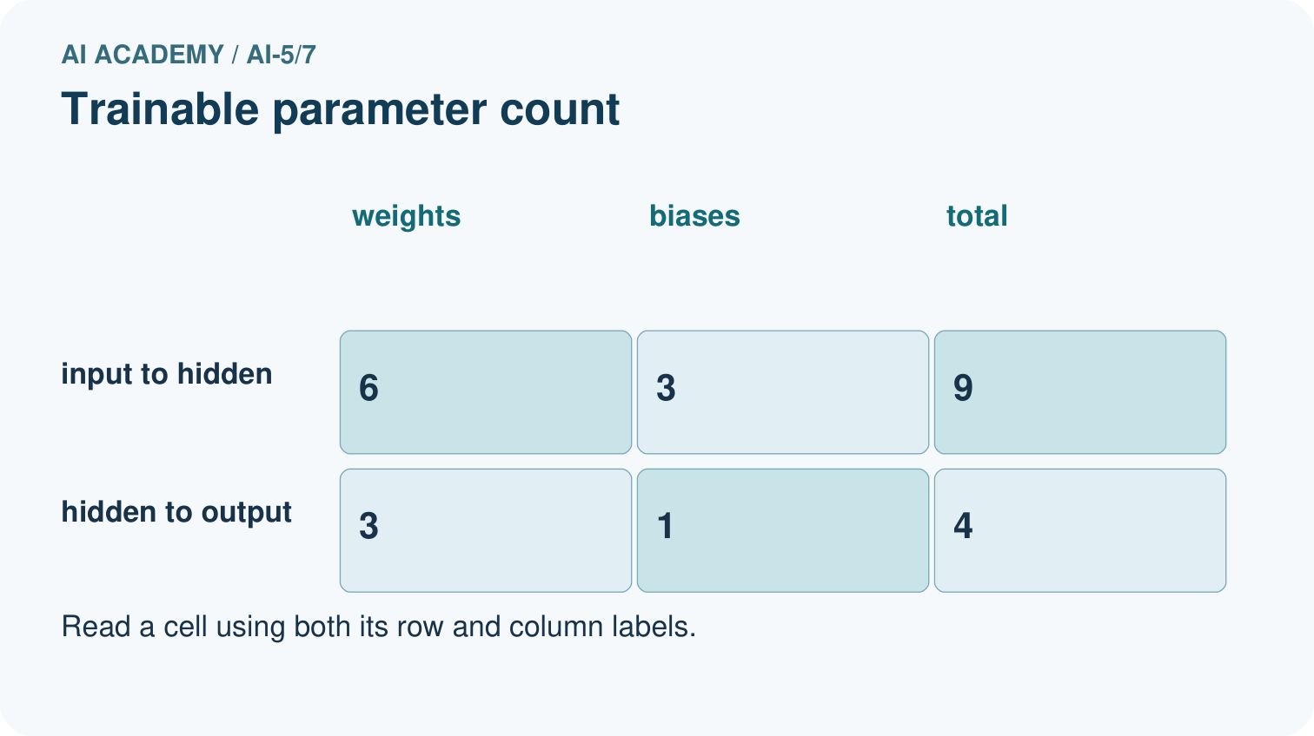
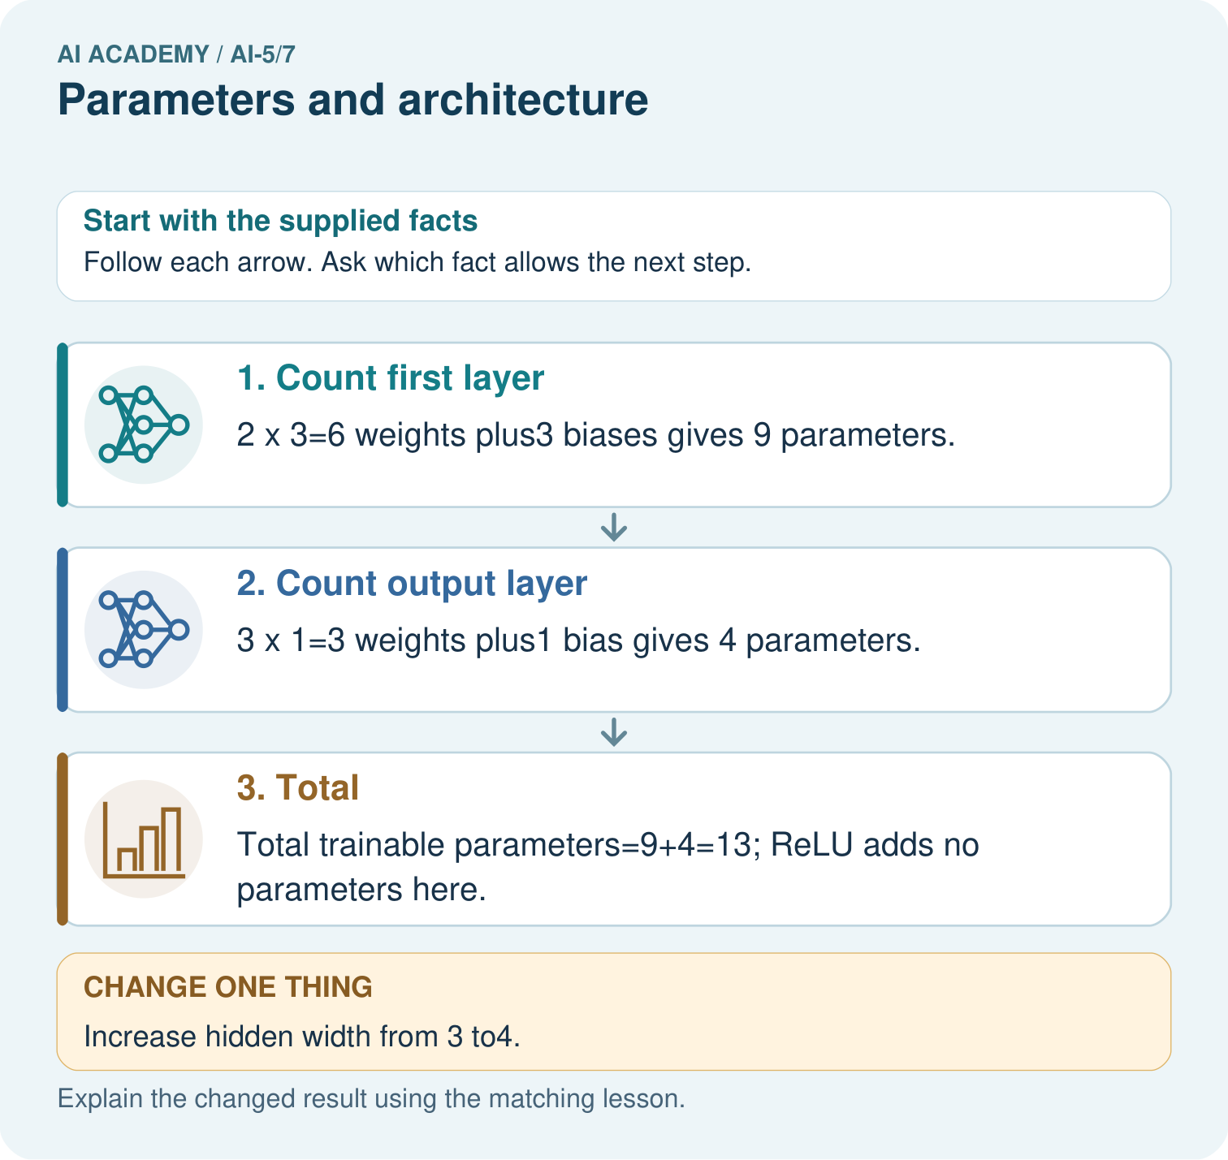

Read the picture one step at a time
Step | What happens and why
1. Count first layer | 2×3=6 weights plus3 biases gives 9 parameters.
2. Count output layer | 3×1=3 weights plus1 bias gives 4 parameters.
3. Total | Total trainable parameters=9+4=13; ReLU adds no parameters here.
Match each pictured step to the supplied facts. This is a worked teaching case, not an independent assessment.

Why this result follows
Count one weight for each input-to-unit connection and one bias for each receiving unit. Two inputs connecting to three hidden units make six weights. The three hidden outputs connect to one output unit through three more weights. ReLU applies a fixed function and adds no adjustable parameter here. Architecture determines the connection pattern; learned values occupy those connections.

What this example does not establish
Parameter count describes capacity and storage structure, not accuracy, intelligence or guaranteed generalisation.
Read the labelled picture: How many new parameters did that one hidden unit add? Point to the relevant step in the picture, then write the changed result and the rule or evidence that supports it.
Change one thing: Increase hidden width from 3 to4. Predict the result before checking the explanation. What remains the same?

07. Find and repair a mistake
Two networks can share an architecture and still make different predictions because their parameter values differ. Conversely, two architectures can happen to produce identical outputs on the few cases tested. A count describes the model, not how well it has learned.
When comparing widths, keep the task, feature schema, training data, validation cases and evaluation rule fixed. Record the training budget and seed as well. More parameters can increase flexibility, but they can also increase resource use and overfitting risk. Neither outcome follows from counting alone.

Locate the earliest unsupported step
Recount the 2 to 3 to 1 model if every bias is omitted. State what the original count assumed.

State one repair and the checks you would rerun.
________________________________________________________________
________________________________________________________________
________________________________________________________________
________________________________________________________________
________________________________________________________________
________________________________________________________________

08. Practise together
A dense layer has 4 inputs and 2 outputs with one bias per output. Count weights, biases and total.

For a dense 2 to 4 to 1 network with one bias per unit, count each layer and the total. How many more parameters does it have than 2 to 3 to 1?
________________________________________________________________
________________________________________________________________
________________________________________________________________
________________________________________________________________

Explain your prediction to a partner before comparing results.
________________________________________________________________
________________________________________________________________
________________________________________________________________
________________________________________________________________

Practise with less help: Sort the quantities
Use workbook W2 for the connected example “Parameters and architecture”. First fill the input and rule boxes. Try the middle steps before asking for a hint. After a hint, try the next step yourself.
Plan | Do | Check
What is given? Which rule or procedure applies? | Record each intermediate step. | Does the result follow? What remains unknown?
Explain your trace to a partner. Your partner points to one step to check. Swap roles on the next case. Each person writes their own explanation.

Check your reasoning
Use the worked case for Parameters and architecture. Proposed explanation: “Count one bias per input”. Decide whether this explanation is supported. Point to the step or supplied fact that decides; explain your repair if needed.
Answer on your own before discussion. If you are unsure, say which step you need help with.

Explain the picture
How many new parameters did that one hidden unit add? Point to the relevant step in the picture, then write the changed result and the rule or evidence that supports it.

My explanation using a pictured step and the given facts
________________________________________________________________
________________________________________________________________
________________________________________________________________
________________________________________________________________
This is supported practice. Keep the separately named independent case for an attempt before feedback.

09. Run the investigation

Predict, investigate and preserve the evidence
Classify hidden activation 0.7, weight -2, hidden width 3 and learning rate 0.1 as computed value, parameter, architecture choice or training setting.
def dense_count(inputs, outputs):
return inputs * outputs + outputs
print(dense_count(2, 3)) # 9
print(dense_count(3, 1)) # 4
print(dense_count(2, 3) + dense_count(3, 1)) # 13
Record | Your evidence
Given input and fixed rule
Prediction before checking
Actual result, or “not run”
First mismatch and one explanation
Boundary or missing input and expected response
On paper, trace the supplied procedure. If code is provided, predict before running it in a local practice file. Never write an expected answer as though it were an observed run.

Plan → try → check
Before trying: what do I expect, and why? While trying: which step could first go wrong? Afterwards: what did I actually observe, and what should change? Keep “not run” if you only traced the procedure.

10. Build your understanding

Explain → apply → challenge
A dense layer has 4 inputs and 2 outputs with one bias per output. Count weights, biases and total.
Recount the 2 to 3 to 1 model if every bias is omitted. State what the original count assumed.
A team says its 26-parameter model must outperform a 14-parameter model. Give a fair check and one reason the claim is unsupported.

Explain which evidence supports your conclusion and which claim remains unproved.
________________________________________________________________
________________________________________________________________
________________________________________________________________
________________________________________________________________
________________________________________________________________

11. Connect your project
Add a labelled parameters and architecture evidence sheet to Image-pattern Network Investigation. Show how you can distinguish architectural choices from parameter values. Use the supplied fictional case and keep its inputs, intermediate steps, calculation or prediction, and limitation. Connect this record to last week’s record; a matching answer without a trace is insufficient.
Project evidence | Record
Component and version
Inputs permitted at prediction time
Trace and comparison with earlier work
Failure, limit and human review

Evidence for your project
For your Image-pattern Network Investigation, save the input, procedure, observed result and limitation of this check. Label this worked example as practice; use a different, previously unreviewed case when checking independent understanding.

12. Show what you know
A reproducible description needs ordered input features, layer widths, connections, activations and the exact parameter values or a way to recover them. A description of training also needs the data split and training settings. The label small neural network does not specify a computation.

Two teams both report 13 parameters. What would you request before claiming they built the same model?
________________________________________________________________
________________________________________________________________
________________________________________________________________
________________________________________________________________
Next week defines a loss so that we can measure how a particular set of parameters performs on labelled examples.
A team says its 26-parameter model must outperform a 14-parameter model. Give a fair check and one reason the claim is unsupported.

My limited claim and a useful next check
________________________________________________________________
________________________________________________________________
________________________________________________________________
________________________________________________________________

13. Study a complete case

Complete evidence record

Decide what a change alters
Proposed change | Type of change | Consequence
Change one weight 2 to 3 | Parameter value | Same architecture
Use 4 hidden units | Architecture width | Different parameter count
Use learning rate 0.1 | Training setting | No extra model weight
Each row is a separate proposed change. A parameter value, an architectural choice and a training setting answer different questions about the system.
Follow the input through the stated procedure to its result. Cover the result first, predict it, then explain every intermediate step. The text/table accompanies the figure so the example can be read without colour.

My complete trace of the worked case
________________________________________________________________
________________________________________________________________
________________________________________________________________
________________________________________________________________
________________________________________________________________
________________________________________________________________

14. Try a new case independently

Independent case: Count a new architecture independently
A dense 3 to 2 to 2 network uses ReLU in the hidden layer and identity in the output layer, with one bias per unit. Give each layer count and the total. If hidden width becomes 4, recount and explain why activation values are excluded.

My independent explanation, trace and limits
________________________________________________________________
________________________________________________________________
________________________________________________________________
________________________________________________________________
________________________________________________________________
________________________________________________________________
________________________________________________________________
Attempt this case before feedback. Record any help. Earlier examples below are further practice; a case already practised with feedback cannot establish fresh transfer.

Attempt this without hints
A dense 3 to 2 to 2 network uses ReLU in the hidden layer and identity in the output layer, with one bias per unit. Give each layer count and the total. If hidden width becomes 4, recount and explain why activation values are excluded.

My independent procedure, result and limitation
________________________________________________________________
________________________________________________________________
________________________________________________________________
________________________________________________________________
________________________________________________________________
________________________________________________________________
________________________________________________________________
________________________________________________________________
Record support used: none, hint or teacher explanation. After feedback, a different case is needed to demonstrate independence.

Use feedback to improve
Attempt the independent case before hints. Record whether you worked alone, used a hint or followed a model. After feedback, fix the first unsupported step and explain why it changed. A later check uses a changed case, not a copied answer.

15. Your lesson route
Start with this question: Count trainable weights and biases separately from activation functions.
By the end, I can | How I will show it
Distinguish architectural choices from parameter values | Explain the deciding step, show a trace or test, and state one limit.
Count weights and biases in a small dense network | Explain the deciding step, show a trace or test, and state one limit.
Explain why parameter count alone cannot establish quality | Explain the deciding step, show a trace or test, and state one limit.
Remember → watch and explain → try with help → investigate → try independently → keep project evidence. Your teacher may spread this lesson across several classes.
Keep your first prediction. Compare it with what the evidence shows and explain any change.

16. Finish and return
Close your notes. Explain this goal in your own words: Distinguish architectural choices from parameter values

My deciding step, evidence and one remaining question
________________________________________________________________
________________________________________________________________
________________________________________________________________
________________________________________________________________
________________________________________________________________
If you are unsure, return to the worked picture and explain one arrow. If you are ready, change an input or assumption and justify your prediction.
Save your workbook evidence. At the next review, try a different case before opening your old answer.

17. Supported practice, repair and portfolio
Use this supported practice once, in the browser or on paper. Keep the reserved independent assessment for a separate first attempt before teacher feedback.
Count trainable weights and biases separately from activation functions.

Practice 1: explain the deciding evidence
Which labelled step matches this detail? Total trainable parameters=9+4=13; ReLU adds no parameters here.
1. Total
2. Count output layer
3. Count first layer

My selected conclusion, deciding fact and explanation
________________________________________________________________
________________________________________________________________
________________________________________________________________
________________________________________________________________
________________________________________________________________
Hint if needed: Read the steps in the pictorial case. Match the supplied detail to the stage that performs or records it.
After your attempt, compare with the supported explanation: Total Total trainable parameters=9+4=13; ReLU adds no parameters here. Count one weight for each input-to-unit connection and one bias for each receiving unit. Two inputs connecting to three hidden units make six weights. The three hidden outputs connect to one output unit through three more weights. ReLU applies a fixed function and adds no adjustable parameter here. Architecture determines the connection pattern; learned values occupy those connections.

Practice 2: explain the deciding evidence
Changed-case practice: Increase hidden width from 3 to4. Which conclusion is supported by the supplied facts?
1. This one example guarantees correct results for every future input.
2. We can decide the result without examining the changed input or the procedure.
3. First layer12 parameters; output layer5; total 17.

My selected conclusion, deciding fact and explanation
________________________________________________________________
________________________________________________________________
________________________________________________________________
________________________________________________________________
________________________________________________________________
Hint if needed: Use the changed condition and the deciding step in the pictorial trace. The answer must say what follows from those facts.
After your attempt, compare with the supported explanation: First layer12 parameters; output layer5; total 17. Each new hidden unit adds2 input weights, 1 hidden bias and 1 outgoing weight.

Repair a missing building block
Review Forward passes by hand (ai-5/6). Goal: Record scores and activations in dependency order. Short practice: Why should feedback identify h before correcting only y? Point to the relevant step in the picture, then write the changed result and the rule or evidence that supports it.. Return to this week and explain what you changed.
Review Activation functions (ai-5/4). Goal: Trace identity ReLU and sigmoid on a numerical score. Short practice: Which original inputs cannot be distinguished by this network’s final output? Point to the relevant step in the picture, then write the changed result and the rule or evidence that supports it.. Return to this week and explain what you changed.
Review Representing inputs as vectors (ai-5/1). Goal: Encode a record using a fixed feature order and units. Short practice: Why does equal total brightness not make A and B identical inputs? Point to the relevant step in the picture, then write the changed result and the rule or evidence that supports it.. Return to this week and explain what you changed.

Predict, run and debug
The browser lab lets you edit the supported Python examples already included in this lesson. Predict first, run, inspect the actual output or error, change one input, then run again. Keep code, predictions, actual results and a reasoned revision together. On paper, label your result as a trace rather than an execution.

Keep your completed work
Use Download completed work in the hosted lesson to export your answers, reflections, practice feedback and code-run evidence. Open the HTML copy to read or print it. Drafts stay in this browser when storage is available; clear drafts on a shared device.

