AI ACADEMY · STUDENT · ai-5/9

Slopes and local change
Project: Image-pattern Network Investigation

Before you start
For one example with prediction 4 and target 2, what is the squared error?

01. Your mission

Your learning target
I can calculate an average rate of change over a stated interval.
I can estimate a local slope with nearby loss values.
I can explain the limits of a local direction clue.

Remember before reading
Close your notes first. A rough first answer helps us choose the right starting point; it is not a score for your ability.
Without opening the old lesson, explain one key idea from Loss functions. Give an example and a mistake that the idea helps you avoid.
Without opening the old lesson, explain one key idea from Forward passes by hand. Give an example and a mistake that the idea helps you avoid.
Without opening the old lesson, explain one key idea from Bias terms and decision boundaries. Give an example and a mistake that the idea helps you avoid.
After trying, check the relevant lesson or ask your teacher. Change the part of your explanation that the evidence shows was wrong.
This week you will practise:
Calculate an average rate of change over a stated interval
Estimate a local slope with nearby loss values
Explain the limits of a local direction clue

Retrieve what you already know
For one example with prediction 4 and target 2, what is the squared error?

My starting explanation
________________________________________________________________
________________________________________________________________
________________________________________________________________

This week’s end goal
By the end, I can explain slopes and local change using a traced example and a stated limitation.

02. Notice the evidence
Let a one-example model predict w and let its target be 2. Its squared loss is L(w) = (w - 2) squared. Here w is the parameter we vary, not a new data example. L is a nonnegative function of that parameter.
w | Prediction minus target | L(w)
0 | -2 | 4
1 | -1 | 1
2 | 0 | 0
3 | 1 | 1
4 | 2 | 4
From w = 0 to w = 1, the loss changes by -3 while w changes by 1. The average slope is -3. From w = 1 to w = 2 it is -1. The curve does not have one fixed slope everywhere.

List the given facts and one fact that is not supplied.
________________________________________________________________
________________________________________________________________
________________________________________________________________

03. See how it works
Near w = 1, use two symmetric nearby values: 0.9 and 1.1. Their losses are 1.21 and 0.81. Change in loss divided by change in w gives (0.81 - 1.21) / (1.1 - 0.9) = -2. This symmetric estimate describes change near the centre w = 1.
def loss(w):
return (w - 2) ** 2
def local_slope(w, step):
if step <= 0:
raise ValueError("Step must be positive")
return (loss(w + step) - loss(w - step)) / (2 * step)
for w in [1, 2, 3]:
print(w, round(local_slope(w, 0.1), 6))
# Slopes near these centres: -2, 0, 2
For this quadratic, the symmetric estimate equals the exact slope 2(w - 2) in exact arithmetic. Numerical estimates for other functions are generally approximate. Smaller steps can reduce some approximation errors, but extremely small steps can suffer from computer rounding.

Connect the picture and the explanation
Point to the input, the deciding step and the result in this week’s visual. Explain the same step in ordinary words. A picture helps when you can say what each part represents.

04. Compare the cases

Compare a familiar case with a changed case
At centre w = 0, use step 0.5. Calculate L(-0.5), L(0.5) and the symmetric slope.

Keep the procedure fixed. Explain what changed in the inputs and result.
________________________________________________________________
________________________________________________________________
________________________________________________________________
________________________________________________________________
________________________________________________________________

Change one thing in the pictured case
Change: Move from 0 all the way to5.
Prediction: Loss becomes9, exceeding the starting4.
Reason: A negative local slope suggests increasing a locally, not that every positive jump decreases loss.

05. Words that unlock the idea
Word | Meaning
Slope | Change in output divided by change in input over a stated interval
Local change | Change considered near a particular input or parameter value
Step size | The amount by which an input or parameter is changed
Stationary point | A point where a differentiable function has zero local slope

Use two terms to explain a step in this week’s example.
________________________________________________________________
________________________________________________________________
________________________________________________________________

06. Follow a worked example

Compare slope clues on the same loss curve
Current w | Local slope | Nearby downhill direction
1 | -2 | Increase w a little
2 | 0 | No first order direction
3 | 2 | Decrease w a little
These are local clues for L(w) = (w - 2) squared. At w = 2 the displayed function has its minimum; zero slope does not establish a minimum for every possible function.

At w = 3, use 2.9 and 3.1. Calculate both losses and the symmetric slope. Which small change should lower loss here?
________________________________________________________________
________________________________________________________________
________________________________________________________________
________________________________________________________________

Learn from the worked case
Cover the result before checking it. Say what is given, choose the procedure, and follow one step at a time. Then uncover the result and explain your first mismatch. Ask why a step is allowed, not only what number it produces.

A pictorial worked case: Slopes and local change
Use a local slope to propose a small move rather than claiming every move helps.

The facts we will use
Toy loss J(a)=(a-2)². At a = 0, use symmetric step 0.5.
All inputs and outcomes in this worked example are invented classroom data; no real model run is claimed.
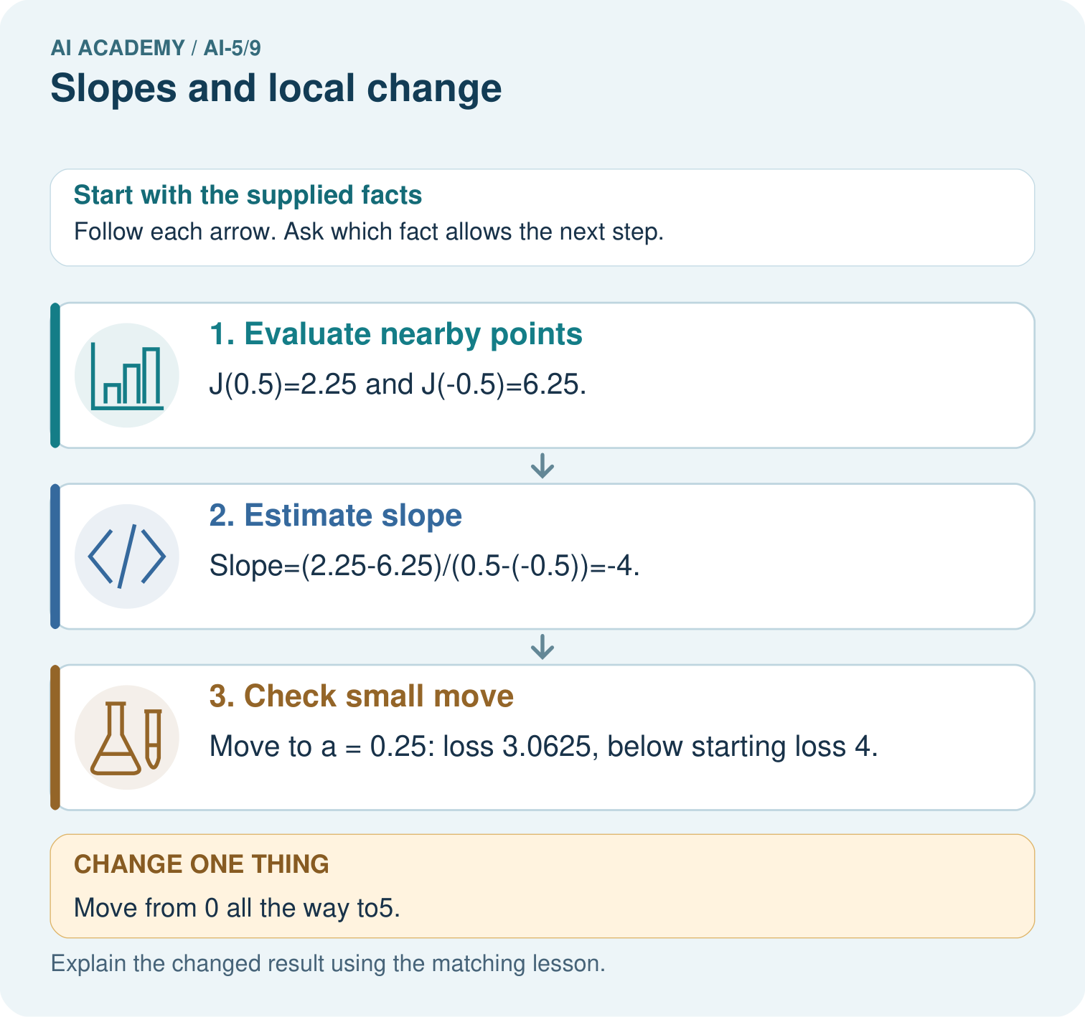

Read the picture one step at a time
Step | What happens and why
1. Evaluate nearby points | J(0.5)=2.25 and J(-0.5)=6.25.
2. Estimate slope | Slope=(2.25-6.25)/(0.5-(-0.5))=-4.
3. Check small move | Move to a = 0.25: loss 3.0625, below starting loss 4.
Match each pictured step to the supplied facts. This is a worked teaching case, not an independent assessment.

Why this result follows
A slope describes how the loss changes near the current parameter. The symmetric calculation compares equal small moves on either side. Its negative result suggests a small increase may help at zero. It does not promise every increase helps: jumping to five passes the optimum at two and produces a larger loss. Check the new loss after each proposed step.

What this example does not establish
A finite difference approximates local change; numerical precision and nonsmooth points need care in more complex objectives.
Read the labelled picture: Which calculation disproves “any increase helps”? Point to the relevant step in the picture, then write the changed result and the rule or evidence that supports it.
Change one thing: Move from 0 all the way to5. Predict the result before checking the explanation. What remains the same?

07. Find and repair a mistake
A negative slope at w = 1 suggests that a sufficiently small increase reduces this smooth loss locally. Moving to 1.1 lowers loss from 1 to 0.81. A jump all the way to 4 raises loss to 4. The initial slope cannot justify a step of any size.
A zero slope is also limited evidence. The nonnegative function F(w) = (w squared - 1) squared has zero local slope at w = 0, yet F(0) = 1 and F(0.1) = 0.9801. Small moves on either side lower that function. A flat first-order clue can occur at a point that is not a minimum.

Locate the earliest unsupported step
Starting at w = 3, compare loss after moving to 2.9 and after moving to -1. Both moves decrease w.

State one repair and the checks you would rerun.
________________________________________________________________
________________________________________________________________
________________________________________________________________
________________________________________________________________
________________________________________________________________
________________________________________________________________

08. Practise together
For L(w) = (w - 2) squared, calculate the average slope from w = 0 to w = 2. Compare it with the local slope at w = 2.

At w = 3, use 2.9 and 3.1. Calculate both losses and the symmetric slope. Which small change should lower loss here?
________________________________________________________________
________________________________________________________________
________________________________________________________________
________________________________________________________________

Explain your prediction to a partner before comparing results.
________________________________________________________________
________________________________________________________________
________________________________________________________________
________________________________________________________________

Practise with less help: Check a symmetric estimate
Use workbook W2 for the connected example “Slopes and local change”. First fill the input and rule boxes. Try the middle steps before asking for a hint. After a hint, try the next step yourself.
Plan | Do | Check
What is given? Which rule or procedure applies? | Record each intermediate step. | Does the result follow? What remains unknown?
Explain your trace to a partner. Your partner points to one step to check. Swap roles on the next case. Each person writes their own explanation.

Check your reasoning
Use the worked case for Slopes and local change. Proposed explanation: “Divide by the step only”. Decide whether this explanation is supported. Point to the step or supplied fact that decides; explain your repair if needed.
Answer on your own before discussion. If you are unsure, say which step you need help with.

Explain the picture
Which calculation disproves “any increase helps”? Point to the relevant step in the picture, then write the changed result and the rule or evidence that supports it.

My explanation using a pictured step and the given facts
________________________________________________________________
________________________________________________________________
________________________________________________________________
________________________________________________________________
This is supported practice. Keep the separately named independent case for an attempt before feedback.

09. Run the investigation

Predict, investigate and preserve the evidence
At centre w = 0, use step 0.5. Calculate L(-0.5), L(0.5) and the symmetric slope.
def loss(w):
return (w - 2) ** 2
def local_slope(w, step):
if step <= 0:
raise ValueError("Step must be positive")
return (loss(w + step) - loss(w - step)) / (2 * step)
for w in [1, 2, 3]:
print(w, round(local_slope(w, 0.1), 6))
# Slopes near these centres: -2, 0, 2
Record | Your evidence
Given input and fixed rule
Prediction before checking
Actual result, or “not run”
First mismatch and one explanation
Boundary or missing input and expected response
On paper, trace the supplied procedure. If code is provided, predict before running it in a local practice file. Never write an expected answer as though it were an observed run.

Plan → try → check
Before trying: what do I expect, and why? While trying: which step could first go wrong? Afterwards: what did I actually observe, and what should change? Keep “not run” if you only traced the procedure.

10. Build your understanding

Explain → apply → challenge
For L(w) = (w - 2) squared, calculate the average slope from w = 0 to w = 2. Compare it with the local slope at w = 2.
Starting at w = 3, compare loss after moving to 2.9 and after moving to -1. Both moves decrease w.
For F(w) = (w squared - 1) squared, compare F(0) and F(0.1). Does zero local slope at zero prove a minimum?

Explain which evidence supports your conclusion and which claim remains unproved.
________________________________________________________________
________________________________________________________________
________________________________________________________________
________________________________________________________________
________________________________________________________________

11. Connect your project
Add a labelled slopes and local change evidence sheet to Image-pattern Network Investigation. Show how you can calculate an average rate of change over a stated interval. Use the supplied fictional case and keep its inputs, intermediate steps, calculation or prediction, and limitation. Connect this record to last week’s record; a matching answer without a trace is insufficient.
Project evidence | Record
Component and version
Inputs permitted at prediction time
Trace and comparison with earlier work
Failure, limit and human review

Evidence for your project
For your Image-pattern Network Investigation, save the input, procedure, observed result and limitation of this check. Label this worked example as practice; use a different, previously unreviewed case when checking independent understanding.

12. Show what you know
Always record the function, centre, nearby values and denominator used in a slope estimate. An average slope across a wide interval is not automatically the local slope at either endpoint. Do not compare slope magnitudes without considering parameter and loss units.

A learner sees a negative estimated slope and says any larger parameter value will improve the loss. Give a counterexample using this lesson.
________________________________________________________________
________________________________________________________________
________________________________________________________________
________________________________________________________________
Next week changes one parameter at a time in a two-parameter model and combines those local slopes into a gradient.
For F(w) = (w squared - 1) squared, compare F(0) and F(0.1). Does zero local slope at zero prove a minimum?

My limited claim and a useful next check
________________________________________________________________
________________________________________________________________
________________________________________________________________
________________________________________________________________

13. Study a complete case

Complete evidence record

Compare slope clues on the same loss curve
Current w | Local slope | Nearby downhill direction
1 | -2 | Increase w a little
2 | 0 | No first order direction
3 | 2 | Decrease w a little
These are local clues for L(w) = (w - 2) squared. At w = 2 the displayed function has its minimum; zero slope does not establish a minimum for every possible function.
Follow the input through the stated procedure to its result. Cover the result first, predict it, then explain every intermediate step. The text/table accompanies the figure so the example can be read without colour.

My complete trace of the worked case
________________________________________________________________
________________________________________________________________
________________________________________________________________
________________________________________________________________
________________________________________________________________
________________________________________________________________

14. Try a new case independently

Independent case: Estimate a new curve independently
Let J(a) = (a + 1) squared. At a = 1 use step 0.25 to find the symmetric slope. Compare J(1) with J(0.9), then explain why moving to -4 does not follow safely from the slope clue.

My independent explanation, trace and limits
________________________________________________________________
________________________________________________________________
________________________________________________________________
________________________________________________________________
________________________________________________________________
________________________________________________________________
________________________________________________________________
Attempt this case before feedback. Record any help. Earlier examples below are further practice; a case already practised with feedback cannot establish fresh transfer.

Attempt this without hints
Let J(a) = (a + 1) squared. At a = 1 use step 0.25 to find the symmetric slope. Compare J(1) with J(0.9), then explain why moving to -4 does not follow safely from the slope clue.

My independent procedure, result and limitation
________________________________________________________________
________________________________________________________________
________________________________________________________________
________________________________________________________________
________________________________________________________________
________________________________________________________________
________________________________________________________________
________________________________________________________________
Record support used: none, hint or teacher explanation. After feedback, a different case is needed to demonstrate independence.

Use feedback to improve
Attempt the independent case before hints. Record whether you worked alone, used a hint or followed a model. After feedback, fix the first unsupported step and explain why it changed. A later check uses a changed case, not a copied answer.

15. Your lesson route
Start with this question: Use a local slope to propose a small move rather than claiming every move helps.
By the end, I can | How I will show it
Calculate an average rate of change over a stated interval | Explain the deciding step, show a trace or test, and state one limit.
Estimate a local slope with nearby loss values | Explain the deciding step, show a trace or test, and state one limit.
Explain the limits of a local direction clue | Explain the deciding step, show a trace or test, and state one limit.
Remember → watch and explain → try with help → investigate → try independently → keep project evidence. Your teacher may spread this lesson across several classes.
Keep your first prediction. Compare it with what the evidence shows and explain any change.

16. Finish and return
Close your notes. Explain this goal in your own words: Calculate an average rate of change over a stated interval

My deciding step, evidence and one remaining question
________________________________________________________________
________________________________________________________________
________________________________________________________________
________________________________________________________________
________________________________________________________________
If you are unsure, return to the worked picture and explain one arrow. If you are ready, change an input or assumption and justify your prediction.
Save your workbook evidence. At the next review, try a different case before opening your old answer.

17. Supported practice, repair and portfolio
Use this supported practice once, in the browser or on paper. Keep the reserved independent assessment for a separate first attempt before teacher feedback.
Use a local slope to propose a small move rather than claiming every move helps.

Practice 1: explain the deciding evidence
Which labelled step matches this detail? Move to a = 0.25: loss 3.0625, below starting loss 4.
1. Check small move
2. Estimate slope
3. Evaluate nearby points

My selected conclusion, deciding fact and explanation
________________________________________________________________
________________________________________________________________
________________________________________________________________
________________________________________________________________
________________________________________________________________
Hint if needed: Read the steps in the pictorial case. Match the supplied detail to the stage that performs or records it.
After your attempt, compare with the supported explanation: Check small move Move to a = 0.25: loss 3.0625, below starting loss 4. A slope describes how the loss changes near the current parameter. The symmetric calculation compares equal small moves on either side. Its negative result suggests a small increase may help at zero. It does not promise every increase helps: jumping to five passes the optimum at two and produces a larger loss. Check the new loss after each proposed step.

Practice 2: explain the deciding evidence
Changed-case practice: Move from 0 all the way to5. Which conclusion is supported by the supplied facts?
1. We can decide the result without examining the changed input or the procedure.
2. Loss becomes9, exceeding the starting4.
3. This one example guarantees correct results for every future input.

My selected conclusion, deciding fact and explanation
________________________________________________________________
________________________________________________________________
________________________________________________________________
________________________________________________________________
________________________________________________________________
Hint if needed: Use the changed condition and the deciding step in the pictorial trace. The answer must say what follows from those facts.
After your attempt, compare with the supported explanation: Loss becomes9, exceeding the starting4. A negative local slope suggests increasing a locally, not that every positive jump decreases loss.

Repair a missing building block
Review Loss functions (ai-5/8). Goal: Calculate per-example squared error and mean squared error. Short practice: Why must the report name the chosen loss? Point to the relevant step in the picture, then write the changed result and the rule or evidence that supports it.. Return to this week and explain what you changed.
Review Forward passes by hand (ai-5/6). Goal: Record scores and activations in dependency order. Short practice: Why should feedback identify h before correcting only y? Point to the relevant step in the picture, then write the changed result and the rule or evidence that supports it.. Return to this week and explain what you changed.
Review Bias terms and decision boundaries (ai-5/3). Goal: Calculate a weighted score with a bias term. Short practice: Is B positive under the original or changed model? Point to the relevant step in the picture, then write the changed result and the rule or evidence that supports it.. Return to this week and explain what you changed.

Predict, run and debug
The browser lab lets you edit the supported Python examples already included in this lesson. Predict first, run, inspect the actual output or error, change one input, then run again. Keep code, predictions, actual results and a reasoned revision together. On paper, label your result as a trace rather than an execution.

Keep your completed work
Use Download completed work in the hosted lesson to export your answers, reflections, practice feedback and code-run evidence. Open the HTML copy to read or print it. Drafts stay in this browser when storage is available; clear drafts on a shared device.

