AI ACADEMY · STUDENT · ai-5/10

Gradients with a numerical check
Project: Image-pattern Network Investigation

Before you start
Why is the symmetric-slope denominator twice the step?

01. Your mission

Your learning target
I can estimate one partial derivative while other parameters stay fixed.
I can assemble a gradient in a declared parameter order.
I can compare numerical and formula based gradients with a tolerance.

Remember before reading
Close your notes first. A rough first answer helps us choose the right starting point; it is not a score for your ability.
Without opening the old lesson, explain one key idea from Slopes and local change. Give an example and a mistake that the idea helps you avoid.
Without opening the old lesson, explain one key idea from Parameters and architecture. Give an example and a mistake that the idea helps you avoid.
Without opening the old lesson, explain one key idea from Activation functions. Give an example and a mistake that the idea helps you avoid.
After trying, check the relevant lesson or ask your teacher. Change the part of your explanation that the evidence shows was wrong.
This week you will practise:
Estimate one partial derivative while other parameters stay fixed
Assemble a gradient in a declared parameter order
Compare numerical and formula based gradients with a tolerance

Retrieve what you already know
Why is the symmetric-slope denominator twice the step?

My starting explanation
________________________________________________________________
________________________________________________________________
________________________________________________________________

This week’s end goal
By the end, I can explain gradients with a numerical check using a traced example and a stated limitation.

02. Notice the evidence
Use one example with input x = 2 and target t = 3. The model predicts y = wx + b, and loss L(w, b) = (2w + b - 3) squared. At w = 1, b = 0, prediction is 2, residual is -1 and loss is 1. There are two parameters in order [w, b].
To estimate the partial slope for w, change w only and keep b = 0. To estimate the partial slope for b, change b only and keep w = 1. Moving both at once measures change along a combined direction; it does not isolate either partial derivative.
Perturbation from [1, 0] | Loss at minus step | Loss at plus step | Symmetric slope
w only with step 0.1 | 1.44 | 0.64 | -4
b only with step 0.1 | 1.21 | 0.81 | -2
The gradient is [-4, -2] in order [w, b]. Both entries refer to the same original parameter vector, not to a partially updated model.

List the given facts and one fact that is not supplied.
________________________________________________________________
________________________________________________________________
________________________________________________________________

03. See how it works
def loss(w, b):
return (2 * w + b - 3) ** 2
def gradient_check(w, b, step=0.001):
dw = (loss(w + step, b) - loss(w - step, b)) / (2 * step)
db = (loss(w, b + step) - loss(w, b - step)) / (2 * step)
residual = 2 * w + b - 3
formula = [4 * residual, 2 * residual]
numerical = [dw, db]
assert all(abs(a - n) < 1e-6
for a, n in zip(formula, numerical))
return numerical
print([round(g, 6) for g in gradient_check(1, 0)])
# [-4.0, -2.0]
The helper assumes finite numerical inputs and a positive nonzero step. The formula follows the squared-loss rule: local loss change is twice the residual times the prediction sensitivity. Changing w by a small amount changes prediction twice as much here; changing b changes prediction by the same amount.
Exact floating-point equality is not required. Record the step and a tolerance, then try more than one parameter setting. A passing numerical check supports agreement for those tested points; it does not prove all possible inputs.

Connect the picture and the explanation
Point to the input, the deciding step and the result in this week’s visual. Explain the same step in ordinary words. A picture helps when you can say what each part represents.

04. Compare the cases

Compare a familiar case with a changed case
A w probe has losses 1.44 and 0.64 at 0.9 and 1.1 with b fixed. A learner divides their difference by 0.1. Correct the result.

Keep the procedure fixed. Explain what changed in the inputs and result.
________________________________________________________________
________________________________________________________________
________________________________________________________________
________________________________________________________________
________________________________________________________________

Change one thing in the pictured case
Change: Swap the two gradient components in the program output.
Prediction: The coordinate-wise numerical check exposes the mismatch.
Reason: The w perturbation changes y twice as strongly as the same b perturbation.

05. Words that unlock the idea
Word | Meaning
Partial derivative | A local slope with respect to one parameter while others are held fixed
Gradient | The ordered vector of partial derivatives of a scalar function
Finite difference | An estimate of change computed from nearby function values
Tolerance | A stated allowance for numerical disagreement

Use two terms to explain a step in this week’s example.
________________________________________________________________
________________________________________________________________
________________________________________________________________

06. Follow a worked example

Two separate probes at one parameter vector
Parameter being probed | Held fixed | Gradient entry
w near 1 | b is 0 and x is 2 | First entry -4
b near 0 | w is 1 and x is 2 | Second entry -2
Assemble in order [w, b] | Same original model | Gradient [-4, -2]
The first two rows are independent local probes, not successive parameter updates. The final row records both results in the declared order.

At w = 0, b = 1, find prediction, residual, loss and the gradient using [4 times residual, 2 times residual].
________________________________________________________________
________________________________________________________________
________________________________________________________________
________________________________________________________________

Learn from the worked case
Cover the result before checking it. Say what is given, choose the procedure, and follow one step at a time. Then uncover the result and explain your first mismatch. Ask why a step is allowed, not only what number it produces.

A pictorial worked case: Gradients with a numerical check
Check each coordinate of a gradient while holding the other parameter fixed.

The facts we will use
Model y=2w+b, target 3. At [w, b]=[1, 0], y = 2, residual y-target=-1; loss is residual².
All inputs and outcomes in this worked example are invented classroom data; no real model run is claimed.
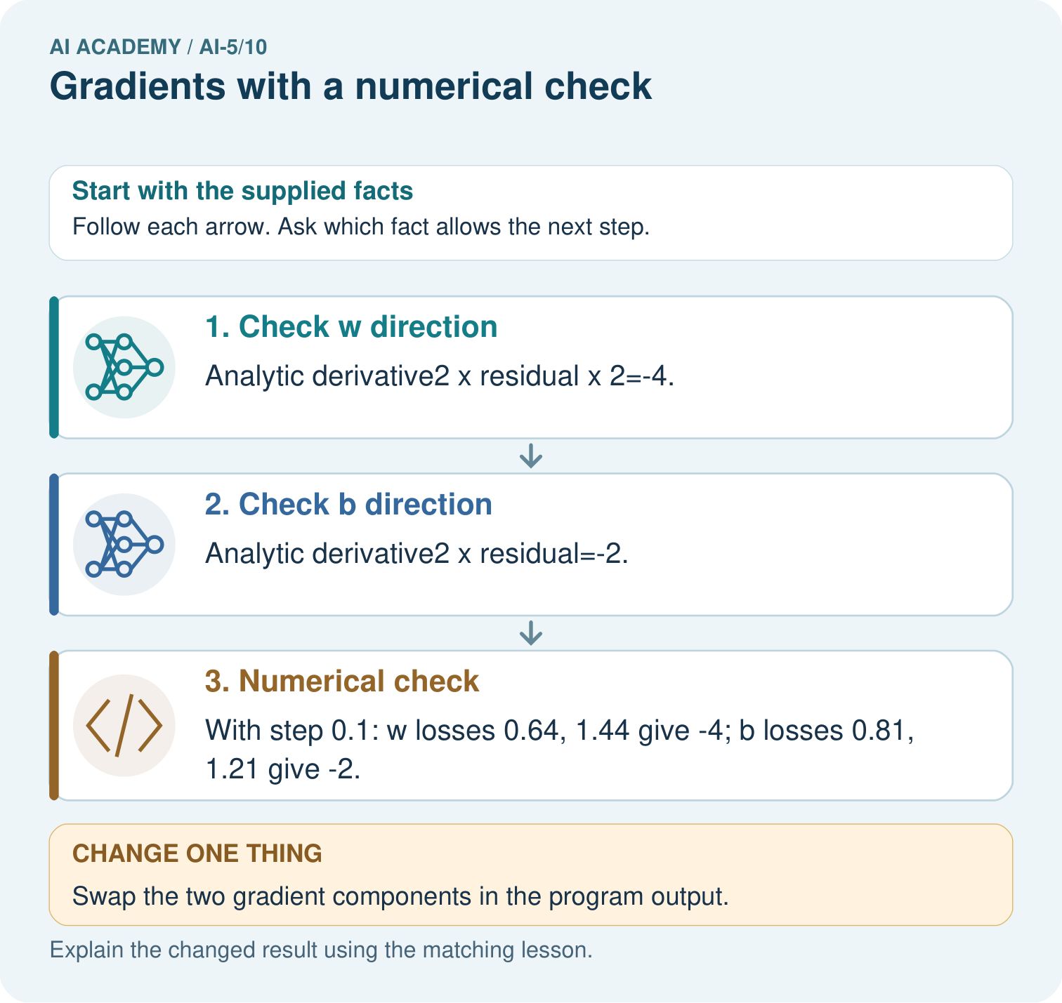

Read the picture one step at a time
Step | What happens and why
1. Check w direction | Analytic derivative2×residual×2=-4.
2. Check b direction | Analytic derivative2×residual=-2.
3. Numerical check | With step 0.1: w losses 0.64, 1.44 give -4; b losses 0.81, 1.21 give -2.
Match each pictured step to the supplied facts. This is a worked teaching case, not an independent assessment.

Why this result follows
A gradient lists the slope for each parameter, in a declared order. Changing w by a small amount changes the prediction twice as much as changing b by the same amount. That explains the different derivative magnitudes. Perturb one coordinate while holding the other fixed, then compare the numerical slope with its analytic counterpart.

What this example does not establish
The exact agreement occurs for this quadratic toy case; finite differences in larger models involve rounding and step-size limits.
Read the labelled picture: Why should the numerical checks perturb one coordinate at a time? Point to the relevant step in the picture, then write the changed result and the rule or evidence that supports it.
Change one thing: Swap the two gradient components in the program output. Predict the result before checking the explanation. What remains the same?

07. Find and repair a mistake
ReLU is not differentiable exactly at zero. A symmetric difference across that corner can average two different behaviours. When checking a network gradient, use points whose relevant scores are safely away from zero, and check that the small perturbations do not cross a corner. Document any derivative convention used at zero.
At the centre of the simple scalar ReLU function, [ReLU(0.1) - ReLU(-0.1)] / 0.2 equals 0.5. This symmetric number does not make the function differentiable at zero. Also avoid assuming an ever-smaller step is always better: subtraction and rounding can spoil numerical differences.

Locate the earliest unsupported step
Starting at [w, b] = [1, 0], both coordinates move by plus or minus 0.1 together. Compute the symmetric slope and explain why it is not either partial derivative.

State one repair and the checks you would rerun.
________________________________________________________________
________________________________________________________________
________________________________________________________________
________________________________________________________________
________________________________________________________________
________________________________________________________________

08. Practise together
For the lesson model at w = 1 and b = 1, calculate prediction, residual, loss and gradient.

At w = 0, b = 1, find prediction, residual, loss and the gradient using [4 times residual, 2 times residual].
________________________________________________________________
________________________________________________________________
________________________________________________________________
________________________________________________________________

Explain your prediction to a partner before comparing results.
________________________________________________________________
________________________________________________________________
________________________________________________________________
________________________________________________________________

Practise with less help: Catch a denominator error
Use workbook W2 for the connected example “Gradients with a numerical check”. First fill the input and rule boxes. Try the middle steps before asking for a hint. After a hint, try the next step yourself.
Plan | Do | Check
What is given? Which rule or procedure applies? | Record each intermediate step. | Does the result follow? What remains unknown?
Explain your trace to a partner. Your partner points to one step to check. Swap roles on the next case. Each person writes their own explanation.

Check your reasoning
Use the worked case for Gradients with a numerical check. Proposed explanation: “The gradient is one scalar”. Decide whether this explanation is supported. Point to the step or supplied fact that decides; explain your repair if needed.
Answer on your own before discussion. If you are unsure, say which step you need help with.

Explain the picture
Why should the numerical checks perturb one coordinate at a time? Point to the relevant step in the picture, then write the changed result and the rule or evidence that supports it.

My explanation using a pictured step and the given facts
________________________________________________________________
________________________________________________________________
________________________________________________________________
________________________________________________________________
This is supported practice. Keep the separately named independent case for an attempt before feedback.

09. Run the investigation

Predict, investigate and preserve the evidence
A w probe has losses 1.44 and 0.64 at 0.9 and 1.1 with b fixed. A learner divides their difference by 0.1. Correct the result.
def loss(w, b):
return (2 * w + b - 3) ** 2
def gradient_check(w, b, step=0.001):
dw = (loss(w + step, b) - loss(w - step, b)) / (2 * step)
db = (loss(w, b + step) - loss(w, b - step)) / (2 * step)
residual = 2 * w + b - 3
formula = [4 * residual, 2 * residual]
numerical = [dw, db]
assert all(abs(a - n) < 1e-6
for a, n in zip(formula, numerical))
return numerical
print([round(g, 6) for g in gradient_check(1, 0)])
# [-4.0, -2.0]
Record | Your evidence
Given input and fixed rule
Prediction before checking
Actual result, or “not run”
First mismatch and one explanation
Boundary or missing input and expected response
On paper, trace the supplied procedure. If code is provided, predict before running it in a local practice file. Never write an expected answer as though it were an observed run.

Plan → try → check
Before trying: what do I expect, and why? While trying: which step could first go wrong? Afterwards: what did I actually observe, and what should change? Keep “not run” if you only traced the procedure.

10. Build your understanding

Explain → apply → challenge
For the lesson model at w = 1 and b = 1, calculate prediction, residual, loss and gradient.
Starting at [w, b] = [1, 0], both coordinates move by plus or minus 0.1 together. Compute the symmetric slope and explain why it is not either partial derivative.
Compute the symmetric difference of ReLU at zero with step 0.1. Explain why this does not prove a derivative exists there.

Explain which evidence supports your conclusion and which claim remains unproved.
________________________________________________________________
________________________________________________________________
________________________________________________________________
________________________________________________________________
________________________________________________________________

11. Connect your project
Add a labelled gradients with a numerical check evidence sheet to Image-pattern Network Investigation. Show how you can estimate one partial derivative while other parameters stay fixed. Use the supplied fictional case and keep its inputs, intermediate steps, calculation or prediction, and limitation. Connect this record to last week’s record; a matching answer without a trace is insufficient.
Project evidence | Record
Component and version
Inputs permitted at prediction time
Trace and comparison with earlier work
Failure, limit and human review

Evidence for your project
For your Image-pattern Network Investigation, save the input, procedure, observed result and limitation of this check. Label this worked example as practice; use a different, previously unreviewed case when checking independent understanding.

12. Show what you know
The gradient describes how the stated loss changes near the current parameters. For a differentiable function, moving a sufficiently small distance opposite a nonzero gradient decreases the function locally. The gradient alone does not choose a safe finite step, establish a global minimum or demonstrate generalisation.

A numerical checker moves w and b together, gets one slope and copies it into both gradient entries. What is wrong with this check?
________________________________________________________________
________________________________________________________________
________________________________________________________________
________________________________________________________________
Next week combines a gradient with an explicit learning rate to update parameters together.
Compute the symmetric difference of ReLU at zero with step 0.1. Explain why this does not prove a derivative exists there.

My limited claim and a useful next check
________________________________________________________________
________________________________________________________________
________________________________________________________________
________________________________________________________________

13. Study a complete case

Complete evidence record

Two separate probes at one parameter vector
Parameter being probed | Held fixed | Gradient entry
w near 1 | b is 0 and x is 2 | First entry -4
b near 0 | w is 1 and x is 2 | Second entry -2
Assemble in order [w, b] | Same original model | Gradient [-4, -2]
The first two rows are independent local probes, not successive parameter updates. The final row records both results in the declared order.
Follow the input through the stated procedure to its result. Cover the result first, predict it, then explain every intermediate step. The text/table accompanies the figure so the example can be read without colour.

My complete trace of the worked case
________________________________________________________________
________________________________________________________________
________________________________________________________________
________________________________________________________________
________________________________________________________________
________________________________________________________________

14. Try a new case independently

Independent case: Check a new example independently
Use x = 3, target 2 and y = wx + b at w = 0, b = 1. With step 0.1, calculate both numerical partials. Compare with [2 times residual times x, 2 times residual].

My independent explanation, trace and limits
________________________________________________________________
________________________________________________________________
________________________________________________________________
________________________________________________________________
________________________________________________________________
________________________________________________________________
________________________________________________________________
Attempt this case before feedback. Record any help. Earlier examples below are further practice; a case already practised with feedback cannot establish fresh transfer.

Attempt this without hints
Use x = 3, target 2 and y = wx + b at w = 0, b = 1. With step 0.1, calculate both numerical partials. Compare with [2 times residual times x, 2 times residual].

My independent procedure, result and limitation
________________________________________________________________
________________________________________________________________
________________________________________________________________
________________________________________________________________
________________________________________________________________
________________________________________________________________
________________________________________________________________
________________________________________________________________
Record support used: none, hint or teacher explanation. After feedback, a different case is needed to demonstrate independence.

Use feedback to improve
Attempt the independent case before hints. Record whether you worked alone, used a hint or followed a model. After feedback, fix the first unsupported step and explain why it changed. A later check uses a changed case, not a copied answer.

15. Your lesson route
Start with this question: Check each coordinate of a gradient while holding the other parameter fixed.
By the end, I can | How I will show it
Estimate one partial derivative while other parameters stay fixed | Explain the deciding step, show a trace or test, and state one limit.
Assemble a gradient in a declared parameter order | Explain the deciding step, show a trace or test, and state one limit.
Compare numerical and formula based gradients with a tolerance | Explain the deciding step, show a trace or test, and state one limit.
Remember → watch and explain → try with help → investigate → try independently → keep project evidence. Your teacher may spread this lesson across several classes.
Keep your first prediction. Compare it with what the evidence shows and explain any change.

16. Finish and return
Close your notes. Explain this goal in your own words: Estimate one partial derivative while other parameters stay fixed

My deciding step, evidence and one remaining question
________________________________________________________________
________________________________________________________________
________________________________________________________________
________________________________________________________________
________________________________________________________________
If you are unsure, return to the worked picture and explain one arrow. If you are ready, change an input or assumption and justify your prediction.
Save your workbook evidence. At the next review, try a different case before opening your old answer.

17. Supported practice, repair and portfolio
Use this supported practice once, in the browser or on paper. Keep the reserved independent assessment for a separate first attempt before teacher feedback.
Check each coordinate of a gradient while holding the other parameter fixed.

Practice 1: explain the deciding evidence
Which labelled step matches this detail? With step 0.1: w losses 0.64, 1.44 give -4; b losses 0.81, 1.21 give -2.
1. Numerical check
2. Check b direction
3. Check w direction

My selected conclusion, deciding fact and explanation
________________________________________________________________
________________________________________________________________
________________________________________________________________
________________________________________________________________
________________________________________________________________
Hint if needed: Read the steps in the pictorial case. Match the supplied detail to the stage that performs or records it.
After your attempt, compare with the supported explanation: Numerical check With step 0.1: w losses 0.64, 1.44 give -4; b losses 0.81, 1.21 give -2. A gradient lists the slope for each parameter, in a declared order. Changing w by a small amount changes the prediction twice as much as changing b by the same amount. That explains the different derivative magnitudes. Perturb one coordinate while holding the other fixed, then compare the numerical slope with its analytic counterpart.

Practice 2: explain the deciding evidence
Changed-case practice: Swap the two gradient components in the program output. Which conclusion is supported by the supplied facts?
1. This one example guarantees correct results for every future input.
2. The coordinate-wise numerical check exposes the mismatch.
3. We can decide the result without examining the changed input or the procedure.

My selected conclusion, deciding fact and explanation
________________________________________________________________
________________________________________________________________
________________________________________________________________
________________________________________________________________
________________________________________________________________
Hint if needed: Use the changed condition and the deciding step in the pictorial trace. The answer must say what follows from those facts.
After your attempt, compare with the supported explanation: The coordinate-wise numerical check exposes the mismatch. The w perturbation changes y twice as strongly as the same b perturbation.

Repair a missing building block
Review Slopes and local change (ai-5/9). Goal: Calculate an average rate of change over a stated interval. Short practice: Which calculation disproves “any increase helps”? Point to the relevant step in the picture, then write the changed result and the rule or evidence that supports it.. Return to this week and explain what you changed.
Review Parameters and architecture (ai-5/7). Goal: Distinguish architectural choices from parameter values. Short practice: How many new parameters did that one hidden unit add? Point to the relevant step in the picture, then write the changed result and the rule or evidence that supports it.. Return to this week and explain what you changed.
Review Activation functions (ai-5/4). Goal: Trace identity ReLU and sigmoid on a numerical score. Short practice: Which original inputs cannot be distinguished by this network’s final output? Point to the relevant step in the picture, then write the changed result and the rule or evidence that supports it.. Return to this week and explain what you changed.

Predict, run and debug
The browser lab lets you edit the supported Python examples already included in this lesson. Predict first, run, inspect the actual output or error, change one input, then run again. Keep code, predictions, actual results and a reasoned revision together. On paper, label your result as a trace rather than an execution.

Keep your completed work
Use Download completed work in the hosted lesson to export your answers, reflections, practice feedback and code-run evidence. Open the HTML copy to read or print it. Drafts stay in this browser when storage is available; clear drafts on a shared device.

