AI ACADEMY · STUDENT · ai-5/16

Regularisation and early stopping
Project: Image-pattern Network Investigation

Before you start
If validation chooses an earlier checkpoint, which parameters should be used after selection?

01. Your mission

Your learning target
I can separate a weight penalty from prediction error.
I can trace a regularised update under a stated objective.
I can apply a stopping rule and restore the best observed checkpoint.

Remember before reading
Close your notes first. A rough first answer helps us choose the right starting point; it is not a score for your ability.
Without opening the old lesson, explain one key idea from Training and validation curves. Give an example and a mistake that the idea helps you avoid.
Without opening the old lesson, explain one key idea from Batching and epochs. Give an example and a mistake that the idea helps you avoid.
Without opening the old lesson, explain one key idea from Gradients with a numerical check. Give an example and a mistake that the idea helps you avoid.
After trying, check the relevant lesson or ask your teacher. Change the part of your explanation that the evidence shows was wrong.
This week you will practise:
Separate a weight penalty from prediction error
Trace a regularised update under a stated objective
Apply a stopping rule and restore the best observed checkpoint

Retrieve what you already know
If validation chooses an earlier checkpoint, which parameters should be used after selection?

My starting explanation
________________________________________________________________
________________________________________________________________
________________________________________________________________

This week’s end goal
By the end, I can explain regularisation and early stopping using a traced example and a stated limitation.

02. Notice the evidence
Keep h = ReLU(x), y = vh, train only v on (1, 2) and (2, 4), and freeze all hidden parameters and the zero output bias. Training MSE is L(v) = 2.5(v - 2) squared. Define J(v) = L(v) + lambda times v squared, with lambda nonnegative. Only this one output weight is penalised here.
For lambda = 0.5, the penalty at v = 1.5 is 0.5 times 2.25 = 1.125. Prediction MSE is 0.625, so total objective J is 1.75. Keep these quantities separate in logs. A smaller total objective does not automatically mean a smaller prediction error.
v | Prediction MSE | Penalty at lambda 0.5 | Total J
1 | 2.5 | 0.5 | 3
1.5 | 0.625 | 1.125 | 1.75
2 | 0 | 2 | 2
Among these three candidates, the smallest penalised objective is at v = 1.5, whereas the smallest training MSE is at v = 2. Penalising a weight changes the tradeoff. It does not guarantee better validation performance or fair outcomes.

List the given facts and one fact that is not supplied.
________________________________________________________________
________________________________________________________________
________________________________________________________________

03. See how it works
The data gradient is 5(v - 2). The penalty gradient is 2 times lambda times v, giving total gradient 5(v - 2) + 2 lambda v. At v = 1.5 and lambda = 0.5, these contributions are -2.5 and 1.5, so total gradient is -1. A rate 0.1 step gives v = 1.6.
def terms(v, penalty):
data_loss = 2.5 * (v - 2) ** 2
weight_cost = penalty * v * v
gradient = 5 * (v - 2) + 2 * penalty * v
return data_loss, weight_cost, data_loss + weight_cost, gradient
v = 1.5
penalty = 0.5
old = terms(v, penalty)
v = v - 0.1 * old[3]
print(round(v, 6)) # 1.6
print([round(x, 6) for x in terms(v, penalty)])
# [0.4, 1.28, 1.68, -0.4]
Assume finite numeric values and nonnegative penalty. At the new v, data loss is 0.4, penalty 1.28 and total 1.68. Choose penalty strength using a declared validation prediction metric, not by comparing total objectives with different lambdas as if they were the same measure.

Connect the picture and the explanation
Point to the input, the deciding step and the result in this week’s visual. Explain the same step in ordinary words. A picture helps when you can say what each part represents.

04. Compare the cases

Compare a familiar case with a changed case
Start v = 1.6 with lambda = 0.5 and rate 0.1. Calculate both gradient contributions, new v and new prediction MSE.

Keep the procedure fixed. Explain what changed in the inputs and result.
________________________________________________________________
________________________________________________________________
________________________________________________________________
________________________________________________________________
________________________________________________________________

Change one thing in the pictured case
Change: Change patience from 1 to2 under the same tie rule.
Prediction: Stop at checkpoint 4; still restore checkpoint 2.
Reason: Checkpoints 3 and 4 are two consecutive non-improvements; a later stop does not redefine the best checkpoint.

05. Words that unlock the idea
Word | Meaning
Regularisation | A constraint or training procedure intended to limit fitting choices and improve generalisation
Weight penalty | An added objective term that discourages specified large parameter values
Patience | The allowed run of consecutive non-improving evaluations before stopping under a stated rule
Restore | Reload the parameters saved at the selected checkpoint

Use two terms to explain a step in this week’s example.
________________________________________________________________
________________________________________________________________
________________________________________________________________

06. Follow a worked example

Patience two with strict improvement
Epoch | Validation MSE | Decision
0 then 1 then 2 | 4 then 2 then 1.5 | Save each improved state
3 then 4 | 1.6 then 1.4 | Wait once then reset
5 then 6 | 1.45 then 1.46 | Two misses so stop at 6
Initial checkpoint is epoch 0. Evaluate once after each epoch. A strict decrease is improvement; an exact tie is a miss. Reset the miss count after improvement and stop at two consecutive misses. Restore epoch 4, the best observed checkpoint.

At epochs 3, 4, 5 and 6, record the miss count after evaluation. Which epoch stops training, and which epoch supplies the restored parameters?
________________________________________________________________
________________________________________________________________
________________________________________________________________
________________________________________________________________

Learn from the worked case
Cover the result before checking it. Say what is given, choose the procedure, and follow one step at a time. Then uncover the result and explain your first mismatch. Ask why a step is allowed, not only what number it produces.

A pictorial worked case: Regularisation and early stopping
Separate a regularisation penalty from prediction loss and an early-stopping rule.

The facts we will use
Toy objective J(a)=(a-3)²+2a²; start a = 0; gradient 6a-6; rate 1/6. Separate validation losses:[5, 3, 3, 4], patience 1, no ties as improvement.
All inputs and outcomes in this worked example are invented classroom data; no real model run is claimed.
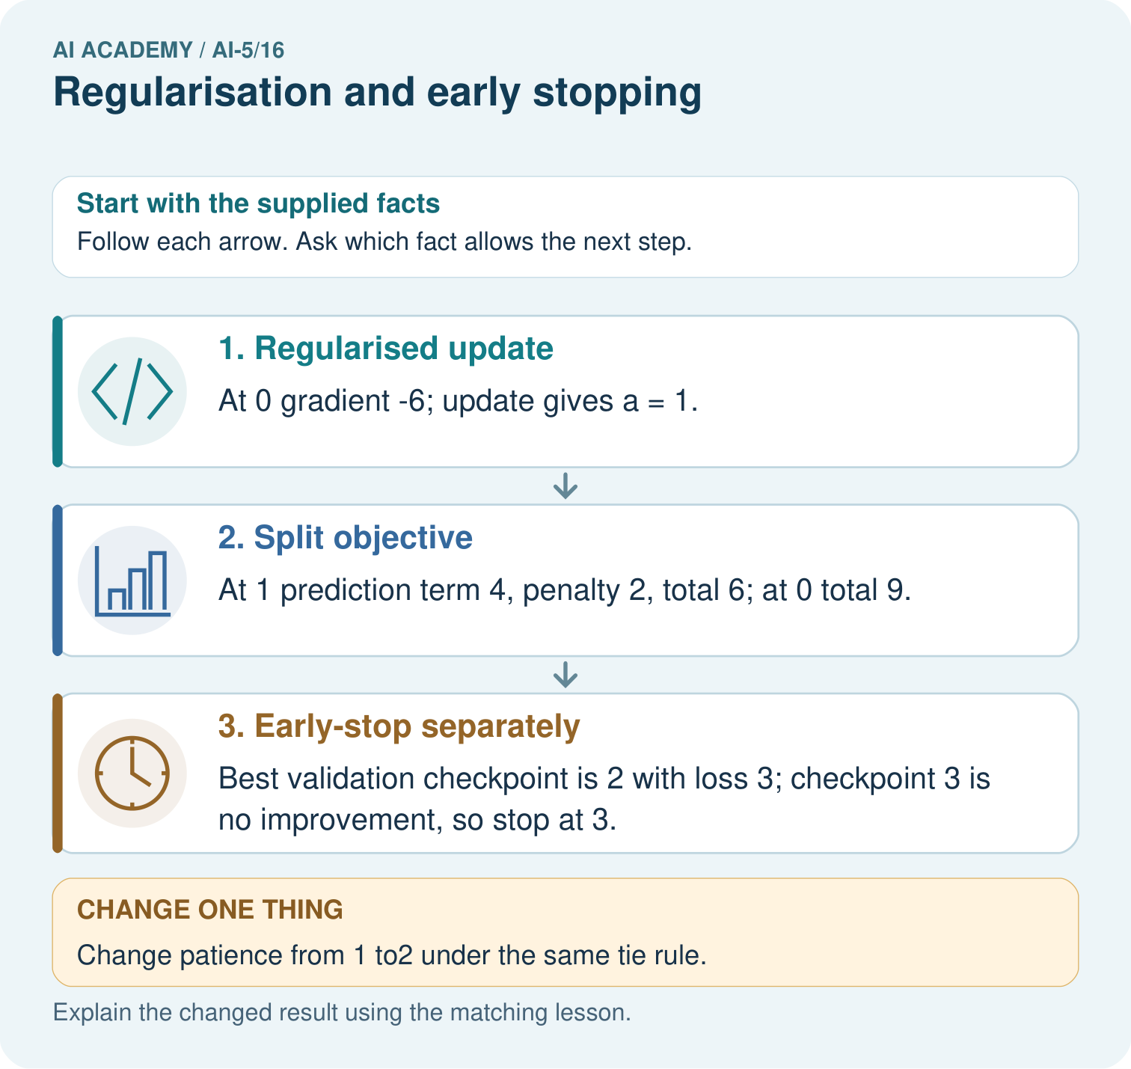

Read the picture one step at a time
Step | What happens and why
1. Regularised update | At 0 gradient -6; update gives a = 1.
2. Split objective | At 1 prediction term 4, penalty 2, total 6; at 0 total 9.
3. Early-stop separately | Best validation checkpoint is 2 with loss 3; checkpoint 3 is no improvement, so stop at 3.
Match each pictured step to the supplied facts. This is a worked teaching case, not an independent assessment.

Why this result follows
Regularisation adds a parameter penalty to the training objective. Here it discourages large a, so the objective balances prediction error against that penalty. Early stopping is a different decision based on the supplied validation sequence. A tied validation loss is not improvement under this policy; stop when the patience allowance is used and restore the best checkpoint.

What this example does not establish
Regularisation and early stopping are different tools; neither guarantees better performance in every dataset.
Read the labelled picture: Why should the penalty value not be reported as validation error? Point to the relevant step in the picture, then write the changed result and the rule or evidence that supports it.
Change one thing: Change patience from 1 to2 under the same tie rule. Predict the result before checking the explanation. What remains the same?

07. Find and repair a mistake
Early stopping limits the training duration using development evidence; it does not add a weight term to the objective. For this policy, initialise the best checkpoint to epoch 0 and the miss count to zero. After each later evaluation, save and reset only on a strict improvement; otherwise increment the count. Stop as soon as the count reaches patience, then reload the best checkpoint.
Suppose a pre-recorded demonstration also lists epoch 7 loss 1.3. A live run following the rule has already stopped at 6 and does not observe 7. Do not use future values to rewrite the stopping decision. The policy can miss a later improvement; patience balances waiting against a training budget and must be specified in advance.
Save actual model parameters with the checkpoint, not just its epoch number or loss. With a fixed maximum epoch budget, stop when either limit is reached and restore the best observed state. An exact tie keeps the earlier checkpoint under our rule. Different minimum-improvement thresholds are possible, but would be different declared policies.

Locate the earliest unsupported step
Validation MSE at epochs 0 to 7 is [4, 2, 1.5, 1.6, 1.4, 1.45, 1.46, 1.3]. Apply the lesson policy with patience 2. Give the stop epoch, restored epoch and why the listed epoch 7 cannot change this decision.

State one repair and the checks you would rerun.
________________________________________________________________
________________________________________________________________
________________________________________________________________
________________________________________________________________
________________________________________________________________
________________________________________________________________

08. Practise together
At v = 2 and lambda = 0.5 in the lesson, compute prediction MSE, penalty, total objective and total gradient. Does zero training MSE make this gradient zero?

At epochs 3, 4, 5 and 6, record the miss count after evaluation. Which epoch stops training, and which epoch supplies the restored parameters?
________________________________________________________________
________________________________________________________________
________________________________________________________________
________________________________________________________________

Explain your prediction to a partner before comparing results.
________________________________________________________________
________________________________________________________________
________________________________________________________________
________________________________________________________________

Practise with less help: Trace the next update
Use workbook W2 for the connected example “Regularisation and early stopping”. First fill the input and rule boxes. Try the middle steps before asking for a hint. After a hint, try the next step yourself.
Plan | Do | Check
What is given? Which rule or procedure applies? | Record each intermediate step. | Does the result follow? What remains unknown?
Explain your trace to a partner. Your partner points to one step to check. Swap roles on the next case. Each person writes their own explanation.

Check your reasoning
Use the worked case for Regularisation and early stopping. Proposed explanation: “Zero prediction error means no regularised update”. Decide whether this explanation is supported. Point to the step or supplied fact that decides; explain your repair if needed.
Answer on your own before discussion. If you are unsure, say which step you need help with.

Explain the picture
Why should the penalty value not be reported as validation error? Point to the relevant step in the picture, then write the changed result and the rule or evidence that supports it.

My explanation using a pictured step and the given facts
________________________________________________________________
________________________________________________________________
________________________________________________________________
________________________________________________________________
This is supported practice. Keep the separately named independent case for an attempt before feedback.

09. Run the investigation

Predict, investigate and preserve the evidence
Start v = 1.6 with lambda = 0.5 and rate 0.1. Calculate both gradient contributions, new v and new prediction MSE.
def terms(v, penalty):
data_loss = 2.5 * (v - 2) ** 2
weight_cost = penalty * v * v
gradient = 5 * (v - 2) + 2 * penalty * v
return data_loss, weight_cost, data_loss + weight_cost, gradient
v = 1.5
penalty = 0.5
old = terms(v, penalty)
v = v - 0.1 * old[3]
print(round(v, 6)) # 1.6
print([round(x, 6) for x in terms(v, penalty)])
# [0.4, 1.28, 1.68, -0.4]
Record | Your evidence
Given input and fixed rule
Prediction before checking
Actual result, or “not run”
First mismatch and one explanation
Boundary or missing input and expected response
On paper, trace the supplied procedure. If code is provided, predict before running it in a local practice file. Never write an expected answer as though it were an observed run.

Plan → try → check
Before trying: what do I expect, and why? While trying: which step could first go wrong? Afterwards: what did I actually observe, and what should change? Keep “not run” if you only traced the procedure.

10. Build your understanding

Explain → apply → challenge
At v = 2 and lambda = 0.5 in the lesson, compute prediction MSE, penalty, total objective and total gradient. Does zero training MSE make this gradient zero?
Validation MSE at epochs 0 to 7 is [4, 2, 1.5, 1.6, 1.4, 1.45, 1.46, 1.3]. Apply the lesson policy with patience 2. Give the stop epoch, restored epoch and why the listed epoch 7 cannot change this decision.
A team compares lambda 0 and lambda 0.5 by choosing whichever has the smaller penalised training objective. Explain why this does not establish the better prediction model and name a suitable development comparison.

Explain which evidence supports your conclusion and which claim remains unproved.
________________________________________________________________
________________________________________________________________
________________________________________________________________
________________________________________________________________
________________________________________________________________

11. Connect your project
Add a labelled regularisation and early stopping evidence sheet to Image-pattern Network Investigation. Show how you can separate a weight penalty from prediction error. Use the supplied fictional case and keep its inputs, intermediate steps, calculation or prediction, and limitation. Connect this record to last week’s record; a matching answer without a trace is insufficient.
Project evidence | Record
Component and version
Inputs permitted at prediction time
Trace and comparison with earlier work
Failure, limit and human review

Evidence for your project
For your Image-pattern Network Investigation, save the input, procedure, observed result and limitation of this check. Label this worked example as practice; use a different, previously unreviewed case when checking independent understanding.

12. Show what you know
Weight penalties and early stopping can be used together, but they act differently. Record which weights receive penalties, the objective convention, lambda, learning rate, checkpoint frequency, patience, tie rule and maximum budget. For this classroom model there are no extra learned preprocessing or running statistics; larger models may require more state to reproduce evaluation.

A team stops at epoch 6, uses its final parameters instead of the saved best state, and chooses patience by looking at final test losses. Identify the two mistakes and explain how to repair the experiment.
________________________________________________________________
________________________________________________________________
________________________________________________________________
________________________________________________________________
Select these settings using validation, freeze the complete procedure, and reserve untouched final test data for reporting. Neither regularisation nor stopping makes a weak validation set representative. Next week studies initialisation and reproducibility.
A team compares lambda 0 and lambda 0.5 by choosing whichever has the smaller penalised training objective. Explain why this does not establish the better prediction model and name a suitable development comparison.

My limited claim and a useful next check
________________________________________________________________
________________________________________________________________
________________________________________________________________
________________________________________________________________

13. Study a complete case

Complete evidence record

Patience two with strict improvement
Epoch | Validation MSE | Decision
0 then 1 then 2 | 4 then 2 then 1.5 | Save each improved state
3 then 4 | 1.6 then 1.4 | Wait once then reset
5 then 6 | 1.45 then 1.46 | Two misses so stop at 6
Initial checkpoint is epoch 0. Evaluate once after each epoch. A strict decrease is improvement; an exact tie is a miss. Reset the miss count after improvement and stop at two consecutive misses. Restore epoch 4, the best observed checkpoint.
Follow the input through the stated procedure to its result. Cover the result first, predict it, then explain every intermediate step. The text/table accompanies the figure so the example can be read without colour.

My complete trace of the worked case
________________________________________________________________
________________________________________________________________
________________________________________________________________
________________________________________________________________
________________________________________________________________
________________________________________________________________

14. Try a new case independently

Independent case: Transfer both rules independently
For a new objective J(a) = (a - 2) squared + a squared, gradient 4a - 4, start a = 0 and take one step at rate 0.25. Give new a, prediction error term, penalty and total J. Separately apply patience 2 with strict improvement to validation values [3, 2, 2, 2, 1] at epochs 0 to 4; report the stop and restored epochs.

My independent explanation, trace and limits
________________________________________________________________
________________________________________________________________
________________________________________________________________
________________________________________________________________
________________________________________________________________
________________________________________________________________
________________________________________________________________
Attempt this case before feedback. Record any help. Earlier examples below are further practice; a case already practised with feedback cannot establish fresh transfer.

Attempt this without hints
For a new objective J(a) = (a - 2) squared + a squared, gradient 4a - 4, start a = 0 and take one step at rate 0.25. Give new a, prediction error term, penalty and total J. Separately apply patience 2 with strict improvement to validation values [3, 2, 2, 2, 1] at epochs 0 to 4; report the stop and restored epochs.

My independent procedure, result and limitation
________________________________________________________________
________________________________________________________________
________________________________________________________________
________________________________________________________________
________________________________________________________________
________________________________________________________________
________________________________________________________________
________________________________________________________________
Record support used: none, hint or teacher explanation. After feedback, a different case is needed to demonstrate independence.

Use feedback to improve
Attempt the independent case before hints. Record whether you worked alone, used a hint or followed a model. After feedback, fix the first unsupported step and explain why it changed. A later check uses a changed case, not a copied answer.

15. Your lesson route
Start with this question: Separate a regularisation penalty from prediction loss and an early-stopping rule.
By the end, I can | How I will show it
Separate a weight penalty from prediction error | Explain the deciding step, show a trace or test, and state one limit.
Trace a regularised update under a stated objective | Explain the deciding step, show a trace or test, and state one limit.
Apply a stopping rule and restore the best observed checkpoint | Explain the deciding step, show a trace or test, and state one limit.
Remember → watch and explain → try with help → investigate → try independently → keep project evidence. Your teacher may spread this lesson across several classes.
Keep your first prediction. Compare it with what the evidence shows and explain any change.

16. Finish and return
Close your notes. Explain this goal in your own words: Separate a weight penalty from prediction error

My deciding step, evidence and one remaining question
________________________________________________________________
________________________________________________________________
________________________________________________________________
________________________________________________________________
________________________________________________________________
If you are unsure, return to the worked picture and explain one arrow. If you are ready, change an input or assumption and justify your prediction.
Save your workbook evidence. At the next review, try a different case before opening your old answer.

17. Supported practice, repair and portfolio
Use this supported practice once, in the browser or on paper. Keep the reserved independent assessment for a separate first attempt before teacher feedback.
Separate a regularisation penalty from prediction loss and an early-stopping rule.

Practice 1: explain the deciding evidence
Which labelled step matches this detail? Best validation checkpoint is 2 with loss 3; checkpoint 3 is no improvement, so stop at 3.
1. Split objective
2. Early-stop separately
3. Regularised update

My selected conclusion, deciding fact and explanation
________________________________________________________________
________________________________________________________________
________________________________________________________________
________________________________________________________________
________________________________________________________________
Hint if needed: Read the steps in the pictorial case. Match the supplied detail to the stage that performs or records it.
After your attempt, compare with the supported explanation: Early-stop separately Best validation checkpoint is 2 with loss 3; checkpoint 3 is no improvement, so stop at 3. Regularisation adds a parameter penalty to the training objective. Here it discourages large a, so the objective balances prediction error against that penalty. Early stopping is a different decision based on the supplied validation sequence. A tied validation loss is not improvement under this policy; stop when the patience allowance is used and restore the best checkpoint.

Practice 2: explain the deciding evidence
Changed-case practice: Change patience from 1 to2 under the same tie rule. Which conclusion is supported by the supplied facts?
1. We can decide the result without examining the changed input or the procedure.
2. Stop at checkpoint 4; still restore checkpoint 2.
3. This one example guarantees correct results for every future input.

My selected conclusion, deciding fact and explanation
________________________________________________________________
________________________________________________________________
________________________________________________________________
________________________________________________________________
________________________________________________________________
Hint if needed: Use the changed condition and the deciding step in the pictorial trace. The answer must say what follows from those facts.
After your attempt, compare with the supported explanation: Stop at checkpoint 4; still restore checkpoint 2. Checkpoints 3 and 4 are two consecutive non-improvements; a later stop does not redefine the best checkpoint.

Repair a missing building block
Review Training and validation curves (ai-5/15). Goal: Compute comparable training and validation losses at saved checkpoints. Short practice: Can the original epoch 3 training loss 1 justify claiming best generalisation? Point to the relevant step in the picture, then write the changed result and the rule or evidence that supports it.. Return to this week and explain what you changed.
Review Batching and epochs (ai-5/13). Goal: Distinguish an example a batch an update and an epoch. Short practice: Why do the single-example orders finish at different weights? Point to the relevant step in the picture, then write the changed result and the rule or evidence that supports it.. Return to this week and explain what you changed.
Review Gradients with a numerical check (ai-5/10). Goal: Estimate one partial derivative while other parameters stay fixed. Short practice: Why should the numerical checks perturb one coordinate at a time? Point to the relevant step in the picture, then write the changed result and the rule or evidence that supports it.. Return to this week and explain what you changed.

Predict, run and debug
The browser lab lets you edit the supported Python examples already included in this lesson. Predict first, run, inspect the actual output or error, change one input, then run again. Keep code, predictions, actual results and a reasoned revision together. On paper, label your result as a trace rather than an execution.

Keep your completed work
Use Download completed work in the hosted lesson to export your answers, reflections, practice feedback and code-run evidence. Open the HTML copy to read or print it. Drafts stay in this browser when storage is available; clear drafts on a shared device.

