AI ACADEMY · STUDENT · ai-5/22

Pooling and spatial information
Project: Image-pattern Network Investigation

Before you start
For a 3 by 3 input and a 2 by 2 window with stride 2 and no padding, how many valid window positions exist?

01. Your mission

Your learning target
I can compute max and mean pooling under an explicit window rule.
I can use collisions to explain lost spatial information.
I can test boundary and movement claims with revealing examples.

Remember before reading
Close your notes first. A rough first answer helps us choose the right starting point; it is not a score for your ability.
Without opening the old lesson, explain one key idea from Convolution as a local operation. Give an example and a mistake that the idea helps you avoid.
Without opening the old lesson, explain one key idea from Learned representations. Give an example and a mistake that the idea helps you avoid.
Without opening the old lesson, explain one key idea from Regularisation and early stopping. Give an example and a mistake that the idea helps you avoid.
After trying, check the relevant lesson or ask your teacher. Change the part of your explanation that the evidence shows was wrong.
This week you will practise:
Compute max and mean pooling under an explicit window rule
Use collisions to explain lost spatial information
Test boundary and movement claims with revealing examples

Retrieve what you already know
For a 3 by 3 input and a 2 by 2 window with stride 2 and no padding, how many valid window positions exist?

My starting explanation
________________________________________________________________
________________________________________________________________
________________________________________________________________

This week’s end goal
By the end, I can explain pooling and spatial information using a traced example and a stated limitation.

02. Notice the evidence
A fictional single-channel feature map has rows [1, 4, 2, 0], [3, 2, 5, 1], [0, 6, 1, 3] and [2, 4, 2, 7]. Use a 2 by 2 window, stride 2, no padding and only complete windows. Coordinates are zero-based. The four starts are [0, 0], [0, 2], [2, 0] and [2, 2].
Max pooling keeps the largest value in each window. Mean pooling adds the four values and divides by 4. Neither operation learns weights in this lesson. These are fixed summaries of the incoming feature map, unlike the trainable kernel parameters introduced last week.
Window start | Values | Maximum | Mean
[0, 0] | 1, 4, 3, 2 | 4 | 2.5
[0, 2] | 2, 0, 5, 1 | 5 | 2
[2, 0] | 0, 6, 2, 4 | 6 | 3
[2, 2] | 1, 3, 2, 7 | 7 | 3.25
The max output is [[4, 5], [6, 7]], and the mean output is [[2.5, 2], [3, 3.25]]. Both have shape 2 by 2. Sixteen values become four, but the four outputs still preserve the coarse arrangement of the four regions.

List the given facts and one fact that is not supplied.
________________________________________________________________
________________________________________________________________
________________________________________________________________

03. See how it works
This code assumes a nonempty rectangular numeric map at least 2 by 2. It uses only complete 2 by 2 windows, stride 2 and no padding. It returns two separate summaries of the same map; it does not apply one pooling operation after the other.
def pool2(image):
h, w = len(image), len(image[0])
if h < 2 or w < 2:
raise ValueError("Need a complete 2 by 2 window")
maxima, means = [], []
for r in range(0, h - 1, 2):
max_row, mean_row = [], []
for c in range(0, w - 1, 2):
values = [image[r+i][c+j]
for i in range(2) for j in range(2)]
max_row.append(max(values))
mean_row.append(sum(values) / 4)
maxima.append(max_row)
means.append(mean_row)
return maxima, means
x = [[1, 4, 2, 0], [3, 2, 5, 1],
[0, 6, 1, 3], [2, 4, 2, 7]]
assert pool2(x) == ([[4, 5], [6, 7]],
[[2.5, 2], [3, 3.25]])
For this complete-window rule the output shape is floor((H - 2) / 2) + 1 by floor((W - 2) / 2) + 1. A 3 by 3 map produces just one output; its last row and last column are not read. Do not silently invent a partial-window rule or pad missing positions.

Connect the picture and the explanation
Point to the input, the deciding step and the result in this week’s visual. Explain the same step in ordinary words. A picture helps when you can say what each part represents.

04. Compare the cases

Compare a familiar case with a changed case
Give two different 2 by 2 windows containing exactly one 4 and three zeros that have the same maximum and mean. Explain why either scalar alone cannot identify the position of the 4.

Keep the procedure fixed. Explain what changed in the inputs and result.
________________________________________________________________
________________________________________________________________
________________________________________________________________
________________________________________________________________
________________________________________________________________

Change one thing in the pictured case
Change: Swap1 and 4 within the left window.
Prediction: Both pooled maps remain unchanged.
Reason: Max and mean ignore the positions of values inside the same window.

05. Words that unlock the idea
Word | Meaning
Max pooling | Replacing each window by its largest value
Mean pooling | Replacing each window by the arithmetic mean of its values
Spatial information | Information about where values occur and how positions relate
Pooling collision | Different inputs producing the same pooled values

Use two terms to explain a step in this week’s example.
________________________________________________________________
________________________________________________________________
________________________________________________________________

06. Follow a worked example

A maximum does not identify its location
Input window rows | Maximum | Mean
[4 0] and [0 0] | 4 | 1
[0 4] and [0 0] | 4 | 1
[4 4] and [4 4] | 4 | 4
The first two windows differ in the position of their nonzero value yet have the same maximum and mean. The third has the same maximum but a different mean. Each summary retains some distinctions and discards others.

Compare windows [[0, 0], [6, 0]] and [[0, 0], [0, 6]]. Compute both summaries. Can a deterministic head receiving only either scalar distinguish bottom-left from bottom-right?
________________________________________________________________
________________________________________________________________
________________________________________________________________
________________________________________________________________

Learn from the worked case
Cover the result before checking it. Say what is given, choose the procedure, and follow one step at a time. Then uncover the result and explain your first mismatch. Ask why a step is allowed, not only what number it produces.

A pictorial worked case: Pooling and spatial information
Pool a small map and show the detail it cannot retain.

The facts we will use
Feature map rows [1, 4, 2, 0],[3, 2, 5, 1]. Pool non-overlapping2×2 windows, stride2, no padding.
All inputs and outcomes in this worked example are invented classroom data; no real model run is claimed.
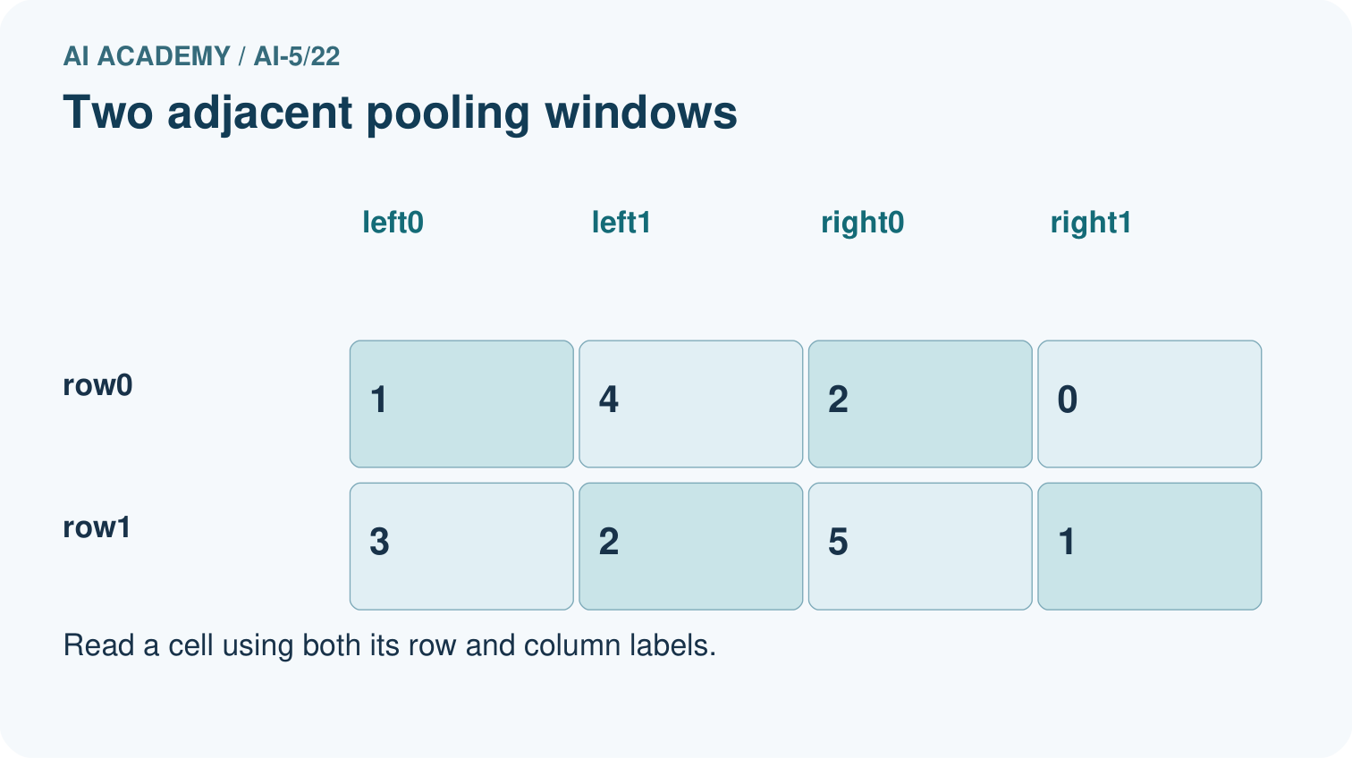
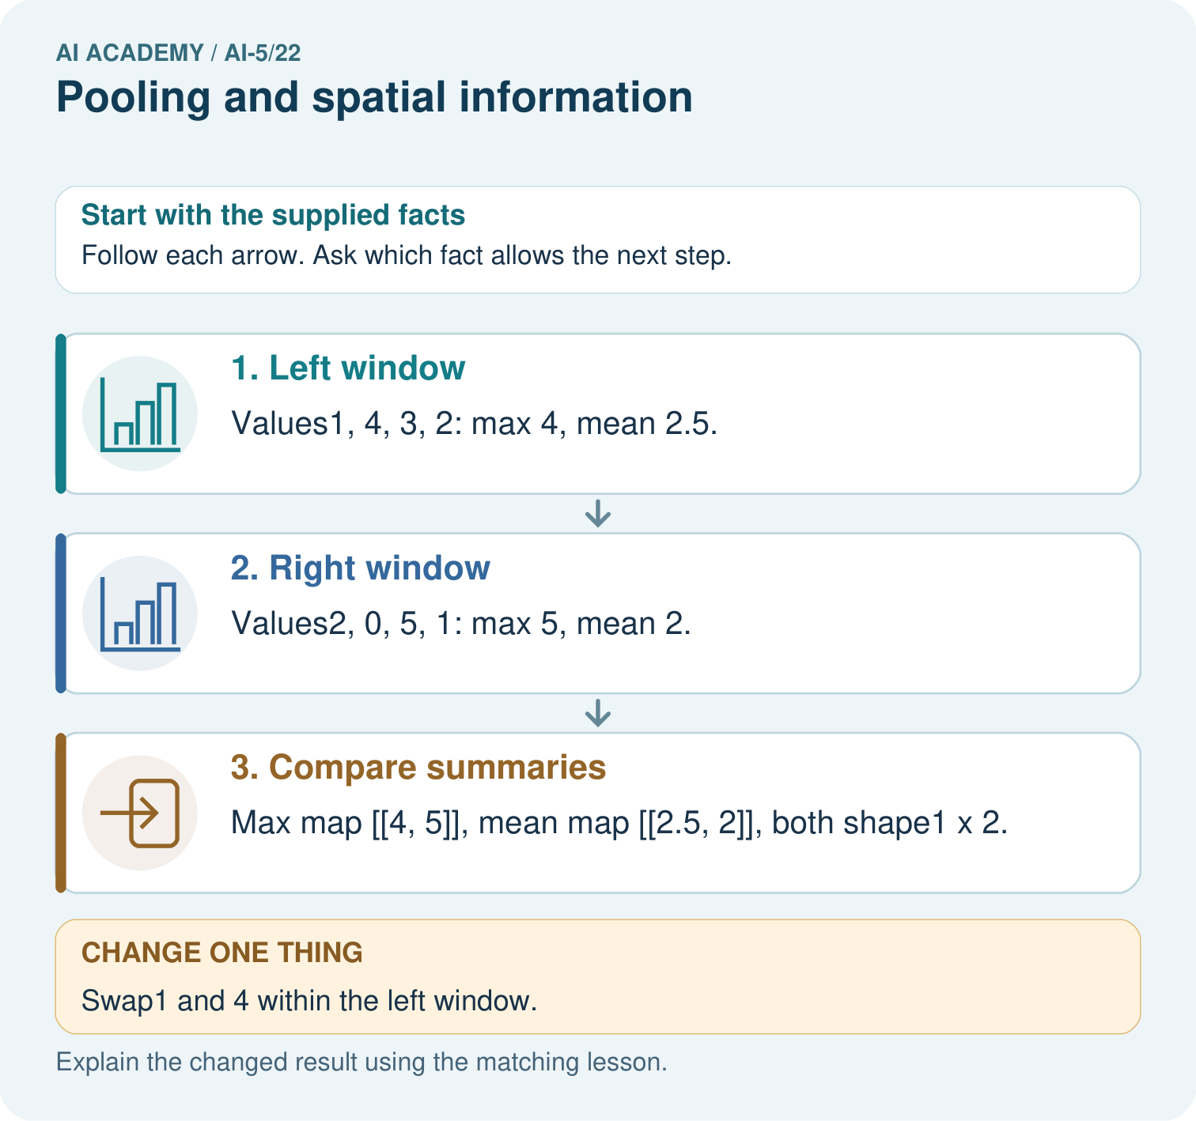

Read the picture one step at a time
Step | What happens and why
1. Left window | Values1, 4, 3, 2: max 4, mean 2.5.
2. Right window | Values2, 0, 5, 1: max 5, mean 2.
3. Compare summaries | Max map [[4, 5]], mean map [[2.5, 2]], both shape1×2.
Match each pictured step to the supplied facts. This is a worked teaching case, not an independent assessment.

Why this result follows
Pooling compresses each local window into a summary. Maximum keeps its largest value; mean keeps its average. Neither summary records where each value appeared. Swapping values inside one window leaves both summaries unchanged here, so the pooled output cannot reconstruct the original arrangement. The chosen window, stride and boundary policy determine the output shape.

What this example does not establish
Pooling is a declared aggregation, not automatic improvement; losing location can harm tasks that need precise positions.
Read the labelled picture: Can the max map reveal where the 4 originally appeared? Point to the relevant step in the picture, then write the changed result and the rule or evidence that supports it.
Change one thing: Swap1 and 4 within the left window. Predict the result before checking the explanation. What remains the same?

07. Find and repair a mistake
Within one isolated window, rearranging its values preserves both its maximum and mean. But moving a value across a window boundary can change the output map. In a 2 by 4 map of zeros, put a single 8 at row 0 column 1. Max pooling gives [[8, 0]]. Move that 8 one column right to column 2, replacing the old position with zero: the output becomes [[0, 8]]. Pooling therefore does not guarantee that a classifier ignores every small movement.
Negative values are valid inputs. For [[-4, -2], [-7, -3]], the maximum is -2 and the mean is -4. Starting a maximum calculation at zero would incorrectly return 0. Adding a zero to the window would also change its maximum: padding choices matter. Our examples use no padding.
Returning the position of a maximum can preserve extra location information, but it still does not restore the discarded values. For example, [[5, 1], [2, 3]] and [[5, 0], [0, 0]] have the same unique maximum 5 at the top-left position. Even the maximum plus its position cannot tell which original window was used.

Locate the earliest unsupported step
Apply the lesson complete-window rule to [[1, 2, 99], [3, 4, 99], [99, 99, 99]]. Give the output shape and both outputs. Explain why neither output includes 99.

State one repair and the checks you would rerun.
________________________________________________________________
________________________________________________________________
________________________________________________________________
________________________________________________________________
________________________________________________________________
________________________________________________________________

08. Practise together
For the lesson window starting at [2, 2], list the four values, sum, maximum and mean. State the complete pooled output shape.

Compare windows [[0, 0], [6, 0]] and [[0, 0], [0, 6]]. Compute both summaries. Can a deterministic head receiving only either scalar distinguish bottom-left from bottom-right?
________________________________________________________________
________________________________________________________________
________________________________________________________________
________________________________________________________________

Explain your prediction to a partner before comparing results.
________________________________________________________________
________________________________________________________________
________________________________________________________________
________________________________________________________________

Practise with less help: Prove that location can be lost
Use workbook W2 for the connected example “Pooling and spatial information”. First fill the input and rule boxes. Try the middle steps before asking for a hint. After a hint, try the next step yourself.
Plan | Do | Check
What is given? Which rule or procedure applies? | Record each intermediate step. | Does the result follow? What remains unknown?
Explain your trace to a partner. Your partner points to one step to check. Swap roles on the next case. Each person writes their own explanation.

Check your reasoning
Use the worked case for Pooling and spatial information. Proposed explanation: “Max pooling turns negative numbers into zero”. Decide whether this explanation is supported. Point to the step or supplied fact that decides; explain your repair if needed.
Answer on your own before discussion. If you are unsure, say which step you need help with.

Explain the picture
Can the max map reveal where the 4 originally appeared? Point to the relevant step in the picture, then write the changed result and the rule or evidence that supports it.

My explanation using a pictured step and the given facts
________________________________________________________________
________________________________________________________________
________________________________________________________________
________________________________________________________________
This is supported practice. Keep the separately named independent case for an attempt before feedback.

09. Run the investigation

Predict, investigate and preserve the evidence
Give two different 2 by 2 windows containing exactly one 4 and three zeros that have the same maximum and mean. Explain why either scalar alone cannot identify the position of the 4.
def pool2(image):
h, w = len(image), len(image[0])
if h < 2 or w < 2:
raise ValueError("Need a complete 2 by 2 window")
maxima, means = [], []
for r in range(0, h - 1, 2):
max_row, mean_row = [], []
for c in range(0, w - 1, 2):
values = [image[r+i][c+j]
for i in range(2) for j in range(2)]
max_row.append(max(values))
mean_row.append(sum(values) / 4)
maxima.append(max_row)
means.append(mean_row)
return maxima, means
x = [[1, 4, 2, 0], [3, 2, 5, 1],
[0, 6, 1, 3], [2, 4, 2, 7]]
assert pool2(x) == ([[4, 5], [6, 7]],
[[2.5, 2], [3, 3.25]])
Record | Your evidence
Given input and fixed rule
Prediction before checking
Actual result, or “not run”
First mismatch and one explanation
Boundary or missing input and expected response
On paper, trace the supplied procedure. If code is provided, predict before running it in a local practice file. Never write an expected answer as though it were an observed run.

Plan → try → check
Before trying: what do I expect, and why? While trying: which step could first go wrong? Afterwards: what did I actually observe, and what should change? Keep “not run” if you only traced the procedure.

10. Build your understanding

Explain → apply → challenge
For the lesson window starting at [2, 2], list the four values, sum, maximum and mean. State the complete pooled output shape.
Apply the lesson complete-window rule to [[1, 2, 99], [3, 4, 99], [99, 99, 99]]. Give the output shape and both outputs. Explain why neither output includes 99.
A 2 by 4 map is zero except for 8 at row 0 column 1. Move the 8 to column 2 and set its old position to zero. Give the max and mean maps before and after. What claim does this refute?

Explain which evidence supports your conclusion and which claim remains unproved.
________________________________________________________________
________________________________________________________________
________________________________________________________________
________________________________________________________________
________________________________________________________________

11. Connect your project
Add a labelled pooling and spatial information evidence sheet to Image-pattern Network Investigation. Show how you can compute max and mean pooling under an explicit window rule. Use the supplied fictional case and keep its inputs, intermediate steps, calculation or prediction, and limitation. Connect this record to last week’s record; a matching answer without a trace is insufficient.
Project evidence | Record
Component and version
Inputs permitted at prediction time
Trace and comparison with earlier work
Failure, limit and human review

Evidence for your project
For your Image-pattern Network Investigation, save the input, procedure, observed result and limitation of this check. Label this worked example as practice; use a different, previously unreviewed case when checking independent understanding.

12. Show what you know
Pooling can reduce the amount of data processed by later layers. Whether the lost information is acceptable depends on the task. A task about whether any large response exists in a region may benefit from a maximum; a task requiring exact positions may need the unpooled map or another representation. Do not assume smaller always means better.

A teammate says a 2 by 2 max-pooled map lets them reconstruct the original 4 by 4 map exactly and guarantees unchanged predictions after any one-pixel shift. Use one collision and one boundary example to challenge those claims.
________________________________________________________________
________________________________________________________________
________________________________________________________________
________________________________________________________________
Compare pooling choices with matched data splits and a declared evaluation rule. Fit model parameters on training data and choose alternatives using validation data, leaving final tests reserved. Next week combines these components in a small image-model experiment.
A 2 by 4 map is zero except for 8 at row 0 column 1. Move the 8 to column 2 and set its old position to zero. Give the max and mean maps before and after. What claim does this refute?

My limited claim and a useful next check
________________________________________________________________
________________________________________________________________
________________________________________________________________
________________________________________________________________

13. Study a complete case

Complete evidence record

A maximum does not identify its location
Input window rows | Maximum | Mean
[4 0] and [0 0] | 4 | 1
[0 4] and [0 0] | 4 | 1
[4 4] and [4 4] | 4 | 4
The first two windows differ in the position of their nonzero value yet have the same maximum and mean. The third has the same maximum but a different mean. Each summary retains some distinctions and discards others.
Follow the input through the stated procedure to its result. Cover the result first, predict it, then explain every intermediate step. The text/table accompanies the figure so the example can be read without colour.

My complete trace of the worked case
________________________________________________________________
________________________________________________________________
________________________________________________________________
________________________________________________________________
________________________________________________________________
________________________________________________________________

14. Try a new case independently

Independent case: Pool a new map independently
Use rows [-4, -1, 2, 6], [-3, -2, 4, 0], [5, 1, -8, -2], [3, 7, -4, -6]. Under the lesson rule, give all four sums, the max map and the mean map. Explain why replacing a negative maximum by zero is an error here.

My independent explanation, trace and limits
________________________________________________________________
________________________________________________________________
________________________________________________________________
________________________________________________________________
________________________________________________________________
________________________________________________________________
________________________________________________________________
Attempt this case before feedback. Record any help. Earlier examples below are further practice; a case already practised with feedback cannot establish fresh transfer.

Attempt this without hints
Use rows [-4, -1, 2, 6], [-3, -2, 4, 0], [5, 1, -8, -2], [3, 7, -4, -6]. Under the lesson rule, give all four sums, the max map and the mean map. Explain why replacing a negative maximum by zero is an error here.

My independent procedure, result and limitation
________________________________________________________________
________________________________________________________________
________________________________________________________________
________________________________________________________________
________________________________________________________________
________________________________________________________________
________________________________________________________________
________________________________________________________________
Record support used: none, hint or teacher explanation. After feedback, a different case is needed to demonstrate independence.

Use feedback to improve
Attempt the independent case before hints. Record whether you worked alone, used a hint or followed a model. After feedback, fix the first unsupported step and explain why it changed. A later check uses a changed case, not a copied answer.

15. Your lesson route
Start with this question: Pool a small map and show the detail it cannot retain.
By the end, I can | How I will show it
Compute max and mean pooling under an explicit window rule | Explain the deciding step, show a trace or test, and state one limit.
Use collisions to explain lost spatial information | Explain the deciding step, show a trace or test, and state one limit.
Test boundary and movement claims with revealing examples | Explain the deciding step, show a trace or test, and state one limit.
Remember → watch and explain → try with help → investigate → try independently → keep project evidence. Your teacher may spread this lesson across several classes.
Keep your first prediction. Compare it with what the evidence shows and explain any change.

16. Finish and return
Close your notes. Explain this goal in your own words: Compute max and mean pooling under an explicit window rule

My deciding step, evidence and one remaining question
________________________________________________________________
________________________________________________________________
________________________________________________________________
________________________________________________________________
________________________________________________________________
If you are unsure, return to the worked picture and explain one arrow. If you are ready, change an input or assumption and justify your prediction.
Save your workbook evidence. At the next review, try a different case before opening your old answer.

17. Supported practice, repair and portfolio
Use this supported practice once, in the browser or on paper. Keep the reserved independent assessment for a separate first attempt before teacher feedback.
Pool a small map and show the detail it cannot retain.

Practice 1: explain the deciding evidence
Which labelled step matches this detail? Max map [[4, 5]], mean map [[2.5, 2]], both shape1×2.
1. Left window
2. Compare summaries
3. Right window

My selected conclusion, deciding fact and explanation
________________________________________________________________
________________________________________________________________
________________________________________________________________
________________________________________________________________
________________________________________________________________
Hint if needed: Read the steps in the pictorial case. Match the supplied detail to the stage that performs or records it.
After your attempt, compare with the supported explanation: Compare summaries Max map [[4, 5]], mean map [[2.5, 2]], both shape1×2. Pooling compresses each local window into a summary. Maximum keeps its largest value; mean keeps its average. Neither summary records where each value appeared. Swapping values inside one window leaves both summaries unchanged here, so the pooled output cannot reconstruct the original arrangement. The chosen window, stride and boundary policy determine the output shape.

Practice 2: explain the deciding evidence
Changed-case practice: Swap1 and 4 within the left window. Which conclusion is supported by the supplied facts?
1. This one example guarantees correct results for every future input.
2. We can decide the result without examining the changed input or the procedure.
3. Both pooled maps remain unchanged.

My selected conclusion, deciding fact and explanation
________________________________________________________________
________________________________________________________________
________________________________________________________________
________________________________________________________________
________________________________________________________________
Hint if needed: Use the changed condition and the deciding step in the pictorial trace. The answer must say what follows from those facts.
After your attempt, compare with the supported explanation: Both pooled maps remain unchanged. Max and mean ignore the positions of values inside the same window.

Repair a missing building block
Review Convolution as a local operation (ai-5/21). Goal: Compute a local weighted sum at each valid image position. Short practice: Why is flipping the kernel an implementation change here? Point to the relevant step in the picture, then write the changed result and the rule or evidence that supports it.. Return to this week and explain what you changed.
Review Learned representations (ai-5/19). Goal: Trace an input through a hidden representation and a decision rule. Short practice: Why can no deterministic head using only the sum classify both correctly? Point to the relevant step in the picture, then write the changed result and the rule or evidence that supports it.. Return to this week and explain what you changed.
Review Regularisation and early stopping (ai-5/16). Goal: Separate a weight penalty from prediction error. Short practice: Why should the penalty value not be reported as validation error? Point to the relevant step in the picture, then write the changed result and the rule or evidence that supports it.. Return to this week and explain what you changed.

Predict, run and debug
The browser lab lets you edit the supported Python examples already included in this lesson. Predict first, run, inspect the actual output or error, change one input, then run again. Keep code, predictions, actual results and a reasoned revision together. On paper, label your result as a trace rather than an execution.

Keep your completed work
Use Download completed work in the hosted lesson to export your answers, reflections, practice feedback and code-run evidence. Open the HTML copy to read or print it. Drafts stay in this browser when storage is available; clear drafts on a shared device.

