AI ACADEMY · STUDENT · ai-5/24

Augmentation and leakage
Project: Image-pattern Network Investigation

Before you start
Why must a checkpoint be chosen before inspecting final evaluation results?

01. Your mission

Your learning target
I can check whether a transformation preserves the task label.
I can keep related examples in one split using source groups.
I can compare augmentation fairly without inflating independent evidence.

Remember before reading
Close your notes first. A rough first answer helps us choose the right starting point; it is not a score for your ability.
Without opening the old lesson, explain one key idea from Training a small image model. Give an example and a mistake that the idea helps you avoid.
Without opening the old lesson, explain one key idea from Convolution as a local operation. Give an example and a mistake that the idea helps you avoid.
Without opening the old lesson, explain one key idea from Debugging shapes and gradients. Give an example and a mistake that the idea helps you avoid.
After trying, check the relevant lesson or ask your teacher. Change the part of your explanation that the evidence shows was wrong.
This week you will practise:
Check whether a transformation preserves the task label
Keep related examples in one split using source groups
Compare augmentation fairly without inflating independent evidence

Retrieve what you already know
Why must a checkpoint be chosen before inspecting final evaluation results?

My starting explanation
________________________________________________________________
________________________________________________________________
________________________________________________________________

This week’s end goal
By the end, I can explain augmentation and leakage using a traced example and a stated limitation.

02. Notice the evidence
Return to the binary image task: class 1 means the left column sum is strictly larger than the right column sum; equal sums belong to class 0. Let d be left sum minus right sum. An augmentation is useful only under a stated task and transformation rule. More image files do not automatically mean more independent evidence.
Operation on rows [1, 0] and [0, 0] | Result rows | d | Class
Original | [1, 0] and [0, 0] | 1 | 1
Swap top and bottom rows | [0, 0] and [1, 0] | 1 | 1
Swap left and right columns | [0, 1] and [0, 0] | -1 | 0
Swapping rows preserves each column sum, so it preserves this task label for every valid image. Swapping columns changes d to -d. For nonzero d the class changes; for d = 0 it stays class 0. Blindly copying the original label after every flip would create incorrect training targets.
A transformation may be valid for one task and invalid for another. A crop can remove the evidence needed for a label. Choose allowed transformations using the task definition and training evidence, document the assumptions, and evaluate the choice on validation data.

List the given facts and one fact that is not supplied.
________________________________________________________________
________________________________________________________________
________________________________________________________________

03. See how it works
This code assumes valid 2 by 2 binary lists. It constructs new lists instead of changing the input. The label function encodes the classroom task rule, not a general method for recovering unknown real-world labels.
def difference(x):
return x[0][0] + x[1][0] - x[0][1] - x[1][1]
def label(x):
return int(difference(x) > 0)
def swap_rows(x):
return [x[1][:], x[0][:]]
def swap_columns(x):
return [row[::-1] for row in x]
x = [[1, 0], [0, 0]]
assert label(x) == label(swap_rows(x)) == 1
assert label(swap_columns(x)) == 0
tie = [[1, 0], [0, 1]]
assert label(tie) == label(swap_columns(tie)) == 0
assert x == [[1, 0], [0, 0]]
If an allowed transformation changes a known target, the transformed example needs a justified new label. Do not invent labels for ambiguous cases. Keep the source ID, transformation and resulting label with every derived image so a teacher can audit what happened.

Connect the picture and the explanation
Point to the input, the deciding step and the result in this week’s visual. Explain the same step in ordinary words. A picture helps when you can say what each part represents.

04. Compare the cases

Compare a familiar case with a changed case
For rows [1, 0], [0, 1], compute d and class before and after a column swap. Why is always replacing a label by 1 minus the label incorrect?

Keep the procedure fixed. Explain what changed in the inputs and result.
________________________________________________________________
________________________________________________________________
________________________________________________________________
________________________________________________________________
________________________________________________________________

Change one thing in the pictured case
Change: Move D’s flipped copy into training.
Prediction: Final-test group separation fails.
Reason: The transformed D image is still derived from the held-out source, despite a new filename.

05. Words that unlock the idea
Word | Meaning
Augmentation | Creating transformed training examples under a declared procedure
Label preservation | A transformation leaving the correct target unchanged for the stated task
Source group | An identifier joining records that must stay together when splitting
Leakage | Information crossing an evaluation boundary in a way that undermines the intended independent check

Use two terms to explain a step in this week’s example.
________________________________________________________________
________________________________________________________________
________________________________________________________________

06. Follow a worked example

Every variant stays with its source group
Source group | Assigned split | Derived records
A | Training | A original and A row swap
B | Validation | B original only
C | Final test | C original only
Assign source groups before generating training variants. A new filename does not make a derived image independent. Evaluation examples follow a fixed declared protocol, not random training augmentation.

A training image has source ID A. Its row-swapped copy is called A2 and placed in validation. No filenames match across splits. Is the split valid for evaluating unseen source images? Describe the repair.
________________________________________________________________
________________________________________________________________
________________________________________________________________
________________________________________________________________

Learn from the worked case
Cover the result before checking it. Say what is given, choose the procedure, and follow one step at a time. Then uncover the result and explain your first mismatch. Ask why a step is allowed, not only what number it produces.

A pictorial worked case: Augmentation and leakage
Keep every augmented image with its original source group.

The facts we will use
Fictional sources A, B, C, D each have original+horizontal-flip copies. A/B train, C validation, D final test.
All inputs and outcomes in this worked example are invented classroom data; no real model run is claimed.
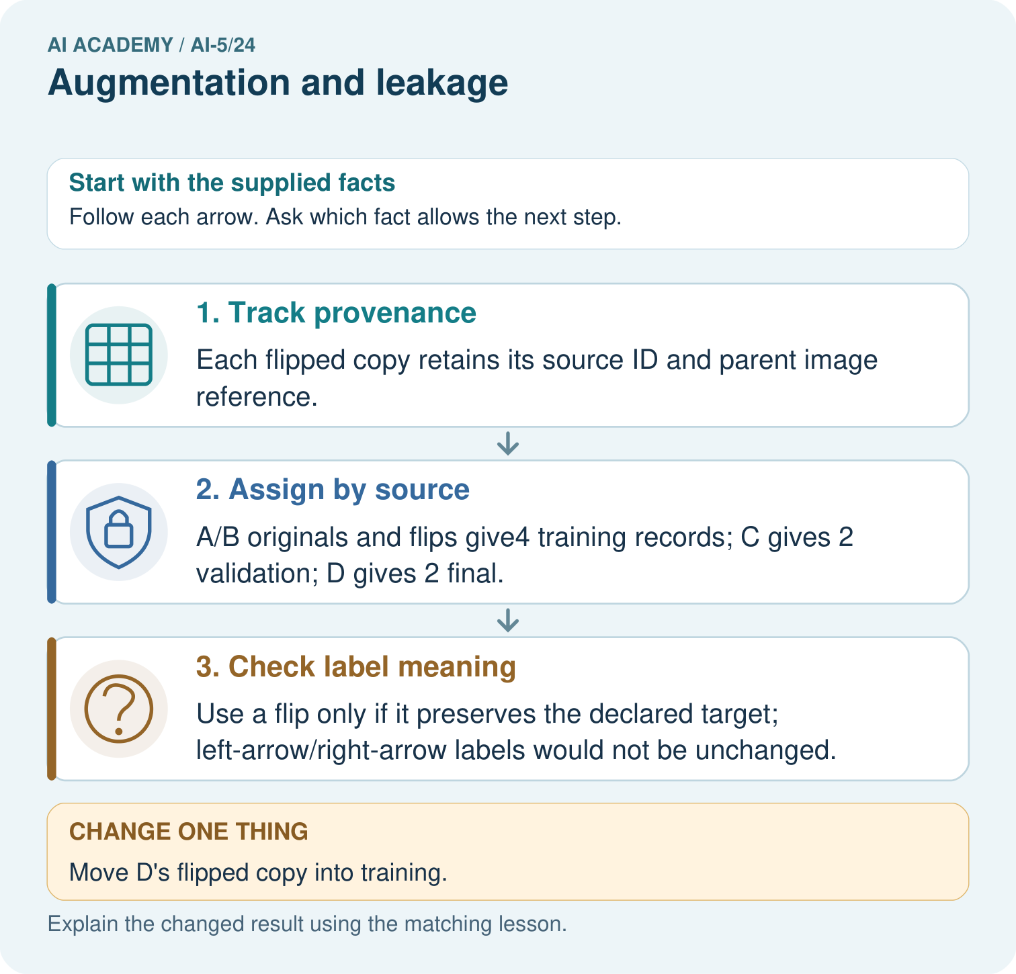

Read the picture one step at a time
Step | What happens and why
1. Track provenance | Each flipped copy retains its source ID and parent image reference.
2. Assign by source | A/B originals and flips give4 training records; C gives 2 validation; D gives 2 final.
3. Check label meaning | Use a flip only if it preserves the declared target; left-arrow/right-arrow labels would not be unchanged.
Match each pictured step to the supplied facts. This is a worked teaching case, not an independent assessment.

Why this result follows
An augmented image remains related to its source. A horizontal flip changes the view, not the identity of the original example. Assign source groups to training, validation and final evaluation before producing copies. Also check that the transformation preserves the target: flipping an arrow can change its correct direction label.

What this example does not establish
Augmentation validity is task-specific, and it cannot manufacture new independent plants or repair inadequate sampling.
Read the labelled picture: How many independent source groups are in the final test? Point to the relevant step in the picture, then write the changed result and the rule or evidence that supports it.
Change one thing: Move D’s flipped copy into training. Predict the result before checking the explanation. What remains the same?

07. Find and repair a mistake
Week 23 used deliberately constructed toy images. Its validation E is exactly a row-swapped version of training A, and F is a row-swapped version of C. They had different pixel arrays, but the transformation relation means they are a weak independence test for an experiment that trains on row-swapped variants. If those variants are added, they become exact training-validation duplicates. Preserve the original narrow claim and design a new grouped split for the augmentation experiment.
Source groups should match the evaluation question. If the goal is generalisation to new objects or people, several photographs of the same object or person may need one group even when they have different original file IDs. A lineage audit catches recorded relationships; an exact-pixel audit catches duplicates with inconsistent IDs. Neither audit alone proves that all dependence has been removed.
When a leak is discovered after validation has influenced choices, repair the split and rerun training and selection. Do not merely rename or remove the overlapping files and keep claiming the old score evaluates the repaired experiment. Final data that influenced decisions is no longer reserved.

Locate the earliest unsupported step
Training contains P original and Q original. Validation contains P crop and R original. Final test contains S original. P crop is derived from P original. Identify the overlap and explain what must be rerun if this validation set already selected a model.

State one repair and the checks you would rerun.
________________________________________________________________
________________________________________________________________
________________________________________________________________
________________________________________________________________
________________________________________________________________
________________________________________________________________

08. Practise together
For rows [0, 1], [0, 1], compute d and class before and after swapping rows and after swapping columns.

A training image has source ID A. Its row-swapped copy is called A2 and placed in validation. No filenames match across splits. Is the split valid for evaluating unseen source images? Describe the repair.
________________________________________________________________
________________________________________________________________
________________________________________________________________
________________________________________________________________

Explain your prediction to a partner before comparing results.
________________________________________________________________
________________________________________________________________
________________________________________________________________
________________________________________________________________

Practise with less help: Keep the equality boundary
Use workbook W2 for the connected example “Augmentation and leakage”. First fill the input and rule boxes. Try the middle steps before asking for a hint. After a hint, try the next step yourself.
Plan | Do | Check
What is given? Which rule or procedure applies? | Record each intermediate step. | Does the result follow? What remains unknown?
Explain your trace to a partner. Your partner points to one step to check. Swap roles on the next case. Each person writes their own explanation.

Check your reasoning
Use the worked case for Augmentation and leakage. Proposed explanation: “Every image flip preserves the label”. Decide whether this explanation is supported. Point to the step or supplied fact that decides; explain your repair if needed.
Answer on your own before discussion. If you are unsure, say which step you need help with.

Explain the picture
How many independent source groups are in the final test? Point to the relevant step in the picture, then write the changed result and the rule or evidence that supports it.

My explanation using a pictured step and the given facts
________________________________________________________________
________________________________________________________________
________________________________________________________________
________________________________________________________________
This is supported practice. Keep the separately named independent case for an attempt before feedback.

09. Run the investigation

Predict, investigate and preserve the evidence
For rows [1, 0], [0, 1], compute d and class before and after a column swap. Why is always replacing a label by 1 minus the label incorrect?
def difference(x):
return x[0][0] + x[1][0] - x[0][1] - x[1][1]
def label(x):
return int(difference(x) > 0)
def swap_rows(x):
return [x[1][:], x[0][:]]
def swap_columns(x):
return [row[::-1] for row in x]
x = [[1, 0], [0, 0]]
assert label(x) == label(swap_rows(x)) == 1
assert label(swap_columns(x)) == 0
tie = [[1, 0], [0, 1]]
assert label(tie) == label(swap_columns(tie)) == 0
assert x == [[1, 0], [0, 0]]
Record | Your evidence
Given input and fixed rule
Prediction before checking
Actual result, or “not run”
First mismatch and one explanation
Boundary or missing input and expected response
On paper, trace the supplied procedure. If code is provided, predict before running it in a local practice file. Never write an expected answer as though it were an observed run.

Plan → try → check
Before trying: what do I expect, and why? While trying: which step could first go wrong? Afterwards: what did I actually observe, and what should change? Keep “not run” if you only traced the procedure.

10. Build your understanding

Explain → apply → challenge
For rows [0, 1], [0, 1], compute d and class before and after swapping rows and after swapping columns.
Training contains P original and Q original. Validation contains P crop and R original. Final test contains S original. P crop is derived from P original. Identify the overlap and explain what must be rerun if this validation set already selected a model.
Eight source images each have an original plus two variants. Compare four epochs of these 24 records with four epochs of the eight originals, using one-example batches. Give both update counts and one way to match budgets without using final outcomes.

Explain which evidence supports your conclusion and which claim remains unproved.
________________________________________________________________
________________________________________________________________
________________________________________________________________
________________________________________________________________
________________________________________________________________

11. Connect your project
Add a labelled augmentation and leakage evidence sheet to Image-pattern Network Investigation. Show how you can check whether a transformation preserves the task label. Use the supplied fictional case and keep its inputs, intermediate steps, calculation or prediction, and limitation. Connect this record to last week’s record; a matching answer without a trace is insufficient.
Project evidence | Record
Component and version
Inputs permitted at prediction time
Trace and comparison with earlier work
Failure, limit and human review

Evidence for your project
For your Image-pattern Network Investigation, save the input, procedure, observed result and limitation of this check. Label this worked example as practice; use a different, previously unreviewed case when checking independent understanding.

12. Show what you know
Suppose 12 training source images each produce an original plus two variants. That creates 36 records but still only 12 source groups. Keep validation and final groups separate. Report source counts as well as record counts; repeated variants are correlated observations, not new independent subjects.

An augmented run uses 36 records for five epochs while a baseline uses 12 records for five epochs. Both use one-example batches. Are their update budgets matched? Propose a controlled comparison and explain what 36 records does not establish.
________________________________________________________________
________________________________________________________________
________________________________________________________________
________________________________________________________________
With one-example batches the runs use 180 and 60 updates. A declared comparison could give both 180 updates, cycle the baseline data and record the exposure policy. Keep starting parameters, architecture and evaluation cases matched where possible. Select augmentation settings using validation evidence and report the limits of the chosen budget. Next week moves from images to sequence representations.
Eight source images each have an original plus two variants. Compare four epochs of these 24 records with four epochs of the eight originals, using one-example batches. Give both update counts and one way to match budgets without using final outcomes.

My limited claim and a useful next check
________________________________________________________________
________________________________________________________________
________________________________________________________________
________________________________________________________________

13. Study a complete case

Complete evidence record

Every variant stays with its source group
Source group | Assigned split | Derived records
A | Training | A original and A row swap
B | Validation | B original only
C | Final test | C original only
Assign source groups before generating training variants. A new filename does not make a derived image independent. Evaluation examples follow a fixed declared protocol, not random training augmentation.
Follow the input through the stated procedure to its result. Cover the result first, predict it, then explain every intermediate step. The text/table accompanies the figure so the example can be read without colour.

My complete trace of the worked case
________________________________________________________________
________________________________________________________________
________________________________________________________________
________________________________________________________________
________________________________________________________________
________________________________________________________________

14. Try a new case independently

Independent case: Design a grouped split independently
Six fictional source groups J, K, L, M, N and O each have one original and three derived records. Assign J, K and L to training, M to validation and N, O to final test. Keep all four records per training group but only originals for evaluation. Give source and retained-record counts per split, total retained records and excluded derived records.

My independent explanation, trace and limits
________________________________________________________________
________________________________________________________________
________________________________________________________________
________________________________________________________________
________________________________________________________________
________________________________________________________________
________________________________________________________________
Attempt this case before feedback. Record any help. Earlier examples below are further practice; a case already practised with feedback cannot establish fresh transfer.

Attempt this without hints
Six fictional source groups J, K, L, M, N and O each have one original and three derived records. Assign J, K and L to training, M to validation and N, O to final test. Keep all four records per training group but only originals for evaluation. Give source and retained-record counts per split, total retained records and excluded derived records.

My independent procedure, result and limitation
________________________________________________________________
________________________________________________________________
________________________________________________________________
________________________________________________________________
________________________________________________________________
________________________________________________________________
________________________________________________________________
________________________________________________________________
Record support used: none, hint or teacher explanation. After feedback, a different case is needed to demonstrate independence.

Use feedback to improve
Attempt the independent case before hints. Record whether you worked alone, used a hint or followed a model. After feedback, fix the first unsupported step and explain why it changed. A later check uses a changed case, not a copied answer.

15. Your lesson route
Start with this question: Keep every augmented image with its original source group.
By the end, I can | How I will show it
Check whether a transformation preserves the task label | Explain the deciding step, show a trace or test, and state one limit.
Keep related examples in one split using source groups | Explain the deciding step, show a trace or test, and state one limit.
Compare augmentation fairly without inflating independent evidence | Explain the deciding step, show a trace or test, and state one limit.
Remember → watch and explain → try with help → investigate → try independently → keep project evidence. Your teacher may spread this lesson across several classes.
Keep your first prediction. Compare it with what the evidence shows and explain any change.

16. Finish and return
Close your notes. Explain this goal in your own words: Check whether a transformation preserves the task label

My deciding step, evidence and one remaining question
________________________________________________________________
________________________________________________________________
________________________________________________________________
________________________________________________________________
________________________________________________________________
If you are unsure, return to the worked picture and explain one arrow. If you are ready, change an input or assumption and justify your prediction.
Save your workbook evidence. At the next review, try a different case before opening your old answer.

17. Supported practice, repair and portfolio
Use this supported practice once, in the browser or on paper. Keep the reserved independent assessment for a separate first attempt before teacher feedback.
Keep every augmented image with its original source group.

Practice 1: explain the deciding evidence
Which labelled step matches this detail? Use a flip only if it preserves the declared target; left-arrow/right-arrow labels would not be unchanged.
1. Assign by source
2. Track provenance
3. Check label meaning

My selected conclusion, deciding fact and explanation
________________________________________________________________
________________________________________________________________
________________________________________________________________
________________________________________________________________
________________________________________________________________
Hint if needed: Read the steps in the pictorial case. Match the supplied detail to the stage that performs or records it.
After your attempt, compare with the supported explanation: Check label meaning Use a flip only if it preserves the declared target; left-arrow/right-arrow labels would not be unchanged. An augmented image remains related to its source. A horizontal flip changes the view, not the identity of the original example. Assign source groups to training, validation and final evaluation before producing copies. Also check that the transformation preserves the target: flipping an arrow can change its correct direction label.

Practice 2: explain the deciding evidence
Changed-case practice: Move D’s flipped copy into training. Which conclusion is supported by the supplied facts?
1. Final-test group separation fails.
2. We can decide the result without examining the changed input or the procedure.
3. This one example guarantees correct results for every future input.

My selected conclusion, deciding fact and explanation
________________________________________________________________
________________________________________________________________
________________________________________________________________
________________________________________________________________
________________________________________________________________
Hint if needed: Use the changed condition and the deciding step in the pictorial trace. The answer must say what follows from those facts.
After your attempt, compare with the supported explanation: Final-test group separation fails. The transformed D image is still derived from the held-out source, despite a new filename.

Repair a missing building block
Review Training a small image model (ai-5/23). Goal: Trace a complete image model with fixed features and one trained weight. Short practice: Does lower training loss alone establish that four updates generalise better? Point to the relevant step in the picture, then write the changed result and the rule or evidence that supports it.. Return to this week and explain what you changed.
Review Convolution as a local operation (ai-5/21). Goal: Compute a local weighted sum at each valid image position. Short practice: Why is flipping the kernel an implementation change here? Point to the relevant step in the picture, then write the changed result and the rule or evidence that supports it.. Return to this week and explain what you changed.
Review Debugging shapes and gradients (ai-5/18). Goal: Check dimension contracts before computing a layer. Short practice: What should a debugging record pair with every gradient value? Point to the relevant step in the picture, then write the changed result and the rule or evidence that supports it.. Return to this week and explain what you changed.

Predict, run and debug
The browser lab lets you edit the supported Python examples already included in this lesson. Predict first, run, inspect the actual output or error, change one input, then run again. Keep code, predictions, actual results and a reasoned revision together. On paper, label your result as a trace rather than an execution.

Keep your completed work
Use Download completed work in the hosted lesson to export your answers, reflections, practice feedback and code-run evidence. Open the HTML copy to read or print it. Drafts stay in this browser when storage is available; clear drafts on a shared device.

