AI ACADEMY · STUDENT · ai-5/32

Documenting a network experiment
Project: Image-pattern Network Investigation

Before you start
Why is “the model was fast and accurate” insufficient as an experiment record?

01. Your mission

Your learning target
I can record a network experiment with enough detail to replay its calculations.
I can trace reported metrics to data roles and saved parameters.
I can write a bounded conclusion and identify missing evaluation evidence.

Remember before reading
Close your notes first. A rough first answer helps us choose the right starting point; it is not a score for your ability.
Without opening the old lesson, explain one key idea from Efficiency and resource measurement. Give an example and a mistake that the idea helps you avoid.
Without opening the old lesson, explain one key idea from Uncertainty and failure analysis. Give an example and a mistake that the idea helps you avoid.
Without opening the old lesson, explain one key idea from Embeddings and neighbourhoods. Give an example and a mistake that the idea helps you avoid.
After trying, check the relevant lesson or ask your teacher. Change the part of your explanation that the evidence shows was wrong.
This week you will practise:
Record a network experiment with enough detail to replay its calculations
Trace reported metrics to data roles and saved parameters
Write a bounded conclusion and identify missing evaluation evidence

Retrieve what you already know
Why is “the model was fast and accurate” insufficient as an experiment record?

My starting explanation
________________________________________________________________
________________________________________________________________
________________________________________________________________

This week’s end goal
By the end, I can explain documenting a network experiment using a traced example and a stated limitation.

02. Notice the evidence
A useful experiment record explains what was asked, what was done, what happened and what remains unknown. Use run NN32-A: does fitting one positive ReLU weight reduce validation mean squared error compared with its initial value? This tiny constructed regression task teaches record keeping; it cannot establish performance on real-world data.
Data role and ID | Input x | Target y
Training T1 | 1 | 2
Training T2 | 2 | 4
Validation V1 | 3 | 6
The network predicts max(0, a*x), with one weight a and no bias. Start at a = 1, use learning rate 0.1, two full-batch training updates and mean squared error, the mean of squared prediction errors. There is no normalisation, random initialisation or shuffling. Use Python float arithmetic and record the actual Python version when replaying.
Before running, set the selection rule: choose the checkpoint with the smaller validation MSE, breaking a tie toward the earlier update. The initial model is the baseline. Validation V1 chooses a checkpoint but never contributes to the training gradient. Final evaluation has not been run; its result must be recorded as not measured.

List the given facts and one fact that is not supplied.
________________________________________________________________
________________________________________________________________
________________________________________________________________

03. See how it works
For these two training cases, MSE = 2.5*(a - 2) squared and its gradient is 5*(a - 2). At a = 1 the gradient is -5, so the first update is 1 - 0.1*(-5) = 1.5. The next gradient is -2.5, giving a = 1.75. All preactivations in this run stay positive, so ReLU’s derivative is one; this is not a general backpropagation implementation.
train = [(1.0, 2.0), (2.0, 4.0)]
validation = [(3.0, 6.0)]
def predict(a, x):
return max(0.0, a*x)
def mse(a, rows):
return sum((predict(a, x)-y)**2 for x, y in rows) / len(rows)
a, rate = 1.0, 0.1
baseline = mse(a, validation)
records = []
for update in [1, 2]:
gradient = sum(2*(a*x-y)*x for x, y in train) / len(train)
a -= rate * gradient
records.append((update, a, mse(a, train), mse(a, validation)))
chosen = min(records, key=lambda r: (r[3], r[0]))
print(baseline, records, chosen[0])
The code assumes the supplied nonempty numeric datasets and positive preactivations. Each record stores update number, weight, training MSE and validation MSE after the update. Keep both records, the initial weight and the rule; saving only the best score erases how the choice was made.

Connect the picture and the explanation
Point to the input, the deciding step and the result in this week’s visual. Explain the same step in ordinary words. A picture helps when you can say what each part represents.

04. Compare the cases

Compare a familiar case with a changed case
Calculate both weight updates and give each training and validation MSE. Name the selected checkpoint and baseline validation MSE. How many independent validation examples support the comparison?

Keep the procedure fixed. Explain what changed in the inputs and result.
________________________________________________________________
________________________________________________________________
________________________________________________________________
________________________________________________________________
________________________________________________________________

Change one thing in the pictured case
Change: A teammate calls V4 a final test after using it to select a=1.25.
Prediction: Correct its role to validation; it was used for selection.
Reason: Changing the label on a dataset does not make its evidence untouched.

05. Words that unlock the idea
Word | Meaning
Run identifier | A unique label linking one experiment’s settings, outputs and records
Checkpoint | Saved model parameters at a specified stage of training
Manifest | An inventory connecting named artifacts with versions, roles and integrity information
Replay | Repeating a recorded procedure to check whether its outputs agree

Use two terms to explain a step in this week’s example.
________________________________________________________________
________________________________________________________________
________________________________________________________________

06. Follow a worked example

Read each checkpoint against the same validation case
Checkpoint weight | Training MSE | Validation MSE
Update 1: a = 1.5 | 0.625 | 2.25
Update 2: a = 1.75 | 0.15625 | 0.5625
The baseline validation MSE is 9. The predeclared rule selects update 2 with validation MSE 0.5625 on one validation case. This is not a final-test score.
A defensible conclusion is: in run NN32-A, update 2 reduced MSE on the single constructed validation case from 9 to 0.5625 compared with the initial model. This checkpoint was selected using that same validation case; generalisation is untested. No timing, peak-memory or energy measurements are provided.

Using the selected weight, calculate the prediction for V1 and its squared error. Explain why the result must be labelled validation rather than independent final evaluation.
________________________________________________________________
________________________________________________________________
________________________________________________________________
________________________________________________________________

Learn from the worked case
Cover the result before checking it. Say what is given, choose the procedure, and follow one step at a time. Then uncover the result and explain your first mismatch. Ask why a step is allowed, not only what number it produces.

A pictorial worked case: Documenting a network experiment
Document checkpoint selection so another team can reconstruct every reported number.

The facts we will use
Run R8 predicts ReLU(a×x). Validation V4 has x = 2, target 3. Baseline a = 0.5; checkpoints a = 1 and 1.25; choose minimum validation squared error.
All inputs and outcomes in this worked example are invented classroom data; no real model run is claimed.
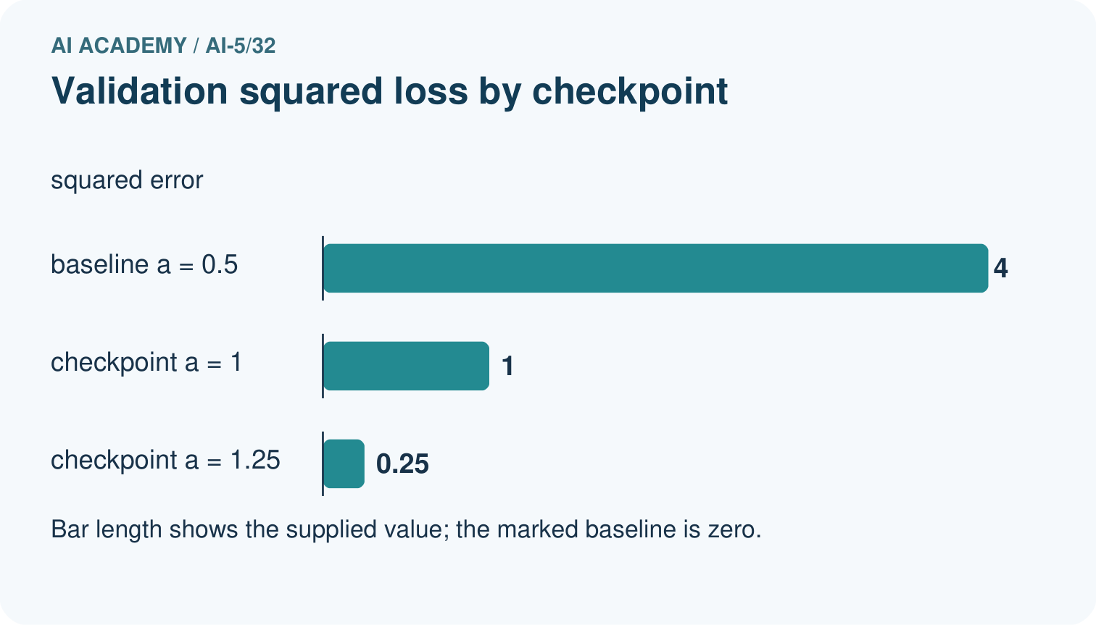
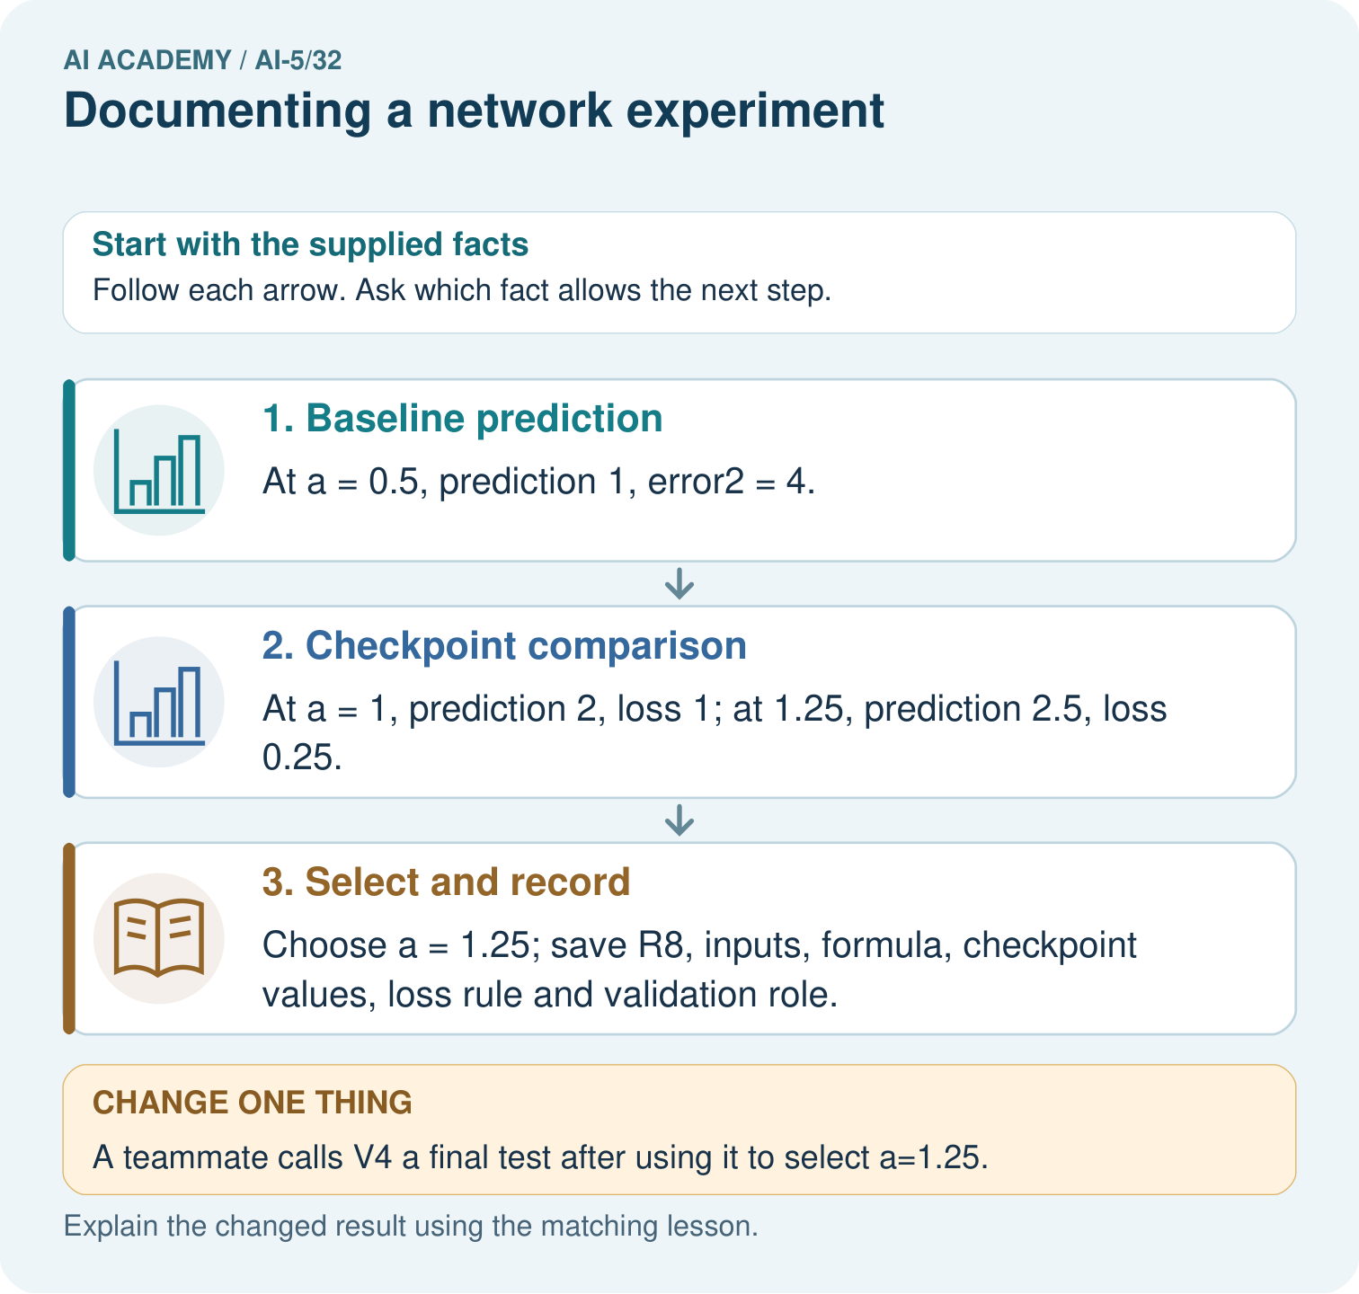

Read the picture one step at a time
Step | What happens and why
1. Baseline prediction | At a = 0.5, prediction 1, error² = 4.
2. Checkpoint comparison | At a = 1, prediction 2, loss 1; at 1.25, prediction 2.5, loss 0.25.
3. Select and record | Choose a = 1.25; save R8, inputs, formula, checkpoint values, loss rule and validation role.
Match each pictured step to the supplied facts. This is a worked teaching case, not an independent assessment.

Why this result follows
A reproducible record includes the actual input, formula, parameters and scoring rule, together with each dataset’s role. The validation case selects the best supplied checkpoint, so it is part of development. Save that selection history and freeze the checkpoint before evaluating fresh final cases. Renaming the same case a test does not change how it was used.

What this example does not establish
Reconstructing one run verifies arithmetic and provenance, not population performance or educational learning impact.
Read the labelled picture: What additional evidence is needed for a final performance claim? Point to the relevant step in the picture, then write the changed result and the rule or evidence that supports it.
Change one thing: A teammate calls V4 a final test after using it to select a=1.25. Predict the result before checking the explanation. What remains the same?

07. Find and repair a mistake
Keep a manifest for the data with IDs and split membership, the exact code, settings, every checkpoint, raw prediction rows and metric calculations. Add run ID, author/date, environment versions, known data provenance and permitted use, failed attempts, decisions and limitations. A descriptive filename helps navigation, but does not prove that file contents stayed unchanged.
When saving artifacts, record their content hashes and keep the exact versions used. Hashes help detect content changes; they do not prove label correctness or experiment quality. Retain the input order, any training-fitted preprocessing, model architecture and numeric precision. Randomised experiments must also record seeds and the relevant random operations; a seed alone does not guarantee identical results across environments.
Ask a partner to replay from the record rather than from memory. If results differ, check inputs, split membership, preprocessing, configuration, code, parameters and environment. Document the discrepancy and the repair instead of overwriting the old record. A rerun on the same data checks the procedure; it does not add new independent evaluation cases.

Locate the earliest unsupported step
A folder contains only best-model.json and a screenshot of 0.5625. Identify four missing artifacts or records and explain what a content hash can and cannot verify.

State one repair and the checks you would rerun.
________________________________________________________________
________________________________________________________________
________________________________________________________________
________________________________________________________________
________________________________________________________________
________________________________________________________________

08. Practise together
For NN32-A, record the prediction rule, initial weight, bias policy, learning rate, update count, loss, training/validation IDs, data order or shuffling policy, and checkpoint selection rule. Name one environment field still to record when you run it.

Using the selected weight, calculate the prediction for V1 and its squared error. Explain why the result must be labelled validation rather than independent final evaluation.
________________________________________________________________
________________________________________________________________
________________________________________________________________
________________________________________________________________

Explain your prediction to a partner before comparing results.
________________________________________________________________
________________________________________________________________
________________________________________________________________
________________________________________________________________

Practise with less help: Trace the selected result
Use workbook W2 for the connected example “Documenting a network experiment”. First fill the input and rule boxes. Try the middle steps before asking for a hint. After a hint, try the next step yourself.
Plan | Do | Check
What is given? Which rule or procedure applies? | Record each intermediate step. | Does the result follow? What remains unknown?
Explain your trace to a partner. Your partner points to one step to check. Swap roles on the next case. Each person writes their own explanation.

Check your reasoning
Use the worked case for Documenting a network experiment. Proposed explanation: “A smaller MSE is an accuracy percentage”. Decide whether this explanation is supported. Point to the step or supplied fact that decides; explain your repair if needed.
Answer on your own before discussion. If you are unsure, say which step you need help with.

Explain the picture
What additional evidence is needed for a final performance claim? Point to the relevant step in the picture, then write the changed result and the rule or evidence that supports it.

My explanation using a pictured step and the given facts
________________________________________________________________
________________________________________________________________
________________________________________________________________
________________________________________________________________
This is supported practice. Keep the separately named independent case for an attempt before feedback.

09. Run the investigation

Predict, investigate and preserve the evidence
Calculate both weight updates and give each training and validation MSE. Name the selected checkpoint and baseline validation MSE. How many independent validation examples support the comparison?
train = [(1.0, 2.0), (2.0, 4.0)]
validation = [(3.0, 6.0)]
def predict(a, x):
return max(0.0, a*x)
def mse(a, rows):
return sum((predict(a, x)-y)**2 for x, y in rows) / len(rows)
a, rate = 1.0, 0.1
baseline = mse(a, validation)
records = []
for update in [1, 2]:
gradient = sum(2*(a*x-y)*x for x, y in train) / len(train)
a -= rate * gradient
records.append((update, a, mse(a, train), mse(a, validation)))
chosen = min(records, key=lambda r: (r[3], r[0]))
print(baseline, records, chosen[0])
Record | Your evidence
Given input and fixed rule
Prediction before checking
Actual result, or “not run”
First mismatch and one explanation
Boundary or missing input and expected response
On paper, trace the supplied procedure. If code is provided, predict before running it in a local practice file. Never write an expected answer as though it were an observed run.

Plan → try → check
Before trying: what do I expect, and why? While trying: which step could first go wrong? Afterwards: what did I actually observe, and what should change? Keep “not run” if you only traced the procedure.

10. Build your understanding

Explain → apply → challenge
For NN32-A, record the prediction rule, initial weight, bias policy, learning rate, update count, loss, training/validation IDs, data order or shuffling policy, and checkpoint selection rule. Name one environment field still to record when you run it.
A folder contains only best-model.json and a screenshot of 0.5625. Identify four missing artifacts or records and explain what a content hash can and cannot verify.
A partner gets different results after changing preprocessing and replacing the validation file. They keep the old run ID and overwrite the old score. Explain what should be preserved and how the revised work should be recorded.

Explain which evidence supports your conclusion and which claim remains unproved.
________________________________________________________________
________________________________________________________________
________________________________________________________________
________________________________________________________________
________________________________________________________________

11. Connect your project
Add a labelled documenting a network experiment evidence sheet to Image-pattern Network Investigation. Show how you can record a network experiment with enough detail to replay its calculations. Use the supplied fictional case and keep its inputs, intermediate steps, calculation or prediction, and limitation. Connect this record to last week’s record; a matching answer without a trace is insufficient.
Project evidence | Record
Component and version
Inputs permitted at prediction time
Trace and comparison with earlier work
Failure, limit and human review

Evidence for your project
For your Image-pattern Network Investigation, save the input, procedure, observed result and limitation of this check. Label this worked example as practice; use a different, previously unreviewed case when checking independent understanding.

12. Show what you know
Report missing measurements as not measured, not as zero. If a final set has influenced a change, document that use and reserve new untouched evaluation before making an independent performance claim. A polished report cannot fix leakage or missing evidence. For larger experiments, preserve denominators, subgroup results and resource conditions from Weeks 29 to 31.

A report says “final accuracy 0.5625, low energy” but includes only the selected weight and no data or code. Repair its claim and name the minimum evidence needed to check this run.
________________________________________________________________
________________________________________________________________
________________________________________________________________
________________________________________________________________
Finish with a next action that follows from the limitations, such as planning a broader reserved evaluation without claiming it has already succeeded. Next week begins the capstone by defining a hypothesis and baseline before controlled experiments.
A partner gets different results after changing preprocessing and replacing the validation file. They keep the old run ID and overwrite the old score. Explain what should be preserved and how the revised work should be recorded.

My limited claim and a useful next check
________________________________________________________________
________________________________________________________________
________________________________________________________________
________________________________________________________________

13. Study a complete case

Complete evidence record

Read each checkpoint against the same validation case
Checkpoint weight | Training MSE | Validation MSE
Update 1: a = 1.5 | 0.625 | 2.25
Update 2: a = 1.75 | 0.15625 | 0.5625
The baseline validation MSE is 9. The predeclared rule selects update 2 with validation MSE 0.5625 on one validation case. This is not a final-test score.
Follow the input through the stated procedure to its result. Cover the result first, predict it, then explain every intermediate step. The text/table accompanies the figure so the example can be read without colour.

My complete trace of the worked case
________________________________________________________________
________________________________________________________________
________________________________________________________________
________________________________________________________________
________________________________________________________________
________________________________________________________________

14. Try a new case independently

Independent case: Audit a new record independently
A separate run R17 records baseline a = 1 and checkpoints a = 1.5 and a = 1.75. It uses prediction max(0, a*x) and one validation case V9 with x = 4, y = 8. Compute baseline and checkpoint predictions and squared errors, choose by lowest validation MSE, and write a bounded conclusion. Final evaluation and runtime have not been measured.

My independent explanation, trace and limits
________________________________________________________________
________________________________________________________________
________________________________________________________________
________________________________________________________________
________________________________________________________________
________________________________________________________________
________________________________________________________________
Attempt this case before feedback. Record any help. Earlier examples below are further practice; a case already practised with feedback cannot establish fresh transfer.

Attempt this without hints
A separate run R17 records baseline a = 1 and checkpoints a = 1.5 and a = 1.75. It uses prediction max(0, a*x) and one validation case V9 with x = 4, y = 8. Compute baseline and checkpoint predictions and squared errors, choose by lowest validation MSE, and write a bounded conclusion. Final evaluation and runtime have not been measured.

My independent procedure, result and limitation
________________________________________________________________
________________________________________________________________
________________________________________________________________
________________________________________________________________
________________________________________________________________
________________________________________________________________
________________________________________________________________
________________________________________________________________
Record support used: none, hint or teacher explanation. After feedback, a different case is needed to demonstrate independence.

Use feedback to improve
Attempt the independent case before hints. Record whether you worked alone, used a hint or followed a model. After feedback, fix the first unsupported step and explain why it changed. A later check uses a changed case, not a copied answer.

15. Your lesson route
Start with this question: Document checkpoint selection so another team can reconstruct every reported number.
By the end, I can | How I will show it
Record a network experiment with enough detail to replay its calculations | Explain the deciding step, show a trace or test, and state one limit.
Trace reported metrics to data roles and saved parameters | Explain the deciding step, show a trace or test, and state one limit.
Write a bounded conclusion and identify missing evaluation evidence | Explain the deciding step, show a trace or test, and state one limit.
Remember → watch and explain → try with help → investigate → try independently → keep project evidence. Your teacher may spread this lesson across several classes.
Keep your first prediction. Compare it with what the evidence shows and explain any change.

16. Finish and return
Close your notes. Explain this goal in your own words: Record a network experiment with enough detail to replay its calculations

My deciding step, evidence and one remaining question
________________________________________________________________
________________________________________________________________
________________________________________________________________
________________________________________________________________
________________________________________________________________
If you are unsure, return to the worked picture and explain one arrow. If you are ready, change an input or assumption and justify your prediction.
Save your workbook evidence. At the next review, try a different case before opening your old answer.

17. Supported practice, repair and portfolio
Use this supported practice once, in the browser or on paper. Keep the reserved independent assessment for a separate first attempt before teacher feedback.
Document checkpoint selection so another team can reconstruct every reported number.

Practice 1: explain the deciding evidence
Which labelled step matches this detail? Choose a = 1.25; save R8, inputs, formula, checkpoint values, loss rule and validation role.
1. Checkpoint comparison
2. Select and record
3. Baseline prediction

My selected conclusion, deciding fact and explanation
________________________________________________________________
________________________________________________________________
________________________________________________________________
________________________________________________________________
________________________________________________________________
Hint if needed: Read the steps in the pictorial case. Match the supplied detail to the stage that performs or records it.
After your attempt, compare with the supported explanation: Select and record Choose a = 1.25; save R8, inputs, formula, checkpoint values, loss rule and validation role. A reproducible record includes the actual input, formula, parameters and scoring rule, together with each dataset’s role. The validation case selects the best supplied checkpoint, so it is part of development. Save that selection history and freeze the checkpoint before evaluating fresh final cases. Renaming the same case a test does not change how it was used.

Practice 2: explain the deciding evidence
Changed-case practice: A teammate calls V4 a final test after using it to select a=1.25. Which conclusion is supported by the supplied facts?
1. We can decide the result without examining the changed input or the procedure.
2. This one example guarantees correct results for every future input.
3. Correct its role to validation; it was used for selection.

My selected conclusion, deciding fact and explanation
________________________________________________________________
________________________________________________________________
________________________________________________________________
________________________________________________________________
________________________________________________________________
Hint if needed: Use the changed condition and the deciding step in the pictorial trace. The answer must say what follows from those facts.
After your attempt, compare with the supported explanation: Correct its role to validation; it was used for selection. Changing the label on a dataset does not make its evidence untouched.

Repair a missing building block
Review Efficiency and resource measurement (ai-5/31). Goal: Calculate throughput and amortised time per example from repeated timings. Short practice: Why is 10ms/case not necessarily a single-request latency? Point to the relevant step in the picture, then write the changed result and the rule or evidence that supports it.. Return to this week and explain what you changed.
Review Uncertainty and failure analysis (ai-5/29). Goal: Distinguish a predicted class, confidence score and observed correctness. Short practice: What is C’s positive-class probability and chosen-label confidence? Point to the relevant step in the picture, then write the changed result and the rule or evidence that supports it.. Return to this week and explain what you changed.
Review Embeddings and neighbourhoods (ai-5/26). Goal: Look up a vector using a token ID and preserve sequence shape. Short practice: What would justify claiming nearby vectors mean related topics? Point to the relevant step in the picture, then write the changed result and the rule or evidence that supports it.. Return to this week and explain what you changed.

Predict, run and debug
The browser lab lets you edit the supported Python examples already included in this lesson. Predict first, run, inspect the actual output or error, change one input, then run again. Keep code, predictions, actual results and a reasoned revision together. On paper, label your result as a trace rather than an execution.

Keep your completed work
Use Download completed work in the hosted lesson to export your answers, reflections, practice feedback and code-run evidence. Open the HTML copy to read or print it. Drafts stay in this browser when storage is available; clear drafts on a shared device.

