AI ACADEMY · STUDENT · ai-5/34

Capstone controlled experiments
Project: Image-pattern Network Investigation

Before you start
What must stay fixed when comparing learning rates?

01. Your mission

Your learning target
I can trace matched two-update learning-rate experiments.
I can select a candidate using a prespecified validation rule.
I can explain the limits of a one-factor comparison.

Remember before reading
Close your notes first. A rough first answer helps us choose the right starting point; it is not a score for your ability.
Without opening the old lesson, explain one key idea from Capstone hypothesis and baseline. Give an example and a mistake that the idea helps you avoid.
Without opening the old lesson, explain one key idea from Efficiency and resource measurement. Give an example and a mistake that the idea helps you avoid.
Without opening the old lesson, explain one key idea from Transfer learning. Give an example and a mistake that the idea helps you avoid.
After trying, check the relevant lesson or ask your teacher. Change the part of your explanation that the evidence shows was wrong.
This week you will practise:
Trace matched two-update learning-rate experiments
Select a candidate using a prespecified validation rule
Explain the limits of a one-factor comparison

Retrieve what you already know
What must stay fixed when comparing learning rates?

My starting explanation
________________________________________________________________
________________________________________________________________
________________________________________________________________

This week’s end goal
Explain capstone controlled experiments with a traceable toy-network case and a bounded conclusion.

02. Notice the evidence
Continue with training (1,2) and (2,4), validation (3,6) and (4,8), and prediction max(0, a*x). Compare learning rates 0.1 and 0.2. Each run starts at a = 1, has no bias and takes two full-batch updates. Keep the loss, data order and arithmetic fixed. This toy model has no randomness; repeating the exact run checks replay, not variation across seeds.
Record the comparison as an explicit revision to the one-candidate Week 33 plan before viewing new results. Validation may guide selection; sealed final data must not. Select lower validation MSE, with a tie going to learning rate 0.1.

List the given facts and one fact that is not supplied.
________________________________________________________________
________________________________________________________________
________________________________________________________________

03. See how it works
For positive weights and these positive inputs, the ReLU is active. Training MSE is ((a-2)^2 + (2*a-4)^2)/2 = 2.5*(a-2)^2. Its gradient is 5*(a-2). Update a to a - rate*5*(a-2). At rate 0.1, weights are 1.5 then 1.75. At rate 0.2, weights are 2 then 2. The formula assumes the active region; do not extend it blindly to nonpositive weights.
Run | Final weight | Training MSE | Validation MSE
Baseline | 1 | 2.5 | 12.5
Rate 0.1, two updates | 1.75 | 0.15625 | 0.78125
Rate 0.2, two updates | 2 | 0 | 0

Keep the evidence roles separate
Plan or input | Procedure | Permitted conclusion
Same initial a = 1 | Rate 0.1, two updates | Validation MSE 0.78125
Same initial a = 1 | Rate 0.2, two updates | Validation MSE 0
Same validation rows | Choose lower MSE | Select rate 0.2
The selected run fits this exact constructed relationship. Its zero error does not establish universal reliability.

Connect the picture and the explanation
Point to the input, the deciding step and the result in this week’s visual. Explain the same step in ordinary words. A picture helps when you can say what each part represents.

04. Compare the cases

Compare a familiar case with a changed case
Compute both updates for rates 0.1 and 0.2 using gradient 5*(a-2).

Keep the procedure fixed. Explain what changed in the inputs and result.
________________________________________________________________
________________________________________________________________
________________________________________________________________
________________________________________________________________
________________________________________________________________

Change one thing in the pictured case
Change: Change B’s training set as well as the feature connection.
Prediction: The experiment no longer isolates the connection change.
Reason: A training-data difference supplies an alternative explanation for the observed result.

05. Words that unlock the idea
Word | Meaning
Controlled comparison | A comparison holding specified conditions constant while changing an intended factor
Full batch | An update whose gradient uses all training rows
Selection rule | A rule for choosing a candidate using development evidence
Confounder | A differing condition that prevents isolating the intended explanation

Use two terms to explain a step in this week’s example.
________________________________________________________________
________________________________________________________________
________________________________________________________________

06. Follow a worked example
At a = 1.75, validation predictions are 5.25 and 7. Errors -0.75 and -1 square to 0.5625 and 1, giving MSE 0.78125. At a = 2 the predictions equal 6 and 8, so MSE is zero. Rate 0.2 wins the written validation rule. This selection uses two validation cases, not four independent cases because two runs used them.
If one run used extra epochs or different training rows, the comparison would mix factors. Either rerun a matched experiment or report the differences and avoid claiming an isolated learning-rate effect. A zero validation score is also compatible with a very simple task and says nothing about a new distribution.

Learn from the worked case
Cover the result before checking it. Say what is given, choose the procedure, and follow one step at a time. Then uncover the result and explain your first mismatch. Ask why a step is allowed, not only what number it produces.

A pictorial worked case: Capstone controlled experiments
One controlled network change. The capstone compares two fixed networks on the same six labelled toy patterns. Only one feature connection is added.

The facts we will use
A scores [1,1,0,1,0,1]; B scores [1,1,1,1,0,1]. Settings, labels and scoring remain fixed. Binary entries mean 1=correct and 0=incorrect.
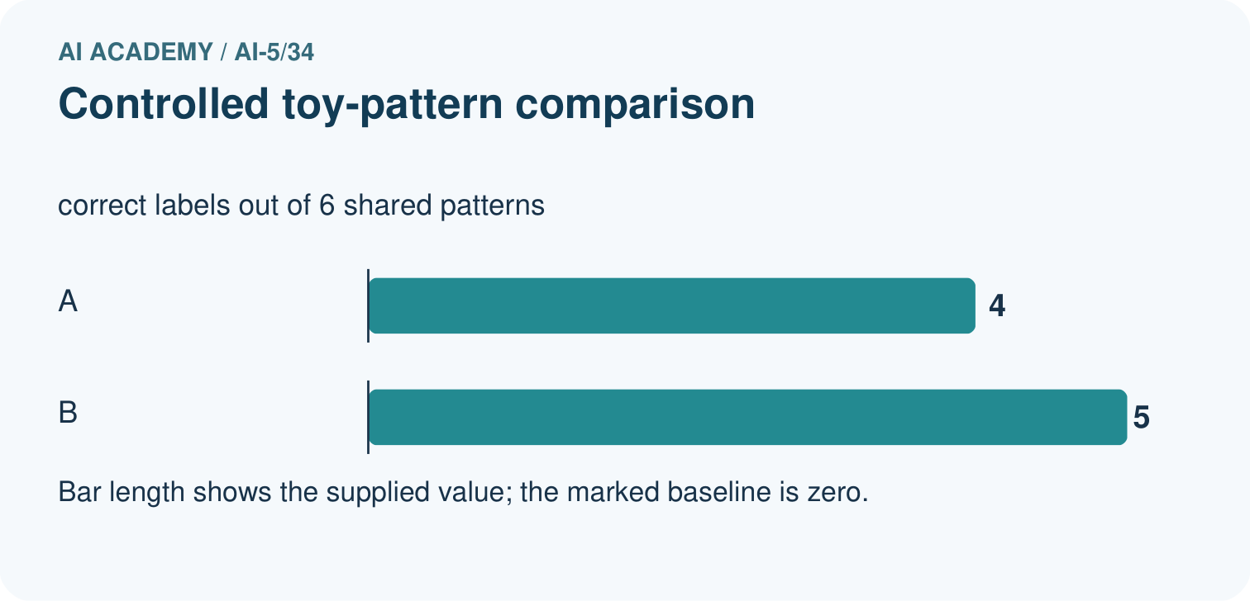
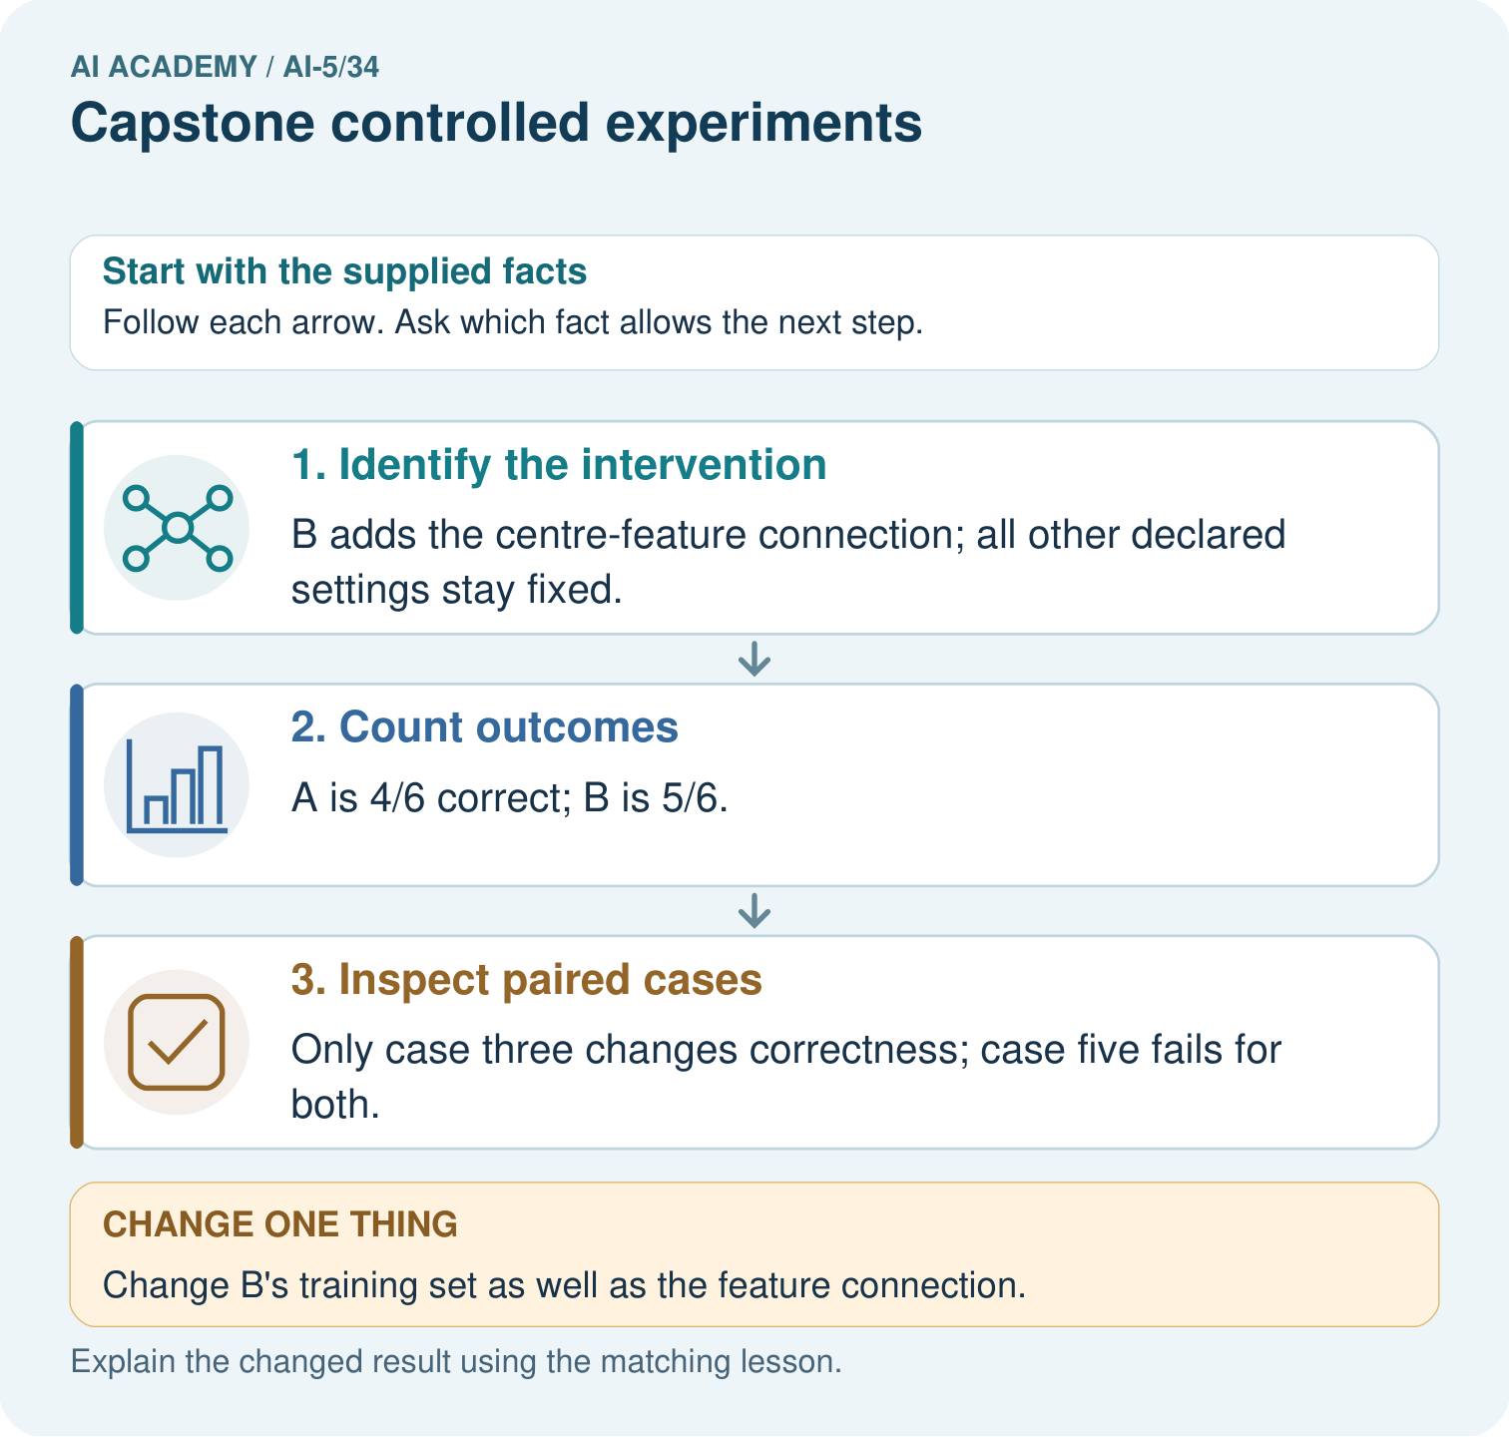

Read the picture one step at a time
Step | What happens and why
1. Identify the intervention | B adds the centre-feature connection; all other declared settings stay fixed.
2. Count outcomes | A is 4/6 correct; B is 5/6.
3. Inspect paired cases | Only case three changes correctness; case five fails for both.
Match each pictured step to the supplied facts. This is a worked teaching case, not an independent assessment.

Why this result follows
Controlled experiments vary the specified component while retaining comparable cases. Pairing the outcomes by pattern shows where the score difference comes from instead of hiding it in an overall average.

What this example does not establish
These descriptive toy results do not establish significance, stable superiority or the full learned mechanism.
Read the labelled picture: Compute the two correct counts and identify the changed case. Why would changing B’s training data weaken the conclusion about its added connection?
Change one thing: Change B’s training set as well as the feature connection. Predict the result before checking the explanation. What remains the same?

07. Find and repair a mistake
Supported example: rate 0.3 starts at a = 1. The first gradient is -5, giving a = 2.5. The next gradient is 2.5, giving a = 1.75. This two-update run finishes at the same weight as rate 0.1 although its path differs.

Guided: calculate the second update and its validation MSE. Explain why equal final scores do not mean identical trajectories.
________________________________________________________________
________________________________________________________________
________________________________________________________________
________________________________________________________________
________________________________________________________________

Locate the earliest unsupported step
Recompute validation MSE for the final weights and apply the written selection rule. How many distinct validation rows were used?

State one repair and the checks you would rerun.
________________________________________________________________
________________________________________________________________
________________________________________________________________
________________________________________________________________
________________________________________________________________
________________________________________________________________

08. Practise together
List six settings held fixed and the single intended changed factor.

Guided: calculate the second update and its validation MSE. Explain why equal final scores do not mean identical trajectories.
________________________________________________________________
________________________________________________________________
________________________________________________________________
________________________________________________________________
________________________________________________________________

Explain your prediction to a partner before comparing results.
________________________________________________________________
________________________________________________________________
________________________________________________________________
________________________________________________________________

Practise with less help: Trace both runs
Use workbook W2 for the connected example “Capstone controlled experiments”. First fill the input and rule boxes. Try the middle steps before asking for a hint. After a hint, try the next step yourself.
Plan | Do | Check
What is given? Which rule or procedure applies? | Record each intermediate step. | Does the result follow? What remains unknown?
Explain your trace to a partner. Your partner points to one step to check. Swap roles on the next case. Each person writes their own explanation.

Check your reasoning
Use the worked case for Capstone controlled experiments. Proposed explanation: “More runs mean more validation examples”. Decide whether this explanation is supported. Point to the step or supplied fact that decides; explain your repair if needed.
Answer on your own before discussion. If you are unsure, say which step you need help with.

Explain the picture
Compute the two correct counts and identify the changed case. Why would changing B’s training data weaken the conclusion about its added connection?

My explanation using a pictured step and the given facts
________________________________________________________________
________________________________________________________________
________________________________________________________________
________________________________________________________________
This is supported practice. Keep the separately named independent case for an attempt before feedback.

09. Run the investigation

Predict, investigate and preserve the evidence
Compute both updates for rates 0.1 and 0.2 using gradient 5*(a-2).
Record | Your evidence
Given input and fixed rule
Prediction before checking
Actual result, or “not run”
First mismatch and one explanation
Boundary or missing input and expected response
On paper, trace the supplied procedure. If code is provided, predict before running it in a local practice file. Never write an expected answer as though it were an observed run.

Plan → try → check
Before trying: what do I expect, and why? While trying: which step could first go wrong? Afterwards: what did I actually observe, and what should change? Keep “not run” if you only traced the procedure.

10. Build your understanding

Explain → apply → challenge
List six settings held fixed and the single intended changed factor.
Recompute validation MSE for the final weights and apply the written selection rule. How many distinct validation rows were used?
Run A uses rate 0.1 for two updates; run B uses rate 0.2 for six updates and different training rows. Can the difference be attributed to rate alone? Propose a repair.

Explain which evidence supports your conclusion and which claim remains unproved.
________________________________________________________________
________________________________________________________________
________________________________________________________________
________________________________________________________________
________________________________________________________________

11. Connect your project
For Image-pattern Network Investigation, use this week’s independent task as a rehearsal for the final evidence pack: For training (1,3),(2,6) and validation (3,9),(4,12), start a = 1. Compare rates 0.1 and 0.2 for two updates. Gradient is 5*(a-3). Compute final weights and validation MSE, then select lower MSE; ties go to 0.1. Keep actual observations separate from expected results, preserve failures, compare a baseline and explain the limits.
Project evidence | Record
Component and version
Inputs permitted at prediction time
Trace and comparison with earlier work
Failure, limit and human review

Evidence for your project
For the Image-pattern Network Investigation, save the labelled trace and the changed-case explanation beside the experiment record. State exactly what this example supports before linking it to the wider capstone claim.

12. Show what you know
Save run IDs, settings, each checkpoint, predictions and metric calculations. Report the losing run as well as the winner. Freeze the selected rate, architecture and update count before the final evaluation. Any change after opening final data requires a new development record and fresh reserved evidence.

Exit: one run receives six updates and the other two. What can the score comparison establish, and what must be rerun to isolate the learning rate?
________________________________________________________________
________________________________________________________________
________________________________________________________________
________________________________________________________________
________________________________________________________________
Run A uses rate 0.1 for two updates; run B uses rate 0.2 for six updates and different training rows. Can the difference be attributed to rate alone? Propose a repair.

My limited claim and a useful next check
________________________________________________________________
________________________________________________________________
________________________________________________________________
________________________________________________________________

13. Study a complete case

Complete evidence record

Keep the evidence roles separate
Plan or input | Procedure | Permitted conclusion
Same initial a = 1 | Rate 0.1, two updates | Validation MSE 0.78125
Same initial a = 1 | Rate 0.2, two updates | Validation MSE 0
Same validation rows | Choose lower MSE | Select rate 0.2
The selected run fits this exact constructed relationship. Its zero error does not establish universal reliability.
Follow the input through the stated procedure to its result. Cover the result first, predict it, then explain every intermediate step. The text/table accompanies the figure so the example can be read without colour.

My complete trace of the worked case
________________________________________________________________
________________________________________________________________
________________________________________________________________
________________________________________________________________
________________________________________________________________
________________________________________________________________

14. Try a new case independently

Independent case: Run a new comparison independently
For training (1,3),(2,6) and validation (3,9),(4,12), start a = 1. Compare rates 0.1 and 0.2 for two updates. Gradient is 5*(a-3). Compute final weights and validation MSE, then select lower MSE; ties go to 0.1.

My independent explanation, trace and limits
________________________________________________________________
________________________________________________________________
________________________________________________________________
________________________________________________________________
________________________________________________________________
________________________________________________________________
________________________________________________________________
Attempt this case before feedback. Record any help. Earlier examples below are further practice; a case already practised with feedback cannot establish fresh transfer.

Attempt this without hints
For training (1,3),(2,6) and validation (3,9),(4,12), start a = 1. Compare rates 0.1 and 0.2 for two updates. Gradient is 5*(a-3). Compute final weights and validation MSE, then select lower MSE; ties go to 0.1.

My independent procedure, result and limitation
________________________________________________________________
________________________________________________________________
________________________________________________________________
________________________________________________________________
________________________________________________________________
________________________________________________________________
________________________________________________________________
________________________________________________________________
Record support used: none, hint or teacher explanation. After feedback, a different case is needed to demonstrate independence.

Use feedback to improve
Attempt the independent case before hints. Record whether you worked alone, used a hint or followed a model. After feedback, fix the first unsupported step and explain why it changed. A later check uses a changed case, not a copied answer.

15. Your lesson route
Start with this question: One controlled network change. The capstone compares two fixed networks on the same six labelled toy patterns. Only one feature connection is added.
By the end, I can | How I will show it
Trace matched two-update learning-rate experiments | Explain the deciding step, show a trace or test, and state one limit.
Select a candidate using a prespecified validation rule | Explain the deciding step, show a trace or test, and state one limit.
Explain the limits of a one-factor comparison | Explain the deciding step, show a trace or test, and state one limit.
Remember → watch and explain → try with help → investigate → try independently → keep project evidence. Your teacher may spread this lesson across several classes.
Keep your first prediction. Compare it with what the evidence shows and explain any change.

16. Finish and return
Close your notes. Explain this goal in your own words: Trace matched two-update learning-rate experiments

My deciding step, evidence and one remaining question
________________________________________________________________
________________________________________________________________
________________________________________________________________
________________________________________________________________
________________________________________________________________
If you are unsure, return to the worked picture and explain one arrow. If you are ready, change an input or assumption and justify your prediction.
Save your workbook evidence. At the next review, try a different case before opening your old answer.

17. Supported practice, repair and portfolio
Use this supported practice once, in the browser or on paper. Keep the reserved independent assessment for a separate first attempt before teacher feedback.
One controlled network change. The capstone compares two fixed networks on the same six labelled toy patterns. Only one feature connection is added.

Practice 1: explain the deciding evidence
Which labelled step matches this detail? Only case three changes correctness; case five fails for both.
1. Inspect paired cases
2. Identify the intervention
3. Count outcomes

My selected conclusion, deciding fact and explanation
________________________________________________________________
________________________________________________________________
________________________________________________________________
________________________________________________________________
________________________________________________________________
Hint if needed: Read the steps in the pictorial case. Match the supplied detail to the stage that performs or records it.
After your attempt, compare with the supported explanation: Inspect paired cases Only case three changes correctness; case five fails for both. Controlled experiments vary the specified component while retaining comparable cases. Pairing the outcomes by pattern shows where the score difference comes from instead of hiding it in an overall average.

Practice 2: explain the deciding evidence
Changed-case practice: Change B’s training set as well as the feature connection. Which conclusion is supported by the supplied facts?
1. This one example guarantees correct results for every future input.
2. We can decide the result without examining the changed input or the procedure.
3. The experiment no longer isolates the connection change.

My selected conclusion, deciding fact and explanation
________________________________________________________________
________________________________________________________________
________________________________________________________________
________________________________________________________________
________________________________________________________________
Hint if needed: Use the changed condition and the deciding step in the pictorial trace. The answer must say what follows from those facts.
After your attempt, compare with the supported explanation: The experiment no longer isolates the connection change. A training-data difference supplies an alternative explanation for the observed result.

Repair a missing building block
Review Capstone hypothesis and baseline (ai-5/33). Goal: Write a testable capstone hypothesis and a credible baseline. Short practice: Name the intended change, the baseline and the measured outcome. Why must both versions avoid training on the eight reserved labels?. Return to this week and explain what you changed.
Review Efficiency and resource measurement (ai-5/31). Goal: Calculate throughput and amortised time per example from repeated timings. Short practice: Why is 10ms/case not necessarily a single-request latency? Point to the relevant step in the picture, then write the changed result and the rule or evidence that supports it.. Return to this week and explain what you changed.
Review Transfer learning (ai-5/28). Goal: Trace a reused feature extractor and a newly fitted output head. Short practice: Which part was trained for the new task? Point to the relevant step in the picture, then write the changed result and the rule or evidence that supports it.. Return to this week and explain what you changed.

Keep your completed work
Use Download completed work in the hosted lesson to export your answers, reflections, practice feedback and code-run evidence. Open the HTML copy to read or print it. Drafts stay in this browser when storage is available; clear drafts on a shared device.

