AI ACADEMY · STUDENT · ai-6/21

Caching and stale information
Project: Grounded Learning Service

Before you start
Recall Data retention and deletion. Explain why a recorded result needs its input conditions and evidence source before it can support a claim.

01. Your mission

Your learning target
I can explain the mechanism and terminology of caching and stale information.
I can apply the stated procedure to a new case with a traceable result.
I can identify an assumption or limitation and design a revealing follow-up.

Remember before reading
Close your notes first. A rough first answer helps us choose the right starting point; it is not a score for your ability.
Without opening the old lesson, explain one key idea from Data retention and deletion. Give an example and a mistake that the idea helps you avoid.
Without opening the old lesson, explain one key idea from Untrusted input boundaries. Give an example and a mistake that the idea helps you avoid.
Without opening the old lesson, explain one key idea from Approval gates and idempotency. Give an example and a mistake that the idea helps you avoid.
After trying, check the relevant lesson or ask your teacher. Change the part of your explanation that the evidence shows was wrong.
This week you will practise:
Explain the mechanism and terminology of caching and stale information
Apply the stated procedure to a new case with a traceable result
Identify an assumption or limitation and design a revealing follow-up

Retrieve what you already know
Recall Data retention and deletion. Explain why a recorded result needs its input conditions and evidence source before it can support a claim.

My starting explanation
________________________________________________________________
________________________________________________________________
________________________________________________________________

This week’s end goal
Explain caching and stale information using the deciding step in this fictional service.

02. Notice the evidence
Caching reuses results but needs freshness and access-aware keys. A cached answer must not cross role or corpus-version boundaries.
Begin by writing the question the procedure is intended to answer. Identify the information already supplied, the information it will produce and the information still missing. These are constructed classroom examples; they do not require live accounts, private records or an external service. Do not treat a plausible explanation as a measured outcome.

List the given facts and one fact that is not supplied.
________________________________________________________________
________________________________________________________________
________________________________________________________________

03. See how it works
Cache key includes query, role, corpus version and procedure version. Entry valid only while age<TTL. At exact TTL it expires. Teacher and student results never share a role-agnostic key.

Caching and stale information — evidence trace
Input and scope | Check or calculation | Conclusion and limit
Teacher response is cached by query only and returned to a student. | Cache key includes query, role, corpus version and procedure version. Entry valid only while age<TTL. At exact TTL it expires. Teacher and student results never share a role-agnostic key. | Role omission creates an access leak. Include role and enforce current permission before returning any cached content.
The figure connects this chapter's worked input, declared procedure and result. Read the complete worked reasoning for qualifiers and intermediate steps; the abbreviated labels do not replace that reasoning.
Before applying the procedure, write its units, denominator or decision boundary where relevant. A partner should be able to repeat each step using the same inputs. If a required input is absent or violates the stated contract, record that condition explicitly instead of quietly replacing it with a convenient value.

Connect the picture and the explanation
Point to the input, the deciding step and the result in this week’s visual. Explain the same step in ordinary words. A picture helps when you can say what each part represents.

04. Compare the cases

Compare a familiar case with a changed case
Teacher response is cached by query only and returned to a student. Show the intermediate steps and give the conclusion with its scope.

Keep the procedure fixed. Explain what changed in the inputs and result.
________________________________________________________________
________________________________________________________________
________________________________________________________________
________________________________________________________________
________________________________________________________________

Change one thing in the pictured case
Change: The next request still uses approved version 5.
Prediction: The matching version-5 entry can supply 09:30 under the freshness policy.
Reason: Request and cached source version now agree.

05. Words that unlock the idea
Word | Meaning
Cache key | Fields identifying a reusable result
TTL | The lifetime allowed by the cache contract
Invalidation | Marking an entry unusable after a relevant change

Use two terms to explain a step in this week’s example.
________________________________________________________________
________________________________________________________________
________________________________________________________________

06. Follow a worked example
Teacher response is cached by query only and returned to a student.
Role omission creates an access leak. Include role and enforce current permission before returning any cached content.
Compare the intermediate evidence with the final statement. Explain why each number or decision follows from the stated inputs. The conclusion belongs to this scenario and procedure; changing the inputs, evaluation population or authority can change what it establishes. Retain the raw record so a later revision can be compared honestly.
Optional local lab: predict the printed result before running this standalone Python 3 example. Change one relevant boundary input, record the outcome and state the contract or statistical assumptions. The program uses fictional values and the Python standard library; it performs no external operations.
def cache_key(query, role, corpus_version, procedure_version):
return (query, role, corpus_version, procedure_version)
def cache_valid(age, ttl, saved_version, current_version):
return 0 <= age < ttl and saved_version == current_version
print(cache_valid(10, 10, "v1", "v1"))

Learn from the worked case
Cover the result before checking it. Say what is given, choose the procedure, and follow one step at a time. Then uncover the result and explain your first mismatch. Ask why a step is allowed, not only what number it produces.

A pictorial worked case: Caching and stale information
Cache by source version. A service has an opening-time answer cached from version 4, but version 5 is now approved.

The facts we will use
Version 4 says 09:00; version 5 says 09:30. Cache key contains room and source version.
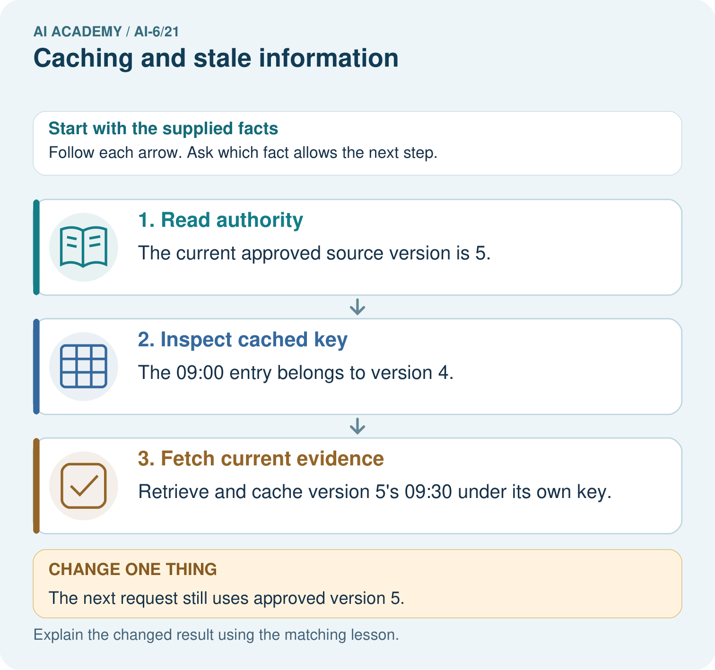

Read the picture one step at a time
Step | What happens and why
1. Read authority | The current approved source version is 5.
2. Inspect cached key | The 09:00 entry belongs to version 4.
3. Fetch current evidence | Retrieve and cache version 5’s 09:30 under its own key.
Match each pictured step to the supplied facts. This is a worked teaching case, not an independent assessment.

Why this result follows
A cache saves repeated work but can retain obsolete facts. Version-aware keys distinguish answers grounded in different records.

What this example does not establish
Version keys cannot detect silent unversioned edits; the source publication process must update versions reliably.
Read the labelled picture: Identify the version mismatch in the cached 09:00 answer. What should the first version-5 request return, and what permits a later version-5 cache hit?
Change one thing: The next request still uses approved version 5. Predict the result before checking the explanation. What remains the same?

07. Find and repair a mistake
A cached result retains the limitations of its original evidence and can become stale independently of TTL.
A useful check asks what would make the reasoning fail. Distinguish a failure to execute the declared procedure from a weakness in the procedure itself. The first may require a correction; the second requires an explicitly revised method and new evidence. Preserve unsuccessful cases so an improved result cannot hide the original problem.

Guided: restate the worked result, then name the assumption or limitation that prevents a broader conclusion.
________________________________________________________________
________________________________________________________________
________________________________________________________________
________________________________________________________________
________________________________________________________________

Locate the earliest unsupported step
A report omits this qualification: A cached result retains the limitations of its original evidence and can become stale independently of TTL. Explain how omitting it could change a reader's interpretation, and write an accurate replacement.

State one repair and the checks you would rerun.
________________________________________________________________
________________________________________________________________
________________________________________________________________
________________________________________________________________
________________________________________________________________
________________________________________________________________

08. Practise together
Explain the weekly mechanism in your own words. Use the worked scenario to name its input, decision rule and output.

Guided: restate the worked result, then name the assumption or limitation that prevents a broader conclusion.
________________________________________________________________
________________________________________________________________
________________________________________________________________
________________________________________________________________
________________________________________________________________

Explain your prediction to a partner before comparing results.
________________________________________________________________
________________________________________________________________
________________________________________________________________
________________________________________________________________

Practise with less help: Trace the worked case
Use workbook W2 for the connected example “Caching and stale information”. First fill the input and rule boxes. Try the middle steps before asking for a hint. After a hint, try the next step yourself.
Plan | Do | Check
What is given? Which rule or procedure applies? | Record each intermediate step. | Does the result follow? What remains unknown?
Explain your trace to a partner. Your partner points to one step to check. Swap roles on the next case. Each person writes their own explanation.

Check your reasoning
Use the worked case for Caching and stale information. Proposed explanation: “The worked result establishes every future case”. Decide whether this explanation is supported. Point to the step or supplied fact that decides; explain your repair if needed.
Answer on your own before discussion. If you are unsure, say which step you need help with.

Explain the picture
Identify the version mismatch in the cached 09:00 answer. What should the first version-5 request return, and what permits a later version-5 cache hit?

My explanation using a pictured step and the given facts
________________________________________________________________
________________________________________________________________
________________________________________________________________
________________________________________________________________
This is supported practice. Keep the separately named independent case for an attempt before feedback.

09. Run the investigation

Predict, investigate and preserve the evidence
Teacher response is cached by query only and returned to a student. Show the intermediate steps and give the conclusion with its scope.
def cache_key(query, role, corpus_version, procedure_version):
return (query, role, corpus_version, procedure_version)
def cache_valid(age, ttl, saved_version, current_version):
return 0 <= age < ttl and saved_version == current_version
print(cache_valid(10, 10, "v1", "v1"))
Record | Your evidence
Given input and fixed rule
Prediction before checking
Actual result, or “not run”
First mismatch and one explanation
Boundary or missing input and expected response
On paper, trace the supplied procedure. If code is provided, predict before running it in a local practice file. Never write an expected answer as though it were an observed run.

Plan → try → check
Before trying: what do I expect, and why? While trying: which step could first go wrong? Afterwards: what did I actually observe, and what should change? Keep “not run” if you only traced the procedure.

10. Build your understanding

Explain → apply → challenge
Explain the weekly mechanism in your own words. Use the worked scenario to name its input, decision rule and output.
A report omits this qualification: A cached result retains the limitations of its original evidence and can become stale independently of TTL. Explain how omitting it could change a reader's interpretation, and write an accurate replacement.
For the worked scenario, propose one additional case that could reveal a failure, describe its expected outcome before running it, and explain what would need to remain fixed for a fair comparison. Do not reuse W4 as a new final test after receiving feedback.

Explain which evidence supports your conclusion and which claim remains unproved.
________________________________________________________________
________________________________________________________________
________________________________________________________________
________________________________________________________________
________________________________________________________________

11. Connect your project
Add a labelled caching and stale information evidence sheet to Grounded Learning Service. Show how you can explain the mechanism and terminology of caching and stale information. Use the supplied fictional case and keep its inputs, intermediate steps, calculation or prediction, and limitation. Connect this record to last week’s record; a matching answer without a trace is insufficient.
Project evidence | Record
Component and version
Inputs permitted at prediction time
Trace and comparison with earlier work
Failure, limit and human review

Evidence for your project
For the Grounded Learning Service, retain an annotated trace and the changed-case result. Name the contract or evidence that makes the deciding step valid, so another team can review it.

12. Show what you know
Complete the supported workbook tasks before attempting W4 independently. Record any hints or help used. After feedback, use the teacher's fresh retry rather than copying the earlier answer. For a project, select a relevant new case, predict the outcome from the declared rule and preserve the result alongside any revision.

Exit: propose one revealing change to the worked scenario. State the expected outcome and the evidence that would make you revise your explanation.
________________________________________________________________
________________________________________________________________
________________________________________________________________
________________________________________________________________
________________________________________________________________
For the worked scenario, propose one additional case that could reveal a failure, describe its expected outcome before running it, and explain what would need to remain fixed for a fair comparison. Do not reuse W4 as a new final test after receiving feedback.

My limited claim and a useful next check
________________________________________________________________
________________________________________________________________
________________________________________________________________
________________________________________________________________

13. Study a complete case

Complete evidence record

Caching and stale information — evidence trace
Input and scope | Check or calculation | Conclusion and limit
Teacher response is cached by query only and returned to a student. | Cache key includes query, role, corpus version and procedure version. Entry valid only while age<TTL. At exact TTL it expires. Teacher and student results never share a role-agnostic key. | Role omission creates an access leak. Include role and enforce current permission before returning any cached content.
The figure connects this chapter's worked input, declared procedure and result. Read the complete worked reasoning for qualifiers and intermediate steps; the abbreviated labels do not replace that reasoning.
Follow the input through the stated procedure to its result. Cover the result first, predict it, then explain every intermediate step. The text/table accompanies the figure so the example can be read without colour.

My complete trace of the worked case
________________________________________________________________
________________________________________________________________
________________________________________________________________
________________________________________________________________
________________________________________________________________
________________________________________________________________

14. Try a new case independently

Independent case: Apply a new case independently
TTL10 minutes; ages9, 10, 11. Corpus version changes at age9. Decide validity.

My independent explanation, trace and limits
________________________________________________________________
________________________________________________________________
________________________________________________________________
________________________________________________________________
________________________________________________________________
________________________________________________________________
________________________________________________________________
Attempt this case before feedback. Record any help. Earlier examples below are further practice; a case already practised with feedback cannot establish fresh transfer.

Attempt this without hints
TTL10 minutes; ages9, 10, 11. Corpus version changes at age9. Decide validity.

My independent procedure, result and limitation
________________________________________________________________
________________________________________________________________
________________________________________________________________
________________________________________________________________
________________________________________________________________
________________________________________________________________
________________________________________________________________
________________________________________________________________
Record support used: none, hint or teacher explanation. After feedback, a different case is needed to demonstrate independence.

Use feedback to improve
Attempt the independent case before hints. Record whether you worked alone, used a hint or followed a model. After feedback, fix the first unsupported step and explain why it changed. A later check uses a changed case, not a copied answer.

15. Your lesson route
Start with this question: Cache by source version. A service has an opening-time answer cached from version 4, but version 5 is now approved.
By the end, I can | How I will show it
Explain the mechanism and terminology of caching and stale information | Explain the deciding step, show a trace or test, and state one limit.
Apply the stated procedure to a new case with a traceable result | Explain the deciding step, show a trace or test, and state one limit.
Identify an assumption or limitation and design a revealing follow-up | Explain the deciding step, show a trace or test, and state one limit.
Remember → watch and explain → try with help → investigate → try independently → keep project evidence. Your teacher may spread this lesson across several classes.
Keep your first prediction. Compare it with what the evidence shows and explain any change.

16. Finish and return
Close your notes. Explain this goal in your own words: Explain the mechanism and terminology of caching and stale information

My deciding step, evidence and one remaining question
________________________________________________________________
________________________________________________________________
________________________________________________________________
________________________________________________________________
________________________________________________________________
If you are unsure, return to the worked picture and explain one arrow. If you are ready, change an input or assumption and justify your prediction.
Save your workbook evidence. At the next review, try a different case before opening your old answer.

17. Supported practice, repair and portfolio
Use this supported practice once, in the browser or on paper. Keep the reserved independent assessment for a separate first attempt before teacher feedback.
Cache by source version. A service has an opening-time answer cached from version 4, but version 5 is now approved.

Practice 1: explain the deciding evidence
Which labelled step matches this detail? Retrieve and cache version 5’s 09:30 under its own key.
1. Read authority
2. Fetch current evidence
3. Inspect cached key

My selected conclusion, deciding fact and explanation
________________________________________________________________
________________________________________________________________
________________________________________________________________
________________________________________________________________
________________________________________________________________
Hint if needed: Read the steps in the pictorial case. Match the supplied detail to the stage that performs or records it.
After your attempt, compare with the supported explanation: Fetch current evidence Retrieve and cache version 5’s 09:30 under its own key. A cache saves repeated work but can retain obsolete facts. Version-aware keys distinguish answers grounded in different records.

Practice 2: explain the deciding evidence
Changed-case practice: The next request still uses approved version 5. Which conclusion is supported by the supplied facts?
1. The matching version-5 entry can supply 09:30 under the freshness policy.
2. This one example guarantees correct results for every future input.
3. We can decide the result without examining the changed input or the procedure.

My selected conclusion, deciding fact and explanation
________________________________________________________________
________________________________________________________________
________________________________________________________________
________________________________________________________________
________________________________________________________________
Hint if needed: Use the changed condition and the deciding step in the pictorial trace. The answer must say what follows from those facts.
After your attempt, compare with the supported explanation: The matching version-5 entry can supply 09:30 under the freshness policy. Request and cached source version now agree.

Repair a missing building block
Review Data retention and deletion (ai-6/20). Goal: Explain the mechanism and terminology of data retention and deletion. Short practice: Apply the seven-day boundary to T1 and T2. How many T2 locations need verification, and may deletion be called complete if its backup remains?. Return to this week and explain what you changed.
Review Untrusted input boundaries (ai-6/18). Goal: Explain the mechanism and terminology of untrusted input boundaries. Short practice: Classify h3, H3, h30 and the trailing-space input by the stated shape contract. Does a valid z0 grant record access, and which separate gate still remains?. Return to this week and explain what you changed.
Review Approval gates and idempotency (ai-6/15). Goal: Explain the mechanism and terminology of approval gates and idempotency. Short practice: Trace the two deliveries of approved K9. How many reservations should occur, and why can a new K10 for desk 5 not borrow K9’s approval?. Return to this week and explain what you changed.

Predict, run and debug
The browser lab lets you edit the supported Python examples already included in this lesson. Predict first, run, inspect the actual output or error, change one input, then run again. Keep code, predictions, actual results and a reasoned revision together. On paper, label your result as a trace rather than an execution.

Keep your completed work
Use Download completed work in the hosted lesson to export your answers, reflections, practice feedback and code-run evidence. Open the HTML copy to read or print it. Drafts stay in this browser when storage is available; clear drafts on a shared device.

