AI ACADEMY · STUDENT · ai-6/26

Incident investigation
Project: Grounded Learning Service

Before you start
Recall Monitoring quality drift. Explain why a recorded result needs its input conditions and evidence source before it can support a claim.

01. Your mission

Your learning target
I can explain the mechanism and terminology of incident investigation.
I can apply the stated procedure to a new case with a traceable result.
I can identify an assumption or limitation and design a revealing follow-up.

Remember before reading
Close your notes first. A rough first answer helps us choose the right starting point; it is not a score for your ability.
Without opening the old lesson, explain one key idea from Monitoring quality drift. Give an example and a mistake that the idea helps you avoid.
Without opening the old lesson, explain one key idea from Deployment environments. Give an example and a mistake that the idea helps you avoid.
Without opening the old lesson, explain one key idea from Data retention and deletion. Give an example and a mistake that the idea helps you avoid.
After trying, check the relevant lesson or ask your teacher. Change the part of your explanation that the evidence shows was wrong.
This week you will practise:
Explain the mechanism and terminology of incident investigation
Apply the stated procedure to a new case with a traceable result
Identify an assumption or limitation and design a revealing follow-up

Retrieve what you already know
Recall Monitoring quality drift. Explain why a recorded result needs its input conditions and evidence source before it can support a claim.

My starting explanation
________________________________________________________________
________________________________________________________________
________________________________________________________________

This week’s end goal
Explain incident investigation using the deciding step in this fictional service.

02. Notice the evidence
Incident investigation preserves a timeline and distinguishes observation from hypothesis. Repair before evidence collection can erase clues.
Begin by writing the question the procedure is intended to answer. Identify the information already supplied, the information it will produce and the information still missing. These are constructed classroom examples; they do not require live accounts, private records or an external service. Do not treat a plausible explanation as a measured outcome.

List the given facts and one fact that is not supplied.
________________________________________________________________
________________________________________________________________
________________________________________________________________

03. See how it works
Record timestamps, versions, requests, authorised actions and outcomes with minimised logs. Separate immediate containment from diagnosis. Compare candidate explanations against evidence.

Incident investigation — evidence trace
Input and scope | Check or calculation | Conclusion and limit
At09:00 corpus updates; 09:05 stale cache response; 09:06 cache disabled. Team says model weights changed, but weight version is unchanged. | Record timestamps, versions, requests, authorised actions and outcomes with minimised logs. Separate immediate containment from diagnosis. Compare candidate explanations against evidence. | Weight-change claim is contradicted by the version record. Stale cache is a supported candidate explanation; preserve timeline and test it with controlled reproduction.
The figure connects this chapter's worked input, declared procedure and result. Read the complete worked reasoning for qualifiers and intermediate steps; the abbreviated labels do not replace that reasoning.
Before applying the procedure, write its units, denominator or decision boundary where relevant. A partner should be able to repeat each step using the same inputs. If a required input is absent or violates the stated contract, record that condition explicitly instead of quietly replacing it with a convenient value.

Connect the picture and the explanation
Point to the input, the deciding step and the result in this week’s visual. Explain the same step in ordinary words. A picture helps when you can say what each part represents.

04. Compare the cases

Compare a familiar case with a changed case
At09:00 corpus updates; 09:05 stale cache response; 09:06 cache disabled. Team says model weights changed, but weight version is unchanged. Show the intermediate steps and give the conclusion with its scope.

Keep the procedure fixed. Explain what changed in the inputs and result.
________________________________________________________________
________________________________________________________________
________________________________________________________________
________________________________________________________________
________________________________________________________________

Change one thing in the pictured case
Change: Trace instead shows version 6 retrieved and room C drafted.
Prediction: Investigate drafting or validation before blaming caching.
Reason: The mismatch now appears after retrieval.

05. Words that unlock the idea
Word | Meaning
Incident timeline | Ordered records of relevant events
Containment | An action limiting ongoing harm or failure
Root-cause hypothesis | A proposed mechanism requiring evidence

Use two terms to explain a step in this week’s example.
________________________________________________________________
________________________________________________________________
________________________________________________________________

06. Follow a worked example
At09:00 corpus updates; 09:05 stale cache response; 09:06 cache disabled. Team says model weights changed, but weight version is unchanged.
Weight-change claim is contradicted by the version record. Stale cache is a supported candidate explanation; preserve timeline and test it with controlled reproduction.
Compare the intermediate evidence with the final statement. Explain why each number or decision follows from the stated inputs. The conclusion belongs to this scenario and procedure; changing the inputs, evaluation population or authority can change what it establishes. Retain the raw record so a later revision can be compared honestly.

Learn from the worked case
Cover the result before checking it. Say what is given, choose the procedure, and follow one step at a time. Then uncover the result and explain your first mismatch. Ask why a step is allowed, not only what number it produces.

A pictorial worked case: Incident investigation
An incident timeline. After a schedule update, a service gives an old classroom location.

The facts we will use
14:00 version 6 publishes room D; 14:05 answer uses version 5 room C; 14:06 user reports mismatch.
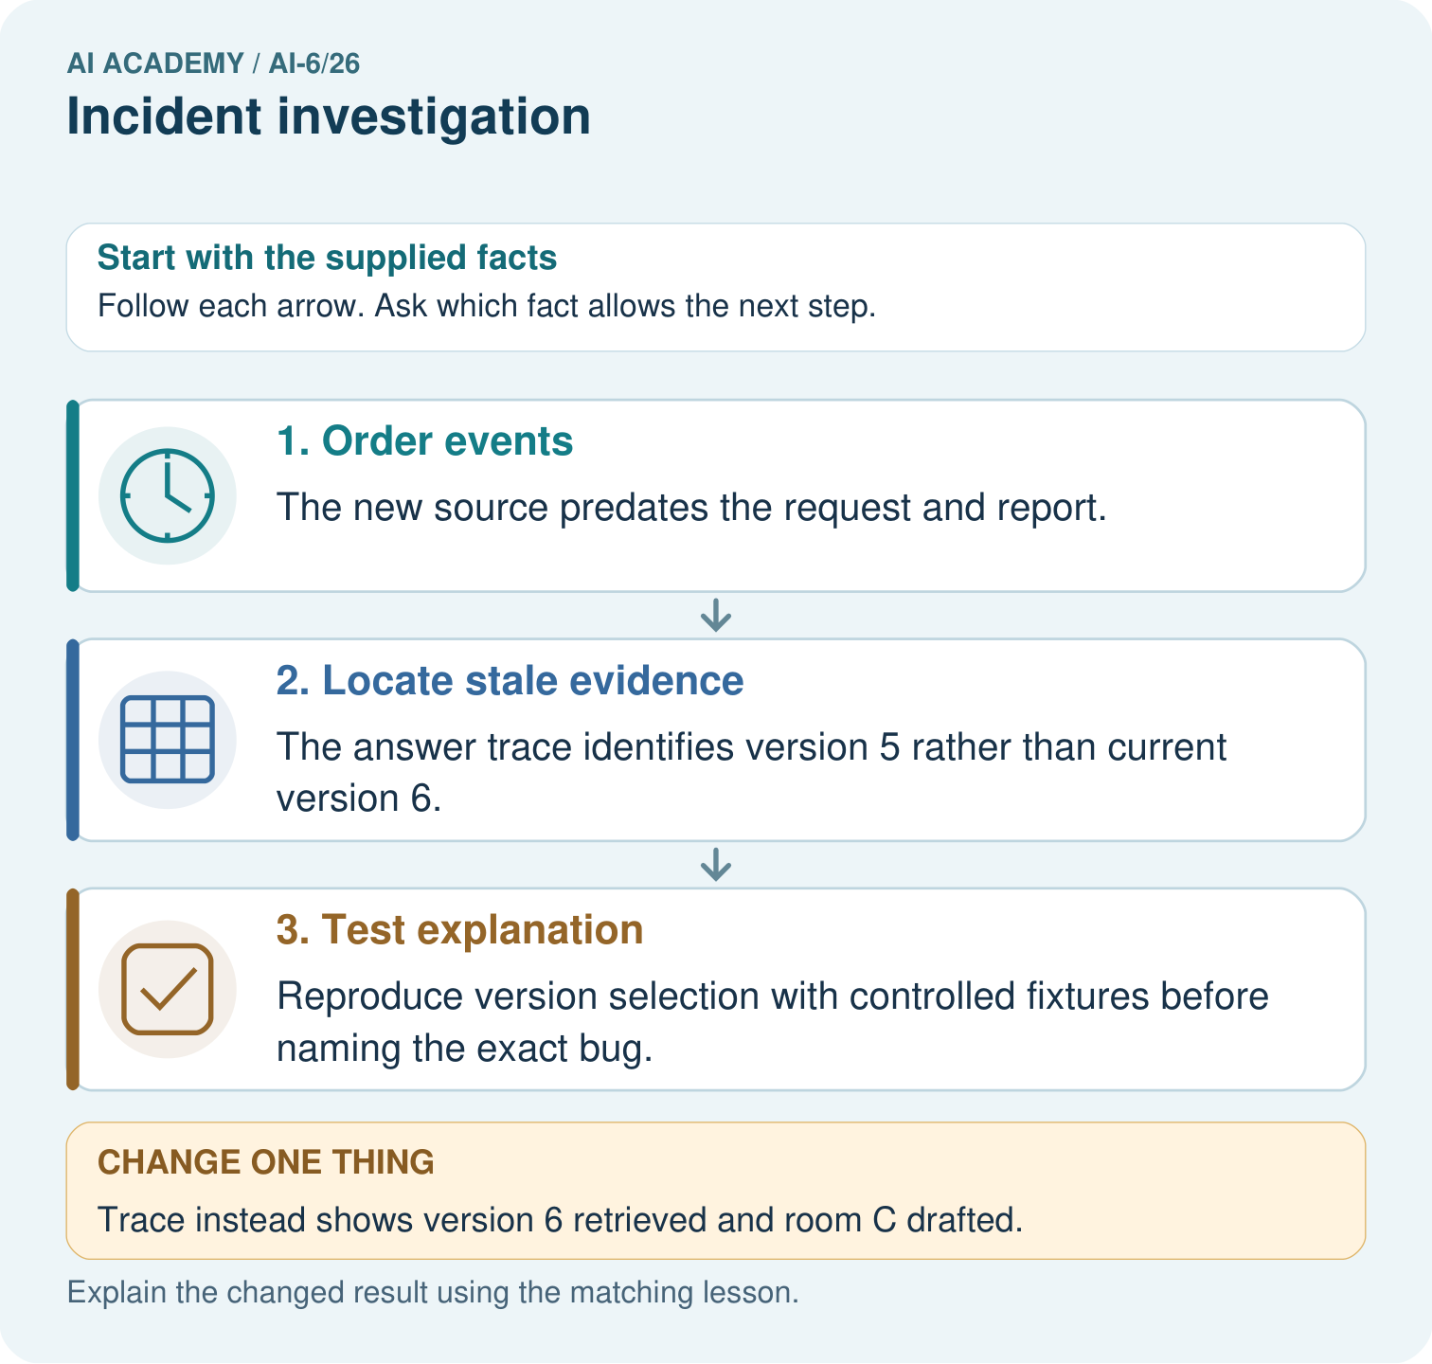

Read the picture one step at a time
Step | What happens and why
1. Order events | The new source predates the request and report.
2. Locate stale evidence | The answer trace identifies version 5 rather than current version 6.
3. Test explanation | Reproduce version selection with controlled fixtures before naming the exact bug.
Match each pictured step to the supplied facts. This is a worked teaching case, not an independent assessment.

Why this result follows
A timeline separates observed events from a proposed cause. Evidence can locate a mismatch without yet explaining why it happened.

What this example does not establish
Missing events may change the account; temporal order alone does not prove causation.
Read the labelled picture: Order the three incident records and locate the old evidence version. How does the investigation change if the trace instead retrieves version 6 but drafts room C?
Change one thing: Trace instead shows version 6 retrieved and room C drafted. Predict the result before checking the explanation. What remains the same?

07. Find and repair a mistake
A plausible narrative needs controlled or record-based confirmation and must preserve unknowns.
A useful check asks what would make the reasoning fail. Distinguish a failure to execute the declared procedure from a weakness in the procedure itself. The first may require a correction; the second requires an explicitly revised method and new evidence. Preserve unsuccessful cases so an improved result cannot hide the original problem.

Guided: restate the worked result, then name the assumption or limitation that prevents a broader conclusion.
________________________________________________________________
________________________________________________________________
________________________________________________________________
________________________________________________________________
________________________________________________________________

Locate the earliest unsupported step
A report omits this qualification: A plausible narrative needs controlled or record-based confirmation and must preserve unknowns. Explain how omitting it could change a reader's interpretation, and write an accurate replacement.

State one repair and the checks you would rerun.
________________________________________________________________
________________________________________________________________
________________________________________________________________
________________________________________________________________
________________________________________________________________
________________________________________________________________

08. Practise together
Explain the weekly mechanism in your own words. Use the worked scenario to name its input, decision rule and output.

Guided: restate the worked result, then name the assumption or limitation that prevents a broader conclusion.
________________________________________________________________
________________________________________________________________
________________________________________________________________
________________________________________________________________
________________________________________________________________

Explain your prediction to a partner before comparing results.
________________________________________________________________
________________________________________________________________
________________________________________________________________
________________________________________________________________

Practise with less help: Trace the worked case
Use workbook W2 for the connected example “Incident investigation”. First fill the input and rule boxes. Try the middle steps before asking for a hint. After a hint, try the next step yourself.
Plan | Do | Check
What is given? Which rule or procedure applies? | Record each intermediate step. | Does the result follow? What remains unknown?
Explain your trace to a partner. Your partner points to one step to check. Swap roles on the next case. Each person writes their own explanation.

Check your reasoning
Use the worked case for Incident investigation. Proposed explanation: “The worked result establishes every future case”. Decide whether this explanation is supported. Point to the step or supplied fact that decides; explain your repair if needed.
Answer on your own before discussion. If you are unsure, say which step you need help with.

Explain the picture
Order the three incident records and locate the old evidence version. How does the investigation change if the trace instead retrieves version 6 but drafts room C?

My explanation using a pictured step and the given facts
________________________________________________________________
________________________________________________________________
________________________________________________________________
________________________________________________________________
This is supported practice. Keep the separately named independent case for an attempt before feedback.

09. Run the investigation

Predict, investigate and preserve the evidence
At09:00 corpus updates; 09:05 stale cache response; 09:06 cache disabled. Team says model weights changed, but weight version is unchanged. Show the intermediate steps and give the conclusion with its scope.
Record | Your evidence
Given input and fixed rule
Prediction before checking
Actual result, or “not run”
First mismatch and one explanation
Boundary or missing input and expected response
On paper, trace the supplied procedure. If code is provided, predict before running it in a local practice file. Never write an expected answer as though it were an observed run.

Plan → try → check
Before trying: what do I expect, and why? While trying: which step could first go wrong? Afterwards: what did I actually observe, and what should change? Keep “not run” if you only traced the procedure.

10. Build your understanding

Explain → apply → challenge
Explain the weekly mechanism in your own words. Use the worked scenario to name its input, decision rule and output.
A report omits this qualification: A plausible narrative needs controlled or record-based confirmation and must preserve unknowns. Explain how omitting it could change a reader's interpretation, and write an accurate replacement.
For the worked scenario, propose one additional case that could reveal a failure, describe its expected outcome before running it, and explain what would need to remain fixed for a fair comparison. Do not reuse W4 as a new final test after receiving feedback.

Explain which evidence supports your conclusion and which claim remains unproved.
________________________________________________________________
________________________________________________________________
________________________________________________________________
________________________________________________________________
________________________________________________________________

11. Connect your project
Add a labelled incident investigation evidence sheet to Grounded Learning Service. Show how you can explain the mechanism and terminology of incident investigation. Use the supplied fictional case and keep its inputs, intermediate steps, calculation or prediction, and limitation. Connect this record to last week’s record; a matching answer without a trace is insufficient.
Project evidence | Record
Component and version
Inputs permitted at prediction time
Trace and comparison with earlier work
Failure, limit and human review

Evidence for your project
For the Grounded Learning Service, retain an annotated trace and the changed-case result. Name the contract or evidence that makes the deciding step valid, so another team can review it.

12. Show what you know
Complete the supported workbook tasks before attempting W4 independently. Record any hints or help used. After feedback, use the teacher's fresh retry rather than copying the earlier answer. For a project, select a relevant new case, predict the outcome from the declared rule and preserve the result alongside any revision.

Exit: propose one revealing change to the worked scenario. State the expected outcome and the evidence that would make you revise your explanation.
________________________________________________________________
________________________________________________________________
________________________________________________________________
________________________________________________________________
________________________________________________________________
For the worked scenario, propose one additional case that could reveal a failure, describe its expected outcome before running it, and explain what would need to remain fixed for a fair comparison. Do not reuse W4 as a new final test after receiving feedback.

My limited claim and a useful next check
________________________________________________________________
________________________________________________________________
________________________________________________________________
________________________________________________________________

13. Study a complete case

Complete evidence record

Incident investigation — evidence trace
Input and scope | Check or calculation | Conclusion and limit
At09:00 corpus updates; 09:05 stale cache response; 09:06 cache disabled. Team says model weights changed, but weight version is unchanged. | Record timestamps, versions, requests, authorised actions and outcomes with minimised logs. Separate immediate containment from diagnosis. Compare candidate explanations against evidence. | Weight-change claim is contradicted by the version record. Stale cache is a supported candidate explanation; preserve timeline and test it with controlled reproduction.
The figure connects this chapter's worked input, declared procedure and result. Read the complete worked reasoning for qualifiers and intermediate steps; the abbreviated labels do not replace that reasoning.
Follow the input through the stated procedure to its result. Cover the result first, predict it, then explain every intermediate step. The text/table accompanies the figure so the example can be read without colour.

My complete trace of the worked case
________________________________________________________________
________________________________________________________________
________________________________________________________________
________________________________________________________________
________________________________________________________________
________________________________________________________________

14. Try a new case independently

Independent case: Apply a new case independently
10:00 permissions config changes; 10:03 restricted read; model version unchanged. Name a plausible cause and one test.

My independent explanation, trace and limits
________________________________________________________________
________________________________________________________________
________________________________________________________________
________________________________________________________________
________________________________________________________________
________________________________________________________________
________________________________________________________________
Attempt this case before feedback. Record any help. Earlier examples below are further practice; a case already practised with feedback cannot establish fresh transfer.

Attempt this without hints
10:00 permissions config changes; 10:03 restricted read; model version unchanged. Name a plausible cause and one test.

My independent procedure, result and limitation
________________________________________________________________
________________________________________________________________
________________________________________________________________
________________________________________________________________
________________________________________________________________
________________________________________________________________
________________________________________________________________
________________________________________________________________
Record support used: none, hint or teacher explanation. After feedback, a different case is needed to demonstrate independence.

Use feedback to improve
Attempt the independent case before hints. Record whether you worked alone, used a hint or followed a model. After feedback, fix the first unsupported step and explain why it changed. A later check uses a changed case, not a copied answer.

15. Your lesson route
Start with this question: An incident timeline. After a schedule update, a service gives an old classroom location.
By the end, I can | How I will show it
Explain the mechanism and terminology of incident investigation | Explain the deciding step, show a trace or test, and state one limit.
Apply the stated procedure to a new case with a traceable result | Explain the deciding step, show a trace or test, and state one limit.
Identify an assumption or limitation and design a revealing follow-up | Explain the deciding step, show a trace or test, and state one limit.
Remember → watch and explain → try with help → investigate → try independently → keep project evidence. Your teacher may spread this lesson across several classes.
Keep your first prediction. Compare it with what the evidence shows and explain any change.

16. Finish and return
Close your notes. Explain this goal in your own words: Explain the mechanism and terminology of incident investigation

My deciding step, evidence and one remaining question
________________________________________________________________
________________________________________________________________
________________________________________________________________
________________________________________________________________
________________________________________________________________
If you are unsure, return to the worked picture and explain one arrow. If you are ready, change an input or assumption and justify your prediction.
Save your workbook evidence. At the next review, try a different case before opening your old answer.

17. Supported practice, repair and portfolio
Use this supported practice once, in the browser or on paper. Keep the reserved independent assessment for a separate first attempt before teacher feedback.
An incident timeline. After a schedule update, a service gives an old classroom location.

Practice 1: explain the deciding evidence
Which labelled step matches this detail? Reproduce version selection with controlled fixtures before naming the exact bug.
1. Test explanation
2. Order events
3. Locate stale evidence

My selected conclusion, deciding fact and explanation
________________________________________________________________
________________________________________________________________
________________________________________________________________
________________________________________________________________
________________________________________________________________
Hint if needed: Read the steps in the pictorial case. Match the supplied detail to the stage that performs or records it.
After your attempt, compare with the supported explanation: Test explanation Reproduce version selection with controlled fixtures before naming the exact bug. A timeline separates observed events from a proposed cause. Evidence can locate a mismatch without yet explaining why it happened.

Practice 2: explain the deciding evidence
Changed-case practice: Trace instead shows version 6 retrieved and room C drafted. Which conclusion is supported by the supplied facts?
1. This one example guarantees correct results for every future input.
2. Investigate drafting or validation before blaming caching.
3. We can decide the result without examining the changed input or the procedure.

My selected conclusion, deciding fact and explanation
________________________________________________________________
________________________________________________________________
________________________________________________________________
________________________________________________________________
________________________________________________________________
Hint if needed: Use the changed condition and the deciding step in the pictorial trace. The answer must say what follows from those facts.
After your attempt, compare with the supported explanation: Investigate drafting or validation before blaming caching. The mismatch now appears after retrieval.

Repair a missing building block
Review Monitoring quality drift (ai-6/25). Goal: Explain the mechanism and terminology of monitoring quality drift. Short practice: Compute both clear and ambiguous slice rates for A and B. Which slice weakens, and how should that slice be reported when no ambiguous questions are observed?. Return to this week and explain what you changed.
Review Deployment environments (ai-6/23). Goal: Explain the mechanism and terminology of deployment environments. Short practice: Identify the staging data and credential boundary. Why must the rehearsal stop if its credential reaches production even though the process is labelled staging?. Return to this week and explain what you changed.
Review Data retention and deletion (ai-6/20). Goal: Explain the mechanism and terminology of data retention and deletion. Short practice: Apply the seven-day boundary to T1 and T2. How many T2 locations need verification, and may deletion be called complete if its backup remains?. Return to this week and explain what you changed.

Keep your completed work
Use Download completed work in the hosted lesson to export your answers, reflections, practice feedback and code-run evidence. Open the HTML copy to read or print it. Drafts stay in this browser when storage is available; clear drafts on a shared device.

