AI ACADEMY · STUDENT · ai-7/6

A literature comparison matrix
Project: Reproducible AI Research Study

Before you start
Recall Replication and reproduction. Explain why a recorded result needs its input conditions and evidence source before it can support a claim.

01. Your mission

Your learning target
I can explain the mechanism and terminology of a literature comparison matrix.
I can apply the stated procedure to a new case with a traceable result.
I can identify an assumption or limitation and design a revealing follow-up.

Remember before reading
Close your notes first. A rough first answer helps us choose the right starting point; it is not a score for your ability.
Without opening the old lesson, explain one key idea from Replication and reproduction. Give an example and a mistake that the idea helps you avoid.
Without opening the old lesson, explain one key idea from Finding primary research. Give an example and a mistake that the idea helps you avoid.
After trying, check the relevant lesson or ask your teacher. Change the part of your explanation that the evidence shows was wrong.
This week you will practise:
Explain the mechanism and terminology of a literature comparison matrix
Apply the stated procedure to a new case with a traceable result
Identify an assumption or limitation and design a revealing follow-up

Retrieve what you already know
Recall Replication and reproduction. Explain why a recorded result needs its input conditions and evidence source before it can support a claim.

My starting explanation
________________________________________________________________
________________________________________________________________
________________________________________________________________

This week’s end goal
Explain a literature comparison matrix using the records and boundaries of this fictional investigation.

02. Notice the evidence
A literature matrix compares studies using aligned columns rather than sorting headline numbers with different meanings.
Begin by writing the question the procedure is intended to answer. Identify the information already supplied, the information it will produce and the information still missing. These are constructed classroom examples; they do not require live accounts, private records or an external service. Do not treat a plausible explanation as a measured outcome.

List the given facts and one fact that is not supplied.
________________________________________________________________
________________________________________________________________
________________________________________________________________

03. See how it works
Record question, data, unit, baseline, metric, split, resources and limitations. Mark incomparable fields rather than forcing a ranking.

A literature comparison matrix — evidence trace
Input and scope | Check or calculation | Conclusion and limit
Study A reports accuracy90% on easy classification; B reports claim support80% on difficult generated answers. | Record question, data, unit, baseline, metric, split, resources and limitations. Mark incomparable fields rather than forcing a ranking. | Different tasks and metrics cannot establish A superior to B. Keep separate columns and identify a common evaluation needed.
The figure connects this chapter's worked input, declared procedure and result. Read the complete worked reasoning for qualifiers and intermediate steps; the abbreviated labels do not replace that reasoning.
Before applying the procedure, write its units, denominator or decision boundary where relevant. A partner should be able to repeat each step using the same inputs. If a required input is absent or violates the stated contract, record that condition explicitly instead of quietly replacing it with a convenient value.

Connect the picture and the explanation
Point to the input, the deciding step and the result in this week’s visual. Explain the same step in ordinary words. A picture helps when you can say what each part represents.

04. Compare the cases

Compare a familiar case with a changed case
Study A reports accuracy90% on easy classification; B reports claim support80% on difficult generated answers. Show the intermediate steps and give the conclusion with its scope.

Keep the procedure fixed. Explain what changed in the inputs and result.
________________________________________________________________
________________________________________________________________
________________________________________________________________
________________________________________________________________
________________________________________________________________

Change one thing in the pictured case
Change: Remove the indoor/outdoor column.
Prediction: The matrix conceals an important condition difference.
Reason: A reader might now mistake unlike studies for a controlled head-to-head comparison.

05. Words that unlock the idea
Word | Meaning
Literature matrix | A structured comparison of study methods and results
Comparable metric | A measure with aligned definition and scope
Evidence gap | Information needed but not supplied

Use two terms to explain a step in this week’s example.
________________________________________________________________
________________________________________________________________
________________________________________________________________

06. Follow a worked example
Study A reports accuracy90% on easy classification; B reports claim support80% on difficult generated answers.
Different tasks and metrics cannot establish A superior to B. Keep separate columns and identify a common evaluation needed.
Compare the intermediate evidence with the final statement. Explain why each number or decision follows from the stated inputs. The conclusion belongs to this scenario and procedure; changing the inputs, evaluation population or authority can change what it establishes. Retain the raw record so a later revision can be compared honestly.

Learn from the worked case
Cover the result before checking it. Say what is given, choose the procedure, and follow one step at a time. Then uncover the result and explain your first mismatch. Ask why a step is allowed, not only what number it produces.

A pictorial worked case: A literature comparison matrix
A literature matrix that preserves differences. Two fictional studies evaluate related tools under different conditions.

The facts we will use
Study S1: 8/10 correct on indoor photos. S2: 16/20 on outdoor photos. Both report 80%.
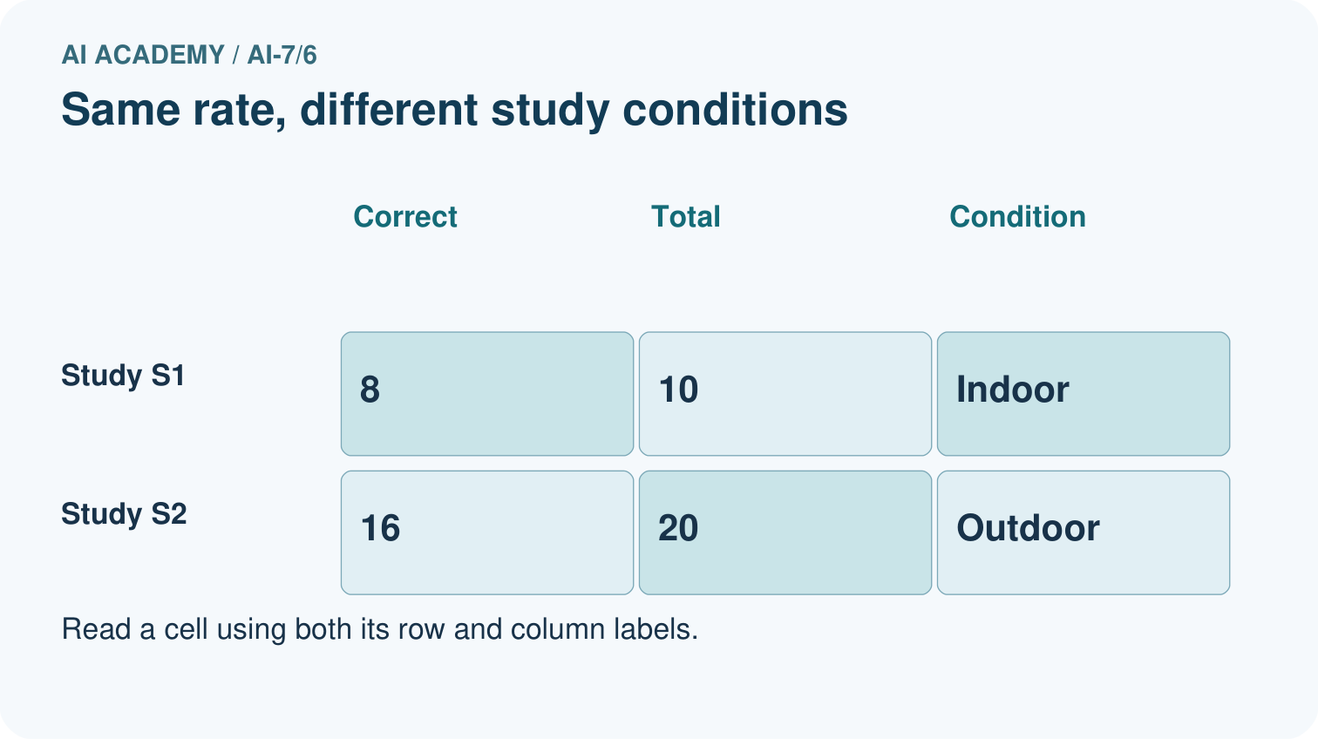
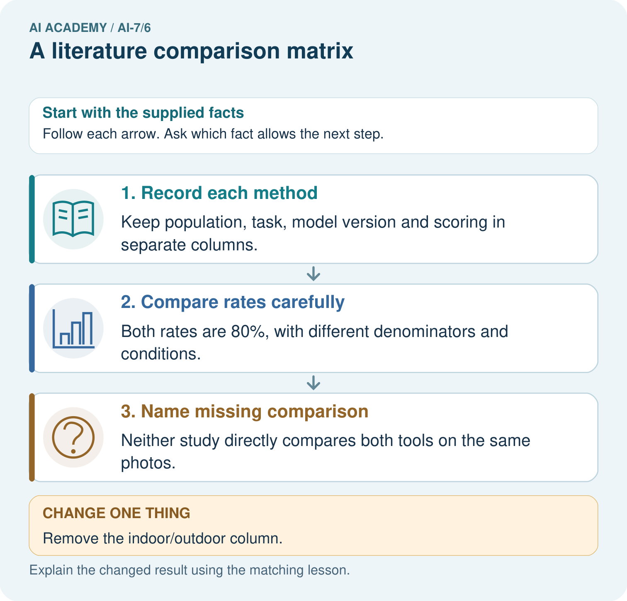

Read the picture one step at a time
Step | What happens and why
1. Record each method | Keep population, task, model version and scoring in separate columns.
2. Compare rates carefully | Both rates are 80%, with different denominators and conditions.
3. Name missing comparison | Neither study directly compares both tools on the same photos.
Match each pictured step to the supplied facts. This is a worked teaching case, not an independent assessment.

Why this result follows
A literature matrix helps compare evidence without flattening differences. Equal percentages do not mean equivalent tasks, samples or methods.

What this example does not establish
These fictional studies illustrate comparison practice; no real literature finding is asserted.
Read the labelled picture: Explain why 8/10 indoors and 16/20 outdoors share a rate but not a controlled comparison. Which condition column must the literature matrix preserve?
Change one thing: Remove the indoor/outdoor column. Predict the result before checking the explanation. What remains the same?

07. Find and repair a mistake
A matrix documents comparison limits; it does not create missing common evidence.
A useful check asks what would make the reasoning fail. Distinguish a failure to execute the declared procedure from a weakness in the procedure itself. The first may require a correction; the second requires an explicitly revised method and new evidence. Preserve unsuccessful cases so an improved result cannot hide the original problem.

Guided: restate the worked result, then name the assumption or limitation that prevents a broader conclusion.
________________________________________________________________
________________________________________________________________
________________________________________________________________
________________________________________________________________
________________________________________________________________

Locate the earliest unsupported step
A report omits this qualification: A matrix documents comparison limits; it does not create missing common evidence. Explain how omitting it could change a reader's interpretation, and write an accurate replacement.

State one repair and the checks you would rerun.
________________________________________________________________
________________________________________________________________
________________________________________________________________
________________________________________________________________
________________________________________________________________
________________________________________________________________

08. Practise together
Explain the weekly mechanism in your own words. Use the worked scenario to name its input, decision rule and output.

Guided: restate the worked result, then name the assumption or limitation that prevents a broader conclusion.
________________________________________________________________
________________________________________________________________
________________________________________________________________
________________________________________________________________
________________________________________________________________

Explain your prediction to a partner before comparing results.
________________________________________________________________
________________________________________________________________
________________________________________________________________
________________________________________________________________

Practise with less help: Trace the worked case
Use workbook W2 for the connected example “A literature comparison matrix”. First fill the input and rule boxes. Try the middle steps before asking for a hint. After a hint, try the next step yourself.
Plan | Do | Check
What is given? Which rule or procedure applies? | Record each intermediate step. | Does the result follow? What remains unknown?
Explain your trace to a partner. Your partner points to one step to check. Swap roles on the next case. Each person writes their own explanation.

Check your reasoning
Use the worked case for A literature comparison matrix. Proposed explanation: “The worked result establishes every future case”. Decide whether this explanation is supported. Point to the step or supplied fact that decides; explain your repair if needed.
Answer on your own before discussion. If you are unsure, say which step you need help with.

Explain the picture
Explain why 8/10 indoors and 16/20 outdoors share a rate but not a controlled comparison. Which condition column must the literature matrix preserve?

My explanation using a pictured step and the given facts
________________________________________________________________
________________________________________________________________
________________________________________________________________
________________________________________________________________
This is supported practice. Keep the separately named independent case for an attempt before feedback.

09. Run the investigation

Predict, investigate and preserve the evidence
Study A reports accuracy90% on easy classification; B reports claim support80% on difficult generated answers. Show the intermediate steps and give the conclusion with its scope.
Record | Your evidence
Given input and fixed rule
Prediction before checking
Actual result, or “not run”
First mismatch and one explanation
Boundary or missing input and expected response
On paper, trace the supplied procedure. If code is provided, predict before running it in a local practice file. Never write an expected answer as though it were an observed run.

Plan → try → check
Before trying: what do I expect, and why? While trying: which step could first go wrong? Afterwards: what did I actually observe, and what should change? Keep “not run” if you only traced the procedure.

10. Build your understanding

Explain → apply → challenge
Explain the weekly mechanism in your own words. Use the worked scenario to name its input, decision rule and output.
A report omits this qualification: A matrix documents comparison limits; it does not create missing common evidence. Explain how omitting it could change a reader's interpretation, and write an accurate replacement.
For the worked scenario, propose one additional case that could reveal a failure, describe its expected outcome before running it, and explain what would need to remain fixed for a fair comparison. Do not reuse W4 as a new final test after receiving feedback.

Explain which evidence supports your conclusion and which claim remains unproved.
________________________________________________________________
________________________________________________________________
________________________________________________________________
________________________________________________________________
________________________________________________________________

11. Connect your project
Add a labelled a literature comparison matrix evidence sheet to Reproducible AI Research Study. Show how you can explain the mechanism and terminology of a literature comparison matrix. Use the supplied fictional case and keep its inputs, intermediate steps, calculation or prediction, and limitation. Connect this record to last week’s record; a matching answer without a trace is insufficient.
Project evidence | Record
Component and version
Inputs permitted at prediction time
Trace and comparison with earlier work
Failure, limit and human review

Evidence for your project
For the Reproducible AI Research Study, retain an annotated worked trace and the changed-case reasoning. Connect the claim to its records, units and assumptions so another investigator can challenge or reproduce it.

12. Show what you know
Complete the supported workbook tasks before attempting W4 independently. Record any hints or help used. After feedback, use the teacher's fresh retry rather than copying the earlier answer. For a project, select a relevant new case, predict the outcome from the declared rule and preserve the result alongside any revision.

Exit: propose one revealing change to the worked scenario. State the expected outcome and the evidence that would make you revise your explanation.
________________________________________________________________
________________________________________________________________
________________________________________________________________
________________________________________________________________
________________________________________________________________
For the worked scenario, propose one additional case that could reveal a failure, describe its expected outcome before running it, and explain what would need to remain fixed for a fair comparison. Do not reuse W4 as a new final test after receiving feedback.

My limited claim and a useful next check
________________________________________________________________
________________________________________________________________
________________________________________________________________
________________________________________________________________

13. Study a complete case

Complete evidence record

A literature comparison matrix — evidence trace
Input and scope | Check or calculation | Conclusion and limit
Study A reports accuracy90% on easy classification; B reports claim support80% on difficult generated answers. | Record question, data, unit, baseline, metric, split, resources and limitations. Mark incomparable fields rather than forcing a ranking. | Different tasks and metrics cannot establish A superior to B. Keep separate columns and identify a common evaluation needed.
The figure connects this chapter's worked input, declared procedure and result. Read the complete worked reasoning for qualifiers and intermediate steps; the abbreviated labels do not replace that reasoning.
Follow the input through the stated procedure to its result. Cover the result first, predict it, then explain every intermediate step. The text/table accompanies the figure so the example can be read without colour.

My complete trace of the worked case
________________________________________________________________
________________________________________________________________
________________________________________________________________
________________________________________________________________
________________________________________________________________
________________________________________________________________

14. Try a new case independently

Independent case: Apply a new case independently
A has recall@5 .8; B has precision@3 .9 on another corpus. Can you rank them?

My independent explanation, trace and limits
________________________________________________________________
________________________________________________________________
________________________________________________________________
________________________________________________________________
________________________________________________________________
________________________________________________________________
________________________________________________________________
Attempt this case before feedback. Record any help. Earlier examples below are further practice; a case already practised with feedback cannot establish fresh transfer.

Attempt this without hints
A has recall@5 .8; B has precision@3 .9 on another corpus. Can you rank them?

My independent procedure, result and limitation
________________________________________________________________
________________________________________________________________
________________________________________________________________
________________________________________________________________
________________________________________________________________
________________________________________________________________
________________________________________________________________
________________________________________________________________
Record support used: none, hint or teacher explanation. After feedback, a different case is needed to demonstrate independence.

Use feedback to improve
Attempt the independent case before hints. Record whether you worked alone, used a hint or followed a model. After feedback, fix the first unsupported step and explain why it changed. A later check uses a changed case, not a copied answer.

15. Your lesson route
Start with this question: A literature matrix that preserves differences. Two fictional studies evaluate related tools under different conditions.
By the end, I can | How I will show it
Explain the mechanism and terminology of a literature comparison matrix | Explain the deciding step, show a trace or test, and state one limit.
Apply the stated procedure to a new case with a traceable result | Explain the deciding step, show a trace or test, and state one limit.
Identify an assumption or limitation and design a revealing follow-up | Explain the deciding step, show a trace or test, and state one limit.
Remember → watch and explain → try with help → investigate → try independently → keep project evidence. Your teacher may spread this lesson across several classes.
Keep your first prediction. Compare it with what the evidence shows and explain any change.

16. Finish and return
Close your notes. Explain this goal in your own words: Explain the mechanism and terminology of a literature comparison matrix

My deciding step, evidence and one remaining question
________________________________________________________________
________________________________________________________________
________________________________________________________________
________________________________________________________________
________________________________________________________________
If you are unsure, return to the worked picture and explain one arrow. If you are ready, change an input or assumption and justify your prediction.
Save your workbook evidence. At the next review, try a different case before opening your old answer.

17. Supported practice, repair and portfolio
Use this supported practice once, in the browser or on paper. Keep the reserved independent assessment for a separate first attempt before teacher feedback.
A literature matrix that preserves differences. Two fictional studies evaluate related tools under different conditions.

Practice 1: explain the deciding evidence
Which labelled step matches this detail? Neither study directly compares both tools on the same photos.
1. Name missing comparison
2. Record each method
3. Compare rates carefully

My selected conclusion, deciding fact and explanation
________________________________________________________________
________________________________________________________________
________________________________________________________________
________________________________________________________________
________________________________________________________________
Hint if needed: Read the steps in the pictorial case. Match the supplied detail to the stage that performs or records it.
After your attempt, compare with the supported explanation: Name missing comparison Neither study directly compares both tools on the same photos. A literature matrix helps compare evidence without flattening differences. Equal percentages do not mean equivalent tasks, samples or methods.

Practice 2: explain the deciding evidence
Changed-case practice: Remove the indoor/outdoor column. Which conclusion is supported by the supplied facts?
1. The matrix conceals an important condition difference.
2. We can decide the result without examining the changed input or the procedure.
3. This one example guarantees correct results for every future input.

My selected conclusion, deciding fact and explanation
________________________________________________________________
________________________________________________________________
________________________________________________________________
________________________________________________________________
________________________________________________________________
Hint if needed: Use the changed condition and the deciding step in the pictorial trace. The answer must say what follows from those facts.
After your attempt, compare with the supported explanation: The matrix conceals an important condition difference. A reader might now mistake unlike studies for a controlled head-to-head comparison.

Repair a missing building block
Review Replication and reproduction (ai-7/5). Goal: Explain the mechanism and terminology of replication and reproduction. Short practice: Calculate the scores from the original and new four-record sets. Which activity reproduces saved analysis, which repeats the protocol, and why does a different rerun of the original data need investigation?. Return to this week and explain what you changed.
Review Finding primary research (ai-7/3). Goal: Explain the mechanism and terminology of finding primary research. Short practice: Separate what the blog claims from what the original report records. Which methods and denominator must be inspected, and what status is honest if the original report is unavailable?. Return to this week and explain what you changed.

Keep your completed work
Use Download completed work in the hosted lesson to export your answers, reflections, practice feedback and code-run evidence. Open the HTML copy to read or print it. Drafts stay in this browser when storage is available; clear drafts on a shared device.

