AI ACADEMY · STUDENT · python-bridge/7

Lists and indexing
Project: Python readiness portfolio

Before you start
What values does range(3) supply? How many iterations occur?

01. Your mission

Your learning target
I can distinguish a list index from the value stored at that position.
I can read and update an item using a valid index.
I can trace a loop through list values and test an empty list.

Remember before reading
Close your notes first. A rough first answer helps us choose the right starting point; it is not a score for your ability.
Without opening the old lesson, explain one key idea from Loops and trace tables. Give an example and a mistake that the idea helps you avoid.
Without opening the old lesson, explain one key idea from Boolean conditions. Give an example and a mistake that the idea helps you avoid.
Without opening the old lesson, explain one key idea from From a paper algorithm to Python. Give an example and a mistake that the idea helps you avoid.
After trying, check the relevant lesson or ask your teacher. Change the part of your explanation that the evidence shows was wrong.
This week you will practise:
Distinguish a list index from the value stored at that position
Read and update an item using a valid index
Trace a loop through list values and test an empty list

Retrieve what you already know
What values does range(3) supply? How many iterations occur?

My starting explanation
________________________________________________________________
________________________________________________________________
________________________________________________________________

This week’s end goal
Trace lists and indexing and explain the changed program before running it.

02. Notice the evidence
A fictional supply shelf has three trays with counts 4, 7 and 4 in that order. Store them as counts = [4, 7, 4]. Square brackets enclose the list and commas separate its items. The order matters: the first and third trays contain equal values but occupy different positions.
Python counts positions from zero. counts[0] reads the first item, counts[1] the second and counts[2] the third. len(counts) is 3 because there are three items. It is a count, not the last nonnegative index. This lesson uses integer counts and nonnegative indices; Python also supports negative indices, which are outside our current indexing convention.

List the given facts and one fact that is not supplied.
________________________________________________________________
________________________________________________________________
________________________________________________________________

03. See how it works

Positions and stored counts
Tray position | Index | Value
First | 0 | 4
Second | 1 | 7
Third | 2 | 4
Equal stored values do not imply equal positions. There is no item at index 3.
counts = [4, 7, 4]
print(len(counts))
print(counts[0])
print(counts[1])
counts[1] = 9
print(counts)
The printed lines are 3, 4, 7 and [4, 9, 4]. The assignment counts[1] = 9 replaces the item at index 1; it does not add a fourth item or change the two other values. The length stays 3. A recorded count can be changed by code without proving that the physical tray really contains that many objects.

Connect the picture and the explanation
Point to the input, the deciding step and the result in this week’s visual. Explain the same step in ordinary words. A picture helps when you can say what each part represents.

04. Compare the cases

Compare a familiar case with a changed case
Start with counts = [4, 7, 4]. Run counts[0] = 6. Write the resulting list, its length and the value at index 2. Predict before running.

Keep the procedure fixed. Explain what changed in the inputs and result.
________________________________________________________________
________________________________________________________________
________________________________________________________________
________________________________________________________________
________________________________________________________________

Change one thing in the pictured case
Change: Replace the second print with print(counts[3]).
Prediction: The first print shows 6, then IndexError stops the script before the length print.
Reason: The attempted position does not exist.

05. Words that unlock the idea
Word | Meaning
List | An ordered collection of items
Index | An integer position used to access an item
Length | The number of items in a collection
Item | One value stored in a collection
IndexError | An error raised when an index is outside a sequence

Use two terms to explain a step in this week’s example.
________________________________________________________________
________________________________________________________________
________________________________________________________________

06. Follow a worked example
counts = [4, 7, 4]
total = 0
for count in counts:
total = total + count
print(total)
Item read as count | total before | total after
4 | 0 | 4
7 | 4 | 11
4 | 11 | 15
This fresh script prints 15. for count in counts supplies the stored values, not the indices. Both copies of 4 are processed because both are items. For an empty list written [], the body runs zero times and total stays 0. For [7], it runs once and prints 7.

Change only the list to [2, 0, 5]. Trace the three additions and state the final output. Explain why the middle item is processed even though its value is zero.
________________________________________________________________
________________________________________________________________
________________________________________________________________
________________________________________________________________
________________________________________________________________

Learn from the worked case
Cover the result before checking it. Say what is given, choose the procedure, and follow one step at a time. Then uncover the result and explain your first mismatch. Ask why a step is allowed, not only what number it produces.

A pictorial worked case: Lists and indexing
Indexes are positions, not values. A list of shelf counts is read by position.

The facts we will use
Python 3: counts=[6,1,8]; print(counts[0]); print(counts[-1]); print(len(counts)).
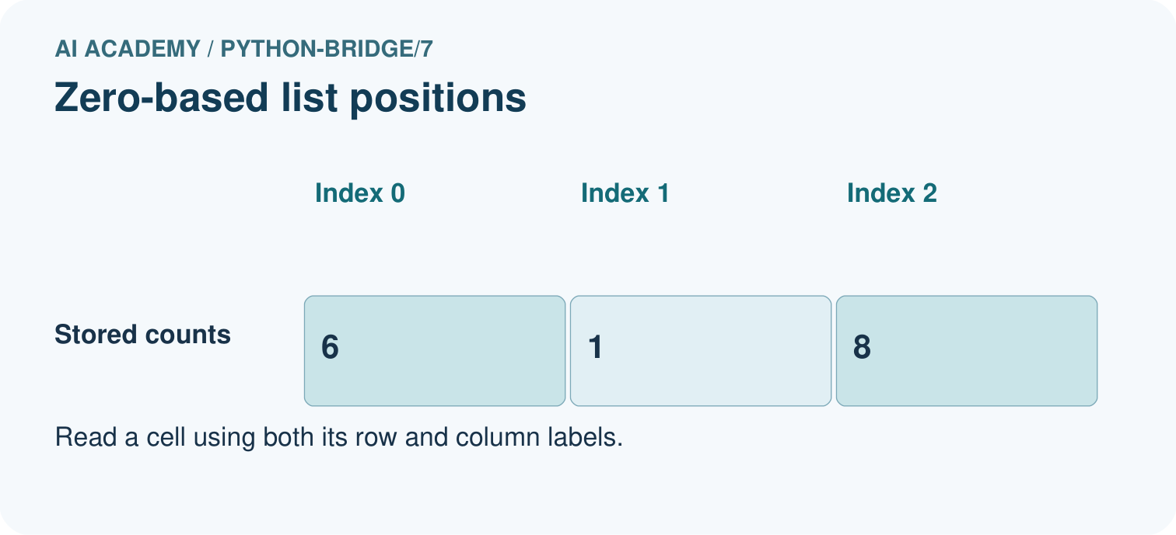
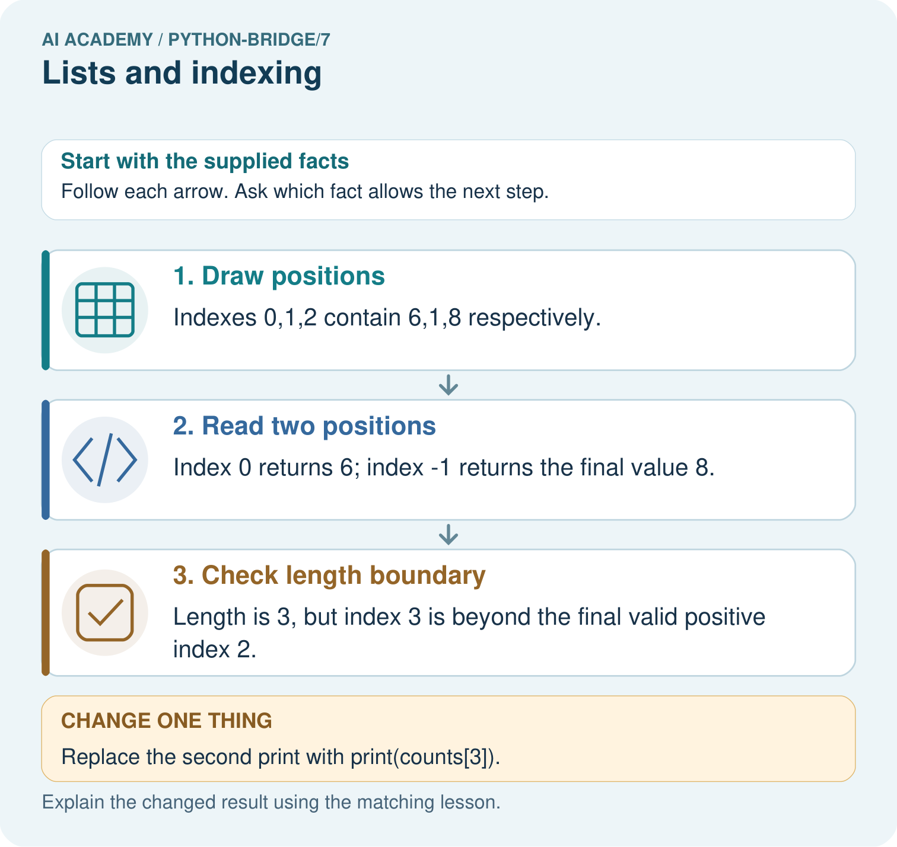

Read the picture one step at a time
Step | What happens and why
1. Draw positions | Indexes 0,1,2 contain 6,1,8 respectively.
2. Read two positions | Index 0 returns 6; index -1 returns the final value 8.
3. Check length boundary | Length is 3, but index 3 is beyond the final valid positive index 2.
Match each pictured step to the supplied facts. This is a worked teaching case, not an independent assessment.

Why this result follows
List positions begin at zero. A negative index counts from the end; the list length counts entries and is not itself a valid positive index for the final entry.

What this example does not establish
A valid position does not establish that the stored count is accurate; empty lists also have no final element to read.
Read the labelled picture: Label the three index positions. Predict all original outputs, then name the first output and stopping point after using index 3.
Change one thing: Replace the second print with print(counts[3]). Predict the result before checking the explanation. What remains the same?

07. Find and repair a mistake
counts = [4, 7, 4]
print(counts[3])
This deliberately faulty script raises IndexError. The list has three items, but its nonnegative indices are 0, 1 and 2. Replace 3 with 2 to read the third item, which is 4. For any nonempty list, len(counts) - 1 identifies the last item using a nonnegative index. An empty list has no valid item index.
Avoid confusing values with positions: for count in counts followed by counts[count] would try indices 4, 7 and 4 in this example. If you need both, use for index in range(len(counts)) and read counts[index]. If you only need a total, looping directly through values is simpler.

Locate the earliest unsupported step
A learner loops with for count in counts and tries to read counts[count] for counts = [4, 7, 4]. Identify the first attempted index and error. Explain how to print each value directly.

State one repair and the checks you would rerun.
________________________________________________________________
________________________________________________________________
________________________________________________________________
________________________________________________________________
________________________________________________________________
________________________________________________________________

08. Practise together
For counts = [4, 7, 4], give the length, valid nonnegative indices and value at index 1. Explain how the two items with value 4 differ.

Change only the list to [2, 0, 5]. Trace the three additions and state the final output. Explain why the middle item is processed even though its value is zero.
________________________________________________________________
________________________________________________________________
________________________________________________________________
________________________________________________________________
________________________________________________________________

Explain your prediction to a partner before comparing results.
________________________________________________________________
________________________________________________________________
________________________________________________________________
________________________________________________________________

Practise with less help: Trace an update
Use workbook W2 for the connected example “Lists and indexing”. First fill the input and rule boxes. Try the middle steps before asking for a hint. After a hint, try the next step yourself.
Plan | Do | Check
What is given? Which rule or procedure applies? | Record each intermediate step. | Does the result follow? What remains unknown?
Explain your trace to a partner. Your partner points to one step to check. Swap roles on the next case. Each person writes their own explanation.

Check your reasoning
Use the worked case for Lists and indexing. Proposed explanation: “Length is the last nonnegative index”. Decide whether this explanation is supported. Point to the step or supplied fact that decides; explain your repair if needed.
Answer on your own before discussion. If you are unsure, say which step you need help with.

Explain the picture
Label the three index positions. Predict all original outputs, then name the first output and stopping point after using index 3.

My explanation using a pictured step and the given facts
________________________________________________________________
________________________________________________________________
________________________________________________________________
________________________________________________________________
This is supported practice. Keep the separately named independent case for an attempt before feedback.

09. Run the investigation

Predict, investigate and preserve the evidence
Start with counts = [4, 7, 4]. Run counts[0] = 6. Write the resulting list, its length and the value at index 2. Predict before running.
counts = [4, 7, 4]
print(len(counts))
print(counts[0])
print(counts[1])
counts[1] = 9
print(counts)
counts = [4, 7, 4]
total = 0
for count in counts:
total = total + count
print(total)
counts = [4, 7, 4]
print(counts[3])
Record | Your evidence
Given input and fixed rule
Prediction before checking
Actual result, or “not run”
First mismatch and one explanation
Boundary or missing input and expected response
On paper, trace the supplied procedure. If code is provided, predict before running it in a local practice file. Never write an expected answer as though it were an observed run.

Plan → try → check
Before trying: what do I expect, and why? While trying: which step could first go wrong? Afterwards: what did I actually observe, and what should change? Keep “not run” if you only traced the procedure.

10. Build your understanding

Explain → apply → challenge
For counts = [4, 7, 4], give the length, valid nonnegative indices and value at index 1. Explain how the two items with value 4 differ.
A learner loops with for count in counts and tries to read counts[count] for counts = [4, 7, 4]. Identify the first attempted index and error. Explain how to print each value directly.
Compare [1, 5, 2] and [5, 1, 2]. State their totals and first items. Would storing only the total answer which first item was larger? Explain.

Explain which evidence supports your conclusion and which claim remains unproved.
________________________________________________________________
________________________________________________________________
________________________________________________________________
________________________________________________________________
________________________________________________________________

11. Connect your project
Add a labelled lists and indexing evidence sheet to Python readiness portfolio. Show how you can distinguish a list index from the value stored at that position. Use the supplied fictional case and keep its inputs, intermediate steps, calculation or prediction, and limitation. Connect this record to last week’s record; a matching answer without a trace is insufficient.
Project evidence | Record
Component and version
Inputs permitted at prediction time
Trace and comparison with earlier work
Failure, limit and human review

Evidence for your project
For Python readiness before the Responsible Plant Classifier, retain a trace of the values, the predicted outputs and the changed-case explanation. Use actual Python 3 results to check the prediction after reasoning first.

12. Show what you know
Before running a script, sketch positions above the stored values. Test an empty list, a one-item list and a list with repeated values. These cases reveal different mistakes. A total alone loses order: [4, 7, 4] and [7, 4, 4] both total 15 even though their first items differ. Data checks should retain the detail needed for the question.

A learner uses counts[len(counts)] to read the final item. Explain the error for [8, 3] and give a valid nonnegative index. Explain why your repair still needs an empty-list check.
________________________________________________________________
________________________________________________________________
________________________________________________________________
________________________________________________________________
________________________________________________________________
Compare [1, 5, 2] and [5, 1, 2]. State their totals and first items. Would storing only the total answer which first item was larger? Explain.

My limited claim and a useful next check
________________________________________________________________
________________________________________________________________
________________________________________________________________
________________________________________________________________

13. Study a complete case

Complete evidence record

Positions and stored counts
Tray position | Index | Value
First | 0 | 4
Second | 1 | 7
Third | 2 | 4
Equal stored values do not imply equal positions. There is no item at index 3.
Follow the input through the stated procedure to its result. Cover the result first, predict it, then explain every intermediate step. The text/table accompanies the figure so the example can be read without colour.

My complete trace of the worked case
________________________________________________________________
________________________________________________________________
________________________________________________________________
________________________________________________________________
________________________________________________________________
________________________________________________________________

14. Try a new case independently

Independent case: Distinguish a value from an index
Predict the three outputs. If the second print uses values[3] instead, where does execution stop and which later output is not produced?
values = [4, 9, 2]
print(values[1])
print(values[-1])
print(len(values))

My independent explanation, trace and limits
________________________________________________________________
________________________________________________________________
________________________________________________________________
________________________________________________________________
________________________________________________________________
________________________________________________________________
________________________________________________________________
Attempt this case before feedback. Record any help. Earlier examples below are further practice; a case already practised with feedback cannot establish fresh transfer.

Attempt this without hints
Start with readings = [3, 0, 3, 2]. Replace the second item with 5 using its index. Write a loop that adds all updated readings and prints one final total. Trace every update of the total. Then test the summing part alone on [] and [6].

My independent procedure, result and limitation
________________________________________________________________
________________________________________________________________
________________________________________________________________
________________________________________________________________
________________________________________________________________
________________________________________________________________
________________________________________________________________
________________________________________________________________
Record support used: none, hint or teacher explanation. After feedback, a different case is needed to demonstrate independence.

Use feedback to improve
Attempt the independent case before hints. Record whether you worked alone, used a hint or followed a model. After feedback, fix the first unsupported step and explain why it changed. A later check uses a changed case, not a copied answer.

15. Your lesson route
Start with this question: Indexes are positions, not values. A list of shelf counts is read by position.
By the end, I can | How I will show it
Distinguish a list index from the value stored at that position | Explain the deciding step, show a trace or test, and state one limit.
Read and update an item using a valid index | Explain the deciding step, show a trace or test, and state one limit.
Trace a loop through list values and test an empty list | Explain the deciding step, show a trace or test, and state one limit.
Remember → watch and explain → try with help → investigate → try independently → keep project evidence. Your teacher may spread this lesson across several classes.
Keep your first prediction. Compare it with what the evidence shows and explain any change.

16. Finish and return
Close your notes. Explain this goal in your own words: Distinguish a list index from the value stored at that position

My deciding step, evidence and one remaining question
________________________________________________________________
________________________________________________________________
________________________________________________________________
________________________________________________________________
________________________________________________________________
If you are unsure, return to the worked picture and explain one arrow. If you are ready, change an input or assumption and justify your prediction.
Save your workbook evidence. At the next review, try a different case before opening your old answer.

17. Supported practice, repair and portfolio
Use this supported practice once, in the browser or on paper. Keep the reserved independent assessment for a separate first attempt before teacher feedback.
Indexes are positions, not values. A list of shelf counts is read by position.

Practice 1: explain the deciding evidence
Which labelled step matches this detail? Length is 3, but index 3 is beyond the final valid positive index 2.
1. Read two positions
2. Check length boundary
3. Draw positions

My selected conclusion, deciding fact and explanation
________________________________________________________________
________________________________________________________________
________________________________________________________________
________________________________________________________________
________________________________________________________________
Hint if needed: Read the steps in the pictorial case. Match the supplied detail to the stage that performs or records it.
After your attempt, compare with the supported explanation: Check length boundary Length is 3, but index 3 is beyond the final valid positive index 2. List positions begin at zero. A negative index counts from the end; the list length counts entries and is not itself a valid positive index for the final entry.

Practice 2: explain the deciding evidence
Changed-case practice: Replace the second print with print(counts[3]). Which conclusion is supported by the supplied facts?
1. The first print shows 6, then IndexError stops the script before the length print.
2. We can decide the result without examining the changed input or the procedure.
3. This one example guarantees correct results for every future input.

My selected conclusion, deciding fact and explanation
________________________________________________________________
________________________________________________________________
________________________________________________________________
________________________________________________________________
________________________________________________________________
Hint if needed: Use the changed condition and the deciding step in the pictorial trace. The answer must say what follows from those facts.
After your attempt, compare with the supported explanation: The first print shows 6, then IndexError stops the script before the length print. The attempted position does not exist.

Repair a missing building block
Review Loops and trace tables (python-bridge/6). Goal: Trace variable values before and after each loop iteration. Short practice: List the four visited values and their running totals. Explain why 5 is absent and what prints for range(1,1).. Return to this week and explain what you changed.
Review Boolean conditions (python-bridge/4). Goal: Translate stated requirements into comparisons. Short practice: Give both comparison results for ages 11, 15 and 16. Which comparison rejects each outside value, and why does and matter?. Return to this week and explain what you changed.
Review From a paper algorithm to Python (python-bridge/1). Goal: Translate a short paper calculation into a Python script. Short practice: Match each paper quantity to its Python name. Why does the spare count get added once, and what prints when spare is five?. Return to this week and explain what you changed.

Predict, run and debug
The browser lab lets you edit the supported Python examples already included in this lesson. Predict first, run, inspect the actual output or error, change one input, then run again. Keep code, predictions, actual results and a reasoned revision together. On paper, label your result as a trace rather than an execution.

Keep your completed work
Use Download completed work in the hosted lesson to export your answers, reflections, practice feedback and code-run evidence. Open the HTML copy to read or print it. Drafts stay in this browser when storage is available; clear drafts on a shared device.

