AI ACADEMY · STUDENT · python-bridge/12

Testing and debugging functions
Project: Python readiness portfolio

Before you start
For capacity 9 and used 2, what should remaining return?

01. Your mission

Your learning target
I can design revealing tests for a function.
I can compare expected and actual results.
I can repair a defect and rerun earlier cases.

Remember before reading
Close your notes first. A rough first answer helps us choose the right starting point; it is not a score for your ability.
Without opening the old lesson, explain one key idea from Reading structured data. Give an example and a mistake that the idea helps you avoid.
Without opening the old lesson, explain one key idea from Return values and local state. Give an example and a mistake that the idea helps you avoid.
Without opening the old lesson, explain one key idea from Loops and trace tables. Give an example and a mistake that the idea helps you avoid.
After trying, check the relevant lesson or ask your teacher. Change the part of your explanation that the evidence shows was wrong.
This week you will practise:
Design revealing tests for a function
Compare expected and actual results
Repair a defect and rerun earlier cases

Retrieve what you already know
For capacity 9 and used 2, what should remaining return?

My starting explanation
________________________________________________________________
________________________________________________________________
________________________________________________________________

This week’s end goal
Trace testing and debugging functions and explain the changed program before running it.

02. Notice the evidence
A function can pass one example by coincidence. Start with a written rule, calculate expected results independently, and include ordinary, zero and boundary cases. We will test a subtraction function under the contract 0 <= used <= capacity.

List the given facts and one fact that is not supplied.
________________________________________________________________
________________________________________________________________
________________________________________________________________

03. See how it works
def remaining(capacity, used):
return capacity - used
cases = [(8, 3, 5), (8, 8, 0), (8, 0, 8)]
for capacity, used, expected in cases:
actual = remaining(capacity, used)
print(actual == expected)

Follow the evidence
Step or case | Evidence | Meaning
Ordinary case | 8 and 3 | Expect 5
Full case | 8 and 8 | Expect 0
Unused case | 8 and 0 | Expect 8
Read each row from left to right and connect the evidence to the stated rule.
Each parenthesized group is a tuple, an ordered group of values. The loop unpacks each group into three names. Equality compares the actual result to the independently calculated expected result. The worked script prints True three times. An assert actual == expected could instead stop at the first mismatch with AssertionError.

Connect the picture and the explanation
Point to the input, the deciding step and the result in this week’s visual. Explain the same step in ordinary words. A picture helps when you can say what each part represents.

04. Compare the cases

Compare a familiar case with a changed case
A faulty function always returns 4. Which of your three cases pass and fail?

Keep the procedure fixed. Explain what changed in the inputs and result.
________________________________________________________________
________________________________________________________________
________________________________________________________________
________________________________________________________________
________________________________________________________________

Change one thing in the pictured case
Change: Remove the test at 3 and keep only 2 and 4.
Prediction: The buggy <= function passes those remaining tests.
Reason: Both procedures agree away from the equality boundary.

05. Words that unlock the idea
Word | Meaning
Test case | Inputs and an expected result
Boundary | An edge of a permitted range
Regression | A previously working case that fails after a change
Assertion | A check that raises an error when its condition is false

Use two terms to explain a step in this week’s example.
________________________________________________________________
________________________________________________________________
________________________________________________________________

06. Follow a worked example

Would replacing the body with return 5 pass every worked case? Identify the first revealing test.
________________________________________________________________
________________________________________________________________
________________________________________________________________
________________________________________________________________
________________________________________________________________
________________________________________________________________

Learn from the worked case
Cover the result before checking it. Say what is given, choose the procedure, and follow one step at a time. Then uncover the result and explain your first mismatch. Ask why a step is allowed, not only what number it produces.

A pictorial worked case: Testing and debugging functions
Use a test that catches the boundary bug. A function should classify an integer as tiny exactly when it is less than three.

The facts we will use
Python 3 intended function: return x<3. Test cases: (2,True),(3,False),(4,False). Candidate bug: return x<=3.
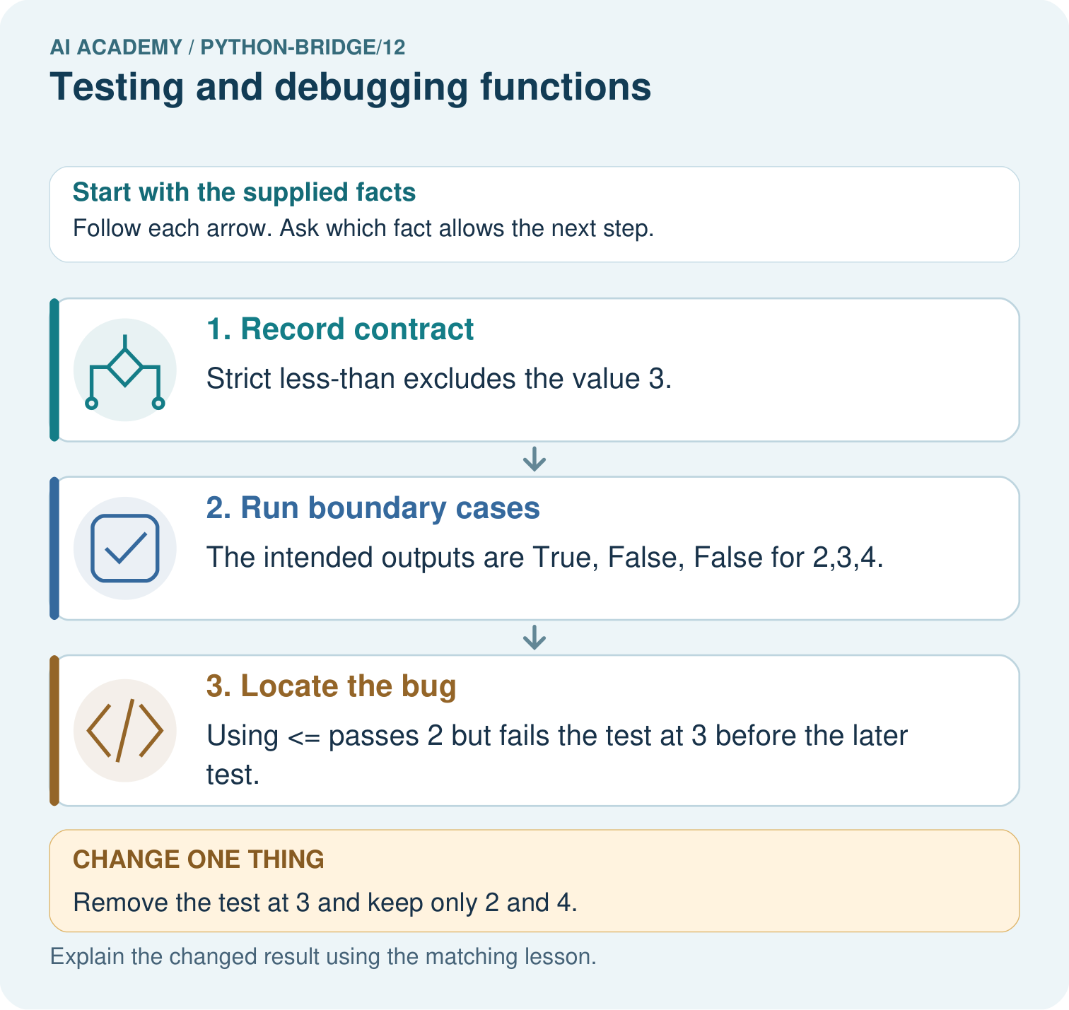

Read the picture one step at a time
Step | What happens and why
1. Record contract | Strict less-than excludes the value 3.
2. Run boundary cases | The intended outputs are True, False, False for 2,3,4.
3. Locate the bug | Using <= passes 2 but fails the test at 3 before the later test.
Match each pictured step to the supplied facts. This is a worked teaching case, not an independent assessment.

Why this result follows
A revealing test distinguishes a correct implementation from a plausible mistake. Checking only values far from the boundary would miss this inclusive-versus-strict bug.

What this example does not establish
Passing these cases does not prove correctness for every type or input; the contract and coverage determine what was actually checked.
Read the labelled picture: Predict the three correct outputs. Which test first catches <=, and why do tests at only two and four miss the bug?
Change one thing: Remove the test at 3 and keep only 2 and 4. Predict the result before checking the explanation. What remains the same?

07. Find and repair a mistake
A faulty return capacity + used gives 11, 16 and 8. The unused case passes even though the rule is wrong. Repair the operator to subtraction and rerun all three cases. Never change an expected result merely to match faulty output.

Locate the earliest unsupported step
A faulty function adds capacity and used. For (6, 2), state actual and expected. Repair it and name a regression case.

State one repair and the checks you would rerun.
________________________________________________________________
________________________________________________________________
________________________________________________________________
________________________________________________________________
________________________________________________________________
________________________________________________________________

08. Practise together
Give expected results for remaining(6, 2), remaining(6, 6) and remaining(6, 0).

Would replacing the body with return 5 pass every worked case? Identify the first revealing test.
________________________________________________________________
________________________________________________________________
________________________________________________________________
________________________________________________________________
________________________________________________________________
________________________________________________________________

Explain your prediction to a partner before comparing results.
________________________________________________________________
________________________________________________________________
________________________________________________________________
________________________________________________________________

Practise with less help: Find a revealing case
Use workbook W2 for the connected example “Testing and debugging functions”. First fill the input and rule boxes. Try the middle steps before asking for a hint. After a hint, try the next step yourself.
Plan | Do | Check
What is given? Which rule or procedure applies? | Record each intermediate step. | Does the result follow? What remains unknown?
Explain your trace to a partner. Your partner points to one step to check. Swap roles on the next case. Each person writes their own explanation.

Check your reasoning
Use the worked case for Testing and debugging functions. Proposed explanation: “A successful run proves the conclusion”. Decide whether this explanation is supported. Point to the step or supplied fact that decides; explain your repair if needed.
Answer on your own before discussion. If you are unsure, say which step you need help with.

Explain the picture
Predict the three correct outputs. Which test first catches <=, and why do tests at only two and four miss the bug?

My explanation using a pictured step and the given facts
________________________________________________________________
________________________________________________________________
________________________________________________________________
________________________________________________________________
This is supported practice. Keep the separately named independent case for an attempt before feedback.

09. Run the investigation

Predict, investigate and preserve the evidence
A faulty function always returns 4. Which of your three cases pass and fail?
def remaining(capacity, used):
return capacity - used
cases = [(8, 3, 5), (8, 8, 0), (8, 0, 8)]
for capacity, used, expected in cases:
actual = remaining(capacity, used)
print(actual == expected)
Record | Your evidence
Given input and fixed rule
Prediction before checking
Actual result, or “not run”
First mismatch and one explanation
Boundary or missing input and expected response
On paper, trace the supplied procedure. If code is provided, predict before running it in a local practice file. Never write an expected answer as though it were an observed run.

Plan → try → check
Before trying: what do I expect, and why? While trying: which step could first go wrong? Afterwards: what did I actually observe, and what should change? Keep “not run” if you only traced the procedure.

10. Build your understanding

Explain → apply → challenge
Give expected results for remaining(6, 2), remaining(6, 6) and remaining(6, 0).
A faulty function adds capacity and used. For (6, 2), state actual and expected. Repair it and name a regression case.
All three stock tests pass. Does that prove correct handling of negative counts?

Explain which evidence supports your conclusion and which claim remains unproved.
________________________________________________________________
________________________________________________________________
________________________________________________________________
________________________________________________________________
________________________________________________________________

11. Connect your project
Add a labelled testing and debugging functions evidence sheet to Python readiness portfolio. Show how you can design revealing tests for a function. Use the supplied fictional case and keep its inputs, intermediate steps, calculation or prediction, and limitation. Connect this record to last week’s record; a matching answer without a trace is insufficient.
Project evidence | Record
Component and version
Inputs permitted at prediction time
Trace and comparison with earlier work
Failure, limit and human review

Evidence for your project
For Python readiness before the Responsible Plant Classifier, retain a trace of the values, the predicted outputs and the changed-case explanation. Use actual Python 3 results to check the prediction after reasoning first.

12. Show what you know
Passing this small suite supports these particular cases. It neither proves every allowed input correct nor checks invalid input handling. A test outside the contract needs a separately specified expected behavior.

All three stock tests pass. Does that prove correct handling of negative counts?
________________________________________________________________
________________________________________________________________
________________________________________________________________
________________________________________________________________
________________________________________________________________
________________________________________________________________
All three stock tests pass. Does that prove correct handling of negative counts?

My limited claim and a useful next check
________________________________________________________________
________________________________________________________________
________________________________________________________________
________________________________________________________________

13. Study a complete case

Complete evidence record

Follow the evidence
Step or case | Evidence | Meaning
Ordinary case | 8 and 3 | Expect 5
Full case | 8 and 8 | Expect 0
Unused case | 8 and 0 | Expect 8
Read each row from left to right and connect the evidence to the stated rule.
Follow the input through the stated procedure to its result. Cover the result first, predict it, then explain every intermediate step. The text/table accompanies the figure so the example can be read without colour.

My complete trace of the worked case
________________________________________________________________
________________________________________________________________
________________________________________________________________
________________________________________________________________
________________________________________________________________
________________________________________________________________

14. Try a new case independently

Independent case: Use boundary tests to reveal a function defect
Predict the output. If the function mistakenly uses x<=10, identify the first failing assertion and whether the final print happens. State the repair and which earlier tests must be rerun. Do these cases prove all input types are handled?
def below_limit(x):
return x < 10
assert below_limit(9) is True
assert below_limit(10) is False
assert below_limit(11) is False
print("three checks passed")

My independent explanation, trace and limits
________________________________________________________________
________________________________________________________________
________________________________________________________________
________________________________________________________________
________________________________________________________________
________________________________________________________________
________________________________________________________________
Attempt this case before feedback. Record any help. Earlier examples below are further practice; a case already practised with feedback cannot establish fresh transfer.

Attempt this without hints
Define stock(packs, loose) to return packs * 4 + loose. Create expected tests for (2, 3), (0, 3), (2, 0), then show which detects a faulty packs + loose body.

My independent procedure, result and limitation
________________________________________________________________
________________________________________________________________
________________________________________________________________
________________________________________________________________
________________________________________________________________
________________________________________________________________
________________________________________________________________
________________________________________________________________
Record support used: none, hint or teacher explanation. After feedback, a different case is needed to demonstrate independence.

Use feedback to improve
Attempt the independent case before hints. Record whether you worked alone, used a hint or followed a model. After feedback, fix the first unsupported step and explain why it changed. A later check uses a changed case, not a copied answer.

15. Your lesson route
Start with this question: Use a test that catches the boundary bug. A function should classify an integer as tiny exactly when it is less than three.
By the end, I can | How I will show it
Design revealing tests for a function | Explain the deciding step, show a trace or test, and state one limit.
Compare expected and actual results | Explain the deciding step, show a trace or test, and state one limit.
Repair a defect and rerun earlier cases | Explain the deciding step, show a trace or test, and state one limit.
Remember → watch and explain → try with help → investigate → try independently → keep project evidence. Your teacher may spread this lesson across several classes.
Keep your first prediction. Compare it with what the evidence shows and explain any change.

16. Finish and return
Close your notes. Explain this goal in your own words: Design revealing tests for a function

My deciding step, evidence and one remaining question
________________________________________________________________
________________________________________________________________
________________________________________________________________
________________________________________________________________
________________________________________________________________
If you are unsure, return to the worked picture and explain one arrow. If you are ready, change an input or assumption and justify your prediction.
Save your workbook evidence. At the next review, try a different case before opening your old answer.

17. Supported practice, repair and portfolio
Use this supported practice once, in the browser or on paper. Keep the reserved independent assessment for a separate first attempt before teacher feedback.
Use a test that catches the boundary bug. A function should classify an integer as tiny exactly when it is less than three.

Practice 1: explain the deciding evidence
Which labelled step matches this detail? Using <= passes 2 but fails the test at 3 before the later test.
1. Locate the bug
2. Record contract
3. Run boundary cases

My selected conclusion, deciding fact and explanation
________________________________________________________________
________________________________________________________________
________________________________________________________________
________________________________________________________________
________________________________________________________________
Hint if needed: Read the steps in the pictorial case. Match the supplied detail to the stage that performs or records it.
After your attempt, compare with the supported explanation: Locate the bug Using <= passes 2 but fails the test at 3 before the later test. A revealing test distinguishes a correct implementation from a plausible mistake. Checking only values far from the boundary would miss this inclusive-versus-strict bug.

Practice 2: explain the deciding evidence
Changed-case practice: Remove the test at 3 and keep only 2 and 4. Which conclusion is supported by the supplied facts?
1. The buggy <= function passes those remaining tests.
2. This one example guarantees correct results for every future input.
3. We can decide the result without examining the changed input or the procedure.

My selected conclusion, deciding fact and explanation
________________________________________________________________
________________________________________________________________
________________________________________________________________
________________________________________________________________
________________________________________________________________
Hint if needed: Use the changed condition and the deciding step in the pictorial trace. The answer must say what follows from those facts.
After your attempt, compare with the supported explanation: The buggy <= function passes those remaining tests. Both procedures agree away from the equality boundary.

Repair a missing building block
Review Reading structured data (python-bridge/11). Goal: Process a list of records consistently. Short practice: Circle the included rows, calculate the sum and mean, and state coverage. Repeat after adding the fourth row with count four.. Return to this week and explain what you changed.
Review Return values and local state (python-bridge/9). Goal: Use a returned value in a later calculation. Short practice: Trace the two returned values and explain why first stays seven. What happens if the caller tries to print result directly?. Return to this week and explain what you changed.
Review Loops and trace tables (python-bridge/6). Goal: Trace variable values before and after each loop iteration. Short practice: List the four visited values and their running totals. Explain why 5 is absent and what prints for range(1,1).. Return to this week and explain what you changed.

Predict, run and debug
The browser lab lets you edit the supported Python examples already included in this lesson. Predict first, run, inspect the actual output or error, change one input, then run again. Keep code, predictions, actual results and a reasoned revision together. On paper, label your result as a trace rather than an execution.

Keep your completed work
Use Download completed work in the hosted lesson to export your answers, reflections, practice feedback and code-run evidence. Open the HTML copy to read or print it. Drafts stay in this browser when storage is available; clear drafts on a shared device.

