AI ACADEMY · TEACHER · ai-1/3

Sensors Are Messengers
Project: Helpful Classroom Sorter

01. Sensors Are Messengers

Teach the learning cycle
Primary target: Describe a measurement using its quantity, value, unit and conditions
Session | Sequence and minutes | Resources
Session 1 · Understand · 45 min | 0–7: recall and prerequisite; 7–15: inspect the concrete case and predict; 15–30: teacher models the worked trace; 30–40: learners explain a step using the text and visual; 40–45: check the core idea. | Sections 1–6; record the brief recall in the workbook.
Session 2 · Practise · 45 min | 0–5: retrieve the procedure; 5–15: W2 completion practice; 15–23: explain and check with a partner; 23–30: each learner answers the misconception check; 30–40: targeted reteaching or a harder variation; 40–45: prepare the investigation. | Sections 7–10; use the matching workbook W2 and misconception check.
Session 3 · Investigate and transfer · 45 min | 0–5: retrieve the decision rule; 5–20: investigate or trace; 20–30: start the independent case; 30–38: connect the project; 38–43: act on feedback; 43–45: plan the return check. | Sections 9 and 11–14. Give extra time to finish the full task set; use Section 15 when the week includes a coding lab.
This is a starting allocation of 135 minutes, not a validated duration. Preserve all named topics. Schedule extra time for connected examples, the full investigation, independent cases and project building. Repeated copies of a case share one recorded attempt; they are not new evidence.

Retrieval answer guidance

Input, Process, Output
Without opening the old lesson, explain one key idea from Input, Process, Output. Give an example and a mistake that the idea helps you avoid.
Look for: Trace information through a system without confusing information with a physical action
Reference example, not the only acceptable wording: Input includes both request fields and all three catalogue records. The process checks science AND pages<=120. Output contains A only; B fails the length condition and C fails the genre condition. Listing A does not establish that a copy was reserved.
Use the student module and workbook section with this exact week title. The worked case, independent question and answers below form one aligned lesson sequence.

What the learner must demonstrate
Two light sensors report 40 and 80 in different rooms. Their settings and units are unknown. Can you conclude the second room is twice as bright? Design a fair comparison without using a camera or personal data.

Concept to explain
Sensors measure signals; later processing gives those signals meaning.
Term | Meaning
sensor | device that measures a physical signal
signal | a changing quantity that can be measured
measurement | a recorded value describing part of a signal
data | represented information available for processing

Prepare the class
Use the supplied scenario, student illustrations and blank paper. For numeric work, offer counters or a calculator after learners show the setup. Fictional records are supplied; personal data and paid accounts are unnecessary.
Allow 80 minutes: recall 8; explanation 12; worked demonstration 15; guided practice 20; independent assessment 15; project and reflection 10. Extend the lab into a second session when needed.

Preparation for the connected explanation
Separate physical quantity, recorded measurement and interpretation throughout. No hardware is required. Avoid describing every difference as error or every repeated value as accuracy. Consistent disagreement is a finding; deciding which device is accurate requires additional reference evidence. Keep units visible in both speech and written work.

Readiness answer
No. A maximum of 26 degrees C could occur at noon or at 3 pm. The retained number does not preserve time.
The paired-temperature table and two paper device labels
A sketch of a classroom with a window, shaded wall, speaker and door
Optional ordinary room thermometers used according to school procedures; paper data is sufficient

End goal for the pictorial case
By the end, I can compare sensor readings while controlling where and when they are measured.
This added worked case illustrates the week’s main idea. Retain all original and connected topics; schedule its practice within the teaching cycle.

02. Explain the mechanism

Explain the mechanism
Follow the information instead of imagining magic inside the machine.
INPUT light, sound, or heat from the environment
PROCESS a sensor converts the signal into recorded values
OUTPUT numbers or pixel/sound data sent to a later process
CORE IDEA Sensors measure signals; later processing gives those signals meaning.
UNDER THE HOOD A sensor is a transducer: it converts a physical quantity into a signal a computing system can represent. Sensing and interpretation are separate. A camera measures light; an image model may later infer a label.
Draw a fresh example with all three stages:
Every step connects a claim to observable evidence.
CASE A classroom weather station measures light, sound, and temperature but does not decide what those measurements mean.
STEP 1 — OBSERVE light, sound, or heat from the environment
STEP 2 — TRACE a sensor converts the signal into recorded values
STEP 3 — CONCLUDE numbers or pixel/sound data sent to a later process
MODEL REASONING 820 could be a light measurement, 24 C comes from a temperature sensor, and changing sound values come from a microphone. The numbers alone do not prove whether the plant needs water or whether a voice was present; later processing must interpret them.
DO NOT OVERCLAIM Do not say a sensor sees, hears, or understands. It measures and sends a representation.
What new evidence could change this answer?

Concrete teaching case
A light sensor reads 15 in a cupboard and 90 near a window. A microphone records a clap.
Which measures a light-related signal? Can either directly measure happiness?

Exact explanation to model
The light sensor measures light; the microphone measures sound. Neither directly measures feelings. Units and calibration matter when comparing devices.

Explain the added worked example
A garden display shows 24. Is that warm? We cannot interpret the number until we know what was measured and the unit. It might mean 24 degrees Celsius, 24 percent soil moisture according to a particular device, or 24 hours since watering. The screen alone does not supply the missing meaning.
A useful measurement record names the quantity, value, unit, time and relevant conditions. For air temperature, the location and exposure matter: a device in direct sunshine may warm differently from one in shade. Record the conditions rather than assuming that every nearby device measured the same situation.
Measurement is a way of representing part of the physical world. It does not capture everything about that world. One air-temperature reading does not tell us how dry the roots are, whether a plant is diseased or whether watering is permitted.
The sensor responds to a physical quantity. Electronics convert the response into a recorded value. A later program can compare the value with a threshold. Nothing about this path requires us to claim that the sensor understands plant health.
The rule uses exceeds 28, so a reading of exactly 28 does not trigger it. At 29 it does. This boundary is a property of the written rule; it is separate from the question of whether the measuring device is accurate enough for the intended purpose.

Key terms
Term | Meaning
Sensor | A device that responds to a physical quantity and helps turn it into a signal
Measurement | A value obtained by comparing a quantity with a scale or standard
Unit | An agreed amount used to express a quantity, such as a second or a degree Celsius
Variation | Differences among readings or observations
Calibration | Checking and, when appropriate, adjusting a measuring system against a reference

Model the reasoning aloud
Use the complete worked example below before asking learners to complete W2. Reveal a small part, invite a prediction, then explain the deciding step. These teacher notes contain solutions; do not reveal the independent case answer during modelling.
Two devices are placed side by side in a shaded room and allowed to settle. At three agreed times, device A reads 20, 21 and 20 degrees C; device B reads 22, 23 and 22 degrees C. B is 2 degrees higher on every comparison. That pattern is evidence of a consistent difference under these test conditions.
10:00 | 20 | 22 | 2
10:05 | 21 | 23 | 2
10:10 | 20 | 22 | 2
We cannot conclude from agreement patterns alone that A is correct and B is wrong. A suitable checked reference can help investigate. We also need to consider whether the devices have different response times, resolutions or placement. Three comparisons in one room do not prove performance in every temperature range.
Calibration is a reference check, sometimes followed by an adjustment. Do not simply subtract 2 from every future B reading because these three pairs happened to differ by 2. A correction needs support over the conditions where it will be used.
Thinking move | Teacher prompt
Plan | What is given? What is the question? Which procedure fits these facts?
Do | Point to each input and intermediate step in the worked trace. Name the rule that allows the next step.
Check | Does the output answer the question? Which assumption or limitation prevents a larger claim?
Use the diagram and verbal explanation together. Ask learners to match a sentence to a specific visual step; do not assign learners fixed visual or auditory learning styles.

A pictorial worked case: Sensors Are Messengers
Two fictional light sensors disagree in a classroom. Compare them fairly rather than declaring one broken.

The facts we will use
On the same shelf, simultaneous readings are A: 40,50,60 and B: 45,55,65 in declared toy light units.
Neither device has been compared with a trusted reference.
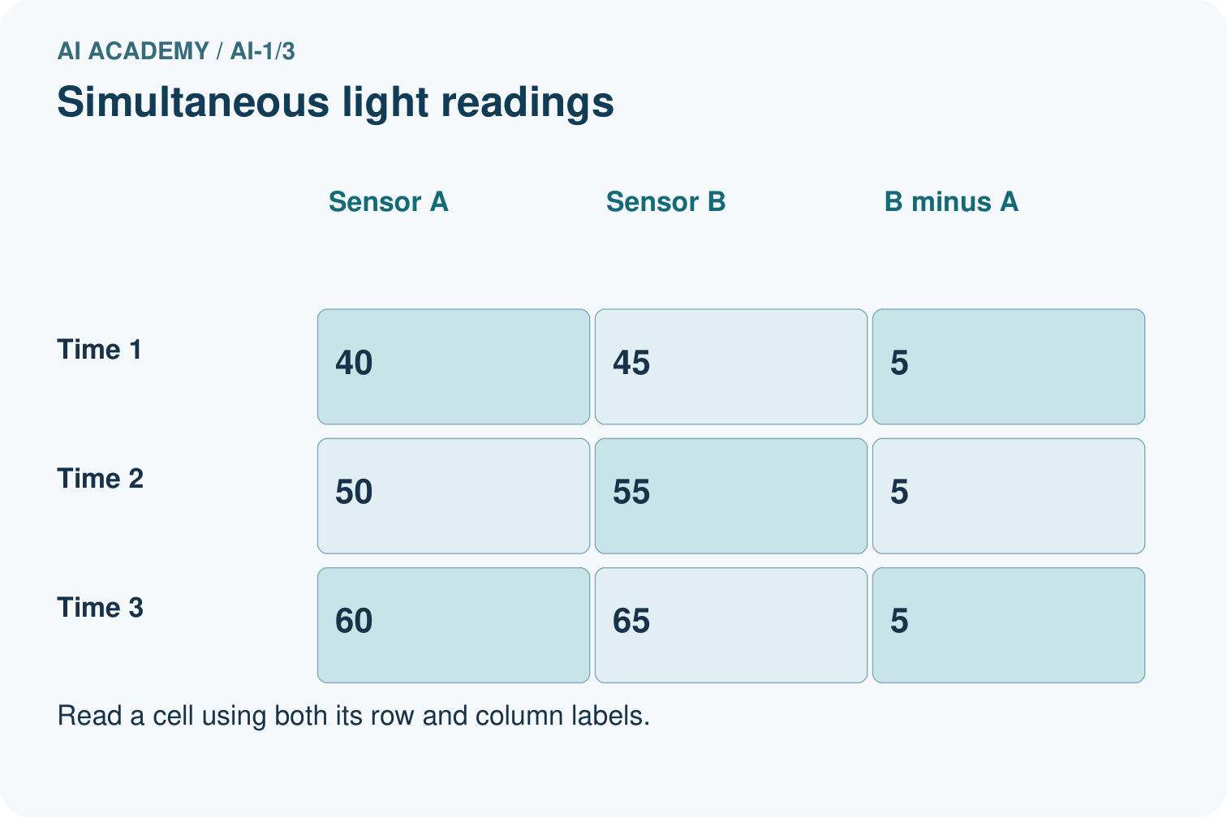
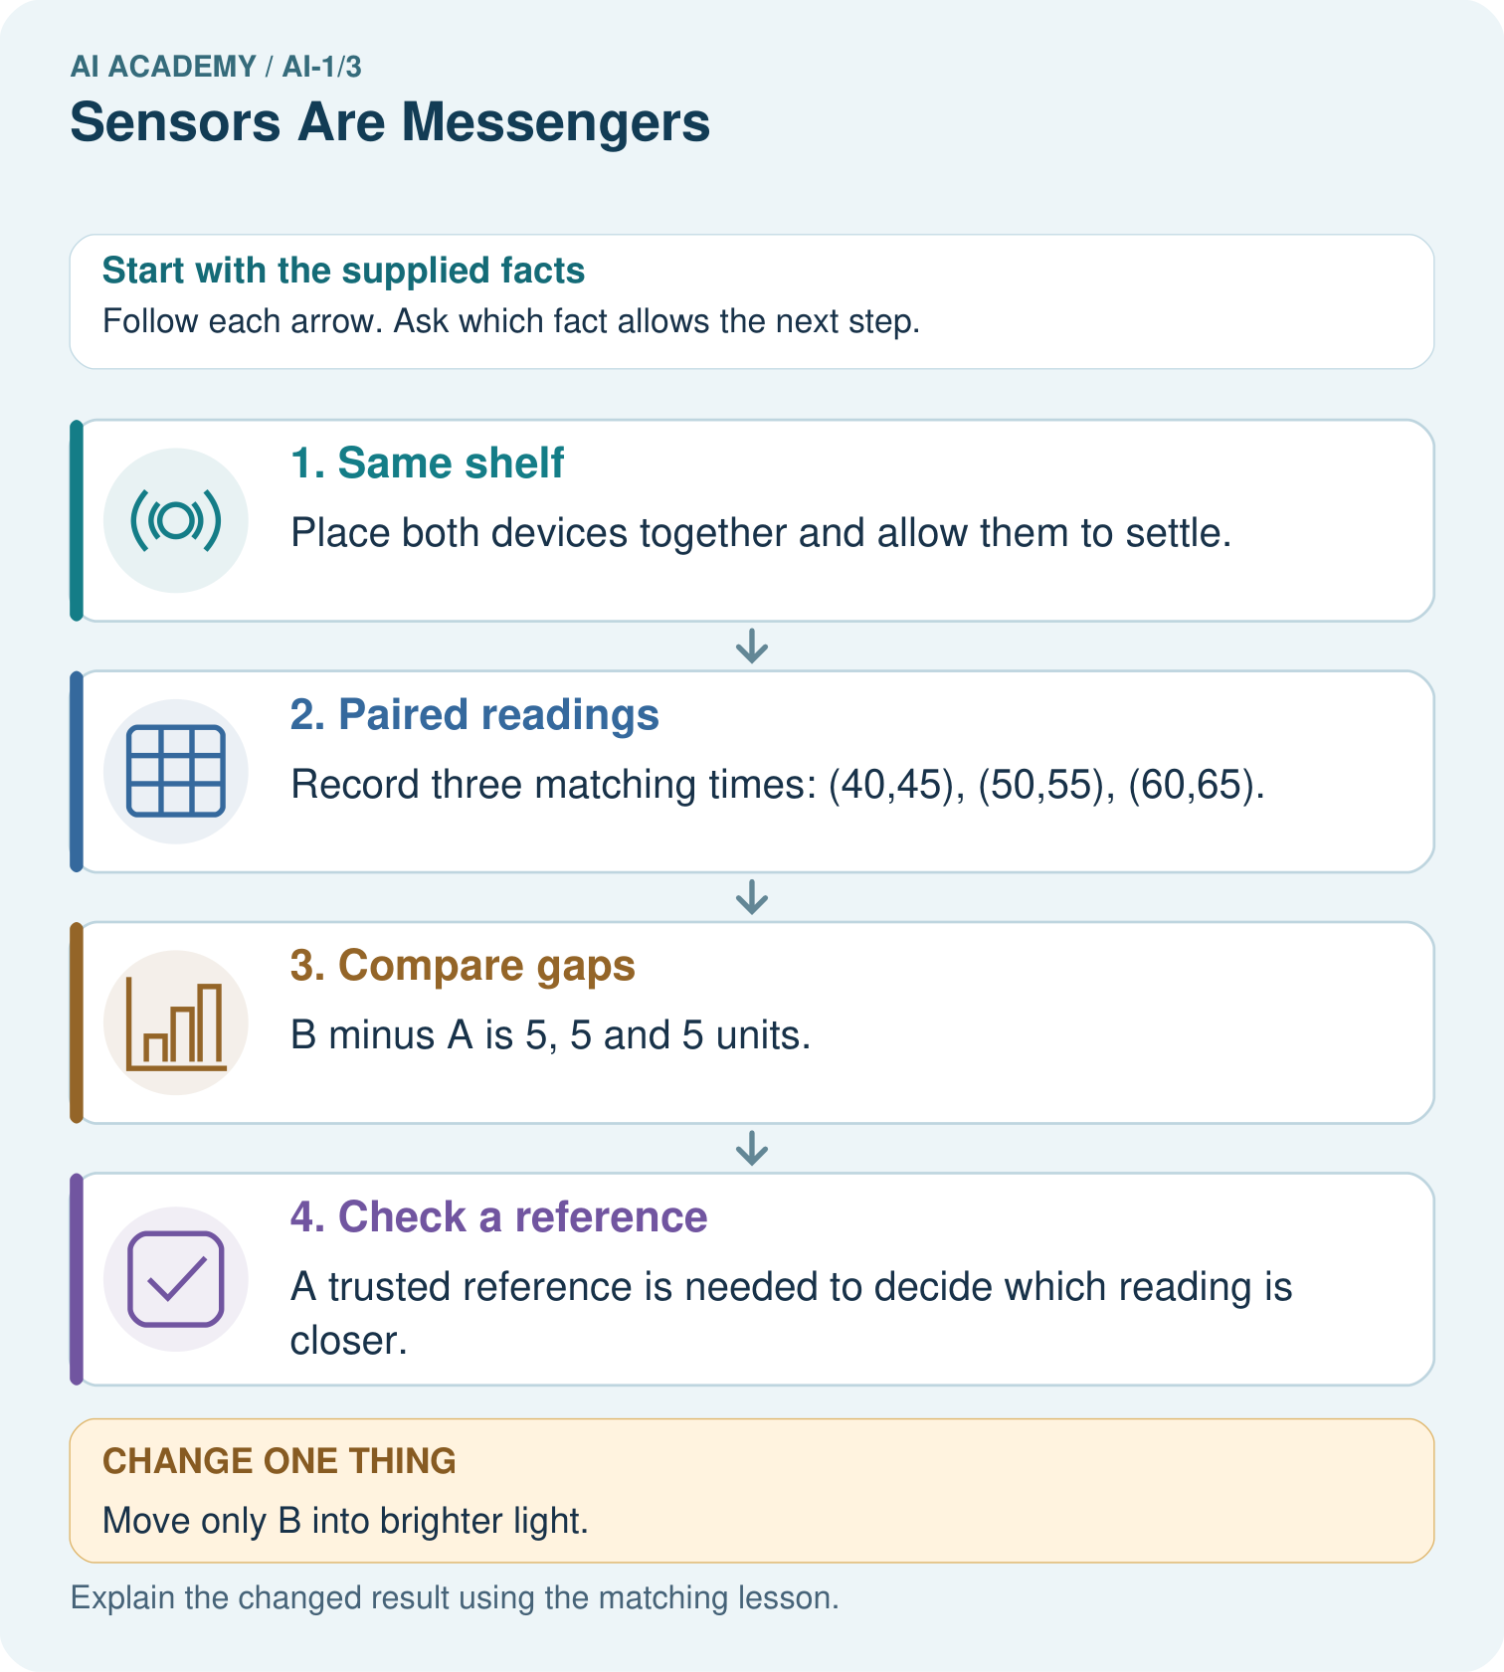

Read the picture one step at a time
Step | What happens and why
1. Same shelf | Place both devices together and allow them to settle.
2. Paired readings | Record three matching times: (40,45), (50,55), (60,65).
3. Compare gaps | B minus A is 5, 5 and 5 units.
4. Check a reference | A trusted reference is needed to decide which reading is closer.
Match each pictured step to the supplied facts. This is a worked teaching case, not an independent assessment.

Why this result follows
A repeated difference of 5 supports investigating an offset between devices. Matching time and location removes two obvious comparison problems. It does not show which device is correct: both could have errors. Preserve paired readings instead of adjusting them silently.

What this example does not establish
Three pairs do not prove an offset holds at every light level, nor identify the accurate device.

Change one thing in the pictured case
Change: Move only B into brighter light.
Prediction: The next gap could change for reasons other than a difference in device accuracy.
Reason: The comparison now changes location as well as device; there is no supplied reading from the new location.

Ask while showing the picture
Cover the result. Ask learners to name the inputs and predict the next step. Uncover one step, connect the icon to the actual procedure, and explain its evidence. Then change the supplied condition and compare. The picture is a representation; it does not document execution of a real AI model.

03. Demonstrate and guide practice

Demonstrate and guide practice

Board sequence
Write the given facts: A light sensor reads 15 in a cupboard and 90 near a window. A microphone records a clap.
Write the question to explain: Which measures a light-related signal? Can either directly measure happiness?
Reveal after predictions: The light sensor measures light; the microphone measures sound. Neither directly measures feelings. Units and calibration matter when comparing devices.
Keep for an independent attempt: A station reports light level 18 and temperature 22 degrees C. Which sensor produced each reading? Can either reading alone tell whether a child feels comfortable? Explain.

Classroom dialogue
Ask: Which facts are given, and which would we have to assume? Learners mark relevant details before discussing answers.
Say: Predict first. Show the rule, information path or calculation that would produce the result. A correct guess is not yet an explanation.
Reveal reasoning one step at a time. Explain why a tempting alternative fails. Write units and denominators for arithmetic, trace conditions for decisions, and identify supporting sources for claims.
In pairs, one learner solves while the other checks evidence; exchange roles. Remove the worked answer before independent assessment.

Model these guided questions
Put the devices together, use comparable settings and times, allow settling and repeat, or swap positions while recording conditions. If the difference follows position, location is plausible; if it follows device, investigate the device or settings. For the exit: ask what quantity and unit 30 refers to, when and where it was measured, and whether that measurement is suitable for the rule.

Case-specific teaching sequence
Stage | Teacher action
Session 1 start 0 to 7 minutes | Retrieve information loss with the maximum-temperature prompt. Ask what time information disappeared.
7 to 20 minutes | Show only 24. Collect possible meanings, then build a measurement record with unknown fields.
20 to 33 minutes | Trace the garden diagram and test 27, 28 and 29. Separate sensing from the rule.
33 to 45 minutes | Pairs complete W1 and W2. Reject invented record details while accepting explicit unknowns.
Session 2 start 0 to 8 minutes | Compute paired differences in the worked table. Ask whether consistent disagreement identifies the correct device.
8 to 23 minutes | Model a location comparison. Complete W3 and discuss what a reference adds.
23 to 38 minutes | Collect W4 independently. Ask for two predicted outcomes, not just a procedure.
38 to 45 minutes | Use W5 and the exit question to distinguish measurement from an unsupported plant-health claim.

Reduce help deliberately
Completion task: A warning rule is recorded temperature greater than 28 degrees C. State its output for 27, 28 and 29 degrees C. Explain why an off warning does not prove that the sensor is working correctly.
Teacher check: 27 off, 28 off, 29 on. These outputs follow the comparison applied to the recorded values. A device could report an incorrect low value while the rule correctly stays off; measurement quality needs a separate check.
Start by identifying the given inputs together. Leave the intermediate steps blank. If needed, model one step, then withdraw that help on the next step. Move to a full trace only when the partial trace is understood. For partners, alternate explainer and checker; collect a response from every learner before discussion.

Individual reasoning check
Use the worked case for Sensors and measurement. Proposed explanation: “The more stable device must be accurate”. Decide whether this explanation is supported. Point to the step or supplied fact that decides; explain your repair if needed.
Expected correction: A device can repeatedly report an offset value. Stability and closeness to a reference answer different questions.
Collect explanations, not only yes/no votes. If a misunderstanding is common, re-model the relevant step for the class. If it affects a few learners, give a short targeted group explanation while others solve a more demanding variation.

Pictorial practice question
Why can we calculate the earlier gap but not predict an exact new B reading?

Reasoned teacher answer
The earlier pairs give 5 each time. No measurement or light-response rule is given for B’s new location.
Changed-case reasoning: The next gap could change for reasons other than a difference in device accuracy. The comparison now changes location as well as device; there is no supplied reading from the new location.
Collect each learner’s explanation before discussion. Use the first missing connection between input, deciding step and result to choose support. This question is worked-case practice, not fresh mastery evidence.

04. Run the weekly evidence lab

Run the weekly evidence lab
Predict first, test honestly, and explain what the evidence means.
State your prediction before the result is known.
Complete the task: Match camera, microphone, and temperature sensors to data.
Keep a normal case and an edge case clearly separated.
Record what happened—even when it does not match your prediction.
Explain the result, one limitation, and the next useful test.
INDEPENDENCE After support is removed, repeat the proof with a fresh case.

Make the lab runnable
Use the concrete case as the shared normal case and the independent question as a second case. Each pair creates a boundary or missing-information case and predicts its result before testing. Keep the expected result separate from an observed mistake.
Record | What to capture
Input or evidence | Exact data, instruction or claim
Expected result | Answer or safe fallback declared before the run
Observed result | Actual result, including errors
Explanation | Rule, calculation or evidence explaining the outcome
Next test | One justified change and a new prediction

Diagnose and reteach
CLAIM TO REPAIR A sensor knows what a person feels.
For guessing, return to given facts and request a trace. For vocabulary without application, use one example and one non-example. For arithmetic errors, check the setup before the calculation. Finish with a different uncoached case before recording mastery.

Address these additional misconceptions
The more stable device must be accurate: A device can repeatedly report an offset value. Stability and closeness to a reference answer different questions.
The warning proves the condition in the world: Trace the recorded number into the rule. An incorrect or irrelevant input can produce a correctly computed warning.
Missing details can be filled with sensible guesses: Keep unknown fields explicit until evidence supplies them. Guesses must be labelled as assumptions.

Match the support to the first error
What the response shows | Next teaching action
Missing or misread facts | Read the case aloud, mark supplied versus unknown facts, and let the learner restate it.
Wrong procedure | Return to the deciding step in the worked case. Contrast it with the proposed incorrect explanation.
Arithmetic or implementation error | Trace intermediate values or lines; preserve the first mismatch and retry that step.
Correct result without a reason | Ask for a trace and a changed case before marking independent understanding.
An unsupported wider claim | Ask which supplied evidence supports the claim and which further observation would be needed.
Offer an oral explanation, drawing, enlarged visual or fewer examples when that removes a reading/writing barrier. Keep the same reasoning goal. Stretch secure learners by changing a boundary or assumption and asking them to defend the effect, not simply by assigning more of the same questions.

05. Assess and explain the answers

Assess and explain the answers

Worked case answer
The light sensor measures light; the microphone measures sound. Neither directly measures feelings. Units and calibration matter when comparing devices.

Independent question
A station reports light level 18 and temperature 22 degrees C. Which sensor produced each reading? Can either reading alone tell whether a child feels comfortable? Explain.

Expected independent answer
A light sensor produced 18; a temperature sensor produced 22 degrees C. Neither directly measures a child's comfort. Ask the person rather than treating a measurement as their feelings.

What counts as evidence
Criterion | 0 points | 1 point | 2 points
Result | Incorrect or absent | Partly correct | Correct with necessary conditions
Reasoning | No supporting trace | Some steps | Clear mechanism, calculation or source support
Limit | Overclaims certainty | Vague limitation | Relevant uncertainty or missing fact
Transfer | Copies without adapting | Adapts with prompts | Solves a changed case independently
Use 6/8 as a classroom checkpoint, with 2 required for both Result and Reasoning. This is a proposed teaching rule, not a validated certification threshold. Do not count a coached answer as independent mastery; correct unsafe or unsupported claims regardless of total.

Feedback
Ask the learner to find the evidence that challenges this claim: “A sensor knows what a person feels.” Keep the first attempt and an uncoached retry separate.

Original transfer answer
No: scales, calibration and settings may differ. Use the same calibrated sensor and settings in both rooms, record units and repeat at comparable positions and times. A larger uncalibrated number alone cannot establish a brightness ratio.

Explanations for the additional workbook examples

W1 Repair an incomplete record
A notebook entry says 24 at lunchtime. Rewrite it as a useful air-temperature record by stating which missing fields must be collected. Do not invent values that were not observed.
Keep the observed value 24 and approximate time lunchtime; mark the unit, exact time if needed, location, exposure and device identity as unknown or to be checked. A suitable completed record needs air temperature, value, unit and relevant conditions. Invented degrees C or shade is not an observation.

W2 Trace a boundary
A warning rule is recorded temperature greater than 28 degrees C. State its output for 27, 28 and 29 degrees C. Explain why an off warning does not prove that the sensor is working correctly.
27 off, 28 off, 29 on. These outputs follow the comparison applied to the recorded values. A device could report an incorrect low value while the rule correctly stays off; measurement quality needs a separate check.

W3 Compare without choosing a winner
At the same three times, A records 18, 19 and 18 degrees C and B records 21, 22 and 21 degrees C in the same location. Calculate the paired differences. What is established, and what further evidence would help judge accuracy?
B minus A is 3, 3 and 3 degrees C. This establishes a consistent observed difference in these comparisons. It does not show which device is closer to the actual temperature. Use an appropriate checked reference, allow settling, record conditions and investigate across the intended range.

W4 Investigate a new measurement dispute
A classroom sound display near a speaker reads higher than one near the door. A student declares the door device broken. Propose a safe comparison using normal classroom sound. Predict one result consistent with location explaining the difference and one result that would leave a device difference worth investigating.
Place both devices side by side under the same normal sound conditions, using the same settings and reading times, or exchange positions and repeat. If readings become similar together or the higher reading follows the speaker location, location is a plausible explanation. If one device remains consistently lower side by side or after swapping, a device or setting difference remains plausible. Neither result alone proves a device broken; a checked reference and repeated observations help.

W5 Limit a system's conclusion
An air-temperature sensor reports 29 degrees C and a rule turns on a warning. Someone writes The plant is thirsty. Explain the unsupported step and name information more directly relevant to deciding whether watering is needed.
Crossing an air-temperature threshold does not establish root-zone dryness or a plant's watering need. Soil conditions, the kind of plant, recent watering and a gardener's inspection are more relevant. The warning can be correctly on while the thirst claim remains unsupported.

Assess independent transfer
Selected case: A classroom sound display near a speaker reads higher than one near the door. A student declares the door device broken. Propose a safe comparison using normal classroom sound. Predict one result consistent with location explaining the difference and one result that would leave a device difference worth investigating.

Selected case answer
Place both devices side by side under the same normal sound conditions, using the same settings and reading times, or exchange positions and repeat. If readings become similar together or the higher reading follows the speaker location, location is a plausible explanation. If one device remains consistently lower side by side or after swapping, a device or setting difference remains plausible. Neither result alone proves a device broken; a checked reference and repeated observations help.
Dimension | Evidence required
Explanation | Names the applicable idea or procedure and ties it to the supplied facts.
Trace and result | Preserves the given inputs and shows the relevant intermediate steps; distinguishes a prediction from an observed execution.
Limits | States the assumptions, missing evidence or conditions under which the result would change.
Record each dimension as not yet, with support, or independent. Accept a valid alternative procedure with a defensible trace. Do not penalise an honestly recorded model failure if the learner correctly explains its evidence and limits.

Feedback that the learner uses
Name the earliest unsupported step and give one action to repair it. Have the learner make that repair now and explain why. Then assess the relevant skill on a fresh, fully specified case. Confirm it was not previously practised with feedback; solve and check the new case before assigning it. A follow-up design prompt is a starting brief, not automatically an equivalent test.

06. Connect and extend learning

Connect and extend learning

Helpful Classroom Sorter
Mark which sensor, if any, would collect each Classroom Sorter input; prefer direct human entry when a sensor is unnecessary.
Keep the decision, input, result, explanation and remaining limitation in the project evidence record. Retrieve this record next week rather than restarting the project.

Support and stretch
Use physical cards, spoken explanations and a three-stage drawing. Read aloud without giving the answer. Stretch: compare two mechanisms with the same visible output and explain what evidence distinguishes them.

Exit reflection
Ask for one decision the learner can now justify and one situation requiring more evidence or human review. Confidence ratings are separate from correct independent performance.

Bridge to the next week
Next: Week 4: Rules or Learned Patterns?. Retrieve today’s evidence and identify what carries forward and what is new.

Support and fresh reassessment
Give a record frame with quantity, value, unit, time and location boxes. Use a number line for paired differences. Extension: discuss why devices that round to whole degrees can differ at a boundary without either being grossly faulty.
W4 is secure when it controls location or device identity in a meaningful comparison, keeps ordinary safe conditions, states two interpretable outcomes and avoids declaring certainty. If the learner only says try again, ask which factor will change and what each possible result would mean. Retest independently with light readings at a desk and window.
Week 4 uses reliable recorded features to compare an explicitly written rule with a rule selected from labelled examples.

Plan the delayed return
Suggested return points in this level: ai-1/4, ai-1/6, ai-1/9. Use actual classroom dates, adjusting for holidays and gaps. One, three and six teaching weeks are scheduling choices, not a claimed optimal spacing.
At a delayed check, ask for the idea from memory and a changed application. Compare with the earlier independent response and record support used. For a new level, revisit the previous capstone before checking the new prerequisites.
Record | Teacher evidence
Learner code and date
Concept and case used; prior exposure
Explanation / trace / limits
Support and first repair
Changed case and delayed outcome
Next teaching action
Use the evidence to choose reteaching or the next step. A completed page, confidence rating or attractive project does not by itself demonstrate understanding.

Project evidence from this case
Save sorter measurements with device, location and time so unusual inputs can be checked before decisions.

07. Prepare, teach and assess
Teaching target: Describe a measurement using its quantity, value, unit and conditions
Prepare the labelled worked-case picture, the matching workbook, fictional input cards and a place for individual responses. No paid AI account is required for the paper reasoning activities.
Session | Plan | Resources
Session 1 · Understand · 45 min | 0–7: recall and prerequisite; 7–15: inspect the concrete case and predict; 15–30: teacher models the worked trace; 30–40: learners explain a step using the text and visual; 40–45: check the core idea. | Sections 1–6; record the brief recall in the workbook.
Session 2 · Practise · 45 min | 0–5: retrieve the procedure; 5–15: W2 completion practice; 15–23: explain and check with a partner; 23–30: each learner answers the misconception check; 30–40: targeted reteaching or a harder variation; 40–45: prepare the investigation. | Sections 7–10; use the matching workbook W2 and misconception check.
Session 3 · Investigate and transfer · 45 min | 0–5: retrieve the decision rule; 5–20: investigate or trace; 20–30: start the independent case; 30–38: connect the project; 38–43: act on feedback; 43–45: plan the return check. | Sections 9 and 11–14. Give extra time to finish the full task set; use Section 15 when the week includes a coding lab.
Before class, solve the supported practice: A warning rule is recorded temperature greater than 28 degrees C. State its output for 27, 28 and 29 degrees C. Explain why an off warning does not prove that the sensor is working correctly.
Reasoned practice answer: 27 off, 28 off, 29 on. These outputs follow the comparison applied to the recorded values. A device could report an incorrect low value while the rule correctly stays off; measurement quality needs a separate check.
Check every learner before discussion: Use the worked case for Sensors and measurement. Proposed explanation: “The more stable device must be accurate”. Decide whether this explanation is supported. Point to the step or supplied fact that decides; explain your repair if needed.
Misconception repair: A device can repeatedly report an offset value. Stability and closeness to a reference answer different questions.
Support: read the exact case aloud, enlarge the labelled picture, supply input cards and model only the first deciding step. Accept a spoken explanation or drawing; retain the reasoning goal.
Extension: Move only B into brighter light. Require a prediction and a reason before comparing. Expected result: The next gap could change for reasons other than a difference in device accuracy. Reason: The comparison now changes location as well as device; there is no supplied reading from the new location.
Independent assessment: withhold the reserved answer until the learner has attempted the new case. Record support separately from correctness.
Criterion | Not yet | With support | Independent
Explanation | Names an answer without a deciding fact | Uses a hint to link fact and decision | Explains the deciding fact in own words
Trace or test | Cannot connect input and result | Completes steps with prompts | Traces or tests a changed case accurately
Limits and revision | Claims more than evidence supports | Names a limit after a prompt | States a defensible limit and useful next test
Project checkpoint: Frame the need. Name the user, the problem, allowed inputs and a safe simple starting method.
Use the weekly teacher answer for topic-specific reasoning. A saved progress tick is an activity record; judge mastery from the learner’s explanation and evidence.

08. Use feedback, labs and repair paths
Use the two formative questions as supported practice, not as independent mastery scores. Discuss the deciding evidence rather than accepting a guessed selection.
The feedback comes from the reviewed public worked case. Do not reveal the separately reserved independent teacher answer until the learner has attempted that case.
Ask students to predict before running code. Preserve errors and actual outputs; collect a changed test and an explanation. The branch-boundary and indexing lessons deliberately include failure cases.
Use the earlier worked-explanation links to address a specific missing building block, then return to the current question. Adapt this suggestion after observing the learner; it is not an automatic diagnosis.
Collect the completed-work portfolio as evidence. Record support separately from correctness, and assess explanation, trace/test and limitations. Progress ticks and quiz selections alone do not establish mastery.

