AI ACADEMY · TEACHER · ai-1/8

Features: Useful Clues
Project: Helpful Classroom Sorter

01. Features: Useful Clues

Teach the learning cycle
Primary target: Choose recorded properties that preserve distinctions needed for a stated task
Session | Sequence and minutes | Resources
Session 1 · Understand · 45 min | 0–7: recall and prerequisite; 7–15: inspect the concrete case and predict; 15–30: teacher models the worked trace; 30–40: learners explain a step using the text and visual; 40–45: check the core idea. | Sections 1–6; record the brief recall in the workbook.
Session 2 · Practise · 45 min | 0–5: retrieve the procedure; 5–15: W2 completion practice; 15–23: explain and check with a partner; 23–30: each learner answers the misconception check; 30–40: targeted reteaching or a harder variation; 40–45: prepare the investigation. | Sections 7–10; use the matching workbook W2 and misconception check.
Session 3 · Investigate and transfer · 45 min | 0–5: retrieve the decision rule; 5–20: investigate or trace; 20–30: start the independent case; 30–38: connect the project; 38–43: act on feedback; 43–45: plan the return check. | Sections 9 and 11–14. Give extra time to finish the full task set; use Section 15 when the week includes a coding lab.
This is a starting allocation of 135 minutes, not a validated duration. Preserve all named topics. Schedule extra time for connected examples, the full investigation, independent cases and project building. Repeated copies of a case share one recorded attempt; they are not new evidence.
Case exposure check: this source example appears in ai-1/8, ai-2/9. Reuse a familiar case for recall or modelling; verify that the case used to assess transfer has not already received feedback.

Retrieval answer guidance

Categories and Labels
Without opening the old lesson, explain one key idea from Categories and Labels. Give an example and a mistake that the idea helps you avoid.
Look for: Apply a category definition using explicit evidence and boundary rules
Reference example, not the only acceptable wording: In order: ready because both known fields pass; revise because 31 exceeds 30; review because the known day passes but the room is unknown; revise because the known day failure has priority over the unknown room. Equality at 30 is accepted.

Pictures Become Numbers
Without opening the old lesson, explain one key idea from Pictures Become Numbers. Give an example and a mistake that the idea helps you avoid.
Look for: Encode and reconstruct a small image using an explicit grid convention
Reference example, not the only acceptable wording: The upper row has black, white, black; the lower row has white, black, white. Reading back gives the supplied two rows. There are three black pixels among six total positions.

Input, Process, Output
Without opening the old lesson, explain one key idea from Input, Process, Output. Give an example and a mistake that the idea helps you avoid.
Look for: Trace information through a system without confusing information with a physical action
Reference example, not the only acceptable wording: Input includes both request fields and all three catalogue records. The process checks science AND pages<=120. Output contains A only; B fails the length condition and C fails the genre condition. Listing A does not establish that a copy was reserved.
Use the student module and workbook section with this exact week title. The worked case, independent question and answers below form one aligned lesson sequence.

What the learner must demonstrate
A dataset contains only small smooth leaves and large toothed leaves. A model separates them by size. Design two fresh examples that distinguish a size shortcut from an edge-based rule.

Concept to explain
Some observable clues help a decision more than others.
Term | Meaning
feature | represented clue used in a decision
relevant | connected to the task goal
distraction | available clue that should not drive the decision
spurious clue | accidental pattern that may fail later

Prepare the class
Use the supplied scenario, student illustrations and blank paper. For numeric work, offer counters or a calculator after learners show the setup. Fictional records are supplied; personal data and paid accounts are unnecessary.
Allow 80 minutes: recall 8; explanation 12; worked demonstration 15; guided practice 20; independent assessment 15; project and reflection 10. Extend the lab into a second session when needed.

Preparation for the connected explanation
Students investigate representation before fitting a model. Keep the paper rule explicit: positive known measurements, fixed orientation, no thickness in the card task, and both boundaries inclusive. Length and width suffice for that limited rule. A collision between feature records with different correct labels demonstrates lost information; it does not prove that every task needs these same inputs. Explain leakage through timing and the copied sticker, without requiring model training or statistics.

Readiness answer
Check the card fields against the same explicit policy and version. Agreement alone can preserve a shared mistake; it does not prove that an event exists or has permission.
Four cards matching the worked table, with dimensions, colour and identifying letters written as text
Two paper columns headed Before the decision and After inspection, plus removable label stickers
Blank records headed Length in cm and Width in cm, and the independent display-tray task from W4

End goal for the pictorial case
By the end, I can choose task-relevant features and avoid a clue created after the decision.
This added worked case illustrates the week’s main idea. Retain all original and connected topics; schedule its practice within the teaching cycle.

02. Explain the mechanism

Explain the mechanism
Follow the information instead of imagining magic inside the machine.
INPUT measured candidate clues
PROCESS compare useful patterns and ignore distractions
OUTPUT predicted cat/dog label with evidence
CORE IDEA Some observable clues help a decision more than others.
UNDER THE HOOD A feature is a represented property used by a decision process. Predictive usefulness depends on the task and data. Spurious features correlate in a sample without reflecting the intended concept and often fail when conditions change.
Draw a fresh example with all three stages:
Every step connects a claim to observable evidence.
CASE Ear shape, muzzle length, and paw shape may help distinguish cats from dogs; background color and photo border usually do not.
STEP 1 — OBSERVE measured candidate clues
STEP 2 — TRACE compare useful patterns and ignore distractions
STEP 3 — CONCLUDE predicted cat/dog label with evidence
MODEL REASONING Useful features describe the animal and remain available across settings. Borders and backgrounds describe the photo setup. Even ear shape may fail for unusual breeds or blocked views, so multiple clues and uncertainty are needed.
DO NOT OVERCLAIM A clue can be observable yet still be irrelevant, unfair, or fragile.
What new evidence could change this answer?

Concrete teaching case
Two green leaves have smooth and toothed edges. The task is to distinguish edge types.
Choose the relevant feature and explain why size is insufficient.

Exact explanation to model
Edge shape directly addresses the target. Size can vary within both categories. Feature usefulness depends on the task.

Explain the added worked example
Imagine a paper sorting task for a model delivery station. Each rectangular card has a length, width, colour and card number. The station labels a card fits if its length is at most 12 centimetres and its width is at most 8 centimetres. Both limits include equality. Cards stay flat in the marked orientation; turning, bending and thickness are outside this paper task. All measurements in the first examples are known positive whole numbers.
A feature is a recorded input property, such as width in centimetres. The target label is the answer we want to produce: fits or too large under this guide. Decide what the answer means before choosing the inputs. A card number can help us find a record, but knowing its number does not tell us its dimensions.
This guide already gives us a direct rule, so we do not need to train a model to solve it. We use the task to investigate the information that either a rule or a learned model would need. Later, when relationships are learned from examples, the same question remains: did we supply the distinctions the task requires?
Card A is 10 centimetres long and 7 centimetres wide. Card B is 10 centimetres long and 9 centimetres wide. A fits; B is too large because its width exceeds 8. Compare two ways of recording these cards.
A system receiving only the length cannot use the hidden width to tell these two cards apart. The same input, 10, is paired with two different correct answers. It may guess, return an uncertainty, or use a usual answer, but length alone cannot guarantee the right label for both. A more complicated model cannot reconstruct this missing distinction with certainty from that input alone.
A feature record needs a consistent order and units. Here we write length in centimetres first, then width in centimetres. The record 10, 7 means something different if someone silently switches the order or records millimetres. Write the definitions alongside the data.

Key terms
Term | Meaning
Feature | A recorded property supplied as an input to a system
Target label | The answer a supervised learning task asks a model to predict
Feature record | The selected input values for one example, in a defined order
Relevant feature | An input property that helps make distinctions needed for the stated task
Leakage | Information used during development that would not legitimately be available when making the intended prediction

Model the reasoning aloud
Use the complete worked example below before asking learners to complete W2. Reveal a small part, invite a prediction, then explain the deciding step. These teacher notes contain solutions; do not reveal the independent case answer during modelling.
10 by 7 cm and blue | Fits | Compare with the next card
10 by 9 cm and blue | Too large | Same length and colour but width changes the label
13 by 7 cm and blue | Too large | Same width and colour as the first card but length changes the label
10 by 7 cm and red | Fits | Changing only colour does not change this guide
The first two cards show why width matters. The first and third show why length matters. The first and fourth show that colour has no part in this particular rule. That is a statement about our task, not a claim that colour is useless for every task. For sorting red and blue cards, colour would be essential.
Suppose every fitting card in a small practice set is blue and every oversized card is red. Colour would appear to predict the labels perfectly in that set. A red 10 by 7 card and a blue 13 by 7 card expose the shortcut. Check a proposed feature on deliberately different cases before trusting the practice score.
Thinking move | Teacher prompt
Plan | What is given? What is the question? Which procedure fits these facts?
Do | Point to each input and intermediate step in the worked trace. Name the rule that allows the next step.
Check | Does the output answer the question? Which assumption or limitation prevents a larger claim?
Use the diagram and verbal explanation together. Ask learners to match a sentence to a specific visual step; do not assign learners fixed visual or auditory learning styles.

A pictorial worked case: Features: Useful Clues
A fictional shelf accepts a craft box only if width is at most 6 cm and height at most 4 cm.

The facts we will use
Boxes P=(6,4,stripes), Q=(7,4,stripes), R=(6,5,dots), S=(6,4,dots).
A green acceptance sticker is attached only after the shelf check.
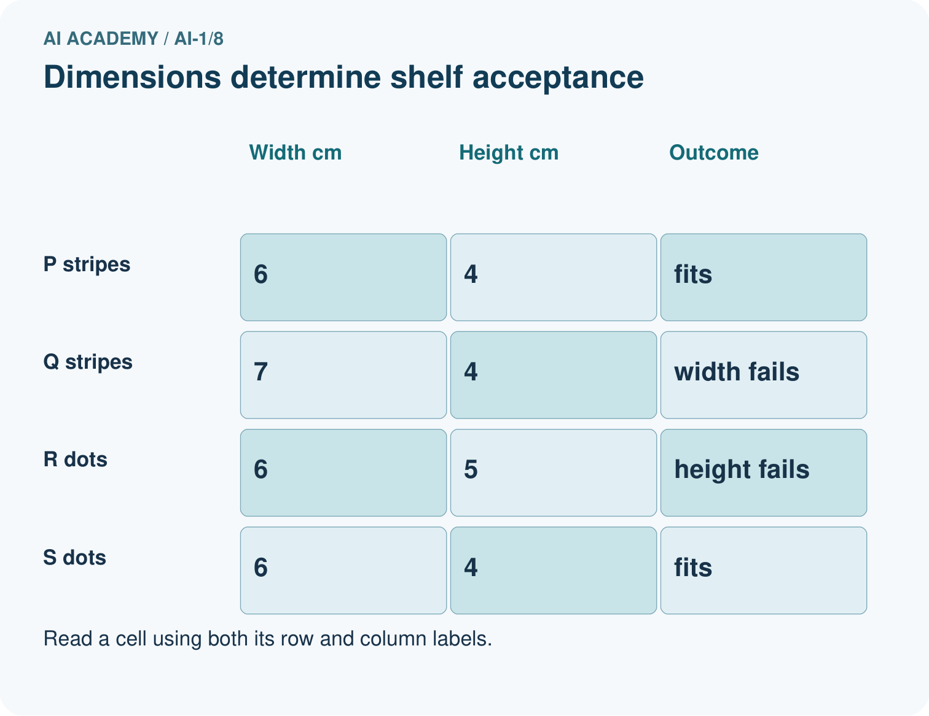
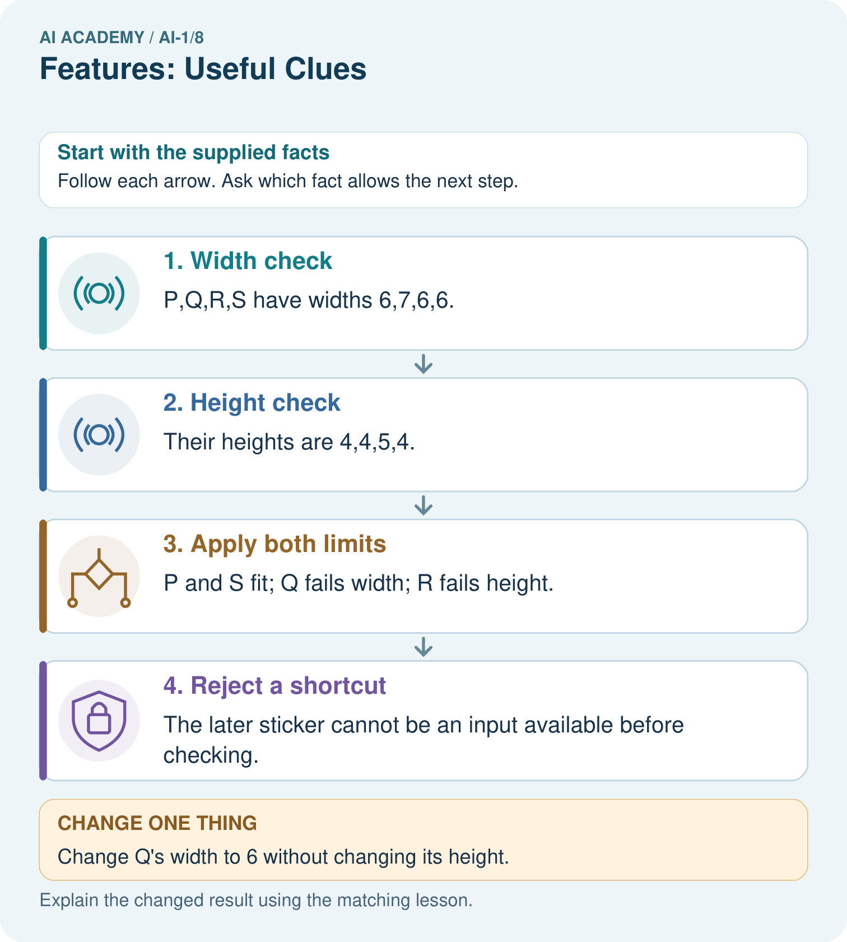

Read the picture one step at a time
Step | What happens and why
1. Width check | P,Q,R,S have widths 6,7,6,6.
2. Height check | Their heights are 4,4,5,4.
3. Apply both limits | P and S fit; Q fails width; R fails height.
4. Reject a shortcut | The later sticker cannot be an input available before checking.
Match each pictured step to the supplied facts. This is a worked teaching case, not an independent assessment.

Why this result follows
Comparing P with Q isolates width; comparing P with R isolates height. Comparing P with S changes pattern while both remain accepted. Under this declared policy, pattern is not a deciding feature. A later acceptance sticker leaks the very answer the system should produce.

What this example does not establish
These comparisons establish the written shelf rule, not the importance of pattern for unrelated tasks.

Change one thing in the pictured case
Change: Change Q’s width to 6 without changing its height.
Prediction: Q fits the shelf.
Reason: Both dimensions now meet their including equality limits; stripe pattern does not change the rule.

Ask while showing the picture
Cover the result. Ask learners to name the inputs and predict the next step. Uncover one step, connect the icon to the actual procedure, and explain its evidence. Then change the supplied condition and compare. The picture is a representation; it does not document execution of a real AI model.

03. Demonstrate and guide practice

Demonstrate and guide practice

Board sequence
Write the given facts: Two green leaves have smooth and toothed edges. The task is to distinguish edge types.
Write the question to explain: Choose the relevant feature and explain why size is insufficient.
Reveal after predictions: Edge shape directly addresses the target. Size can vary within both categories. Feature usefulness depends on the task.
Keep for an independent attempt: A sorter separates round and square tiles. Both shapes come in red and blue. Choose a useful feature and a distracting feature. Test your choice on a blue circle.

Classroom dialogue
Ask: Which facts are given, and which would we have to assume? Learners mark relevant details before discussing answers.
Say: Predict first. Show the rule, information path or calculation that would produce the result. A correct guess is not yet an explanation.
Reveal reasoning one step at a time. Explain why a tempting alternative fails. Write units and denominators for arithmetic, trace conditions for decisions, and identify supporting sources for claims.
In pairs, one learner solves while the other checks evidence; exchange roles. Remove the worked answer before independent assessment.

Model these guided questions
Length 12 cm is usable before inspection and passes its criterion. The unreadable width remains unknown, so it might be at most 8 or above 8; the available measurements do not establish fits or too large. The final sticker does not exist before inspection, so it cannot supply an input at the time the answer is needed. Using it would leak the later answer. The exit answer may use red 10 by 7 cm, which fits, or blue 13 by 7 cm, which is too large. Check the dimensions and use new cases that break the practice colour pattern.

Case-specific teaching sequence
Stage | Teacher action
Session 1 start 0 to 7 minutes | Retrieve Week 7: agreement is not proof of a correct label. State the new target and check both inclusive boundaries.
7 to 20 minutes | Show cards A and B. Cover their widths and identifying letters. Ask what identical length-only inputs allow the system to distinguish, then reveal width.
20 to 33 minutes | Trace the four-row comparison table. Have students cite the pair showing each measurement matters and the pair showing colour does not enter this rule.
33 to 45 minutes | Complete W1 and W2 with partners. Require a constructed pair and reasons; do not accept only a list of feature names.
Session 2 start 0 to 8 minutes | Retrieve the same-input problem using length 11 width 5 and length 11 width 10. Both length-only records are 11; the first fits and the second is too large.
8 to 23 minutes | Use W3 to break the colour shortcut. Place the sticker after the decision line and discuss why its apparent predictive success is misleading.
23 to 38 minutes | Collect W4 independently. Look for height and thickness, a valid equal-height pair, boundary reasoning and the timing explanation.
38 to 45 minutes | Use W5 and the exit response to revisit task-dependent relevance. Preview algorithms that update a recorded state one step at a time.

Reduce help deliberately
Completion task: Invent two cards with the same width but different correct labels under the card guide. Give both lengths and widths and justify the labels. Explain why a system receiving only width cannot always label both correctly.
Teacher check: One valid pair is length 11 width 6, which fits, and length 13 width 6, which is too large. Both give the width-only input 6 but require different labels. Without length or other permitted distinguishing information, the system cannot guarantee correct labels for both. Accept any valid pair with positive measurements, equal widths at most 8, and lengths on opposite sides of 12.
Start by identifying the given inputs together. Leave the intermediate steps blank. If needed, model one step, then withdraw that help on the next step. Move to a full trace only when the partial trace is understood. For partners, alternate explainer and checker; collect a response from every learner before discussion.

Individual reasoning check
Use the worked case for Features and useful distinctions. Proposed explanation: “A stronger model can always recover an omitted measurement”. Decide whether this explanation is supported. Point to the step or supplied fact that decides; explain your repair if needed.
Expected correction: Cover width and all identifiers for two same-length cards with different labels. Ask which supplied value tells them apart. Guessing or using typical values cannot guarantee correctness for both.
Collect explanations, not only yes/no votes. If a misunderstanding is common, re-model the relevant step for the class. If it affects a few learners, give a short targeted group explanation while others solve a more demanding variation.

Pictorial practice question
Point to the pair that tests pattern, then explain why the sticker is a bad early input.

Reasoned teacher answer
P and S test pattern. The sticker is attached after the decision, so it is unavailable when a new box must be checked.
Changed-case reasoning: Q fits the shelf. Both dimensions now meet their including equality limits; stripe pattern does not change the rule.
Collect each learner’s explanation before discussion. Use the first missing connection between input, deciding step and result to choose support. This question is worked-case practice, not fresh mastery evidence.

04. Run the weekly evidence lab

Run the weekly evidence lab
Predict first, test honestly, and explain what the evidence means.
State your prediction before the result is known.
Complete the task: Choose three clues for cat/dog sorting; reject distractions.
Keep a normal case and an edge case clearly separated.
Record what happened—even when it does not match your prediction.
Explain the result, one limitation, and the next useful test.
INDEPENDENCE After support is removed, repeat the proof with a fresh case.

Make the lab runnable
Use the concrete case as the shared normal case and the independent question as a second case. Each pair creates a boundary or missing-information case and predicts its result before testing. Keep the expected result separate from an observed mistake.
Record | What to capture
Input or evidence | Exact data, instruction or claim
Expected result | Answer or safe fallback declared before the run
Observed result | Actual result, including errors
Explanation | Rule, calculation or evidence explaining the outcome
Next test | One justified change and a new prediction

Diagnose and reteach
CLAIM TO REPAIR The brightest feature is always the best clue.
For guessing, return to given facts and request a trace. For vocabulary without application, use one example and one non-example. For arithmetic errors, check the setup before the calculation. Finish with a different uncoached case before recording mastery.

Address these additional misconceptions
A stronger model can always recover an omitted measurement: Cover width and all identifiers for two same-length cards with different labels. Ask which supplied value tells them apart. Guessing or using typical values cannot guarantee correctness for both.
A feature that matches practice labels must be useful: Use a red fitting card or a blue oversized card. Ask whether the feature preserves the stated distinction when the practice pattern changes.
The final label is the best input feature: Place the sticker after inspection on the timeline. It is a target for checking or teaching, not an available input for a prediction before inspection.
Useful features stay useful for every task: Change the target to red or blue bins. Identical dimensions can now require different answers, so colour matters.

Match the support to the first error
What the response shows | Next teaching action
Missing or misread facts | Read the case aloud, mark supplied versus unknown facts, and let the learner restate it.
Wrong procedure | Return to the deciding step in the worked case. Contrast it with the proposed incorrect explanation.
Arithmetic or implementation error | Trace intermediate values or lines; preserve the first mismatch and retry that step.
Correct result without a reason | Ask for a trace and a changed case before marking independent understanding.
An unsupported wider claim | Ask which supplied evidence supports the claim and which further observation would be needed.
Offer an oral explanation, drawing, enlarged visual or fewer examples when that removes a reading/writing barrier. Keep the same reasoning goal. Stretch secure learners by changing a boundary or assumption and asking them to defend the effect, not simply by assigning more of the same questions.

05. Assess and explain the answers

Assess and explain the answers

Worked case answer
Edge shape directly addresses the target. Size can vary within both categories. Feature usefulness depends on the task.

Independent question
A sorter separates round and square tiles. Both shapes come in red and blue. Choose a useful feature and a distracting feature. Test your choice on a blue circle.

Expected independent answer
Shape is useful; colour is distracting for this task. A blue circle is round. A feature is useful because it relates to the intended category, not because it is easy to see.

What counts as evidence
Criterion | 0 points | 1 point | 2 points
Result | Incorrect or absent | Partly correct | Correct with necessary conditions
Reasoning | No supporting trace | Some steps | Clear mechanism, calculation or source support
Limit | Overclaims certainty | Vague limitation | Relevant uncertainty or missing fact
Transfer | Copies without adapting | Adapts with prompts | Solves a changed case independently
Use 6/8 as a classroom checkpoint, with 2 required for both Result and Reasoning. This is a proposed teaching rule, not a validated certification threshold. Do not count a coached answer as independent mastery; correct unsafe or unsupported claims regardless of total.

Feedback
Ask the learner to find the evidence that challenges this claim: “The brightest feature is always the best clue.” Keep the first attempt and an uncoached retry separate.

Original transfer answer
Test a large smooth leaf and a small toothed leaf with reliable labels. An edge-based rule predicts smooth and toothed respectively; a size shortcut reverses them. Two tests expose this specific shortcut, but do not establish performance on every leaf.

Explanations for the additional workbook examples

W1 Separate inputs from the target
For the fixed-orientation card task, fits requires length at most 12 cm and width at most 8 cm, including equality. Choose the measurements needed as inputs from length, width, colour, card number and the final inspection sticker. State the target label and write the feature record for a 12 cm by 8 cm red card using a defined order.
Use length and width measured before the decision. State the order as length in cm, then width in cm; the record is 12, 8. The target is fits or too large under the guide, and this card is fits because both equalities are included. Colour and card number are not needed for this rule; the final inspection sticker copies the answer and is unavailable before inspection.

W2 Prove that one measurement is insufficient
Invent two cards with the same width but different correct labels under the card guide. Give both lengths and widths and justify the labels. Explain why a system receiving only width cannot always label both correctly.
One valid pair is length 11 width 6, which fits, and length 13 width 6, which is too large. Both give the width-only input 6 but require different labels. Without length or other permitted distinguishing information, the system cannot guarantee correct labels for both. Accept any valid pair with positive measurements, equal widths at most 8, and lengths on opposite sides of 12.

W3 Challenge an apparent colour shortcut
A practice set contains three blue cards that fit and three red cards that are too large. A helper uses blue means fits and red means too large. Create a new card that this helper mislabels. Explain why the perfect practice score did not establish that colour was a reliable feature for this task.
A red 10 by 7 cm card fits but the helper says too large; alternatively a blue 13 by 7 cm card is too large but the helper says fits. The practice set paired colour with size and did not test cases that separate them. The stated guide depends on measurements, so compare predictions with that guide on cases where colour and size no longer follow the shortcut.

W4 Design a record for a new task
A fictional display tray accepts a tile if its height is at most 9 cm and its thickness is at most 2 cm, including equality. Other dimensions are fixed. Before checking, you can record height, thickness and pattern name. A pass sticker is added afterward. Choose inputs with units. Construct two tiles with the same height but different labels. Then label a 9 cm high, 2 cm thick striped tile and explain why the sticker is unsuitable as an input before checking.
Record height in cm and thickness in cm. A valid pair is height 8 thickness 1, which passes, and height 8 thickness 3, which fails: equal height hides the required thickness distinction. The 9 cm high, 2 cm thick tile passes both inclusive boundaries. Pattern name does not affect the stated rule. The pass sticker is created after checking and copies the target; using it to predict before checking is leakage.

W5 Notice when the task changes
The delivery station now sorts cards into red and blue bins instead of checking dimensions. Which previously unneeded feature becomes useful? Explain why length and width alone may now be insufficient. Give two cards that support your explanation.
Colour becomes useful because the new target is red or blue. A red 10 by 7 card and a blue 10 by 7 card have identical length-width records but require different bins. Feature relevance depends on the task; reusing the previous feature set without reviewing the target can discard the needed distinction.

Assess independent transfer
Selected case: A fictional display tray accepts a tile if its height is at most 9 cm and its thickness is at most 2 cm, including equality. Other dimensions are fixed. Before checking, you can record height, thickness and pattern name. A pass sticker is added afterward. Choose inputs with units. Construct two tiles with the same height but different labels. Then label a 9 cm high, 2 cm thick striped tile and explain why the sticker is unsuitable as an input before checking.

Selected case answer
Record height in cm and thickness in cm. A valid pair is height 8 thickness 1, which passes, and height 8 thickness 3, which fails: equal height hides the required thickness distinction. The 9 cm high, 2 cm thick tile passes both inclusive boundaries. Pattern name does not affect the stated rule. The pass sticker is created after checking and copies the target; using it to predict before checking is leakage.
Dimension | Evidence required
Explanation | Names the applicable idea or procedure and ties it to the supplied facts.
Trace and result | Preserves the given inputs and shows the relevant intermediate steps; distinguishes a prediction from an observed execution.
Limits | States the assumptions, missing evidence or conditions under which the result would change.
Record each dimension as not yet, with support, or independent. Accept a valid alternative procedure with a defensible trace. Do not penalise an honestly recorded model failure if the learner correctly explains its evidence and limits.

Feedback that the learner uses
Name the earliest unsupported step and give one action to repair it. Have the learner make that repair now and explain why. Then assess the relevant skill on a fresh, fully specified case. Confirm it was not previously practised with feedback; solve and check the new case before assigning it. A follow-up design prompt is a starting brief, not automatically an equivalent test.

06. Connect and extend learning

Connect and extend learning

Helpful Classroom Sorter
Select the smallest useful features for lost-and-found sorting and reject clues tied to a particular classroom or owner.
Keep the decision, input, result, explanation and remaining limitation in the project evidence record. Retrieve this record next week rather than restarting the project.

Support and stretch
Use physical cards, spoken explanations and a three-stage drawing. Read aloud without giving the answer. Stretch: compare two mechanisms with the same visible output and explain what evidence distinguishes them.

Exit reflection
Ask for one decision the learner can now justify and one situation requiring more evidence or human review. Confidence ratings are separate from correct independent performance.

Bridge to the next week
Next: Week 9: Algorithms as Recipes. Retrieve today’s evidence and identify what carries forward and what is new.

Support and fresh reassessment
Let students physically cover unselected columns and compare two records side by side. Provide the sentence frame Same input ___ but labels ___ and ___ because ___. Use written colour names so no task depends on colour vision. Extension: ask learners to prove the width-only input fails using a second valid pair, or explain how permitting card rotation would change the decision procedure even when the recorded dimensions stay the same.
W4 shows secure independent understanding when the learner selects height and thickness with units, supplies an equal-height pair on opposite sides of the thickness limit, labels the boundary tile correctly, and explains the sticker timing. Naming inputs without a counterexample is partial evidence. After support, retry with a new tray limit of height 7 cm and thickness 3 cm; ask for a fresh equal-height pair before confirming mastery.
Week 9 introduces algorithms and changing state. Students will trace ordered instructions and record how values change, keeping the initial conditions and the sequence visible.

Plan the delayed return
Suggested return points in this level: ai-1/9, ai-1/11, ai-1/14. Use actual classroom dates, adjusting for holidays and gaps. One, three and six teaching weeks are scheduling choices, not a claimed optimal spacing.
At a delayed check, ask for the idea from memory and a changed application. Compare with the earlier independent response and record support used. For a new level, revisit the previous capstone before checking the new prerequisites.
Record | Teacher evidence
Learner code and date
Concept and case used; prior exposure
Explanation / trace / limits
Support and first repair
Changed case and delayed outcome
Next teaching action
Use the evidence to choose reteaching or the next step. A completed page, confidence rating or attractive project does not by itself demonstrate understanding.

Project evidence from this case
Choose sorter features that exist at decision time and actually connect to the stated classroom requirement.

07. Prepare, teach and assess
Teaching target: Choose recorded properties that preserve distinctions needed for a stated task
Prepare the labelled worked-case picture, the matching workbook, fictional input cards and a place for individual responses. No paid AI account is required for the paper reasoning activities.
Session | Plan | Resources
Session 1 · Understand · 45 min | 0–7: recall and prerequisite; 7–15: inspect the concrete case and predict; 15–30: teacher models the worked trace; 30–40: learners explain a step using the text and visual; 40–45: check the core idea. | Sections 1–6; record the brief recall in the workbook.
Session 2 · Practise · 45 min | 0–5: retrieve the procedure; 5–15: W2 completion practice; 15–23: explain and check with a partner; 23–30: each learner answers the misconception check; 30–40: targeted reteaching or a harder variation; 40–45: prepare the investigation. | Sections 7–10; use the matching workbook W2 and misconception check.
Session 3 · Investigate and transfer · 45 min | 0–5: retrieve the decision rule; 5–20: investigate or trace; 20–30: start the independent case; 30–38: connect the project; 38–43: act on feedback; 43–45: plan the return check. | Sections 9 and 11–14. Give extra time to finish the full task set; use Section 15 when the week includes a coding lab.
Before class, solve the supported practice: Invent two cards with the same width but different correct labels under the card guide. Give both lengths and widths and justify the labels. Explain why a system receiving only width cannot always label both correctly.
Reasoned practice answer: One valid pair is length 11 width 6, which fits, and length 13 width 6, which is too large. Both give the width-only input 6 but require different labels. Without length or other permitted distinguishing information, the system cannot guarantee correct labels for both. Accept any valid pair with positive measurements, equal widths at most 8, and lengths on opposite sides of 12.
Check every learner before discussion: Use the worked case for Features and useful distinctions. Proposed explanation: “A stronger model can always recover an omitted measurement”. Decide whether this explanation is supported. Point to the step or supplied fact that decides; explain your repair if needed.
Misconception repair: Cover width and all identifiers for two same-length cards with different labels. Ask which supplied value tells them apart. Guessing or using typical values cannot guarantee correctness for both.
Support: read the exact case aloud, enlarge the labelled picture, supply input cards and model only the first deciding step. Accept a spoken explanation or drawing; retain the reasoning goal.
Extension: Change Q’s width to 6 without changing its height. Require a prediction and a reason before comparing. Expected result: Q fits the shelf. Reason: Both dimensions now meet their including equality limits; stripe pattern does not change the rule.
Independent assessment: withhold the reserved answer until the learner has attempted the new case. Record support separately from correctness.
Criterion | Not yet | With support | Independent
Explanation | Names an answer without a deciding fact | Uses a hint to link fact and decision | Explains the deciding fact in own words
Trace or test | Cannot connect input and result | Completes steps with prompts | Traces or tests a changed case accurately
Limits and revision | Claims more than evidence supports | Names a limit after a prompt | States a defensible limit and useful next test
Project checkpoint: Make a transparent first version. Keep a trace of how one input becomes an output; explain the rule or learned component.
Use the weekly teacher answer for topic-specific reasoning. A saved progress tick is an activity record; judge mastery from the learner’s explanation and evidence.

08. Use feedback, labs and repair paths
Use the two formative questions as supported practice, not as independent mastery scores. Discuss the deciding evidence rather than accepting a guessed selection.
The feedback comes from the reviewed public worked case. Do not reveal the separately reserved independent teacher answer until the learner has attempted that case.
Ask students to predict before running code. Preserve errors and actual outputs; collect a changed test and an explanation. The branch-boundary and indexing lessons deliberately include failure cases.
Use the earlier worked-explanation links to address a specific missing building block, then return to the current question. Adapt this suggestion after observing the learner; it is not an automatic diagnosis.
Collect the completed-work portfolio as evidence. Record support separately from correctness, and assess explanation, trace/test and limitations. Progress ticks and quiz selections alone do not establish mastery.

