AI ACADEMY · TEACHER · ai-1/12

Debug the Cause
Project: Helpful Classroom Sorter

01. Debug the Cause

Teach the learning cycle
Primary target: Compare expected and observed traces to locate the first difference
Session | Sequence and minutes | Resources
Session 1 · Understand · 45 min | 0–7: recall and prerequisite; 7–15: inspect the concrete case and predict; 15–30: teacher models the worked trace; 30–40: learners explain a step using the text and visual; 40–45: check the core idea. | Sections 1–6; record the brief recall in the workbook.
Session 2 · Practise · 45 min | 0–5: retrieve the procedure; 5–15: W2 completion practice; 15–23: explain and check with a partner; 23–30: each learner answers the misconception check; 30–40: targeted reteaching or a harder variation; 40–45: prepare the investigation. | Sections 7–10; use the matching workbook W2 and misconception check.
Session 3 · Investigate and transfer · 45 min | 0–5: retrieve the decision rule; 5–20: investigate or trace; 20–30: start the independent case; 30–38: connect the project; 38–43: act on feedback; 43–45: plan the return check. | Sections 9 and 11–14. Give extra time to finish the full task set; use Section 15 when the week includes a coding lab.
This is a starting allocation of 135 minutes, not a validated duration. Preserve all named topics. Schedule extra time for connected examples, the full investigation, independent cases and project building. Repeated copies of a case share one recorded attempt; they are not new evidence.

Retrieval answer guidance

Repeating Efficiently
Without opening the old lesson, explain one key idea from Repeating Efficiently. Give an example and a mistake that the idea helps you avoid.
Look for: Trace a loop by testing its condition before every repetition
Reference example, not the only acceptable wording: Tests: 2 true, 4 true, 6 true, 8 false. Three additions are three iterations. The loop reports 8; the fourth test does not run the body.

Algorithms as Recipes
Without opening the old lesson, explain one key idea from Algorithms as Recipes. Give an example and a mistake that the idea helps you avoid.
Look for: Trace an ordered algorithm using the current value after every instruction
Reference example, not the only acceptable wording: The trace is 3, 7, 14, 9. The doubling step uses 7, the current value after adding 4 to 3. It must not double the initial 3. Accept a table, arrows or clearly labelled sentences that preserve the order.

Sound Becomes a Signal
Without opening the old lesson, explain one key idea from Sound Becomes a Signal. Give an example and a mistake that the idea helps you avoid.
Look for: Interpret an ordered sequence of sound-signal samples with a stated time interval
Reference example, not the only acceptable wording: Five samples, a 2 ms interval, and 8 ms from first to last. Consecutive pairs make gaps 0-2, 2-4, 4-6 and 6-8: four gaps between five samples.
Use the student module and workbook section with this exact week title. The worked case, independent question and answers below form one aligned lesson sequence.

What the learner must demonstrate
Starting at square 0, the target is square 3. Program: repeat twice {MOVE 1}; STOP. A teammate changes the target to 2 and calls the bug fixed. Repair the program and give two tests.

Concept to explain
Debugging finds the broken assumption or step before changing the solution.
Term | Meaning
bug | cause of incorrect or unexpected behavior
trace | record of steps and changing state
expected | result predicted before the test
actual | result observed during the test

Prepare the class
Use the supplied scenario, student illustrations and blank paper. For numeric work, offer counters or a calculator after learners show the setup. Fictional records are supplied; personal data and paid accounts are unnecessary.
Allow 80 minutes: recall 8; explanation 12; worked demonstration 15; guided practice 20; independent assessment 15; project and reflection 10. Extend the lab into a second session when needed.

Preparation for the connected explanation
Use debugging as evidence-based investigation of a stated procedure. Distinguish finding the first observed divergence from establishing a unique root cause. The arithmetic examples show that two faults can fit one result and that a test may separate two explanations while still missing a different fault. Use paper traces and preserve the original failing case throughout repair.

Readiness answer
The tests see 3 true, 5 true and 7 false. Two iterations occur; the body does not run after the false test. Report 7.
The points-machine specification and its observed trace on separate cards
An expected and observed trace sheet with an instruction-version field
Cards for add 4 and add original start, plus the ticket rule for independent assessment

End goal for the pictorial case
By the end, I can choose a test that separates two possible causes of an error.
This added worked case illustrates the week’s main idea. Retain all original and connected topics; schedule its practice within the teaching cycle.

02. Explain the mechanism

Explain the mechanism
Follow the information instead of imagining magic inside the machine.
INPUT expected path and actual trace
PROCESS locate the first difference and test one cause
OUTPUT targeted correction plus repeated test
CORE IDEA Debugging finds the broken assumption or step before changing the solution.
UNDER THE HOOD Debugging is causal diagnosis. The first observable divergence narrows the faulty assumption, data, state, condition, or step. Changing multiple things at once destroys evidence about which change repaired the behavior.
Draw a fresh example with all three stages:
Every step connects a claim to observable evidence.
CASE A paper robot hits a wall because one turn instruction assumes it faces north when it actually faces east.
STEP 1 — OBSERVE expected path and actual trace
STEP 2 — TRACE locate the first difference and test one cause
STEP 3 — CONCLUDE targeted correction plus repeated test
MODEL REASONING Trace expected and actual positions step by step. The first mismatch reveals the earliest plausible cause. Change that instruction or assumption only, then rerun the identical maze to show whether the cause was correct.
DO NOT OVERCLAIM A successful new run does not prove the diagnosis if several things changed together.
What new evidence could change this answer?

Concrete teaching case
A robot should go from square one to square three. Its program is MOVE ONE, STOP.
Find the cause and repair one thing.

Exact explanation to model
It stops at square two because one move is missing. Add MOVE ONE before STOP and retest from the same start.

Explain the added worked example
A paper points machine must add 3 to its starting score, double the updated score, then subtract 2 and report. From 4 the expected values are 4, 7, 14 and 12. These instructions are the specification. Calculate the expected result from them before looking at the machine output.
An observed run instead records 4, 7, 11 and 9. The final result is wrong, but changing the report from 9 to 12 would only hide this particular failure. Compare the intermediate values to find where the behaviour first stopped matching the instructions.
The first difference is after the doubling instruction: expected 14, observed 11. The final subtraction is consistent with the observed 11, since 11 minus 2 is 9. That later difference can be a consequence of the earlier fault rather than a second faulty subtraction. A trace narrows the investigation; it does not automatically reveal every cause.
Record the input, the exact instruction version, expected values, observed values and first mismatch. This makes the failure reproducible: someone else can follow the same procedure with the same starting value and check your observation.
Do not rewrite the expected column to match the observed result. If the specification itself seems ambiguous, clarify it first and record that change openly. A test can judge an implementation only against a stated expectation.

Key terms
Term | Meaning
Specification | A statement of what a system is required to do
Expected result | The result worked out from the specification before running a test
Observed result | The result actually recorded during a test
First divergence | The earliest step where observed behaviour differs from expected behaviour
Regression test | A repeated check that previously correct behaviour still works after a change

Model the reasoning aloud
Use the complete worked example below before asking learners to complete W2. Reveal a small part, invite a prediction, then explain the deciding step. These teacher notes contain solutions; do not reveal the independent case answer during modelling.
For the faulty doubling step, two explanations fit the observed change from 7 to 11. Perhaps the step adds 4. Perhaps it adds the original starting score, which was 4. Repeating the same start 4 cannot separate those explanations because they make the same prediction.
4 | 12 | 9 under either explanation
2 | 8 | 7 if add 4 or 5 if add original 2
5 | 14 | 10 if add 4 or 11 if add original 5
Starting at 2 produces 5 after the first addition. The intended double gives 10 and then reports 8. Adding 4 would give 9 and report 7. Adding the original 2 would give 7 and report 5. The different predictions make this a revealing test.
If the observed final result is 7, it supports add 4 over add original among these two explanations. Other faults could still give 7, so inspect the actual instruction or more checkpoints before claiming a unique cause.
Thinking move | Teacher prompt
Plan | What is given? What is the question? Which procedure fits these facts?
Do | Point to each input and intermediate step in the worked trace. Name the rule that allows the next step.
Check | Does the output answer the question? Which assumption or limitation prevents a larger claim?
Use the diagram and verbal explanation together. Ask learners to match a sentence to a specific visual step; do not assign learners fixed visual or auditory learning styles.

A pictorial worked case: Debug the Cause
A fictional paper calculator should double the current value, but a copied instruction behaves strangely.

The facts we will use
After input 6, the faulty step reports 12. Hypothesis A: add 6. Hypothesis B: double.
Both hypotheses fit this first observation. A new input may be chosen.
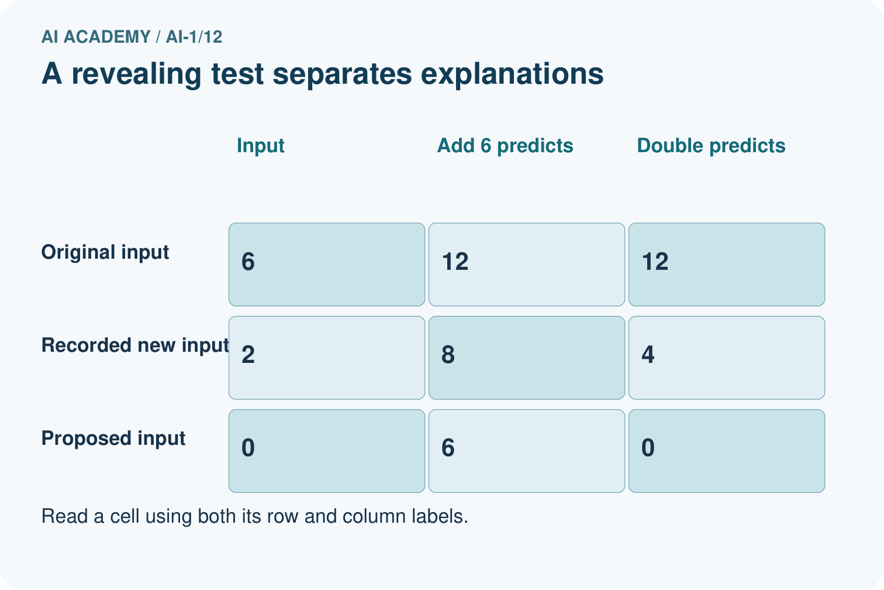
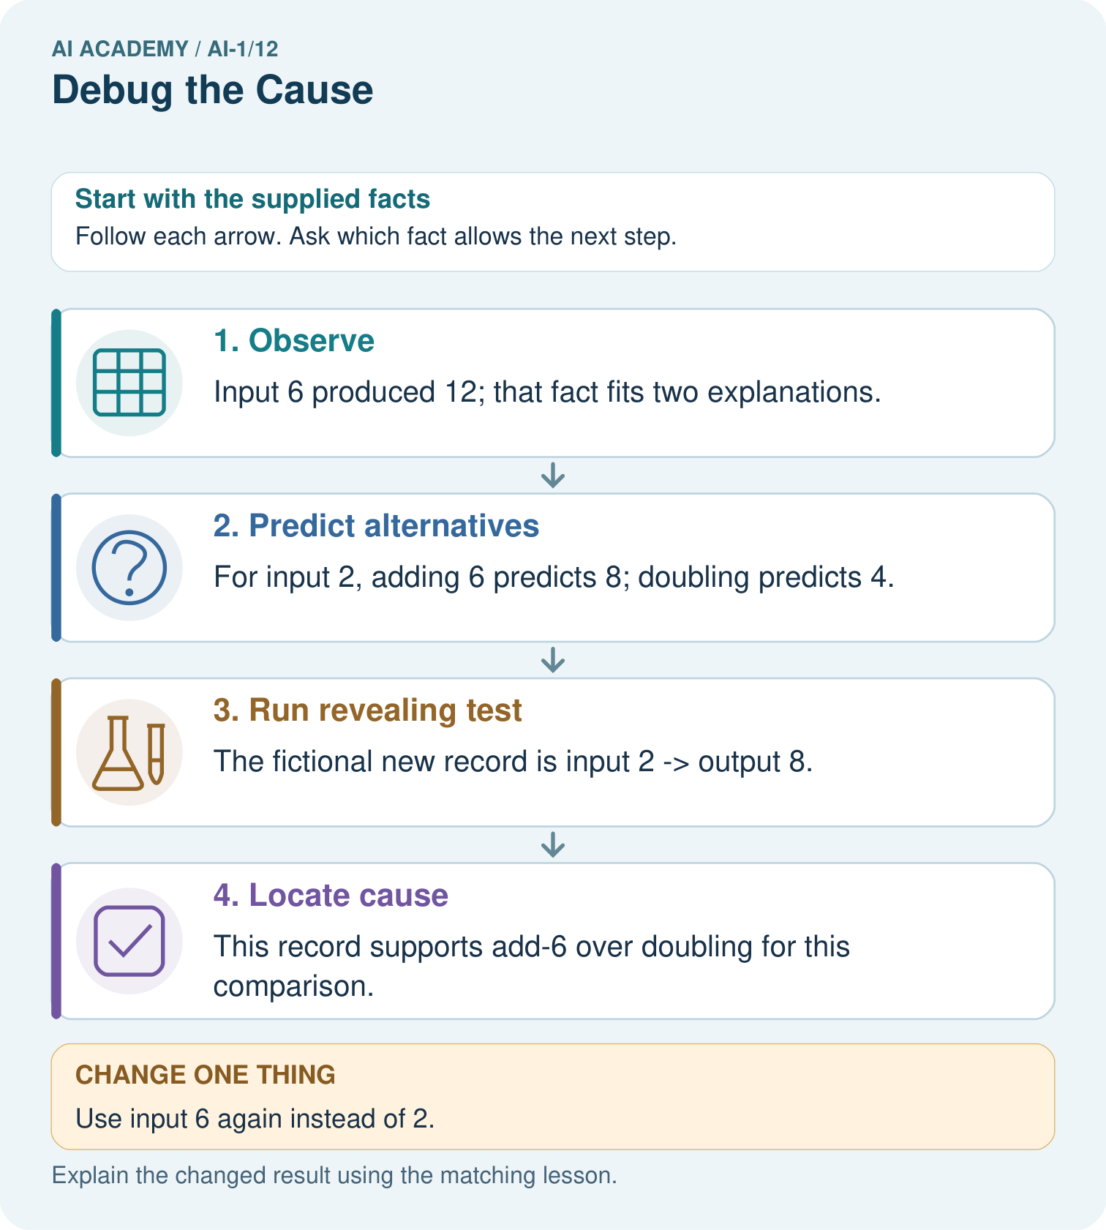

Read the picture one step at a time
Step | What happens and why
1. Observe | Input 6 produced 12; that fact fits two explanations.
2. Predict alternatives | For input 2, adding 6 predicts 8; doubling predicts 4.
3. Run revealing test | The fictional new record is input 2 → output 8.
4. Locate cause | This record supports add-6 over doubling for this comparison.
Match each pictured step to the supplied facts. This is a worked teaching case, not an independent assessment.

Why this result follows
Repeating input 6 would not separate the two hypotheses because both again predict 12. Input 2 makes their predictions different before the test is run. The second record supports investigating an added constant, but inspecting the instruction is still needed to confirm the implementation.

What this example does not establish
Two toy hypotheses do not exhaust every possible bug; a matching output alone cannot identify arbitrary hidden code.

Change one thing in the pictured case
Change: Use input 6 again instead of 2.
Prediction: Both hypotheses predict 12; the test remains inconclusive.
Reason: A revealing test requires different predicted outputs, not merely another recorded run.

Ask while showing the picture
Cover the result. Ask learners to name the inputs and predict the next step. Uncover one step, connect the icon to the actual procedure, and explain its evidence. Then change the supplied condition and compare. The picture is a representation; it does not document execution of a real AI model.

03. Demonstrate and guide practice

Demonstrate and guide practice

Board sequence
Write the given facts: A robot should go from square one to square three. Its program is MOVE ONE, STOP.
Write the question to explain: Find the cause and repair one thing.
Reveal after predictions: It stops at square two because one move is missing. Add MOVE ONE before STOP and retest from the same start.
Keep for an independent attempt: A sorting rule says blue goes left. A blue card goes right. The reader correctly reports blue, but the direction rule says blue goes right. Which part should you fix first?

Classroom dialogue
Ask: Which facts are given, and which would we have to assume? Learners mark relevant details before discussing answers.
Say: Predict first. Show the rule, information path or calculation that would produce the result. A correct guess is not yet an explanation.
Reveal reasoning one step at a time. Explain why a tempting alternative fails. Write units and denominators for arithmetic, trace conditions for decisions, and identify supporting sources for claims.
In pairs, one learner solves while the other checks evidence; exchange roles. Remove the worked answer before independent assessment.

Model these guided questions
Add 4 fits both reported results: from 4, 7 plus 4 minus 2 is 9; from 2, 5 plus 4 minus 2 is 7. Adding the original start predicts 5 on the second run and is inconsistent. Inspect the actual middle instruction. If it says add 4, restore double the current score and expect 12 from start 4 and 8 from start 2; also check start 5 gives 14. This distinguishes the proposed faults without claiming no other cause exists. Exit: start 7. Below 7 runs zero times and reports 7; at most 7 adds 2 once and reports 9.

Case-specific teaching sequence
Stage | Teacher action
Session 1 start 0 to 7 minutes | Retrieve the complete loop trace. Emphasise that the false test is a checkpoint that must be recorded.
7 to 20 minutes | Work the points-machine specification before revealing the observed run. Align checkpoints and find the first mismatch at the doubling step.
20 to 33 minutes | Compare add 4 with add original start. Predict outcomes from 2 before showing any observations. Explain the limits of choosing between two proposed causes.
33 to 45 minutes | Complete W1 and W2 in pairs. Ask why a passing result from start 1 does not remove the failure from start 3.
Session 2 start 0 to 8 minutes | Use W3 to distinguish repairing an instruction from replacing a reported answer. Retrieve the need for an unchanged specification.
8 to 23 minutes | Complete the guided repair and write expected retest results. Keep a record of the original failing case and prior passing cases.
23 to 38 minutes | Collect W4 independently. Check that starts are chosen before the add 1 step, so equality is reached from start 4.
38 to 45 minutes | Use W5 and the exit to practise a limited, evidence-based completion claim. Preview fitting a rule from examples next week.

Reduce help deliberately
Completion task: In W1 the faulty middle step may add 3, or add the original starting value. Both explain 5 becoming 8 when the start is 3. Choose start 1 or start 3 for a revealing new test. Predict the final result under each explanation and under the intended procedure.
Teacher check: Choose start 1. After add 2 the value is 3. Adding 3 then subtracting 1 reports 5; adding original 1 then subtracting 1 reports 3. Doubling then subtracting 1 should report 5. This separates the two fault explanations, but a final 5 alone cannot separate add 3 from correct doubling on this input; retain the original failing start 3.
Start by identifying the given inputs together. Leave the intermediate steps blank. If needed, model one step, then withdraw that help on the next step. Move to a full trace only when the partial trace is understood. For partners, alternate explainer and checker; collect a response from every learner before discussion.

Individual reasoning check
Use the worked case for Debugging with revealing tests. Proposed explanation: “The last wrong number locates the fault”. Decide whether this explanation is supported. Point to the step or supplied fact that decides; explain your repair if needed.
Expected correction: Compare every aligned checkpoint; an early mismatch can cause several later wrong values.
Collect explanations, not only yes/no votes. If a misunderstanding is common, re-model the relevant step for the class. If it affects a few learners, give a short targeted group explanation while others solve a more demanding variation.

Pictorial practice question
Propose input 0 and give both predicted outputs without inventing an observed result.

Reasoned teacher answer
Add-6 predicts 6; doubling predicts 0. No actual result has been supplied for input 0.
Changed-case reasoning: Both hypotheses predict 12; the test remains inconclusive. A revealing test requires different predicted outputs, not merely another recorded run.
Collect each learner’s explanation before discussion. Use the first missing connection between input, deciding step and result to choose support. This question is worked-case practice, not fresh mastery evidence.

04. Run the weekly evidence lab

Run the weekly evidence lab
Predict first, test honestly, and explain what the evidence means.
State your prediction before the result is known.
Complete the task: Repair a maze algorithm and explain the exact failure.
Keep a normal case and an edge case clearly separated.
Record what happened—even when it does not match your prediction.
Explain the result, one limitation, and the next useful test.
INDEPENDENCE After support is removed, repeat the proof with a fresh case.

Make the lab runnable
Use the concrete case as the shared normal case and the independent question as a second case. Each pair creates a boundary or missing-information case and predicts its result before testing. Keep the expected result separate from an observed mistake.
Record | What to capture
Input or evidence | Exact data, instruction or claim
Expected result | Answer or safe fallback declared before the run
Observed result | Actual result, including errors
Explanation | Rule, calculation or evidence explaining the outcome
Next test | One justified change and a new prediction

Diagnose and reteach
CLAIM TO REPAIR Changing every part is the best way to find a cause.
For guessing, return to given facts and request a trace. For vocabulary without application, use one example and one non-example. For arithmetic errors, check the setup before the calculation. Finish with a different uncoached case before recording mastery.

Address these additional misconceptions
The last wrong number locates the fault: Compare every aligned checkpoint; an early mismatch can cause several later wrong values.
One revealing test proves the only possible cause: List the explanations actually compared. A different, untested fault may make the same prediction.
A correct answer on one input proves the repair: Use the constant-report example and rerun original failing and previously passing cases.
Expected results should follow observed results: Calculate expectations from the specification first. Clarify genuine specification changes explicitly rather than hiding a failure.

Match the support to the first error
What the response shows | Next teaching action
Missing or misread facts | Read the case aloud, mark supplied versus unknown facts, and let the learner restate it.
Wrong procedure | Return to the deciding step in the worked case. Contrast it with the proposed incorrect explanation.
Arithmetic or implementation error | Trace intermediate values or lines; preserve the first mismatch and retry that step.
Correct result without a reason | Ask for a trace and a changed case before marking independent understanding.
An unsupported wider claim | Ask which supplied evidence supports the claim and which further observation would be needed.
Offer an oral explanation, drawing, enlarged visual or fewer examples when that removes a reading/writing barrier. Keep the same reasoning goal. Stretch secure learners by changing a boundary or assumption and asking them to defend the effect, not simply by assigning more of the same questions.

05. Assess and explain the answers

Assess and explain the answers

Worked case answer
It stops at square two because one move is missing. Add MOVE ONE before STOP and retest from the same start.

Independent question
A sorting rule says blue goes left. A blue card goes right. The reader correctly reports blue, but the direction rule says blue goes right. Which part should you fix first?

Expected independent answer
Fix the direction rule, because the colour reading is already correct and the written mapping contradicts the intended behaviour. Retest the same blue card after the change.

What counts as evidence
Criterion | 0 points | 1 point | 2 points
Result | Incorrect or absent | Partly correct | Correct with necessary conditions
Reasoning | No supporting trace | Some steps | Clear mechanism, calculation or source support
Limit | Overclaims certainty | Vague limitation | Relevant uncertainty or missing fact
Transfer | Copies without adapting | Adapts with prompts | Solves a changed case independently
Use 6/8 as a classroom checkpoint, with 2 required for both Result and Reasoning. This is a proposed teaching rule, not a validated certification threshold. Do not count a coached answer as independent mastery; correct unsafe or unsupported claims regardless of total.

Feedback
Ask the learner to find the evidence that challenges this claim: “Changing every part is the best way to find a cause.” Keep the first attempt and an uncoached retry separate.

Original transfer answer
Repeat three times, then stop. From start 0 the result must be 3; from start 2 it must be 5 if the requirement is to move three squares. Changing the target hides the bug. Distinguish a fixed destination from a fixed travel distance before choosing the second test.

Explanations for the additional workbook examples

W1 Locate the first difference
A procedure must add 2, double the updated value, then subtract 1. Starting at 3, an observed trace is 3, 5, 8, 7. Write the expected trace, identify the first difference and explain why the final subtraction is not necessarily a separate fault.
Expected trace: 3, 5, 10, 9. First difference is the doubling checkpoint: 10 expected versus 8 observed. The later 8 minus 1 equals 7, so the observed subtraction is consistent with its input. Investigate the earlier step before claiming another fault.

W2 Choose between two explanations
In W1 the faulty middle step may add 3, or add the original starting value. Both explain 5 becoming 8 when the start is 3. Choose start 1 or start 3 for a revealing new test. Predict the final result under each explanation and under the intended procedure.
Choose start 1. After add 2 the value is 3. Adding 3 then subtracting 1 reports 5; adding original 1 then subtracting 1 reports 3. Doubling then subtracting 1 should report 5. This separates the two fault explanations, but a final 5 alone cannot separate add 3 from correct doubling on this input; retain the original failing start 3.

W3 Reject a repair that hides the symptom
A learner repairs the original points machine by reporting 12 for every input, because 12 is correct from start 4. Give a different starting input and its expected output under add 3, double, subtract 2. Explain why the constant report is not a valid repair and what earlier evidence should be preserved.
Start 2 should report 8, with trace 2, 5, 10, 8; other correctly calculated starts with a different output also work. Always reporting 12 breaks the specification. Preserve the original input and observed intermediate trace as evidence, then correct the faulty instruction and rerun the cases.

W4 Debug a new ticket rule
A paper ticket rule must add 1 to the input count. If the updated count is at least 5, report Group; otherwise report Single. A copied version says above 5. Choose the smallest three consecutive nonnegative starting counts that test just below, exactly at and just above the comparison boundary. Predict both versions, identify the revealing start and state the repair and retests.
Use starts 3, 4 and 5, which reach 4, 5 and 6. Intended results are Single, Group, Group. Copied results are Single, Single, Group. Start 4 exposes the equality fault. Restore at least 5 and rerun all three, retaining starts 3 and 5 as previously passing regression cases.

W5 Make a defensible completion claim
After repairing W4, all three chosen tests pass. Write a short report with the fault, the exact repair, the three inputs and expected outputs, and what those passing tests establish. Explain why saying every possible error is now impossible would go beyond the evidence.
The copied rule excluded equality. Change above 5 to at least 5 after the add 1 step. Tests 3, 4 and 5 now report Single, Group and Group. The repair passes these checks around this boundary and retains the tested neighbouring behaviour. Other inputs, missing values or unrelated implementation faults were not established by these three tests.

Assess independent transfer
Selected case: A paper ticket rule must add 1 to the input count. If the updated count is at least 5, report Group; otherwise report Single. A copied version says above 5. Choose the smallest three consecutive nonnegative starting counts that test just below, exactly at and just above the comparison boundary. Predict both versions, identify the revealing start and state the repair and retests.

Selected case answer
Use starts 3, 4 and 5, which reach 4, 5 and 6. Intended results are Single, Group, Group. Copied results are Single, Single, Group. Start 4 exposes the equality fault. Restore at least 5 and rerun all three, retaining starts 3 and 5 as previously passing regression cases.
Dimension | Evidence required
Explanation | Names the applicable idea or procedure and ties it to the supplied facts.
Trace and result | Preserves the given inputs and shows the relevant intermediate steps; distinguishes a prediction from an observed execution.
Limits | States the assumptions, missing evidence or conditions under which the result would change.
Record each dimension as not yet, with support, or independent. Accept a valid alternative procedure with a defensible trace. Do not penalise an honestly recorded model failure if the learner correctly explains its evidence and limits.

Feedback that the learner uses
Name the earliest unsupported step and give one action to repair it. Have the learner make that repair now and explain why. Then assess the relevant skill on a fresh, fully specified case. Confirm it was not previously practised with feedback; solve and check the new case before assigning it. A follow-up design prompt is a starting brief, not automatically an equivalent test.

06. Connect and extend learning

Connect and extend learning

Helpful Classroom Sorter
When the sorter fails, log the first wrong stage and change only the responsible rule, input, or label.
Keep the decision, input, result, explanation and remaining limitation in the project evidence record. Retrieve this record next week rather than restarting the project.

Support and stretch
Use physical cards, spoken explanations and a three-stage drawing. Read aloud without giving the answer. Stretch: compare two mechanisms with the same visible output and explain what evidence distinguishes them.

Exit reflection
Ask for one decision the learner can now justify and one situation requiring more evidence or human review. Confidence ratings are separate from correct independent performance.

Bridge to the next week
Next: Week 13: Learning from Examples. Retrieve today’s evidence and identify what carries forward and what is new.

Support and fresh reassessment
Provide aligned expected and observed columns and ask learners to point to the first unequal pair. Separate predicting a result from running the procedure. Extension: explain why start 1 in W2 is useful for comparing the two faults but cannot alone prove correct doubling.
W4 is secure when the learner chooses starts 3, 4, 5, tests the updated values, explains equality, repairs the comparator and retains both neighbouring cases. W5 must limit the claim to the tested evidence. After support, retry add 2 then if current is at most 6 report A otherwise B, with a below 6 fault. Starts 3, 4, 5 should produce A, A, B; the fault produces A, B, B.
Week 13 introduces fitting a pattern from examples. Students will carry forward the need to state candidate rules, compare their predictions and keep fitting evidence distinct from later evaluation.

Plan the delayed return
Suggested return points in this level: ai-1/13, ai-1/15, ai-1/18. Use actual classroom dates, adjusting for holidays and gaps. One, three and six teaching weeks are scheduling choices, not a claimed optimal spacing.
At a delayed check, ask for the idea from memory and a changed application. Compare with the earlier independent response and record support used. For a new level, revisit the previous capstone before checking the new prerequisites.
Record | Teacher evidence
Learner code and date
Concept and case used; prior exposure
Explanation / trace / limits
Support and first repair
Changed case and delayed outcome
Next teaching action
Use the evidence to choose reteaching or the next step. A completed page, confidence rating or attractive project does not by itself demonstrate understanding.

Project evidence from this case
When the sorter fails, write competing explanations and predicted traces before changing code or instructions.

07. Prepare, teach and assess
Teaching target: Compare expected and observed traces to locate the first difference
Prepare the labelled worked-case picture, the matching workbook, fictional input cards and a place for individual responses. No paid AI account is required for the paper reasoning activities.
Session | Plan | Resources
Session 1 · Understand · 45 min | 0–7: recall and prerequisite; 7–15: inspect the concrete case and predict; 15–30: teacher models the worked trace; 30–40: learners explain a step using the text and visual; 40–45: check the core idea. | Sections 1–6; record the brief recall in the workbook.
Session 2 · Practise · 45 min | 0–5: retrieve the procedure; 5–15: W2 completion practice; 15–23: explain and check with a partner; 23–30: each learner answers the misconception check; 30–40: targeted reteaching or a harder variation; 40–45: prepare the investigation. | Sections 7–10; use the matching workbook W2 and misconception check.
Session 3 · Investigate and transfer · 45 min | 0–5: retrieve the decision rule; 5–20: investigate or trace; 20–30: start the independent case; 30–38: connect the project; 38–43: act on feedback; 43–45: plan the return check. | Sections 9 and 11–14. Give extra time to finish the full task set; use Section 15 when the week includes a coding lab.
Before class, solve the supported practice: In W1 the faulty middle step may add 3, or add the original starting value. Both explain 5 becoming 8 when the start is 3. Choose start 1 or start 3 for a revealing new test. Predict the final result under each explanation and under the intended procedure.
Reasoned practice answer: Choose start 1. After add 2 the value is 3. Adding 3 then subtracting 1 reports 5; adding original 1 then subtracting 1 reports 3. Doubling then subtracting 1 should report 5. This separates the two fault explanations, but a final 5 alone cannot separate add 3 from correct doubling on this input; retain the original failing start 3.
Check every learner before discussion: Use the worked case for Debugging with revealing tests. Proposed explanation: “The last wrong number locates the fault”. Decide whether this explanation is supported. Point to the step or supplied fact that decides; explain your repair if needed.
Misconception repair: Compare every aligned checkpoint; an early mismatch can cause several later wrong values.
Support: read the exact case aloud, enlarge the labelled picture, supply input cards and model only the first deciding step. Accept a spoken explanation or drawing; retain the reasoning goal.
Extension: Use input 6 again instead of 2. Require a prediction and a reason before comparing. Expected result: Both hypotheses predict 12; the test remains inconclusive. Reason: A revealing test requires different predicted outputs, not merely another recorded run.
Independent assessment: withhold the reserved answer until the learner has attempted the new case. Record support separately from correctness.
Criterion | Not yet | With support | Independent
Explanation | Names an answer without a deciding fact | Uses a hint to link fact and decision | Explains the deciding fact in own words
Trace or test | Cannot connect input and result | Completes steps with prompts | Traces or tests a changed case accurately
Limits and revision | Claims more than evidence supports | Names a limit after a prompt | States a defensible limit and useful next test
Project checkpoint: Make a transparent first version. Keep a trace of how one input becomes an output; explain the rule or learned component.
Use the weekly teacher answer for topic-specific reasoning. A saved progress tick is an activity record; judge mastery from the learner’s explanation and evidence.

08. Use feedback, labs and repair paths
Use the two formative questions as supported practice, not as independent mastery scores. Discuss the deciding evidence rather than accepting a guessed selection.
The feedback comes from the reviewed public worked case. Do not reveal the separately reserved independent teacher answer until the learner has attempted that case.
Ask students to predict before running code. Preserve errors and actual outputs; collect a changed test and an explanation. The branch-boundary and indexing lessons deliberately include failure cases.
Use the earlier worked-explanation links to address a specific missing building block, then return to the current question. Adapt this suggestion after observing the learner; it is not an automatic diagnosis.
Collect the completed-work portfolio as evidence. Record support separately from correctness, and assess explanation, trace/test and limitations. Progress ticks and quiz selections alone do not establish mastery.

