AI ACADEMY · TEACHER · ai-1/36

Expo and Defense
Project: Helpful Classroom Sorter

01. Expo and Defense

Teach the learning cycle
Primary target: Evaluate a saved candidate and a manual baseline fairly
Session | Sequence and minutes | Resources
Session 1 · Understand · 45 min | 0–7: recall and prerequisite; 7–15: inspect the concrete case and predict; 15–30: teacher models the worked trace; 30–40: learners explain a step using the text and visual; 40–45: check the core idea. | Sections 1–6; record the brief recall in the workbook.
Session 2 · Practise · 45 min | 0–5: retrieve the procedure; 5–15: W2 completion practice; 15–23: explain and check with a partner; 23–30: each learner answers the misconception check; 30–40: targeted reteaching or a harder variation; 40–45: prepare the investigation. | Sections 7–10; use the matching workbook W2 and misconception check.
Session 3 · Investigate and transfer · 45 min | 0–5: retrieve the decision rule; 5–20: investigate or trace; 20–30: start the independent case; 30–38: connect the project; 38–43: act on feedback; 43–45: plan the return check. | Sections 9 and 11–14. Give extra time to finish the full task set; use Section 15 when the week includes a coding lab.
This is a starting allocation of 135 minutes, not a validated duration. Preserve all named topics. Schedule extra time for connected examples, the full investigation, independent cases and project building. Repeated copies of a case share one recorded attempt; they are not new evidence.

Retrieval answer guidance

Improve One Cause
Without opening the old lesson, explain one key idea from Improve One Cause. Give an example and a mistake that the idea helps you avoid.
Look for: Repair a located defect without changing the agreed requirements
Reference example, not the only acceptable wording: Expected B1 with equality and quiet satisfied; S0 incorrectly returns no match because its time condition is strictly less than. S1 uses no more than, including equality. Preserve validation, quiet, first-match order, advancement, stopping and reset. Save S0, its failing trace and exact request/catalogue labels beside the new S1 change record and rerun.

Test Normal Cases
Without opening the old lesson, explain one key idea from Test Normal Cases. Give an example and a mistake that the idea helps you avoid.
Look for: Plan routine cases with expected results derived from the requirements
Reference example, not the only acceptable wording: R1 B1 because time fits and it is quiet; early match. R2 B2 because B1 is too long, B2 fits and quiet is unrestricted; later match. R3 no match because every time exceeds 6; exhaustion. R4 no match because B2 fails quiet while other rows exceed 9; both conditions. Record P1 version 1, B version 1 and the manual baseline. A full pass needs the required output and a correct explanation.

Choose Inputs and Outputs
Without opening the old lesson, explain one key idea from Choose Inputs and Outputs. Give an example and a mistake that the idea helps you avoid.
Look for: Turn the project outcome into precise input and output requirements
Reference example, not the only acceptable wording: Time required must be no more than available time; when quiet is required the activity must be quiet. Choose the first compatible activity in B1 to B4 order. No means quiet is not required, not forbidden, so quiet B1 is permitted if 10 minutes fits.
Use the student module and workbook section with this exact week title. The worked case, independent question and answers below form one aligned lesson sequence.

What the learner must demonstrate
Defend a sorter with 10/12 routine successes and 2/4 mixed-material successes. Report overall and separate results, show one failure and propose a justified next step. What claim would overstate the evidence?

Concept to explain
Understanding is shown by explanation, transfer, testing, and limits.
Term | Meaning
demonstration | live showing of system behavior
defense | evidence-based explanation under questions
transfer | applying understanding to a fresh case
limitation | condition where performance or use is restricted

Prepare the class
Use the supplied scenario, student illustrations and blank paper. For numeric work, offer counters or a calculator after learners show the setup. Fictional records are supplied; personal data and paid accounts are unnecessary.
Allow 80 minutes: recall 8; explanation 12; worked demonstration 15; guided practice 20; independent assessment 15; project and reflection 10. Extend the lab into a second session when needed.

Preparation for the connected explanation
This final week evaluates the saved paper candidate, not presentation polish or an imagined trained model. Fix instructions before revealing the new catalogue and requests. Keep the key below teacher-only until observations are recorded. If a pupil has already seen these cases, use a fresh teacher-checked set and record that substitution; do not call familiar cases unseen.

Readiness answer
No. It informed the change and is now development evidence for the revision. Keep the old candidate and its final result; a fresh evaluation of the revision needs new reserved cases.
Saved candidate, manual baseline, development folder and blank record sheets with the fields listed in W2. Provide the catalogue and requests without the answer key after candidates are fixed.
Reserved catalogue B version 4 keeps B1 to B4 order and names, with times 18, 14, 11, 7 minutes and quiet labels Yes, No, Yes, No. All materials are assumed available. Same input and matching rules as before.
Reserved requests and key: F1 7 No → B4; F2 11 Yes → B3; F3 14 No → B2; F4 18 Yes → B1; F5 6 No → no match; F6 7 Yes → no match; F7 0 No → no match; F8 30 Yes → B1; F9 31 No → clarify; F10 blank minutes Yes → clarify. For F1–F4, earlier rows fail time; the selected row fits with equality and satisfies quiet. F5 and F7 fail all times. F6 fits only nonquiet B4, which quiet excludes. F8 accepts first quiet B1. F9 and F10 fail validation before search.

End goal for the pictorial case
By the end, I can defend a project using measured results, limits and an honest baseline comparison.
This added worked case illustrates the week’s main idea. Retain all original and connected topics; schedule its practice within the teaching cycle.

02. Explain the mechanism

Explain the mechanism
Follow the information instead of imagining magic inside the machine.
INPUT fresh item and documented system
PROCESS execute and explain each stage under questions
OUTPUT result, evidence, limitation, and responsible next action
CORE IDEA Understanding is shown by explanation, transfer, testing, and limits.
UNDER THE HOOD A defense evaluates transferable understanding, not presentation polish. Strong evidence includes system architecture, version history, planned tests, failures, controlled improvement, fairness/privacy boundaries, and independent response to a novel case.
Draw a fresh example with all three stages:
Every step connects a claim to observable evidence.
CASE A team presents the Classroom Sorter, traces a new item live, shows test evidence, explains one failure, and states when a human must decide.
STEP 1 — OBSERVE fresh item and documented system
STEP 2 — TRACE execute and explain each stage under questions
STEP 3 — CONCLUDE result, evidence, limitation, and responsible next action
MODEL REASONING A complete defense traces input, process, and output; distinguishes rules from learned parts; presents normal and edge tests; explains one controlled improvement; states privacy, fairness, uncertainty, and human-review boundaries; and handles a fresh case independently.
DO NOT OVERCLAIM Confidence, decoration, or memorized vocabulary cannot replace a fresh trace and evidence-based answers.
What new evidence could change this answer?

Concrete teaching case
The expo poster says always correct after six classroom passes.
Write a defensible claim.

Exact explanation to model
Report six specified passes with conditions and limits. Show an input, decision trace, output and test record, including an uncertain case.

Explain the added worked example
This week you will evaluate your activity adviser and explain what its evidence supports. A project with an honestly reported failure can show strong understanding. Save your candidate instructions, version label, input rules, development records and known problems before your teacher reveals the final requests and catalogue. Keep the instructions unchanged during this evaluation.
The agreed rule remains: validate whole available minutes from 0 to 30 and Quiet required Yes or No. No allows quiet or nonquiet activities. Start at the first row and suggest the first activity whose time is no more than available time AND whose quiet label satisfies the request. Explain the choice. If all rows fail, report no match. Invalid or missing input needs clarification before searching. Clear the previous output for each run.
Your teacher will supply a fresh, labelled catalogue in the same format. Its values are test inputs, not permission to rewrite your instructions. All materials are assumed available. The manual baseline checks every row against the same requirements, then selects the first fit. Both methods advise only; neither books, publishes or chooses on a person’s behalf.
Use the same final requests, catalogue, requirements and full-pass rule for both methods. Record the candidate output and reason before looking at the expected answer. Record the baseline separately; do not copy the candidate result into it. Your teacher holds the answer key. A full pass needs both the required output and a valid reason, including why earlier rows fail when a later row is selected.
For each request record its ID, inputs, catalogue label, candidate label, candidate output and reason, baseline output and reason, and both results after checking. Keep a trace for any failure. Mark unrun cases explicitly. Do not silently correct an observation. If a person misreads an instruction, record that execution error separately from a defect in the written instruction.

Key terms
Term | Meaning
Final evaluation | Testing a saved candidate under stated conditions after development
Baseline | A comparison method tested under the same conditions
Evidence | Recorded observations that support or challenge a claim
Limitation | A boundary on what a result or system can establish
Defence | An explanation of a decision using evidence and reasoning

Model the reasoning aloud
Use the complete worked example below before asking learners to complete W2. Reveal a small part, invite a prediction, then explain the deciding step. These teacher notes contain solutions; do not reveal the independent case answer during modelling.
Here is a fictional example from a different project, not your class results. A candidate has 6 full passes from 8 attempted cases; the baseline has 8 from the same 8. Two more planned cases were not run. The candidate passed 75 percent of attempted cases; the baseline passed 100 percent. Neither has evidence for the two unrun cases. The candidate did not outperform the baseline on this measure.
6 of 8 full passes | Six attempted cases met the full rule | It works for every request
Both methods pass the same cases | They tie on this measured result | Automation must be better
A time was not measured | Speed is unknown | The candidate is faster
Only fictional catalogue data | Results concern these test conditions | People will enjoy every suggestion
Explain each failure and its consequence instead of hiding it inside a total. Even perfect results on a small reserved set do not establish reliability in every situation. Our paper adviser applies human-written rules; it has not learned a model from training examples. It checks compatibility, not enjoyment, popularity or real material availability.

In the fictional example, state the candidate and baseline results, explain how the two unrun cases should be reported, and give one useful next action. Why is “the adviser is ready for every classroom” unsupported?
________________________________________________________________
________________________________________________________________
________________________________________________________________
________________________________________________________________
________________________________________________________________
________________________________________________________________
Thinking move | Teacher prompt
Plan | What is given? What is the question? Which procedure fits these facts?
Do | Point to each input and intermediate step in the worked trace. Name the rule that allows the next step.
Check | Does the output answer the question? Which assumption or limitation prevents a larger claim?
Use the diagram and verbal explanation together. Ask learners to match a sentence to a specific visual step; do not assign learners fixed visual or auditory learning styles.

A pictorial worked case: Expo and Defense
A fictional paper sorter team prepares an exhibition evidence board.

The facts we will use
Both prototype and manual baseline attempt the same 10 reserved cases. Prototype passes 8; baseline passes 9.
Two additional planned cases are unrun. No timing or pupil-satisfaction measures were collected.
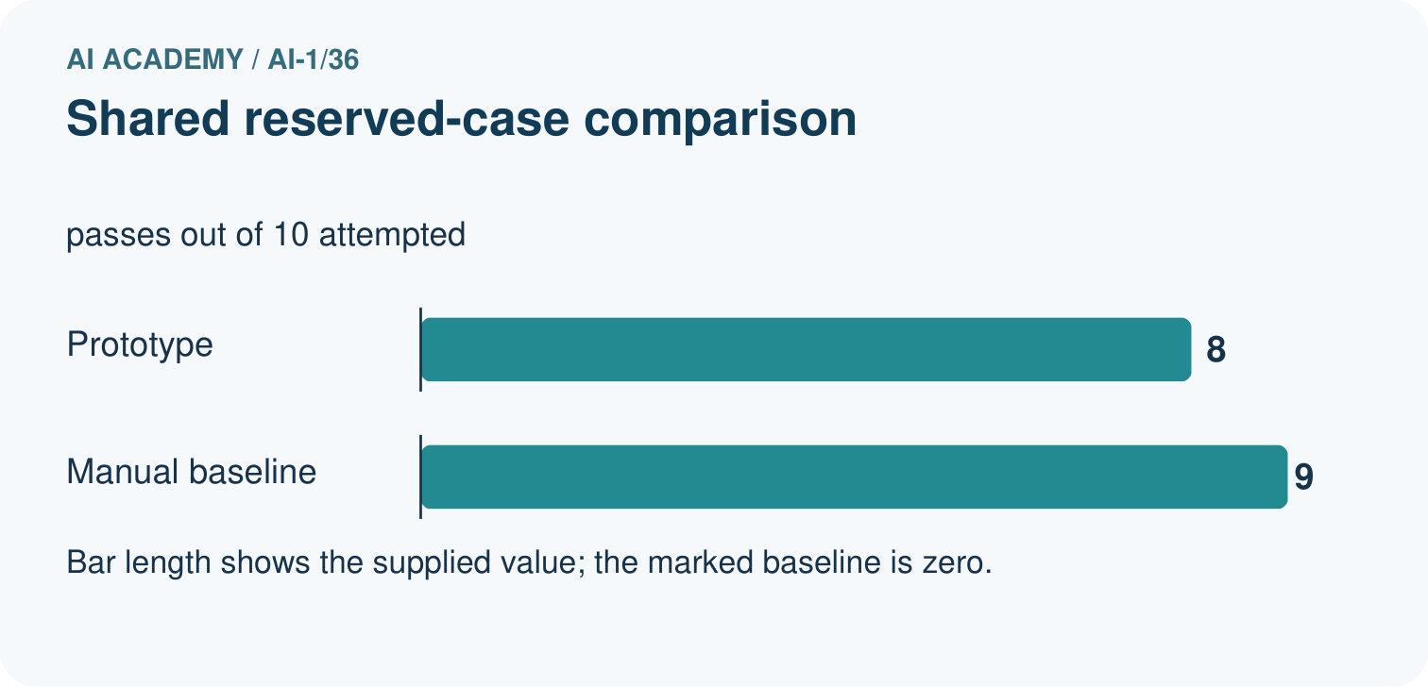
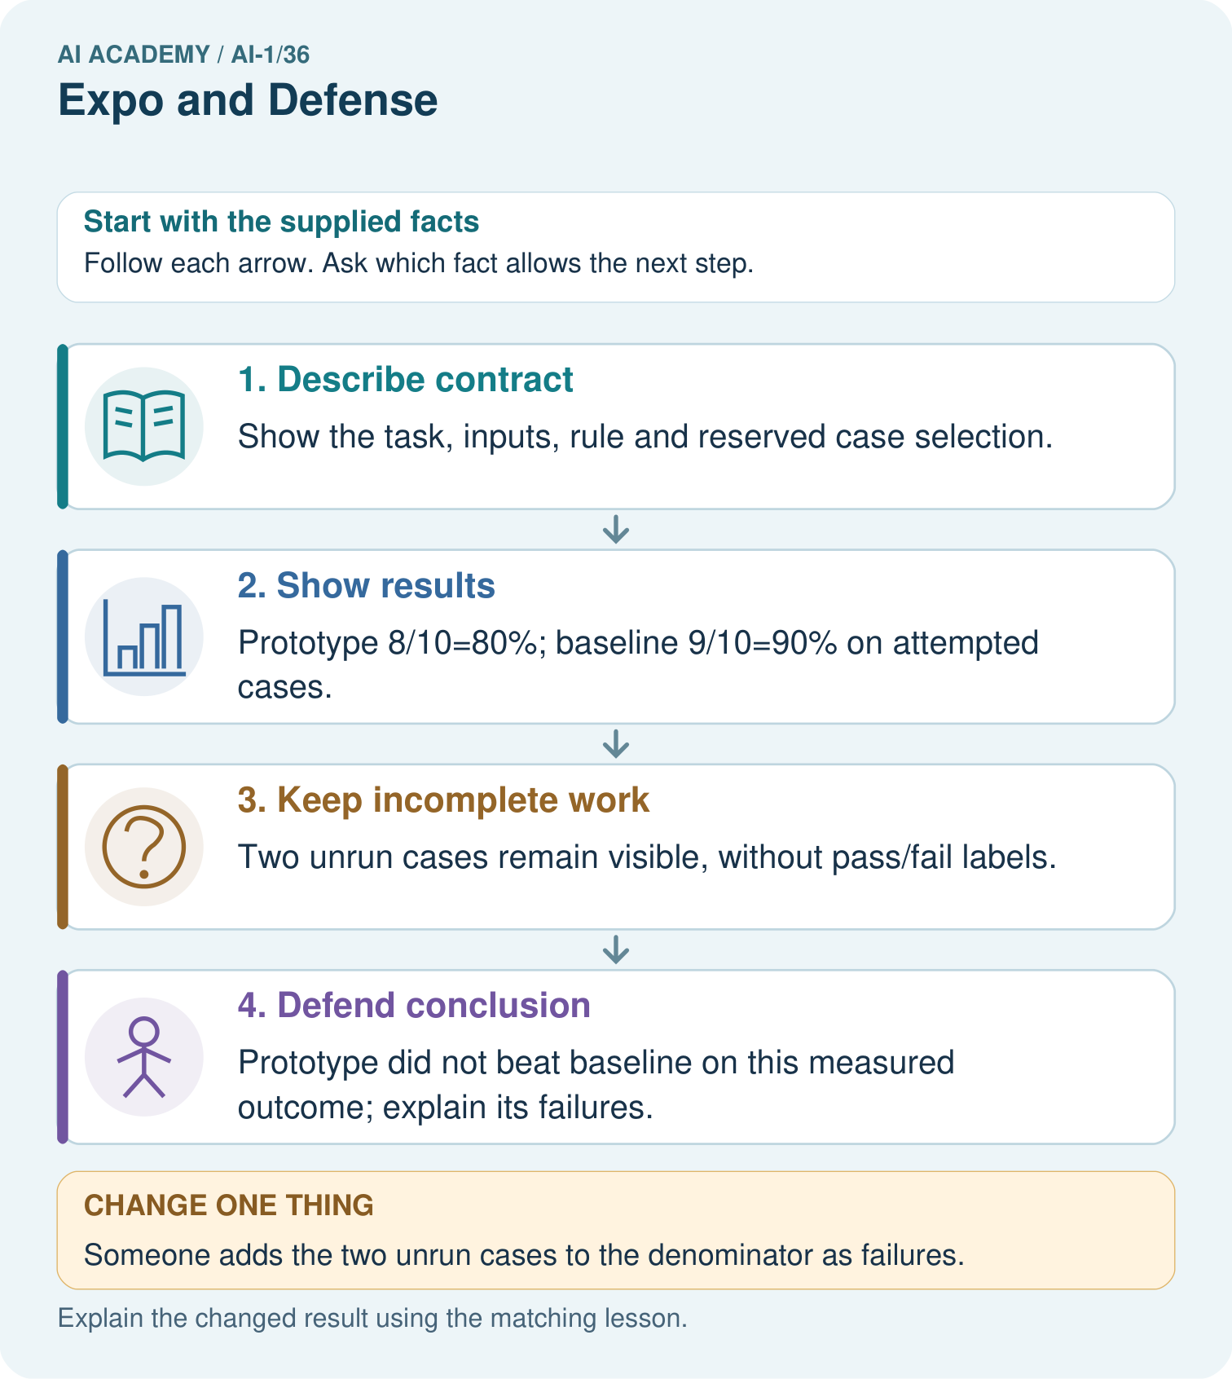

Read the picture one step at a time
Step | What happens and why
1. Describe contract | Show the task, inputs, rule and reserved case selection.
2. Show results | Prototype 8/10=80%; baseline 9/10=90% on attempted cases.
3. Keep incomplete work | Two unrun cases remain visible, without pass/fail labels.
4. Defend conclusion | Prototype did not beat baseline on this measured outcome; explain its failures.
Match each pictured step to the supplied facts. This is a worked teaching case, not an independent assessment.

Why this result follows
An exhibition should make the evidence inspectable. A polished demonstration is not a substitute for the reserved-case record. The shared cases allow a direct descriptive comparison of pass rates; missing timing data prevents a claim that the prototype is faster. Unrun cases must not be treated as successes.

What this example does not establish
This fictional evaluation does not demonstrate classroom learning impact or performance on every future request.

Change one thing in the pictured case
Change: Someone adds the two unrun cases to the denominator as failures.
Prediction: That reports a different measure, 8/12 completed successes out of planned cases.
Reason: It cannot be called the original attempted-case pass rate; distinguish completion from evaluated correctness.

Ask while showing the picture
Cover the result. Ask learners to name the inputs and predict the next step. Uncover one step, connect the icon to the actual procedure, and explain its evidence. Then change the supplied condition and compare. The picture is a representation; it does not document execution of a real AI model.

03. Demonstrate and guide practice

Demonstrate and guide practice

Board sequence
Write the given facts: The expo poster says always correct after six classroom passes.
Write the question to explain: Write a defensible claim.
Reveal after predictions: Report six specified passes with conditions and limits. Show an input, decision trace, output and test record, including an uncertain case.
Keep for an independent attempt: At the expo, a team says our sorter never fails after testing four cards. Replace the claim with an evidence-based statement and name a next test.

Classroom dialogue
Ask: Which facts are given, and which would we have to assume? Learners mark relevant details before discussing answers.
Say: Predict first. Show the rule, information path or calculation that would produce the result. A correct guess is not yet an explanation.
Reveal reasoning one step at a time. Explain why a tempting alternative fails. Write units and denominators for arithmetic, trace conditions for decisions, and identify supporting sources for claims.
In pairs, one learner solves while the other checks evidence; exchange roles. Remove the worked answer before independent assessment.

Model these guided questions
Fictional candidate 6/8 and baseline 8/8 attempted, with two unrun planned cases each; candidate 75 percent and baseline 100 percent on that set. Investigate retained failure traces before a versioned repair. Neither has evidence for all classrooms. Exit answers must use the pupil’s real record, limit the conclusion, name a next step and distinguish explicit rules from fitted models. Passing tests grants no booking authority.

Case-specific teaching sequence
Stage | Teacher action
Session 1 start to 7 minutes | Check the prerequisite and W1; collect or photograph each fixed instruction set before revealing any final inputs.
7 to 12 minutes | Reveal B version 4 and F1–F10 requests without the key. Explain W2 record fields and the unchanged full-pass criterion.
12 to 37 minutes | Run all ten cases with candidate and baseline. Partners swap operating and recording; preserve each output before comparison with the key. Record assistance and unrun cases.
37 to 45 minutes | Reveal the key, check reasons and summarise actual results in W2. Retain failure traces; do not edit the evaluated instructions.
Session 2 start to 8 minutes | Discuss the fictional 6-of-8 example and collect the guided explanation. Keep hypothetical results separate from class records.
8 to 22 minutes | Prepare W3 and run paired two-minute presentations with questions and role swaps. Sample individual traces; offer accessible spoken or written responses.
22 to 37 minutes | Collect W4 independently before hints. Assess evidence claims and the meaning of a rerun after revision.
37 to 45 minutes | Complete W5 and the exit. Archive the candidate, final results and next action; note support needs for Grade 7.

Reduce help deliberately
Completion task: Use a separate sheet for the teacher’s reserved cases. For every case record its ID and inputs, catalogue and candidate labels, both methods’ observed outputs and reasons, and results after checking. Preserve failure traces. Here summarise each method’s full passes over attempted cases and list unrun cases. State what the comparison supports.
Teacher check: Use the reserved key in Preparation only after observations are saved. Full pass requires output and reason; no-match explanations must rule out all rows. Clarification must precede search. Report actual candidate and baseline counts over the same attempted cases, plus unrun cases. Never substitute the key for an observation or assume a baseline run was correct.
Start by identifying the given inputs together. Leave the intermediate steps blank. If needed, model one step, then withdraw that help on the next step. Move to a full trace only when the partial trace is understood. For partners, alternate explainer and checker; collect a response from every learner before discussion.

Individual reasoning check
Use the worked case for Evaluating and explaining your project. Proposed explanation: “A polished presentation proves the system works”. Decide whether this explanation is supported. Point to the step or supplied fact that decides; explain your repair if needed.
Expected correction: Ask for the saved instruction, trace and actual result behind the claim.
Collect explanations, not only yes/no votes. If a misunderstanding is common, re-model the relevant step for the class. If it affects a few learners, give a short targeted group explanation while others solve a more demanding variation.

Pictorial practice question
Write one defensible success statement and one claim the evidence cannot support.

Reasoned teacher answer
Defensible: 8 of 10 attempted reserved cases passed. Unsupported: the prototype is faster or more accurate than the baseline.
Changed-case reasoning: That reports a different measure, 8/12 completed successes out of planned cases. It cannot be called the original attempted-case pass rate; distinguish completion from evaluated correctness.
Collect each learner’s explanation before discussion. Use the first missing connection between input, deciding step and result to choose support. This question is worked-case practice, not fresh mastery evidence.

04. Run the weekly evidence lab

Run the weekly evidence lab
Predict first, test honestly, and explain what the evidence means.
State your prediction before the result is known.
Complete the task: Demo the system, solve a fresh case, and answer why it may fail.
Keep a normal case and an edge case clearly separated.
Record what happened—even when it does not match your prediction.
Explain the result, one limitation, and the next useful test.
INDEPENDENCE After support is removed, repeat the proof with a fresh case.

Make the lab runnable
Use the concrete case as the shared normal case and the independent question as a second case. Each pair creates a boundary or missing-information case and predicts its result before testing. Keep the expected result separate from an observed mistake.
Record | What to capture
Input or evidence | Exact data, instruction or claim
Expected result | Answer or safe fallback declared before the run
Observed result | Actual result, including errors
Explanation | Rule, calculation or evidence explaining the outcome
Next test | One justified change and a new prediction

Diagnose and reteach
CLAIM TO REPAIR A successful demonstration proves universal reliability.
For guessing, return to given facts and request a trace. For vocabulary without application, use one example and one non-example. For arithmetic errors, check the setup before the calculation. Finish with a different uncoached case before recording mastery.

Address these additional misconceptions
A polished presentation proves the system works: Ask for the saved instruction, trace and actual result behind the claim.
Unrun cases count as passes: Report attempted denominators and unrun cases separately.
The baseline must lose: A tie or a better baseline can justify retaining the simpler method.
A repair erases the final failure: Preserve the evaluated version and results; revealed cases become development checks for the revision.

Match the support to the first error
What the response shows | Next teaching action
Missing or misread facts | Read the case aloud, mark supplied versus unknown facts, and let the learner restate it.
Wrong procedure | Return to the deciding step in the worked case. Contrast it with the proposed incorrect explanation.
Arithmetic or implementation error | Trace intermediate values or lines; preserve the first mismatch and retry that step.
Correct result without a reason | Ask for a trace and a changed case before marking independent understanding.
An unsupported wider claim | Ask which supplied evidence supports the claim and which further observation would be needed.
Offer an oral explanation, drawing, enlarged visual or fewer examples when that removes a reading/writing barrier. Keep the same reasoning goal. Stretch secure learners by changing a boundary or assumption and asking them to defend the effect, not simply by assigning more of the same questions.

05. Assess and explain the answers

Assess and explain the answers

Worked case answer
Report six specified passes with conditions and limits. Show an input, decision trace, output and test record, including an uncertain case.

Independent question
At the expo, a team says our sorter never fails after testing four cards. Replace the claim with an evidence-based statement and name a next test.

Expected independent answer
Say it succeeded on these four named cards, with the observed count reported. Four cases do not prove it never fails. Next test unfamiliar, blurred or dim examples and explain human review.

What counts as evidence
Criterion | 0 points | 1 point | 2 points
Result | Incorrect or absent | Partly correct | Correct with necessary conditions
Reasoning | No supporting trace | Some steps | Clear mechanism, calculation or source support
Limit | Overclaims certainty | Vague limitation | Relevant uncertainty or missing fact
Transfer | Copies without adapting | Adapts with prompts | Solves a changed case independently
Use 6/8 as a classroom checkpoint, with 2 required for both Result and Reasoning. This is a proposed teaching rule, not a validated certification threshold. Do not count a coached answer as independent mastery; correct unsafe or unsupported claims regardless of total.

Feedback
Ask the learner to find the evidence that challenges this claim: “A successful demonstration proves universal reliability.” Keep the first attempt and an uncoached retry separate.

Original transfer answer
Overall is 12/16=75%; routine is about 83.3%; mixed is 50%. Show the actual failed trace and investigate mixed-material handling or review rules. 'Works reliably on every material' overstates these small specified tests. Advancement requires independent explanation, not presentation polish alone.

Explanations for the additional workbook examples

W1 Record the fixed candidate
Before final cases are revealed, record your version label, where its complete instructions are saved, the agreed input and matching rules, the manual baseline and any known limitation. Confirm that the instructions stay unchanged while the assigned catalogue is used as input.
Require an identifiable saved version, complete instructions, valid whole minutes 0 to 30, Yes or No quiet input, inclusive time AND quiet compatibility, first-fit order, reset, stopping and clarification. The baseline checks all rows and selects the first fit under the same contract. Accept honestly stated known failures; do not award a stronger result for hiding them.

W2 Keep the final evaluation record
Use a separate sheet for the teacher’s reserved cases. For every case record its ID and inputs, catalogue and candidate labels, both methods’ observed outputs and reasons, and results after checking. Preserve failure traces. Here summarise each method’s full passes over attempted cases and list unrun cases. State what the comparison supports.
Use the reserved key in Preparation only after observations are saved. Full pass requires output and reason; no-match explanations must rule out all rows. Clarification must precede search. Report actual candidate and baseline counts over the same attempted cases, plus unrun cases. Never substitute the key for an observation or assume a baseline run was correct.

W3 Prepare your evidence defence
Write a two-minute explanation of the problem, one trace, your actual comparison, a limitation and a next action. Explain why this is a written-rule design rather than a model trained on examples. State which personal information is unnecessary and who decides whether to act.
Look for a saved trace connected to the actual instruction, accurate counts, a specific failure or limitation and a justified next step. The project applies explicit human-written rules, with no fitted model. Only minutes and quiet preference are needed; names and reasons for quiet are unnecessary. The person may decline and the teacher checks real conditions; the adviser does not book or publish.

W4 Judge a different project independently
A fictional library adviser and its manual baseline face the same 6 reserved cases. The candidate has 4 full passes; the baseline has 5. One additional planned case is unrun by both. No speed data was collected. The team says “ours is faster and more reliable everywhere” and repairs it after seeing the failures. Explain what the counts support, two unsupported claims and how to label a rerun of the revealed cases.
Report candidate 4 of 6 and baseline 5 of 6 full passes, with one unrun case for each. The baseline performed better on this measured set; neither result establishes reliability everywhere. Speed was not measured. A rerun after the failures informed a repair is development evidence for the revised version, not an unseen final test. Preserve the old results and label both versions.

W5 Write your final conclusion
Use your own records to complete: Under these conditions, our saved version showed… The baseline showed… We still do not know… Our next action is… Include one privacy or human-control choice. If a case failed, explain its consequence without deleting the result.
Accept different conclusions grounded in actual observations, including a decision to retain the baseline. Require stated conditions, honest comparison, a real uncertainty and a specific action. A quiet requirement does not require a diagnosis; an output does not authorise action. A failure remains part of the evaluated version’s record even after a repair.

Assess independent transfer
Selected case: A fictional library adviser and its manual baseline face the same 6 reserved cases. The candidate has 4 full passes; the baseline has 5. One additional planned case is unrun by both. No speed data was collected. The team says “ours is faster and more reliable everywhere” and repairs it after seeing the failures. Explain what the counts support, two unsupported claims and how to label a rerun of the revealed cases.

Selected case answer
Report candidate 4 of 6 and baseline 5 of 6 full passes, with one unrun case for each. The baseline performed better on this measured set; neither result establishes reliability everywhere. Speed was not measured. A rerun after the failures informed a repair is development evidence for the revised version, not an unseen final test. Preserve the old results and label both versions.
Dimension | Evidence required
Explanation | Names the applicable idea or procedure and ties it to the supplied facts.
Trace and result | Preserves the given inputs and shows the relevant intermediate steps; distinguishes a prediction from an observed execution.
Limits | States the assumptions, missing evidence or conditions under which the result would change.
Record each dimension as not yet, with support, or independent. Accept a valid alternative procedure with a defensible trace. Do not penalise an honestly recorded model failure if the learner correctly explains its evidence and limits.

Feedback that the learner uses
Name the earliest unsupported step and give one action to repair it. Have the learner make that repair now and explain why. Then assess the relevant skill on a fresh, fully specified case. Confirm it was not previously practised with feedback; solve and check the new case before assigning it. A follow-up design prompt is a starting brief, not automatically an equivalent test.

06. Connect and extend learning

Connect and extend learning

Helpful Classroom Sorter
Present the final Classroom Sorter portfolio and complete the AI-1 certification defense.
Keep the decision, input, result, explanation and remaining limitation in the project evidence record. Retrieve this record next week rather than restarting the project.

Support and stretch
Use physical cards, spoken explanations and a three-stage drawing. Read aloud without giving the answer. Stretch: compare two mechanisms with the same visible output and explain what evidence distinguishes them.

Exit reflection
Ask for one decision the learner can now justify and one situation requiring more evidence or human review. Confidence ratings are separate from correct independent performance.

Bridge to the next week
Review the full project evidence and choose concepts needing another independent attempt before the next level. One expo is not proof of mastery of all AI.

Support and fresh reassessment
Provide a blank record grid, read instructions aloud and allow oral defence, while recording assistance. Keep independent W4 responses before feedback. Allow additional time for unrun cases with the same fixed version and record when they ran; do not manufacture completion. Extension: propose an additional test for a stated limitation and explain why it would help without claiming proof of every situation.
Assess four strands separately: faithful execution with traces; honest comparison including failures; independent explanation of rule-based mechanism and human control; justified limits and next action. Mark each secure, developing or not yet evidenced, with one cited observation. Do not infer individual mastery from group totals. W4 requires 4/6 versus 5/6, one unrun, unknown speed and a development rerun. After support, retry with candidate 3/5 and baseline 3/5, two unrun and no timing: a tie on observed passes, no universal or speed claim. Require fresh reasoning.
Grade 6 Foundations is complete. Grade 7 AI 2 begins programming and data. Carry forward versioned instructions, validation, tests, privacy and evidence-based conclusions; use the recorded assessment strands to plan support.

Plan the delayed return
Suggested return points in this level: plan a review after the level ends. Use actual classroom dates, adjusting for holidays and gaps. One, three and six teaching weeks are scheduling choices, not a claimed optimal spacing.
At a delayed check, ask for the idea from memory and a changed application. Compare with the earlier independent response and record support used. For a new level, revisit the previous capstone before checking the new prerequisites.
Record | Teacher evidence
Learner code and date
Concept and case used; prior exposure
Explanation / trace / limits
Support and first repair
Changed case and delayed outcome
Next teaching action
Use the evidence to choose reteaching or the next step. A completed page, confidence rating or attractive project does not by itself demonstrate understanding.

Project evidence from this case
Present the Helpful Classroom Sorter’s versions, test records, baseline, failures and next investigation as an evidence portfolio.

07. Prepare, teach and assess
Teaching target: Evaluate a saved candidate and a manual baseline fairly
Prepare the labelled worked-case picture, the matching workbook, fictional input cards and a place for individual responses. No paid AI account is required for the paper reasoning activities.
Session | Plan | Resources
Session 1 · Understand · 45 min | 0–7: recall and prerequisite; 7–15: inspect the concrete case and predict; 15–30: teacher models the worked trace; 30–40: learners explain a step using the text and visual; 40–45: check the core idea. | Sections 1–6; record the brief recall in the workbook.
Session 2 · Practise · 45 min | 0–5: retrieve the procedure; 5–15: W2 completion practice; 15–23: explain and check with a partner; 23–30: each learner answers the misconception check; 30–40: targeted reteaching or a harder variation; 40–45: prepare the investigation. | Sections 7–10; use the matching workbook W2 and misconception check.
Session 3 · Investigate and transfer · 45 min | 0–5: retrieve the decision rule; 5–20: investigate or trace; 20–30: start the independent case; 30–38: connect the project; 38–43: act on feedback; 43–45: plan the return check. | Sections 9 and 11–14. Give extra time to finish the full task set; use Section 15 when the week includes a coding lab.
Before class, solve the supported practice: Use a separate sheet for the teacher’s reserved cases. For every case record its ID and inputs, catalogue and candidate labels, both methods’ observed outputs and reasons, and results after checking. Preserve failure traces. Here summarise each method’s full passes over attempted cases and list unrun cases. State what the comparison supports.
Reasoned practice answer: Use the reserved key in Preparation only after observations are saved. Full pass requires output and reason; no-match explanations must rule out all rows. Clarification must precede search. Report actual candidate and baseline counts over the same attempted cases, plus unrun cases. Never substitute the key for an observation or assume a baseline run was correct.
Check every learner before discussion: Use the worked case for Evaluating and explaining your project. Proposed explanation: “A polished presentation proves the system works”. Decide whether this explanation is supported. Point to the step or supplied fact that decides; explain your repair if needed.
Misconception repair: Ask for the saved instruction, trace and actual result behind the claim.
Support: read the exact case aloud, enlarge the labelled picture, supply input cards and model only the first deciding step. Accept a spoken explanation or drawing; retain the reasoning goal.
Extension: Someone adds the two unrun cases to the denominator as failures. Require a prediction and a reason before comparing. Expected result: That reports a different measure, 8/12 completed successes out of planned cases. Reason: It cannot be called the original attempted-case pass rate; distinguish completion from evaluated correctness.
Independent assessment: withhold the reserved answer until the learner has attempted the new case. Record support separately from correctness.
Criterion | Not yet | With support | Independent
Explanation | Names an answer without a deciding fact | Uses a hint to link fact and decision | Explains the deciding fact in own words
Trace or test | Cannot connect input and result | Completes steps with prompts | Traces or tests a changed case accurately
Limits and revision | Claims more than evidence supports | Names a limit after a prompt | States a defensible limit and useful next test
Project checkpoint: Present and defend. Demonstrate the system, explain one failure and justify the next improvement with evidence.
Use the weekly teacher answer for topic-specific reasoning. A saved progress tick is an activity record; judge mastery from the learner’s explanation and evidence.

08. Use feedback, labs and repair paths
Use the two formative questions as supported practice, not as independent mastery scores. Discuss the deciding evidence rather than accepting a guessed selection.
The feedback comes from the reviewed public worked case. Do not reveal the separately reserved independent teacher answer until the learner has attempted that case.
Ask students to predict before running code. Preserve errors and actual outputs; collect a changed test and an explanation. The branch-boundary and indexing lessons deliberately include failure cases.
Use the earlier worked-explanation links to address a specific missing building block, then return to the current question. Adapt this suggestion after observing the learner; it is not an automatic diagnosis.
Collect the completed-work portfolio as evidence. Record support separately from correctness, and assess explanation, trace/test and limitations. Progress ticks and quiz selections alone do not establish mastery.

