AI ACADEMY · TEACHER · ai-2/5

Loops and Stopping
Project: Transparent Book Recommender

01. Loops and Stopping

Teach the learning cycle
Primary target: Trace variable values before and after each loop iteration
Session | Sequence and minutes | Resources
Session 1 · Understand · 45 min | 0–7: recall and prerequisite; 7–15: inspect the concrete case and predict; 15–30: teacher models the worked trace; 30–40: learners explain a step using the text and visual; 40–45: check the core idea. | Sections 1–6; record the brief recall in the workbook.
Session 2 · Practise · 45 min | 0–5: retrieve the procedure; 5–15: W2 completion practice; 15–23: explain and check with a partner; 23–30: each learner answers the misconception check; 30–40: targeted reteaching or a harder variation; 40–45: prepare the investigation. | Sections 7–10; use the matching workbook W2 and misconception check.
Session 3 · Investigate and transfer · 45 min | 0–5: retrieve the decision rule; 5–20: investigate or trace; 20–30: start the independent case; 30–38: connect the project; 38–43: act on feedback; 43–45: plan the return check. | Sections 9 and 11–14. Give extra time to finish the full task set; use Section 15 when the week includes a coding lab.
This is a starting allocation of 135 minutes, not a validated duration. Preserve all named topics. Schedule extra time for connected examples, the full investigation, independent cases and project building. Repeated copies of a case share one recorded attempt; they are not new evidence.
Case exposure check: this source example appears in ai-2/4, ai-2/5, python-bridge/6. Reuse a familiar case for recall or modelling; verify that the case used to assess transfer has not already received feedback.

Retrieval answer guidance

Trace Tables
Without opening the old lesson, explain one key idea from Trace Tables. Give an example and a mistake that the idea helps you avoid.
Look for: Trace variable values before and after each loop iteration
Reference example, not the only acceptable wording: 2, 3 and 4; the stop value is excluded. The body runs three times.

Decompose a Goal
Without opening the old lesson, explain one key idea from Decompose a Goal. Give an example and a mistake that the idea helps you avoid.
Look for: Distinguish a function definition from a function call
Reference example, not the only acceptable wording: Name show_remaining; parameters capacity and used. Arguments 15 and 6 match capacity = 15 and used = 6. Expected printed result 9.
Use the student module and workbook section with this exact week title. The worked case, independent question and answers below form one aligned lesson sequence.

What the learner must demonstrate
Trace count=0; while count<4: count=count+2. List values tested by the condition and final count. Would replacing <4 with !=5 terminate?

Concept to explain
Useful repetition needs a clear update and stopping rule.
Term | Meaning
loop | A structure that repeats instructions according to a count or condition.
update | Change a stored value or state according to a specified operation or new evidence.
stopping rule | A specified condition that ends a repeated process.
infinite loop | A loop that never reaches its stopping condition under the assumed execution model.

Prepare the class
Use the supplied scenario, student illustrations and blank paper. For numeric work, offer counters or a calculator after learners show the setup. Fictional records are supplied; personal data and paid accounts are unnecessary.
Allow 80 minutes: recall 8; explanation 12; worked demonstration 15; guided practice 20; independent assessment 15; project and reflection 10. Extend the lab into a second session when needed.

Preparation for the connected explanation
Teach for loops with finite integer ranges before adding more loop forms. Keep range values, body executions and output events separate. Reference: https://docs.python.org/3/tutorial/controlflow.html#the-range-function. The examples use a positive default step and do not require lists or while loops.

Readiness answer
It reads the old 2, adds 3 and stores 5. Assignment updates a value; it is not an algebraic equality.
Python 3 editor and loops.py
Counters or numbered paper cards
Blank trace table with turn total before and total after columns

End goal for the pictorial case
By the end, I can trace a while-loop and recognise when its update cannot satisfy the stopping test.
This added worked case illustrates the week’s main idea. Retain all original and connected topics; schedule its practice within the teaching cycle.

02. Explain the mechanism

Explain the mechanism
Input → Process → Output
Trace the information. At each stage, ask what changed and how you could test it.
Which stage could fail even when the other two are correct? Explain:
Predict first. Then check each step. A correct answer without visible reasoning is incomplete evidence.
2. Repeat while count < 4: show a card; count = count + 1.
3. The loop runs 4 times and stops when count becomes 4.
4. If count never changes, the stopping condition never becomes false.
Recalculate, retrace, or restate the reasoning in your own representation:
CHECK Did the evidence answer the exact question? Did the total, path, or source record stay consistent?

Concrete teaching case
Start n=0; while n<3, add 1 and record n.
List records and stopping condition.

Exact explanation to model
1,2,3. The next comparison is false. The update makes progress toward termination.

Explain the added worked example
Imagine adding numbered counters: first 1, then 2, then 3. A loop can repeat the same addition with a different number each time. This week you will predict each change before running a short Python script. Tracing repeated calculations prepares you to inspect the data processing used in larger AI applications.
In for turn in range(1, 4), Python supplies 1, 2 and 3 in order. The start is included and the stop is excluded. The indented body runs once for each supplied value. The colon and four-space indentation mark that body. This lesson uses integer range values with the default positive step of 1.
The output is 6. Before the first iteration, total is 0. Each assignment reads the previous total and adds the current turn. After turn 3, the range is exhausted, so execution continues after the loop. The table records state; it does not create extra instructions.

Key terms
Term | Meaning
Loop | A block of instructions that can run repeatedly
Iteration | One execution of a loop body
Accumulator | A variable that keeps a running result
Initialization | Giving a variable its starting value
Trace table | A record of variable values as instructions execute

Model the reasoning aloud
Use the complete worked example below before asking learners to complete W2. Reveal a small part, invite a prediction, then explain the deciding step. These teacher notes contain solutions; do not reveal the independent case answer during modelling.
range(1, 4) | 1, 2, 3 | 3
range(1, 2) | 1 | 1
range(1, 1) | No values | 0
range(4) | 0, 1, 2, 3 | 4
With one argument, range starts at zero. range(4) supplies four values but none is 4. If the worked script uses range(1, 1), the body never runs and the initialized total remains 0. Do not rely on a variable first assigned inside a loop: a zero-iteration run might never assign it.

Replace range(1, 4) with range(1, 3) in the worked script. Predict the supplied values and final total. What stop value is needed to include 3?
________________________________________________________________
________________________________________________________________
________________________________________________________________
________________________________________________________________
________________________________________________________________
Thinking move | Teacher prompt
Plan | What is given? What is the question? Which procedure fits these facts?
Do | Point to each input and intermediate step in the worked trace. Name the rule that allows the next step.
Check | Does the output answer the question? Which assumption or limitation prevents a larger claim?
Use the diagram and verbal explanation together. Ask learners to match a sentence to a specific visual step; do not assign learners fixed visual or auditory learning styles.

A pictorial worked case: Loops and Stopping
A fictional counter starts at 12 and decreases while above a boundary.

The facts we will use
Python: count=12; while count>3: count=count-4; print after the loop.
The condition is checked before each subtraction.
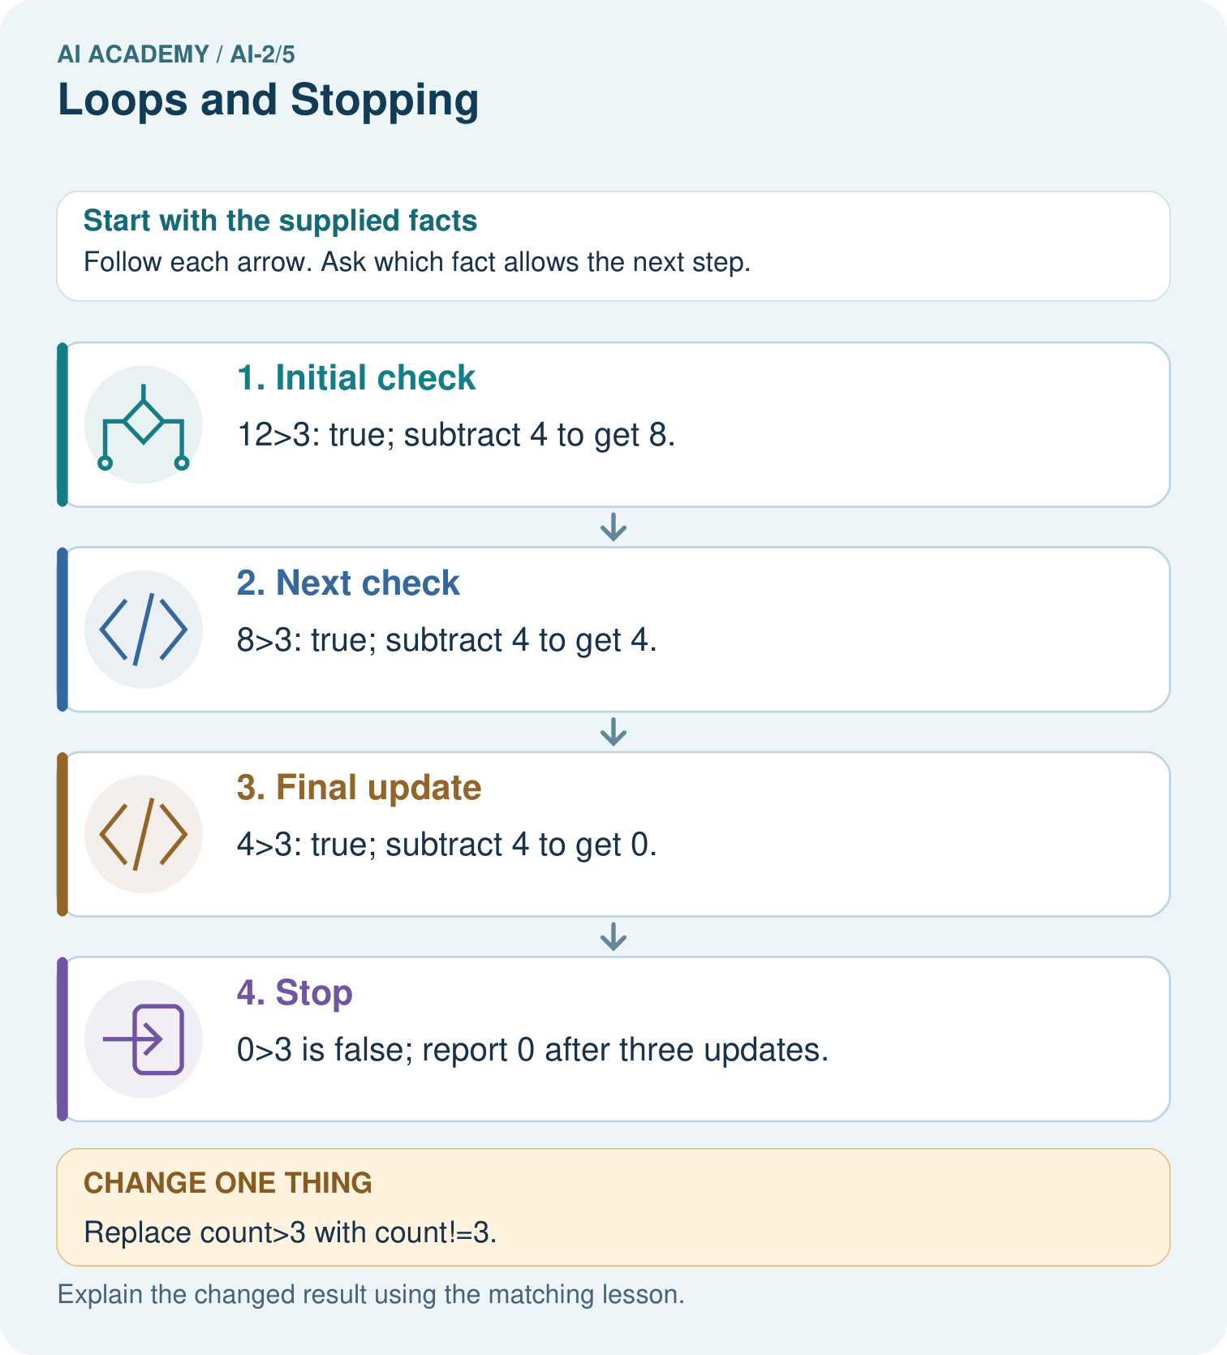

Read the picture one step at a time
Step | What happens and why
1. Initial check | 12>3: true; subtract 4 to get 8.
2. Next check | 8>3: true; subtract 4 to get 4.
3. Final update | 4>3: true; subtract 4 to get 0.
4. Stop | 0>3 is false; report 0 after three updates.
Match each pictured step to the supplied facts. This is a worked teaching case, not an independent assessment.

Why this result follows
The condition does not promise the counter ends exactly at 3. Subtractions can cross the boundary. The count strictly decreases, so the below-or-equal stopping region is eventually reached from this start. A condition requiring exact equality can be unsafe when repeated updates skip that value.

What this example does not establish
Do not run an intentionally unbounded loop in class; trace a finite prefix to inspect the defect safely.

Change one thing in the pictured case
Change: Replace count>3 with count!=3.
Prediction: From 12, the loop never reaches 3 and does not terminate in this toy model.
Reason: 12,8,4,0,−4,… are multiples of 4; none equals 3.

Ask while showing the picture
Cover the result. Ask learners to name the inputs and predict the next step. Uncover one step, connect the icon to the actual procedure, and explain its evidence. Then change the supplied condition and compare. The picture is a representation; it does not document execution of a real AI model.

03. Demonstrate and guide practice

Demonstrate and guide practice

Board sequence
Write the given facts: Start n=0; while n<3, add 1 and record n.
Write the question to explain: List records and stopping condition.
Reveal after predictions: 1,2,3. The next comparison is false. The update makes progress toward termination.
Keep for an independent attempt: Start at count 0. While count is less than 3, add 1 and display count. List the displays and the stopping value.

Classroom dialogue
Ask: Which facts are given, and which would we have to assume? Learners mark relevant details before discussing answers.
Say: Predict first. Show the rule, information path or calculation that would produce the result. A correct guess is not yet an explanation.
Reveal reasoning one step at a time. Explain why a tempting alternative fails. Write units and denominators for arithmetic, trace conditions for decisions, and identify supporting sources for claims.
In pairs, one learner solves while the other checks evidence; exchange roles. Remove the worked answer before independent assessment.

Model these guided questions
range(1, 3) supplies 1 and 2, giving total 3. Stop 4 includes 3. Exit: the reset bug agrees for one iteration because there are no earlier additions to lose. range(1, 4) should give 6; the faulty version gives 3.

Case-specific teaching sequence
Stage | Teacher action
Session 1 start to 7 minutes | Retrieve assignment using the prerequisite.
7 to 20 minutes | Model range with numbered cards and complete W1.
20 to 33 minutes | Trace each row of the worked addition and predict output.
33 to 45 minutes | Complete W2 and compare predicted and observed values.
Session 2 start to 8 minutes | Retrieve included start and excluded stop.
8 to 20 minutes | Trace the reset bug, complete W3 and discuss the guided response.
20 to 35 minutes | Collect independent W4 code and zero one and several iteration traces.
35 to 45 minutes | Use W5 and the exit to examine assumptions and revealing tests.

Reduce help deliberately
Completion task: Copy the worked script. Change the range to range(2, 5). Record turn, total before and total after each iteration. Predict the single output, then run and compare.
Teacher check: Rows are 2 / 0 / 2, 3 / 2 / 5, 4 / 5 / 9. Final output 9. Keep the observed result distinct from the prediction.
Start by identifying the given inputs together. Leave the intermediate steps blank. If needed, model one step, then withdraw that help on the next step. Move to a full trace only when the partial trace is understood. For partners, alternate explainer and checker; collect a response from every learner before discussion.

Individual reasoning check
Use the worked case for Loops and trace tables. Proposed explanation: “The stop value is included”. Decide whether this explanation is supported. Point to the step or supplied fact that decides; explain your repair if needed.
Expected correction: List the supplied values before tracing; range(1, 4) excludes 4.
Collect explanations, not only yes/no votes. If a misunderstanding is common, re-model the relevant step for the class. If it affects a few learners, give a short targeted group explanation while others solve a more demanding variation.

Pictorial practice question
Why is report 0 correct for the original loop, and why is equality-only stopping risky here?

Reasoned teacher answer
The original stops as soon as count is not above 3. Exact equality fails because the update sequence skips 3.
Changed-case reasoning: From 12, the loop never reaches 3 and does not terminate in this toy model. 12,8,4,0,−4,… are multiples of 4; none equals 3.
Collect each learner’s explanation before discussion. Use the first missing connection between input, deciding step and result to choose support. This question is worked-case practice, not fresh mastery evidence.

04. Run the weekly evidence lab

Run the weekly evidence lab
Words You Can Use to Reason
A definition matters when you can recognize the idea, use it, and contrast it with a near-miss.
Predict → Test → Record → Explain
Keep expected and actual results separate. Surprises are useful data when recorded honestly.
Walk a robot around a four-card loop. Record the update each time; remove the update to observe the failure; restore it and retest.
What did the hardest test teach you that the normal test did not?

Make the lab runnable
Use the concrete case as the shared normal case and the independent question as a second case. Each pair creates a boundary or missing-information case and predicts its result before testing. Keep the expected result separate from an observed mistake.
Record | What to capture
Input or evidence | Exact data, instruction or claim
Expected result | Answer or safe fallback declared before the run
Observed result | Actual result, including errors
Explanation | Rule, calculation or evidence explaining the outcome
Next test | One justified change and a new prediction

Diagnose and reteach
For guessing, return to given facts and request a trace. For vocabulary without application, use one example and one non-example. For arithmetic errors, check the setup before the calculation. Finish with a different uncoached case before recording mastery.

Address these additional misconceptions
The stop value is included: List the supplied values before tracing; range(1, 4) excludes 4.
Initialization belongs inside every iteration: Resetting the accumulator loses earlier work.
An unindented print repeats with the body: Indentation determines which statements repeat.
Zero iterations mean the entire program does nothing: Initialization and statements after the loop still execute.

Match the support to the first error
What the response shows | Next teaching action
Missing or misread facts | Read the case aloud, mark supplied versus unknown facts, and let the learner restate it.
Wrong procedure | Return to the deciding step in the worked case. Contrast it with the proposed incorrect explanation.
Arithmetic or implementation error | Trace intermediate values or lines; preserve the first mismatch and retry that step.
Correct result without a reason | Ask for a trace and a changed case before marking independent understanding.
An unsupported wider claim | Ask which supplied evidence supports the claim and which further observation would be needed.
Offer an oral explanation, drawing, enlarged visual or fewer examples when that removes a reading/writing barrier. Keep the same reasoning goal. Stretch secure learners by changing a boundary or assumption and asking them to defend the effect, not simply by assigning more of the same questions.

05. Assess and explain the answers

Assess and explain the answers

Worked case answer
1,2,3. The next comparison is false. The update makes progress toward termination.

Independent question
Start at count 0. While count is less than 3, add 1 and display count. List the displays and the stopping value.

Expected independent answer
Displays are 1, 2 and 3. The next condition check finds 3 is not less than 3, so the loop stops.

What counts as evidence
Criterion | 0 points | 1 point | 2 points
Result | Incorrect or absent | Partly correct | Correct with necessary conditions
Reasoning | No supporting trace | Some steps | Clear mechanism, calculation or source support
Limit | Overclaims certainty | Vague limitation | Relevant uncertainty or missing fact
Transfer | Copies without adapting | Adapts with prompts | Solves a changed case independently
Use 6/8 as a classroom checkpoint, with 2 required for both Result and Reasoning. This is a proposed teaching rule, not a validated certification threshold. Do not count a coached answer as independent mastery; correct unsafe or unsupported claims regardless of total.

Feedback
Ask the learner to find the evidence that challenges this claim: “A less-than-3 loop can never display 3.” Keep the first attempt and an uncoached retry separate.

Original transfer answer
The condition tests 0,2,4; the body runs twice and ends at 4. With !=5, even counts never equal 5, so it does not terminate under unbounded arithmetic. A stopping rule should match the update and include resource bounds in an actual application.

Explanations for the additional workbook examples

W1 Explain the range
List the values supplied by range(2, 5) and explain why 5 is absent. How many times does its body run?
2, 3 and 4; the stop value is excluded. The body runs three times.

W2 Trace before running
Copy the worked script. Change the range to range(2, 5). Record turn, total before and total after each iteration. Predict the single output, then run and compare.
Rows are 2 / 0 / 2, 3 / 2 / 5, 4 / 5 / 9. Final output 9. Keep the observed result distinct from the prediction.

W3 Repair the reset
For the faulty script with range(1, 4), record total after each addition. Explain the wrong final output and remove only the faulty reset.
Faulty after-addition values are 1, 2, 3 because each starts from zero. Remove the indented total = 0. Correct after-addition values are 1, 3, 6; final output 6.

W4 Build a repeated addition independently
A box starts with 5 counters. Each round adds 2 counters. Use rounds = 3, an initialized total and for turn in range(rounds). Print the final total once after the loop. Trace the totals and predict fresh runs with rounds 0, 1 and 3. Assume rounds is a nonnegative integer.
Initialize total = 5 before the loop; add 2 inside it. For three rounds, turn values 0, 1, 2 give totals 7, 9, 11. Final outputs for 0, 1, 3 rounds are 5, 7, 11. Print is unindented.

W5 Check a contract limitation
In your counter script, range(-2) performs no iterations. Does returning the initial 5 make negative rounds valid? Explain what the script checks and what it assumes.
No. The written contract requires a nonnegative integer. The script assumes this and does not reject negative values. Empty range behavior does not validate the input; report the limitation or add an explicit check.

Assess independent transfer
Selected case: Start count at 1. While count < 8, add 3. Trace the condition and values. What happens if the condition becomes count != 8?

Selected case answer
The condition is true at 1,4,7, then false at 10. Final count is 10. With !=8 the sequence never reaches 8: all values are 1 modulo 3, so this loop does not terminate.
Dimension | Evidence required
Explanation | Names the applicable idea or procedure and ties it to the supplied facts.
Trace and result | Preserves the given inputs and shows the relevant intermediate steps; distinguishes a prediction from an observed execution.
Limits | States the assumptions, missing evidence or conditions under which the result would change.
Record each dimension as not yet, with support, or independent. Accept a valid alternative procedure with a defensible trace. Do not penalise an honestly recorded model failure if the learner correctly explains its evidence and limits.

Feedback that the learner uses
Name the earliest unsupported step and give one action to repair it. Have the learner make that repair now and explain why. Then assess the relevant skill on a fresh, fully specified case. Confirm it was not previously practised with feedback; solve and check the new case before assigning it. A follow-up design prompt is a starting brief, not automatically an equivalent test.

06. Connect and extend learning

Connect and extend learning

Transparent Book Recommender
Loop through every candidate book, update its score, then stop at the end of the list.
Keep the decision, input, result, explanation and remaining limitation in the project evidence record. Retrieve this record next week rather than restarting the project.

Support and stretch
Trace one record or condition at a time with counters and labelled columns. Stretch: introduce a tie, boundary or missing field and declare its handling policy before rerunning.

Exit reflection
Ask for one decision the learner can now justify and one situation requiring more evidence or human review. Confidence ratings are separate from correct independent performance.

Bridge to the next week
Next: Week 6: Debugging Strategies. Retrieve today’s evidence and identify what carries forward and what is new.

Support and fresh reassessment
Use counters and let the learner move a pointer through one instruction at a time. Offer a blank trace grid and permit oral explanation. Extension: put print inside the correct loop and explain why zero rounds produces no output while an outside print still does.
W4 must preserve the initial 5, update by 2, trace three iterations and print once. Require outputs 5, 7, 11 for zero one and three rounds. After support, retry with an initial 4 and additions of 3 for zero one and two rounds: outputs 4, 7, 10. Record assistance before judging independence.
Week 7 stores several values in a list and distinguishes an index from the value at that position.

Plan the delayed return
Suggested return points in this level: ai-2/6, ai-2/8, ai-2/11. Use actual classroom dates, adjusting for holidays and gaps. One, three and six teaching weeks are scheduling choices, not a claimed optimal spacing.
At a delayed check, ask for the idea from memory and a changed application. Compare with the earlier independent response and record support used. For a new level, revisit the previous capstone before checking the new prerequisites.
Record | Teacher evidence
Learner code and date
Concept and case used; prior exposure
Explanation / trace / limits
Support and first repair
Changed case and delayed outcome
Next teaching action
Use the evidence to choose reteaching or the next step. A completed page, confidence rating or attractive project does not by itself demonstrate understanding.

Project evidence from this case
Use progress and stopping arguments for any repeated recommender process; test inputs that require zero, one and several updates.

07. Prepare, teach and assess
Teaching target: Trace variable values before and after each loop iteration
Prepare the labelled worked-case picture, the matching workbook, fictional input cards and a place for individual responses. No paid AI account is required for the paper reasoning activities.
Session | Plan | Resources
Session 1 · Understand · 45 min | 0–7: recall and prerequisite; 7–15: inspect the concrete case and predict; 15–30: teacher models the worked trace; 30–40: learners explain a step using the text and visual; 40–45: check the core idea. | Sections 1–6; record the brief recall in the workbook.
Session 2 · Practise · 45 min | 0–5: retrieve the procedure; 5–15: W2 completion practice; 15–23: explain and check with a partner; 23–30: each learner answers the misconception check; 30–40: targeted reteaching or a harder variation; 40–45: prepare the investigation. | Sections 7–10; use the matching workbook W2 and misconception check.
Session 3 · Investigate and transfer · 45 min | 0–5: retrieve the decision rule; 5–20: investigate or trace; 20–30: start the independent case; 30–38: connect the project; 38–43: act on feedback; 43–45: plan the return check. | Sections 9 and 11–14. Give extra time to finish the full task set; use Section 15 when the week includes a coding lab.
Before class, solve the supported practice: Copy the worked script. Change the range to range(2, 5). Record turn, total before and total after each iteration. Predict the single output, then run and compare.
Reasoned practice answer: Rows are 2 / 0 / 2, 3 / 2 / 5, 4 / 5 / 9. Final output 9. Keep the observed result distinct from the prediction.
Check every learner before discussion: Use the worked case for Loops and trace tables. Proposed explanation: “The stop value is included”. Decide whether this explanation is supported. Point to the step or supplied fact that decides; explain your repair if needed.
Misconception repair: List the supplied values before tracing; range(1, 4) excludes 4.
Support: read the exact case aloud, enlarge the labelled picture, supply input cards and model only the first deciding step. Accept a spoken explanation or drawing; retain the reasoning goal.
Extension: Replace count>3 with count!=3. Require a prediction and a reason before comparing. Expected result: From 12, the loop never reaches 3 and does not terminate in this toy model. Reason: 12,8,4,0,−4,… are multiples of 4; none equals 3.
Independent assessment: withhold the reserved answer until the learner has attempted the new case. Record support separately from correctness.
Criterion | Not yet | With support | Independent
Explanation | Names an answer without a deciding fact | Uses a hint to link fact and decision | Explains the deciding fact in own words
Trace or test | Cannot connect input and result | Completes steps with prompts | Traces or tests a changed case accurately
Limits and revision | Claims more than evidence supports | Names a limit after a prompt | States a defensible limit and useful next test
Project checkpoint: Frame the need. Name the user, the problem, allowed inputs and a safe simple starting method.
Use the weekly teacher answer for topic-specific reasoning. A saved progress tick is an activity record; judge mastery from the learner’s explanation and evidence.

08. Use feedback, labs and repair paths
Use the two formative questions as supported practice, not as independent mastery scores. Discuss the deciding evidence rather than accepting a guessed selection.
The feedback comes from the reviewed public worked case. Do not reveal the separately reserved independent teacher answer until the learner has attempted that case.
Ask students to predict before running code. Preserve errors and actual outputs; collect a changed test and an explanation. The branch-boundary and indexing lessons deliberately include failure cases.
Use the earlier worked-explanation links to address a specific missing building block, then return to the current question. Adapt this suggestion after observing the learner; it is not an automatic diagnosis.
Collect the completed-work portfolio as evidence. Record support separately from correctness, and assess explanation, trace/test and limitations. Progress ticks and quiz selections alone do not establish mastery.

