AI ACADEMY · TEACHER · ai-2/16

Overfitting Intuition
Project: Transparent Book Recommender

01. Overfitting Intuition

Teach the learning cycle
Primary target: Compare training and validation evidence for model capacity
Session | Sequence and minutes | Resources
Session 1 · Understand · 45 min | 0–7: recall and prerequisite; 7–15: inspect the concrete case and predict; 15–30: teacher models the worked trace; 30–40: learners explain a step using the text and visual; 40–45: check the core idea. | Sections 1–6; record the brief recall in the workbook.
Session 2 · Practise · 45 min | 0–5: retrieve the procedure; 5–15: W2 completion practice; 15–23: explain and check with a partner; 23–30: each learner answers the misconception check; 30–40: targeted reteaching or a harder variation; 40–45: prepare the investigation. | Sections 7–10; use the matching workbook W2 and misconception check.
Session 3 · Investigate and transfer · 45 min | 0–5: retrieve the decision rule; 5–20: investigate or trace; 20–30: start the independent case; 30–38: connect the project; 38–43: act on feedback; 43–45: plan the return check. | Sections 9 and 11–14. Give extra time to finish the full task set; use Section 15 when the week includes a coding lab.
This is a starting allocation of 135 minutes, not a validated duration. Preserve all named topics. Schedule extra time for connected examples, the full investigation, independent cases and project building. Repeated copies of a case share one recorded attempt; they are not new evidence.
Case exposure check: this source example appears in ai-2/16, ai-4/27, ai-4/30. Reuse a familiar case for recall or modelling; verify that the case used to assess transfer has not already received feedback.

Retrieval answer guidance

Choose Informative Questions
Without opening the old lesson, explain one key idea from Choose Informative Questions. Give an example and a mistake that the idea helps you avoid.
Look for: Fit a root question and leaf predictions from training examples
Reference example, not the only acceptable wording: The root asks near, with branches 0 and 1. Leaves predict clear for 0 and blocked for 1. Depth is one. Training labels determined both leaf majorities and the error comparison that selected near rather than tall.

Types of Classification Error
Without opening the old lesson, explain one key idea from Types of Classification Error. Give an example and a mistake that the idea helps you avoid.
Look for: Build a labelled confusion matrix from matched reference and prediction pairs
Reference example, not the only acceptable wording: Reference clear/predicted clear contains V1,V2: 2. Clear/blocked contains V3: 1. Blocked/clear contains V4,V5: 2. Blocked/blocked contains V6,V7,V8: 3. Matrix [[2,1],[2,3]].

Human Classifier Simulation
Without opening the old lesson, explain one key idea from Human Classifier Simulation. Give an example and a mistake that the idea helps you avoid.
Look for: Construct a classifier with a stated input format, selected rule and recorded output
Reference example, not the only acceptable wording: Require a present height, unit cm, a whole number and range 1 through 10 inclusive. For example, 7 cm is accepted; blank is missing, 60 mm has the wrong unit and 11 cm is outside the range. Fractional values such as 4.5 cm also fail. The contract defines accepted inputs; it does not list only the fitting records or establish prediction correctness.
Use the student module and workbook section with this exact week title. The worked case, independent question and answers below form one aligned lesson sequence.

What the learner must demonstrate
Rule A memorises eight training IDs and gets 8/8 training, 2/8 validation. Rule B uses genre and gets 6/8 training, 6/8 validation. Which is preferable on this evidence, and what test remains?

Concept to explain
A rule that memorizes examples may fail on new cases.
Term | Meaning
overfitting | Adapting too closely to development examples so performance does not transfer well to new relevant cases.
generalize | Perform usefully on new relevant cases beyond those used to develop a system.
complexity | The amount of structure, work or resources a method requires, measured in a stated way.
exception | A condition that requires handling outside the usual path.

Prepare the class
Use the supplied scenario, student illustrations and blank paper. For numeric work, offer counters or a calculator after learners show the setup. Fictional records are supplied; personal data and paid accounts are unnecessary.
Allow 80 minutes: recall 8; explanation 12; worked demonstration 15; guided practice 20; independent assessment 15; project and reflection 10. Extend the lab into a second session when needed.

Preparation for the connected explanation
Teach two 45-minute sessions. This week focuses on overfitting and model capacity. Model the worked example first, collect the new W 4 case independently before feedback, and use the fresh retry to check transfer. Award credit for traceable reasoning and bounded claims, including justified uncertainty.

Readiness answer
No; it may fit peculiarities of the training sample.
Printed student lesson and workbook
Paper, pencils and a calculator for fractions
The fictional examples and a blank evidence table
Saved classroom project records for critique; no personal student dataset required

End goal for the pictorial case
By the end, I can use development performance rather than training fit alone to choose model complexity.
This added worked case illustrates the week’s main idea. Retain all original and connected topics; schedule its practice within the teaching cycle.

02. Explain the mechanism

Explain the mechanism
Input → Process → Output
Trace the information. At each stage, ask what changed and how you could test it.
Which stage could fail even when the other two are correct? Explain:
Predict first. Then check each step. A correct answer without visible reasoning is incomplete evidence.
1. Simple rule: difficulty ≤ reader level + 1.
2. Memorized rule: seven title-specific exceptions.
3. Both fit the seen books; only new books reveal generalization.
4. Prefer the simplest rule that performs well on fair validation cases.
Recalculate, retrace, or restate the reasoning in your own representation:
CHECK Did the evidence answer the exact question? Did the total, path, or source record stay consistent?

Concrete teaching case
Rule A memorises six training book names. It scores 6/6 familiar and 2/6 new. Rule B uses relevant traits but is untested.
What does the evidence support?

Exact explanation to model
A shows weak transfer. B might generalise better but requires testing; simplicity is not proof.

Explain the added worked example
A more flexible model can represent complicated relationships and accidental details. Capacity can help when there is enough relevant evidence, but perfect training performance is not the goal. Compare training and validation using the same metric while checking leakage and representativeness.
Use fictional classroom data throughout this investigation. Keep the task, units, reference labels and data split visible as you reason. Earlier weeks supplied the model-building process; this week examines overfitting and model capacity.
On the same regression split, a constant has training MAE 5 and validation 6, a line has training 2 and validation 3, and a highly flexible curve has training 0 and validation 8. Under smallest validation MAE, choose the line. The curve has the lowest training loss but the worst validation result.
Before continuing, underline the decision rule and circle the evidence that supports the conclusion. Explain the example to a partner without replacing the counts or conditions with a stronger claim. Keep the distinction between an observed result and a proposed next step.

Key terms
Term | Meaning
Capacity | Flexibility of a model to represent patterns
Overfitting | Learning details that fail to generalize well
Underfitting | Failing to capture useful structure
Generalization | Performance on relevant unseen examples

Model the reasoning aloud
Use the complete worked example below before asking learners to complete W2. Reveal a small part, invite a prediction, then explain the deciding step. These teacher notes contain solutions; do not reveal the independent case answer during modelling.

Overfitting and model capacity at a glance
Part | Evidence or action | Interpretation
Constant | Training 5 | Validation 6
Line | Training 2 | Validation 3
Flexible curve | Training 0 | Validation 8
The curve result is consistent with overfitting, but a gap alone does not prove its cause. A changed population, bad labels or a split error could also produce a gap. Inspect the procedure before claiming a diagnosis. The constant may miss useful structure, but these numbers alone do not identify the true relationship.

Does a training-validation gap alone prove overfitting? Explain the steps or evidence behind your response.
________________________________________________________________
________________________________________________________________
________________________________________________________________
________________________________________________________________
Thinking move | Teacher prompt
Plan | What is given? What is the question? Which procedure fits these facts?
Do | Point to each input and intermediate step in the worked trace. Name the rule that allows the next step.
Check | Does the output answer the question? Which assumption or limitation prevents a larger claim?
Use the diagram and verbal explanation together. Ask learners to match a sentence to a specific visual step; do not assign learners fixed visual or auditory learning styles.

A pictorial worked case: Overfitting Intuition
A fictional project compares three book-length prediction models on the same development sets.

The facts we will use
Mean absolute errors in pages: Simple training 5, validation 6; Medium training 2, validation 3; Complex training 0, validation 7.
Select lowest validation error; untouched final tests are not used for selection.
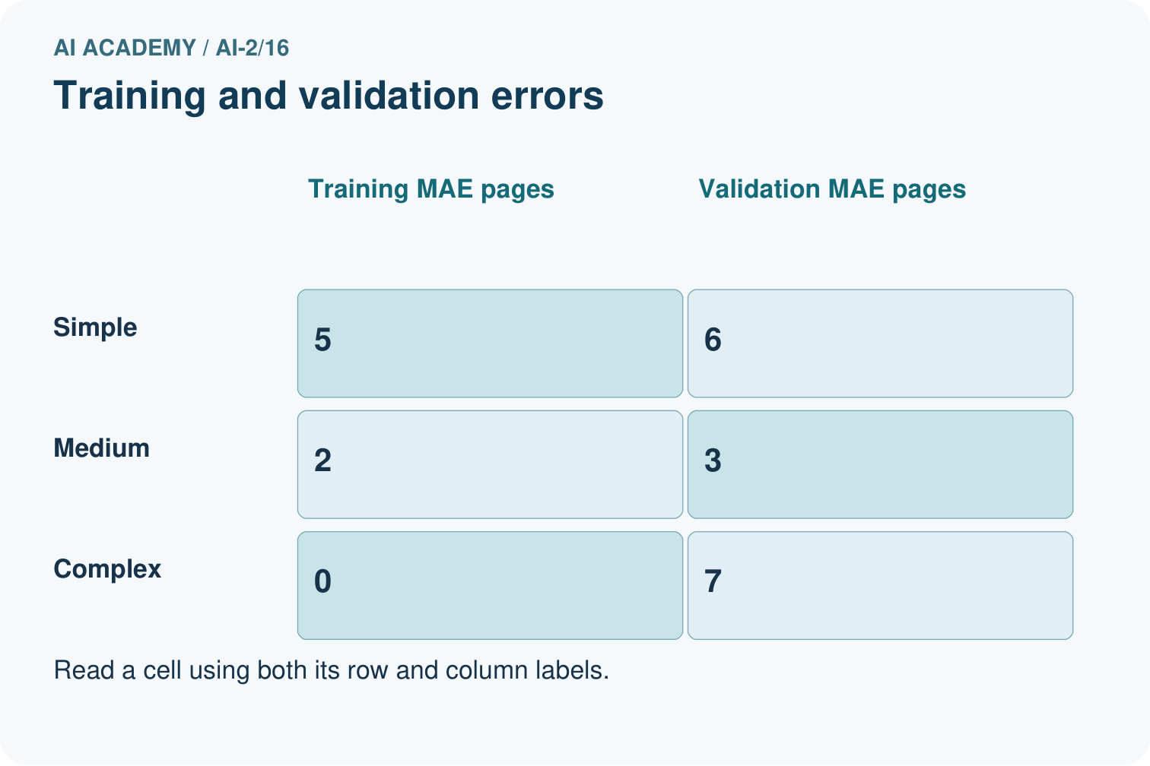
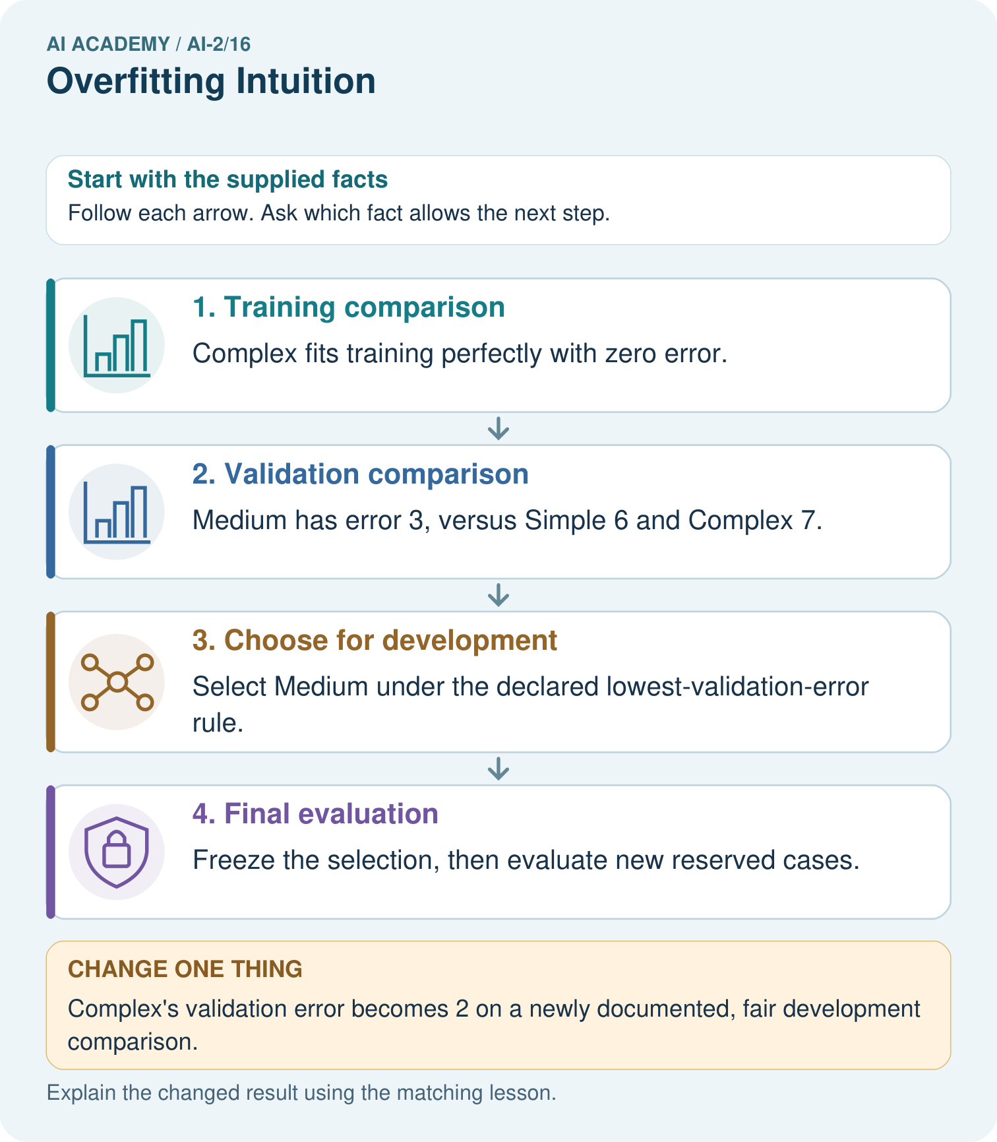

Read the picture one step at a time
Step | What happens and why
1. Training comparison | Complex fits training perfectly with zero error.
2. Validation comparison | Medium has error 3, versus Simple 6 and Complex 7.
3. Choose for development | Select Medium under the declared lowest-validation-error rule.
4. Final evaluation | Freeze the selection, then evaluate new reserved cases.
Match each pictured step to the supplied facts. This is a worked teaching case, not an independent assessment.

Why this result follows
A flexible model can fit quirks of its training set without predicting new examples well. Here Complex’s training success occur togethers with the worst validation error. The numbers are invented comparisons, not a claim that complexity always hurts. Choosing Medium uses development evidence; its validation score must not be advertised as an untouched final-test result.

What this example does not establish
A single small validation set may be noisy; selection evidence does not prove future population performance.

Change one thing in the pictured case
Change: Complex’s validation error becomes 2 on a newly documented, fair development comparison.
Prediction: The stated rule now selects Complex.
Reason: The rule compares validation errors; it does not ban complex models.

Ask while showing the picture
Cover the result. Ask learners to name the inputs and predict the next step. Uncover one step, connect the icon to the actual procedure, and explain its evidence. Then change the supplied condition and compare. The picture is a representation; it does not document execution of a real AI model.

03. Demonstrate and guide practice

Demonstrate and guide practice

Board sequence
Write the given facts: Rule A memorises six training book names. It scores 6/6 familiar and 2/6 new. Rule B uses relevant traits but is untested.
Write the question to explain: What does the evidence support?
Reveal after predictions: A shows weak transfer. B might generalise better but requires testing; simplicity is not proof.
Keep for an independent attempt: Rule A memorises six training book IDs. Rule B uses a relevant topic feature. Why might A fail on a new ID? What test is needed?

Classroom dialogue
Ask: Which facts are given, and which would we have to assume? Learners mark relevant details before discussing answers.
Say: Predict first. Show the rule, information path or calculation that would produce the result. A correct guess is not yet an explanation.
Reveal reasoning one step at a time. Explain why a tempting alternative fails. Write units and denominators for arithmetic, trace conditions for decisions, and identify supporting sources for claims.
In pairs, one learner solves while the other checks evidence; exchange roles. Remove the worked answer before independent assessment.

Model these guided questions
Guided response: No. It is consistent with overfitting but may also reflect shift, data quality or split problems. Exit response: Check data provenance, split grouping, label quality and repeated development results; inspect representative residuals without using final test feedback to tune.

Case-specific teaching sequence
Stage | Teacher action
Session 1 start to 7 minutes | Use the prerequisite question: Can a zero training error guarantee good validation performance? Check the explanation before proceeding.
7 to 18 minutes | Read the opening and model the worked evidence. Ask students to identify capacity in context.
18 to 32 minutes | Complete W 1 and W 2 with support: select from evidence; interpret a gap. Require the evidence, not only the final response.
32 to 45 minutes | Read the visual row by row. Collect the guided explanation and compare reasoning in pairs. Connect each conclusion to the stated evidence.
Session 2 start to 8 minutes | Retrieve the distinction between capacity and overfitting. Invite a counterexample to an overconfident claim.
8 to 20 minutes | Discuss the application and complete W 3: Describe one fair next development comparison.
20 to 35 minutes | Collect W4 independently before giving hints. Assess these outcomes: Compare training and validation evidence for model capacity; Explain overfitting without assuming every gap proves it. Record any support used.
35 to 45 minutes | Use W 5 and the exit response to assess limits. Give targeted feedback, then the fresh retry. Save evidence of independent understanding.

Reduce help deliberately
Completion task: Does a training-validation gap alone prove overfitting?
Teacher check: Teacher explanation: No. It is consistent with overfitting but may also reflect shift, data quality or split problems.
Start by identifying the given inputs together. Leave the intermediate steps blank. If needed, model one step, then withdraw that help on the next step. Move to a full trace only when the partial trace is understood. For partners, alternate explainer and checker; collect a response from every learner before discussion.

Individual reasoning check
Use the worked case for Overfitting and model capacity. Proposed explanation: “A final answer is enough”. Decide whether this explanation is supported. Point to the step or supplied fact that decides; explain your repair if needed.
Expected correction: Ask for the relevant counts, units, procedure or saved record. For this week: Choose the line with validation MAE 3. The curve training MAE 0 does not compensate for validation MAE 8.
Collect explanations, not only yes/no votes. If a misunderstanding is common, re-model the relevant step for the class. If it affects a few learners, give a short targeted group explanation while others solve a more demanding variation.

Pictorial practice question
Does zero training error justify choosing Complex in the original record?

Reasoned teacher answer
No. The declared criterion is validation error; Medium’s 3 is lowest, while Complex’s validation error is 7.
Changed-case reasoning: The stated rule now selects Complex. The rule compares validation errors; it does not ban complex models.
Collect each learner’s explanation before discussion. Use the first missing connection between input, deciding step and result to choose support. This question is worked-case practice, not fresh mastery evidence.

04. Run the weekly evidence lab

Run the weekly evidence lab
Words You Can Use to Reason
A definition matters when you can recognize the idea, use it, and contrast it with a near-miss.
Predict → Test → Record → Explain
Keep expected and actual results separate. Surprises are useful data when recorded honestly.
Compare simple and exception-heavy rules on training cards, then on sealed new cards. Count where performance changes and explain why.
What did the hardest test teach you that the normal test did not?

Make the lab runnable
Use the concrete case as the shared normal case and the independent question as a second case. Each pair creates a boundary or missing-information case and predicts its result before testing. Keep the expected result separate from an observed mistake.
Record | What to capture
Input or evidence | Exact data, instruction or claim
Expected result | Answer or safe fallback declared before the run
Observed result | Actual result, including errors
Explanation | Rule, calculation or evidence explaining the outcome
Next test | One justified change and a new prediction

Diagnose and reteach
For guessing, return to given facts and request a trace. For vocabulary without application, use one example and one non-example. For arithmetic errors, check the setup before the calculation. Finish with a different uncoached case before recording mastery.

Address these additional misconceptions
A final answer is enough: Ask for the relevant counts, units, procedure or saved record. For this week: Choose the line with validation MAE 3. The curve training MAE 0 does not compensate for validation MAE 8.
A stronger claim makes a stronger project: Check data provenance, split grouping, label quality and repeated development results; inspect representative residuals without using final test feedback to tune.
The new case can be copied from the example: The independent task changes the evidence. Require a fresh explanation: B wins the validation tie by the declared simplicity rule. C is not selected merely for its zero training error.

Match the support to the first error
What the response shows | Next teaching action
Missing or misread facts | Read the case aloud, mark supplied versus unknown facts, and let the learner restate it.
Wrong procedure | Return to the deciding step in the worked case. Contrast it with the proposed incorrect explanation.
Arithmetic or implementation error | Trace intermediate values or lines; preserve the first mismatch and retry that step.
Correct result without a reason | Ask for a trace and a changed case before marking independent understanding.
An unsupported wider claim | Ask which supplied evidence supports the claim and which further observation would be needed.
Offer an oral explanation, drawing, enlarged visual or fewer examples when that removes a reading/writing barrier. Keep the same reasoning goal. Stretch secure learners by changing a boundary or assumption and asking them to defend the effect, not simply by assigning more of the same questions.

05. Assess and explain the answers

Assess and explain the answers

Worked case answer
A shows weak transfer. B might generalise better but requires testing; simplicity is not proof.

Independent question
Rule A memorises six training book IDs. Rule B uses a relevant topic feature. Why might A fail on a new ID? What test is needed?

Expected independent answer
A has no learned relationship for the new ID beyond memorised records. Test both on unseen books with correct labels; B's relevance is promising but does not guarantee success.

What counts as evidence
Criterion | 0 points | 1 point | 2 points
Result | Incorrect or absent | Partly correct | Correct with necessary conditions
Reasoning | No supporting trace | Some steps | Clear mechanism, calculation or source support
Limit | Overclaims certainty | Vague limitation | Relevant uncertainty or missing fact
Transfer | Copies without adapting | Adapts with prompts | Solves a changed case independently
Use 6/8 as a classroom checkpoint, with 2 required for both Result and Reasoning. This is a proposed teaching rule, not a validated certification threshold. Do not count a coached answer as independent mastery; correct unsafe or unsupported claims regardless of total.

Feedback
Ask the learner to find the evidence that challenges this claim: “Perfect training results guarantee unseen performance.” Keep the first attempt and an uncoached retry separate.

Original transfer answer
B has better validation performance and is the stronger candidate here. A's large gap suggests poor transfer. Evaluate the selected rule on fresh final cases; neither simplicity nor one small validation set proves universal superiority.

Explanations for the additional workbook examples

W1 Select from evidence
Choose among the three worked candidates and explain the training trap.
Teacher explanation: Choose the line with validation MAE 3. The curve training MAE 0 does not compensate for validation MAE 8.

W2 Interpret a gap
Does a training-validation gap alone prove overfitting?
Teacher explanation: No. It is consistent with overfitting but may also reflect shift, data quality or split problems.

W3 Propose a controlled change
Describe one fair next development comparison.
Teacher explanation: Compare a simpler curve against the current curve on the same validation rows, retaining the same metric and training-only fitting; log the change.

W4 Apply independently
Models A training 4 validation 5, B training 1 validation 2, C training 0 validation 2. Lowest validation MAE then simpler; B is simpler than C. Choose and justify.
Teacher explanation: B wins the validation tie by the declared simplicity rule. C is not selected merely for its zero training error.

W5 Limit a diagnosis
What extra evidence would you inspect before concluding a model memorized noise?
Teacher explanation: Check data provenance, split grouping, label quality and repeated development results; inspect representative residuals without using final test feedback to tune.

Assess independent transfer
Selected case: Models A training 4 validation 5, B training 1 validation 2, C training 0 validation 2. Lowest validation MAE then simpler; B is simpler than C. Choose and justify.

Selected case answer
Teacher explanation: B wins the validation tie by the declared simplicity rule. C is not selected merely for its zero training error.
Dimension | Evidence required
Explanation | Names the applicable idea or procedure and ties it to the supplied facts.
Trace and result | Preserves the given inputs and shows the relevant intermediate steps; distinguishes a prediction from an observed execution.
Limits | States the assumptions, missing evidence or conditions under which the result would change.
Record each dimension as not yet, with support, or independent. Accept a valid alternative procedure with a defensible trace. Do not penalise an honestly recorded model failure if the learner correctly explains its evidence and limits.

Feedback that the learner uses
Name the earliest unsupported step and give one action to repair it. Have the learner make that repair now and explain why. Then assess the relevant skill on a fresh, fully specified case. Confirm it was not previously practised with feedback; solve and check the new case before assigning it. A follow-up design prompt is a starting brief, not automatically an equivalent test.

06. Connect and extend learning

Connect and extend learning

Transparent Book Recommender
Avoid title-by-title patches; improve features or thresholds that transfer.
Keep the decision, input, result, explanation and remaining limitation in the project evidence record. Retrieve this record next week rather than restarting the project.

Support and stretch
Trace one record or condition at a time with counters and labelled columns. Stretch: introduce a tie, boundary or missing field and declare its handling policy before rerunning.

Exit reflection
Ask for one decision the learner can now justify and one situation requiring more evidence or human review. Confidence ratings are separate from correct independent performance.

Bridge to the next week
Next: Week 17: Noise and Outliers. Retrieve today’s evidence and identify what carries forward and what is new.

Support and fresh reassessment
Provide a blank evidence table and allow a verbal explanation before writing. Highlight the given conditions without supplying the W 4 conclusion. Use capacity and overfitting in full sentences. Extension: alter one condition in the worked example and explain which conclusion changes and which remains supported.
For independent W 4, require: B wins the validation tie by the declared simplicity rule. C is not selected merely for its zero training error. Fresh retry training/validation D 3/4 E 0/7 F 2/3: choose F under lowest validation loss. Explain why E is not automatically best. Mark each criterion as independent, supported or not yet demonstrated. Reassess the reasoning after feedback; do not replace the first attempt silently.
Next week: Learning curves and variability. Carry forward the saved evidence and the distinction between development choices and justified claims.

Plan the delayed return
Suggested return points in this level: ai-2/17, ai-2/19, ai-2/22. Use actual classroom dates, adjusting for holidays and gaps. One, three and six teaching weeks are scheduling choices, not a claimed optimal spacing.
At a delayed check, ask for the idea from memory and a changed application. Compare with the earlier independent response and record support used. For a new level, revisit the previous capstone before checking the new prerequisites.
Record | Teacher evidence
Learner code and date
Concept and case used; prior exposure
Explanation / trace / limits
Support and first repair
Changed case and delayed outcome
Next teaching action
Use the evidence to choose reteaching or the next step. A completed page, confidence rating or attractive project does not by itself demonstrate understanding.

Project evidence from this case
Compare recommender revisions on fixed development cases, reserving new cases for the final presentation.

07. Prepare, teach and assess
Teaching target: Compare training and validation evidence for model capacity
Prepare the labelled worked-case picture, the matching workbook, fictional input cards and a place for individual responses. No paid AI account is required for the paper reasoning activities.
Session | Plan | Resources
Session 1 · Understand · 45 min | 0–7: recall and prerequisite; 7–15: inspect the concrete case and predict; 15–30: teacher models the worked trace; 30–40: learners explain a step using the text and visual; 40–45: check the core idea. | Sections 1–6; record the brief recall in the workbook.
Session 2 · Practise · 45 min | 0–5: retrieve the procedure; 5–15: W2 completion practice; 15–23: explain and check with a partner; 23–30: each learner answers the misconception check; 30–40: targeted reteaching or a harder variation; 40–45: prepare the investigation. | Sections 7–10; use the matching workbook W2 and misconception check.
Session 3 · Investigate and transfer · 45 min | 0–5: retrieve the decision rule; 5–20: investigate or trace; 20–30: start the independent case; 30–38: connect the project; 38–43: act on feedback; 43–45: plan the return check. | Sections 9 and 11–14. Give extra time to finish the full task set; use Section 15 when the week includes a coding lab.
Before class, solve the supported practice: Does a training-validation gap alone prove overfitting?
Reasoned practice answer: Teacher explanation: No. It is consistent with overfitting but may also reflect shift, data quality or split problems.
Check every learner before discussion: Use the worked case for Overfitting and model capacity. Proposed explanation: “A final answer is enough”. Decide whether this explanation is supported. Point to the step or supplied fact that decides; explain your repair if needed.
Misconception repair: Ask for the relevant counts, units, procedure or saved record. For this week: Choose the line with validation MAE 3. The curve training MAE 0 does not compensate for validation MAE 8.
Support: read the exact case aloud, enlarge the labelled picture, supply input cards and model only the first deciding step. Accept a spoken explanation or drawing; retain the reasoning goal.
Extension: Complex’s validation error becomes 2 on a newly documented, fair development comparison. Require a prediction and a reason before comparing. Expected result: The stated rule now selects Complex. Reason: The rule compares validation errors; it does not ban complex models.
Independent assessment: withhold the reserved answer until the learner has attempted the new case. Record support separately from correctness.
Criterion | Not yet | With support | Independent
Explanation | Names an answer without a deciding fact | Uses a hint to link fact and decision | Explains the deciding fact in own words
Trace or test | Cannot connect input and result | Completes steps with prompts | Traces or tests a changed case accurately
Limits and revision | Claims more than evidence supports | Names a limit after a prompt | States a defensible limit and useful next test
Project checkpoint: Test changed cases. Keep normal, boundary and failure cases; compare expected and observed results.
Use the weekly teacher answer for topic-specific reasoning. A saved progress tick is an activity record; judge mastery from the learner’s explanation and evidence.

08. Use feedback, labs and repair paths
Use the two formative questions as supported practice, not as independent mastery scores. Discuss the deciding evidence rather than accepting a guessed selection.
The feedback comes from the reviewed public worked case. Do not reveal the separately reserved independent teacher answer until the learner has attempted that case.
Ask students to predict before running code. Preserve errors and actual outputs; collect a changed test and an explanation. The branch-boundary and indexing lessons deliberately include failure cases.
Use the earlier worked-explanation links to address a specific missing building block, then return to the current question. Adapt this suggestion after observing the learner; it is not an automatic diagnosis.
Collect the completed-work portfolio as evidence. Record support separately from correctness, and assess explanation, trace/test and limitations. Progress ticks and quiz selections alone do not establish mastery.

