AI ACADEMY · TEACHER · ai-2/20

Repair Bias in Data
Project: Transparent Book Recommender

01. Repair Bias in Data

Teach the learning cycle
Primary target: Identify selection and coverage bias
Session | Sequence and minutes | Resources
Session 1 · Understand · 45 min | 0–7: recall and prerequisite; 7–15: inspect the concrete case and predict; 15–30: teacher models the worked trace; 30–40: learners explain a step using the text and visual; 40–45: check the core idea. | Sections 1–6; record the brief recall in the workbook.
Session 2 · Practise · 45 min | 0–5: retrieve the procedure; 5–15: W2 completion practice; 15–23: explain and check with a partner; 23–30: each learner answers the misconception check; 30–40: targeted reteaching or a harder variation; 40–45: prepare the investigation. | Sections 7–10; use the matching workbook W2 and misconception check.
Session 3 · Investigate and transfer · 45 min | 0–5: retrieve the decision rule; 5–20: investigate or trace; 20–30: start the independent case; 30–38: connect the project; 38–43: act on feedback; 43–45: plan the return check. | Sections 9 and 11–14. Give extra time to finish the full task set; use Section 15 when the week includes a coding lab.
This is a starting allocation of 135 minutes, not a validated duration. Preserve all named topics. Schedule extra time for connected examples, the full investigation, independent cases and project building. Repeated copies of a case share one recorded attempt; they are not new evidence.

Retrieval answer guidance

Sampling and Representation
Without opening the old lesson, explain one key idea from Sampling and Representation. Give an example and a mistake that the idea helps you avoid.
Look for: Define a question and target population
Reference example, not the only acceptable wording: Population: all Grade 7 students. Only lunch-club members or one friend group is an unsuitable basis for a whole-grade claim.

Noise and Outliers
Without opening the old lesson, explain one key idea from Noise and Outliers. Give an example and a mistake that the idea helps you avoid.
Look for: Calculate mean and median
Reference example, not the only acceptable wording: Sum 30 divided by 5 gives 6.

Decision Trees
Without opening the old lesson, explain one key idea from Decision Trees. Give an example and a mistake that the idea helps you avoid.
Look for: Fit a root question and leaf predictions from training examples
Reference example, not the only acceptable wording: The root asks near, with branches 0 and 1. Leaves predict clear for 0 and blocked for 1. Depth is one. Training labels determined both leaf majorities and the error comparison that selected near rather than tall.
Use the student module and workbook section with this exact week title. The worked case, independent question and answers below form one aligned lesson sequence.

What the learner must demonstrate
A catalogue has 30 adventure titles and 2 poetry titles. A recommender rarely suggests poetry. Design a repair and an evaluation that distinguishes catalogue coverage from scoring preference.

Concept to explain
Fairness work changes data, features, tests, or use conditions, then rechecks outcomes.
Term | Meaning
bias | A systematic tendency in data, decisions or outcomes that can distort a result or disadvantage people.
rebalance | Change the relative representation of groups or classes in data using a stated method.
subgroup | A defined subset of cases considered separately in analysis.
retest | Run a test again after a change or under specified new conditions.

Prepare the class
Use the supplied scenario, student illustrations and blank paper. For numeric work, offer counters or a calculator after learners show the setup. Fictional records are supplied; personal data and paid accounts are unnecessary.
Allow 80 minutes: recall 8; explanation 12; worked demonstration 15; guided practice 20; independent assessment 15; project and reflection 10. Extend the lab into a second session when needed.

Preparation for the connected explanation
Teach Week 20 as a two-session investigation using fictional data. A fictional poll has 8 Yes among 10 club respondents and 2 Yes among 10 other respondents. If only club members are surveyed, an 80 percent result misses a group with a different pattern. Examine who is included before treating a larger sample as better. Assess the three stated outcomes through the independent task, not by copying the worked result.

Readiness answer
The population is the full target group; the sample is the observed subset.
Python 3 editor with a fresh local practice file
Paper trace table and the student workbook
Fictional input records from this lesson; no real student identifiers

End goal for the pictorial case
By the end, I can distinguish a biased collection process from a mere small dataset.
This added worked case illustrates the week’s main idea. Retain all original and connected topics; schedule its practice within the teaching cycle.

02. Explain the mechanism

Explain the mechanism
Input → Process → Output
Trace the information. At each stage, ask what changed and how you could test it.
Which stage could fail even when the other two are correct? Explain:
Predict first. Then check each step. A correct answer without visible reasoning is incomplete evidence.
1. Audit: quiet-room voices work; noisy-room voices often fail.
2. Possible causes: missing environments, microphone differences, narrow speakers.
3. Repair: collect consented examples across settings; remove shortcut features.
4. Retest the same subgroup cases and report before/after results.
Recalculate, retrace, or restate the reasoning in your own representation:
CHECK Did the evidence answer the exact question? Did the total, path, or source record stay consistent?

Concrete teaching case
Training has eighteen adventure readers and two poetry readers; many intended users prefer poetry.
Propose repair and evaluation.

Exact explanation to model
Collect varied relevant poetry examples with consistent labels. Compare both interests on separate evaluation cases before and after repair.

Explain the added worked example
A fictional poll has 8 Yes among 10 club respondents and 2 Yes among 10 other respondents. If only club members are surveyed, an 80 percent result misses a group with a different pattern. Examine who is included before treating a larger sample as better.
The combined observed sample has 50 percent Yes. This is not automatically a population estimate: we also need to know how the groups were selected and how many people each represents. Do not average percentages without considering their denominators.

Key terms
Term | Meaning
Selection bias | Systematic distortion caused by who enters the data
Undercoverage | Leaving part of the target group out of selection
Nonresponse | A selected participant does not respond
Subgroup | A defined part of a larger group

Model the reasoning aloud
Use the complete worked example below before asking learners to complete W2. Reveal a small part, invite a prediction, then explain the deciding step. These teacher notes contain solutions; do not reveal the independent case answer during modelling.

Suppose 90 club respondents give 72 Yes and 10 others give 2 Yes. What is the combined observed proportion?
________________________________________________________________
________________________________________________________________
________________________________________________________________
________________________________________________________________
________________________________________________________________
________________________________________________________________
Thinking move | Teacher prompt
Plan | What is given? What is the question? Which procedure fits these facts?
Do | Point to each input and intermediate step in the worked trace. Name the rule that allows the next step.
Check | Does the output answer the question? Which assumption or limitation prevents a larger claim?
Use the diagram and verbal explanation together. Ask learners to match a sentence to a specific visual step; do not assign learners fixed visual or auditory learning styles.

A pictorial worked case: Repair Bias in Data
A fictional school polls learners about adding comic recommendations.

The facts we will use
Library-club respondents: 12 Yes out of 15. Other respondents: 3 Yes out of 15.
The full grade has 30 club members and 90 others. These respondents were volunteers, not random selections.
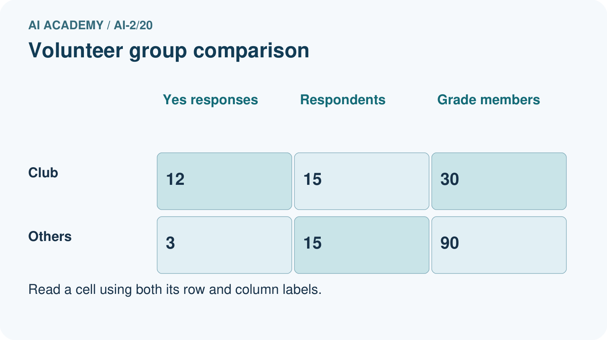
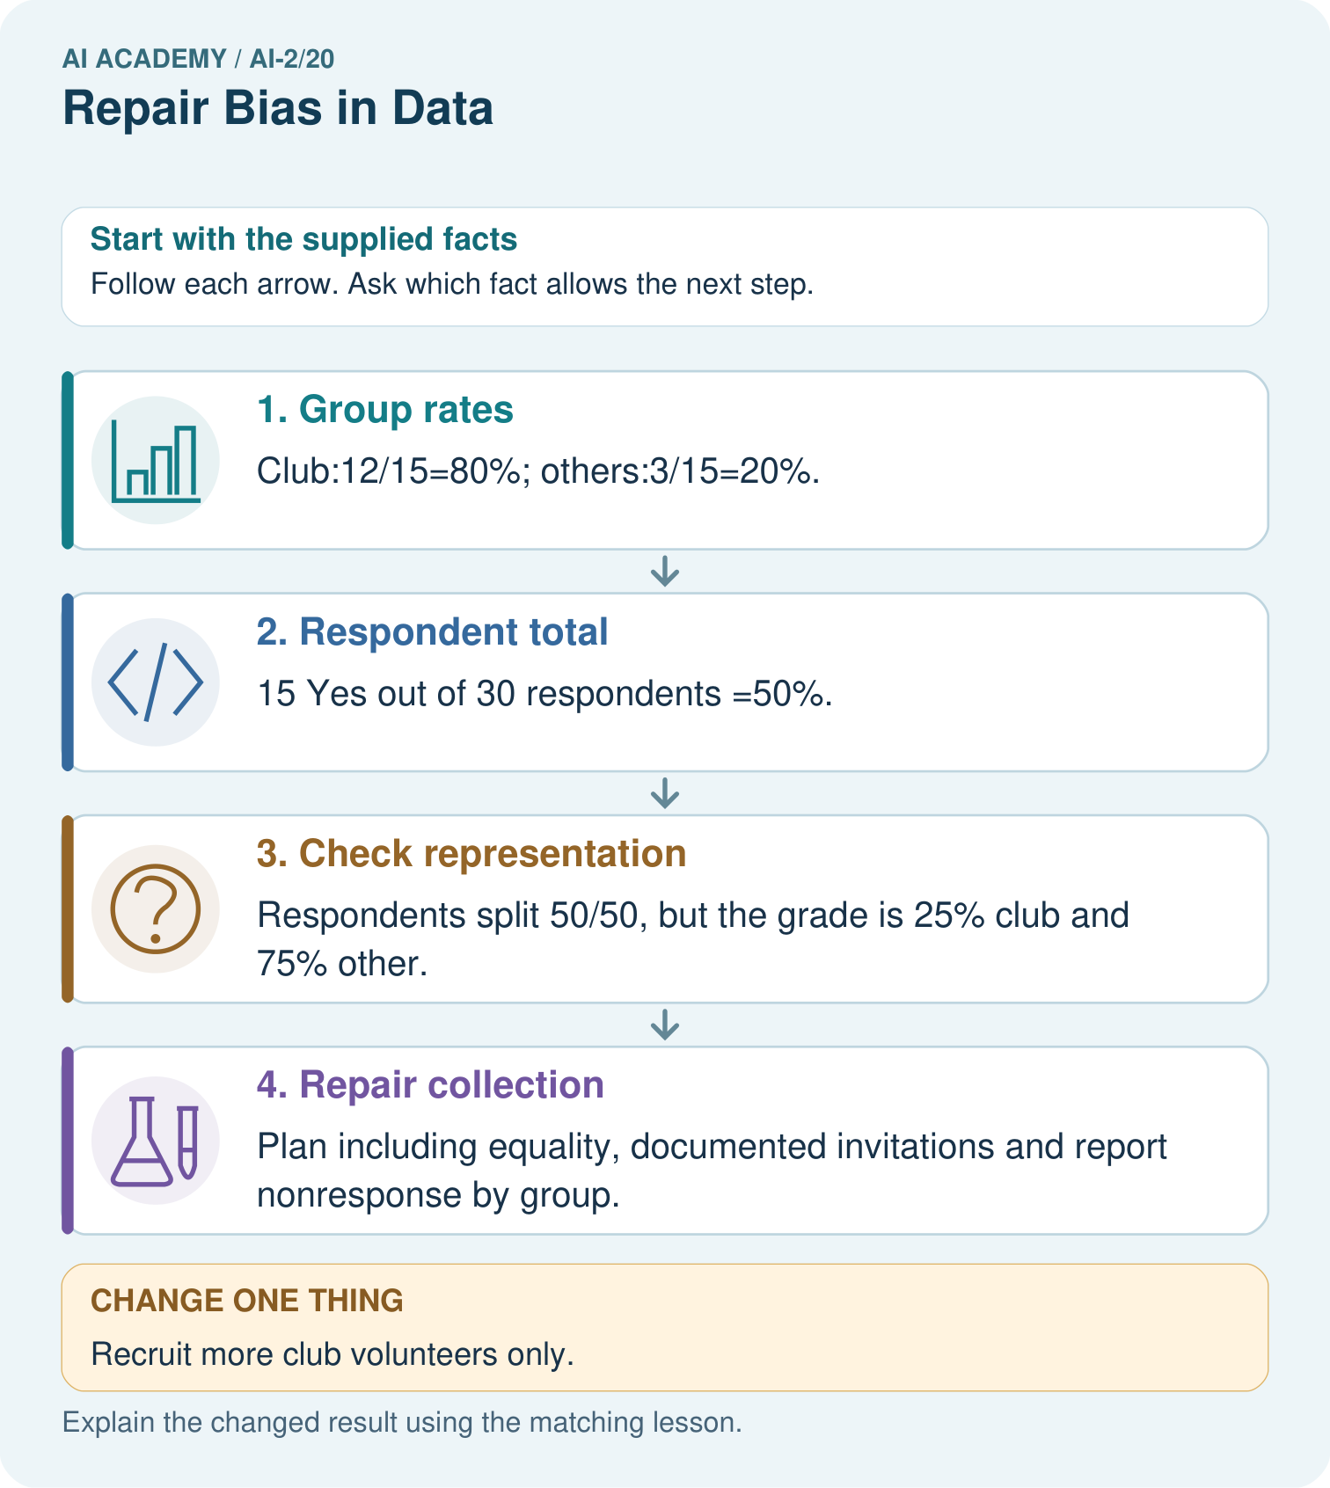

Read the picture one step at a time
Step | What happens and why
1. Group rates | Club:12/15=80%; others:3/15=20%.
2. Respondent total | 15 Yes out of 30 respondents =50%.
3. Check representation | Respondents split 50/50, but the grade is 25% club and 75% other.
4. Repair collection | Plan including equality, documented invitations and report nonresponse by group.
Match each pictured step to the supplied facts. This is a worked teaching case, not an independent assessment.

Why this result follows
The combined respondent result gives club members more influence than their share of the grade. A weighted illustration using 25% and 75% gives 0.25×80%+0.75×20%=35%, but volunteers may differ within each group, so weighting alone does not establish the true grade preference. Improve the collection process rather than announcing the weighted number as fact.

What this example does not establish
Neither raw nor weighted volunteer rates prove the whole grade’s opinion; privacy and consent rules still apply.

Change one thing in the pictured case
Change: Recruit more club volunteers only.
Prediction: Sample size increases without fixing missing representation of other learners.
Reason: The added respondents come from the already overrepresented group.

Ask while showing the picture
Cover the result. Ask learners to name the inputs and predict the next step. Uncover one step, connect the icon to the actual procedure, and explain its evidence. Then change the supplied condition and compare. The picture is a representation; it does not document execution of a real AI model.

03. Demonstrate and guide practice

Demonstrate and guide practice

Board sequence
Write the given facts: Training has eighteen adventure readers and two poetry readers; many intended users prefer poetry.
Write the question to explain: Propose repair and evaluation.
Reveal after predictions: Collect varied relevant poetry examples with consistent labels. Compare both interests on separate evaluation cases before and after repair.
Keep for an independent attempt: A dataset has 18 adventure readers and 2 poetry readers. A recommender ignores poetry preferences. What would you inspect and test after a repair?

Classroom dialogue
Ask: Which facts are given, and which would we have to assume? Learners mark relevant details before discussing answers.
Say: Predict first. Show the rule, information path or calculation that would produce the result. A correct guess is not yet an explanation.
Reveal reasoning one step at a time. Explain why a tempting alternative fails. Write units and denominators for arithmetic, trace conditions for decisions, and identify supporting sources for claims.
In pairs, one learner solves while the other checks evidence; exchange roles. Remove the worked answer before independent assessment.

Model these guided questions
74/100 = 74 percent. The sample is dominated by club respondents. Exit: No. Existing interest could influence club membership, and other factors may differ.

Case-specific teaching sequence
Stage | Teacher action
Session 1 start to 7 minutes | Retrieve the prerequisite and explain the purpose in the opening section.
7 to 20 minutes | Read the worked example and diagram; ask learners to trace each step aloud.
20 to 33 minutes | Complete W1 and W2, then compare predictions with observed results.
33 to 45 minutes | Collect the guided prediction before running; discuss a mismatch and its cause.
Session 2 start to 8 minutes | Retrieve the main rule without showing the previous answer.
8 to 20 minutes | Use W3 to diagnose and repair the stated failure; rerun an earlier case.
20 to 35 minutes | Collect W4 independently, including code or plan, predictions and explanations, before hints.
35 to 45 minutes | Discuss W5 and the exit; use the fresh retry when support was needed.

Reduce help deliberately
Completion task: Group A has 3 Yes of 4 and B has 2 Yes of 6. Find the combined proportion.
Teacher check: 5/10 = 50 percent. The unweighted average of 75 percent and about 33.3 percent is not the combined sample rate.
Start by identifying the given inputs together. Leave the intermediate steps blank. If needed, model one step, then withdraw that help on the next step. Move to a full trace only when the partial trace is understood. For partners, alternate explainer and checker; collect a response from every learner before discussion.

Individual reasoning check
Use the worked case for Selection bias and coverage. Proposed explanation: “A successful run proves the conclusion”. Decide whether this explanation is supported. Point to the step or supplied fact that decides; explain your repair if needed.
Expected correction: Group differences suggest that coverage matters, but do not explain why choices differ. Small group counts also make percentages unstable. Use neutral group labels in fictional data rather than personal or sensitive attributes.
Collect explanations, not only yes/no votes. If a misunderstanding is common, re-model the relevant step for the class. If it affects a few learners, give a short targeted group explanation while others solve a more demanding variation.

Pictorial practice question
Why must 35% be labelled an illustration rather than the measured grade-wide Yes rate?

Reasoned teacher answer
It assumes each volunteer group rate represents its whole group; that assumption has not been established.
Changed-case reasoning: Sample size increases without fixing missing representation of other learners. The added respondents come from the already overrepresented group.
Collect each learner’s explanation before discussion. Use the first missing connection between input, deciding step and result to choose support. This question is worked-case practice, not fresh mastery evidence.

04. Run the weekly evidence lab

Run the weekly evidence lab
Words You Can Use to Reason
A definition matters when you can recognize the idea, use it, and contrast it with a near-miss.
Predict → Test → Record → Explain
Keep expected and actual results separate. Surprises are useful data when recorded honestly.
Given an uneven dataset, name the missing coverage, choose one repair, predict an outcome, and rerun a fixed subgroup test set.
What did the hardest test teach you that the normal test did not?

Make the lab runnable
Use the concrete case as the shared normal case and the independent question as a second case. Each pair creates a boundary or missing-information case and predicts its result before testing. Keep the expected result separate from an observed mistake.
Record | What to capture
Input or evidence | Exact data, instruction or claim
Expected result | Answer or safe fallback declared before the run
Observed result | Actual result, including errors
Explanation | Rule, calculation or evidence explaining the outcome
Next test | One justified change and a new prediction

Diagnose and reteach
For guessing, return to given facts and request a trace. For vocabulary without application, use one example and one non-example. For arithmetic errors, check the setup before the calculation. Finish with a different uncoached case before recording mastery.

Address these additional misconceptions
A successful run proves the conclusion: Group differences suggest that coverage matters, but do not explain why choices differ. Small group counts also make percentages unstable. Use neutral group labels in fictional data rather than personal or sensitive attributes.
Matching the example is enough: Require the new W4 case, explicit predictions and an explanation. Fresh retry: A 6/8 and B 1/2 combine to 7/10 = 70 percent, with group rates 75 and 50 percent. Require a selection limitation.
A convenient shortcut preserves meaning: Surveying another 100 people from the same undercovered source may make the sample larger without fixing the selection problem. Improve access to missing groups and record nonresponse; do not simply duplicate existing rows.

Match the support to the first error
What the response shows | Next teaching action
Missing or misread facts | Read the case aloud, mark supplied versus unknown facts, and let the learner restate it.
Wrong procedure | Return to the deciding step in the worked case. Contrast it with the proposed incorrect explanation.
Arithmetic or implementation error | Trace intermediate values or lines; preserve the first mismatch and retry that step.
Correct result without a reason | Ask for a trace and a changed case before marking independent understanding.
An unsupported wider claim | Ask which supplied evidence supports the claim and which further observation would be needed.
Offer an oral explanation, drawing, enlarged visual or fewer examples when that removes a reading/writing barrier. Keep the same reasoning goal. Stretch secure learners by changing a boundary or assumption and asking them to defend the effect, not simply by assigning more of the same questions.

05. Assess and explain the answers

Assess and explain the answers

Worked case answer
Collect varied relevant poetry examples with consistent labels. Compare both interests on separate evaluation cases before and after repair.

Independent question
A dataset has 18 adventure readers and 2 poetry readers. A recommender ignores poetry preferences. What would you inspect and test after a repair?

Expected independent answer
Inspect representation and recommendation results for poetry readers. Gather relevant varied examples and compare performance for both interests on separate test cases.

What counts as evidence
Criterion | 0 points | 1 point | 2 points
Result | Incorrect or absent | Partly correct | Correct with necessary conditions
Reasoning | No supporting trace | Some steps | Clear mechanism, calculation or source support
Limit | Overclaims certainty | Vague limitation | Relevant uncertainty or missing fact
Transfer | Copies without adapting | Adapts with prompts | Solves a changed case independently
Use 6/8 as a classroom checkpoint, with 2 required for both Result and Reasoning. This is a proposed teaching rule, not a validated certification threshold. Do not count a coached answer as independent mastery; correct unsafe or unsupported claims regardless of total.

Feedback
Ask the learner to find the evidence that challenges this claim: “Duplicating one poetry record supplies diverse evidence.” Keep the first attempt and an uncoached retry separate.

Original transfer answer
Add varied relevant poetry titles with consistent metadata, keep scoring fixed and compare results on the same validation requests by interest. Then inspect whether scoring still disadvantages poetry. Save fresh final requests and do not infer cause from suggestion counts alone.

Explanations for the additional workbook examples

W1 Locate undercoverage
A morning-only survey claims to represent all library visitors. Which visitors may be missed?
Afternoon or evening visitors, and people unable to attend in the morning.

W2 Combine counts
Group A has 3 Yes of 4 and B has 2 Yes of 6. Find the combined proportion.
5/10 = 50 percent. The unweighted average of 75 percent and about 33.3 percent is not the combined sample rate.

W3 Repair the collection
A form is shared only in the robotics club. How can the process better cover the grade?
Use a full-grade selection frame and access channels available across groups, with a nonresponse record. State remaining limitations.

W4 Audit independently
A survey has 18 Yes of 20 club members and 2 Yes of 10 others. Compute both group rates and combined rate. Explain why 20/30 does not automatically describe the whole grade.
90 percent, 20 percent and 20/30 about 66.7 percent. Group sampling proportions and response patterns may differ from the grade.

W5 Avoid causal claims
Club members favor coding more often. Does club membership necessarily cause that preference?
No. Existing interest could influence club membership, and other factors may differ.

Assess independent transfer
Selected case: A survey has 18 Yes of 20 club members and 2 Yes of 10 others. Compute both group rates and combined rate. Explain why 20/30 does not automatically describe the whole grade.

Selected case answer
90 percent, 20 percent and 20/30 about 66.7 percent. Group sampling proportions and response patterns may differ from the grade.
Dimension | Evidence required
Explanation | Names the applicable idea or procedure and ties it to the supplied facts.
Trace and result | Preserves the given inputs and shows the relevant intermediate steps; distinguishes a prediction from an observed execution.
Limits | States the assumptions, missing evidence or conditions under which the result would change.
Record each dimension as not yet, with support, or independent. Accept a valid alternative procedure with a defensible trace. Do not penalise an honestly recorded model failure if the learner correctly explains its evidence and limits.

Feedback that the learner uses
Name the earliest unsupported step and give one action to repair it. Have the learner make that repair now and explain why. Then assess the relevant skill on a fresh, fully specified case. Confirm it was not previously practised with feedback; solve and check the new case before assigning it. A follow-up design prompt is a starting brief, not automatically an equivalent test.

06. Connect and extend learning

Connect and extend learning

Transparent Book Recommender
Change feature coverage or weights only after locating which reader profiles are underserved.
Keep the decision, input, result, explanation and remaining limitation in the project evidence record. Retrieve this record next week rather than restarting the project.

Support and stretch
Trace one record or condition at a time with counters and labelled columns. Stretch: introduce a tie, boundary or missing field and declare its handling policy before rerunning.

Exit reflection
Ask for one decision the learner can now justify and one situation requiring more evidence or human review. Confidence ratings are separate from correct independent performance.

Bridge to the next week
Next: Week 21: Similarity by Selected Traits. Retrieve today’s evidence and identify what carries forward and what is new.

Support and fresh reassessment
Use two colors of anonymous group cards. Extension: compare combined rates after changing only sample group sizes while preserving group rates.
Independent W4 evidence: 90 percent, 20 percent and 20/30 about 66.7 percent. Group sampling proportions and response patterns may differ from the grade. Record whether the learner needed no help, a hint or explanation. Fresh retry: A 6/8 and B 1/2 combine to 7/10 = 70 percent, with group rates 75 and 50 percent. Require a selection limitation.
Next week: Relationships and confounding. Reuse this week's explicit contracts and evidence.

Plan the delayed return
Suggested return points in this level: ai-2/21, ai-2/23, ai-2/26. Use actual classroom dates, adjusting for holidays and gaps. One, three and six teaching weeks are scheduling choices, not a claimed optimal spacing.
At a delayed check, ask for the idea from memory and a changed application. Compare with the earlier independent response and record support used. For a new level, revisit the previous capstone before checking the new prerequisites.
Record | Teacher evidence
Learner code and date
Concept and case used; prior exposure
Explanation / trace / limits
Support and first repair
Changed case and delayed outcome
Next teaching action
Use the evidence to choose reteaching or the next step. A completed page, confidence rating or attractive project does not by itself demonstrate understanding.

Project evidence from this case
Broaden recommender feedback collection and show respondent group coverage before making user-preference claims.

07. Prepare, teach and assess
Teaching target: Identify selection and coverage bias
Prepare the labelled worked-case picture, the matching workbook, fictional input cards and a place for individual responses. No paid AI account is required for the paper reasoning activities.
Session | Plan | Resources
Session 1 · Understand · 45 min | 0–7: recall and prerequisite; 7–15: inspect the concrete case and predict; 15–30: teacher models the worked trace; 30–40: learners explain a step using the text and visual; 40–45: check the core idea. | Sections 1–6; record the brief recall in the workbook.
Session 2 · Practise · 45 min | 0–5: retrieve the procedure; 5–15: W2 completion practice; 15–23: explain and check with a partner; 23–30: each learner answers the misconception check; 30–40: targeted reteaching or a harder variation; 40–45: prepare the investigation. | Sections 7–10; use the matching workbook W2 and misconception check.
Session 3 · Investigate and transfer · 45 min | 0–5: retrieve the decision rule; 5–20: investigate or trace; 20–30: start the independent case; 30–38: connect the project; 38–43: act on feedback; 43–45: plan the return check. | Sections 9 and 11–14. Give extra time to finish the full task set; use Section 15 when the week includes a coding lab.
Before class, solve the supported practice: Group A has 3 Yes of 4 and B has 2 Yes of 6. Find the combined proportion.
Reasoned practice answer: 5/10 = 50 percent. The unweighted average of 75 percent and about 33.3 percent is not the combined sample rate.
Check every learner before discussion: Use the worked case for Selection bias and coverage. Proposed explanation: “A successful run proves the conclusion”. Decide whether this explanation is supported. Point to the step or supplied fact that decides; explain your repair if needed.
Misconception repair: Group differences suggest that coverage matters, but do not explain why choices differ. Small group counts also make percentages unstable. Use neutral group labels in fictional data rather than personal or sensitive attributes.
Support: read the exact case aloud, enlarge the labelled picture, supply input cards and model only the first deciding step. Accept a spoken explanation or drawing; retain the reasoning goal.
Extension: Recruit more club volunteers only. Require a prediction and a reason before comparing. Expected result: Sample size increases without fixing missing representation of other learners. Reason: The added respondents come from the already overrepresented group.
Independent assessment: withhold the reserved answer until the learner has attempted the new case. Record support separately from correctness.
Criterion | Not yet | With support | Independent
Explanation | Names an answer without a deciding fact | Uses a hint to link fact and decision | Explains the deciding fact in own words
Trace or test | Cannot connect input and result | Completes steps with prompts | Traces or tests a changed case accurately
Limits and revision | Claims more than evidence supports | Names a limit after a prompt | States a defensible limit and useful next test
Project checkpoint: Evaluate and revise. Compare with your starting method, explain errors and record a justified revision.
Use the weekly teacher answer for topic-specific reasoning. A saved progress tick is an activity record; judge mastery from the learner’s explanation and evidence.

08. Use feedback, labs and repair paths
Use the two formative questions as supported practice, not as independent mastery scores. Discuss the deciding evidence rather than accepting a guessed selection.
The feedback comes from the reviewed public worked case. Do not reveal the separately reserved independent teacher answer until the learner has attempted that case.
Ask students to predict before running code. Preserve errors and actual outputs; collect a changed test and an explanation. The branch-boundary and indexing lessons deliberately include failure cases.
Use the earlier worked-explanation links to address a specific missing building block, then return to the current question. Adapt this suggestion after observing the learner; it is not an automatic diagnosis.
Collect the completed-work portfolio as evidence. Record support separately from correctness, and assess explanation, trace/test and limitations. Progress ticks and quiz selections alone do not establish mastery.

