AI ACADEMY · TEACHER · ai-3/10

Image Generation Models
Project: Verified Study Buddy

01. Image Generation Models

Teach the learning cycle
Primary target: Explain the mechanism and terminology of image generation and provenance
Session | Sequence and minutes | Resources
Session 1 · Understand · 45 min | 0–7: recall and prerequisite; 7–15: inspect the concrete case and predict; 15–30: teacher models the worked trace; 30–40: learners explain a step using the text and visual; 40–45: check the core idea. | Sections 1–6; record the brief recall in the workbook.
Session 2 · Practise · 45 min | 0–5: retrieve the procedure; 5–15: W2 completion practice; 15–23: explain and check with a partner; 23–30: each learner answers the misconception check; 30–40: targeted reteaching or a harder variation; 40–45: prepare the investigation. | Sections 7–10; use the matching workbook W2 and misconception check.
Session 3 · Investigate and transfer · 45 min | 0–5: retrieve the decision rule; 5–20: investigate or trace; 20–30: start the independent case; 30–38: connect the project; 38–43: act on feedback; 43–45: plan the return check. | Sections 9 and 11–14. Give extra time to finish the full task set; use Section 15 when the week includes a coding lab.
This is a starting allocation of 135 minutes, not a validated duration. Preserve all named topics. Schedule extra time for connected examples, the full investigation, independent cases and project building. Repeated copies of a case share one recorded attempt; they are not new evidence.
Case exposure check: this source example appears in ai-3/10, ai-3/11. Reuse a familiar case for recall or modelling; verify that the case used to assess transfer has not already received feedback.

Retrieval answer guidance

Prompt Evaluation
Without opening the old lesson, explain one key idea from Prompt Evaluation. Give an example and a mistake that the idea helps you avoid.
Look for: Explain the mechanism and terminology of controlled prompt experiments
Reference example, not the only acceptable wording: Teacher explanation: A prompt experiment compares complete specifications using the same task cases. Define success before inspecting outputs; change one intended instruction and preserve other settings. Evaluate both prompts on paired cases with fixed model/version, source records, output contract and scoring rubric. Use development results for selection, then reserve new final cases. Score each case rather than counting attractive sentences.

Iterative Prompting
Without opening the old lesson, explain one key idea from Iterative Prompting. Give an example and a mistake that the idea helps you avoid.
Look for: Explain the mechanism and terminology of controlled prompt experiments
Reference example, not the only acceptable wording: Teacher explanation: A prompt experiment compares complete specifications using the same task cases. Define success before inspecting outputs; change one intended instruction and preserve other settings. Evaluate both prompts on paired cases with fixed model/version, source records, output contract and scoring rubric. Use development results for selection, then reserve new final cases. Score each case rather than counting attractive sentences.

Sampling and Variability
Without opening the old lesson, explain one key idea from Sampling and Variability. Give an example and a mistake that the idea helps you avoid.
Look for: Sample from a distribution using explicit cumulative intervals
Reference example, not the only acceptable wording: Teacher explanation: Selections red,blue,green,green. The draw 1 violates the half-open [0,1) input contract and must be rejected.
Use the student module and workbook section with this exact week title. The worked case, independent question and answers below form one aligned lesson sequence.

What the learner must demonstrate
An image generator produces a convincing picture of a school greenhouse on Mars. A student calls it photographic evidence. Explain what the image can and cannot establish.

Concept to explain
Image generation iteratively constructs pixels guided by learned representations.
Term | Meaning
latent representation | An internal representation learned or constructed by a model rather than directly supplied as the original observation.
noise | Variation or interference that obscures the information relevant to a task.
denoising | Reducing noise in a representation; some generative models learn repeated denoising steps to create outputs.
conditioning | Making a model's output depend on supplied information, such as a prompt or image.

Prepare the class
Use the supplied scenario, student illustrations and blank paper. For numeric work, offer counters or a calculator after learners show the setup. Fictional records are supplied; personal data and paid accounts are unnecessary.
Allow 80 minutes: recall 8; explanation 12; worked demonstration 15; guided practice 20; independent assessment 15; project and reflection 10. Extend the lab into a second session when needed.

Preparation for the connected explanation
Two 45-minute sessions. An image generator constructs an output from learned patterns and a specification. A generated picture is not a record that the depicted event occurred. Use the supplied constructed scenarios to make the mechanism inspectable. Collect W4 before sharing solutions. Students should name intermediate evidence and limitations; classroom pacing and learning effectiveness remain unvalidated.

Readiness answer
A result depends on the inputs, procedure and conditions that produced it. Preserve data roles and distinguish observed outcomes from predictions or unmeasured conditions. If the prior concept cannot be explained, use a short retrieval activity before this chapter.
Lesson and workbook; paper and pencil
Calculator and optional local Python 3 for arithmetic; no live API or private data
Prepare the fresh retry separately and withhold its solution until after collection

End goal for the pictorial case
By the end, I can describe a toy denoising process and distinguish generated illustrations from observations.
This added worked case illustrates the week’s main idea. Retain all original and connected topics; schedule its practice within the teaching cycle.

02. Explain the mechanism

Explain the mechanism
Input → Process → Output
Trace the information. At each stage, ask what changed and how you could test it.
Which stage could fail even when the other two are correct? Explain:
Predict first. Then check each step. A correct answer without visible reasoning is incomplete evidence.
1. In this simplified diffusion-style image generator, begin with random visual noise. Other image-generation methods use different procedures.
2. At each step, predict a slightly more structured image guided by the prompt.
3. Learned patterns influence shapes, textures, and relationships.
4. The result is generated, not retrieved evidence of a real event.
Recalculate, retrace, or restate the reasoning in your own representation:
CHECK Did the evidence answer the exact question? Did the total, path, or source record stay consistent?

Concrete teaching case
A generator creates a realistic fictional bicycle beside a tree.
How does this differ from event photography?

Exact explanation to model
It synthesises an image from learned patterns and instructions; it does not document that event. Many systems denoise iteratively, but architectures vary.

Explain the added worked example
An image generator constructs an output from learned patterns and a specification. A generated picture is not a record that the depicted event occurred.
Begin by writing the question the procedure is intended to answer. Identify the information already supplied, the information it will produce and the information still missing. These are constructed classroom examples; they do not require live accounts, private records or an external service. Do not treat a plausible explanation as a measured outcome.
Keep a provenance record containing specification, tool/version when known, generation date, edits, permissions and intended use. Label fictional imagery. Inspect visual requirements and avoid inferring identity or event authenticity from appearance.
Before applying the procedure, write its units, denominator or decision boundary where relevant. A partner should be able to repeat each step using the same inputs. If a required input is absent or violates the stated contract, record that condition explicitly instead of quietly replacing it with a convenient value.

Key terms
Term | Meaning
Provenance | Recorded origin and transformation history
Visual criterion | A stated requirement checked against an image
Authenticity claim | A claim about the source or reality of depicted content

Model the reasoning aloud
Use the complete worked example below before asking learners to complete W2. Reveal a small part, invite a prediction, then explain the deciding step. These teacher notes contain solutions; do not reveal the independent case answer during modelling.
A fictional poster requires exactly three labelled circles. Generated image shows four circles and one unreadable label. A caption calls it a photograph of a real lesson.
It fails count and label criteria; the photograph claim is unsupported. Record it as a generated fictional illustration and revise or reject before use.
Compare the intermediate evidence with the final statement. Explain why each number or decision follows from the stated inputs. The conclusion belongs to this scenario and procedure; changing the inputs, evaluation population or authority can change what it establishes. Retain the raw record so a later revision can be compared honestly.
Thinking move | Teacher prompt
Plan | What is given? What is the question? Which procedure fits these facts?
Do | Point to each input and intermediate step in the worked trace. Name the rule that allows the next step.
Check | Does the output answer the question? Which assumption or limitation prevents a larger claim?
Use the diagram and verbal explanation together. Ask learners to match a sentence to a specific visual step; do not assign learners fixed visual or auditory learning styles.

A pictorial worked case: Image Generation Models
A fictional lesson poster illustrates one family of image-generation approaches.

The facts we will use
Toy 2×2 noisy numerical grid: [[0.2,0.8],[0.6,0.3]]. A specified illustrative denoising step gives [[0.1,0.9],[0.4,0.2]].
These supplied arrays illustrate steps only; they are not outputs from a real trained diffusion model.
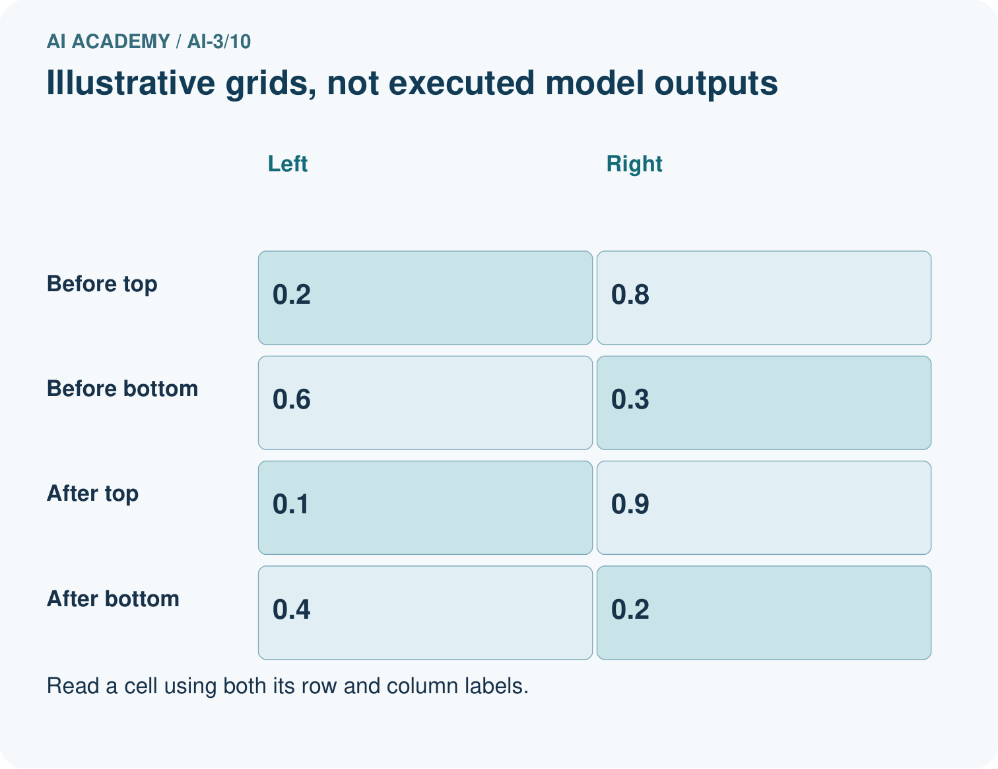
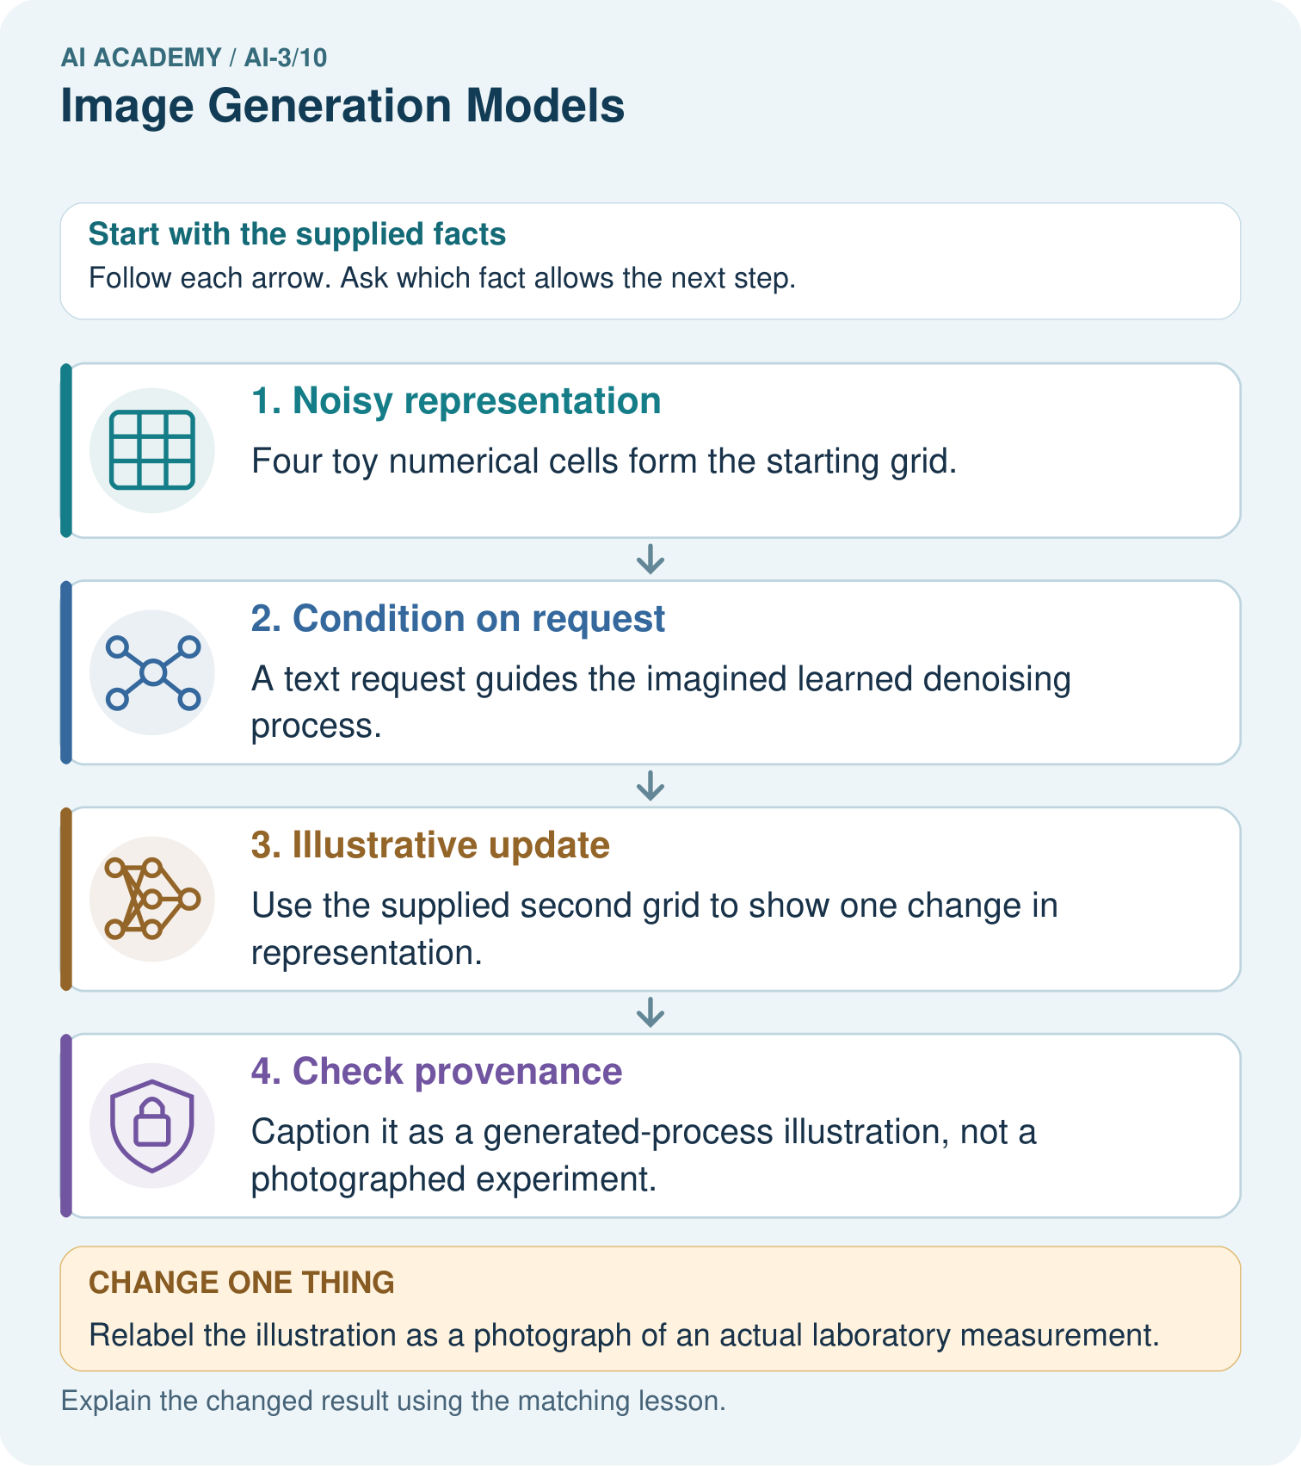

Read the picture one step at a time
Step | What happens and why
1. Noisy representation | Four toy numerical cells form the starting grid.
2. Condition on request | A text request guides the imagined learned denoising process.
3. Illustrative update | Use the supplied second grid to show one change in representation.
4. Check provenance | Caption it as a generated-process illustration, not a photographed experiment.
Match each pictured step to the supplied facts. This is a worked teaching case, not an independent assessment.

Why this result follows
Diffusion-style generators learn to remove noise in stages, often guided by text, but a real implementation can operate in a latent representation rather than direct pixels. The toy values let us inspect an update without pretending to simulate that trained process. An attractive final image still needs checks for labels, requested relations and factual claims.

What this example does not establish
Not all image generators use diffusion; this toy step is neither a complete algorithm nor an executed model.

Change one thing in the pictured case
Change: Relabel the illustration as a photograph of an actual laboratory measurement.
Prediction: That caption is unsupported.
Reason: Its provenance is an invented diagram of a process, not a camera record of an event.

Ask while showing the picture
Cover the result. Ask learners to name the inputs and predict the next step. Uncover one step, connect the icon to the actual procedure, and explain its evidence. Then change the supplied condition and compare. The picture is a representation; it does not document execution of a real AI model.

03. Demonstrate and guide practice

Demonstrate and guide practice

Board sequence
Write the given facts: A generator creates a realistic fictional bicycle beside a tree.
Write the question to explain: How does this differ from event photography?
Reveal after predictions: It synthesises an image from learned patterns and instructions; it does not document that event. Many systems denoise iteratively, but architectures vary.
Keep for an independent attempt: An image model draws a plant with seven roots after a request for exactly four. What does this show, and where should an exact count diagram be made?

Classroom dialogue
Ask: Which facts are given, and which would we have to assume? Learners mark relevant details before discussing answers.
Say: Predict first. Show the rule, information path or calculation that would produce the result. A correct guess is not yet an explanation.
Reveal reasoning one step at a time. Explain why a tempting alternative fails. Write units and denominators for arithmetic, trace conditions for decisions, and identify supporting sources for claims.
In pairs, one learner solves while the other checks evidence; exchange roles. Remove the worked answer before independent assessment.

Model these guided questions
Guided: It fails count and label criteria; the photograph claim is unsupported. Record it as a generated fictional illustration and revise or reject before use. Qualification: Provenance tracks production history; it does not prove the content is accurate or establish every legal permission. Exit: accept a concrete variation with its predicted outcome and a stated condition that would challenge the mechanism; reject a claim resting on unmeasured evidence.

Case-specific teaching sequence
Stage | Teacher action
Session 1: 0–7 minutes | Retrieve the prerequisite; identify the input, procedure and evidence source.
7–18 minutes | Explain section 1 and vocabulary. Complete W1 with a mechanism-based explanation.
18–32 minutes | Trace the declared procedure and worked case. Complete W2, recording intermediate steps.
32–45 minutes | Discuss the diagram with the worked input; use W3 to distinguish measured claims and limitations.
Session 2: 0–8 minutes | Retrieve the worked reasoning and collect the guided response before discussing it.
8–20 minutes | Compare a proposed boundary variant with the original case; identify what remains fixed.
20–35 minutes | Collect W4 independently. Require the procedure trace and the bounded conclusion.
35–45 minutes | Use W5 and exit responses for feedback. Administer the fresh retry after feedback and preserve both attempts.

Reduce help deliberately
Completion task: A fictional poster requires exactly three labelled circles. Generated image shows four circles and one unreadable label. A caption calls it a photograph of a real lesson. Show the intermediate steps and give the conclusion with its scope.
Teacher check: Teacher explanation: It fails count and label criteria; the photograph claim is unsupported. Record it as a generated fictional illustration and revise or reject before use.
Start by identifying the given inputs together. Leave the intermediate steps blank. If needed, model one step, then withdraw that help on the next step. Move to a full trace only when the partial trace is understood. For partners, alternate explainer and checker; collect a response from every learner before discussion.

Individual reasoning check
Use the worked case for Image generation and provenance. Proposed explanation: “The worked result establishes every future case”. Decide whether this explanation is supported. Point to the step or supplied fact that decides; explain your repair if needed.
Expected correction: Provenance tracks production history; it does not prove the content is accurate or establish every legal permission.
Collect explanations, not only yes/no votes. If a misunderstanding is common, re-model the relevant step for the class. If it affects a few learners, give a short targeted group explanation while others solve a more demanding variation.

Pictorial practice question
What may these two grids explain, and what can they not establish about a real generator?

Reasoned teacher answer
They explain an illustrative staged change. They cannot establish learned weights, actual image quality or accurate scientific observation.
Changed-case reasoning: That caption is unsupported. Its provenance is an invented diagram of a process, not a camera record of an event.
Collect each learner’s explanation before discussion. Use the first missing connection between input, deciding step and result to choose support. This question is worked-case practice, not fresh mastery evidence.

04. Run the weekly evidence lab

Run the weekly evidence lab
Words You Can Use to Reason
A definition matters when you can recognize the idea, use it, and contrast it with a near-miss.
Predict → Test → Record → Explain
Keep expected and actual results separate. Surprises are useful data when recorded honestly.
Order noise-to-image cards, vary one prompt condition, compare composition changes, and label what cannot be inferred as fact.
What did the hardest test teach you that the normal test did not?

Make the lab runnable
Use the concrete case as the shared normal case and the independent question as a second case. Each pair creates a boundary or missing-information case and predicts its result before testing. Keep the expected result separate from an observed mistake.
Record | What to capture
Input or evidence | Exact data, instruction or claim
Expected result | Answer or safe fallback declared before the run
Observed result | Actual result, including errors
Explanation | Rule, calculation or evidence explaining the outcome
Next test | One justified change and a new prediction

Diagnose and reteach
For guessing, return to given facts and request a trace. For vocabulary without application, use one example and one non-example. For arithmetic errors, check the setup before the calculation. Finish with a different uncoached case before recording mastery.

Address these additional misconceptions
The worked result establishes every future case: Provenance tracks production history; it does not prove the content is accurate or establish every legal permission.
A missing input may be replaced without recording the change: A replacement changes the evidence or contract. Record the change and its justification; do not silently turn unknown into a measured value.
Repeating an assessed case is new independent evidence: A replay checks consistency. An example used for feedback or revision cannot later be described as untouched final evaluation.

Match the support to the first error
What the response shows | Next teaching action
Missing or misread facts | Read the case aloud, mark supplied versus unknown facts, and let the learner restate it.
Wrong procedure | Return to the deciding step in the worked case. Contrast it with the proposed incorrect explanation.
Arithmetic or implementation error | Trace intermediate values or lines; preserve the first mismatch and retry that step.
Correct result without a reason | Ask for a trace and a changed case before marking independent understanding.
An unsupported wider claim | Ask which supplied evidence supports the claim and which further observation would be needed.
Offer an oral explanation, drawing, enlarged visual or fewer examples when that removes a reading/writing barrier. Keep the same reasoning goal. Stretch secure learners by changing a boundary or assumption and asking them to defend the effect, not simply by assigning more of the same questions.

05. Assess and explain the answers

Assess and explain the answers

Worked case answer
It synthesises an image from learned patterns and instructions; it does not document that event. Many systems denoise iteratively, but architectures vary.

Independent question
An image model draws a plant with seven roots after a request for exactly four. What does this show, and where should an exact count diagram be made?

Expected independent answer
Generated images can miss exact counting constraints. Use a checked, editable drawing or diagram tool for an instructional diagram requiring exactly four roots.

What counts as evidence
Criterion | 0 points | 1 point | 2 points
Result | Incorrect or absent | Partly correct | Correct with necessary conditions
Reasoning | No supporting trace | Some steps | Clear mechanism, calculation or source support
Limit | Overclaims certainty | Vague limitation | Relevant uncertainty or missing fact
Transfer | Copies without adapting | Adapts with prompts | Solves a changed case independently
Use 6/8 as a classroom checkpoint, with 2 required for both Result and Reasoning. This is a proposed teaching rule, not a validated certification threshold. Do not count a coached answer as independent mastery; correct unsafe or unsupported claims regardless of total.

Feedback
Ask the learner to find the evidence that challenges this claim: “An image generator always obeys numerical constraints precisely.” Keep the first attempt and an uncoached retry separate.

Original transfer answer
It demonstrates a generated depiction, not that a greenhouse exists on Mars. Label it as generated and separate design imagination from factual evidence. Some image models use iterative denoising, but no single architecture describes every generator.

Explanations for the additional workbook examples

W1 Explain the mechanism
Explain the weekly mechanism in your own words. Use the worked scenario to name its input, decision rule and output.
Teacher explanation: An image generator constructs an output from learned patterns and a specification. A generated picture is not a record that the depicted event occurred. Keep a provenance record containing specification, tool/version when known, generation date, edits, permissions and intended use. Label fictional imagery. Inspect visual requirements and avoid inferring identity or event authenticity from appearance.

W2 Trace the worked case
A fictional poster requires exactly three labelled circles. Generated image shows four circles and one unreadable label. A caption calls it a photograph of a real lesson. Show the intermediate steps and give the conclusion with its scope.
Teacher explanation: It fails count and label criteria; the photograph claim is unsupported. Record it as a generated fictional illustration and revise or reject before use.

W3 Audit the limit
A report omits this qualification: Provenance tracks production history; it does not prove the content is accurate or establish every legal permission. Explain how omitting it could change a reader's interpretation, and write an accurate replacement.
Teacher explanation: Provenance tracks production history; it does not prove the content is accurate or establish every legal permission. State the observed result separately from the unverified or out-of-scope claim; preserve the original evidence rather than inventing a missing fact.

W4 Apply a new case independently
A generated diagram requires two arrows and labels input/output. It has two arrows but swapped labels. Metadata records generation, yet the caption says experimental observation. Audit.
Teacher explanation: Arrow count passes; label semantics fail. Metadata supports generation provenance, not observed-event authenticity; replace the caption and correct labels.

W5 Design a revealing follow-up
For the worked scenario, propose one additional case that could reveal a failure, describe its expected outcome before running it, and explain what would need to remain fixed for a fair comparison. Do not reuse W4 as a new final test after receiving feedback.
Teacher explanation: Accept a concrete variant of the worked input or a missing/conflicting/boundary condition, with an expectation derived from the declared procedure. Require preserved settings, original outputs and data roles. Provenance tracks production history; it does not prove the content is accurate or establish every legal permission. The new case should test this particular mechanism rather than merely restate the original result.

Assess independent transfer
Selected case: A generated diagram requires two arrows and labels input/output. It has two arrows but swapped labels. Metadata records generation, yet the caption says experimental observation. Audit.

Selected case answer
Teacher explanation: Arrow count passes; label semantics fail. Metadata supports generation provenance, not observed-event authenticity; replace the caption and correct labels.
Dimension | Evidence required
Explanation | Names the applicable idea or procedure and ties it to the supplied facts.
Trace and result | Preserves the given inputs and shows the relevant intermediate steps; distinguishes a prediction from an observed execution.
Limits | States the assumptions, missing evidence or conditions under which the result would change.
Record each dimension as not yet, with support, or independent. Accept a valid alternative procedure with a defensible trace. Do not penalise an honestly recorded model failure if the learner correctly explains its evidence and limits.

Feedback that the learner uses
Name the earliest unsupported step and give one action to repair it. Have the learner make that repair now and explain why. Then assess the relevant skill on a fresh, fully specified case. Confirm it was not previously practised with feedback; solve and check the new case before assigning it. A follow-up design prompt is a starting brief, not automatically an equivalent test.

06. Connect and extend learning

Connect and extend learning

Verified Study Buddy
Treat generated diagrams as illustrations; pair factual claims with approved sources.
Keep the decision, input, result, explanation and remaining limitation in the project evidence record. Retrieve this record next week rather than restarting the project.

Support and stretch
Provide one short approved passage; separate instruction, input, output and evidence. Stretch: introduce an unsupported claim or conflicting source and validate claim by claim with a fallback.

Exit reflection
Ask for one decision the learner can now justify and one situation requiring more evidence or human review. Confidence ratings are separate from correct independent performance.

Bridge to the next week
Next: Week 11: Visual Composition. Retrieve today’s evidence and identify what carries forward and what is new.

Support and fresh reassessment
Provide an input/procedure/result/limit frame and a calculator when needed. Ask students to identify the first step before completing the whole trace. Extension: compare two concrete variants of this mechanism while holding unrelated conditions fixed; report both successful and unsuccessful outcomes.
W4: Arrow count passes; label semantics fail. Metadata supports generation provenance, not observed-event authenticity; replace the caption and correct labels. Require intermediate reasoning and the stated scope. Fresh retry: A generated map has three required labels but omits one and is captioned survey evidence. Expected reasoning: Completeness fails; generation cannot establish surveyed geography. Use verified map data for geographical claims. If students need support, record it and reassess with another new case rather than awarding independence to a copied answer.
Next connection: Speech pipelines and multimodal evidence. Preserve the current case record and retrieve its evidence boundary before moving on.

Plan the delayed return
Suggested return points in this level: ai-3/11, ai-3/13, ai-3/16. Use actual classroom dates, adjusting for holidays and gaps. One, three and six teaching weeks are scheduling choices, not a claimed optimal spacing.
At a delayed check, ask for the idea from memory and a changed application. Compare with the earlier independent response and record support used. For a new level, revisit the previous capstone before checking the new prerequisites.
Record | Teacher evidence
Learner code and date
Concept and case used; prior exposure
Explanation / trace / limits
Support and first repair
Changed case and delayed outcome
Next teaching action
Use the evidence to choose reteaching or the next step. A completed page, confidence rating or attractive project does not by itself demonstrate understanding.

Project evidence from this case
Use Study Buddy generated diagrams only with clear provenance and checked educational labels.

07. Prepare, teach and assess
Teaching target: Explain the mechanism and terminology of image generation and provenance
Prepare the labelled worked-case picture, the matching workbook, fictional input cards and a place for individual responses. No paid AI account is required for the paper reasoning activities.
Session | Plan | Resources
Session 1 · Understand · 45 min | 0–7: recall and prerequisite; 7–15: inspect the concrete case and predict; 15–30: teacher models the worked trace; 30–40: learners explain a step using the text and visual; 40–45: check the core idea. | Sections 1–6; record the brief recall in the workbook.
Session 2 · Practise · 45 min | 0–5: retrieve the procedure; 5–15: W2 completion practice; 15–23: explain and check with a partner; 23–30: each learner answers the misconception check; 30–40: targeted reteaching or a harder variation; 40–45: prepare the investigation. | Sections 7–10; use the matching workbook W2 and misconception check.
Session 3 · Investigate and transfer · 45 min | 0–5: retrieve the decision rule; 5–20: investigate or trace; 20–30: start the independent case; 30–38: connect the project; 38–43: act on feedback; 43–45: plan the return check. | Sections 9 and 11–14. Give extra time to finish the full task set; use Section 15 when the week includes a coding lab.
Before class, solve the supported practice: A fictional poster requires exactly three labelled circles. Generated image shows four circles and one unreadable label. A caption calls it a photograph of a real lesson. Show the intermediate steps and give the conclusion with its scope.
Reasoned practice answer: Teacher explanation: It fails count and label criteria; the photograph claim is unsupported. Record it as a generated fictional illustration and revise or reject before use.
Check every learner before discussion: Use the worked case for Image generation and provenance. Proposed explanation: “The worked result establishes every future case”. Decide whether this explanation is supported. Point to the step or supplied fact that decides; explain your repair if needed.
Misconception repair: Provenance tracks production history; it does not prove the content is accurate or establish every legal permission.
Support: read the exact case aloud, enlarge the labelled picture, supply input cards and model only the first deciding step. Accept a spoken explanation or drawing; retain the reasoning goal.
Extension: Relabel the illustration as a photograph of an actual laboratory measurement. Require a prediction and a reason before comparing. Expected result: That caption is unsupported. Reason: Its provenance is an invented diagram of a process, not a camera record of an event.
Independent assessment: withhold the reserved answer until the learner has attempted the new case. Record support separately from correctness.
Criterion | Not yet | With support | Independent
Explanation | Names an answer without a deciding fact | Uses a hint to link fact and decision | Explains the deciding fact in own words
Trace or test | Cannot connect input and result | Completes steps with prompts | Traces or tests a changed case accurately
Limits and revision | Claims more than evidence supports | Names a limit after a prompt | States a defensible limit and useful next test
Project checkpoint: Make a transparent first version. Keep a trace of how one input becomes an output; explain the rule or learned component.
Use the weekly teacher answer for topic-specific reasoning. A saved progress tick is an activity record; judge mastery from the learner’s explanation and evidence.

08. Use feedback, labs and repair paths
Use the two formative questions as supported practice, not as independent mastery scores. Discuss the deciding evidence rather than accepting a guessed selection.
The feedback comes from the reviewed public worked case. Do not reveal the separately reserved independent teacher answer until the learner has attempted that case.
Ask students to predict before running code. Preserve errors and actual outputs; collect a changed test and an explanation. The branch-boundary and indexing lessons deliberately include failure cases.
Use the earlier worked-explanation links to address a specific missing building block, then return to the current question. Adapt this suggestion after observing the learner; it is not an automatic diagnosis.
Collect the completed-work portfolio as evidence. Record support separately from correctness, and assess explanation, trace/test and limitations. Progress ticks and quiz selections alone do not establish mastery.

