AI ACADEMY · TEACHER · ai-4/19

Regression and Residuals
Project: Responsible Plant Classifier

01. Regression and Residuals

Teach the learning cycle
Primary target: Distinguish numeric prediction from classification
Session | Sequence and minutes | Resources
Session 1 · Understand · 45 min | 0–7: recall and prerequisite; 7–15: inspect the concrete case and predict; 15–30: teacher models the worked trace; 30–40: learners explain a step using the text and visual; 40–45: check the core idea. | Sections 1–6; record the brief recall in the workbook.
Session 2 · Practise · 45 min | 0–5: retrieve the procedure; 5–15: W2 completion practice; 15–23: explain and check with a partner; 23–30: each learner answers the misconception check; 30–40: targeted reteaching or a harder variation; 40–45: prepare the investigation. | Sections 7–10; use the matching workbook W2 and misconception check.
Session 3 · Investigate and transfer · 45 min | 0–5: retrieve the decision rule; 5–20: investigate or trace; 20–30: start the independent case; 30–38: connect the project; 38–43: act on feedback; 43–45: plan the return check. | Sections 9 and 11–14. Give extra time to finish the full task set; use Section 15 when the week includes a coding lab.
This is a starting allocation of 135 minutes, not a validated duration. Preserve all named topics. Schedule extra time for connected examples, the full investigation, independent cases and project building. Repeated copies of a case share one recorded attempt; they are not new evidence.

Retrieval answer guidance

Error Analysis
Without opening the old lesson, explain one key idea from Error Analysis. Give an example and a mistake that the idea helps you avoid.
Look for: Categorize development errors using evidence
Reference example, not the only acceptable wording: Teacher explanation: Dim 4/12 about 33.3 percent; bright 3/18 about 16.7 percent.

Accuracy and Imbalance
Without opening the old lesson, explain one key idea from Accuracy and Imbalance. Give an example and a mistake that the idea helps you avoid.
Look for: Explain why overall accuracy can hide failure on a less common class
Reference example, not the only acceptable wording: The training-majority rule always predicts clear. Matrix [[16,0],[4,0]] gives 16/20=80 percent, FP=0,FN=4. It misses all four blocked cases, so the overall score hides complete failure on that evaluated class.

Train a Classifier
Without opening the old lesson, explain one key idea from Train a Classifier. Give an example and a mistake that the idea helps you avoid.
Look for: Connect training-only scaling and neighbour prediction in one pipeline
Reference example, not the only acceptable wording: fit learns training minima and ranges and stores scaled training rows with IDs and labels. predict takes a raw feature pair and the fitted state. Evaluation compares a prediction with its reference label afterward. Validation references belong only in evaluation, not in fitting or the neighbour pool.
Use the student module and workbook section with this exact week title. The worked case, independent question and answers below form one aligned lesson sequence.

What the learner must demonstrate
Actual leaf length is 7 cm and prediction is 10 cm. Using residual=actual−predicted, calculate residual and absolute error. Interpret the sign.

Concept to explain
Regression predicts a number; a residual records signed error and reveals direction as well as size.
Term | Meaning
regression | prediction of a numerical target
prediction | model-estimated value
residual | actual value minus predicted value
residual plot | errors displayed against predictions or inputs

Prepare the class
Use the supplied scenario, student illustrations and blank paper. For numeric work, offer counters or a calculator after learners show the setup. Fictional records are supplied; personal data and paid accounts are unnecessary.
Allow 80 minutes: recall 8; explanation 12; worked demonstration 15; guided practice 20; independent assessment 15; project and reflection 10. Extend the lab into a second session when needed.

Preparation for the connected explanation
Teach two 45-minute sessions. This week focuses on regression and residuals. Model the worked example first, collect the new W 4 case independently before feedback, and use the fresh retry to check transfer. Award credit for traceable reasoning and bounded claims, including justified uncertainty.

Readiness answer
A category; regression predicts a numeric target instead.
Printed student lesson and workbook
Paper, pencils and a calculator for fractions
The fictional examples and a blank evidence table
Optional Python 3 editor; no external packages or AI accounts required

End goal for the pictorial case
By the end, I can explain regression and residuals using a traced example and a stated limitation.
This added worked case illustrates the week’s main idea. Retain all original and connected topics; schedule its practice within the teaching cycle.

02. Explain the mechanism

Explain the mechanism
Trace the information, fitted behavior, and evaluation proof separately.
QUESTION Plot predictions and calculate positive and negative residuals.
MODEL IDEA Regression predicts a number; a residual records signed error and reveals direction as well as size.
PROOF NEEDED Use an unseen case, visible calculation, error analysis, and a stated limitation.
UNDER THE HOOD Actual plant height is 30 cm; prediction is 27 cm. Residual = actual − predicted = 30 − 27 = +3 cm.
Draw a fresh data → model → prediction → evaluation trace:
Predict first. Then check each step. A correct answer without visible evidence cannot be audited.
STEP 1 Actual plant height is 30 cm; prediction is 27 cm.
STEP 2 Residual = actual − predicted = 30 − 27 = +3 cm.
STEP 3 Another case has actual 20 and predicted 24, residual −4 cm.
STEP 4 Plot residuals; a pattern above or below zero suggests systematic model error.
CHECK Verify the denominator, unit, split, class definition, and data version before interpreting a score.
Recalculate, retrace, or restate the evidence independently:

Concrete teaching case
Actual height=12 cm, prediction=9 cm. Residual means actual minus predicted.
Calculate and interpret.

Exact explanation to model
+3 cm means underprediction by 3 cm. State this sign convention consistently.

Explain the added worked example
A school garden example predicts plant height in cm from recorded conditions. The target is numeric, so a prediction can be too high or too low by different amounts. Define residual as observed minus predicted. Keep units and the sign convention visible; some software uses the opposite error convention.
Use fictional classroom data throughout this investigation. Keep the task, units, reference labels and data split visible as you reason. Earlier weeks supplied the model-building process; this week examines regression and residuals.
Observed heights [4, 7, 9] cm and predictions [5, 6, 9] cm give residuals [-1, 1, 0] cm. The first prediction is too high, the second too low and the third exact. Mean signed residual is zero, yet two predictions are wrong. Opposite errors can cancel.
Trace the calculation on paper before running this optional Python check. Use the stated fictional inputs and compare intermediate values. The code checks this example; your independent workbook case uses different evidence.

Key terms
Term | Meaning
Regression | Prediction of a numeric target
Residual | Observed target minus predicted target in this course
Underprediction | A prediction below the observed value
Overprediction | A prediction above the observed value

Model the reasoning aloud
Use the complete worked example below before asking learners to complete W2. Reveal a small part, invite a prediction, then explain the deciding step. These teacher notes contain solutions; do not reveal the independent case answer during modelling.

Regression and residuals at a glance
Part | Evidence or action | Interpretation
Observed 4 predicted 5 | Residual minus 1 | Overprediction
Observed 7 predicted 6 | Residual plus 1 | Underprediction
Observed 9 predicted 9 | Residual zero | Exact on this record
To inspect a residual plot, place a feature or prediction on the horizontal axis and residual on the vertical axis. A trend can suggest a missed relationship. It does not by itself identify the cause or validate a new model. Use development data for analysis and preserve an independent final test.

Why does mean residual zero not imply perfect predictions? Explain the steps or evidence behind your response.
________________________________________________________________
________________________________________________________________
________________________________________________________________
________________________________________________________________
Thinking move | Teacher prompt
Plan | What is given? What is the question? Which procedure fits these facts?
Do | Point to each input and intermediate step in the worked trace. Name the rule that allows the next step.
Check | Does the output answer the question? Which assumption or limitation prevents a larger claim?
Use the diagram and verbal explanation together. Ask learners to match a sentence to a specific visual step; do not assign learners fixed visual or auditory learning styles.

A pictorial worked case: Regression and Residuals
Use residual signs to say whether each plant-height estimate is too high or low.

The facts we will use
Residual=observed-predicted. Observed heights [5, 8, 12] cm; predicted [7, 7, 10] cm.
All inputs and outcomes in this worked example are invented classroom data; no real model run is claimed.
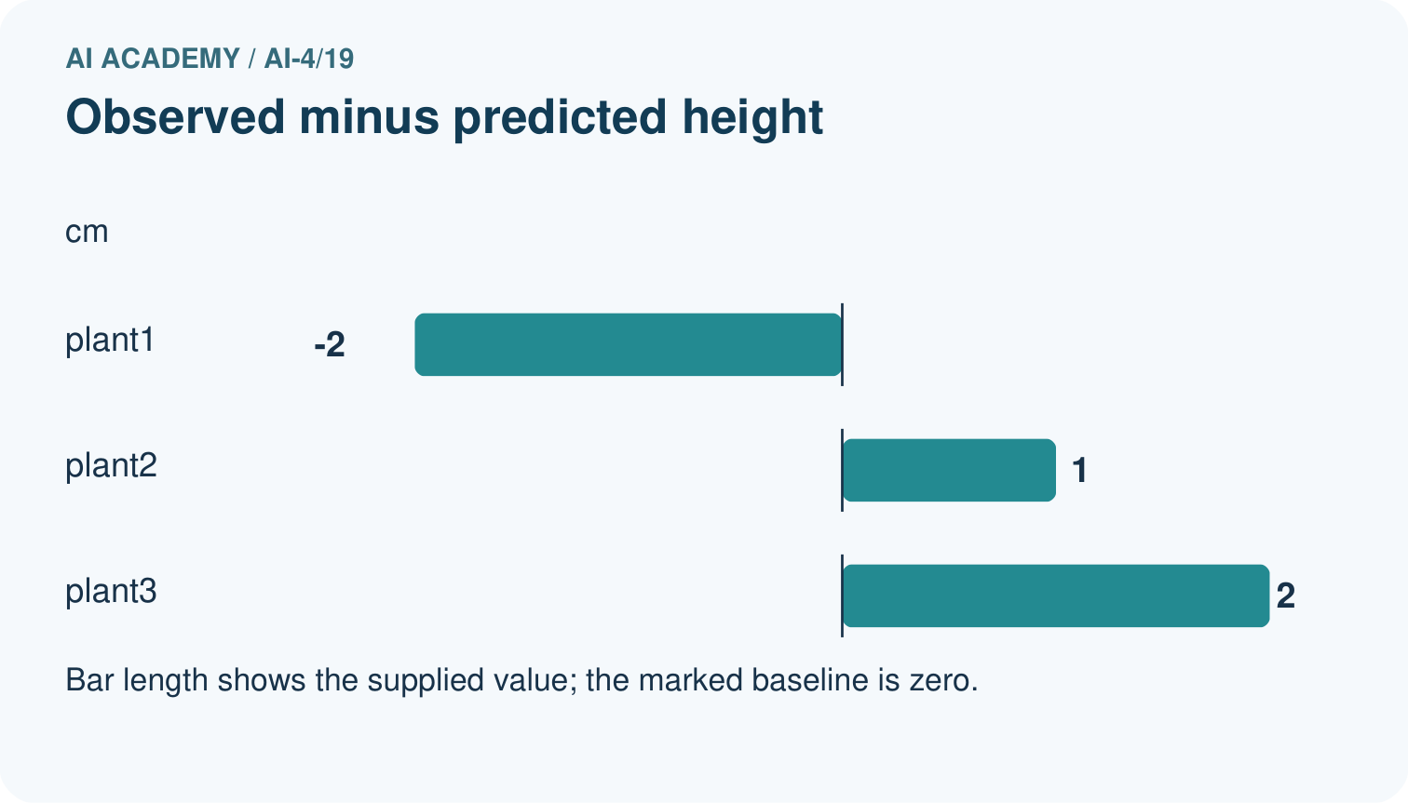
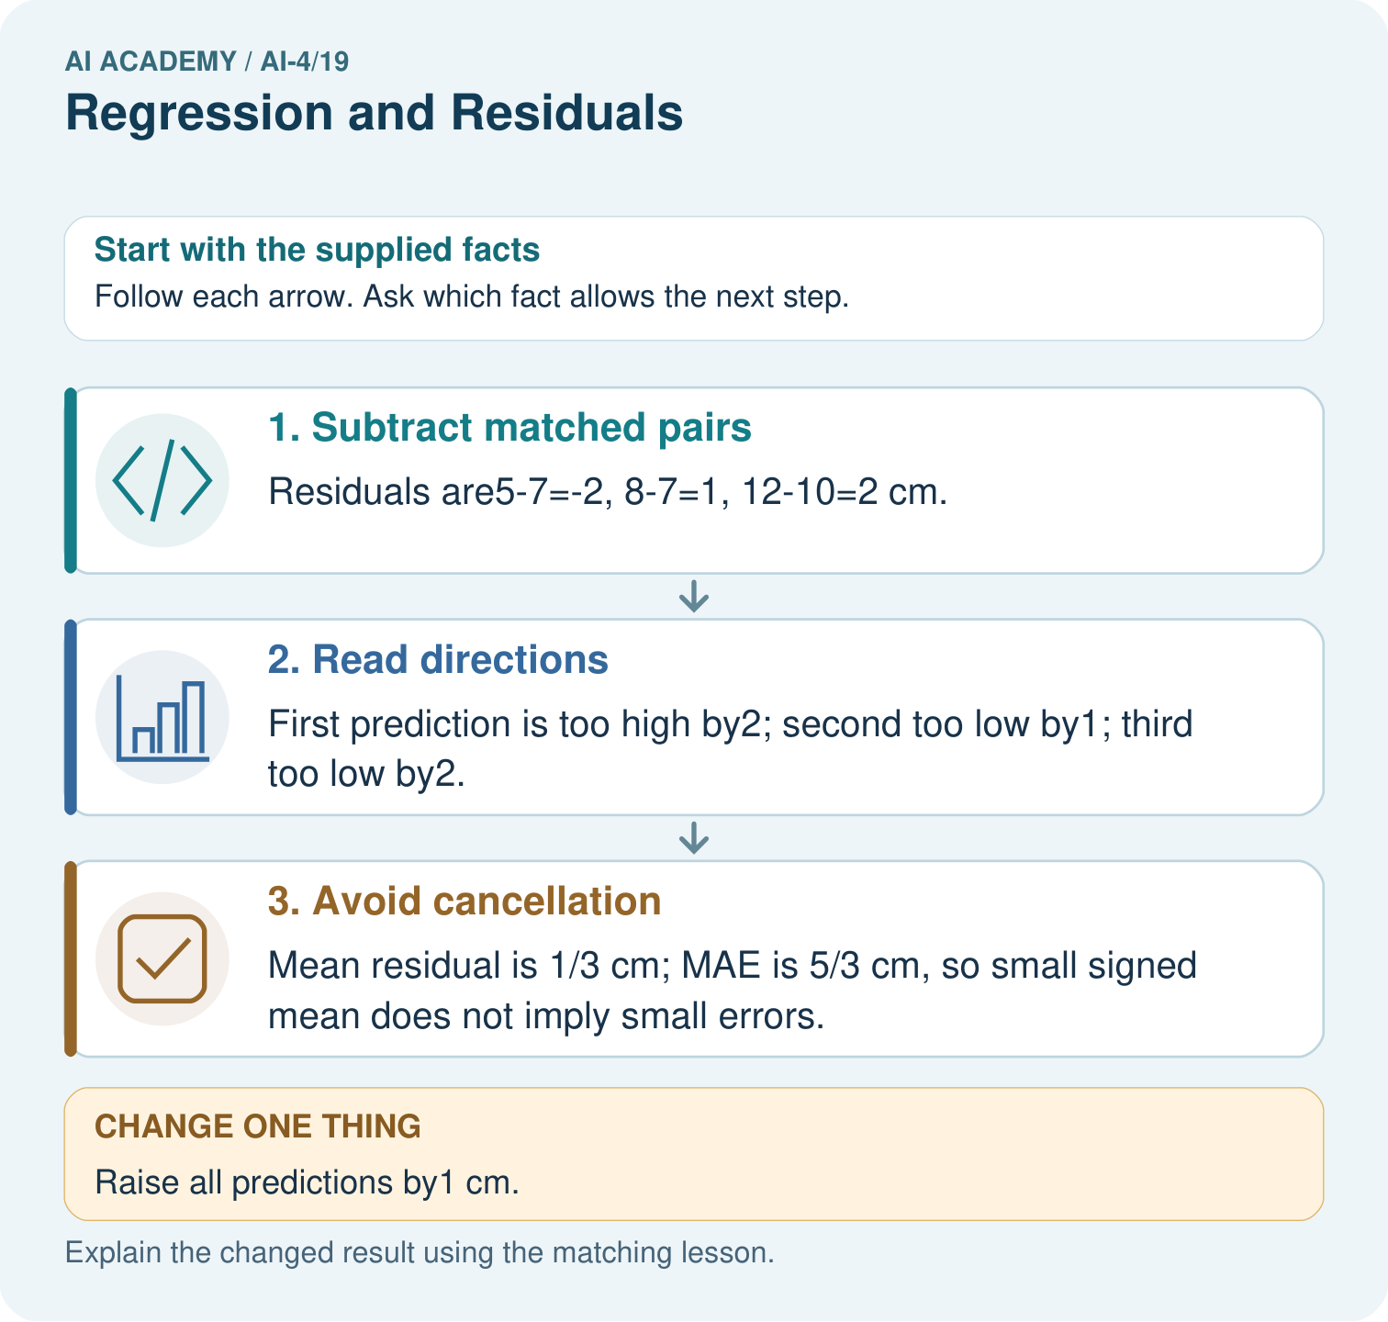

Read the picture one step at a time
Step | What happens and why
1. Subtract matched pairs | Residuals are5-7=-2, 8-7=1, 12-10=2 cm.
2. Read directions | First prediction is too high by2; second too low by1; third too low by2.
3. Avoid cancellation | Mean residual is 1/3 cm; MAE is 5/3 cm, so small signed mean does not imply small errors.
Match each pictured step to the supplied facts. This is a worked teaching case, not an independent assessment.

Why this result follows
Read the picture in order. Mean residual is 1/3 cm; MAE is 5/3 cm, so small signed mean does not imply small errors. The arrows show which recorded input or intermediate result each decision uses. Explain the deciding step aloud before checking the changed case; pointing to the final answer alone does not show how it follows.

What this example does not establish
Always declare the residual sign convention; some software uses predicted minus observed.

Change one thing in the pictured case
Change: Raise all predictions by1 cm.
Prediction: Residuals become [-3, 0, 1]; mean=-2/3 cm and MAE=4/3 cm.
Reason: Each residual decreases by1 under the observed-minus-predicted convention.

Ask while showing the picture
Cover the result. Ask learners to name the inputs and predict the next step. Uncover one step, connect the icon to the actual procedure, and explain its evidence. Then change the supplied condition and compare. The picture is a representation; it does not document execution of a real AI model.

03. Demonstrate and guide practice

Demonstrate and guide practice

Board sequence
Write the given facts: Actual height=12 cm, prediction=9 cm. Residual means actual minus predicted.
Write the question to explain: Calculate and interpret.
Reveal after predictions: +3 cm means underprediction by 3 cm. State this sign convention consistently.
Keep for an independent attempt: Define residual as actual minus predicted. Actual height is 14 cm and prediction is 17 cm. Calculate residual and interpret its sign.

Classroom dialogue
Ask: Which facts are given, and which would we have to assume? Learners mark relevant details before discussing answers.
Say: Predict first. Show the rule, information path or calculation that would produce the result. A correct guess is not yet an explanation.
Reveal reasoning one step at a time. Explain why a tempting alternative fails. Write units and denominators for arithmetic, trace conditions for decisions, and identify supporting sources for claims.
In pairs, one learner solves while the other checks evidence; exchange roles. Remove the worked answer before independent assessment.

Model these guided questions
Guided response: Negative and positive residuals cancel even when individual errors are nonzero. Exit response: Convert to a shared unit; both represent 2 cm. Document units before comparing or aggregating errors.

Case-specific teaching sequence
Stage | Teacher action
Session 1 start to 7 minutes | Use the prerequisite question: What does a class label predict? Check the explanation before proceeding.
7 to 18 minutes | Read the opening and model the worked evidence. Ask students to identify regression in context.
18 to 32 minutes | Complete W 1 and W 2 with support: calculate residuals; explain cancellation. Require the evidence, not only the final response.
32 to 45 minutes | Read the visual row by row. Collect the guided explanation and compare reasoning in pairs. Trace the Python check after the paper calculation.
Session 2 start to 8 minutes | Retrieve the distinction between regression and residual. Invite a counterexample to an overconfident claim.
8 to 20 minutes | Discuss the application and complete W 3: Interpret residuals -2, 0, 3 ordered by growth stage.
20 to 35 minutes | Collect W4 independently before giving hints. Assess these outcomes: Distinguish numeric prediction from classification; Calculate signed residuals with a stated convention. Record any support used.
35 to 45 minutes | Use W 5 and the exit response to assess limits. Give targeted feedback, then the fresh retry. Save evidence of independent understanding.

Reduce help deliberately
Completion task: Why does mean residual zero not imply perfect predictions?
Teacher check: Teacher explanation: Negative and positive residuals cancel even when individual errors are nonzero.
Start by identifying the given inputs together. Leave the intermediate steps blank. If needed, model one step, then withdraw that help on the next step. Move to a full trace only when the partial trace is understood. For partners, alternate explainer and checker; collect a response from every learner before discussion.

Individual reasoning check
Use the worked case for Regression and residuals. Proposed explanation: “A final answer is enough”. Decide whether this explanation is supported. Point to the step or supplied fact that decides; explain your repair if needed.
Expected correction: Ask for the relevant counts, units, procedure or saved record. For this week: Residuals -1, 1, 0 cm; the first record is overpredicted.
Collect explanations, not only yes/no votes. If a misunderstanding is common, re-model the relevant step for the class. If it affects a few learners, give a short targeted group explanation while others solve a more demanding variation.

Pictorial practice question
Which statistic reveals the size of errors without cancellation? Point to the relevant step in the picture, then write the changed result and the rule or evidence that supports it.

Reasoned teacher answer
MAE: original5/3 cm and changed4/3 cm. Signed mean reports average direction and can hide offsetting errors. Changed-case check: Residuals become [-3, 0, 1]; mean=-2/3 cm and MAE=4/3 cm. Each residual decreases by1 under the observed-minus-predicted convention.
Changed-case reasoning: Residuals become [-3, 0, 1]; mean=-2/3 cm and MAE=4/3 cm. Each residual decreases by1 under the observed-minus-predicted convention.
Collect each learner’s explanation before discussion. Use the first missing connection between input, deciding step and result to choose support. This question is worked-case practice, not fresh mastery evidence.

04. Run the weekly evidence lab

Run the weekly evidence lab
Keep the test conditions fixed, record every result, and change only one planned factor.
1. Write the hypothesis and expected evidence before running.
2. Residual Walk: calculate signed errors, place them on a plot, and identify bias, outliers, or changing spread.
3. Run one normal, one boundary, one missing, and one shifted case.
4. Calculate the metric from raw counts or row-level errors.
5. Interpret what changed, what did not, and what remains unsafe or unknown.

Make the lab runnable
Use the concrete case as the shared normal case and the independent question as a second case. Each pair creates a boundary or missing-information case and predicts its result before testing. Keep the expected result separate from an observed mistake.
Record | What to capture
Input or evidence | Exact data, instruction or claim
Expected result | Answer or safe fallback declared before the run
Observed result | Actual result, including errors
Explanation | Rule, calculation or evidence explaining the outcome
Next test | One justified change and a new prediction

Diagnose and reteach
MISCONCEPTION TO REPAIR Positive and negative residuals cancel, so their average proves accuracy.
For guessing, return to given facts and request a trace. For vocabulary without application, use one example and one non-example. For arithmetic errors, check the setup before the calculation. Finish with a different uncoached case before recording mastery.

Address these additional misconceptions
A final answer is enough: Ask for the relevant counts, units, procedure or saved record. For this week: Residuals -1, 1, 0 cm; the first record is overpredicted.
A stronger claim makes a stronger project: Convert to a shared unit; both represent 2 cm. Document units before comparing or aggregating errors.
The new case can be copied from the example: The independent task changes the evidence. Require a fresh explanation: Residuals [-2, 1, 2] cm; mean 1/3 cm. First overpredicted, others underpredicted.

Match the support to the first error
What the response shows | Next teaching action
Missing or misread facts | Read the case aloud, mark supplied versus unknown facts, and let the learner restate it.
Wrong procedure | Return to the deciding step in the worked case. Contrast it with the proposed incorrect explanation.
Arithmetic or implementation error | Trace intermediate values or lines; preserve the first mismatch and retry that step.
Correct result without a reason | Ask for a trace and a changed case before marking independent understanding.
An unsupported wider claim | Ask which supplied evidence supports the claim and which further observation would be needed.
Offer an oral explanation, drawing, enlarged visual or fewer examples when that removes a reading/writing barrier. Keep the same reasoning goal. Stretch secure learners by changing a boundary or assumption and asking them to defend the effect, not simply by assigning more of the same questions.

05. Assess and explain the answers

Assess and explain the answers

Worked case answer
+3 cm means underprediction by 3 cm. State this sign convention consistently.

Independent question
Define residual as actual minus predicted. Actual height is 14 cm and prediction is 17 cm. Calculate residual and interpret its sign.

Expected independent answer
Residual is 14−17 = −3 cm. The model overpredicts by 3 cm under the stated convention.

What counts as evidence
Criterion | 0 points | 1 point | 2 points
Result | Incorrect or absent | Partly correct | Correct with necessary conditions
Reasoning | No supporting trace | Some steps | Clear mechanism, calculation or source support
Limit | Overclaims certainty | Vague limitation | Relevant uncertainty or missing fact
Transfer | Copies without adapting | Adapts with prompts | Solves a changed case independently
Use 6/8 as a classroom checkpoint, with 2 required for both Result and Reasoning. This is a proposed teaching rule, not a validated certification threshold. Do not count a coached answer as independent mastery; correct unsafe or unsupported claims regardless of total.

Feedback
Ask the learner to find the evidence that challenges this claim: “A negative residual means a negative physical height.” Keep the first attempt and an uncoached retry separate.

Original transfer answer
Residual=-3 cm means overprediction by 3 cm. Absolute error=3 cm. State the sign convention because some sources reverse it; keep units and convention consistent across plots and calculations.

Explanations for the additional workbook examples

W1 Calculate residuals
Compute the worked residuals and identify overprediction.
Teacher explanation: Residuals -1, 1, 0 cm; the first record is overpredicted.

W2 Explain cancellation
Why does mean residual zero not imply perfect predictions?
Teacher explanation: Negative and positive residuals cancel even when individual errors are nonzero.

W3 Read a pattern
Interpret residuals -2, 0, 3 ordered by growth stage.
Teacher explanation: They shift from overprediction to underprediction; investigate a missed relationship without claiming a proven cause.

W4 Apply independently
Observed [6, 10, 13], predicted [8, 9, 11] cm. Give residuals, mean residual and error directions.
Teacher explanation: Residuals [-2, 1, 2] cm; mean 1/3 cm. First overpredicted, others underpredicted.

W5 Check units
A report combines 2 cm and .02 m as if they were different magnitudes. Repair it.
Teacher explanation: Convert to a shared unit; both represent 2 cm. Document units before comparing or aggregating errors.

Assess independent transfer
Selected case: Observed [6, 10, 13], predicted [8, 9, 11] cm. Give residuals, mean residual and error directions.

Selected case answer
Teacher explanation: Residuals [-2, 1, 2] cm; mean 1/3 cm. First overpredicted, others underpredicted.
Dimension | Evidence required
Explanation | Names the applicable idea or procedure and ties it to the supplied facts.
Trace and result | Preserves the given inputs and shows the relevant intermediate steps; distinguishes a prediction from an observed execution.
Limits | States the assumptions, missing evidence or conditions under which the result would change.
Record each dimension as not yet, with support, or independent. Accept a valid alternative procedure with a defensible trace. Do not penalise an honestly recorded model failure if the learner correctly explains its evidence and limits.

Feedback that the learner uses
Name the earliest unsupported step and give one action to repair it. Have the learner make that repair now and explain why. Then assess the relevant skill on a fresh, fully specified case. Confirm it was not previously practised with feedback; solve and check the new case before assigning it. A follow-up design prompt is a starting brief, not automatically an equivalent test.

06. Connect and extend learning

Connect and extend learning

Responsible Plant Classifier
Use a miniature growth-prediction side experiment to distinguish regression evidence from the main classifier metrics.
Keep the decision, input, result, explanation and remaining limitation in the project evidence record. Retrieve this record next week rather than restarting the project.

Support and stretch
Use a tiny labelled dataset, explicit units and a named positive class. Stretch: require a baseline, held-out evaluation and subgroup or shifted-condition analysis with denominators.

Exit reflection
Ask for one decision the learner can now justify and one situation requiring more evidence or human review. Confidence ratings are separate from correct independent performance.

Bridge to the next week
Next: Week 20: Mean, Median, and Baselines. Retrieve today’s evidence and identify what carries forward and what is new.

Support and fresh reassessment
Provide a blank evidence table and allow a verbal explanation before writing. Highlight the given conditions without supplying the W 4 conclusion. Use regression and residual in full sentences. Extension: alter one condition in the worked example and explain which conclusion changes and which remains supported.
For independent W 4, require: Residuals [-2, 1, 2] cm; mean 1/3 cm. First overpredicted, others underpredicted. Fresh retry observed [3, 8, 12], predicted [4, 8, 10]: residuals [-1, 0, 2], mean 1/3 in the target unit. Require sign interpretations. Mark each criterion as independent, supported or not yet demonstrated. Reassess the reasoning after feedback; do not replace the first attempt silently.
Next week: Constant prediction baselines. Carry forward the saved evidence and the distinction between development choices and justified claims.

Plan the delayed return
Suggested return points in this level: ai-4/20, ai-4/22, ai-4/25. Use actual classroom dates, adjusting for holidays and gaps. One, three and six teaching weeks are scheduling choices, not a claimed optimal spacing.
At a delayed check, ask for the idea from memory and a changed application. Compare with the earlier independent response and record support used. For a new level, revisit the previous capstone before checking the new prerequisites.
Record | Teacher evidence
Learner code and date
Concept and case used; prior exposure
Explanation / trace / limits
Support and first repair
Changed case and delayed outcome
Next teaching action
Use the evidence to choose reteaching or the next step. A completed page, confidence rating or attractive project does not by itself demonstrate understanding.

Project evidence from this case
For your Responsible Plant Classifier, save the input, procedure, observed result and limitation of this check. Label this worked example as practice; use a different, previously unreviewed case when checking independent understanding.

07. Prepare, teach and assess
Teaching target: Distinguish numeric prediction from classification
Prepare the labelled worked-case picture, the matching workbook, fictional input cards and a place for individual responses. Check a local Python 3 environment before class; have a paper-trace version ready.
Session | Plan | Resources
Session 1 · Understand · 45 min | 0–7: recall and prerequisite; 7–15: inspect the concrete case and predict; 15–30: teacher models the worked trace; 30–40: learners explain a step using the text and visual; 40–45: check the core idea. | Sections 1–6; record the brief recall in the workbook.
Session 2 · Practise · 45 min | 0–5: retrieve the procedure; 5–15: W2 completion practice; 15–23: explain and check with a partner; 23–30: each learner answers the misconception check; 30–40: targeted reteaching or a harder variation; 40–45: prepare the investigation. | Sections 7–10; use the matching workbook W2 and misconception check.
Session 3 · Investigate and transfer · 45 min | 0–5: retrieve the decision rule; 5–20: investigate or trace; 20–30: start the independent case; 30–38: connect the project; 38–43: act on feedback; 43–45: plan the return check. | Sections 9 and 11–14. Give extra time to finish the full task set; use Section 15 when the week includes a coding lab.
Before class, solve the supported practice: Why does mean residual zero not imply perfect predictions?
Reasoned practice answer: Teacher explanation: Negative and positive residuals cancel even when individual errors are nonzero.
Check every learner before discussion: Use the worked case for Regression and residuals. Proposed explanation: “A final answer is enough”. Decide whether this explanation is supported. Point to the step or supplied fact that decides; explain your repair if needed.
Misconception repair: Ask for the relevant counts, units, procedure or saved record. For this week: Residuals -1, 1, 0 cm; the first record is overpredicted.
Support: read the exact case aloud, enlarge the labelled picture, supply input cards and model only the first deciding step. Accept a spoken explanation or drawing; retain the reasoning goal.
Extension: Raise all predictions by1 cm. Require a prediction and a reason before comparing. Expected result: Residuals become [-3, 0, 1]; mean=-2/3 cm and MAE=4/3 cm. Reason: Each residual decreases by1 under the observed-minus-predicted convention.
Independent assessment: withhold the reserved answer until the learner has attempted the new case. Record support separately from correctness.
Criterion | Not yet | With support | Independent
Explanation | Names an answer without a deciding fact | Uses a hint to link fact and decision | Explains the deciding fact in own words
Trace or test | Cannot connect input and result | Completes steps with prompts | Traces or tests a changed case accurately
Limits and revision | Claims more than evidence supports | Names a limit after a prompt | States a defensible limit and useful next test
Project checkpoint: Evaluate and revise. Compare with your starting method, explain errors and record a justified revision.
Use the weekly teacher answer for topic-specific reasoning. A saved progress tick is an activity record; judge mastery from the learner’s explanation and evidence.

08. Use feedback, labs and repair paths
Use the two formative questions as supported practice, not as independent mastery scores. Discuss the deciding evidence rather than accepting a guessed selection.
The feedback comes from the reviewed public worked case. Do not reveal the separately reserved independent teacher answer until the learner has attempted that case.
Ask students to predict before running code. Preserve errors and actual outputs; collect a changed test and an explanation. The branch-boundary and indexing lessons deliberately include failure cases.
Use the earlier worked-explanation links to address a specific missing building block, then return to the current question. Adapt this suggestion after observing the learner; it is not an automatic diagnosis.
Collect the completed-work portfolio as evidence. Record support separately from correctness, and assess explanation, trace/test and limitations. Progress ticks and quiz selections alone do not establish mastery.

