AI ACADEMY · TEACHER · ai-4/31

Subgroup Performance
Project: Responsible Plant Classifier

01. Subgroup Performance

Teach the learning cycle
Primary target: Calculate subgroup results with sample sizes
Session | Sequence and minutes | Resources
Session 1 · Understand · 45 min | 0–7: recall and prerequisite; 7–15: inspect the concrete case and predict; 15–30: teacher models the worked trace; 30–40: learners explain a step using the text and visual; 40–45: check the core idea. | Sections 1–6; record the brief recall in the workbook.
Session 2 · Practise · 45 min | 0–5: retrieve the procedure; 5–15: W2 completion practice; 15–23: explain and check with a partner; 23–30: each learner answers the misconception check; 30–40: targeted reteaching or a harder variation; 40–45: prepare the investigation. | Sections 7–10; use the matching workbook W2 and misconception check.
Session 3 · Investigate and transfer · 45 min | 0–5: retrieve the decision rule; 5–20: investigate or trace; 20–30: start the independent case; 30–38: connect the project; 38–43: act on feedback; 43–45: plan the return check. | Sections 9 and 11–14. Give extra time to finish the full task set; use Section 15 when the week includes a coding lab.
This is a starting allocation of 135 minutes, not a validated duration. Preserve all named topics. Schedule extra time for connected examples, the full investigation, independent cases and project building. Repeated copies of a case share one recorded attempt; they are not new evidence.

Retrieval answer guidance

Improve Generalization
Without opening the old lesson, explain one key idea from Improve Generalization. Give an example and a mistake that the idea helps you avoid.
Look for: Compare training and validation evidence for model capacity
Reference example, not the only acceptable wording: Teacher explanation: Choose the line with validation MAE 3. The curve training MAE 0 does not compensate for validation MAE 8.

Learning Curves
Without opening the old lesson, explain one key idea from Learning Curves. Give an example and a mistake that the idea helps you avoid.
Look for: Read training-size learning curves
Reference example, not the only acceptable wording: Teacher explanation: Mean(5+7+6)/3=6; range 7-5=2.

Metrics Match Consequences
Without opening the old lesson, explain one key idea from Metrics Match Consequences. Give an example and a mistake that the idea helps you avoid.
Look for: Apply a declared score threshold including equality
Reference example, not the only acceptable wording: Teacher explanation: At .5: A, B, C. At .3: A, B, C, D, E, including equality.
Use the student module and workbook section with this exact week title. The worked case, independent question and answers below form one aligned lesson sequence.

What the learner must demonstrate
Device A gets 18/20 correct; B gets 6/10. Compute overall accuracy and the subgroup gap. What causal claim is not supported?

Concept to explain
Overall metrics can conceal uneven behavior across meaningful conditions or user groups.
Term | Meaning
subgroup | meaningful slice of evaluation cases
performance gap | difference between subgroup metrics
denominator | number of cases behind a rate
intersection | cases belonging to multiple slices

Prepare the class
Use the supplied scenario, student illustrations and blank paper. For numeric work, offer counters or a calculator after learners show the setup. Fictional records are supplied; personal data and paid accounts are unnecessary.
Allow 80 minutes: recall 8; explanation 12; worked demonstration 15; guided practice 20; independent assessment 15; project and reflection 10. Extend the lab into a second session when needed.

Preparation for the connected explanation
Teach two 45-minute sessions. This week focuses on subgroup evaluation. Model the worked example first, collect the new W 4 case independently before feedback, and use the fresh retry to check transfer. Award credit for traceable reasoning and bounded claims, including justified uncertainty.

Readiness answer
Different error patterns in different evaluated conditions or groups.
Printed student lesson and workbook
Paper, pencils and a calculator for fractions
The fictional examples and a blank evidence table
Saved classroom project records for critique; no personal student dataset required

End goal for the pictorial case
By the end, I can explain subgroup performance using a traced example and a stated limitation.
This added worked case illustrates the week’s main idea. Retain all original and connected topics; schedule its practice within the teaching cycle.

02. Explain the mechanism

Explain the mechanism
Trace the information, fitted behavior, and evaluation proof separately.
QUESTION Calculate subgroup accuracy and recall gaps with adequate denominators.
MODEL IDEA Overall metrics can conceal uneven behavior across meaningful conditions or user groups.
PROOF NEEDED Use an unseen case, visible calculation, error analysis, and a stated limitation.
UNDER THE HOOD Daylight: 18/20 correct = 90%; evening: 10/20 = 50%. Accuracy gap = 90% − 50% = 40 percentage points.
Draw a fresh data → model → prediction → evaluation trace:
Predict first. Then check each step. A correct answer without visible evidence cannot be audited.
STEP 1 Daylight: 18/20 correct = 90%; evening: 10/20 = 50%.
STEP 2 Accuracy gap = 90% − 50% = 40 percentage points.
STEP 3 Evening spotted recall is 4/10 = 40%, versus daylight 8/10 = 80%.
STEP 4 Inspect representation and image quality; report counts and uncertainty before repairing.
CHECK Verify the denominator, unit, split, class definition, and data version before interpreting a score.
Recalculate, retrace, or restate the evidence independently:

Concrete teaching case
A has18/20 correct; B has6/10.
Compute subgroup results and evidence limits.

Exact explanation to model
90% versus60%, gap30 percentage points. Report denominators and investigate collection/label differences without assuming an inherent group cause.

Explain the added worked example
A single overall score can hide different experiences. Define relevant groups before evaluation and report counts as well as rates. This classroom exercise uses fictional sensor conditions, not personal identities. Real evaluations involving people require appropriate permissions, privacy and contextual expertise.
Use fictional classroom data throughout this investigation. Keep the task, units, reference labels and data split visible as you reason. Earlier weeks supplied the model-building process; this week examines subgroup evaluation.
Sensor group A has 2 errors in 20 examples and group B has 3 in 5. Error rates are 10 and 60 percent; pooled error is 5/25=20 percent. The group difference is 50 percentage points. B has only five examples, so its rate is sensitive to each individual result.
Before continuing, underline the decision rule and circle the evidence that supports the conclusion. Explain the example to a partner without replacing the counts or conditions with a stronger claim. Keep the distinction between an observed result and a proposed next step.

Key terms
Term | Meaning
Subgroup | A defined subset of the evaluated examples
Disaggregation | Reporting results separately for defined groups
Coverage | Which groups and conditions are represented
Disparity | An observed difference between group results

Model the reasoning aloud
Use the complete worked example below before asking learners to complete W2. Reveal a small part, invite a prediction, then explain the deciding step. These teacher notes contain solutions; do not reveal the independent case answer during modelling.

Subgroup evaluation at a glance
Part | Evidence or action | Interpretation
Group A | 2 errors of 20 | 10 percent
Group B | 3 errors of 5 | 60 percent
Pooled | 5 errors of 25 | 20 percent
Changing one B error to a correct result changes its rate from 60 to 40 percent. Small samples can be unstable without making the observed errors unimportant. A missing group has no measured rate, not zero error. Intersections of conditions may be even smaller.

How does correcting one B error affect its rate? Explain the steps or evidence behind your response.
________________________________________________________________
________________________________________________________________
________________________________________________________________
________________________________________________________________
Thinking move | Teacher prompt
Plan | What is given? What is the question? Which procedure fits these facts?
Do | Point to each input and intermediate step in the worked trace. Name the rule that allows the next step.
Check | Does the output answer the question? Which assumption or limitation prevents a larger claim?
Use the diagram and verbal explanation together. Ask learners to match a sentence to a specific visual step; do not assign learners fixed visual or auditory learning styles.

A pictorial worked case: Subgroup Performance
Calculate subgroup and pooled error rates without letting the larger group hide a gap.

The facts we will use
Group Sun: 2 errors in20 photos; Shade: 3 errors in5. Same error definition; related plant views are documented.
All inputs and outcomes in this worked example are invented classroom data; no real model run is claimed.
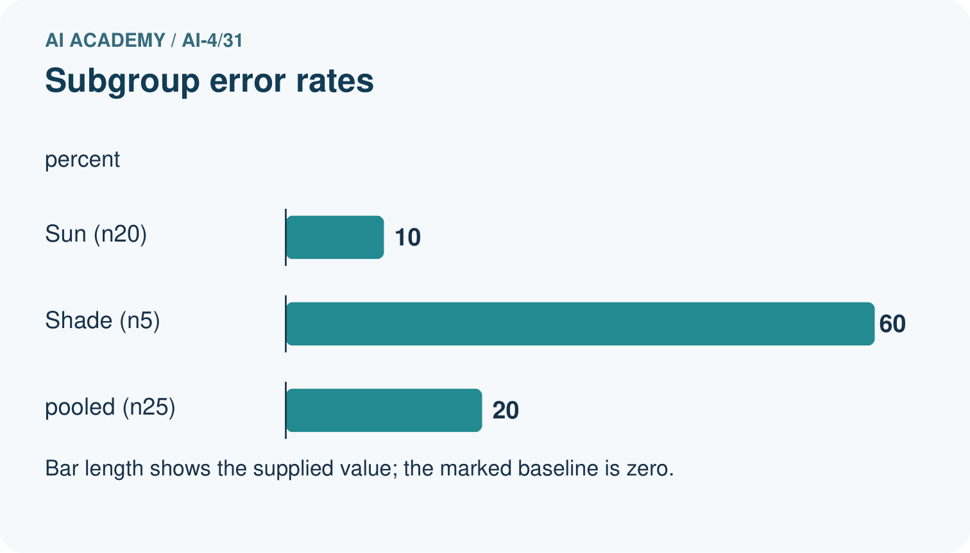
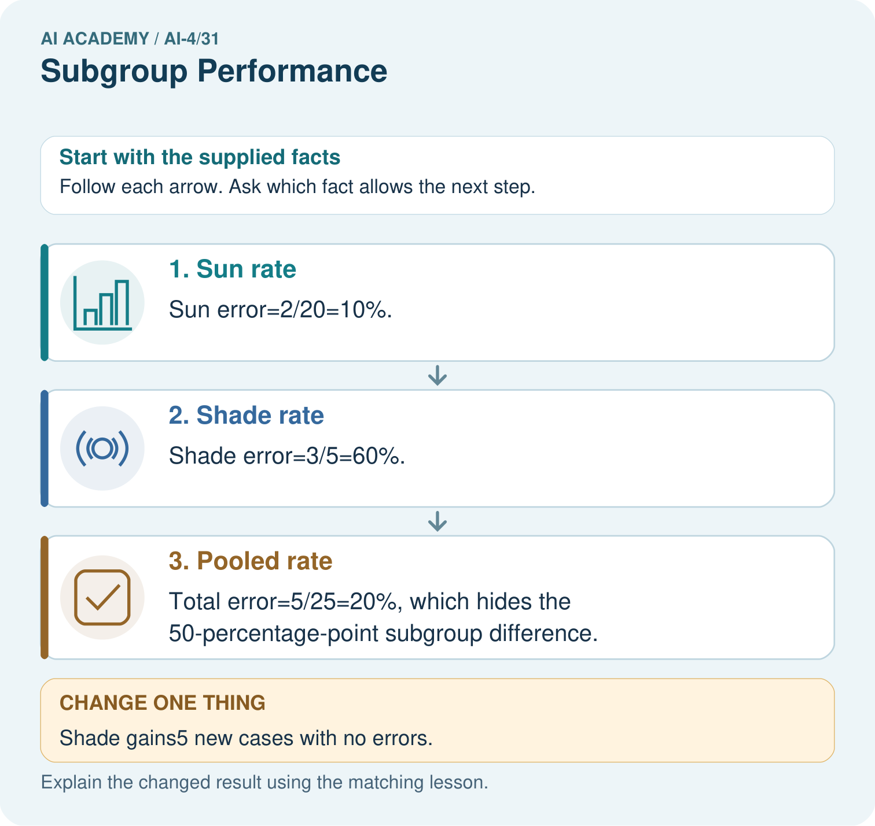

Read the picture one step at a time
Step | What happens and why
1. Sun rate | Sun error=2/20=10%.
2. Shade rate | Shade error=3/5=60%.
3. Pooled rate | Total error=5/25=20%, which hides the 50-percentage-point subgroup difference.
Match each pictured step to the supplied facts. This is a worked teaching case, not an independent assessment.

Why this result follows
Read the picture in order. Total error=5/25=20%, which hides the 50-percentage-point subgroup difference. The arrows show which recorded input or intermediate result each decision uses. Explain the deciding step aloud before checking the changed case; pointing to the final answer alone does not show how it follows.

What this example does not establish
Small subgroup samples have high variability. An observed gap does not by itself establish discrimination or a causal explanation.

Change one thing in the pictured case
Change: Shade gains5 new cases with no errors.
Prediction: Shade error becomes3/10=30%; pooled error becomes5/30≈16.7%.
Reason: Extra evaluated cases change denominators; existing errors have not disappeared.

Ask while showing the picture
Cover the result. Ask learners to name the inputs and predict the next step. Uncover one step, connect the icon to the actual procedure, and explain its evidence. Then change the supplied condition and compare. The picture is a representation; it does not document execution of a real AI model.

03. Demonstrate and guide practice

Demonstrate and guide practice

Board sequence
Write the given facts: A has18/20 correct; B has6/10.
Write the question to explain: Compute subgroup results and evidence limits.
Reveal after predictions: 90% versus60%, gap30 percentage points. Report denominators and investigate collection/label differences without assuming an inherent group cause.
Keep for an independent attempt: Accuracy is 18/20 in bright light and 6/10 in dim light. Compute both rates and the percentage-point gap.

Classroom dialogue
Ask: Which facts are given, and which would we have to assume? Learners mark relevant details before discussing answers.
Say: Predict first. Show the rule, information path or calculation that would produce the result. A correct guess is not yet an explanation.
Reveal reasoning one step at a time. Explain why a tempting alternative fails. Write units and denominators for arithmetic, trace conditions for decisions, and identify supporting sources for claims.
In pairs, one learner solves while the other checks evidence; exchange roles. Remove the worked answer before independent assessment.

Model these guided questions
Guided response: B becomes 2/5=40 percent, a 20-percentage-point change from one case. Exit response: Error types, consequences, access, labels and context can differ; a single equality does not establish acceptable treatment.

Case-specific teaching sequence
Stage | Teacher action
Session 1 start to 7 minutes | Use the prerequisite question: What can a pooled error rate hide? Check the explanation before proceeding.
7 to 18 minutes | Read the opening and model the worked evidence. Ask students to identify subgroup in context.
18 to 32 minutes | Complete W 1 and W 2 with support: calculate group rates; check sensitivity. Require the evidence, not only the final response.
32 to 45 minutes | Read the visual row by row. Collect the guided explanation and compare reasoning in pairs. Connect each conclusion to the stated evidence.
Session 2 start to 8 minutes | Retrieve the distinction between subgroup and disaggregation. Invite a counterexample to an overconfident claim.
8 to 20 minutes | Discuss the application and complete W 3: Group C has no evaluated cases. What is its measured error rate?
20 to 35 minutes | Collect W4 independently before giving hints. Assess these outcomes: Calculate subgroup results with sample sizes; Distinguish missing evidence from equal performance. Record any support used.
35 to 45 minutes | Use W 5 and the exit response to assess limits. Give targeted feedback, then the fresh retry. Save evidence of independent understanding.

Reduce help deliberately
Completion task: How does correcting one B error affect its rate?
Teacher check: Teacher explanation: B becomes 2/5=40 percent, a 20-percentage-point change from one case.
Start by identifying the given inputs together. Leave the intermediate steps blank. If needed, model one step, then withdraw that help on the next step. Move to a full trace only when the partial trace is understood. For partners, alternate explainer and checker; collect a response from every learner before discussion.

Individual reasoning check
Use the worked case for Subgroup evaluation. Proposed explanation: “A final answer is enough”. Decide whether this explanation is supported. Point to the step or supplied fact that decides; explain your repair if needed.
Expected correction: Ask for the relevant counts, units, procedure or saved record. For this week: A 2/20=10 percent; B 3/5=60 percent; pooled 5/25=20 percent, a 50-point group gap.
Collect explanations, not only yes/no votes. If a misunderstanding is common, re-model the relevant step for the class. If it affects a few learners, give a short targeted group explanation while others solve a more demanding variation.

Pictorial practice question
Why should the report retain subgroup rates alongside the total? Point to the relevant step in the picture, then write the changed result and the rule or evidence that supports it.

Reasoned teacher answer
The20% original total is dominated by Sun’s larger sample and understates the observed Shade difficulty. Include counts, conditions and uncertainty. Changed-case check: Shade error becomes3/10=30%; pooled error becomes5/30≈16.7%. Extra evaluated cases change denominators; existing errors have not disappeared.
Changed-case reasoning: Shade error becomes3/10=30%; pooled error becomes5/30≈16.7%. Extra evaluated cases change denominators; existing errors have not disappeared.
Collect each learner’s explanation before discussion. Use the first missing connection between input, deciding step and result to choose support. This question is worked-case practice, not fresh mastery evidence.

04. Run the weekly evidence lab

Run the weekly evidence lab
Keep the test conditions fixed, record every result, and change only one planned factor.
1. Write the hypothesis and expected evidence before running.
2. Slice Audit: compute metrics and denominators for lighting, species, and camera; flag small samples and prioritize one gap.
3. Run one normal, one boundary, one missing, and one shifted case.
4. Calculate the metric from raw counts or row-level errors.
5. Interpret what changed, what did not, and what remains unsafe or unknown.

Make the lab runnable
Use the concrete case as the shared normal case and the independent question as a second case. Each pair creates a boundary or missing-information case and predicts its result before testing. Keep the expected result separate from an observed mistake.
Record | What to capture
Input or evidence | Exact data, instruction or claim
Expected result | Answer or safe fallback declared before the run
Observed result | Actual result, including errors
Explanation | Rule, calculation or evidence explaining the outcome
Next test | One justified change and a new prediction

Diagnose and reteach
MISCONCEPTION TO REPAIR A good overall result guarantees acceptable performance for every subgroup.
For guessing, return to given facts and request a trace. For vocabulary without application, use one example and one non-example. For arithmetic errors, check the setup before the calculation. Finish with a different uncoached case before recording mastery.

Address these additional misconceptions
A final answer is enough: Ask for the relevant counts, units, procedure or saved record. For this week: A 2/20=10 percent; B 3/5=60 percent; pooled 5/25=20 percent, a 50-point group gap.
A stronger claim makes a stronger project: Error types, consequences, access, labels and context can differ; a single equality does not establish acceptable treatment.
The new case can be copied from the example: The independent task changes the evidence. Require a fresh explanation: X 10 percent; Y 50 percent; pooled 3/14 about 21.4 percent. Y has only four examples, and the table does not establish a cause.

Match the support to the first error
What the response shows | Next teaching action
Missing or misread facts | Read the case aloud, mark supplied versus unknown facts, and let the learner restate it.
Wrong procedure | Return to the deciding step in the worked case. Contrast it with the proposed incorrect explanation.
Arithmetic or implementation error | Trace intermediate values or lines; preserve the first mismatch and retry that step.
Correct result without a reason | Ask for a trace and a changed case before marking independent understanding.
An unsupported wider claim | Ask which supplied evidence supports the claim and which further observation would be needed.
Offer an oral explanation, drawing, enlarged visual or fewer examples when that removes a reading/writing barrier. Keep the same reasoning goal. Stretch secure learners by changing a boundary or assumption and asking them to defend the effect, not simply by assigning more of the same questions.

05. Assess and explain the answers

Assess and explain the answers

Worked case answer
90% versus60%, gap30 percentage points. Report denominators and investigate collection/label differences without assuming an inherent group cause.

Independent question
Accuracy is 18/20 in bright light and 6/10 in dim light. Compute both rates and the percentage-point gap.

Expected independent answer
Bright: 90%; dim: 60%; gap: 30 percentage points. Report denominators and uncertainty from small samples before making broad claims.

What counts as evidence
Criterion | 0 points | 1 point | 2 points
Result | Incorrect or absent | Partly correct | Correct with necessary conditions
Reasoning | No supporting trace | Some steps | Clear mechanism, calculation or source support
Limit | Overclaims certainty | Vague limitation | Relevant uncertainty or missing fact
Transfer | Copies without adapting | Adapts with prompts | Solves a changed case independently
Use 6/8 as a classroom checkpoint, with 2 required for both Result and Reasoning. This is a proposed teaching rule, not a validated certification threshold. Do not count a coached answer as independent mastery; correct unsafe or unsupported claims regardless of total.

Feedback
Ask the learner to find the evidence that challenges this claim: “The difference is 30 percent of all examples rather than 30 percentage points between rates.” Keep the first attempt and an uncoached retry separate.

Original transfer answer
Overall=24/30=80%; A=90%, B=60%, gap=30 percentage points. These data do not prove the device itself causes the difference; lighting, leaf mix or labels may differ. Investigate with comparable cases and preserve small-sample uncertainty.

Explanations for the additional workbook examples

W1 Calculate group rates
Calculate the worked group and pooled rates.
Teacher explanation: A 2/20=10 percent; B 3/5=60 percent; pooled 5/25=20 percent, a 50-point group gap.

W2 Check sensitivity
How does correcting one B error affect its rate?
Teacher explanation: B becomes 2/5=40 percent, a 20-percentage-point change from one case.

W3 Report missing coverage
Group C has no evaluated cases. What is its measured error rate?
Teacher explanation: Unavailable because the denominator is zero; report missing coverage and do not substitute zero.

W4 Apply independently
Groups X 1 error/10 and Y 2/4: calculate separate and pooled rates, then state one limit.
Teacher explanation: X 10 percent; Y 50 percent; pooled 3/14 about 21.4 percent. Y has only four examples, and the table does not establish a cause.

W5 Avoid a fairness shortcut
Why does equal accuracy not settle whether use is fair?
Teacher explanation: Error types, consequences, access, labels and context can differ; a single equality does not establish acceptable treatment.

Assess independent transfer
Selected case: Groups X 1 error/10 and Y 2/4: calculate separate and pooled rates, then state one limit.

Selected case answer
Teacher explanation: X 10 percent; Y 50 percent; pooled 3/14 about 21.4 percent. Y has only four examples, and the table does not establish a cause.
Dimension | Evidence required
Explanation | Names the applicable idea or procedure and ties it to the supplied facts.
Trace and result | Preserves the given inputs and shows the relevant intermediate steps; distinguishes a prediction from an observed execution.
Limits | States the assumptions, missing evidence or conditions under which the result would change.
Record each dimension as not yet, with support, or independent. Accept a valid alternative procedure with a defensible trace. Do not penalise an honestly recorded model failure if the learner correctly explains its evidence and limits.

Feedback that the learner uses
Name the earliest unsupported step and give one action to repair it. Have the learner make that repair now and explain why. Then assess the relevant skill on a fresh, fully specified case. Confirm it was not previously practised with feedback; solve and check the new case before assigning it. A follow-up design prompt is a starting brief, not automatically an equivalent test.

06. Connect and extend learning

Connect and extend learning

Responsible Plant Classifier
Add subgroup tables and a minimum acceptable threshold to the Plant Classifier release criteria.
Keep the decision, input, result, explanation and remaining limitation in the project evidence record. Retrieve this record next week rather than restarting the project.

Support and stretch
Use a tiny labelled dataset, explicit units and a named positive class. Stretch: require a baseline, held-out evaluation and subgroup or shifted-condition analysis with denominators.

Exit reflection
Ask for one decision the learner can now justify and one situation requiring more evidence or human review. Confidence ratings are separate from correct independent performance.

Bridge to the next week
Next: Week 32: Proxy Features and Fairness. Retrieve today’s evidence and identify what carries forward and what is new.

Support and fresh reassessment
Provide a blank evidence table and allow a verbal explanation before writing. Highlight the given conditions without supplying the W 4 conclusion. Use subgroup and disaggregation in full sentences. Extension: alter one condition in the worked example and explain which conclusion changes and which remains supported.
For independent W 4, require: X 10 percent; Y 50 percent; pooled 3/14 about 21.4 percent. Y has only four examples, and the table does not establish a cause. Fresh retry X 2/8 and Y 1/2:25 and 50 percent, pooled 3/10=30 percent. Require denominators, the small Y sample and no causal inference. Mark each criterion as independent, supported or not yet demonstrated. Reassess the reasoning after feedback; do not replace the first attempt silently.
Next week: Proxy features and fairness. Carry forward the saved evidence and the distinction between development choices and justified claims.

Plan the delayed return
Suggested return points in this level: ai-4/32, ai-4/34. Use actual classroom dates, adjusting for holidays and gaps. One, three and six teaching weeks are scheduling choices, not a claimed optimal spacing.
At a delayed check, ask for the idea from memory and a changed application. Compare with the earlier independent response and record support used. For a new level, revisit the previous capstone before checking the new prerequisites.
Record | Teacher evidence
Learner code and date
Concept and case used; prior exposure
Explanation / trace / limits
Support and first repair
Changed case and delayed outcome
Next teaching action
Use the evidence to choose reteaching or the next step. A completed page, confidence rating or attractive project does not by itself demonstrate understanding.

Project evidence from this case
For your Responsible Plant Classifier, save the input, procedure, observed result and limitation of this check. Label this worked example as practice; use a different, previously unreviewed case when checking independent understanding.

07. Prepare, teach and assess
Teaching target: Calculate subgroup results with sample sizes
Prepare the labelled worked-case picture, the matching workbook, fictional input cards and a place for individual responses. Check a local Python 3 environment before class; have a paper-trace version ready.
Session | Plan | Resources
Session 1 · Understand · 45 min | 0–7: recall and prerequisite; 7–15: inspect the concrete case and predict; 15–30: teacher models the worked trace; 30–40: learners explain a step using the text and visual; 40–45: check the core idea. | Sections 1–6; record the brief recall in the workbook.
Session 2 · Practise · 45 min | 0–5: retrieve the procedure; 5–15: W2 completion practice; 15–23: explain and check with a partner; 23–30: each learner answers the misconception check; 30–40: targeted reteaching or a harder variation; 40–45: prepare the investigation. | Sections 7–10; use the matching workbook W2 and misconception check.
Session 3 · Investigate and transfer · 45 min | 0–5: retrieve the decision rule; 5–20: investigate or trace; 20–30: start the independent case; 30–38: connect the project; 38–43: act on feedback; 43–45: plan the return check. | Sections 9 and 11–14. Give extra time to finish the full task set; use Section 15 when the week includes a coding lab.
Before class, solve the supported practice: How does correcting one B error affect its rate?
Reasoned practice answer: Teacher explanation: B becomes 2/5=40 percent, a 20-percentage-point change from one case.
Check every learner before discussion: Use the worked case for Subgroup evaluation. Proposed explanation: “A final answer is enough”. Decide whether this explanation is supported. Point to the step or supplied fact that decides; explain your repair if needed.
Misconception repair: Ask for the relevant counts, units, procedure or saved record. For this week: A 2/20=10 percent; B 3/5=60 percent; pooled 5/25=20 percent, a 50-point group gap.
Support: read the exact case aloud, enlarge the labelled picture, supply input cards and model only the first deciding step. Accept a spoken explanation or drawing; retain the reasoning goal.
Extension: Shade gains5 new cases with no errors. Require a prediction and a reason before comparing. Expected result: Shade error becomes3/10=30%; pooled error becomes5/30≈16.7%. Reason: Extra evaluated cases change denominators; existing errors have not disappeared.
Independent assessment: withhold the reserved answer until the learner has attempted the new case. Record support separately from correctness.
Criterion | Not yet | With support | Independent
Explanation | Names an answer without a deciding fact | Uses a hint to link fact and decision | Explains the deciding fact in own words
Trace or test | Cannot connect input and result | Completes steps with prompts | Traces or tests a changed case accurately
Limits and revision | Claims more than evidence supports | Names a limit after a prompt | States a defensible limit and useful next test
Project checkpoint: Present and defend. Demonstrate the system, explain one failure and justify the next improvement with evidence.
Use the weekly teacher answer for topic-specific reasoning. A saved progress tick is an activity record; judge mastery from the learner’s explanation and evidence.

08. Use feedback, labs and repair paths
Use the two formative questions as supported practice, not as independent mastery scores. Discuss the deciding evidence rather than accepting a guessed selection.
The feedback comes from the reviewed public worked case. Do not reveal the separately reserved independent teacher answer until the learner has attempted that case.
Ask students to predict before running code. Preserve errors and actual outputs; collect a changed test and an explanation. The branch-boundary and indexing lessons deliberately include failure cases.
Use the earlier worked-explanation links to address a specific missing building block, then return to the current question. Adapt this suggestion after observing the learner; it is not an automatic diagnosis.
Collect the completed-work portfolio as evidence. Record support separately from correctness, and assess explanation, trace/test and limitations. Progress ticks and quiz selections alone do not establish mastery.

