AI ACADEMY · TEACHER · ai-5/11

Updating parameters
Project: Image-pattern Network Investigation

01. Prepare the purpose, prerequisites and materials

Teach the learning cycle
Primary target: Apply a learning rate to an ordered gradient
Session | Sequence and minutes | Resources
Session 1 · Understand · 45 min | 0–7: recall and prerequisite; 7–15: inspect the concrete case and predict; 15–30: teacher models the worked trace; 30–40: learners explain a step using the text and visual; 40–45: check the core idea. | Sections 1–6; record the brief recall in the workbook.
Session 2 · Practise · 45 min | 0–5: retrieve the procedure; 5–15: W2 completion practice; 15–23: explain and check with a partner; 23–30: each learner answers the misconception check; 30–40: targeted reteaching or a harder variation; 40–45: prepare the investigation. | Sections 7–10; use the matching workbook W2 and misconception check.
Session 3 · Investigate and transfer · 45 min | 0–5: retrieve the decision rule; 5–20: investigate or trace; 20–30: start the independent case; 30–38: connect the project; 38–43: act on feedback; 43–45: plan the return check. | Sections 9 and 11–14. Give extra time to finish the full task set; use Section 15 when the week includes a coding lab.
This is a starting allocation of 135 minutes, not a validated duration. Preserve all named topics. Schedule extra time for connected examples, the full investigation, independent cases and project building. Repeated copies of a case share one recorded attempt; they are not new evidence.

Retrieval answer guidance

Gradients with a numerical check
Without opening the old lesson, explain one key idea from Gradients with a numerical check. Give an example and a mistake that the idea helps you avoid.
Look for: Estimate one partial derivative while other parameters stay fixed
Reference example, not the only acceptable wording: Teacher explanation: Prediction 3, residual 0, loss 0, gradient [0, 0].

Loss functions
Without opening the old lesson, explain one key idea from Loss functions. Give an example and a mistake that the idea helps you avoid.
Look for: Calculate per-example squared error and mean squared error
Reference example, not the only acceptable wording: Teacher explanation: Residuals are -1 and 2, squares 1 and 4, MSE 2.5.

Composing layers
Without opening the old lesson, explain one key idea from Composing layers. Give an example and a mistake that the idea helps you avoid.
Look for: Trace how one layer supplies the next layer inputs
Reference example, not the only acceptable wording: Teacher explanation: Scores are -2 and 2; activations are 0 and 2; y = 0 - 2 + 1 = -1.
Use two 45-minute sessions and keep old and new parameter boxes separate. This lesson checks one update, not a full optimiser. Treat the mixed-state procedure as different from the stated algorithm, rather than claiming all sequential methods are invalid.

Outcomes
Apply a learning rate to an ordered gradient
Update all parameters from the same saved state
Verify the new loss and identify overshooting

Preparation
Printed lesson and workbook; paper and pencil
Calculator and optional local Python 3 editor; no packages or AI accounts needed
Use the fictional examples supplied; prepare the fresh retry before class

Prerequisite answer
The residual is -1 and the gradient is [-4, -2].

End goal for the pictorial case
By the end, I can explain updating parameters using a traced example and a stated limitation.
This added worked case illustrates the week’s main idea. Retain all original and connected topics; schedule its practice within the teaching cycle.

02. Explain and model the mechanism
Gradient descent uses new parameter = old parameter - learning rate times its gradient entry. The minus sign chooses the locally downhill direction for a positive learning rate. A negative gradient therefore increases the corresponding parameter.
Keep the Week 10 example: x = 2, target 3, y = 2w + b and L = (y - 3) squared. At [w, b] = [1, 0], the loss is 1 and gradient is [-4, -2]. With learning rate 0.1, new w = 1 - 0.1 times -4 = 1.4 and new b = 0 - 0.1 times -2 = 0.2.
This particular step reaches zero loss on one example. It does not establish a unique parameter solution, successful learning on other examples or a generally ideal learning rate.
Predict the rows: unchanged parameters and loss 1 at rate 0; [1.2, 0.1] and loss 0.25 at rate 0.05; [1.4, 0.2] and loss 0 at rate 0.1; [2.2, 0.6] and loss 4 at rate 0.3. The helper performs one step on this fixed example; it assumes numeric inputs and does not choose a learning rate for you.
Term | Meaning
Learning rate | A multiplier that controls the size of a gradient update
Gradient descent | Updating parameters in the direction opposite the gradient
Simultaneous update | Computing all new parameter values from the same old state
Overshoot | A step that moves too far and can increase the objective

Use one gradient for one parameter snapshot
Stage | Saved values | Action
Before the step | w is 1 and b is 0 | Compute gradient [-4, -2]
Apply rate 0.1 | Use both old parameters | Produce [1.4, 0.2]
After the step | Use both new parameters | Recompute loss 0
Read top to bottom. All gradient entries come from the same old model. The final row evaluates the fully updated model rather than mixing old and new coordinates.
Guided: [1.2, 0.1] gives prediction 2.5, residual -0.5 and loss 0.25. Exit: no. The mixed-state procedure lowers this loss but does not implement the specified simultaneous gradient step; compare states and gradients, not just whether loss decreased.

Model the reasoning aloud
Use the complete worked example below before asking learners to complete W2. Reveal a small part, invite a prediction, then explain the deciding step. These teacher notes contain solutions; do not reveal the independent case answer during modelling.

Use one gradient for one parameter snapshot
Stage | Saved values | Action
Before the step | w is 1 and b is 0 | Compute gradient [-4, -2]
Apply rate 0.1 | Use both old parameters | Produce [1.4, 0.2]
After the step | Use both new parameters | Recompute loss 0
Read top to bottom. All gradient entries come from the same old model. The final row evaluates the fully updated model rather than mixing old and new coordinates.

Starting again from [1, 0], use learning rate 0.05. Show both new parameters, the new prediction and the new loss.
________________________________________________________________
________________________________________________________________
________________________________________________________________
________________________________________________________________
Thinking move | Teacher prompt
Plan | What is given? What is the question? Which procedure fits these facts?
Do | Point to each input and intermediate step in the worked trace. Name the rule that allows the next step.
Check | Does the output answer the question? Which assumption or limitation prevents a larger claim?
Use the diagram and verbal explanation together. Ask learners to match a sentence to a specific visual step; do not assign learners fixed visual or auditory learning styles.

A pictorial worked case: Updating parameters
Use one explicit gradient update and then recompute the loss.

The facts we will use
Model y=2w+b, target 5. Start w=1, b=1; learning rate 0.05. Initial y=3, error y−target=−2, squared loss 4.
All inputs and outcomes in this worked example are invented classroom data; no real model run is claimed.
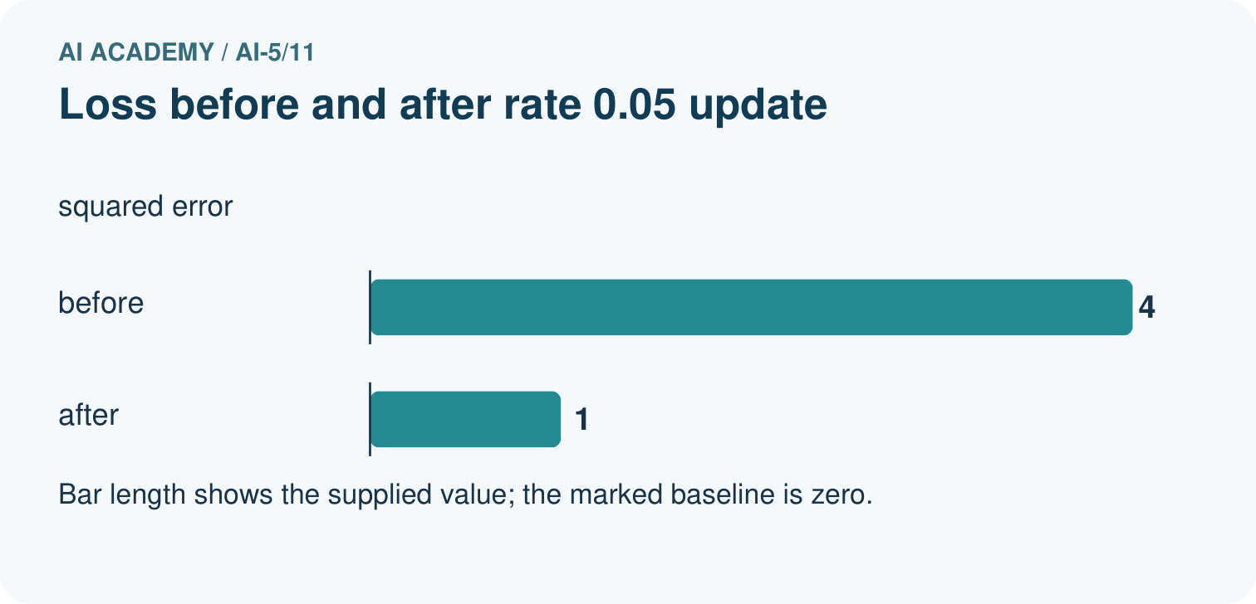
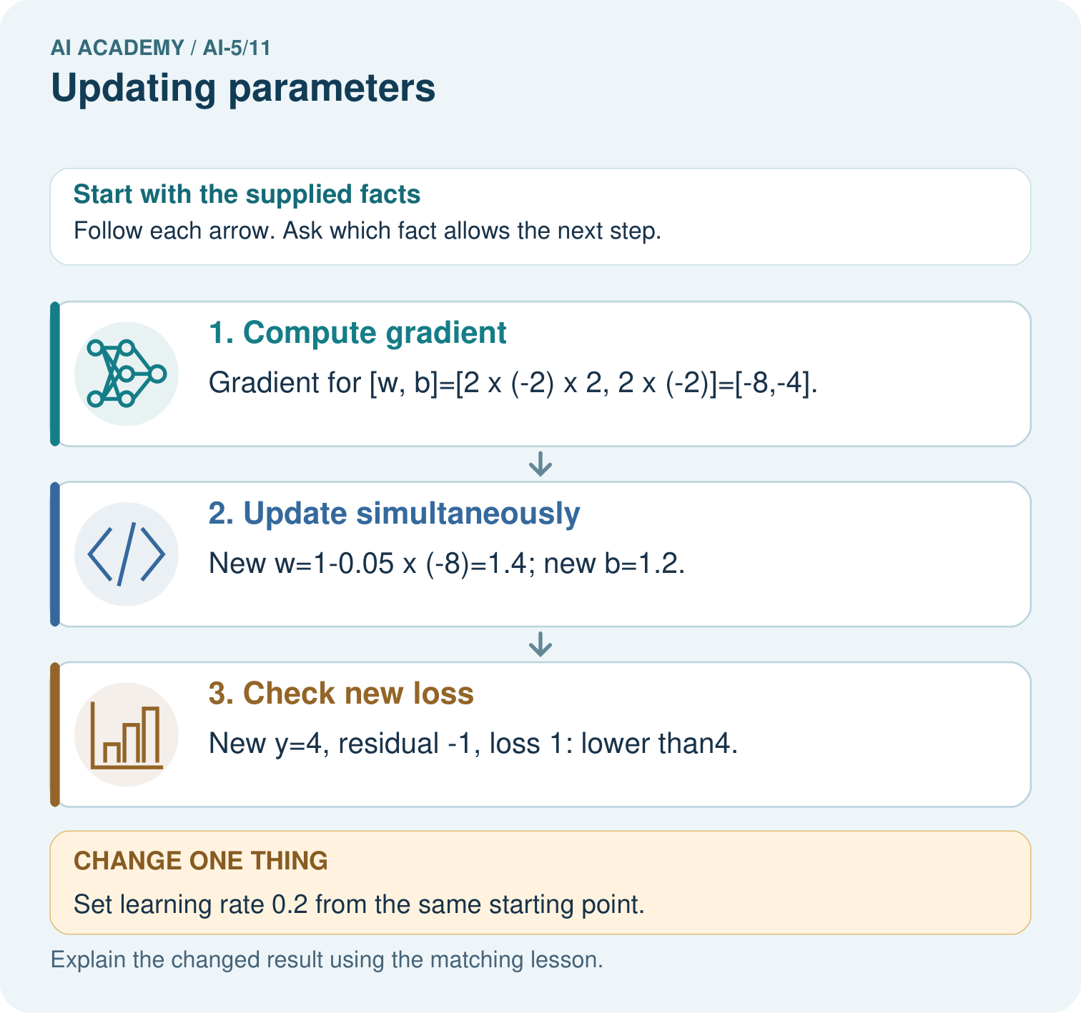

Read the picture one step at a time
Step | What happens and why
1. Compute gradient | Gradient for [w, b]=[2×(-2)×2, 2×(-2)]=[-8,-4].
2. Update simultaneously | New w=1-0.05×(-8)=1.4; new b=1.2.
3. Check new loss | New y=4, residual -1, loss 1: lower than4.
Match each pictured step to the supplied facts. This is a worked teaching case, not an independent assessment.

Why this result follows
Gradient descent subtracts learning rate times gradient. A negative gradient makes this subtraction increase the parameter. Compute both gradients at the original [w,b] before updating either one. The small step brings the prediction closer to five, reducing squared error. A larger step can cross the target and undo that gain, so the new prediction and loss must be recalculated.

What this example does not establish
One successful toy update is not evidence of convergence for a real network or generalisation to unseen data.

Change one thing in the pictured case
Change: Set learning rate 0.2 from the same starting point.
Prediction: New w=2.6, b=1.8, y=7, squared loss 4: no improvement.
Reason: The larger update jumps to an equally distant point on the opposite side of the target.

Ask while showing the picture
Cover the result. Ask learners to name the inputs and predict the next step. Uncover one step, connect the icon to the actual procedure, and explain its evidence. Then change the supplied condition and compare. The picture is a representation; it does not document execution of a real AI model.

03. Demonstrate and guide practice
Time or stage | Teacher action
Session 1 start to 7 minutes | Retrieve the Week 10 gradient and write the update rule with parentheses around negative entries.
7 to 18 minutes | Calculate the rate 0.1 worked step and recompute the loss from the new parameters.
18 to 32 minutes | Complete W1 and the guided rate 0.05 calculation.
32 to 45 minutes | Run or trace all four code rows and complete W2.
Session 2 start to 8 minutes | Rebuild the old-state snapshot and compare it with the mixed-state example.
8 to 20 minutes | Complete W3 and discuss zero gradient with W5.
20 to 35 minutes | Collect W4 independently, including old loss, both new parameters and new loss.
35 to 45 minutes | Use the exit response and a fresh retry. Keep the model-quality claim separate from implementation correctness.
Use the worked example in Sections 3 and 6. Collect a prediction before revealing its result; ask the learner to point to each intermediate fact.
Use separate old, gradient and new columns. Extension: for the lesson example, show that the new residual is the old residual multiplied by (1 - 10 times rate). Explain why rates 0 and 0.2 preserve loss while 0.3 raises it for a nonzero residual.

Reduce help deliberately
Completion task: For the lesson start [1, 0], apply rate 0.3 and calculate prediction and loss.
Teacher check: Teacher explanation: Gradient [-4, -2] gives [2.2, 0.6], prediction 5 and loss 4, larger than the starting loss 1.
Start by identifying the given inputs together. Leave the intermediate steps blank. If needed, model one step, then withdraw that help on the next step. Move to a full trace only when the partial trace is understood. For partners, alternate explainer and checker; collect a response from every learner before discussion.

Individual reasoning check
Use the worked case for Updating parameters. Proposed explanation: “Subtracting a negative gradient decreases the parameter”. Decide whether this explanation is supported. Point to the step or supplied fact that decides; explain your repair if needed.
Expected correction: Subtracting a negative adds a positive amount; show the signed calculation.
Collect explanations, not only yes/no votes. If a misunderstanding is common, re-model the relevant step for the class. If it affects a few learners, give a short targeted group explanation while others solve a more demanding variation.

Pictorial practice question
Why must new loss be recomputed rather than assumed smaller? Point to the relevant step in the picture, then write the changed result and the rule or evidence that supports it.

Reasoned teacher answer
A gradient supplies a local direction, but step size can overshoot. Rate0.2 gives the same loss 4 despite using the correct gradient. Changed-case check: New w = 2.6, b=1.8, y = 7, loss 4: no improvement. The larger update jumps to an equally distant point on the opposite side of the target.
Changed-case reasoning: New w=2.6, b=1.8, y=7, squared loss 4: no improvement. The larger update jumps to an equally distant point on the opposite side of the target.
Collect each learner’s explanation before discussion. Use the first missing connection between input, deciding step and result to choose support. This question is worked-case practice, not fresh mastery evidence.

04. Run the investigation and diagnose misconceptions
Subtracting a negative gradient decreases the parameter: Subtracting a negative adds a positive amount; show the signed calculation.
A downhill direction allows any rate: A finite step can overshoot and increase loss.
Recompute each gradient after its assignment: For this algorithm, all entries are computed at the same saved state.
Use Section 9 for the evidence ledger. Add a boundary or missing-input case and record the expected response before checking. More successful repeats of one case do not establish wider coverage.

Match the support to the first error
What the response shows | Next teaching action
Missing or misread facts | Read the case aloud, mark supplied versus unknown facts, and let the learner restate it.
Wrong procedure | Return to the deciding step in the worked case. Contrast it with the proposed incorrect explanation.
Arithmetic or implementation error | Trace intermediate values or lines; preserve the first mismatch and retry that step.
Correct result without a reason | Ask for a trace and a changed case before marking independent understanding.
An unsupported wider claim | Ask which supplied evidence supports the claim and which further observation would be needed.
Offer an oral explanation, drawing, enlarged visual or fewer examples when that removes a reading/writing barrier. Keep the same reasoning goal. Stretch secure learners by changing a boundary or assumption and asking them to defend the effect, not simply by assigning more of the same questions.

05. Assess and explain the answers

Guided and exit questions
Guided: [1.2, 0.1] gives prediction 2.5, residual -0.5 and loss 0.25. Exit: no. The mixed-state procedure lowers this loss but does not implement the specified simultaneous gradient step; compare states and gradients, not just whether loss decreased.

W1 Apply a negative gradient
Starting with parameter a = 2, gradient -3 and learning rate 0.2, calculate the new a.
Teacher explanation: New a = 2 - 0.2 times -3 = 2.6.

W2 Detect overshooting
For the lesson start [1, 0], apply rate 0.3 and calculate prediction and loss.
Teacher explanation: Gradient [-4, -2] gives [2.2, 0.6], prediction 5 and loss 4, larger than the starting loss 1.

W3 Preserve one snapshot
Explain why recomputing the bias gradient after changing w is not the simultaneous update specified here.
Teacher explanation: The two gradient entries then belong to different parameter vectors. Save the full old gradient and use it for both assignments.

W4 Update a new model independently
Use x = 1, target 4, w = 1, b = 1, squared loss and learning rate 0.1. Compute prediction, residual, gradient [2 times residual times x, 2 times residual], new parameters and new loss.
Teacher explanation: Prediction 2, residual -2, gradient [-4, -4]. New parameters [1.4, 1.4] give prediction 2.8, residual -1.2 and loss 1.44, down from 4.

W5 Evaluate a zero gradient
At a point with gradient [0, 0], what does this update do? Does that alone prove a global minimum on any loss surface?
Teacher explanation: It leaves parameters unchanged for a finite learning rate. Zero gradient alone does not establish a global minimum; stationary points can have other meanings.

Independent assessment and fresh retry
W4 requires gradient [-4, -4], parameters [1.4, 1.4] and loss 1.44. Fresh retry: x = 1, target 1, w = 1, b = 1, rate 0.25 gives residual 1, gradient [2, 2], new parameters [0.5, 0.5] and loss 0. Require both updates to use the original residual.

Assess independent transfer
Selected case: Use x = 1, target 4, w = 1, b = 1, squared loss and learning rate 0.1. Compute prediction, residual, gradient [2 times residual times x, 2 times residual], new parameters and new loss.

Selected case answer
Teacher explanation: Prediction 2, residual -2, gradient [-4, -4]. New parameters [1.4, 1.4] give prediction 2.8, residual -1.2 and loss 1.44, down from 4.
Dimension | Evidence required
Explanation | Names the applicable idea or procedure and ties it to the supplied facts.
Trace and result | Preserves the given inputs and shows the relevant intermediate steps; distinguishes a prediction from an observed execution.
Limits | States the assumptions, missing evidence or conditions under which the result would change.
Record each dimension as not yet, with support, or independent. Accept a valid alternative procedure with a defensible trace. Do not penalise an honestly recorded model failure if the learner correctly explains its evidence and limits.

Feedback that the learner uses
Name the earliest unsupported step and give one action to repair it. Have the learner make that repair now and explain why. Then assess the relevant skill on a fresh, fully specified case. Confirm it was not previously practised with feedback; solve and check the new case before assigning it. A follow-up design prompt is a starting brief, not automatically an equivalent test.

06. Connect the project, support and next lesson
Add a labelled updating parameters evidence sheet to Image-pattern Network Investigation. Show how you can apply a learning rate to an ordered gradient. Use the supplied fictional case and keep its inputs, intermediate steps, calculation or prediction, and limitation. Connect this record to last week’s record; a matching answer without a trace is insufficient.
Use separate old, gradient and new columns. Extension: for the lesson example, show that the new residual is the old residual multiplied by (1 - 10 times rate). Explain why rates 0 and 0.2 preserve loss while 0.3 raises it for a nonzero residual.
Week 12 repeats the training cycle for a small network.
Retain the project ledger and assess a changed case after support. Check the relevant prerequisite before carrying this component forward.

Plan the delayed return
Suggested return points in this level: ai-5/12, ai-5/14, ai-5/17. Use actual classroom dates, adjusting for holidays and gaps. One, three and six teaching weeks are scheduling choices, not a claimed optimal spacing.
At a delayed check, ask for the idea from memory and a changed application. Compare with the earlier independent response and record support used. For a new level, revisit the previous capstone before checking the new prerequisites.
Record | Teacher evidence
Learner code and date
Concept and case used; prior exposure
Explanation / trace / limits
Support and first repair
Changed case and delayed outcome
Next teaching action
Use the evidence to choose reteaching or the next step. A completed page, confidence rating or attractive project does not by itself demonstrate understanding.

Project evidence from this case
For your Image-pattern Network Investigation, save the input, procedure, observed result and limitation of this check. Label this worked example as practice; use a different, previously unreviewed case when checking independent understanding.

07. Prepare, teach and assess
Teaching target: Apply a learning rate to an ordered gradient
Prepare the labelled worked-case picture, the matching workbook, fictional input cards and a place for individual responses. Check a local Python 3 environment before class; have a paper-trace version ready.
Session | Plan | Resources
Session 1 · Understand · 45 min | 0–7: recall and prerequisite; 7–15: inspect the concrete case and predict; 15–30: teacher models the worked trace; 30–40: learners explain a step using the text and visual; 40–45: check the core idea. | Sections 1–6; record the brief recall in the workbook.
Session 2 · Practise · 45 min | 0–5: retrieve the procedure; 5–15: W2 completion practice; 15–23: explain and check with a partner; 23–30: each learner answers the misconception check; 30–40: targeted reteaching or a harder variation; 40–45: prepare the investigation. | Sections 7–10; use the matching workbook W2 and misconception check.
Session 3 · Investigate and transfer · 45 min | 0–5: retrieve the decision rule; 5–20: investigate or trace; 20–30: start the independent case; 30–38: connect the project; 38–43: act on feedback; 43–45: plan the return check. | Sections 9 and 11–14. Give extra time to finish the full task set; use Section 15 when the week includes a coding lab.
Before class, solve the supported practice: For the lesson start [1, 0], apply rate 0.3 and calculate prediction and loss.
Reasoned practice answer: Teacher explanation: Gradient [-4, -2] gives [2.2, 0.6], prediction 5 and loss 4, larger than the starting loss 1.
Check every learner before discussion: Use the worked case for Updating parameters. Proposed explanation: “Subtracting a negative gradient decreases the parameter”. Decide whether this explanation is supported. Point to the step or supplied fact that decides; explain your repair if needed.
Misconception repair: Subtracting a negative adds a positive amount; show the signed calculation.
Support: read the exact case aloud, enlarge the labelled picture, supply input cards and model only the first deciding step. Accept a spoken explanation or drawing; retain the reasoning goal.
Extension: Set learning rate 0.2 from the same starting point. Require a prediction and a reason before comparing. Expected result: New w=2.6, b=1.8, y=7, squared loss 4: no improvement. Reason: The larger update jumps to an equally distant point on the opposite side of the target.
Independent assessment: withhold the reserved answer until the learner has attempted the new case. Record support separately from correctness.
Criterion | Not yet | With support | Independent
Explanation | Names an answer without a deciding fact | Uses a hint to link fact and decision | Explains the deciding fact in own words
Trace or test | Cannot connect input and result | Completes steps with prompts | Traces or tests a changed case accurately
Limits and revision | Claims more than evidence supports | Names a limit after a prompt | States a defensible limit and useful next test
Project checkpoint: Make a transparent first version. Keep a trace of how one input becomes an output; explain the rule or learned component.
Use the weekly teacher answer for topic-specific reasoning. A saved progress tick is an activity record; judge mastery from the learner’s explanation and evidence.

08. Use feedback, labs and repair paths
Use the two formative questions as supported practice, not as independent mastery scores. Discuss the deciding evidence rather than accepting a guessed selection.
The feedback comes from the reviewed public worked case. Do not reveal the separately reserved independent teacher answer until the learner has attempted that case.
Ask students to predict before running code. Preserve errors and actual outputs; collect a changed test and an explanation. The branch-boundary and indexing lessons deliberately include failure cases.
Use the earlier worked-explanation links to address a specific missing building block, then return to the current question. Adapt this suggestion after observing the learner; it is not an automatic diagnosis.
Collect the completed-work portfolio as evidence. Record support separately from correctness, and assess explanation, trace/test and limitations. Progress ticks and quiz selections alone do not establish mastery.

