AI ACADEMY · TEACHER · ai-5/27

Similarity and normalisation
Project: Image-pattern Network Investigation

01. Prepare the purpose, prerequisites and materials

Teach the learning cycle
Primary target: Calculate vector length and normalise a nonzero vector
Session | Sequence and minutes | Resources
Session 1 · Understand · 45 min | 0–7: recall and prerequisite; 7–15: inspect the concrete case and predict; 15–30: teacher models the worked trace; 30–40: learners explain a step using the text and visual; 40–45: check the core idea. | Sections 1–6; record the brief recall in the workbook.
Session 2 · Practise · 45 min | 0–5: retrieve the procedure; 5–15: W2 completion practice; 15–23: explain and check with a partner; 23–30: each learner answers the misconception check; 30–40: targeted reteaching or a harder variation; 40–45: prepare the investigation. | Sections 7–10; use the matching workbook W2 and misconception check.
Session 3 · Investigate and transfer · 45 min | 0–5: retrieve the decision rule; 5–20: investigate or trace; 20–30: start the independent case; 30–38: connect the project; 38–43: act on feedback; 43–45: plan the return check. | Sections 9 and 11–14. Give extra time to finish the full task set; use Section 15 when the week includes a coding lab.
This is a starting allocation of 135 minutes, not a validated duration. Preserve all named topics. Schedule extra time for connected examples, the full investigation, independent cases and project building. Repeated copies of a case share one recorded attempt; they are not new evidence.

Retrieval answer guidance

Embeddings and neighbourhoods
Without opening the old lesson, explain one key idea from Embeddings and neighbourhoods. Give an example and a mistake that the idea helps you avoid.
Look for: Look up a vector using a token ID and preserve sequence shape
Reference example, not the only acceptable wording: Teacher explanation: Vectors are [[1, 1], [0, 1], [0, 2], [0, 0]], mask [1, 1, 1, 0] and shape 4 by 2.

Augmentation and leakage
Without opening the old lesson, explain one key idea from Augmentation and leakage. Give an example and a mistake that the idea helps you avoid.
Look for: Check whether a transformation preserves the task label
Reference example, not the only acceptable wording: Teacher explanation: Original d = -2 and class 0. Row swapping leaves d = -2 and class 0. Column swapping gives rows [1, 0], [1, 0], d = 2 and class 1.

Convolution as a local operation
Without opening the old lesson, explain one key idea from Convolution as a local operation. Give an example and a mistake that the idea helps you avoid.
Look for: Compute a local weighted sum at each valid image position
Reference example, not the only acceptable wording: Teacher explanation: Window rows are [2, 0] and [1, 3]. Products are 2, 0, 0 and 3, giving output 5.
Use two 45-minute sessions. Supply calculators and connect vector length to the right-triangle calculation 3 squared plus 4 squared equals 5 squared. Students should justify a rule by the information it retains. The supplied vectors are constructed examples; no semantic or accuracy claim is established by their geometry.

Outcomes
Calculate vector length and normalise a nonzero vector
Compare squared distance with cosine similarity and explain a changed ranking
Handle zero vectors explicitly and justify what information a comparison keeps

Preparation
Printed lesson and workbook; paper and pencil
Calculator and optional local Python 3 editor; no packages or AI accounts needed
Use the fictional examples supplied; prepare the fresh retry before class

Prerequisite answer
The squared distance is (3 - 3) squared + (4 - 0) squared = 16. It describes closeness under this representation and rule; it does not prove equivalent meaning.

End goal for the pictorial case
By the end, I can explain similarity and normalisation using a traced example and a stated limitation.
This added worked case illustrates the week’s main idea. Retain all original and connected topics; schedule its practice within the teaching cycle.

02. Explain and model the mechanism
Last week, a neighbourhood depended on a chosen distance rule. This week, compare the same fictional vectors in two ways. Squared distance rewards nearby coordinates. Cosine similarity compares direction and ignores positive changes in length. Neither rule is automatically right for every task.
For Q, length = square root of (3 squared + 4 squared) = square root of 25 = 5. Divide both components by 5 to get its unit vector [0.6, 0.8]. Its length is one because 0.6 squared + 0.8 squared = 1. A becomes the same unit vector. C becomes [-0.6, -0.8], pointing in the opposite direction.
These supplied coordinates are for arithmetic practice. They are not learned language embeddings. Normalising each row keeps its direction but removes its original length unless that length is saved separately.
Multiply matching components and add to obtain the dot product. Cosine similarity equals dot(Q, candidate) divided by (length(Q) times length(candidate)). Higher cosine means a closer direction. For A, the dot product is 3 times 6 + 4 times 8 = 50, so cosine = 50 / (5 times 10) = 1. For B it is 9 / 15 = 0.6; for C it is -25 / 25 = -1.
Trace before running: A gives 1, B gives 0.6 and C gives -1. This classroom code assumes finite, moderate numeric inputs. It rejects empty, unequal-length and zero vectors. Keep full precision for decisions; rounding here is only for display. Cosine lies between -1 and 1 in exact arithmetic and is not a probability.
Term | Meaning
Vector length | The square root of the sum of squared components, also called the L2 norm
L2 normalisation | Dividing every component of a nonzero vector by its length
Cosine similarity | The dot product of two nonzero vectors divided by the product of their lengths
Unit vector | A vector with length one

Compare the same candidates using two rules
Candidate | Raw squared distance | Cosine similarity
A [6, 8] | 25 | 1
B [3, 0] | 16 | 0.6
C [-3, -4] | 100 | -1
For Q [3, 4], raw squared distance selects B by minimising the score. Cosine selects A by maximising the score. The candidates stayed the same; the comparison rule changed.
Guided: D has squared distance 9 + 1 = 10 and cosine 20 / 25 = 0.8. Raw distance prefers D over A (10 versus 25); cosine prefers A (1 versus 0.8). Exit: Q and A share direction but have different lengths and may represent different totals. Cosine 1 proves aligned nonzero vectors, not equivalent meaning. Check the task, retained information, zero and tie policies, and validation performance against a baseline; reserve final evaluation.

Model the reasoning aloud
Use the complete worked example below before asking learners to complete W2. Reveal a small part, invite a prediction, then explain the deciding step. These teacher notes contain solutions; do not reveal the independent case answer during modelling.

Compare the same candidates using two rules
Candidate | Raw squared distance | Cosine similarity
A [6, 8] | 25 | 1
B [3, 0] | 16 | 0.6
C [-3, -4] | 100 | -1
For Q [3, 4], raw squared distance selects B by minimising the score. Cosine selects A by maximising the score. The candidates stayed the same; the comparison rule changed.
After normalising both Q and every candidate, squared distances to A, B and C are 0, 0.8 and 4. For unit vectors, squared distance = 2 - 2 times cosine. Thus the smallest normalised distance and largest cosine produce the same ranking, including ties, in exact arithmetic.

Add candidate D [0, 5]. Calculate its raw squared distance and cosine from Q [3, 4]. Compare D with A under each rule.
________________________________________________________________
________________________________________________________________
________________________________________________________________
________________________________________________________________
Thinking move | Teacher prompt
Plan | What is given? What is the question? Which procedure fits these facts?
Do | Point to each input and intermediate step in the worked trace. Name the rule that allows the next step.
Check | Does the output answer the question? Which assumption or limitation prevents a larger claim?
Use the diagram and verbal explanation together. Ask learners to match a sentence to a specific visual step; do not assign learners fixed visual or auditory learning styles.

A pictorial worked case: Similarity and normalisation
Compare angular alignment with raw distance on the same vectors.

The facts we will use
Query [2, 0]; P=[8, 0]; Q=[2, 1]. Nonzero vectors only; compare squared Euclidean distance and cosine.
All inputs and outcomes in this worked example are invented classroom data; no real model run is claimed.
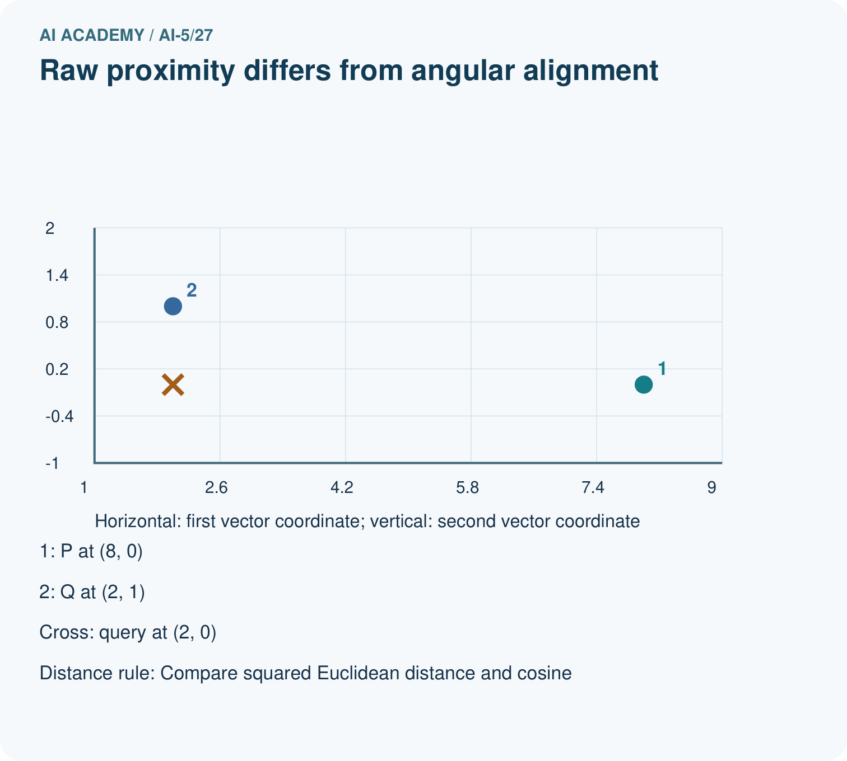
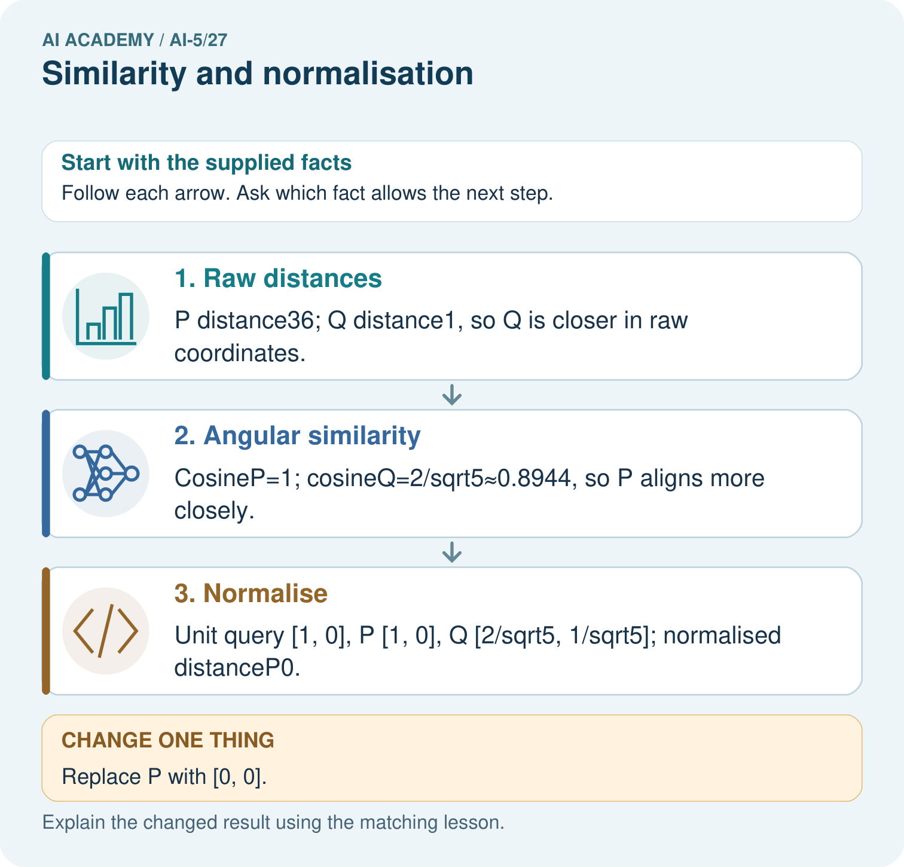

Read the picture one step at a time
Step | What happens and why
1. Raw distances | P distance36; Q distance1, so Q is closer in raw coordinates.
2. Angular similarity | CosineP=1; cosineQ=2/sqrt5≈0.8944, so P aligns more closely.
3. Normalise | Unit query [1, 0], P [1, 0], Q [2/sqrt5, 1/sqrt5]; normalised distanceP0.
Match each pictured step to the supplied facts. This is a worked teaching case, not an independent assessment.

Why this result follows
Raw Euclidean distance includes differences in both direction and magnitude. Cosine compares direction using the vector lengths, so a long vector can align perfectly while being far away in raw coordinates. Declare which question your similarity measure answers. A zero vector has no direction and cannot be divided by its norm for cosine or unit normalisation.

What this example does not establish
Neither metric is universally right; choose it from the task and handle zero vectors explicitly.

Change one thing in the pictured case
Change: Replace P with [0, 0].
Prediction: Cosine and unit normalisation for P are undefined.
Reason: The zero vector has norm0, so dividing by its norm is invalid.

Ask while showing the picture
Cover the result. Ask learners to name the inputs and predict the next step. Uncover one step, connect the icon to the actual procedure, and explain its evidence. Then change the supplied condition and compare. The picture is a representation; it does not document execution of a real AI model.

03. Demonstrate and guide practice
Time or stage | Teacher action
Session 1 start to 7 minutes | Retrieve squared distance and explain why a geometric score alone does not establish meaning.
7 to 18 minutes | Compute lengths and unit vectors. Complete W1 with both positive and opposite directions.
18 to 32 minutes | Trace the cosine formula and optional code, checking which score is maximised.
32 to 45 minutes | Use the diagram and W2 to contrast raw and normalised distance rankings.
Session 2 start to 8 minutes | Complete the guided D comparison, retaining the same query and candidate A.
8 to 20 minutes | Discuss event counts and zero vectors. Complete W3 and require an explicit no-comparison outcome.
20 to 35 minutes | Collect W4 independently, including raw scores, cosines, normalised distances and an explanation.
35 to 45 minutes | Complete W5 and the exit response. Give feedback before administering the fresh retry.
Use the worked example in Sections 3 and 6. Collect a prediction before revealing its result; ask the learner to point to each intermediate fact.
Provide a ledger for squared components, length, unit components and score. Allow a calculator and separate lower-is-better distance from higher-is-better similarity. Extension: expand the squared distance between two unit vectors to derive 2 - 2 times their dot product. For floating-point retrieval, declare a tolerance and retain all scores within it of the best; show that rounding first can create false ties.

Reduce help deliberately
Completion task: For query Q, write the raw squared distances and cosines to A, B and C from the lesson. Name the winner under each rule. Calculate squared distances after normalising both sides and check the relationship to cosine.
Teacher check: Teacher explanation: Raw squared distances are 25, 16, 100, so B wins. Cosines are 1, 0.6, -1, so A wins. Unit-vector squared distances are 0, 0.8, 4, matching 2 - 2 times each cosine and selecting A.
Start by identifying the given inputs together. Leave the intermediate steps blank. If needed, model one step, then withdraw that help on the next step. Move to a full trace only when the partial trace is understood. For partners, alternate explainer and checker; collect a response from every learner before discussion.

Individual reasoning check
Use the worked case for Similarity and normalisation. Proposed explanation: “Cosine is a probability”. Decide whether this explanation is supported. Point to the step or supplied fact that decides; explain your repair if needed.
Expected correction: Its possible negative values and geometric definition show that it is not a calibrated probability.
Collect explanations, not only yes/no votes. If a misunderstanding is common, re-model the relevant step for the class. If it affects a few learners, give a short targeted group explanation while others solve a more demanding variation.

Pictorial practice question
Why do the original two metrics select different winners? Point to the relevant step in the picture, then write the changed result and the rule or evidence that supports it.

Reasoned teacher answer
Raw distance includes length differences; cosine compares direction after accounting for norms. P shares direction but has a much larger magnitude. Changed-case check: Cosine and unit normalisation for P are undefined. The zero vector has norm0, so dividing by its norm is invalid.
Changed-case reasoning: Cosine and unit normalisation for P are undefined. The zero vector has norm0, so dividing by its norm is invalid.
Collect each learner’s explanation before discussion. Use the first missing connection between input, deciding step and result to choose support. This question is worked-case practice, not fresh mastery evidence.

04. Run the investigation and diagnose misconceptions
Cosine is a probability: Its possible negative values and geometric definition show that it is not a calibrated probability.
Normalisation keeps all information: Positive multiples collapse to the same unit vector; preserve length separately if the task needs it.
Any scaling leaves cosine unchanged: Positive scaling preserves direction. Multiplying only one vector by a negative number reverses the cosine sign; zero scaling makes it undefined.
Use Section 9 for the evidence ledger. Add a boundary or missing-input case and record the expected response before checking. More successful repeats of one case do not establish wider coverage.

Match the support to the first error
What the response shows | Next teaching action
Missing or misread facts | Read the case aloud, mark supplied versus unknown facts, and let the learner restate it.
Wrong procedure | Return to the deciding step in the worked case. Contrast it with the proposed incorrect explanation.
Arithmetic or implementation error | Trace intermediate values or lines; preserve the first mismatch and retry that step.
Correct result without a reason | Ask for a trace and a changed case before marking independent understanding.
An unsupported wider claim | Ask which supplied evidence supports the claim and which further observation would be needed.
Offer an oral explanation, drawing, enlarged visual or fewer examples when that removes a reading/writing barrier. Keep the same reasoning goal. Stretch secure learners by changing a boundary or assumption and asking them to defend the effect, not simply by assigning more of the same questions.

05. Assess and explain the answers

Guided and exit questions
Guided: D has squared distance 9 + 1 = 10 and cosine 20 / 25 = 0.8. Raw distance prefers D over A (10 versus 25); cosine prefers A (1 versus 0.8). Exit: Q and A share direction but have different lengths and may represent different totals. Cosine 1 proves aligned nonzero vectors, not equivalent meaning. Check the task, retained information, zero and tie policies, and validation performance against a baseline; reserve final evaluation.

W1 Trace the unit vectors
For Q [3, 4], A [6, 8] and C [-3, -4], give each length and unit vector. Explain one distinction that normalisation removes and one that it preserves.
Teacher explanation: Lengths are 5, 10 and 5. Unit vectors are [0.6, 0.8], [0.6, 0.8] and [-0.6, -0.8]. The length difference between Q and A disappears; the opposite direction of C is preserved.

W2 Compare the rankings
For query Q, write the raw squared distances and cosines to A, B and C from the lesson. Name the winner under each rule. Calculate squared distances after normalising both sides and check the relationship to cosine.
Teacher explanation: Raw squared distances are 25, 16, 100, so B wins. Cosines are 1, 0.6, -1, so A wins. Unit-vector squared distances are 0, 0.8, 4, matching 2 - 2 times each cosine and selecting A.

W3 Handle a vector without direction
A candidate set contains Z [0, 0] and B [3, 0]. With nonzero query Q, what happens under this lesson’s zero-vector policy? What if Q is zero, or Z is the only candidate? Explain why replacing an undefined cosine with zero is misleading.
Teacher explanation: Exclude Z and report it; compare B normally. Reject a zero query. If only Z exists, report no comparison. Zero cosine represents perpendicular nonzero directions, whereas the zero vector has no direction.

W4 Compare a new case independently
Use query [5, 0] and candidates P [10, 0], R [4, 3] and S [0, 5]. Calculate all raw squared distances and cosines, name each winner, and give squared distances after normalising both query and candidates. Explain the changed ranking.
Teacher explanation: Raw squared distances to P, R and S are 25, 10, 50, selecting R. Cosines are 1, 0.8, 0, selecting P. Normalised squared distances are 0, 0.4, 2. P shares the query direction despite its greater length; raw distance also reflects that length difference.

W5 Audit a proposed improvement
For event-count vectors [3, 4] and [6, 8], what useful information can normalisation remove? A team chooses cosine because it improves results on the final evaluation set, then calls that same set independent evidence. Explain how to repair the evaluation plan.
Teacher explanation: Normalisation removes magnitude: totals 7 and 14 become indistinguishable in the unit vectors. Choose the rule using task needs and training/validation evidence, preserving a baseline. A final set used to choose the rule is no longer independent final evidence; reserve new untouched evaluation data or explicitly report the limitation.

Independent assessment and fresh retry
W4 requires raw scores 25, 10, 50; cosines 1, 0.8, 0; normalised distances 0, 0.4, 2; and winners R then P. Fresh retry: query [0, 5], candidates D [0, 10], E [3, 4], F [5, 0]. Raw squared distances are 25, 10, 50; cosines 1, 0.8, 0; unit distances 0, 0.4, 2. Raw distance selects E; cosine selects D. Ask students to explain why a zero query is rejected.

Assess independent transfer
Selected case: Use query [5, 0] and candidates P [10, 0], R [4, 3] and S [0, 5]. Calculate all raw squared distances and cosines, name each winner, and give squared distances after normalising both query and candidates. Explain the changed ranking.

Selected case answer
Teacher explanation: Raw squared distances to P, R and S are 25, 10, 50, selecting R. Cosines are 1, 0.8, 0, selecting P. Normalised squared distances are 0, 0.4, 2. P shares the query direction despite its greater length; raw distance also reflects that length difference.
Dimension | Evidence required
Explanation | Names the applicable idea or procedure and ties it to the supplied facts.
Trace and result | Preserves the given inputs and shows the relevant intermediate steps; distinguishes a prediction from an observed execution.
Limits | States the assumptions, missing evidence or conditions under which the result would change.
Record each dimension as not yet, with support, or independent. Accept a valid alternative procedure with a defensible trace. Do not penalise an honestly recorded model failure if the learner correctly explains its evidence and limits.

Feedback that the learner uses
Name the earliest unsupported step and give one action to repair it. Have the learner make that repair now and explain why. Then assess the relevant skill on a fresh, fully specified case. Confirm it was not previously practised with feedback; solve and check the new case before assigning it. A follow-up design prompt is a starting brief, not automatically an equivalent test.

06. Connect the project, support and next lesson
Add a labelled similarity and normalisation evidence sheet to Image-pattern Network Investigation. Show how you can calculate vector length and normalise a nonzero vector. Use the supplied fictional case and keep its inputs, intermediate steps, calculation or prediction, and limitation. Connect this record to last week’s record; a matching answer without a trace is insufficient.
Provide a ledger for squared components, length, unit components and score. Allow a calculator and separate lower-is-better distance from higher-is-better similarity. Extension: expand the squared distance between two unit vectors to derive 2 - 2 times their dot product. For floating-point retrieval, declare a tolerance and retain all scores within it of the best; show that rounding first can create false ties.
Week 28 examines transfer learning, comparing a reused representation with a baseline and testing what can transfer to a new task.
Retain the project ledger and assess a changed case after support. Check the relevant prerequisite before carrying this component forward.

Plan the delayed return
Suggested return points in this level: ai-5/28, ai-5/30, ai-5/33. Use actual classroom dates, adjusting for holidays and gaps. One, three and six teaching weeks are scheduling choices, not a claimed optimal spacing.
At a delayed check, ask for the idea from memory and a changed application. Compare with the earlier independent response and record support used. For a new level, revisit the previous capstone before checking the new prerequisites.
Record | Teacher evidence
Learner code and date
Concept and case used; prior exposure
Explanation / trace / limits
Support and first repair
Changed case and delayed outcome
Next teaching action
Use the evidence to choose reteaching or the next step. A completed page, confidence rating or attractive project does not by itself demonstrate understanding.

Project evidence from this case
For your Image-pattern Network Investigation, save the input, procedure, observed result and limitation of this check. Label this worked example as practice; use a different, previously unreviewed case when checking independent understanding.

07. Prepare, teach and assess
Teaching target: Calculate vector length and normalise a nonzero vector
Prepare the labelled worked-case picture, the matching workbook, fictional input cards and a place for individual responses. Check a local Python 3 environment before class; have a paper-trace version ready.
Session | Plan | Resources
Session 1 · Understand · 45 min | 0–7: recall and prerequisite; 7–15: inspect the concrete case and predict; 15–30: teacher models the worked trace; 30–40: learners explain a step using the text and visual; 40–45: check the core idea. | Sections 1–6; record the brief recall in the workbook.
Session 2 · Practise · 45 min | 0–5: retrieve the procedure; 5–15: W2 completion practice; 15–23: explain and check with a partner; 23–30: each learner answers the misconception check; 30–40: targeted reteaching or a harder variation; 40–45: prepare the investigation. | Sections 7–10; use the matching workbook W2 and misconception check.
Session 3 · Investigate and transfer · 45 min | 0–5: retrieve the decision rule; 5–20: investigate or trace; 20–30: start the independent case; 30–38: connect the project; 38–43: act on feedback; 43–45: plan the return check. | Sections 9 and 11–14. Give extra time to finish the full task set; use Section 15 when the week includes a coding lab.
Before class, solve the supported practice: For query Q, write the raw squared distances and cosines to A, B and C from the lesson. Name the winner under each rule. Calculate squared distances after normalising both sides and check the relationship to cosine.
Reasoned practice answer: Teacher explanation: Raw squared distances are 25, 16, 100, so B wins. Cosines are 1, 0.6, -1, so A wins. Unit-vector squared distances are 0, 0.8, 4, matching 2 - 2 times each cosine and selecting A.
Check every learner before discussion: Use the worked case for Similarity and normalisation. Proposed explanation: “Cosine is a probability”. Decide whether this explanation is supported. Point to the step or supplied fact that decides; explain your repair if needed.
Misconception repair: Its possible negative values and geometric definition show that it is not a calibrated probability.
Support: read the exact case aloud, enlarge the labelled picture, supply input cards and model only the first deciding step. Accept a spoken explanation or drawing; retain the reasoning goal.
Extension: Replace P with [0, 0]. Require a prediction and a reason before comparing. Expected result: Cosine and unit normalisation for P are undefined. Reason: The zero vector has norm0, so dividing by its norm is invalid.
Independent assessment: withhold the reserved answer until the learner has attempted the new case. Record support separately from correctness.
Criterion | Not yet | With support | Independent
Explanation | Names an answer without a deciding fact | Uses a hint to link fact and decision | Explains the deciding fact in own words
Trace or test | Cannot connect input and result | Completes steps with prompts | Traces or tests a changed case accurately
Limits and revision | Claims more than evidence supports | Names a limit after a prompt | States a defensible limit and useful next test
Project checkpoint: Prepare the demonstration. Gather reproducible instructions, evidence, access checks and remaining limitations.
Use the weekly teacher answer for topic-specific reasoning. A saved progress tick is an activity record; judge mastery from the learner’s explanation and evidence.

08. Use feedback, labs and repair paths
Use the two formative questions as supported practice, not as independent mastery scores. Discuss the deciding evidence rather than accepting a guessed selection.
The feedback comes from the reviewed public worked case. Do not reveal the separately reserved independent teacher answer until the learner has attempted that case.
Ask students to predict before running code. Preserve errors and actual outputs; collect a changed test and an explanation. The branch-boundary and indexing lessons deliberately include failure cases.
Use the earlier worked-explanation links to address a specific missing building block, then return to the current question. Adapt this suggestion after observing the learner; it is not an automatic diagnosis.
Collect the completed-work portfolio as evidence. Record support separately from correctness, and assess explanation, trace/test and limitations. Progress ticks and quiz selections alone do not establish mastery.

