AI ACADEMY · TEACHER · ai-5/31

Efficiency and resource measurement
Project: Image-pattern Network Investigation

01. Prepare the purpose, prerequisites and materials

Teach the learning cycle
Primary target: Calculate throughput and amortised time per example from repeated timings
Session | Sequence and minutes | Resources
Session 1 · Understand · 45 min | 0–7: recall and prerequisite; 7–15: inspect the concrete case and predict; 15–30: teacher models the worked trace; 30–40: learners explain a step using the text and visual; 40–45: check the core idea. | Sections 1–6; record the brief recall in the workbook.
Session 2 · Practise · 45 min | 0–5: retrieve the procedure; 5–15: W2 completion practice; 15–23: explain and check with a partner; 23–30: each learner answers the misconception check; 30–40: targeted reteaching or a harder variation; 40–45: prepare the investigation. | Sections 7–10; use the matching workbook W2 and misconception check.
Session 3 · Investigate and transfer · 45 min | 0–5: retrieve the decision rule; 5–20: investigate or trace; 20–30: start the independent case; 30–38: connect the project; 38–43: act on feedback; 43–45: plan the return check. | Sections 9 and 11–14. Give extra time to finish the full task set; use Section 15 when the week includes a coding lab.
This is a starting allocation of 135 minutes, not a validated duration. Preserve all named topics. Schedule extra time for connected examples, the full investigation, independent cases and project building. Repeated copies of a case share one recorded attempt; they are not new evidence.

Retrieval answer guidance

Dataset shift in neural models
Without opening the old lesson, explain one key idea from Dataset shift in neural models. Give an example and a mistake that the idea helps you avoid.
Look for: Explain how a changed input mix can change overall accuracy
Reference example, not the only acceptable wording: Teacher explanation: Clear accuracy is 90 percent in both cohorts; dim accuracy is 50 percent in both. Development has 80 percent clear and 20 percent dim; new use has 20 percent clear and 80 percent dim. The mix changes while observed group rates remain the same.

Transfer learning
Without opening the old lesson, explain one key idea from Transfer learning. Give an example and a mistake that the idea helps you avoid.
Look for: Trace a reused feature extractor and a newly fitted output head
Reference example, not the only acceptable wording: Teacher explanation: The extractor gives h = 6 and the head predicts 1. Weights [1, 1] and bias 0 stay frozen; only the threshold is fitted. h is a nonnegative sum of counts, with no probability mapping or calibration.

Sequence representations
Without opening the old lesson, explain one key idea from Sequence representations. Give an example and a mistake that the idea helps you avoid.
Look for: Encode an ordered sequence with an explicit vocabulary
Reference example, not the only acceptable wording: Teacher explanation: IDs are [2, 3, 4, 0], mask [1, 1, 1, 0], real length 3 and final real event STOP at position 2.
Use two 45-minute sessions. The timings are invented for arithmetic and do not describe a particular device or trained model. Keep units and denominators visible. Separate a validation choice from a general performance claim, and separate raw parameter payload from file size, runtime memory and energy.

Outcomes
Calculate throughput and amortised time per example from repeated timings
Count dense-network parameters and distinguish storage from peak memory
Compare resource use under fixed quality and measurement conditions

Preparation
Printed lesson and workbook; paper and pencil
Calculator and optional local Python 3 editor; no packages or AI accounts needed
Use the fictional examples supplied; prepare the fresh retry before class

Prerequisite answer
Different examples or group proportions can change accuracy and workload. Shared cases and declared conditions help isolate model differences rather than differences in the evaluation sample.

End goal for the pictorial case
By the end, I can explain efficiency and resource measurement using a traced example and a stated limitation.
This added worked case illustrates the week’s main idea. Retain all original and connected topics; schedule its practice within the teaching cycle.

02. Explain and model the mechanism
A neural model can be faster yet fail the task’s accuracy requirement. Training cost and prediction cost are different: training updates parameters, while inference uses the fitted model. Compare quality and resources together under a declared test, rather than calling a model efficient from one small number.
Use these invented classroom timings for models A and B. Each timed pass processes the same 100 preprocessed examples sequentially, one at a time, on the same device and precision. Start before the first prediction and stop after the final prediction completes. Loading and preprocessing are excluded for both. One untimed warm-up pass precedes three timed passes; the warm-up work must still be reported.
The validation cases are the same for both models and are scored once each; repeating timing passes does not create 300 independent quality examples. No actual benchmark was run to produce this table.
Sort each set of three times and take the middle value. A’s median is 2.0 seconds per 100 examples; B’s is 1.2 seconds. Dividing by 100 gives amortised times of 0.020 and 0.012 seconds per example, or 20 and 12 milliseconds. Median-pass throughput is 100 / 2.0 = 50 examples per second for A and about 83.33 for B.
The code assumes a positive integer example count and numeric times. A outputs (2.0, 20.0, 50.0); B outputs approximately (1.2, 12.0, 83.33). Retain full precision until display. The time reduction is (20 - 12) / 20 = 40 percent, while throughput rises by about 66.67 percent. These are different denominators.
Amortised time does not reveal the slowest request or a latency percentile. In a batched or concurrent workload, total time divided by count is not an individual request’s waiting time. Record per-request timings if the requirement concerns latency; keep batch size and concurrency explicit.
Term | Meaning
Latency | Elapsed time for one request from a declared start to completed response
Throughput | The number of completed examples processed per unit time
Parameter storage | The bytes used to store model weights and biases at a declared precision
Peak memory | The largest amount of memory in use during a measured operation

A faster result can miss the requirement
Model | Quality requirement | Time requirement
A: 92 of 100 | At least 91 correct: pass | At most 25 ms average: pass
B: 90 of 100 | At least 91 correct: fail | At most 25 ms average: pass
For this declared validation rule, only A meets both requirements. The time requirement uses amortised time from the median pass, not a per-request latency guarantee.
Guided: under the alternative rule set in advance, A and B both qualify. B wins the declared lower-amortised-time tie-breaker, 12 versus 20 ms. Exit: best depends on requirements and B fails the original quality rule; greener is unsupported without energy evidence. Use identical workload and declared conditions or label a whole-system comparison, measure completed work, repeat timings, retain raw results and quality outcomes, and reserve final evaluation after selection.

Model the reasoning aloud
Use the complete worked example below before asking learners to complete W2. Reveal a small part, invite a prediction, then explain the deciding step. These teacher notes contain solutions; do not reveal the independent case answer during modelling.

A faster result can miss the requirement
Model | Quality requirement | Time requirement
A: 92 of 100 | At least 91 correct: pass | At most 25 ms average: pass
B: 90 of 100 | At least 91 correct: fail | At most 25 ms average: pass
For this declared validation rule, only A meets both requirements. The time requirement uses amortised time from the median pass, not a per-request latency guarantee.
The requirements were set before inspecting these results. B is faster under this measurement but is not eligible under the quality rule. One hundred validation cases do not establish future accuracy; reserve independent final evaluation after choosing a model, and inspect relevant subgroup results.

If the quality requirement had instead been set in advance to at least 90 correct, with the same time limit, which models would qualify? Which would you choose if lower measured amortised time is the declared tie-breaker?
________________________________________________________________
________________________________________________________________
________________________________________________________________
________________________________________________________________
Thinking move | Teacher prompt
Plan | What is given? What is the question? Which procedure fits these facts?
Do | Point to each input and intermediate step in the worked trace. Name the rule that allows the next step.
Check | Does the output answer the question? Which assumption or limitation prevents a larger claim?
Use the diagram and verbal explanation together. Ask learners to match a sentence to a specific visual step; do not assign learners fixed visual or auditory learning styles.

A pictorial worked case: Efficiency and resource measurement
Compare speed and quality under the same case count and acceptance contract.

The facts we will use
Both evaluate40 cases. P times [0.32, 0.40, 0.48]seconds, 38 correct; Q times [0.20, 0.24, 0.28]seconds, 36 correct. Requireaccuracy>=93% and mean amortised time<=12ms/case.
All inputs and outcomes in this worked example are invented classroom data; no real model run is claimed.
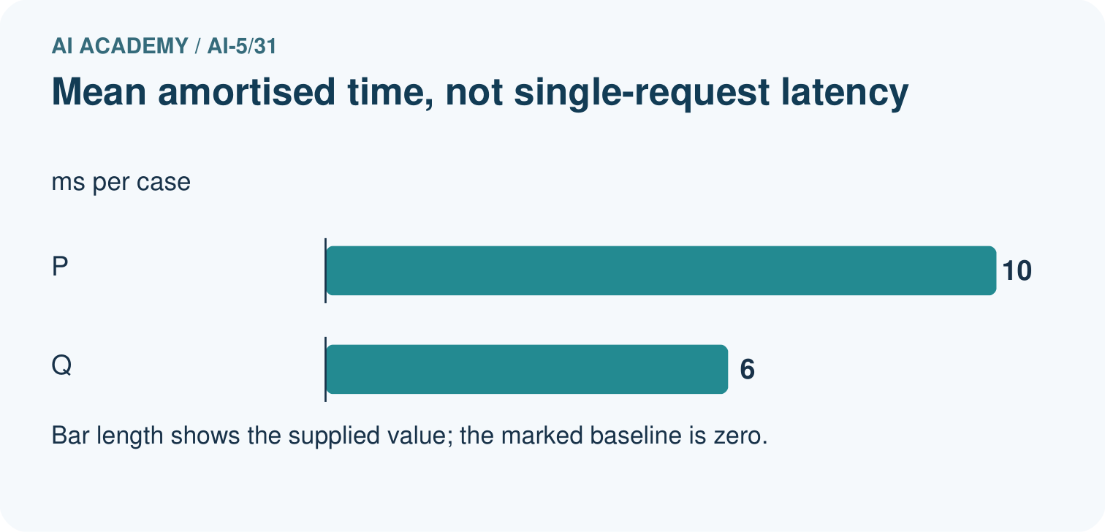
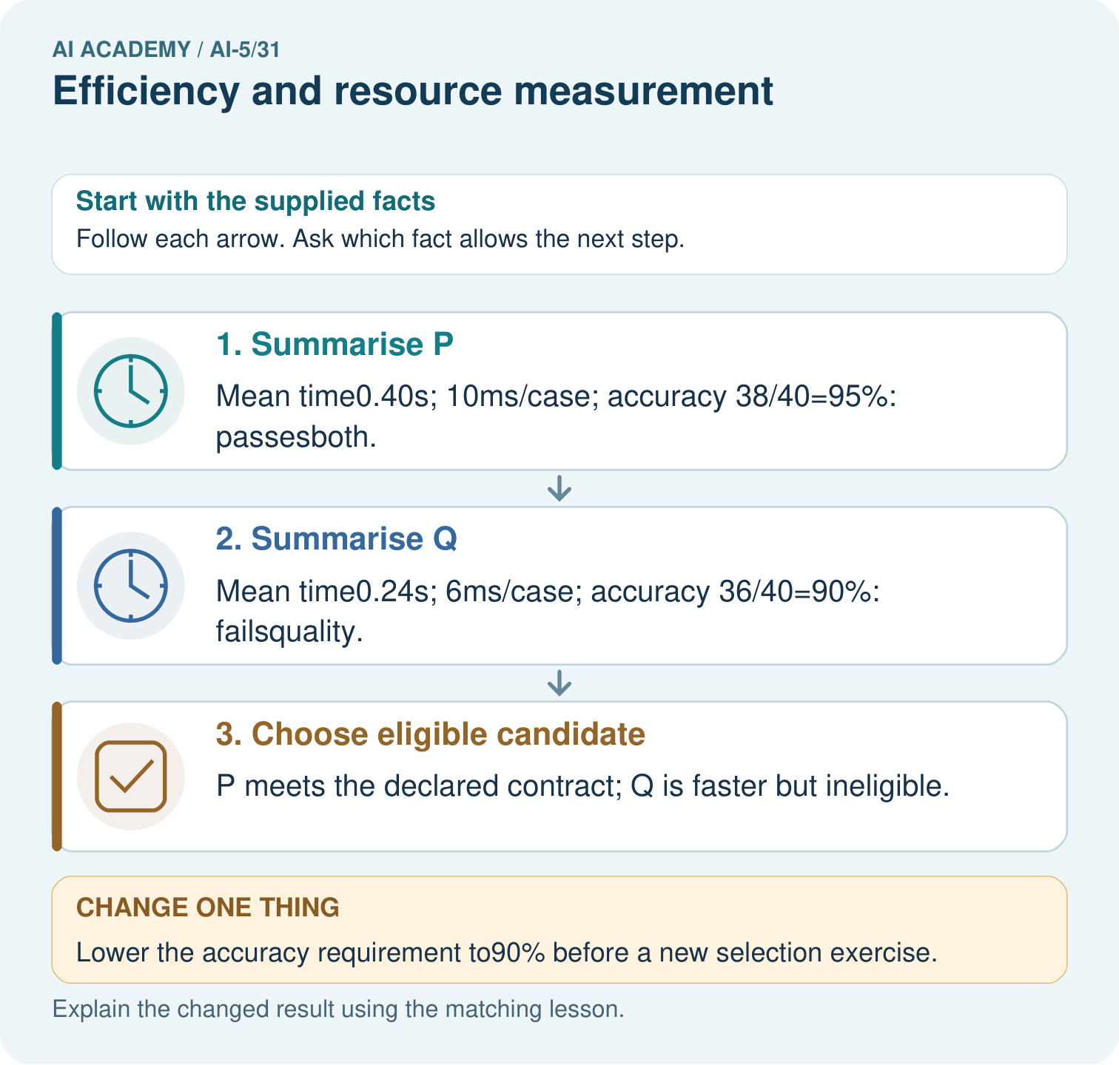

Read the picture one step at a time
Step | What happens and why
1. Summarise P | Mean time0.40s; 10ms/case; accuracy 38/40=95%: passesboth.
2. Summarise Q | Mean time0.24s; 6ms/case; accuracy 36/40=90%: failsquality.
3. Choose eligible candidate | P meets the declared contract; Q is faster but ineligible.
Match each pictured step to the supplied facts. This is a worked teaching case, not an independent assessment.

Why this result follows
Compare models on the same workload and apply every required condition. P meets both quality and time limits; Q’s speed does not compensate for missing the quality gate. Dividing total run duration by forty gives an amortised time per case. It does not measure the wait for one isolated request, which needs its own timed experiment.

What this example does not establish
Record hardware, batching, warm-up and variability; these supplied timings are toy measurements, not actual benchmark runs.

Change one thing in the pictured case
Change: Lower the accuracy requirement to90% before a new selection exercise.
Prediction: Both become eligible; Q has the smaller measured mean amortised time.
Reason: The acceptance contract changed; Q’s measured accuracy did not improve.

Ask while showing the picture
Cover the result. Ask learners to name the inputs and predict the next step. Uncover one step, connect the icon to the actual procedure, and explain its evidence. Then change the supplied condition and compare. The picture is a representation; it does not document execution of a real AI model.

03. Demonstrate and guide practice
Time or stage | Teacher action
Session 1 start to 7 minutes | Retrieve why shared examples and group proportions matter for comparisons.
7 to 18 minutes | Read the timing protocol and table. Label training, warm-up and inference work separately.
18 to 32 minutes | Complete W1 and trace the timing code, including milliseconds and examples per second.
32 to 45 minutes | Use W2 and the visual to apply the quality and time requirements before choosing a model.
Session 2 start to 8 minutes | Complete the guided alternative requirement without retroactively changing the original rule.
8 to 20 minutes | Count weights and biases and complete W3; discuss what memory and energy require beyond counts.
20 to 35 minutes | Collect W4 independently, requiring units, accuracy fractions, eligibility and parameter bytes.
35 to 45 minutes | Use W5 and the exit response to repair benchmark claims. Give feedback before the fresh retry.
Use the worked example in Sections 3 and 6. Collect a prediction before revealing its result; ask the learner to point to each intermediate fact.
Use a units ledger: seconds per pass, examples per pass, milliseconds per example and examples per second. Draw every dense connection and one bias per output. Extension: compare median-pass throughput with total examples divided by total elapsed time; explain why these can differ when pass durations vary. Neither alone measures a latency percentile.

Reduce help deliberately
Completion task: With at least 91 correct out of 100 and at most 25 ms amortised time required, which model qualifies? Calculate B’s time reduction relative to A and explain why the percentage throughput increase differs.
Teacher check: Teacher explanation: Only A qualifies; B misses the quality requirement. B reduces time by 8 / 20 = 40 percent. Throughput rises from 50 to about 83.33, an increase of about 66.67 percent relative to 50. Time and throughput use different baseline denominators and are reciprocal for this fixed workload.
Start by identifying the given inputs together. Leave the intermediate steps blank. If needed, model one step, then withdraw that help on the next step. Move to a full trace only when the partial trace is understood. For partners, alternate explainer and checker; collect a response from every learner before discussion.

Individual reasoning check
Use the worked case for Efficiency and resource measurement. Proposed explanation: “Fewer parameters always means faster”. Decide whether this explanation is supported. Point to the step or supplied fact that decides; explain your repair if needed.
Expected correction: Hardware, operations, memory access, precision and implementation affect runtime; measure the declared workload.
Collect explanations, not only yes/no votes. If a misunderstanding is common, re-model the relevant step for the class. If it affects a few learners, give a short targeted group explanation while others solve a more demanding variation.

Pictorial practice question
Why is 10ms/case not necessarily a single-request latency? Point to the relevant step in the picture, then write the changed result and the rule or evidence that supports it.

Reasoned teacher answer
It divides the mean duration of a 40-case run by 40. Batch overhead and processing overlap mean individual request latency needs its own measurement. Changed-case check: Both become eligible; Q has the smaller measured mean amortised time. The acceptance contract changed; Q’s measured accuracy did not improve.
Changed-case reasoning: Both become eligible; Q has the smaller measured mean amortised time. The acceptance contract changed; Q’s measured accuracy did not improve.
Collect each learner’s explanation before discussion. Use the first missing connection between input, deciding step and result to choose support. This question is worked-case practice, not fresh mastery evidence.

04. Run the investigation and diagnose misconceptions
Fewer parameters always means faster: Hardware, operations, memory access, precision and implementation affect runtime; measure the declared workload.
Total time divided by count is every request’s latency: It is an amortised quantity. Individual requests can vary, and batching or concurrency changes waiting time.
Only the winning run consumed resources: Unsuccessful trials and warm-up also consume resources; record them in the appropriate experiment budget.
Use Section 9 for the evidence ledger. Add a boundary or missing-input case and record the expected response before checking. More successful repeats of one case do not establish wider coverage.

Match the support to the first error
What the response shows | Next teaching action
Missing or misread facts | Read the case aloud, mark supplied versus unknown facts, and let the learner restate it.
Wrong procedure | Return to the deciding step in the worked case. Contrast it with the proposed incorrect explanation.
Arithmetic or implementation error | Trace intermediate values or lines; preserve the first mismatch and retry that step.
Correct result without a reason | Ask for a trace and a changed case before marking independent understanding.
An unsupported wider claim | Ask which supplied evidence supports the claim and which further observation would be needed.
Offer an oral explanation, drawing, enlarged visual or fewer examples when that removes a reading/writing barrier. Keep the same reasoning goal. Stretch secure learners by changing a boundary or assumption and asking them to defend the effect, not simply by assigning more of the same questions.

05. Assess and explain the answers

Guided and exit questions
Guided: under the alternative rule set in advance, A and B both qualify. B wins the declared lower-amortised-time tie-breaker, 12 versus 20 ms. Exit: best depends on requirements and B fails the original quality rule; greener is unsupported without energy evidence. Use identical workload and declared conditions or label a whole-system comparison, measure completed work, repeat timings, retain raw results and quality outcomes, and reserve final evaluation after selection.

W1 Summarise repeated timings
For A and B, calculate median pass time, amortised milliseconds per example and median-pass throughput. State the measured boundary and one latency claim these numbers cannot support.
Teacher explanation: A: 2.0 seconds, 20 ms per example, 50 examples per second. B: 1.2 seconds, 12 ms per example, about 83.33 examples per second. The boundary covers 100 completed sequential predictions on preprocessed inputs, excluding loading and preprocessing. It does not establish worst-case or percentile request latency.

W2 Compare under requirements
With at least 91 correct out of 100 and at most 25 ms amortised time required, which model qualifies? Calculate B’s time reduction relative to A and explain why the percentage throughput increase differs.
Teacher explanation: Only A qualifies; B misses the quality requirement. B reduces time by 8 / 20 = 40 percent. Throughput rises from 50 to about 83.33, an increase of about 66.67 percent relative to 50. Time and throughput use different baseline denominators and are reciprocal for this fixed workload.

W3 Separate storage and memory
Count weights, biases and total parameters in the 4 to 3 to 2 network. Calculate raw parameter bytes at four bytes each. Explain why this cannot be reported as peak training memory or an energy measurement.
Teacher explanation: There are 12 + 6 = 18 weights and 3 + 2 = 5 biases, totalling 23 parameters and 92 bytes. Activations, buffers, gradients, optimiser state and overhead can require additional memory. Energy needs power-and-time evidence; parameter bytes alone provide neither peak training memory nor energy.

W4 Evaluate a new case independently
For 50 shared validation cases, P has times 0.6, 0.5, 0.4 seconds and 47 correct; Q has 0.3, 0.4, 0.5 seconds and 45 correct. Require at least 92 percent accuracy and at most 12 ms amortised time. Give median times, amortised times, throughput, accuracy and eligible models. A separate dense network has dimensions 3 to 2 to 1 with one bias per output: find its parameter count and raw bytes at four bytes each.
Teacher explanation: P: median 0.5 s, 10 ms, 100 examples/s, accuracy 47 / 50 = 94 percent. Q: median 0.4 s, 8 ms, 125 examples/s, accuracy 45 / 50 = 90 percent. Only P qualifies. The separate network has (3*2 + 2) + (2*1 + 1) = 11 parameters, or 44 raw bytes.

W5 Repair an unfair benchmark
A runs on one device with batch size 1; B runs on another with batch size 32. Only B’s fastest trial and the winning training run are reported. Explain how to compare and report the results fairly.
Teacher explanation: Control device, precision, workload, batch size, concurrency and timed boundary for a model-only comparison, or explicitly compare whole systems without attributing the result to the model alone. Use the same quality cases, report repetitions and raw timings rather than one best trial, and count all training trials and warm-up work in their appropriate budgets.

Independent assessment and fresh retry
W4 requires P: 0.5 s, 10 ms, 100/s, 94 percent; Q: 0.4 s, 8 ms, 125/s, 90 percent; only P eligible; 11 parameters and 44 bytes. Fresh retry: 40 shared cases, R times 0.8, 1.0, 0.6 seconds with 38 correct; S times 0.4, 0.6, 0.5 with 36 correct. Require 95 percent accuracy and at most 25 ms. R gives 0.8 s, 20 ms, 50/s and 95 percent; S gives 0.5 s, 12.5 ms, 80/s and 90 percent. Only R qualifies. A 2 to 3 to 1 dense network has 13 parameters and 52 bytes at four bytes each.

Assess independent transfer
Selected case: For 50 shared validation cases, P has times 0.6, 0.5, 0.4 seconds and 47 correct; Q has 0.3, 0.4, 0.5 seconds and 45 correct. Require at least 92 percent accuracy and at most 12 ms amortised time. Give median times, amortised times, throughput, accuracy and eligible models. A separate dense network has dimensions 3 to 2 to 1 with one bias per output: find its parameter count and raw bytes at four bytes each.

Selected case answer
Teacher explanation: P: median 0.5 s, 10 ms, 100 examples/s, accuracy 47 / 50 = 94 percent. Q: median 0.4 s, 8 ms, 125 examples/s, accuracy 45 / 50 = 90 percent. Only P qualifies. The separate network has (3*2 + 2) + (2*1 + 1) = 11 parameters, or 44 raw bytes.
Dimension | Evidence required
Explanation | Names the applicable idea or procedure and ties it to the supplied facts.
Trace and result | Preserves the given inputs and shows the relevant intermediate steps; distinguishes a prediction from an observed execution.
Limits | States the assumptions, missing evidence or conditions under which the result would change.
Record each dimension as not yet, with support, or independent. Accept a valid alternative procedure with a defensible trace. Do not penalise an honestly recorded model failure if the learner correctly explains its evidence and limits.

Feedback that the learner uses
Name the earliest unsupported step and give one action to repair it. Have the learner make that repair now and explain why. Then assess the relevant skill on a fresh, fully specified case. Confirm it was not previously practised with feedback; solve and check the new case before assigning it. A follow-up design prompt is a starting brief, not automatically an equivalent test.

06. Connect the project, support and next lesson
Add a labelled efficiency and resource measurement evidence sheet to Image-pattern Network Investigation. Show how you can calculate throughput and amortised time per example from repeated timings. Use the supplied fictional case and keep its inputs, intermediate steps, calculation or prediction, and limitation. Connect this record to last week’s record; a matching answer without a trace is insufficient.
Use a units ledger: seconds per pass, examples per pass, milliseconds per example and examples per second. Draw every dense connection and one bias per output. Extension: compare median-pass throughput with total examples divided by total elapsed time; explain why these can differ when pass durations vary. Neither alone measures a latency percentile.
Week 32 documents a network experiment, preserving methods, data splits, versions, raw results, resource measurements and limitations.
Retain the project ledger and assess a changed case after support. Check the relevant prerequisite before carrying this component forward.

Plan the delayed return
Suggested return points in this level: ai-5/32, ai-5/34. Use actual classroom dates, adjusting for holidays and gaps. One, three and six teaching weeks are scheduling choices, not a claimed optimal spacing.
At a delayed check, ask for the idea from memory and a changed application. Compare with the earlier independent response and record support used. For a new level, revisit the previous capstone before checking the new prerequisites.
Record | Teacher evidence
Learner code and date
Concept and case used; prior exposure
Explanation / trace / limits
Support and first repair
Changed case and delayed outcome
Next teaching action
Use the evidence to choose reteaching or the next step. A completed page, confidence rating or attractive project does not by itself demonstrate understanding.

Project evidence from this case
For your Image-pattern Network Investigation, save the input, procedure, observed result and limitation of this check. Label this worked example as practice; use a different, previously unreviewed case when checking independent understanding.

07. Prepare, teach and assess
Teaching target: Calculate throughput and amortised time per example from repeated timings
Prepare the labelled worked-case picture, the matching workbook, fictional input cards and a place for individual responses. Check a local Python 3 environment before class; have a paper-trace version ready.
Session | Plan | Resources
Session 1 · Understand · 45 min | 0–7: recall and prerequisite; 7–15: inspect the concrete case and predict; 15–30: teacher models the worked trace; 30–40: learners explain a step using the text and visual; 40–45: check the core idea. | Sections 1–6; record the brief recall in the workbook.
Session 2 · Practise · 45 min | 0–5: retrieve the procedure; 5–15: W2 completion practice; 15–23: explain and check with a partner; 23–30: each learner answers the misconception check; 30–40: targeted reteaching or a harder variation; 40–45: prepare the investigation. | Sections 7–10; use the matching workbook W2 and misconception check.
Session 3 · Investigate and transfer · 45 min | 0–5: retrieve the decision rule; 5–20: investigate or trace; 20–30: start the independent case; 30–38: connect the project; 38–43: act on feedback; 43–45: plan the return check. | Sections 9 and 11–14. Give extra time to finish the full task set; use Section 15 when the week includes a coding lab.
Before class, solve the supported practice: With at least 91 correct out of 100 and at most 25 ms amortised time required, which model qualifies? Calculate B’s time reduction relative to A and explain why the percentage throughput increase differs.
Reasoned practice answer: Teacher explanation: Only A qualifies; B misses the quality requirement. B reduces time by 8 / 20 = 40 percent. Throughput rises from 50 to about 83.33, an increase of about 66.67 percent relative to 50. Time and throughput use different baseline denominators and are reciprocal for this fixed workload.
Check every learner before discussion: Use the worked case for Efficiency and resource measurement. Proposed explanation: “Fewer parameters always means faster”. Decide whether this explanation is supported. Point to the step or supplied fact that decides; explain your repair if needed.
Misconception repair: Hardware, operations, memory access, precision and implementation affect runtime; measure the declared workload.
Support: read the exact case aloud, enlarge the labelled picture, supply input cards and model only the first deciding step. Accept a spoken explanation or drawing; retain the reasoning goal.
Extension: Lower the accuracy requirement to90% before a new selection exercise. Require a prediction and a reason before comparing. Expected result: Both become eligible; Q has the smaller measured mean amortised time. Reason: The acceptance contract changed; Q’s measured accuracy did not improve.
Independent assessment: withhold the reserved answer until the learner has attempted the new case. Record support separately from correctness.
Criterion | Not yet | With support | Independent
Explanation | Names an answer without a deciding fact | Uses a hint to link fact and decision | Explains the deciding fact in own words
Trace or test | Cannot connect input and result | Completes steps with prompts | Traces or tests a changed case accurately
Limits and revision | Claims more than evidence supports | Names a limit after a prompt | States a defensible limit and useful next test
Project checkpoint: Present and defend. Demonstrate the system, explain one failure and justify the next improvement with evidence.
Use the weekly teacher answer for topic-specific reasoning. A saved progress tick is an activity record; judge mastery from the learner’s explanation and evidence.

08. Use feedback, labs and repair paths
Use the two formative questions as supported practice, not as independent mastery scores. Discuss the deciding evidence rather than accepting a guessed selection.
The feedback comes from the reviewed public worked case. Do not reveal the separately reserved independent teacher answer until the learner has attempted that case.
Ask students to predict before running code. Preserve errors and actual outputs; collect a changed test and an explanation. The branch-boundary and indexing lessons deliberately include failure cases.
Use the earlier worked-explanation links to address a specific missing building block, then return to the current question. Adapt this suggestion after observing the learner; it is not an automatic diagnosis.
Collect the completed-work portfolio as evidence. Record support separately from correctness, and assess explanation, trace/test and limitations. Progress ticks and quiz selections alone do not establish mastery.

