AI ACADEMY · TEACHER · ai-5/32

Documenting a network experiment
Project: Image-pattern Network Investigation

01. Prepare the purpose, prerequisites and materials

Teach the learning cycle
Primary target: Record a network experiment with enough detail to replay its calculations
Session | Sequence and minutes | Resources
Session 1 · Understand · 45 min | 0–7: recall and prerequisite; 7–15: inspect the concrete case and predict; 15–30: teacher models the worked trace; 30–40: learners explain a step using the text and visual; 40–45: check the core idea. | Sections 1–6; record the brief recall in the workbook.
Session 2 · Practise · 45 min | 0–5: retrieve the procedure; 5–15: W2 completion practice; 15–23: explain and check with a partner; 23–30: each learner answers the misconception check; 30–40: targeted reteaching or a harder variation; 40–45: prepare the investigation. | Sections 7–10; use the matching workbook W2 and misconception check.
Session 3 · Investigate and transfer · 45 min | 0–5: retrieve the decision rule; 5–20: investigate or trace; 20–30: start the independent case; 30–38: connect the project; 38–43: act on feedback; 43–45: plan the return check. | Sections 9 and 11–14. Give extra time to finish the full task set; use Section 15 when the week includes a coding lab.
This is a starting allocation of 135 minutes, not a validated duration. Preserve all named topics. Schedule extra time for connected examples, the full investigation, independent cases and project building. Repeated copies of a case share one recorded attempt; they are not new evidence.

Retrieval answer guidance

Efficiency and resource measurement
Without opening the old lesson, explain one key idea from Efficiency and resource measurement. Give an example and a mistake that the idea helps you avoid.
Look for: Calculate throughput and amortised time per example from repeated timings
Reference example, not the only acceptable wording: Teacher explanation: A: 2.0 seconds, 20 ms per example, 50 examples per second. B: 1.2 seconds, 12 ms per example, about 83.33 examples per second. The boundary covers 100 completed sequential predictions on preprocessed inputs, excluding loading and preprocessing. It does not establish worst-case or percentile request latency.

Uncertainty and failure analysis
Without opening the old lesson, explain one key idea from Uncertainty and failure analysis. Give an example and a mistake that the idea helps you avoid.
Look for: Distinguish a predicted class, confidence score and observed correctness
Reference example, not the only acceptable wording: Teacher explanation: B predicts 1 with confidence 0.90 and is wrong. E predicts 0 with confidence 0.55 and is correct. F predicts 0 with confidence 0.90 and is wrong. F’s low score for class 1 corresponds to a high score for class 0, the class selected.

Embeddings and neighbourhoods
Without opening the old lesson, explain one key idea from Embeddings and neighbourhoods. Give an example and a mistake that the idea helps you avoid.
Look for: Look up a vector using a token ID and preserve sequence shape
Reference example, not the only acceptable wording: Teacher explanation: Vectors are [[1, 1], [0, 1], [0, 2], [0, 0]], mask [1, 1, 1, 0] and shape 4 by 2.
Use two 45-minute sessions. Treat the tiny ReLU model as a fully inspectable experiment, not a claim about real-world accuracy. The code trains one scalar on two rows and selects using one validation row. Require students to label metrics, denominators and data roles before judging the result; no final evaluation or resource measurement is supplied.

Outcomes
Record a network experiment with enough detail to replay its calculations
Trace reported metrics to data roles and saved parameters
Write a bounded conclusion and identify missing evaluation evidence

Preparation
Printed lesson and workbook; paper and pencil
Calculator and optional local Python 3 editor; no packages or AI accounts needed
Use the fictional examples supplied; prepare the fresh retry before class

Prerequisite answer
It omits the task, data and splits, model and code versions, quality counts or loss definition, hardware, timing boundary and raw results. Another person cannot check what was measured or repeat the comparison.

End goal for the pictorial case
By the end, I can explain documenting a network experiment using a traced example and a stated limitation.
This added worked case illustrates the week’s main idea. Retain all original and connected topics; schedule its practice within the teaching cycle.

02. Explain and model the mechanism
A useful experiment record explains what was asked, what was done, what happened and what remains unknown. Use run NN32-A: does fitting one positive ReLU weight reduce validation mean squared error compared with its initial value? This tiny constructed regression task teaches record keeping; it cannot establish performance on real-world data.
The network predicts max(0, a*x), with one weight a and no bias. Start at a = 1, use learning rate 0.1, two full-batch training updates and mean squared error, the mean of squared prediction errors. There is no normalisation, random initialisation or shuffling. Use Python float arithmetic and record the actual Python version when replaying.
Before running, set the selection rule: choose the checkpoint with the smaller validation MSE, breaking a tie toward the earlier update. The initial model is the baseline. Validation V1 chooses a checkpoint but never contributes to the training gradient. Final evaluation has not been run; its result must be recorded as not measured.
For these two training cases, MSE = 2.5*(a - 2) squared and its gradient is 5*(a - 2). At a = 1 the gradient is -5, so the first update is 1 - 0.1*(-5) = 1.5. The next gradient is -2.5, giving a = 1.75. All preactivations in this run stay positive, so ReLU’s derivative is one; this is not a general backpropagation implementation.
The code assumes the supplied nonempty numeric datasets and positive preactivations. Each record stores update number, weight, training MSE and validation MSE after the update. Keep both records, the initial weight and the rule; saving only the best score erases how the choice was made.
Term | Meaning
Run identifier | A unique label linking one experiment’s settings, outputs and records
Checkpoint | Saved model parameters at a specified stage of training
Manifest | An inventory connecting named artifacts with versions, roles and integrity information
Replay | Repeating a recorded procedure to check whether its outputs agree

Read each checkpoint against the same validation case
Checkpoint weight | Training MSE | Validation MSE
Update 1: a = 1.5 | 0.625 | 2.25
Update 2: a = 1.75 | 0.15625 | 0.5625
The baseline validation MSE is 9. The predeclared rule selects update 2 with validation MSE 0.5625 on one validation case. This is not a final-test score.
Guided: 1.75*3 = 5.25, error 5.25 - 6 = -0.75, squared error 0.5625. V1 selected the checkpoint and is validation, not untouched final evaluation. Exit: replace final accuracy with validation MSE 0.5625 on one constructed case selected using that case. Energy is not measured. Supply data and splits, exact code, settings, baseline and both checkpoints, raw predictions, metric definition, selection rule and environment information.

Model the reasoning aloud
Use the complete worked example below before asking learners to complete W2. Reveal a small part, invite a prediction, then explain the deciding step. These teacher notes contain solutions; do not reveal the independent case answer during modelling.

Read each checkpoint against the same validation case
Checkpoint weight | Training MSE | Validation MSE
Update 1: a = 1.5 | 0.625 | 2.25
Update 2: a = 1.75 | 0.15625 | 0.5625
The baseline validation MSE is 9. The predeclared rule selects update 2 with validation MSE 0.5625 on one validation case. This is not a final-test score.
A defensible conclusion is: in run NN32-A, update 2 reduced MSE on the single constructed validation case from 9 to 0.5625 compared with the initial model. This checkpoint was selected using that same validation case; generalisation is untested. No timing, peak-memory or energy measurements are provided.

Using the selected weight, calculate the prediction for V1 and its squared error. Explain why the result must be labelled validation rather than independent final evaluation.
________________________________________________________________
________________________________________________________________
________________________________________________________________
________________________________________________________________
Thinking move | Teacher prompt
Plan | What is given? What is the question? Which procedure fits these facts?
Do | Point to each input and intermediate step in the worked trace. Name the rule that allows the next step.
Check | Does the output answer the question? Which assumption or limitation prevents a larger claim?
Use the diagram and verbal explanation together. Ask learners to match a sentence to a specific visual step; do not assign learners fixed visual or auditory learning styles.

A pictorial worked case: Documenting a network experiment
Document checkpoint selection so another team can reconstruct every reported number.

The facts we will use
Run R8 predicts ReLU(a×x). Validation V4 has x = 2, target 3. Baseline a = 0.5; checkpoints a = 1 and 1.25; choose minimum validation squared error.
All inputs and outcomes in this worked example are invented classroom data; no real model run is claimed.
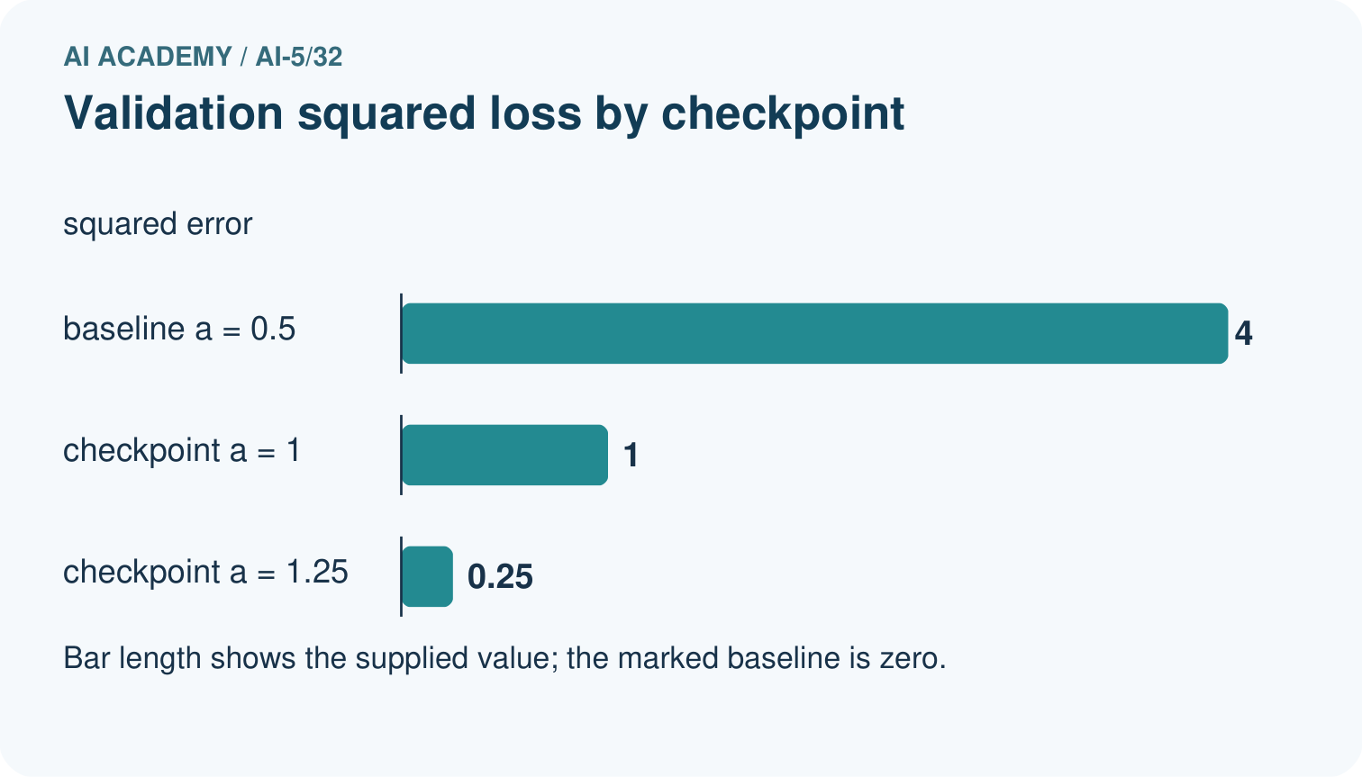
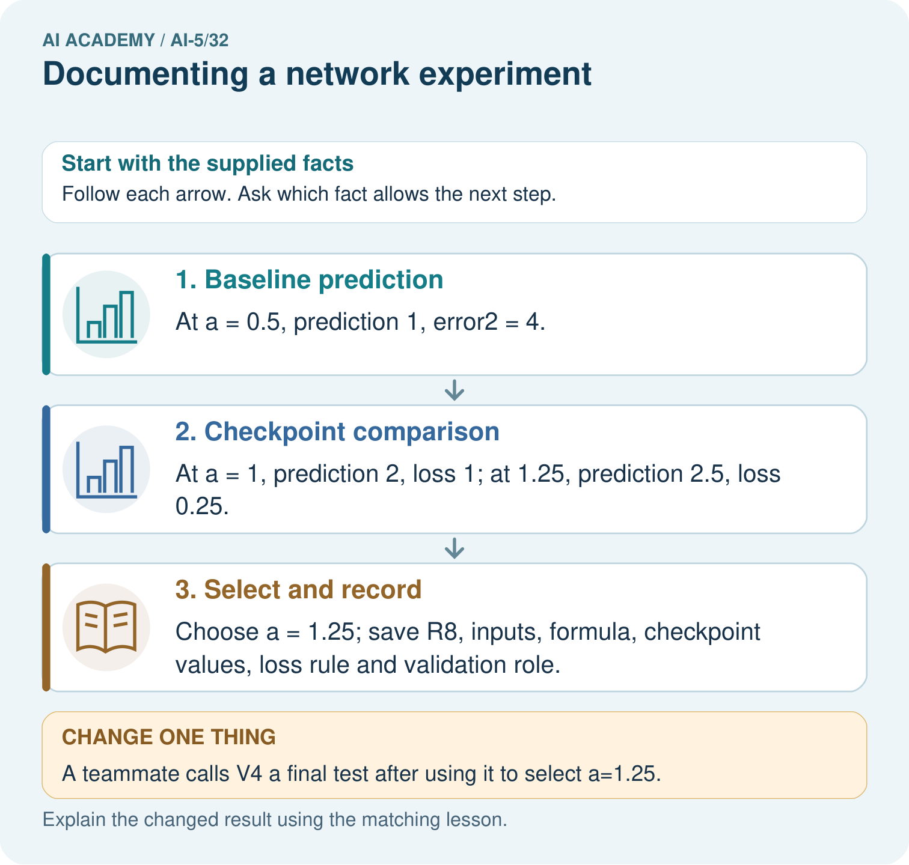

Read the picture one step at a time
Step | What happens and why
1. Baseline prediction | At a = 0.5, prediction 1, error² = 4.
2. Checkpoint comparison | At a = 1, prediction 2, loss 1; at 1.25, prediction 2.5, loss 0.25.
3. Select and record | Choose a = 1.25; save R8, inputs, formula, checkpoint values, loss rule and validation role.
Match each pictured step to the supplied facts. This is a worked teaching case, not an independent assessment.

Why this result follows
A reproducible record includes the actual input, formula, parameters and scoring rule, together with each dataset’s role. The validation case selects the best supplied checkpoint, so it is part of development. Save that selection history and freeze the checkpoint before evaluating fresh final cases. Renaming the same case a test does not change how it was used.

What this example does not establish
Reconstructing one run verifies arithmetic and provenance, not population performance or educational learning impact.

Change one thing in the pictured case
Change: A teammate calls V4 a final test after using it to select a=1.25.
Prediction: Correct its role to validation; it was used for selection.
Reason: Changing the label on a dataset does not make its evidence untouched.

Ask while showing the picture
Cover the result. Ask learners to name the inputs and predict the next step. Uncover one step, connect the icon to the actual procedure, and explain its evidence. Then change the supplied condition and compare. The picture is a representation; it does not document execution of a real AI model.

03. Demonstrate and guide practice
Time or stage | Teacher action
Session 1 start to 7 minutes | Retrieve the missing details in a vague performance claim and introduce run NN32-A.
7 to 18 minutes | Read the data roles and configuration. Complete W1 with a replay settings record.
18 to 32 minutes | Trace the two gradient updates, optionally run the code, and complete W2.
32 to 45 minutes | Use the visual to connect parameters, predictions, metrics and the selection decision.
Session 2 start to 8 minutes | Complete the guided V1 calculation and distinguish replay from independent evidence.
8 to 20 minutes | Build an artifact manifest and complete W3, including the limits of hashes and seeds.
20 to 35 minutes | Collect W4 independently, requiring raw predictions, errors and a bounded validation claim.
35 to 45 minutes | Use W5 and the exit response to repair records. Give feedback, then administer the fresh retry.
Use the worked example in Sections 3 and 6. Collect a prediction before revealing its result; ask the learner to point to each intermediate fact.
Provide a record frame with question, fixed settings, data roles, raw results, selection, limitations and next action. Allow a calculator and compare predictions before squared errors. Extension: rename a data file without changing its bytes, then edit a value; explain why only the content change alters its content hash. Use copies of fictional classroom data.

Reduce help deliberately
Completion task: Calculate both weight updates and give each training and validation MSE. Name the selected checkpoint and baseline validation MSE. How many independent validation examples support the comparison?
Teacher check: Teacher explanation: Weights are 1.5 then 1.75. Training MSE values are 0.625 and 0.15625; validation MSE values are 2.25 and 0.5625. Update 2 is selected; baseline validation MSE is 9. There is one validation example, not two examples created by evaluating two checkpoints.
Start by identifying the given inputs together. Leave the intermediate steps blank. If needed, model one step, then withdraw that help on the next step. Move to a full trace only when the partial trace is understood. For partners, alternate explainer and checker; collect a response from every learner before discussion.

Individual reasoning check
Use the worked case for Documenting a network experiment. Proposed explanation: “A smaller MSE is an accuracy percentage”. Decide whether this explanation is supported. Point to the step or supplied fact that decides; explain your repair if needed.
Expected correction: MSE is an average squared error in squared target units; it is not classification accuracy or a percentage.
Collect explanations, not only yes/no votes. If a misunderstanding is common, re-model the relevant step for the class. If it affects a few learners, give a short targeted group explanation while others solve a more demanding variation.

Pictorial practice question
What additional evidence is needed for a final performance claim? Point to the relevant step in the picture, then write the changed result and the rule or evidence that supports it.

Reasoned teacher answer
Freeze the selected checkpoint, then evaluate an independently reserved final set; retain run settings, baseline and selection history. Changed-case check: Correct its role to validation; it was used for selection. Changing the label on a dataset does not make its evidence untouched.
Changed-case reasoning: Correct its role to validation; it was used for selection. Changing the label on a dataset does not make its evidence untouched.
Collect each learner’s explanation before discussion. Use the first missing connection between input, deciding step and result to choose support. This question is worked-case practice, not fresh mastery evidence.

04. Run the investigation and diagnose misconceptions
A smaller MSE is an accuracy percentage: MSE is an average squared error in squared target units; it is not classification accuracy or a percentage.
A replay adds new evaluation evidence: Reusing the same rows checks procedure consistency, not performance on new independent cases.
A seed or hash proves the experiment is sound: Seeds and hashes help track execution or integrity; they cannot repair bad labels, leakage or an unsupported claim.
Use Section 9 for the evidence ledger. Add a boundary or missing-input case and record the expected response before checking. More successful repeats of one case do not establish wider coverage.

Match the support to the first error
What the response shows | Next teaching action
Missing or misread facts | Read the case aloud, mark supplied versus unknown facts, and let the learner restate it.
Wrong procedure | Return to the deciding step in the worked case. Contrast it with the proposed incorrect explanation.
Arithmetic or implementation error | Trace intermediate values or lines; preserve the first mismatch and retry that step.
Correct result without a reason | Ask for a trace and a changed case before marking independent understanding.
An unsupported wider claim | Ask which supplied evidence supports the claim and which further observation would be needed.
Offer an oral explanation, drawing, enlarged visual or fewer examples when that removes a reading/writing barrier. Keep the same reasoning goal. Stretch secure learners by changing a boundary or assumption and asking them to defend the effect, not simply by assigning more of the same questions.

05. Assess and explain the answers

Guided and exit questions
Guided: 1.75*3 = 5.25, error 5.25 - 6 = -0.75, squared error 0.5625. V1 selected the checkpoint and is validation, not untouched final evaluation. Exit: replace final accuracy with validation MSE 0.5625 on one constructed case selected using that case. Energy is not measured. Supply data and splits, exact code, settings, baseline and both checkpoints, raw predictions, metric definition, selection rule and environment information.

W1 Write the replay settings
For NN32-A, record the prediction rule, initial weight, bias policy, learning rate, update count, loss, training/validation IDs, data order or shuffling policy, and checkpoint selection rule. Name one environment field still to record when you run it.
Teacher explanation: Predict max(0, a*x); start a = 1 with no bias; rate 0.1; two full-batch updates; MSE is mean squared prediction error. T1 and T2 train, V1 validates; no shuffling or normalisation. Select lower validation MSE, ties to earlier update. Record the actual Python version, alongside the code and Python float arithmetic.

W2 Trace the selected result
Calculate both weight updates and give each training and validation MSE. Name the selected checkpoint and baseline validation MSE. How many independent validation examples support the comparison?
Teacher explanation: Weights are 1.5 then 1.75. Training MSE values are 0.625 and 0.15625; validation MSE values are 2.25 and 0.5625. Update 2 is selected; baseline validation MSE is 9. There is one validation example, not two examples created by evaluating two checkpoints.

W3 Audit the artifact record
A folder contains only best-model.json and a screenshot of 0.5625. Identify four missing artifacts or records and explain what a content hash can and cannot verify.
Teacher explanation: Missing items include exact data with IDs and splits, code/configuration, earlier checkpoints, raw predictions and metric definitions, selection rule, and environment details. A hash can detect changes relative to recorded content; it cannot establish correct labels, sound splits or a valid conclusion.

W4 Audit a new record independently
A separate run R17 records baseline a = 1 and checkpoints a = 1.5 and a = 1.75. It uses prediction max(0, a*x) and one validation case V9 with x = 4, y = 8. Compute baseline and checkpoint predictions and squared errors, choose by lowest validation MSE, and write a bounded conclusion. Final evaluation and runtime have not been measured.
Teacher explanation: Predictions are 4, 6 and 7; squared errors are 16, 4 and 1. Choose a = 1.75. In R17, that checkpoint lowers MSE on V9 from 16 to 1 relative to the baseline, but V9 also selects it. This is one-case validation evidence; final performance and runtime are not measured.

W5 Investigate a replay mismatch
A partner gets different results after changing preprocessing and replacing the validation file. They keep the old run ID and overwrite the old score. Explain what should be preserved and how the revised work should be recorded.
Teacher explanation: Preserve the original data, preprocessing, settings, outputs and run ID. Compare exact artifact versions to identify the mismatch. Record changed preprocessing and data under a new run or explicit version, including reasons and results. A changed validation set is a different comparison; do not overwrite it as though it were the same run.

Independent assessment and fresh retry
W4 requires predictions 4, 6, 7 and squared errors 16, 4, 1; choose a = 1.75 and label the result one-case validation with final evaluation and runtime not measured. Fresh retry: R18 has the same baseline and checkpoints but validation x = 5, y = 10. Predictions are 5, 7.5, 8.75; squared errors are 25, 6.25, 1.5625. Choose a = 1.75. Require a validation-only conclusion and a record of which validation data version was used.

Assess independent transfer
Selected case: A separate run R17 records baseline a = 1 and checkpoints a = 1.5 and a = 1.75. It uses prediction max(0, a*x) and one validation case V9 with x = 4, y = 8. Compute baseline and checkpoint predictions and squared errors, choose by lowest validation MSE, and write a bounded conclusion. Final evaluation and runtime have not been measured.

Selected case answer
Teacher explanation: Predictions are 4, 6 and 7; squared errors are 16, 4 and 1. Choose a = 1.75. In R17, that checkpoint lowers MSE on V9 from 16 to 1 relative to the baseline, but V9 also selects it. This is one-case validation evidence; final performance and runtime are not measured.
Dimension | Evidence required
Explanation | Names the applicable idea or procedure and ties it to the supplied facts.
Trace and result | Preserves the given inputs and shows the relevant intermediate steps; distinguishes a prediction from an observed execution.
Limits | States the assumptions, missing evidence or conditions under which the result would change.
Record each dimension as not yet, with support, or independent. Accept a valid alternative procedure with a defensible trace. Do not penalise an honestly recorded model failure if the learner correctly explains its evidence and limits.

Feedback that the learner uses
Name the earliest unsupported step and give one action to repair it. Have the learner make that repair now and explain why. Then assess the relevant skill on a fresh, fully specified case. Confirm it was not previously practised with feedback; solve and check the new case before assigning it. A follow-up design prompt is a starting brief, not automatically an equivalent test.

06. Connect the project, support and next lesson
Add a labelled documenting a network experiment evidence sheet to Image-pattern Network Investigation. Show how you can record a network experiment with enough detail to replay its calculations. Use the supplied fictional case and keep its inputs, intermediate steps, calculation or prediction, and limitation. Connect this record to last week’s record; a matching answer without a trace is insufficient.
Provide a record frame with question, fixed settings, data roles, raw results, selection, limitations and next action. Allow a calculator and compare predictions before squared errors. Extension: rename a data file without changing its bytes, then edit a value; explain why only the content change alters its content hash. Use copies of fictional classroom data.
Week 33 starts the capstone by recording a hypothesis, baseline, evaluation plan and success criteria before running controlled experiments.
Retain the project ledger and assess a changed case after support. Check the relevant prerequisite before carrying this component forward.

Plan the delayed return
Suggested return points in this level: ai-5/33, ai-5/35. Use actual classroom dates, adjusting for holidays and gaps. One, three and six teaching weeks are scheduling choices, not a claimed optimal spacing.
At a delayed check, ask for the idea from memory and a changed application. Compare with the earlier independent response and record support used. For a new level, revisit the previous capstone before checking the new prerequisites.
Record | Teacher evidence
Learner code and date
Concept and case used; prior exposure
Explanation / trace / limits
Support and first repair
Changed case and delayed outcome
Next teaching action
Use the evidence to choose reteaching or the next step. A completed page, confidence rating or attractive project does not by itself demonstrate understanding.

Project evidence from this case
For your Image-pattern Network Investigation, save the input, procedure, observed result and limitation of this check. Label this worked example as practice; use a different, previously unreviewed case when checking independent understanding.

07. Prepare, teach and assess
Teaching target: Record a network experiment with enough detail to replay its calculations
Prepare the labelled worked-case picture, the matching workbook, fictional input cards and a place for individual responses. Check a local Python 3 environment before class; have a paper-trace version ready.
Session | Plan | Resources
Session 1 · Understand · 45 min | 0–7: recall and prerequisite; 7–15: inspect the concrete case and predict; 15–30: teacher models the worked trace; 30–40: learners explain a step using the text and visual; 40–45: check the core idea. | Sections 1–6; record the brief recall in the workbook.
Session 2 · Practise · 45 min | 0–5: retrieve the procedure; 5–15: W2 completion practice; 15–23: explain and check with a partner; 23–30: each learner answers the misconception check; 30–40: targeted reteaching or a harder variation; 40–45: prepare the investigation. | Sections 7–10; use the matching workbook W2 and misconception check.
Session 3 · Investigate and transfer · 45 min | 0–5: retrieve the decision rule; 5–20: investigate or trace; 20–30: start the independent case; 30–38: connect the project; 38–43: act on feedback; 43–45: plan the return check. | Sections 9 and 11–14. Give extra time to finish the full task set; use Section 15 when the week includes a coding lab.
Before class, solve the supported practice: Calculate both weight updates and give each training and validation MSE. Name the selected checkpoint and baseline validation MSE. How many independent validation examples support the comparison?
Reasoned practice answer: Teacher explanation: Weights are 1.5 then 1.75. Training MSE values are 0.625 and 0.15625; validation MSE values are 2.25 and 0.5625. Update 2 is selected; baseline validation MSE is 9. There is one validation example, not two examples created by evaluating two checkpoints.
Check every learner before discussion: Use the worked case for Documenting a network experiment. Proposed explanation: “A smaller MSE is an accuracy percentage”. Decide whether this explanation is supported. Point to the step or supplied fact that decides; explain your repair if needed.
Misconception repair: MSE is an average squared error in squared target units; it is not classification accuracy or a percentage.
Support: read the exact case aloud, enlarge the labelled picture, supply input cards and model only the first deciding step. Accept a spoken explanation or drawing; retain the reasoning goal.
Extension: A teammate calls V4 a final test after using it to select a=1.25. Require a prediction and a reason before comparing. Expected result: Correct its role to validation; it was used for selection. Reason: Changing the label on a dataset does not make its evidence untouched.
Independent assessment: withhold the reserved answer until the learner has attempted the new case. Record support separately from correctness.
Criterion | Not yet | With support | Independent
Explanation | Names an answer without a deciding fact | Uses a hint to link fact and decision | Explains the deciding fact in own words
Trace or test | Cannot connect input and result | Completes steps with prompts | Traces or tests a changed case accurately
Limits and revision | Claims more than evidence supports | Names a limit after a prompt | States a defensible limit and useful next test
Project checkpoint: Present and defend. Demonstrate the system, explain one failure and justify the next improvement with evidence.
Use the weekly teacher answer for topic-specific reasoning. A saved progress tick is an activity record; judge mastery from the learner’s explanation and evidence.

08. Use feedback, labs and repair paths
Use the two formative questions as supported practice, not as independent mastery scores. Discuss the deciding evidence rather than accepting a guessed selection.
The feedback comes from the reviewed public worked case. Do not reveal the separately reserved independent teacher answer until the learner has attempted that case.
Ask students to predict before running code. Preserve errors and actual outputs; collect a changed test and an explanation. The branch-boundary and indexing lessons deliberately include failure cases.
Use the earlier worked-explanation links to address a specific missing building block, then return to the current question. Adapt this suggestion after observing the learner; it is not an automatic diagnosis.
Collect the completed-work portfolio as evidence. Record support separately from correctness, and assess explanation, trace/test and limitations. Progress ticks and quiz selections alone do not establish mastery.

